# Step 1: Identify Objects

|  |  |  |  |
| --- | --- | --- | --- |
| **Nouns** | | | |
| 1User Screen | 2Selection Screen | Starting a one-player game | Starting a two-player game |
| User screen  ~~URL~~  ~~character select screen~~  ~~input box~~  ~~username~~  ~~system created username~~  Selection screen  ~~selector for creating a room~~  ~~selector to join a room~~ | player  ~~image~~  ~~color~~  another player  ~~black and white~~  ~~"ready" button~~  ~~green~~ | ~~user~~  one-player game  ~~"ready" button~~ | ~~two-player game~~  ~~"ready" button~~ |

|  |  |  |  |
| --- | --- | --- | --- |
| **Nouns** | | | |
| Creating a game session | Enemy Movement | Enemy Combat | Player Movement |
| ~~game~~  game engine  map level  dependent game libraries  ~~"Level 1"~~  ~~current level~~  ~~health indicator~~  ~~the start of the map~~  ~~default weapon~~  ~~pistol~~  enemy sprites  ~~interaction events~~  ~~player movement~~ | Enemy classes  ~~autonous movements~~  ~~Enemy movement~~  ~~Enemy type~~  Rifleman-type enemies  Soldier-type enemies  Static-type enemies  weapon | ~~only one at a time~~  ~~shotgun~~  ~~assault rifle~~  ~~laser~~  ~~capabilities (bullets per shot, distance bullets travel, firing rate)~~ | individual player class  ~~autonous movements~~  ~~Player movement (run, jump, crouch, can run and shoot at same time)~~  ~~hazard (kills such as a pit)~~ |

|  |  |  |  |
| --- | --- | --- | --- |
| **Nouns** | | | |
| Player Combat | Player versus Player Combat | Player completes Mission | Game input devices |
| ~~more than one weapon~~  ~~PC user~~  keyboard  touchscreen  collision layer  ~~spot on the screen~~  ~~touch an of an enemy~~  ~~by one bullet~~ | ~~ranged attack (shooting from disance)~~  ~~Player health~~  ~~player's health bar~~  ~~by one bar~~  ~~max capacity for bar is 3~~  ~~contact~~  ~~fully drained~~  ~~respawn same spot the player died~~ | ~~end of a map level~~  ~~door~~  ~~new map level~~  ~~start of a map level~~  ~~a new map level~~  ~~default weapon~~ | keyboard  joystick  touchscreen |

|  |  |
| --- | --- |
| Nouns | |
| Pausing a game | Response time |
| ~~pause system~~  ~~game progress~~  ~~timeout duration~~ | ~~response time from server~~  ~~100 milliseconds~~  ~~maximum of 100 real-time connections~~  ~~minimum~~  ~~1 one-player, 1 two-playe played simultaneously~~  ~~minimum of two user at the same timel~~ |

|  |  |  |  |
| --- | --- | --- | --- |
| **Verbs** | | | |
| User Screen | Selection Screen | Starting a one-player game | Starting a two-player game |
| first screen displayd  types  create  join | have char select screen  appear in color  light up green | starts one-player game  Select screen appears  pressing ready button | starts two-player game  Select screen appears  pressing ready button |

|  |  |  |  |
| --- | --- | --- | --- |
| **Verbs** | | | |
| Creating a game session | Enemy Movement | Enemy Combat | Player Movement |
| -loads the level map  -display ‘Level1’  -indicates current level  -display health indicator  -appear at start of game  -weapon loaded  -wait to be triggered | -move enemey sprites  -allow enemy movement  -not be allowed to mov  change direction | -use various weapons  -will have different capabilities  -dropped upon enemy death  -kill a player | -move a player  -autonomous movement  -to run  -to jump  -to crouch  -die if player falls |

|  |  |  |  |
| --- | --- | --- | --- |
| **Verbs** | | | |
| Player Combat | Player versus Player Combat | Player completes Mission | Game input devices |
| -not possess  -shoot a weapon  pressing a key  -touching a spot  -kill an enemy  shooting it  -die by touch  die by one bullet | -attach other players  -health shall decrease  -will decrease by one bar  -attached by  -lose a life  -respawn | designated by door  finish a map  loaded when  placed at start  start a new level | -move the player using keyboard  -move the player jusing joystick  -move the player using touchscreen |

|  |  |
| --- | --- |
| **Verbs** | |
| Pausing a game | Response time |
| temporarily halt  not have the ability to pause | handle a maximum  allow a minimum  support a minimum |

# **Step 2: Create a Conceptual Model**

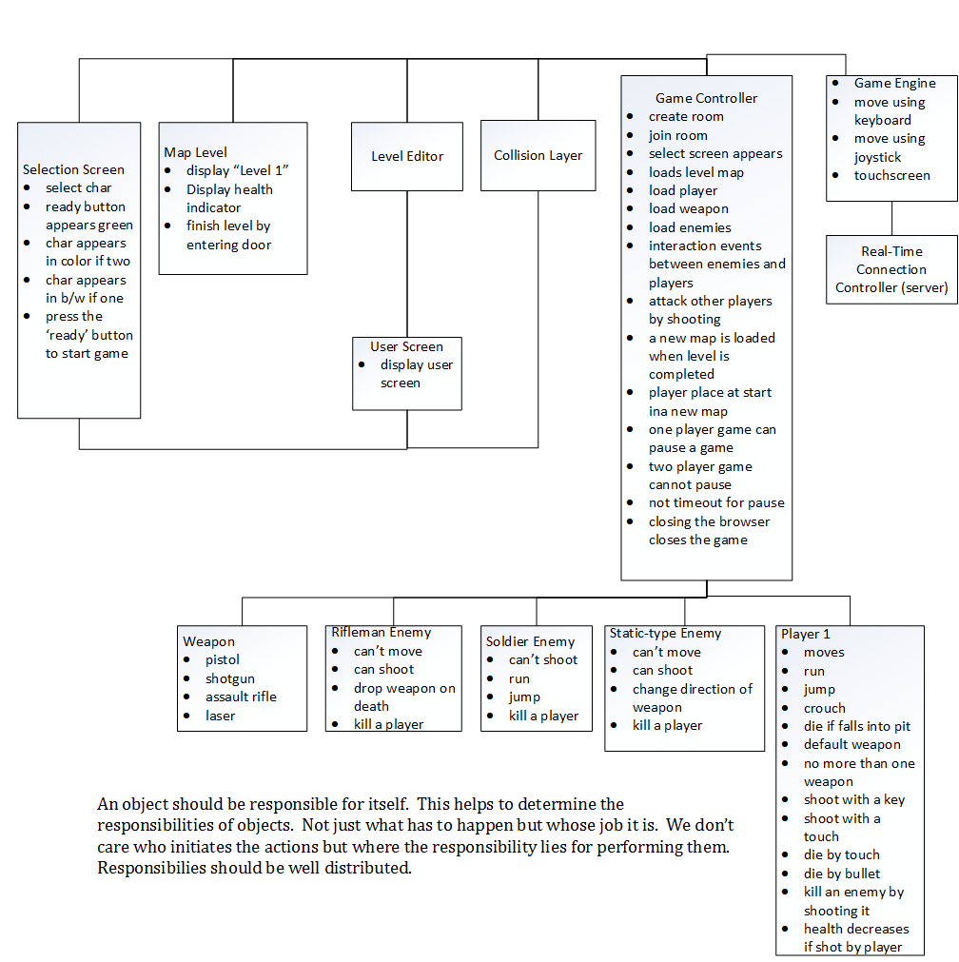

# **Step 3: Identify Responsibilities**

# **Step 4: Assign Responsibilities in Conceptual Model**

# **Functional Requirements**

## **User Screen**

User Name

Figure 1 User screen

### A User screen shall be the first screen displayed in the browser when the user types in the game URL and presses enter.

### In the character select screen there shall be an input box for a username.

### In the User screen the input box for username will have system created username by default.

### The User screen shall have a selector to create a room for a one-player game.

### The User screen shall have a selector to join a room for a two-player game.

### Creating a room takes the player to the Selection screen.

## Joining a room takes the player to the Selection screen

### In the User screen the player starts a one-player game by selecting the selector for creating a room.

### After the selector for creating a room is selected the Selection screen appears.

### In the User screen two players can start a two-player game by selecting the selector to join a room.

### After the selector for creating a room is selected the Selection screen appears.

## **Selection Screen**

1P 2P

Character Image

Character Image

Character Character

name name

Figure 2 Selection Screen

### The Selection screen shall have a character select screen for each player.

### The character select screen shall have an image of each character that can be selected by using an arrow button.

### In the character select screen the image of the character will appear in color if there exists another player.

### In the character select screen the image of the character will appear in black and white if there doesn’t exist another player.

### In the Selection screen there shall be a “ready” button to start the game.

### In the Selection screen there shall be a “ready” button that will light up green after it’s clicked.

## **Starting a 1-player game**

### In the Selection screen the user starts a one-player game by pressing the “ready” button.

## **Starting a 2-player game**

### In the Selection screen the user starts a two-player game by pressing the “ready” button for a two-player game.

## **Creating a game session**

### Once the game is started by pressing the “ready” button for either a one-player or two-player game, the game engine loads the level map.

### After the game session has been initiated and the level map loaded, the dependent game libraries are loaded.

### The main game screen shall briefly display “Level 1” which indicates the current level of the game.

### The game shall display the health indicator of the player during game play.

### The player character(s) shall appear at the start of the map with default weapon loaded (pistol).

### The game engine will load enemy sprites.

### Interaction events between enemy sprites and players will wait to be triggered by player movement.

## **Enemy Movement**

### Enemy classes shall move enemy sprites within the game.

### Enemies will have autonomous movement.

### The game shall allow enemy movement dependent on enemy type.

### Riflemen-type enemies shall not be allowed to move.

### Soldier-type enemies shall be allowed to move (run and jump) toward players.

### Static-type enemies shall be allowed to change direction of their weapon toward a player but othewise may not move.

## **Enemy Combat**

### The game shall allow enemies to use various weapons but only one at a time.

### The game shall allow the weapon type: pistol.

### The game shall allow the weapon type: shotgun

### The game shall allow the weapon type: assault rifle

### The game shall allow the weapon type: laser.

### Each weapon will have different capabilities (bullets per shot, distance bullets travel,

### firing rate).

### The enemy weapon shall be dropped upon enemy death.

### The game shall allow enemies to kill a player.

## **Player Movement**

### An individual Player class shall move a player within the game.

### Players will have autonomous movement within the game.

### The player shall have the ability to run.

### Each player shall have the ability to jump.

### Each player shall have the ability to crouch.

### The player shall die if player falls into a hazard such as a pit.

## **Player Combat**

### The default weapon for a player will be a pistol.

### A player shall not possess more than one weapon at a time.

### The PC user shall be able to shoot a weapon by pressing a key on the keyboard.

### The mobile device user shall be able to shoot a weapon by touching a spot on the screen.

### The player shall be able to kill an enemy by shooting it.

### The player shall die by touch of an enemy

### The player shall die by one bullet shot by an enemy.

## **Player versus Player Combat**

### The game shall allow players to attack other players by ranged attack (shooting).

### Player health shall decrease if attacked by another player.

### The player’s health bar will decrease by one bar (max capacity for bar is 3) per shot that makes contact with the player.

### The player will lose a life if their health bar is fully drained.

### The player will respawn at the same spot the player died if killed by other player.

## **Player completes mission**

### The end of a map level shall be designated by a door .

### A player shall finish a map level by finding the exit portal and entering it.

### A new map level will be loaded when a player finishes a map level.

### A player shall be placed at the start of a map level when starting a new map level.

### A player will start a new level with only the default weapon (a pistol).

## **Game input devices**

### On a personal computer the user shall be able to move the player using a keyboard.

### On a personal computer the user shall be able to move the player using a joystick.

### On a tablet the user shall be able to move the player using the touchscreen.

### On a mobile phone the user shall be able to move the player using the touchscreen.

### On a mobile phone the user shall be able to move the player using the keyboard.

## **Pausing the game**

### The game will have a pause system to temporarily halt game progress.

### For one-player games, the pause system shall have no timeout duration.

### For two-player games, players shall not have the ability to pause.

# **Nonfunctional Requirements**

## **Performance requirements**

## **Response time**

### The response time from the server shall be under 100 milliseconds.

### The server shall be able to handle a maximum of 100 real-time connections.

### The game should allow a minimum of 1 one-player and 1 two-player game to be played simultaneously.

### The game shall support a minimum of two users at the same time.