  Ecodash | name: firdaus Ebrahim  student number :25302156  module code: WAS262  Due date: 28 september 2026

Table of Contents
Table of Figures 2
AI reflection 3
Project Links 4
Final Outcome 5
GitHub Commits 10
Reference list 12

Table of Figures
Figure 1: EcoDash Start Screen 6
Figure 2: EcoDash Gameplay 7
Figure 3: Medical Delivery point 8
Figure 4: Game Over Screen 10
Figure 5: First set of GitHub commits 11
Figure 6: Second set of GitHub commits 12
Figure 7: Third set of GitHub commits 12

AI reflection
In my assignment I used generative AI for a few things like:
- I used it to understand the assignment brief to the best of my abilities
- Choosing an appropriate colour pallet to suit my game
- Correcting the spelling errors that may have occurred throughout my assignment
- Suggesting different environmental factors that I could apply to my rural area
- Help explain complicated JavaScript explanations in way that I could understand
- Helping me create a referencing list

Project Links
GitHub Repository: https://github.com/FirdausEbrahim/EcoDash-African-Logistics
Live Application: https://firdausebrahim.github.io/EcoDash-African-Logistics/

Final Outcome
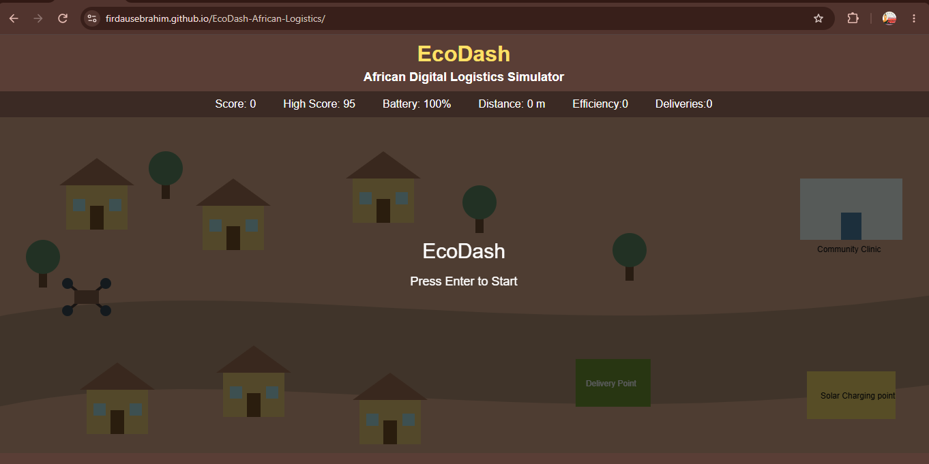
Figure 1: EcoDash Start Screen
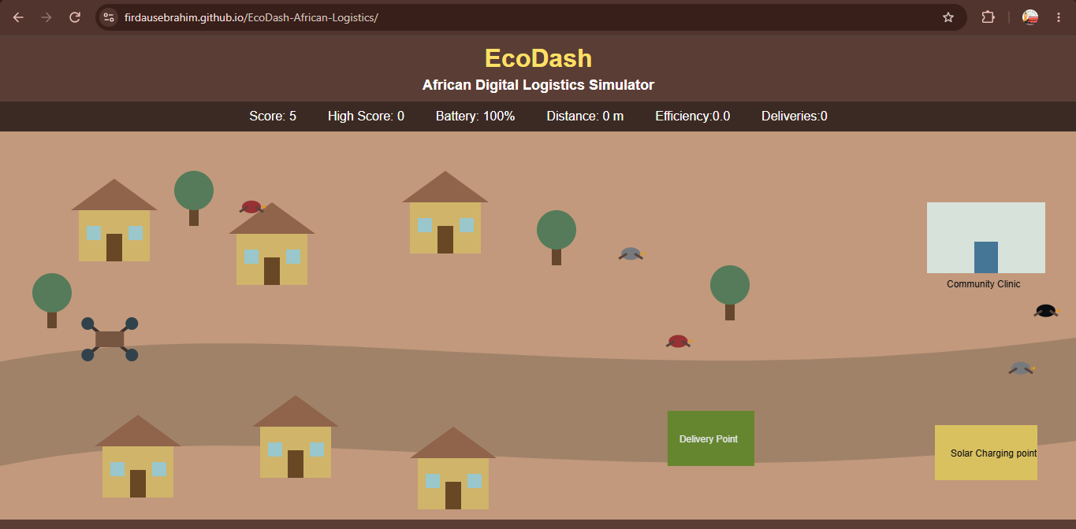
Figure 2: EcoDash Gameplay

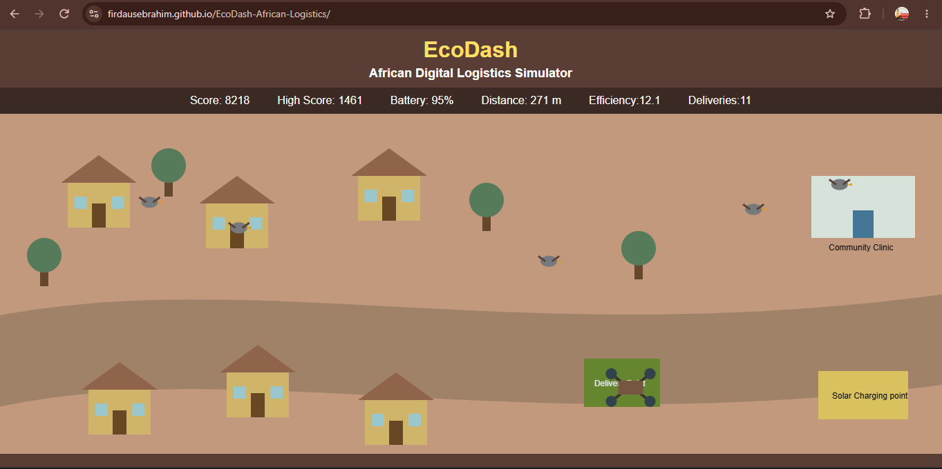
Figure 3: Medical Delivery point
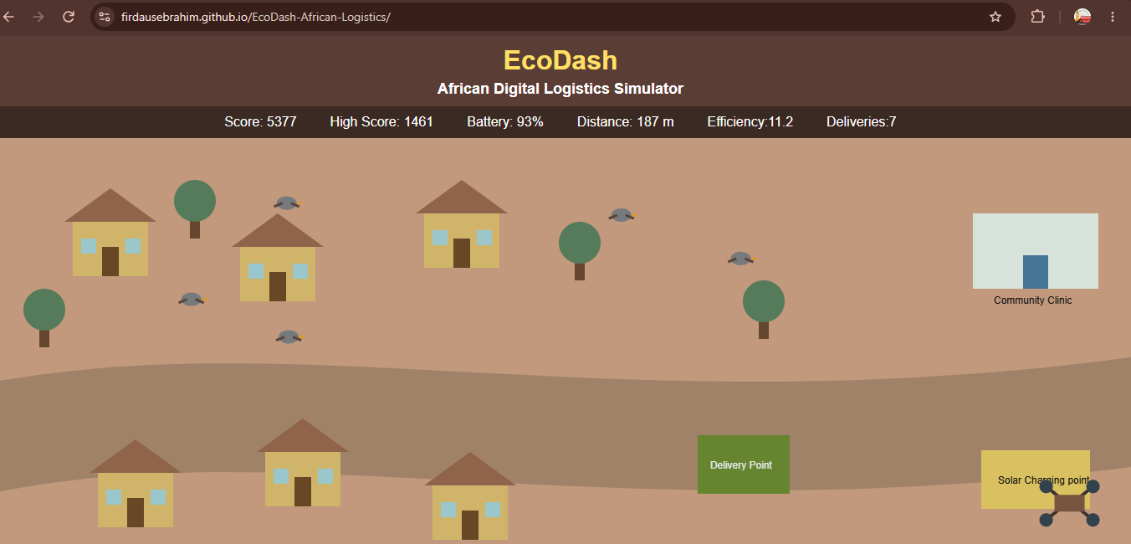

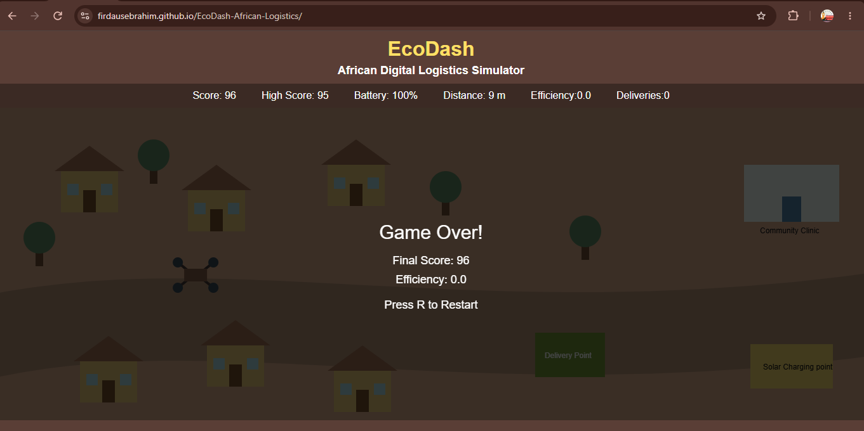
Figure 4: Game Over Screen

GitHub Commits
GitHub was used during this assignment to track the progress of the project. It was required that a minimum of 8 commits were made on 8 different days and that was what was completed on my part. In these commits we can see the progression of the project and new additions such as movement, physics, battery management, scoring, the rural environment, collision detection, as well as gameplay improvements.
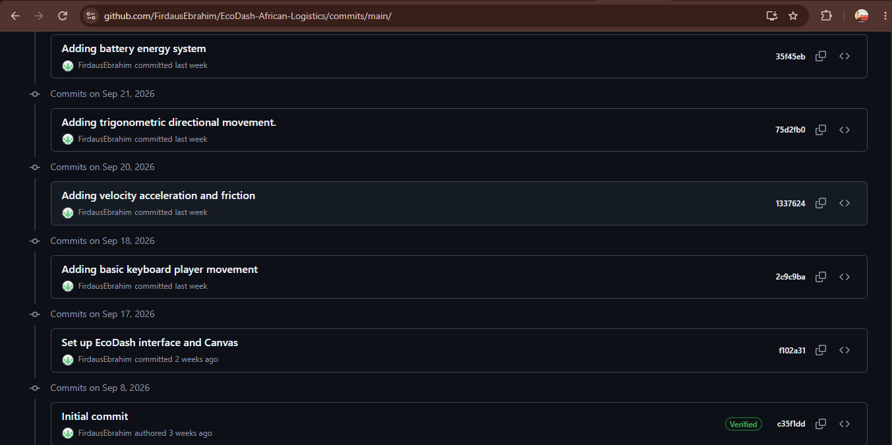
Figure 5: First set of GitHub commits
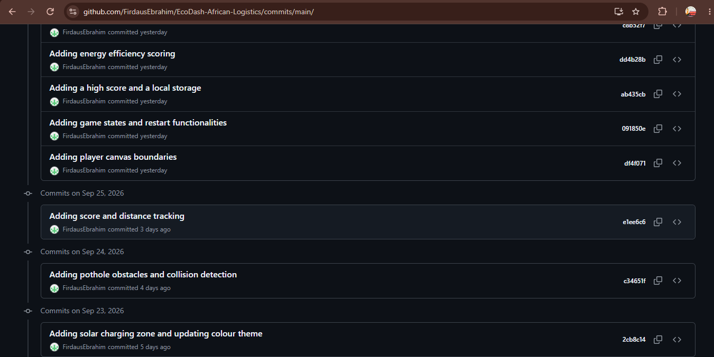Figure 6: Second set of GitHub commits
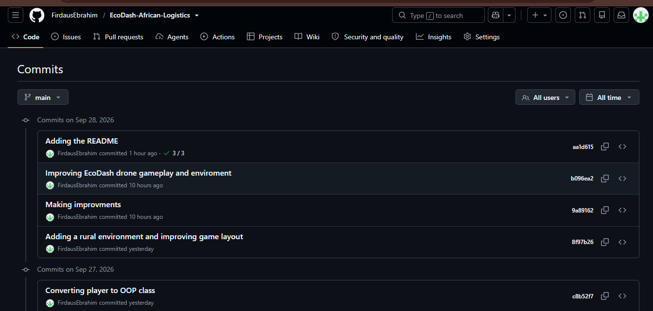Figure 7: Third set of GitHub commits

Reference list
- BananaCoding. (2019). HTML5 Canvas JavaScript Tutorial | Moving objects animation + Collision detection [#4] [YouTube video]. YouTube. https://www.youtube.com/watch?v=-wSn49DV9qU
- Dvorak, F. (2023). JavaScript GameDev Tutorial – Code an Animated Physics Game [Full Course] [YouTube video]. freeCodeCamp.org. https://www.youtube.com/watch?v=U34l-Xz5ynU
- STADIO. (2026a). Web Animation Scripting (WAS262): Week 4, Lecture 1 – Particle Attraction & Gravity. PowerPoint lecture slides.
- STADIO. (2026b). Web Animation Scripting (WAS262): Week 2, Lecture 2 – Trigonometry for Animation. PowerPoint lecture slides.
- STADIO. (2026c). Web Animation Scripting (WAS262): Week 3, Lecture 1 – Velocity & Acceleration. PowerPoint lecture slides.
- W3Schools. (n.d.). JavaScript class inheritance. Retrieved September 28, 2026, from https://www.w3schools.com/js/js_class_inheritance.asp
- W3Schools. (2019). HTML5 Canvas. https://www.w3schools.com/html/html5_canvas.asp
- W3Schools. (2019). HTML5 Web Storage. https://www.w3schools.com/HTML/html5_webstorage.asp

