Conclusion

There is given randomly generated information about social media platform, which is called ‘Twitter’. There are 3 columns: “Date”, “Category”, “Likes”. We can see in first plot that likes between 9000 and 10000, and likes between 1000 and 2000 are more than others. Likes between 7000 and 8000 are less than the others.

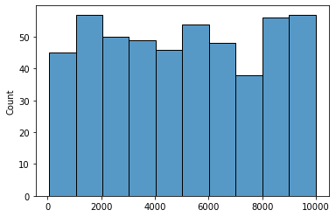

In second plot(boxplot) it’s shown that likes which are grouped by categories. The most likes given category is ‘food’ and it’s mostly between 3000 and 9000 likes. The least likes given for ‘Travel’ category.

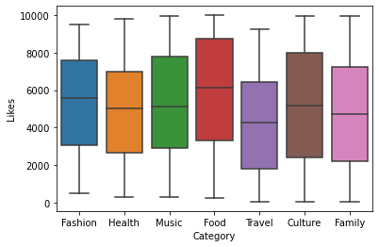

At the end I calculated mean of all given likes, it’s equal to 5079.288. And when I calculated mean in each category and the mean of ‘food’ category is the highest, and the mean of travel is the lowest one. In description field, it’s shown that standard deviation of Likes is equal to 2900.86; and it’s very high, and it’s not very good for concluding about the data. i.e. there is very high difference between standard value of likes and likes of most of the categories by time.