**Laporan Pengembangan Game**

**JumperDude**



**OLEH**

**Firman Dwi Surya Rahardja**

**A11.2019.12332**

**A11.4507**

**UNIVERSITAS DIAN NUSWANTORO**

**SEMARANG**

**2022**

**DAFTAR ISI**

BAB I ................................................................................................................................ 4

TENTANG GAME............................................................................................................... 4

1.1 Deskripsi ......................................................................................................... 4

1.2 Preview............................................................................................................... 5

BAB II................................................................................................................................... 6

DETAIL PENGEMBANGAN APLIKASI ......................................................................... 6

2.1 Flow Chart........................................................................................................... 6

2.2 Class Diagram ................................................................................................... 7

2.3 Preview Lebih Lengkap...................................................................................... 7

2.4 Referensi………………………………………………………………………. 8

**BAB I**

**TENTANG GAME**

1.1 Deskripsi

JumperDude adalah sebuah game 2D yang masih pada thap dvelopement dengan mekanisme gameplay yang simple, catch coin, avoid enemy/traps dengan latar belakang yang menarik atau animated background agar player tidak cepat bosan dengan tampilan pemandangan/scenery game bisa dibilang mirip seperti Super Mario.

1.2 Preview

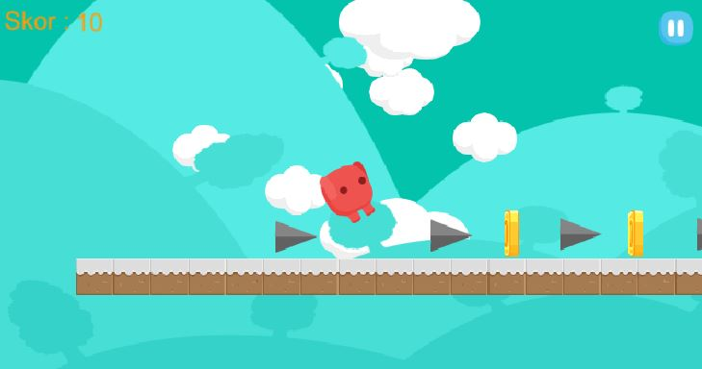

**BAB II**

**DETAIL PENGEMBANGAN GAME**

2.1 Flow Chart

START SCREEN

GAMEPLAY

PLAY

LEVEL 1

LEVEL 2

LEVEL 3

GAME OVER

LEVEL CLEARED

YA

GAMEPLAY

TIDAK

2.2 Class Diagram

|  |
| --- |
| Start Screen |
| - Play |
| +OnPlay () |

|  |
| --- |
| Game Levels |
| - Player  - Score  - Trap  - Coin  - Pause |
|  |
| +followCamera()  +CheckWhereToFace()  +AnimationState()  +hitungKoin()  +Hurt()  +SkorCoin()  +PauseControl() |

|  |
| --- |
| Background |
| - Clouds |
| +SpawnClouds() |

|  |
| --- |
| Game Pause |
| - Resume  - Restart  - Exit |
| +PauseControl()  +Restart ()  +MenuUtama() |

2.3 Preview Lengkap

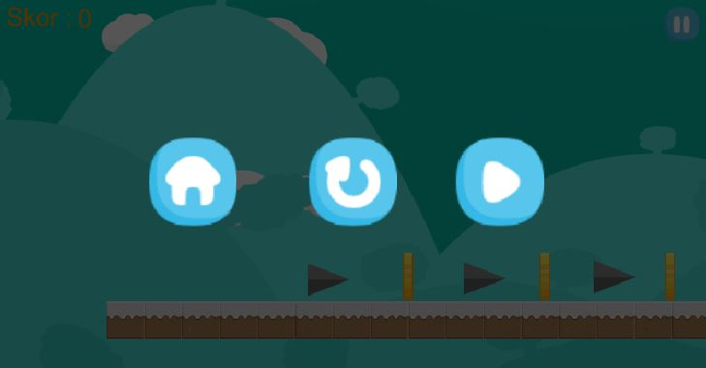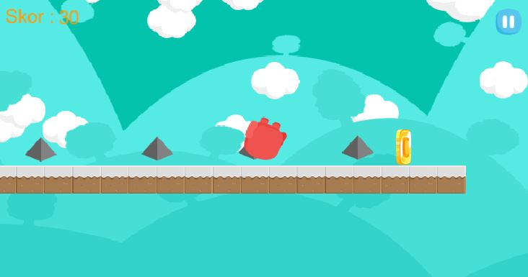

2.4 Referensi

Kyurifu Dev. Channel YouTube (<https://www.youtube.com/channel/UCSxQ6WyuxOhWMmfu1LtfStQ/videos>)

Bayat Games. Game Asstets (<https://assetstore.unity.com/packages/2d/environments/free-platform-game-assets-85838>)

Unity Manual. Spawning GameObjects (<https://docs.unity3d.com/Manual/UNetSpawning.html>)

Dawnreaver & bigmisterb. Random Cloud Generator (<https://forum.unity.com/threads/generating-clouds.67786/>)