a). This prompt is stronger because it provides context and asks for examples as well.
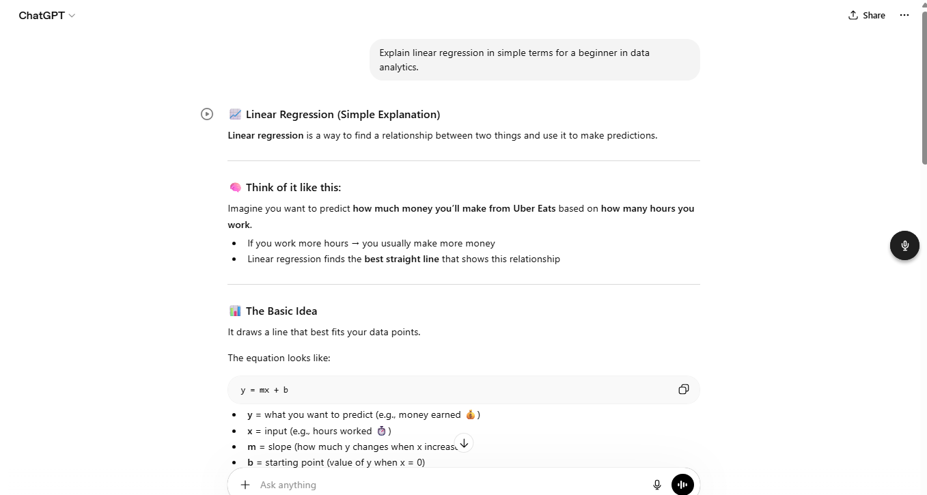
b). This is a better prompt because it adds context and tell s the engine exactly what I am looking for and where I am starting from.
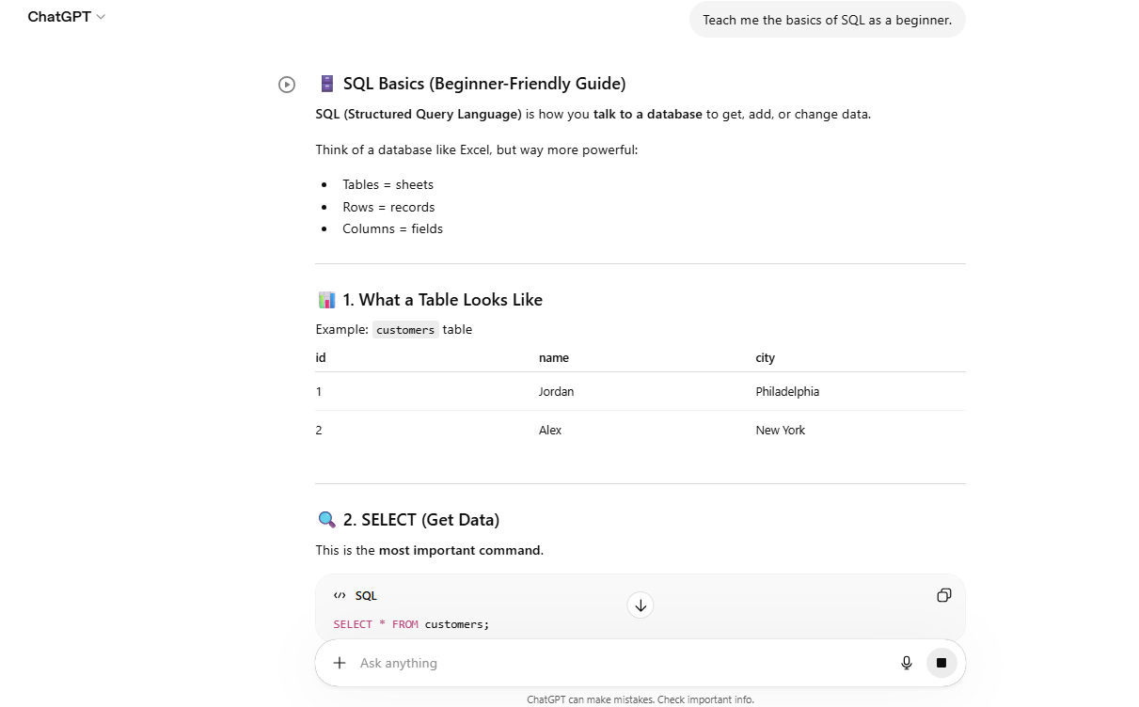

c). This prompt is stronger because it clearly defines the dataset structure, number of rows, and required columns.
