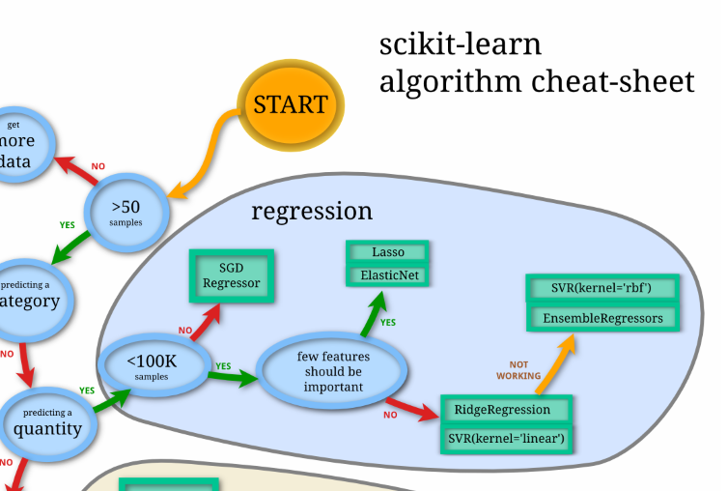

According to scikit overview, I should try the following regressor models and compare their results

* SGD regressor (linear model with stochastic gradient descent method)
* Lasso and Elastic net
* RidgeRegressor
* SVR (support vector regressor)
* One of the ensemble regressors (see below)

