# Equations

## Past week daily average cases (y-axis value)

$Past week daily average cases= \frac{{Dc}_{n}+ {Dc}_{n-1}+…+ {Dc}_{n-6} }{7}, where DC is the number of daily cases$

$$Past week daily average cases per 100K= \frac{Past week daily average cases }{country_region population} ×100000$$

## Adjusted people vaccinated (x-axis value)

For the meaning of vaccination variables, see vaccination variables explained in the next section.

#### For countries where people_fully_vaccinated and people_vaccinated are available

Adjusted people vaccinated number of people = people_fully_vaccinated + 0.5*(people_vaccinated - people_fully_vaccinated)

#### For countries where total_vaccinations is available but people_fully_vaccinated and people_vaccinated are NOT available

Adjusted people vaccinated number of people = 0.5* total_vaccinations

The reason why some countries/regions uses this equation of 0.5*total_vaccinations is because these countries/regions only provide total_vaccinations number. As the number for fully vaccination is 2 (dosages) for these countries, I have used 0.5*total_vaccinations as the adjusted people vaccinated for these countries.

$$Adjusted people vaccinated rate (\%)= \frac{Adjusted people vaccinated }{country_region population }×100$$

# Vaccination variables explained

The information below is from the [Github data source](https://github.com/owid/covid-19-data/tree/master/public/data/vaccinations) of Our World in Data.

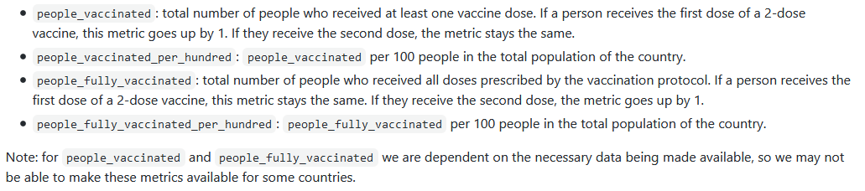

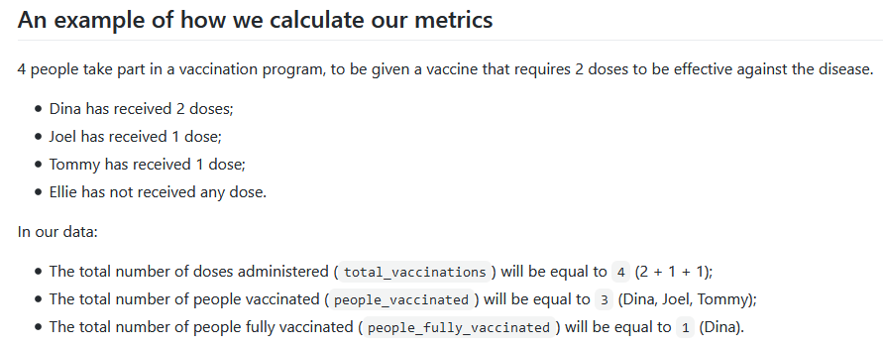

# Different equations used for vaccination rate

Note that the plot presented in [Our World in Data](https://ourworldindata.org/covid-vaccinations) (also the data source provider) uses the number of at least one dose of COVID-19 vaccine (people_vaccinated) to plot the vaccination rate, while my one uses the equations shown in the Adjusted people vaccinated (x-axis value) section. Therefore, the rate on my dashboard plots would be different from theirs.