# Plot descriptions

Note that the plots’ x-axis is vaccination (number or rate) rather than the usual time/date. I got this idea after seeing the “[Covid Trends](https://aatishb.com/covidtrends/)” and adopted this method, just swapped total cases to vaccination number/rate. I think this way of plotting is good for showing (if any) correlation between vaccination number/rate and past week daily average case number/rate. Note that correlation does not necessarily imply causation (cause and effect), where the latter requires rigorous scientific/clinical researches to prove.

## Latest status plot (top plot)

This plot shows only the latest update for a country/region. Note that the latest update date shown would be the date where both daily case and vaccination number are available. For example, if a country/region has daily case updated all the way till 2021-04-20, while the vaccination number was updated to 2021-03-31 only, then the latest status point shows the daily case and vaccination number for 2021-03-31 for that country/region, not 2021-04-20.

This plot is good for showing the latest status of past week daily average cases and vaccination. It is also good to have more countries/regions overlaid together before the plot gets cluttered.

## All available vaccination plot (bottom plot)

This plot shows all the data for dates where daily case and vaccination number are available, instead of just the latest date. The reason why it is called all available vaccination plot is because vaccination number is the one that started late and (for some countries/regions) not updated as frequently/regularly as daily cases.

This plot is good for showing the trend of past week daily average cases and vaccination for a country/region.

# Plotly graph interaction

The module I used to plot these 2 graphs is called [Plotly](https://plotly.com/). It has some nice features allowing users to interact with the plot directly. Below are some of the things that you can do with the plots and the dropdowns on both sides of the plots.

## Hover over the point to see more information

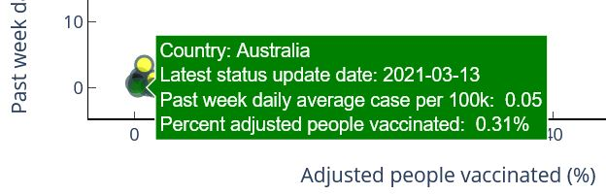

## One click on the legend to toggle hide/show of the point/trend

See how countries/regions in Africa are hidden from the plot after one click on the legend.

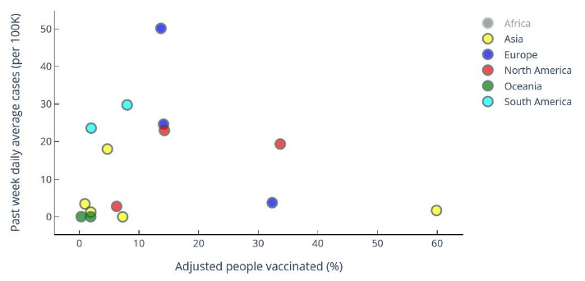

## Double-click on the legend to show only the point/trend

See how only countries/regions in Africa are shown on the plot after double-click on the legend. Double-click again to restore the plot to the original state (showing all points/trends)

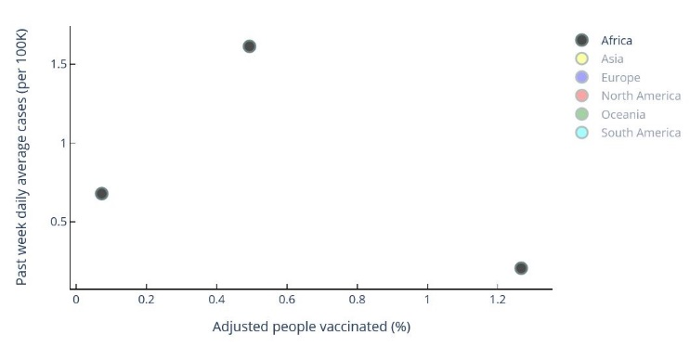

## Click and move on the plot to resize scale

One can click and move (a square would com up) on the plot in an empty area to resize the scale.  
Double click on the plot to restore the original scale.

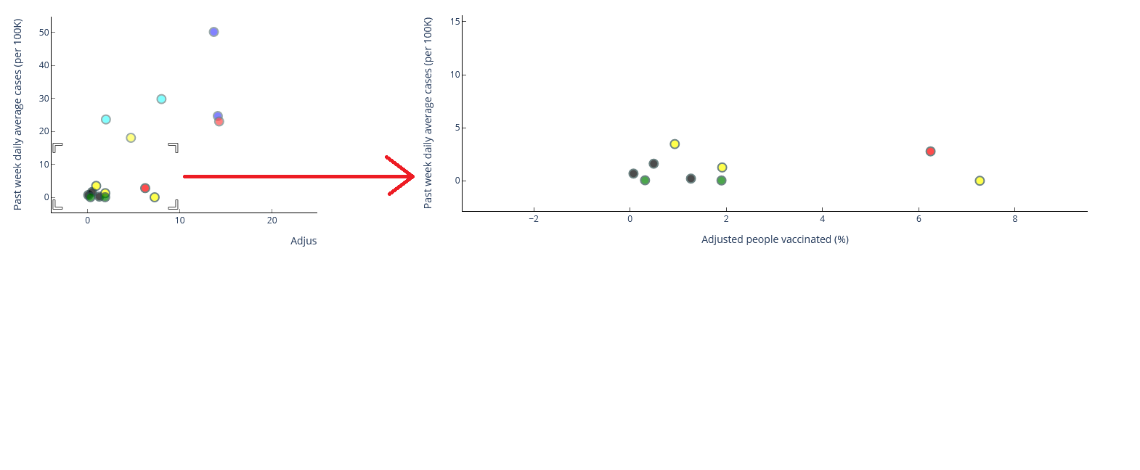

## Select continents or countries/regions for latest status plot to show

For the latest status plot, the 1st dropdown on the left allows one to choose plotting either the continents selected (in the 2nd dropdown) or the countries/regions (3rd dropdown) selected.

If choose to plot the continents selected, all the countries/regions in the continents selected would be plotted. The example below has all the continents, so all countries/regions available are plotted.

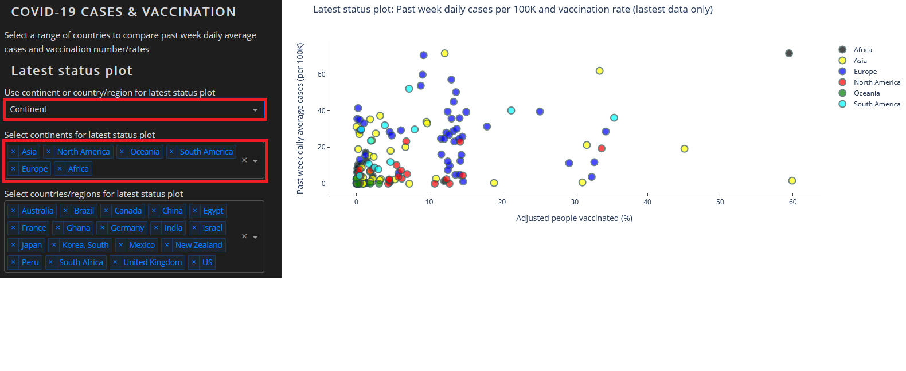

If choose to plot the countries/regions selected, only the countries/regions selected in the 3rd dropdown are plotted.

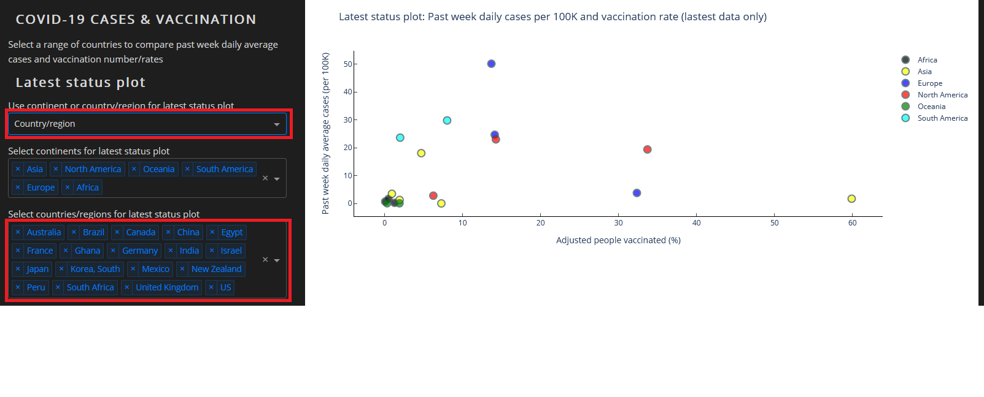

## Fill in countries/regions from continents selected

Clicking the FILL button would fill all the countries/regions in the continents (2nd dropdown) selected to the 3rd dropdown. Be careful that this may add a lot of countries/regions and expand your vertical browser screen by a lot.



## Select countries/regions for all available vaccination plot

For all available vaccination plot, there is only countries/regions dropdown, so there is no continent and country/region switch for this plot. Countries/regions selected in all available vaccination plot dropdown (4th dropdown) will be the ones plotted.

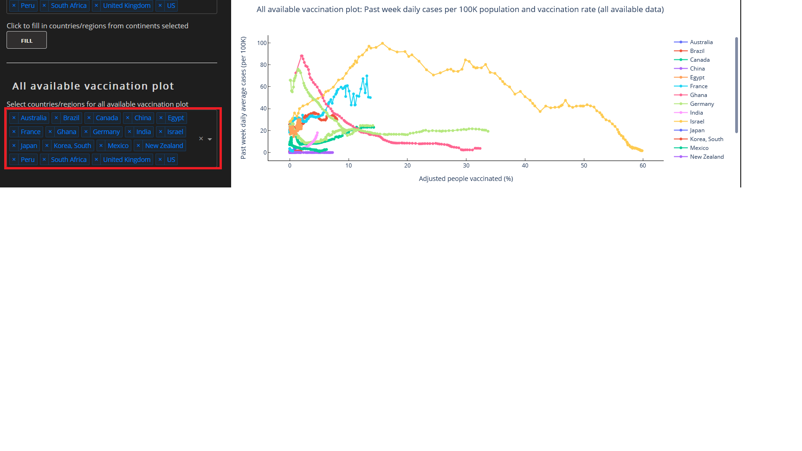

## Interaction between latest status plot and all available vaccination plot

On the latest status plot, if one clicks on a particular dot (a country/region), then that country/region would be added in the all available vaccination plot dropdown and get plotted.

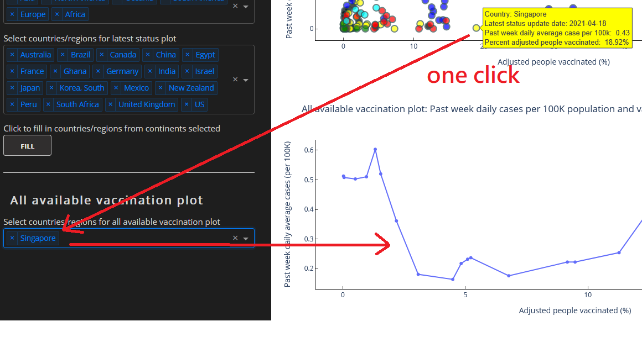

## Value type switch

For both past week daily average case and vaccination, there is a choice of showing either the absolute number or the rate (per 100K population for past week daily average case). The default for them is rate. See the [Equations](https://vacquishcovid19.s3-ap-southeast-2.amazonaws.com/equations.pdf) document for how the values are calculated.

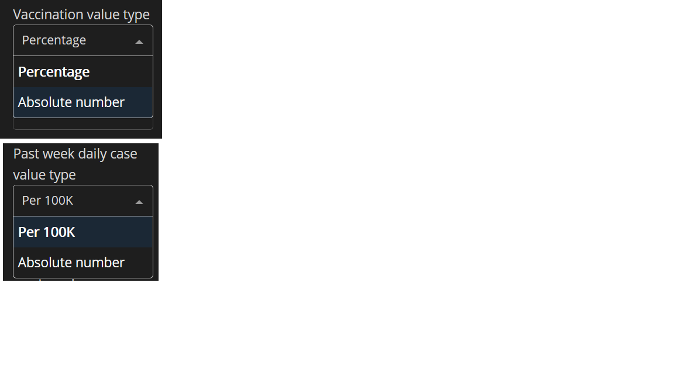

## Axis type switch

For both y-axis and x-axis, there is a choice of using normal (linear) scale or log scale.

