Daniel Clark
Dr. Pablo Rivas
Artificial Intelligence CMPT 404
December 16th, 2016

Final

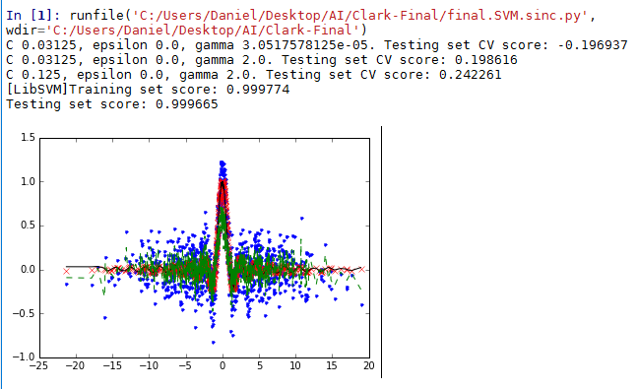
- This problem was to try to approximate a function using a support vector machine given noisy data. The plot above shows the true function as red x's, the noisy data used to train the SVM as blue dots, the values predicted by linear regression as a black line, and the linear regression solution as a green dotted line for comparison. To do this, the program created a support vector regression solution for a variety of hyper-parameters and compared these using a cross validation score to find the best one. The best hyper-parameters found were C=0.125, epsilon=0, gamma=2. This received a final testing score of 0.999665. Let us walk through each of these hyper-parameters and discuss the meaning of each. The C value is the penalty. It is used to adjust how heavily the distance off of the value counts, and a lower C creates a better fit on noisier data. Our C value of 0.125 means that our data is fairly noisy. The next value, epsilon, creates a 'tube' to ignore the penalty completely. Basically, the larger the epsilon, the farther away a point can be and still be counted as spot on. Our epsilon of 0 means that we have no such tube. Generally speaking, the larger the value of C, the larger the value of epsilon, because both hyper-parameters account for noise, so as one accounts for noise less, the other will need to account for it more. The gamma value inversely affects how far each point affects the support vector machine. Our gamma of 2 is about where you might expect for a single-dimensional data set, but perhaps a bit larger than might be expected.
- This problem was to try to recognize digits using a support vector machine given features of the digits. The plot below shows the digits plotted by their features. The colors represent the predicted digit. To do this, the program created a support vector regression solution for a variety of hyper-parameters and compared these using a cross validation score to find the best one. The best hyper-parameters found were C=256, epsilon=1.7, gamma=0.0625. This received a final testing score of 0.325835. Let us walk through each of these hyper-parameters and discuss the meaning of each. The C value is the penalty. It is used to adjust how heavily the distance off of the value counts, and a lower C creates a better fit on noisier data. Our C value of 256 means that we are heavily penalizing the data for being slightly off. The next value, epsilon, creates a 'tube' to ignore the penalty completely. Basically, the larger the epsilon, the farther away a point can be and still be counted as spot on. Our epsilon of 1.7 means that we have a substantial tube where the data are not penalized for being off. Generally speaking, the larger the value of C, the larger the value of epsilon, because both hyper-parameters account for noise, so as one accounts for noise less, the other will need to account for it more. The gamma value inversely affects how far each point affects the support vector machine. Our gamma of .0625 is fairly small for what you might expect from a two dimensional data set. This is interesting, but clearly it is the best solution out of those that were tried.
