Daniel Clark
Pablo Rivas
Artificial Intelligence
September 20th, 2016
Homework 1

1.4 a)

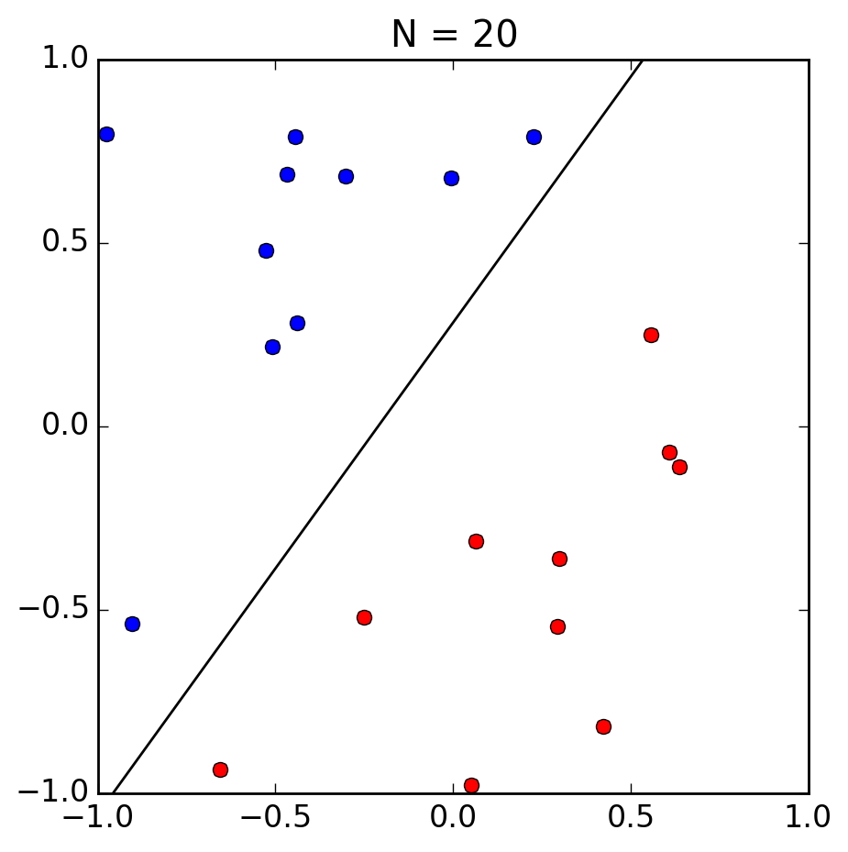

1.4 b) The perceptron took 6 iterations to converge. The hypothesis is fairly far from the true function, possibly due to the large gap in the data near the target function.

1.4 c) For this second data set, the perceptron took 18 iterations to converge. The hypothesis is closer to the target, but is still significantly off.

1.4 d) For this larger data set, the perceptron took 45 iterations to converge. The hypothesis is much

1.4 e) For the data set with 1,000 points, the perceptron took 198 iterations to converge. The hypothesis is imPERCEPTably close to the target function. Get it?

1.4 f) For the ten dimensional data set with 1,000 points, the perceptron took a whopping 5,544 iterations to converge.

1.4 g) Running the perceptron on 100 different data sets of 1,000 points yielded a variety of iterations to convergence. These ranged from 972 to 56,206 iterations, with an average of 6898.94 iterations. The values are roughly bell-shaped with a tail on the right.

