Circuit Solver [Code]

1. Problem Statement

Given, we have a circuit and its graph. Now, the process of writing different matrix, finding A matrix and doing different matrix operations gets very redundant. This gets even more tedious if number of nodes and element is high say 20, which will lead to higher order matrix making calculations messier.

1. Theory Used

We have used Graph-Theory based **node analysis** in our code to solve circuit. First, we need user to have a labeled directed graph of circuit. Then for input we have taken start node and end node to decide assumed current direction in graph, Vs (Voltage Source), Is (Current Source) and Re (Resistance of element) for each element.

With this data code automatically generates A matrix as well as [Ge] (admittance) matrix using Re data, [Ise] and [Vse] matrix,

and uses following algorithm to calculate current in element and voltage across element:

1. [Yn] = [A][Ge][A]T
2. [Isn] = [A][Ge][Vse] – [A][Ise]
3. [Vn] = [Yn]-1[Isn]
4. [Ve] = [A]T[Vn]
5. [Ie] = [Ge][Ve] + [Ise] – [Ge][Vse]

C. The Code

We have used Python 3.10.5 to write this code. Here we are submitting two codes: (does not work for R=0 as of now)

First code is simpler version which takes input in command line. Although process of data entering is not user friendly but, in this code, user can solve circuit with no limit on number of elements.

In second code we have implemented GUI to take input from user, this way of taking data input is little more user friendly. Though due to window size limitation user can only add up to few elements (as of now).

Code for both versions is available in following repository on GitHub:

<https://github.com/FireFist10/Circuit-Solver.git>

(Simply click on any code to view its code or click on Code🡪Download ZIP to download it, and then run it on your PC/Laptop to use it and solve circuits)

D. RESULTS

Testing a sample problem:

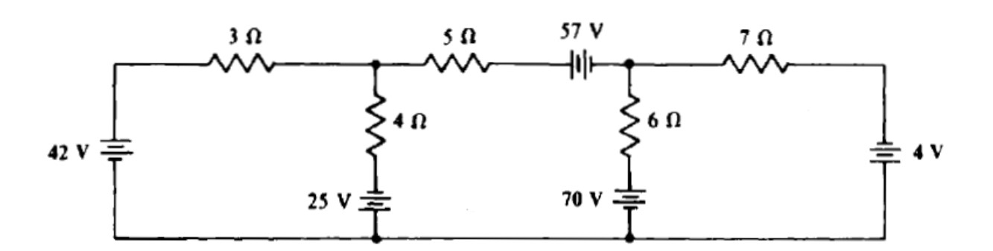

3

2

5

4

3

2

1

1

Solving this problem in version 1:

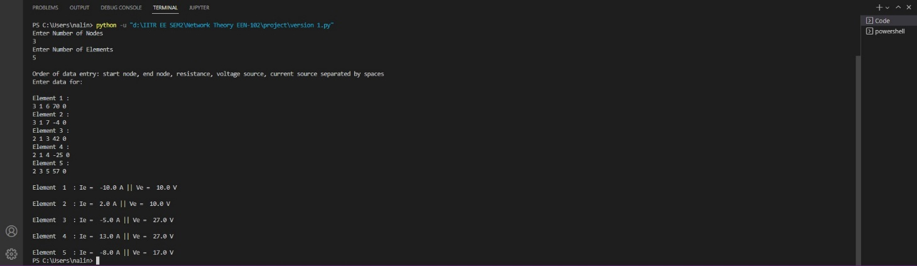

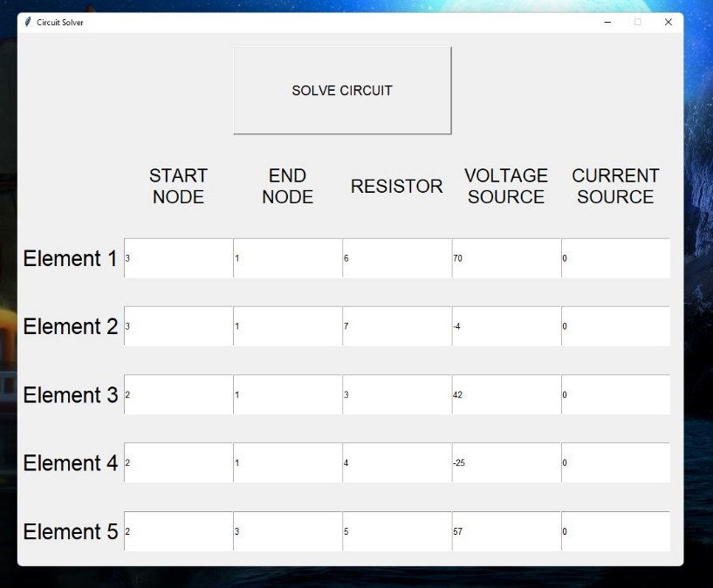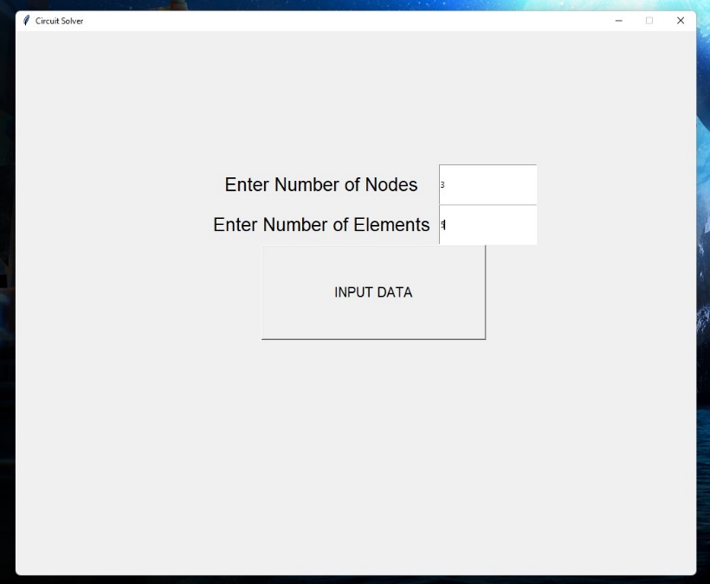Solving this problem in GUI Version: