**Kendriya Vidyalaya, Haldwani Cantt**



**ACADEMIC YEAR: 2021-22**

**PROJECT REPORT ON**

**PyMemo - A CLI Based Memo Application**

**ROLL NO : 28**

**NAME : RUDRANSH JOSHI**

**CLASS : XII-A**

**SHIFT : 2nd**

**SUBJECT : COMPUTER SCIENCE**

**SUB CODE : 083**

**EXAM : AISSCE 2021-2022 (CBSE)**

**PROJECT GUIDE: Mr SAMEER JOSHI**

**PGT (CS)**

**KENDRIYA VIDYALAYA HALDWANI CANTT**

**HALDWANI**

**NAINITAL**

## Kendriya Vidyalaya, Haldwani Cantt



# **CERTIFICATE**

This is to certify that **RUDRANSH JOSHI**, Roll No: 28 has successfully completed the project work titled **PyMemo - A CLI Based Memo Application** in the subject Computer Science (083) laid down in the regulations of CBSE for the purpose of Practical Examination, Class XII-A.

**(Mr Sameer Joshi)**

PGT, Computer Science

**Examiner:**

Name: _______________

Signature:

|  |  |  |
| --- | --- | --- |
| **TABLE OF CONTENTS [ T O C ]** | | |
| **S.NO.** | **DESCRIPTION** | **PAGE NO** |
| 01 | COVER PAGE | **01** |
| 02 | CERTIFICATE | **02** |
| 03 | TABLE OF CONTENTS [TOC] | **03** |
| 04 | ACKNOWLEDGEMENT | **04** |
| 05 | PREFACE | **05** |
| 06 | WORKING DESCRIPTION | **06** |
| 07 | PROJECT REPORT | **07** |
| 08 | SOURCE CODE | **09** |
| 09 | CODE OUTPUT | **14** |
| 10 | HARDWARE AND SOFTWARE SPECIFICATIONS | **18** |
| 11 | BIBLIOGRAPHY & REFERENCES | **19** |
| 12 | LINKS | **19** |

**ACKNOWLEDGEMENT**

Apart from the efforts of me, the success of any project depends largely on the encouragement and guidelines of many others. I take this opportunity to express my gratitude to the people who have been instrumental in the successful completion of this project.

I express deep sense of gratitude to almighty God for giving me strength for the successful completion of the project.

I express my heartfelt gratitude to my parents for constant encouragement while carrying out this project.

My sincere thanks to **Mr Sameer Joshi**, Teacher In-charge, who critically reviewed my project and helped in solving each and every problem, occurred during implementation of the project

The guidance and support received from all the members who contributed and who are contributing to this project, was vital for the success of the project. I am grateful for their constant support and help.

**PREFACE**

The aim of this project is to aid people to keep track of their everyday life. Made with love using Python, PyMemo is very user intuitive—offering the user suggestions on the go—allows the user to create and store memos and retrieve them later on the go in the form of text, and also as an image which can be printed like a card. The project uses an SQLite database to store user information which can make memo storage and reading significantly faster. The program generates a unique key for each memo, called a memo ID, and it is this memo ID to which all the memo information is tied. This avoids duplicates and redundancy in the underlying database.

**WORKING DESCRIPTION**

This project consists of the following sections:

1. Memo Management: This section helps you to add/delete memo to/from the database. It also helps viewing and listing the memos present in the database.
2. UI Management: This section handles the UI of the application. It handles how to represent the memo in the terminal or presents the memo as an image.
3. Saving Zone: This, as its name suggests, handles the saving of the database and the memos as images so that they can be printed easily if needed hard copies of them.
4. Utility Management: This section is purely meant to help other sections of the application. This generally contains the utilities like sleep, parsers, cleaners, used by the other parts of the program.
5. Database Management: This section allows you to connect to the database, initialize it, and create the required tables for the memo. It also allows you to drop tables and reset the database.
6. Exit Zone: Well, you all know what an exit button is used for xD. Nothing specific, just used to exit the application.

**PROJECT REPORT**

**NAME:** Rudransh Joshi **CLASS:** XII (A)

**SUBJECT:** Computer Science **PROJECT NAME:** PyMemo

* **DATA COLLECTION:** Functions
* **HYPOTHESIS:** In this python project, the knowledge of classes and functions were used to make the code more organised and re-usable, which makes the code more beautiful to read and debug. Furthermore, the knowledge of SQL helped to store the data in the database in the form of tables which organises the data for us.
* **WORK PLAN:** To easily make and store memos to keep a track of daily-life related tasks without any hassle and to learn how the logic behind memo storage works.
* **UNDERSTANDING:** It helps us learn the concepts, connectivity and usage of SQL, classes and functions in python, and how these concepts are used to solve real world problems.
* **USER-FRIENDLYNESS:** Yes, the project is user friendly. The user is given each and every bit of information it needs to know, and proper info is given on how to give inputs and read outputs in the form of comments.
* **DEMAND IN REAL WORLD:** This project will be very helpful for people who need to keep a track of their daily-life-related tasks, and those who want to learn how the logic behind small applications like these works. People will be able to get printable memos as images in their machines.
* **CONTENT OF SYLLABUS USED:** Classes, Functions, Modules, Libraries, SQL, Conditions, Loops, Logic Building, File Handling
* **FUTURE PLANS:** The project is completely free and open source and licensed under GNU Lesser General Public License (LGPL) which will be available on my GitHub repository (https://www.github.com/FireHead90544/PyMemo) where all the future updates from me and the open source community will be published.
* **ANALYSIS:** This project is easy and user-friendly and gets well connected with the database engine.
* **CREATIVITY:** The project helps people generate memos based on their needs, which they can even print to get hard copies of it.
* **CONCLUSION:** This project is very well written and easy to understand for everyone and even they may get inspired to create such projects on their own. This also helps people manage their time by writing memos for scheduling their tasks.



**SOURCE CODE**

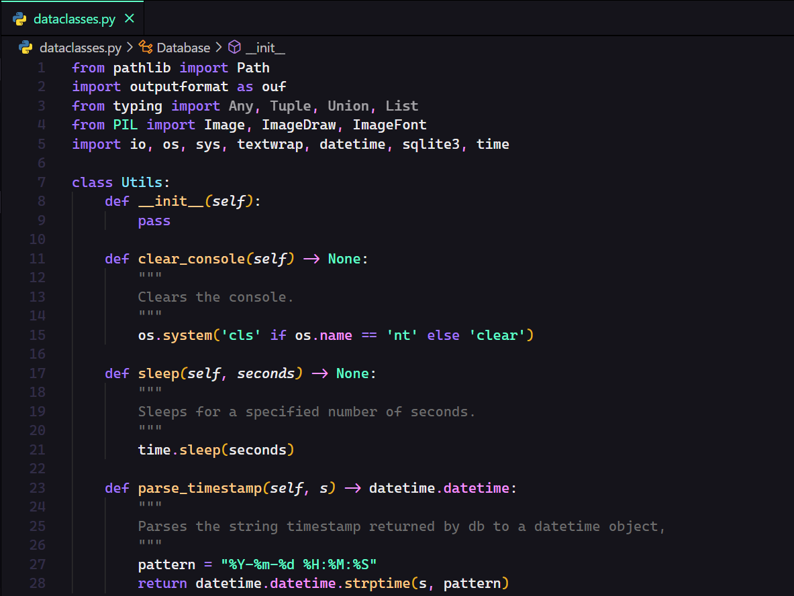

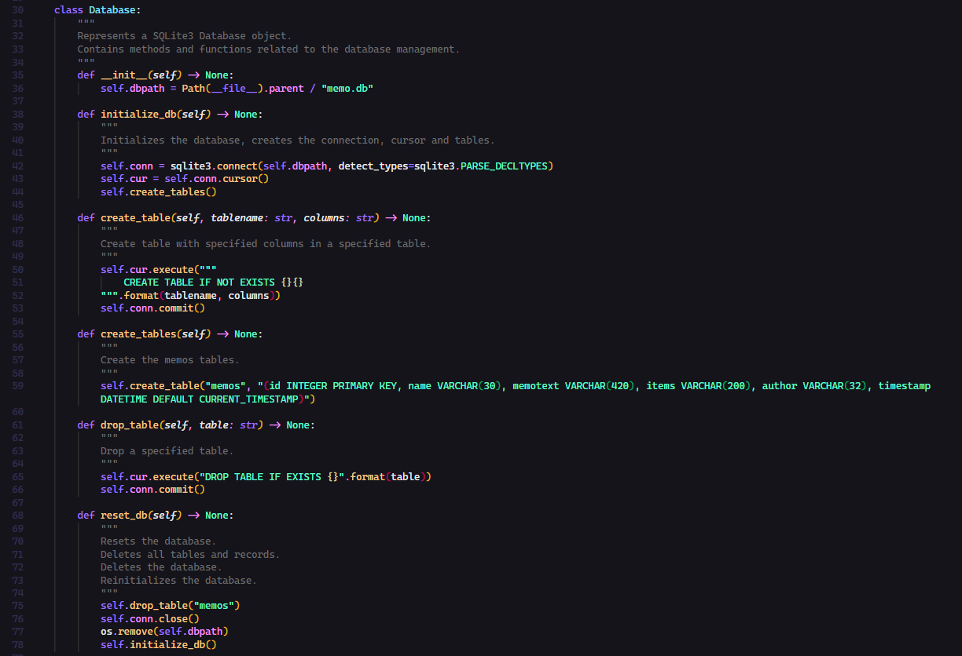

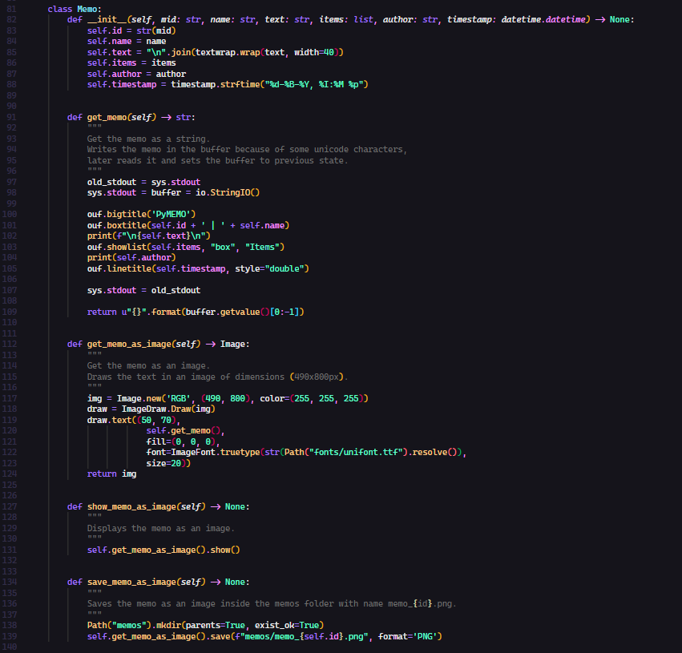

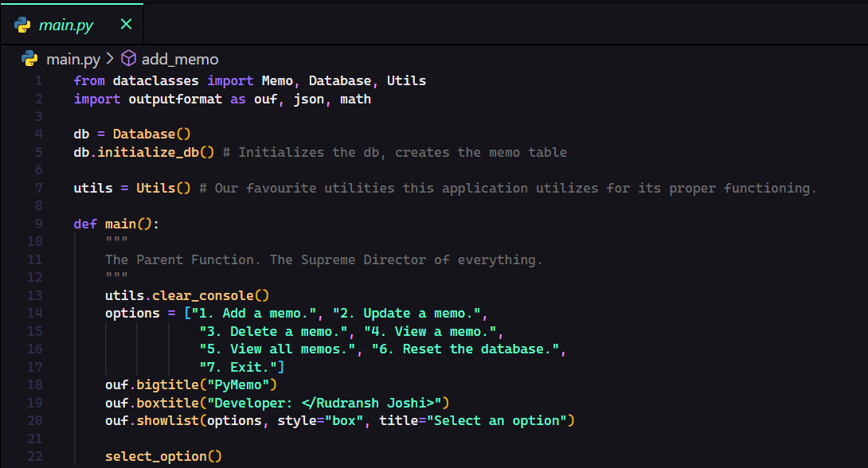

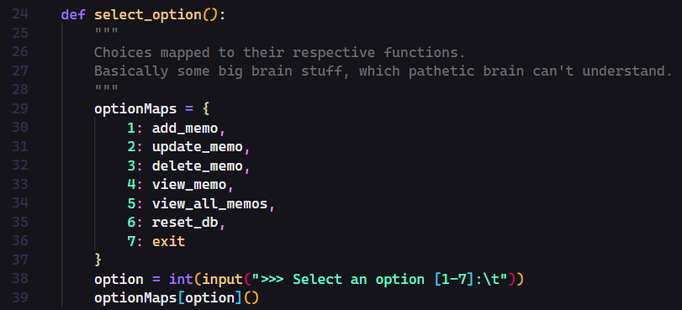

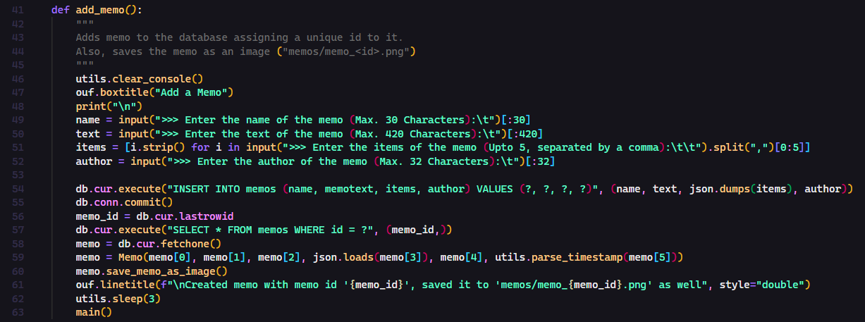

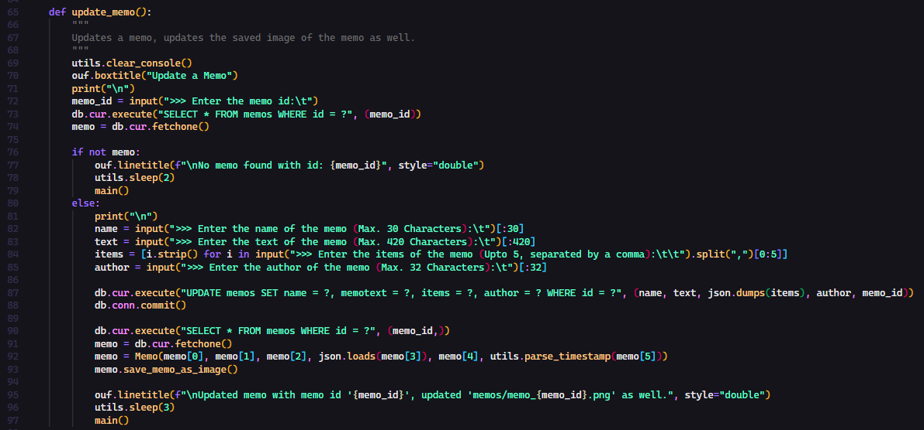

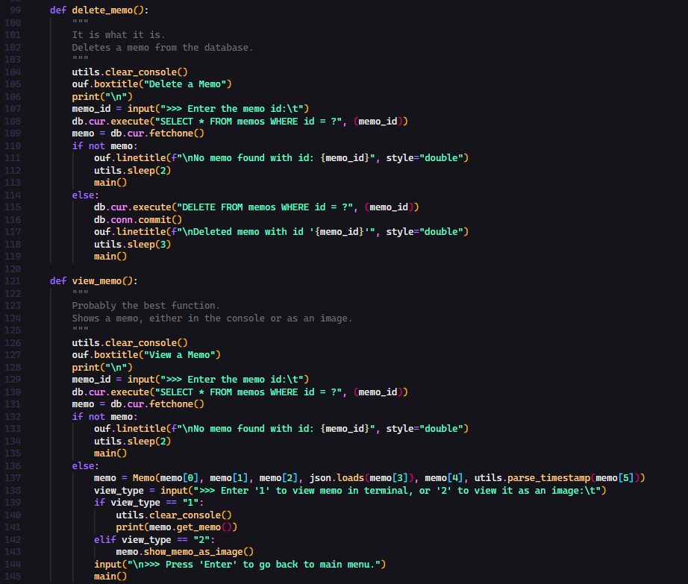

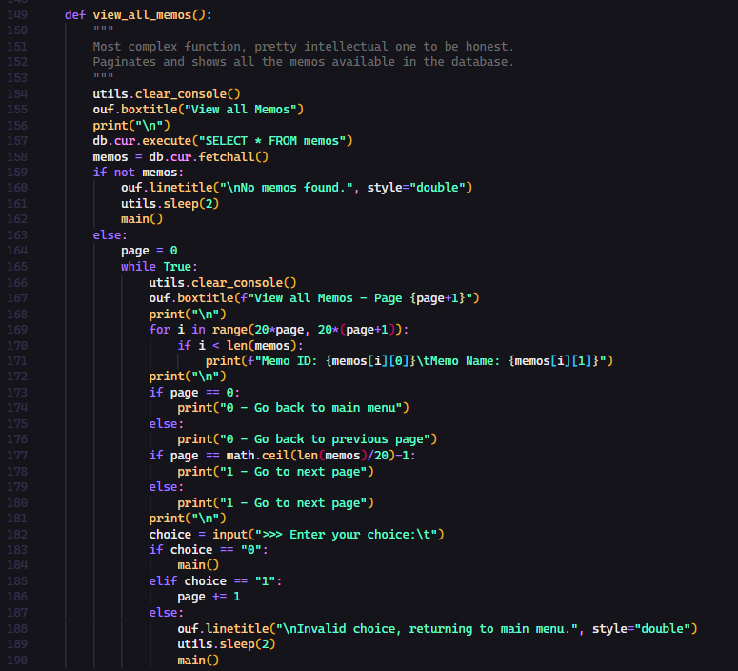

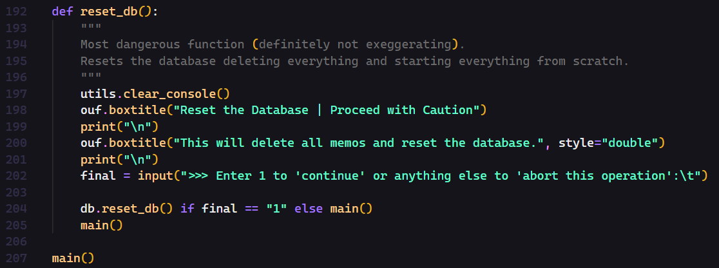

**CODE OUTPUT**

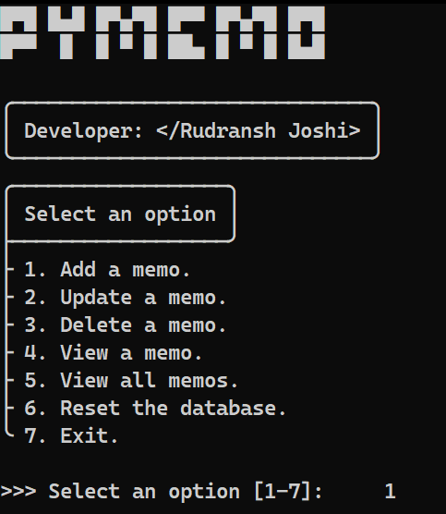

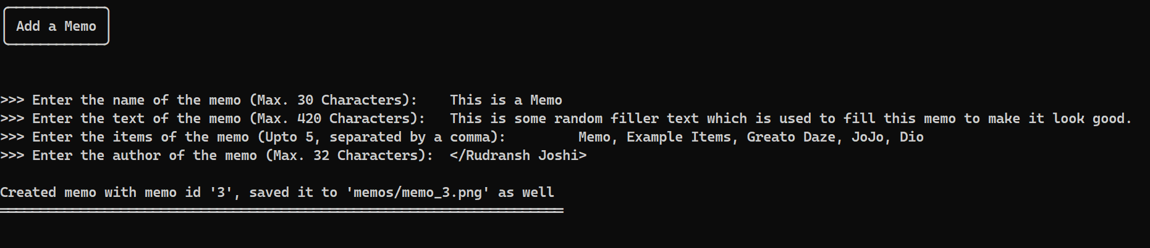

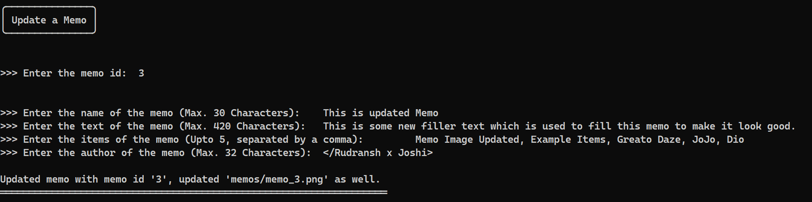

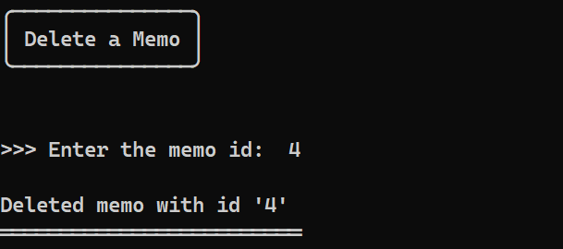

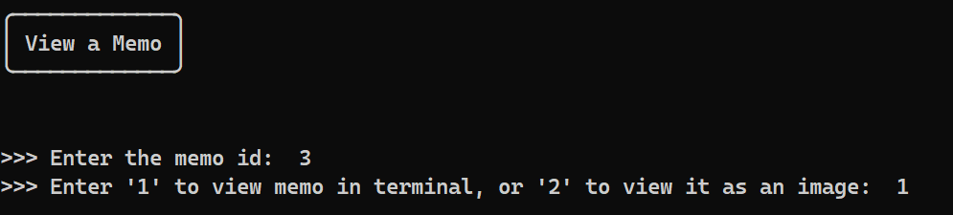

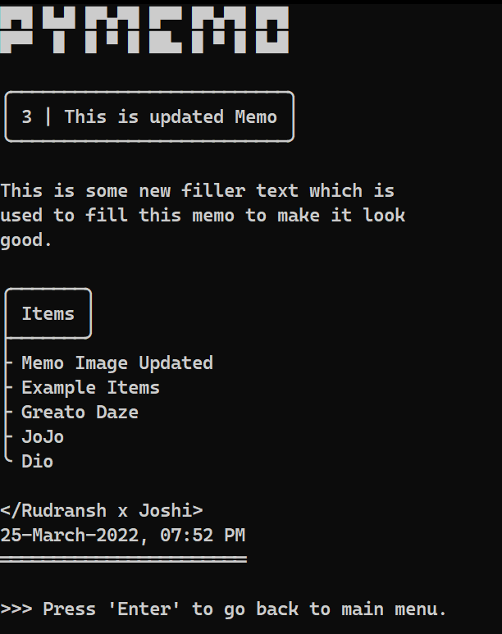

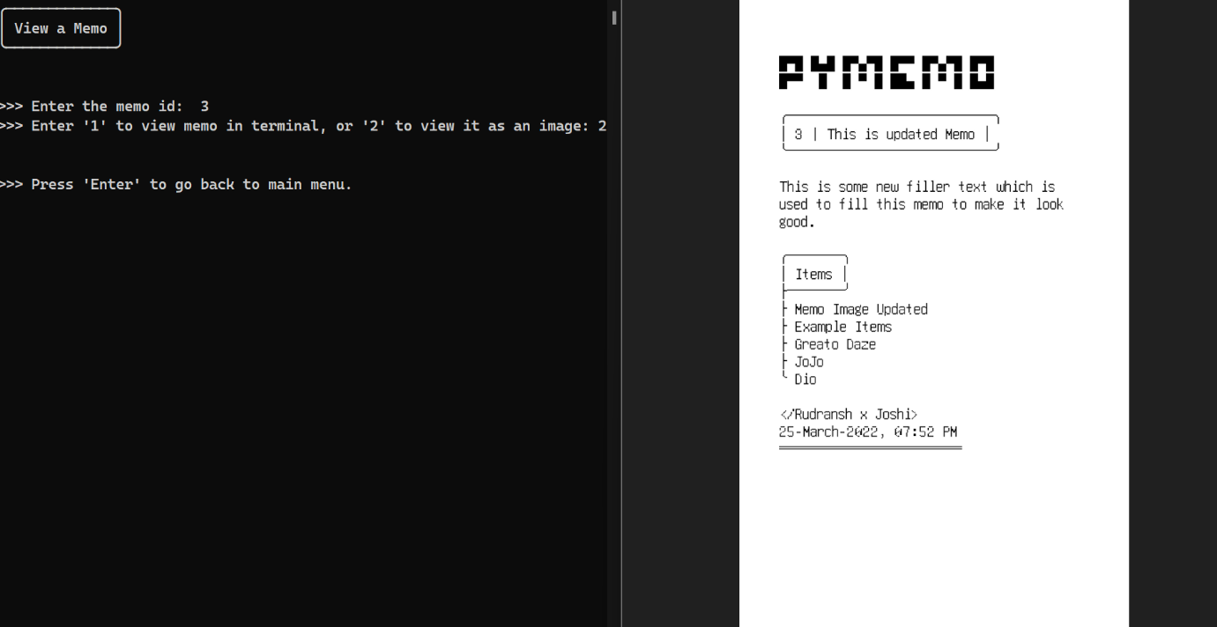

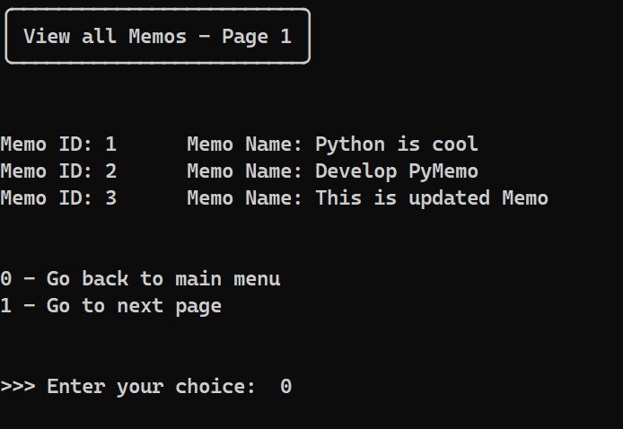

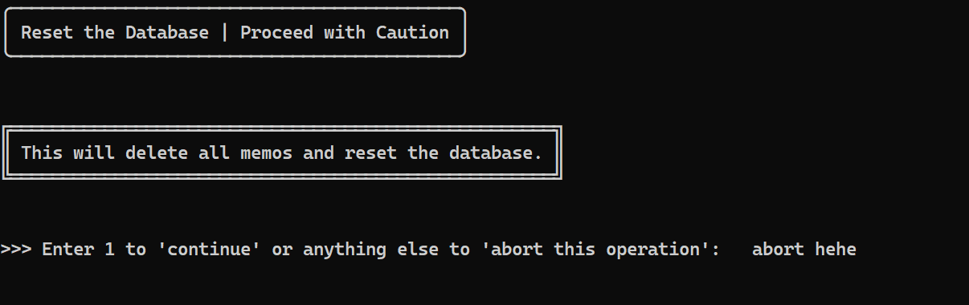

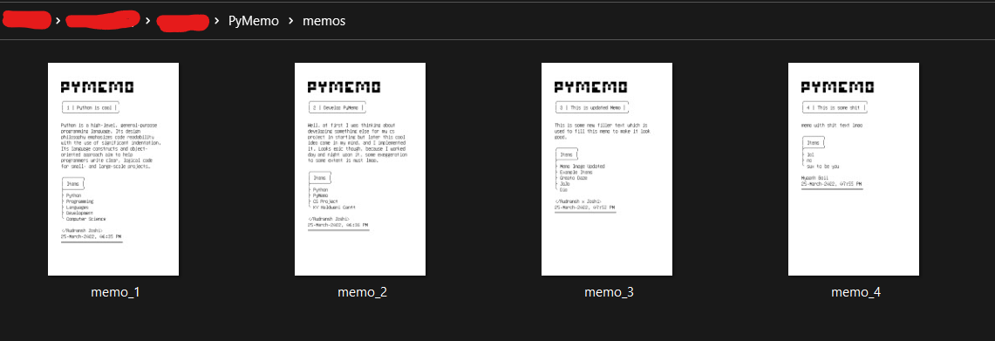

**HARDWARE AND SOFTWARE SPECIFICATIONS**

THE PROJECT HAVE BEEN TESTED AGAINST THE FOLLOWING HARDWARE AND SOFTWARE CONFIGURATIONS.

I. OPERATING SYSTEM : WINDOWS 11 (x64)

II. PROCESSOR : INTEL CORE i5-9300H

III. GPU : NVIDIA GEFORCE GTX 1650

IV. RAM : 8 GB DDR4

V. HARD DISK : 1 TB HDD (+256GB SSD)

VI. PYTHON VERSION : v3.8.6

VII. IDE : VISUAL STUDIO CODE (v1.62.2)

VIII. MODULES USED : SQLITE3, PATHLIB, OS, IO, DATETIME,

TIME, SYS, TEXTWRAP, MATH, OUTPUTFORMAT, JSON, PILLOW

IX. DATABASE ENGINE : SQLITE

**SOFTWARE REQUIREMENTS:**

1. Operating System (Windows/MacOS/Linux)
2. Python (>=3.5)
3. External Python Libraries/Modules (OUTPUTFORMAT, PILLOW)

[ pip install outputformat Pillow ]

**BIBLIOGRAPHY**

* + - [SQLite Documentation](https://www.sqlite.org/docs.html)
    - [sqlite3 — DB-API 2.0 interface for SQLite databases — Python 3.10.0 documentation](https://docs.python.org/3/library/sqlite3.html)
    - [Pillow — Pillow (PIL Fork) 9.0.1 documentation](https://pillow.readthedocs.io/en/stable/)
    - [delestro/outputformat: Python library to decorate and beautify strings](https://github.com/delestro/outputformat)
    - [Stack Overflow - Where Developers Learn, Share, & Build Careers](https://stackoverflow.com/)
    - [FireHead90544/PyShop: A Shopping Cart Simulator](https://github.com/FireHead90544/PyShop/)

**LINKS**

* [FireHead90544/PyMemo: A CLI Based Memo Application](https://github.com/FireHead90544/PyMemo)