**Kendriya Vidyalaya, Haldwani Cantt**



**ACADEMIC YEAR: 2021-22**

**PROJECT REPORT ON**

**PySHOP - A Shopping Cart Simulator**

**ROLL NO : 28**

**NAME : RUDRANSH JOSHI**

**CLASS : XII-A**

**SHIFT : 2nd**

**SUBJECT : COMPUTER SCIENCE**

**SUB CODE : 083**

**EXAM : AISSCE 2021-2022 (CBSE)**

**PROJECT GUIDE: Mr SAMEER JOSHI**

**PGT (CS)**

**KENDRIYA VIDYALAYA HALDWANI CANTT**

**HALDWANI**

**NAINITAL**

## Kendriya Vidyalaya, Haldwani Cantt



# **CERTIFICATE**

This is to certify that **RUDRANSH JOSHI**, Roll No: 28 has successfully completed the project work titled **PySHOP - A Shopping Cart Simulator** in the subject Computer Science (083) laid down in the regulations of CBSE for the purpose of Practical Examination, Class XII-A.

**(Mr Sameer Joshi)**

PGT, Computer Science

**Examiner:**

Name: _______________

Signature:

|  |  |  |
| --- | --- | --- |
| **TABLE OF CONTENTS [ T O C ]** | | |
| **S.NO.** | **DESCRIPTION** | **PAGE NO** |
| 01 | COVER PAGE | **01** |
| 02 | CERTIFICATE | **02** |
| 03 | TABLE OF CONTENTS [TOC] | **03** |
| 04 | ACKNOWLEDGEMENT | **04** |
| 05 | PREFACE | **05** |
| 06 | WORKING DESCRIPTION | **06** |
| 07 | PROJECT REPORT | **07** |
| 08 | SOURCE CODE | **09** |
| 09 | CODE OUTPUT | **15** |
| 10 | HARDWARE AND SOFTWARE SPECIFICATIONS | **20** |
| 11 | BIBLIOGRAPHY & REFERENCES | **21** |
| 12 | LINKS | **21** |

**ACKNOWLEDGEMENT**

Apart from the efforts of me, the success of any project depends largely on the encouragement and guidelines of many others. I take this opportunity to express my gratitude to the people who have been instrumental in the successful completion of this project.

I express deep sense of gratitude to almighty God for giving me strength for the successful completion of the project.

I express my heartfelt gratitude to my parents for constant encouragement while carrying out this project.

My sincere thanks to **Mr Sameer Joshi**, Teacher In-charge, who critically reviewed my project and helped in solving each and every problem, occurred during implementation of the project

The guidance and support received from all the members who contributed and who are contributing to this project, was vital for the success of the project. I am grateful for their constant support and help.

**PREFACE**

The aim of this project is to aid Shopping Complexes to keep track of customer's inventory. Made with love using Python, PySHOP is very user intuitive—offering the user suggestions on the go—generates customer invoice both in text form as well as in the form of a QR code that can be scanned by the user on-the-go to retrieve their billing history. The project uses an SQLite database to store user information which can make checkout significantly faster if the customer is a recurring one. The program generates a unique key for each user, called a unique ID, and it is this unique ID to which all the user information is tied. This avoids duplicates and redundancy in the underlying database.

**WORKING DESCRIPTION**

This project consists of the following sections:

1. User Management: This section helps you to add/delete users to the database. It also helps view and list the registered users in the database.
2. Item Management: This section helps you to add/remove/update items in the shop. It also helps you view and list the available items in the shop from the database.
3. Shopping Zone: This section allows a user to buy items from the shop if available, later on generates a receipt for the purchase and generates a QR code which can also be scanned to get the receipt on your mobiles.
4. Sales Zone: This section helps you to view the total sales from the shop, including the date and time of the purchase.
5. Database Management: This section allows you to connect to the database and create the required tables for the shop.
6. Exit Zone: Well you all know what an exit button is used for xD. Nothing specific, just used to exit the shop.

**PROJECT REPORT**

**NAME:** Rudransh Joshi **CLASS:** XII (A)

**SUBJECT:** Computer Science **PROJECT NAME:** PySHOP

* **DATA COLLECTION:** Functions
* **HYPOTHESIS:** In this python project, the knowledge of functions were used to make the code more organised and re-usable, which makes the code more beautiful to read and debug. Furthermore, the knowledge of SQL helped to store the data in the database in the form of tables which organises the data for us.
* **WORK PLAN:** To simulate the experience of shopping anytime, anywhere and to make shopping easy and hassle-free and to learn how the logic behind shopping works.
* **UNDERSTANDING:** It helps us learn the concepts, connectivity and usage of SQL and functions in python, and how these concepts are used to solve real world problems.
* **USER-FRIENDLYNESS:** Yes, the project is user friendly. The user is given each and every bit of information it needs to know, and proper info is given on how to give inputs and read outputs.
* **DEMAND IN REAL WORLD:** This project will be very useful to those people who are going to start a new shop/mart and those who want to learn how the logic behind shopping works. They will be able to record all the transaction info and do the user and item management very efficiently.
* **CONTENT OF SYLLABUS USED:** Functions, Modules, SQL, Conditions, Loops, Logic Building, File Handling
* **FUTURE PLANS:** The project is completely free and open source and licensed under GNU Lesser General Public License (LGPL) which will be available on my GitHub repository (https://www.github.com/FireHead90544/PyShop) where all the future updates from me and the open source community will be published.
* **ANALYSIS:** This project is user-friendly and gets well connected with the database engine.
* **CREATIVITY:** The project simulates a shopping cart experience. It allows us to add/update/delete users and items to the database and buy items from the shop and generate a receipt for the transaction.
* **CONCLUSION:** This project is very well written and easy to understand for everyone and even they may get inspired to create such projects on their own. This also helps new businesses adapt with the pressure created by their competitors by creating their own Shop management system.

**SOURCE CODE**

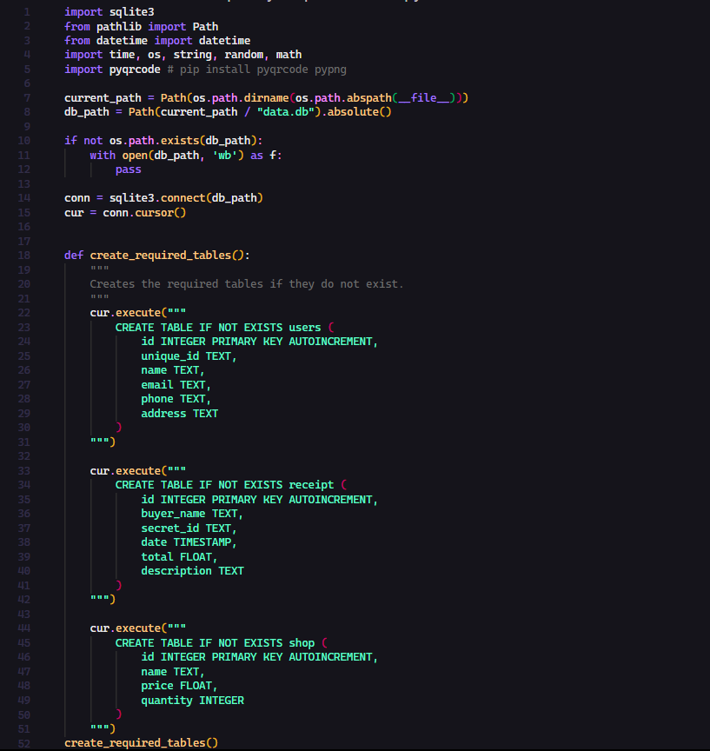

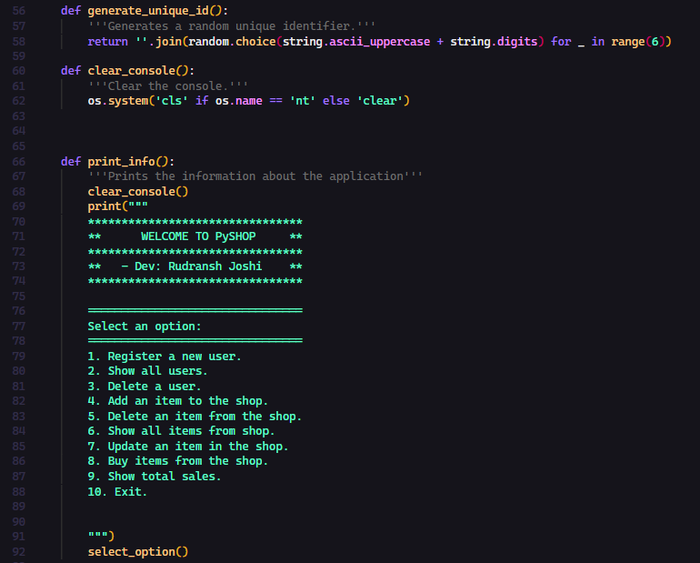

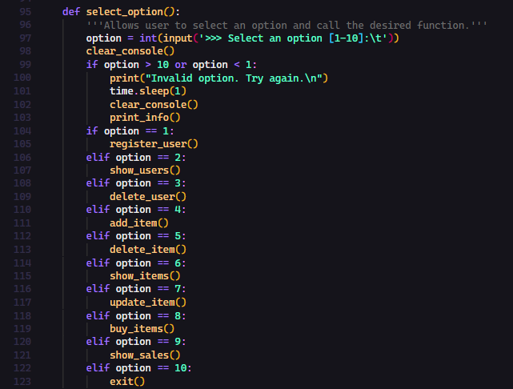

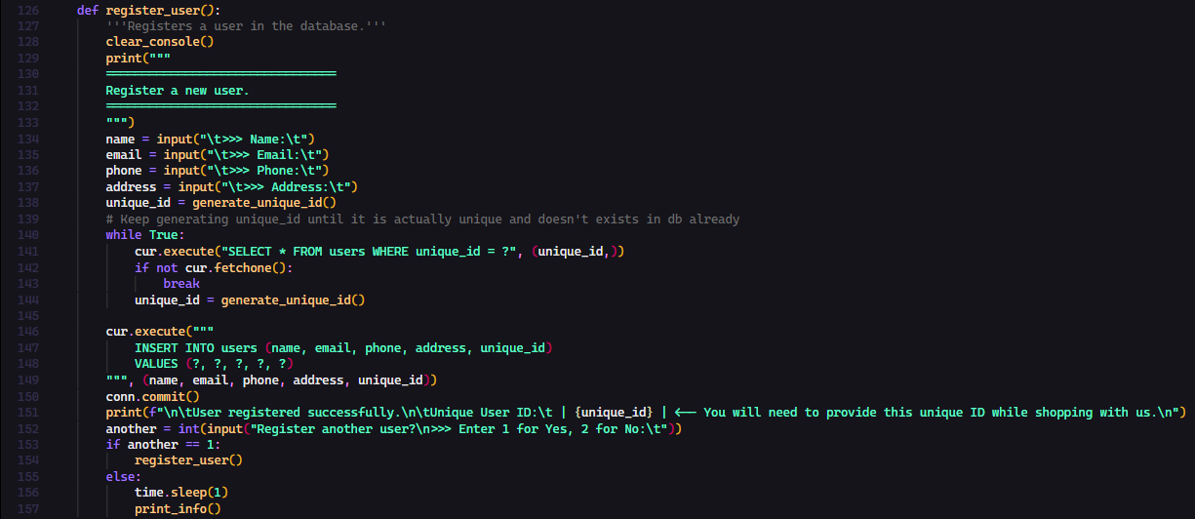

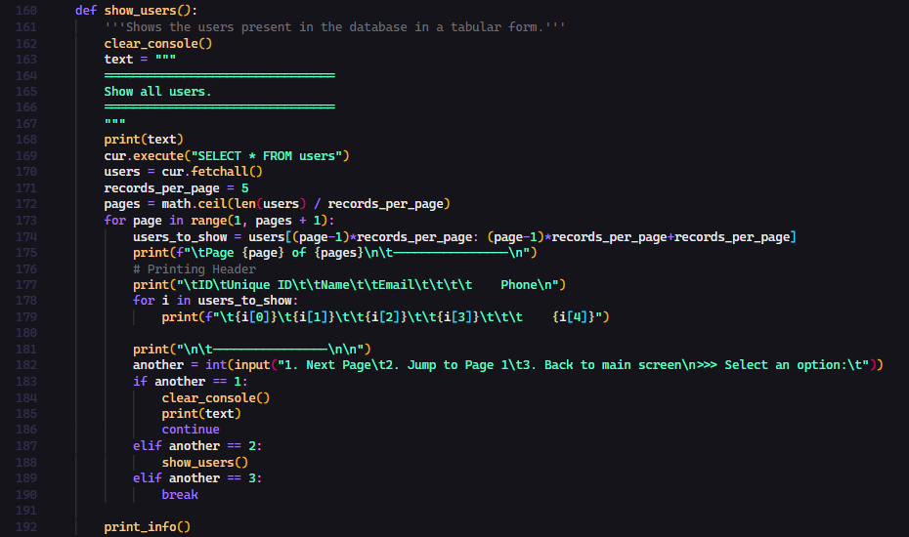

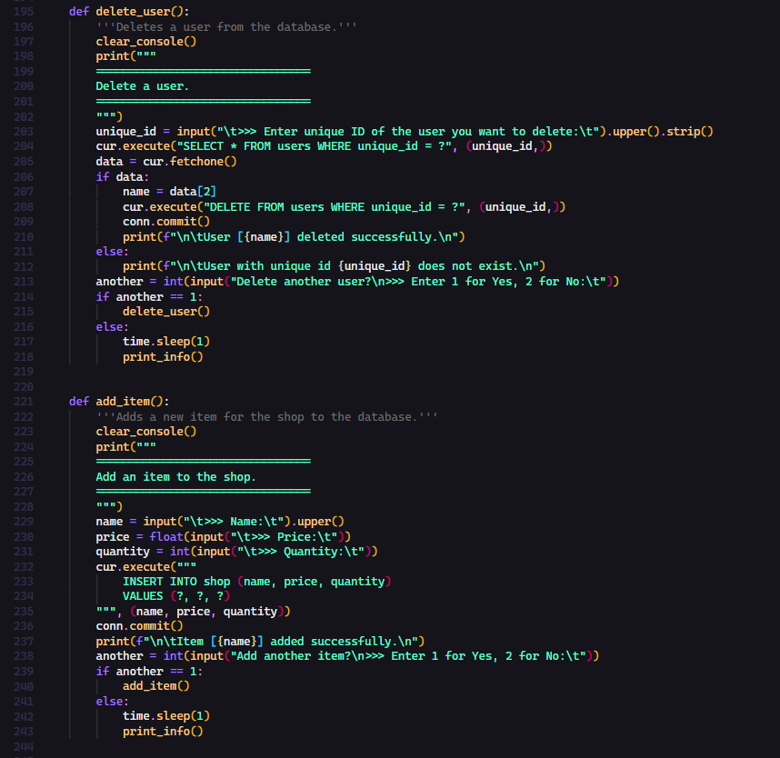

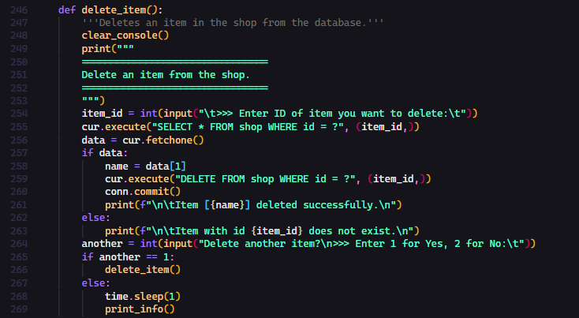

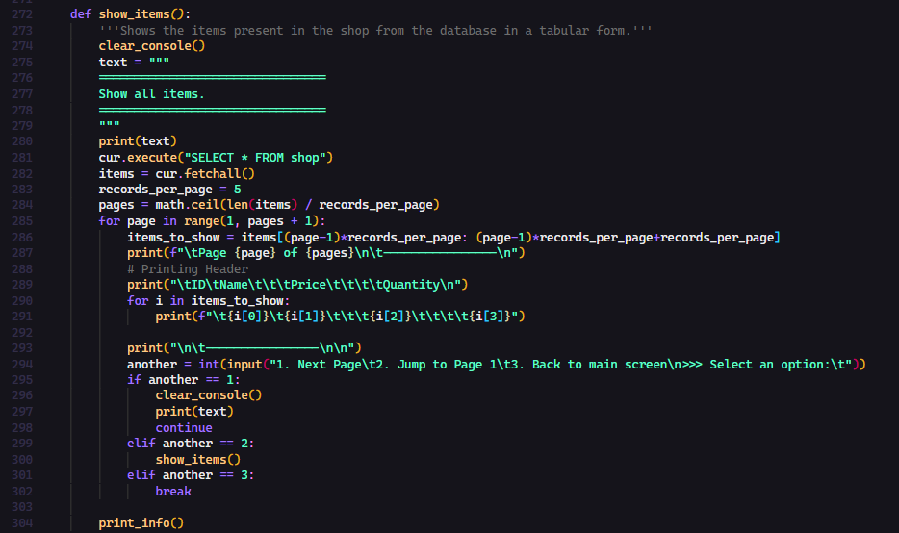

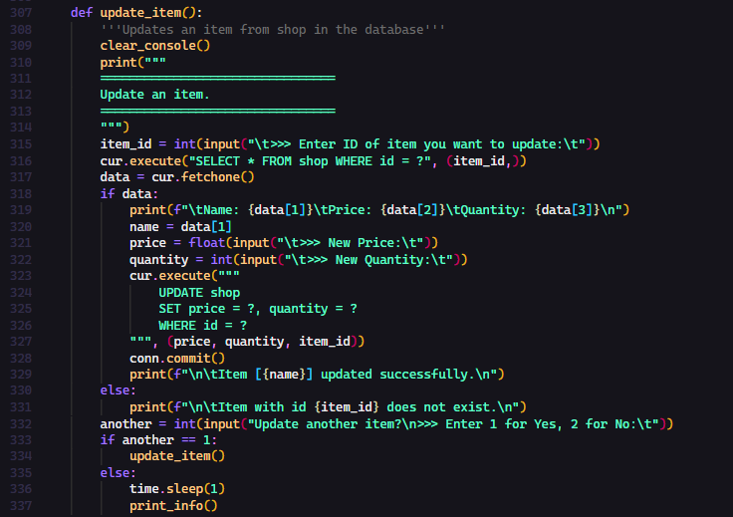

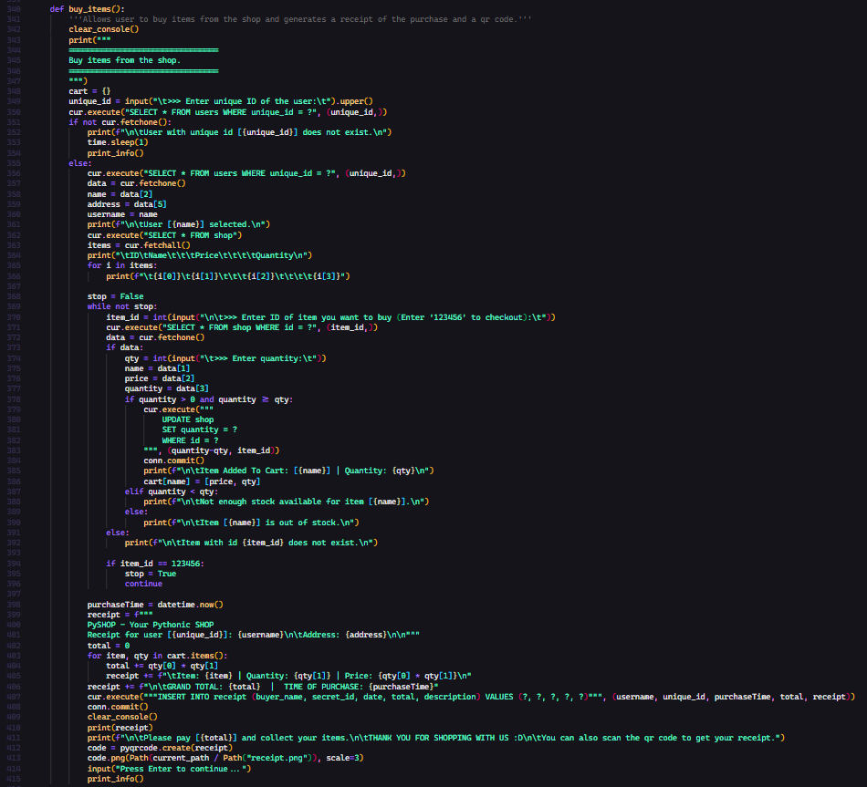

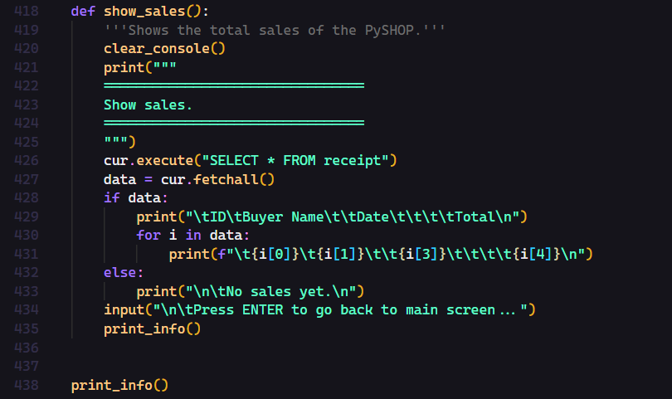

**CODE OUTPUT**

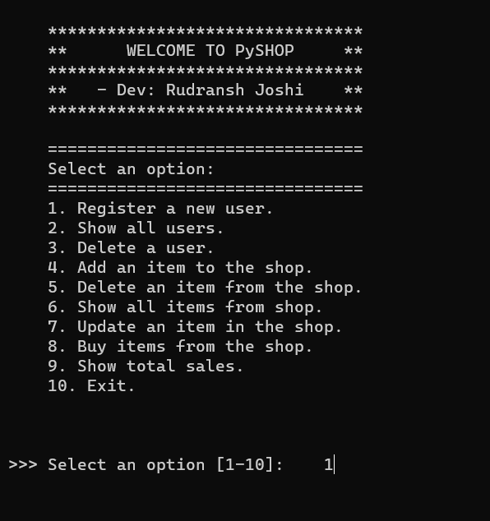

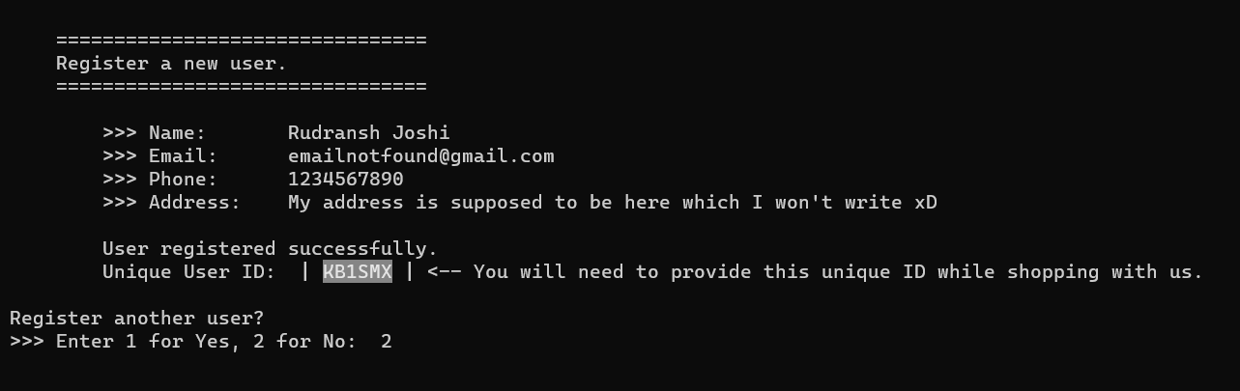

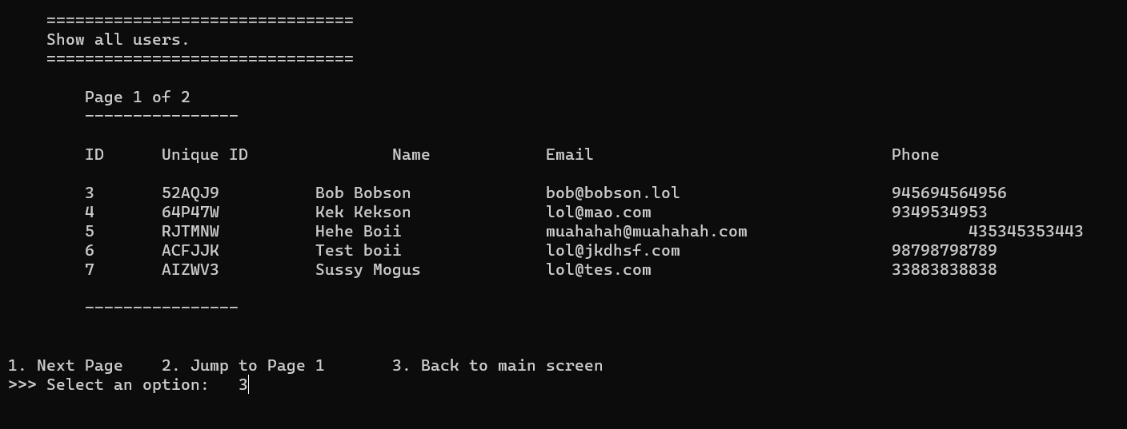

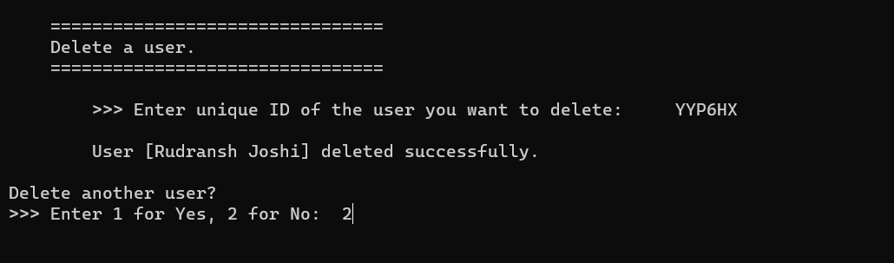

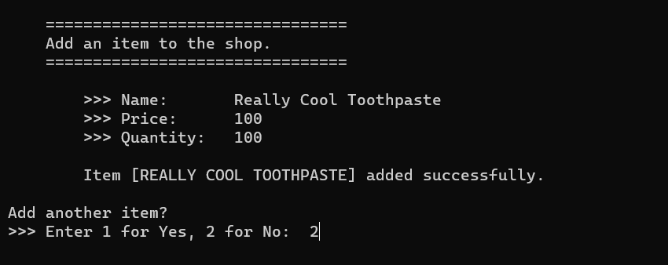

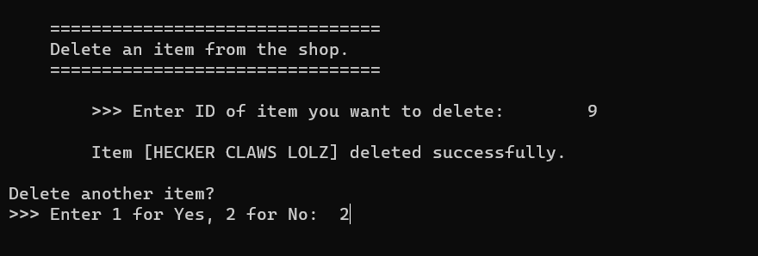

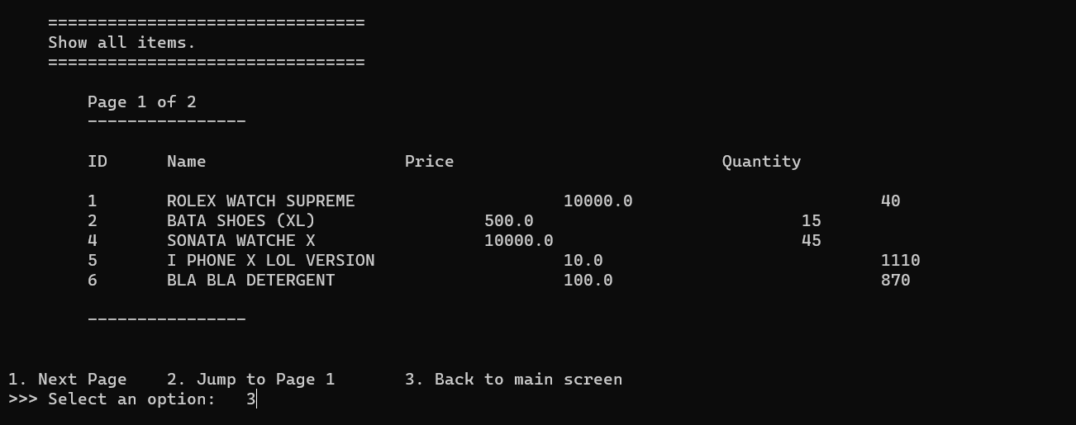

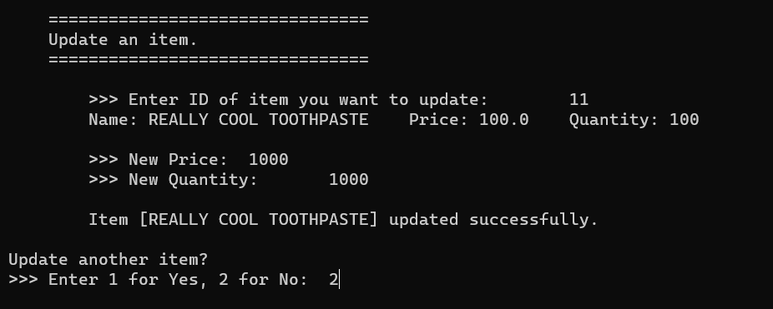

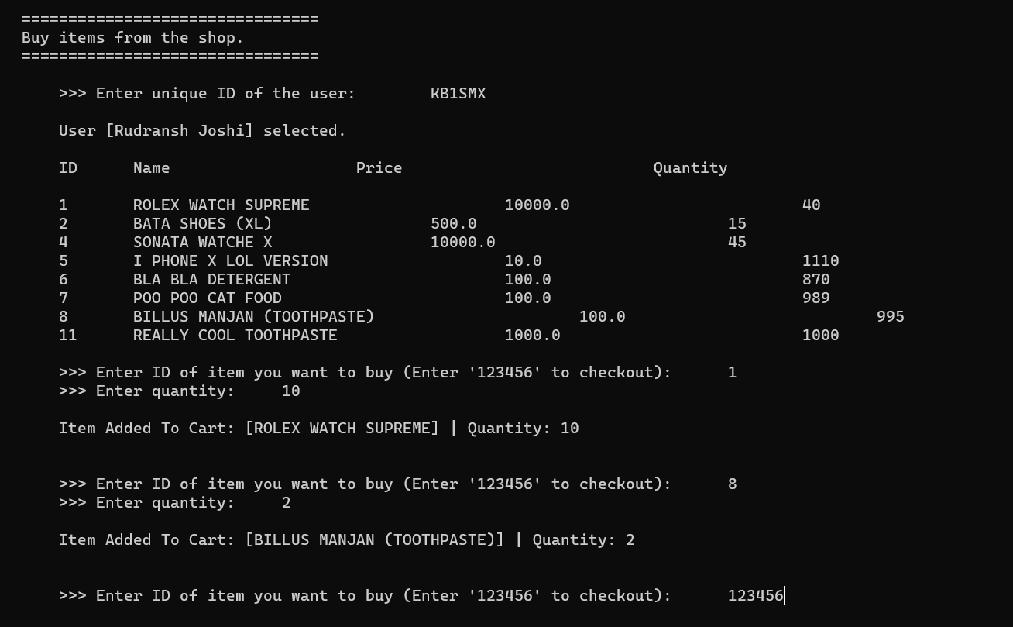

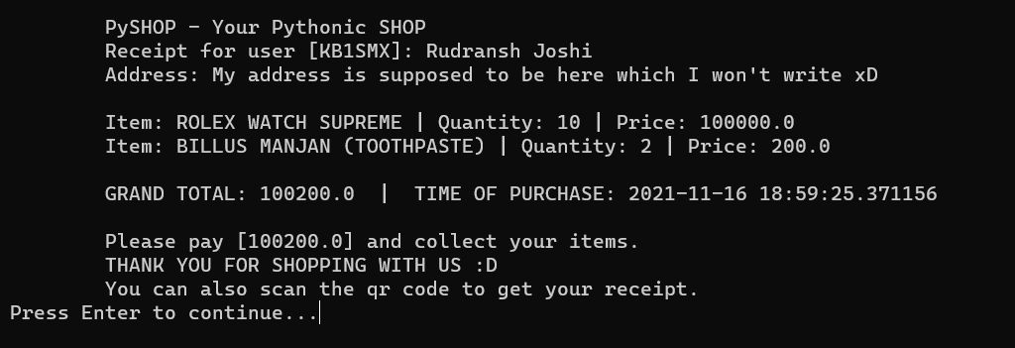

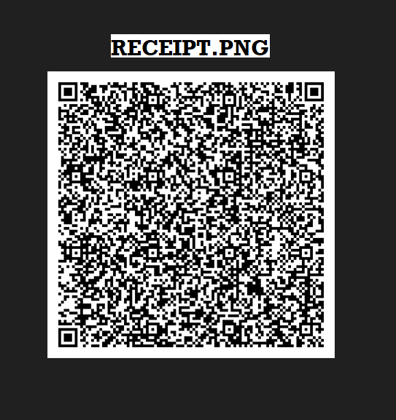

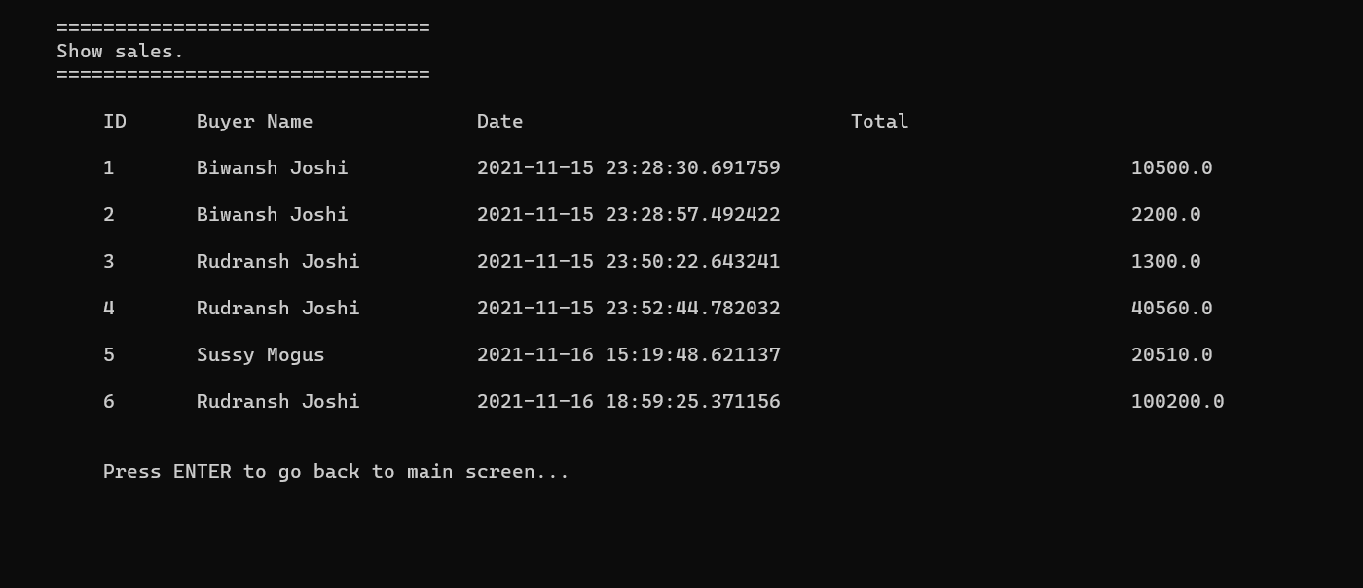

**HARDWARE AND SOFTWARE SPECIFICATIONS**

THE PROJECT HAVE BEEN TESTED AGAINST THE FOLLOWING HARDWARE AND SOFTWARE CONFIGURATIONS.

I. OPERATING SYSTEM : WINDOWS 11 (x64)

II. PROCESSOR : INTEL CORE i5-9300H

III. GPU : NVIDIA GEFORCE GTX 1650

IV. RAM : 8 GB DDR4

V. HARD DISK : 1 TB HDD (+256GB SSD)

VI. PYTHON VERSION : v3.8.6

VII. IDE : VISUAL STUDIO CODE (v1.62.2)

VIII. MODULES USED : SQLITE3, PATHLIB, OS, DATETIME,

TIME, OS, STRING, RANDOM, MATH, PYQRCODE

IX. DATABASE ENGINE : SQLITE

**SOFTWARE REQUIREMENTS:**

1. Operating System (Windows/MacOS/Linux)
2. Python (>=3.5)
3. External Python Libraries/Modules (PYQRCODE, PYPNG)

[ pip install pyqrcode pypng ]

**BIBLIOGRAPHY**

* + - [SQLite Documentation](https://www.sqlite.org/docs.html)
    - [sqlite3 — DB-API 2.0 interface for SQLite databases — Python 3.10.0 documentation](https://docs.python.org/3/library/sqlite3.html)
    - [Welcome to PyQRCode’s documentation! — pyqrcode 1.2 documentation](https://pythonhosted.org/PyQRCode/)
    - [Stack Overflow - Where Developers Learn, Share, & Build Careers](https://stackoverflow.com/)

**LINKS**

* [FireHead90544/PySHOP: A shopping cart simulator](https://github.com/FireHead90544/PyShop)