Camera Pose Estimation Tool
Handoff & User Documentation
Version 1.0 — May 2026

1. Introduction
This tool is an interactive simulator for camera pose estimation developed as part of a computer vision project. It estimates the relative pose (rotation R and translation t) between two cameras from 2D point correspondences, following the methodology used in ORB-SLAM.

What the tool does
From an automatically generated synthetic 3D scene, the tool:
- Projects 3D points onto both camera image planes.
- Estimates the pose of camera 2 relative to camera 1 using two methods:
  - Homography matrix H — suited for planar scenes (points lying on a common plane).
  - Fundamental matrix F — suited for general (non-planar) 3D scenes.
- Automatically selects the most reliable method using an ORB-SLAM-inspired score and ratio.
- Displays results in an interactive 3D view and measures rotation/translation errors against ground truth.

2. Prerequisites & Installation

Python version
Python 3.9 or higher is required. Python 3.10–3.12 is recommended for best compatibility with all dependencies.

Installing dependencies
From the project root directory, run:
pip install -r requirements.txt

Launching the interface
From the project root:
python pipeline/gui_tool.py
Note: If using Anaconda, ensure the active environment has all packages installed. Python 3.13+ may introduce compatibility issues with some dependencies — using a dedicated virtual environment (conda create -n pose python=3.11) is recommended.

3. User Interface Guide

General layout
The interface is divided into two main areas:
- Left column — a scrollable sidebar containing 4 parameter tabs and action buttons at the bottom.
- Right area — a matplotlib canvas that displays results after each Run. Before the first run, it shows a placeholder: "Configure parameters and click Run".
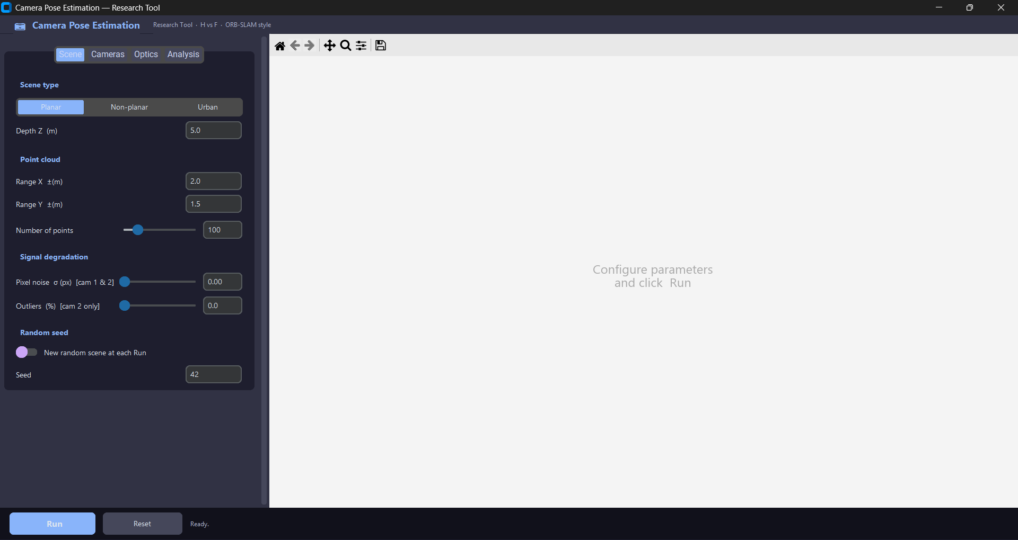

Tab — Scene
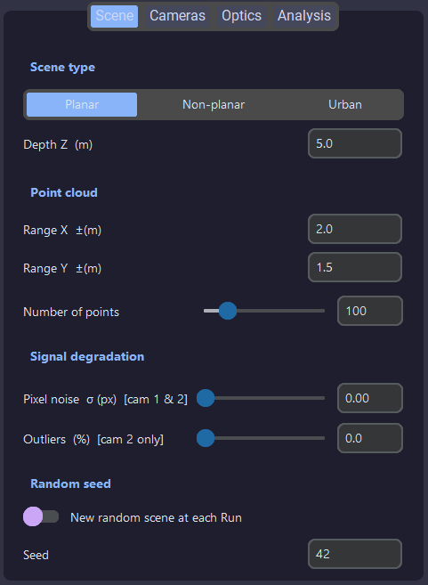
Scene type
A segmented button at the top lets you choose between three scene types:
Planar — all 3D points are generated at the same depth Z (a single front-parallel plane). This is the ideal case for homography estimation: H is exactly valid for coplanar points.
- Depth Z (m) — the single depth at which all points are placed. Typical value: 5.0 m.

Non-planar — 3D points are distributed randomly across a volume. Depths vary between Z min and Z max. This is the ideal case for the fundamental matrix F.
- Z min (m) / Z max (m) — depth range of the generated points.

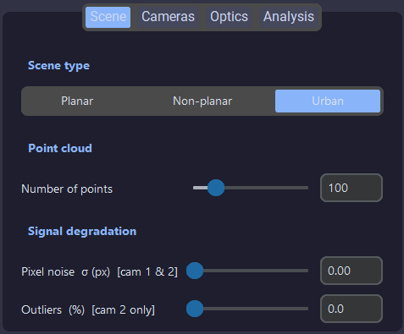
Urban — a fixed synthetic urban environment made of three geometric objects:
  - Building — rectangular box (3 m × 3 m × 6 m height) placed at Z = 10 m.
  - Tree — a thin cylindrical trunk topped by a hemispherical dome (mushroom shape), placed at
Z = 8 m on the left.
  - Car — two stacked boxes (body + roof), placed at Z = 7 m on the right.
The geometry is fixed; only the number of points varies.
Point cloud section
These parameters control the spatial distribution of generated points.
Parameter | Applies to | Description
Range X ±(m) | Planar, Non-planar | Horizontal extent of the scene in meters either side of the central axis.
Range Y ±(m) | Planar, Non-planar | Same principle on the vertical axis.
Number of points | All | Total number of 3D points generated. Range: 8 to 500. In Urban mode, points are split across the three objects: 55% building, 25% tree, 20% car.
⚠ In Urban mode, fewer than 100 points makes the shapes hard to recognise visually. Use 300–400 points for a clear view of the scene.
Signal degradation section
These parameters simulate imperfect acquisition conditions.
Parameter | Description
Pixel noise σ (px) | Zero-mean Gaussian noise with standard deviation σ added to the 2D pixel coordinates of both cameras. σ = 0.0: ideal conditions. σ = 1.0: realistic precision for a good keypoint detector. σ = 3.0–5.0: heavy degradation.
Outliers (%) [cam 2] | Percentage of erroneous correspondences injected into camera 2 only. An outlier replaces a projected point's pixel position with a random position anywhere in the image — simulating false keypoint matches. 0%: no outliers. >0% of matches are false (RANSAC should handle these).
Random seed section (Planar and Non-planar only)
- "New random scene at each Run" switch — when OFF (default): the same seed is used every Run, so the scene is identical across runs (useful for comparing H and F on exactly the same data). When ON: a new random seed between 0 and 99 999 is drawn at each Run.
- Seed field — the numeric seed value (default: 42). Can be edited manually to reproduce a specific scene. When the random switch is ON, this field updates automatically after each Run — useful for noting an interesting scene and reproducing it later.

Tab — Cameras
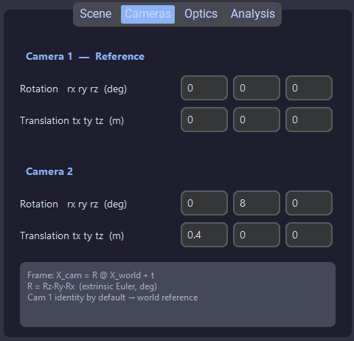
This tab defines the pose of both cameras in the world frame. The rotation is built in the order Rz · Ry · Rx (extrinsic Euler angles).
Camera | Parameter | Default | Description
Camera 1 (reference) | rx ry rz (deg) | 0 / 0 / 0 | Zero rotation: camera 1 sits at the world origin looking in the +Z direction. In practice, Camera 1 is never modified — it defines the reference frame.
Camera 1 (reference) | tx ty tz (m) | 0 / 0 / 0 | Zero translation: the world origin.
Camera 2 | ry (deg) | 8° | 8° rotation around Y: slight horizontal pan of camera 2 relative to camera 1.
Camera 2 | tx (m) | 0.4 m | 0.4 m offset along X. These default values give a realistic stereo setup.

Tab — Optics
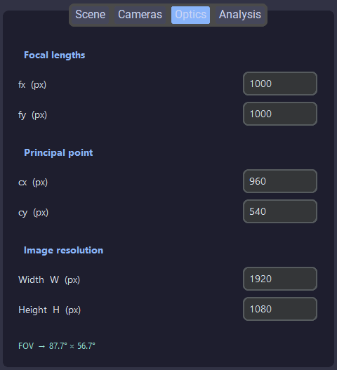
This tab defines the intrinsic parameters shared by both cameras.
Parameter | Default | Description
fx (px) | 1000 | Horizontal focal length in pixels. Defines the horizontal magnification of the camera.
fy (px) | 1000 | Vertical focal length in pixels.
cx (px) | 960 | Horizontal principal point (optical centre). Default = W/2.
cy (px) | 540 | Vertical principal point. Default = H/2.
Width W (px) | 1920 | Image width in pixels. Points projected outside [0, W] × [0, H] are discarded as not visible.
Height H (px) | 1080 | Image height in pixels.
FOV (auto) | ≈ 53.1° × 31.0° | Horizontal and vertical field of view, computed in real time: FOV_h = 2·arctan(W/2fx), FOV_v = 2·arctan(H/2fy).

Tab — Analysis
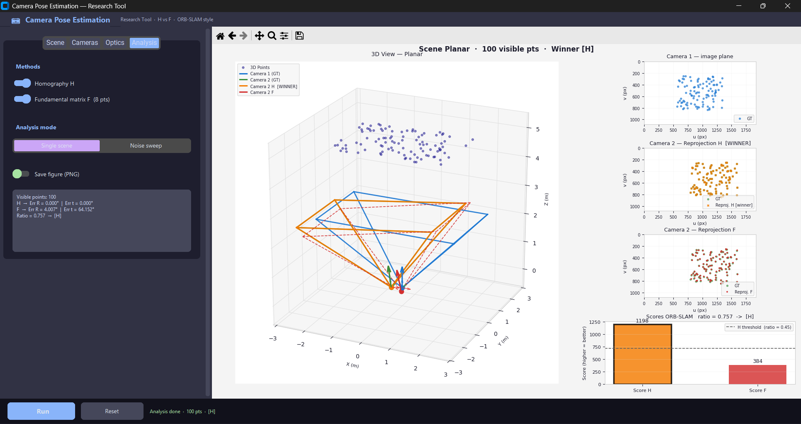
Methods section
- Homography H switch — enables or disables the homography estimation branch.
- Fundamental matrix F (8 pts) switch — enables or disables the fundamental matrix branch. At least one of the two switches must be ON to launch a Run.
Analysis mode
- Single scene — default mode. Runs the full pipeline once with the current parameters. Displays the 3D scene view, reprojection overlays, and the results card.
- Noise sweep — repeats the analysis over multiple noise levels σ defined in the "σ levels" field (default: 0 0.5 1 2 3 5, space-separated). Produces two error curves — rotation error and translation error — as a function of σ, for both H and F. Useful for comparing robustness against noise.
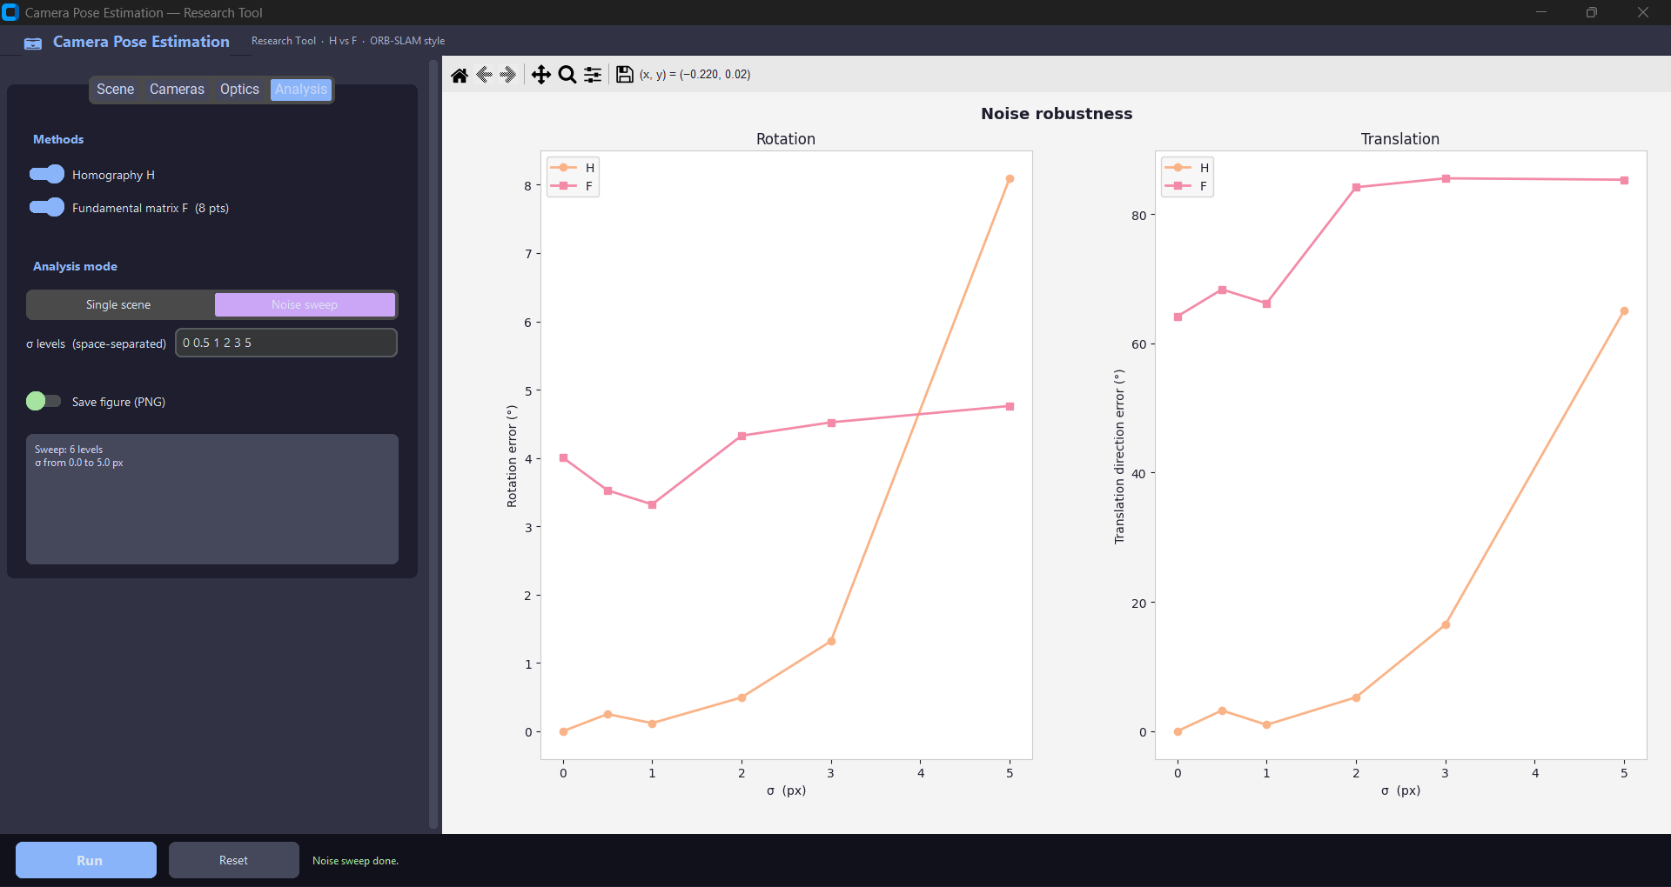
Save figure switch
When enabled, the matplotlib figure is automatically exported to pipeline/exports/ after each Run. The filename includes a timestamp (e.g. result_single_20260507_174532.png).
Results card
After each Run in Single scene mode, a summary box at the bottom of the Analysis tab displays:
Visible points: 115 H → Err R = 0.703° | Err t = 7.859° F → Err R = 0.000° | Err t = 0.000° Ratio = 0.472 → [H]
- Visible points — number of 3D points simultaneously visible to both cameras (i.e. projecting within the image bounds of both).
- Err R — angular rotation error in degrees. 0° = perfect recovery.
- Err t — angular direction error of the translation vector in degrees. Note: the scale of t is not recoverable in monocular estimation, so only the direction is evaluated.
- Ratio = S_H / (S_H + S_F). Decision threshold: if Ratio > 0.45, the homography model is selected (shown as [H]). Otherwise the fundamental matrix is used ([F]).

Action buttons (bottom bar)

- Run — launches the analysis with the current parameters. During computation the button displays "Running…" and is disabled. A progress indicator appears.
- Reset — resets all parameters to their default values and clears the display back to the placeholder.
Status bar — displays real-time feedback: "Ready.", "Analysis running…", "Analysis done · 115 pts · [F]", or error messages if something goes wrong.

4. Understanding the Results

4.1 Layout of the results area
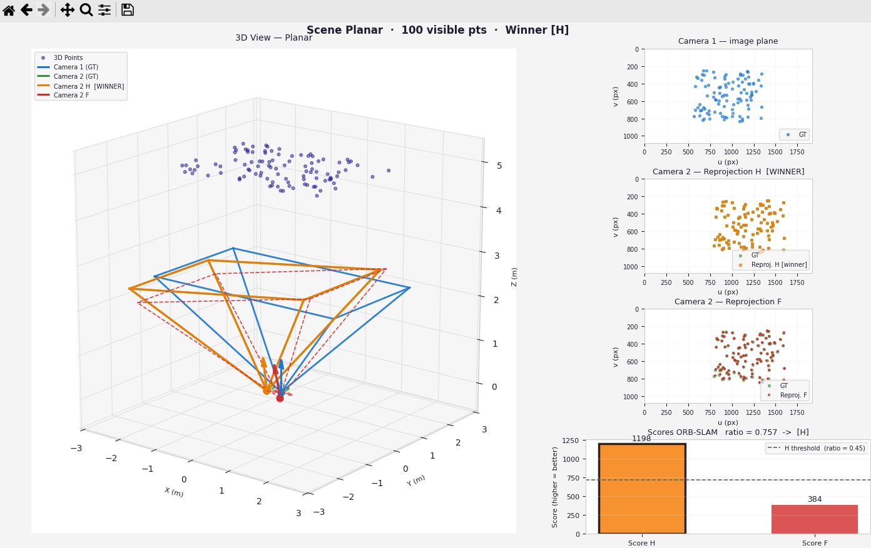
After a Run in Single scene mode, the right-hand canvas is divided into 5 panels:
- 3D scene view
- Camera 1 – image
- Camera 2 – reprojection H
- Camera 2 – reprojection F
- ORB-SLAM score bar

4.2 The 3D scene view
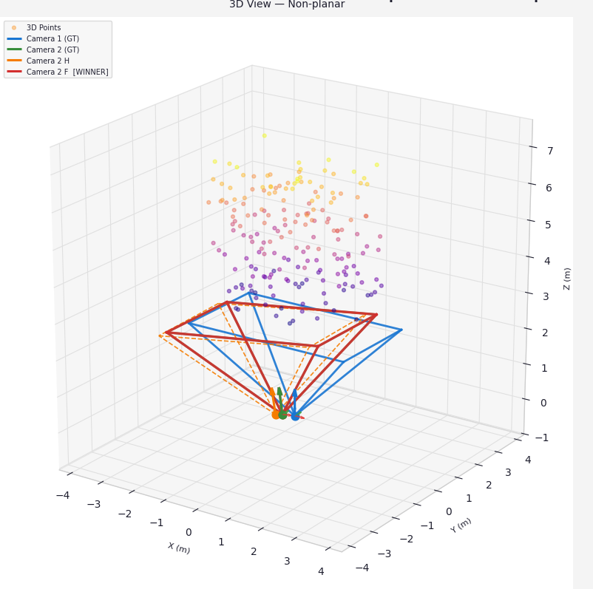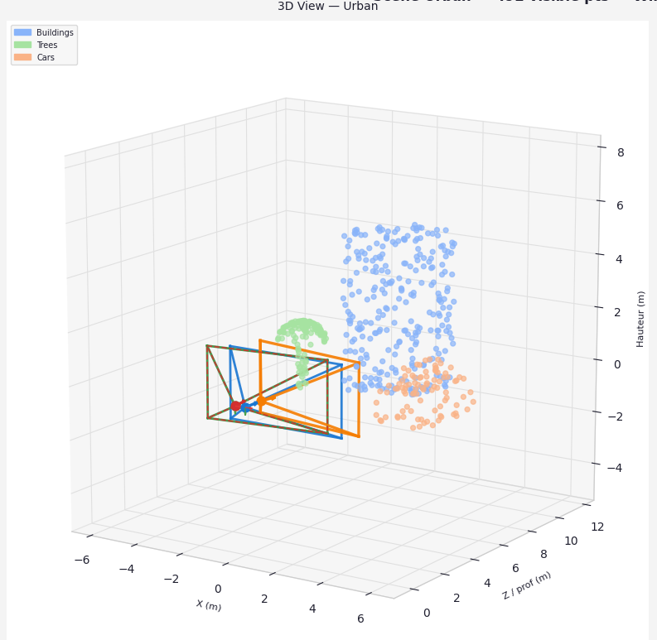

Point cloud colouring
- Planar / Non-planar — points are coloured by depth Z using a plasma colormap (purple = near, yellow = far).
- Urban — points are coloured by object type:
  - Blue = Building
  - Green = Tree
  - Orange = Car

Camera frustums
Each camera is represented by a truncated pyramid (frustum) delimiting its field of view, plus an arrow indicating its viewing direction.
Frustum colour | Camera | Meaning
Blue | Camera 1 | Reference camera — fixed ground truth pose.
Green | Camera 2 | Ground truth pose of camera 2.
Orange | Camera 2 | Pose estimated via H.
Red | Camera 2 | Pose estimated via F.
The winner (selected model) is drawn with a thick solid line. The loser is drawn with a thin dashed line. The closer the estimated frustum (orange or red) overlaps the green frustum, the more accurate the estimation is.

4.3 Reprojection panels: H and F
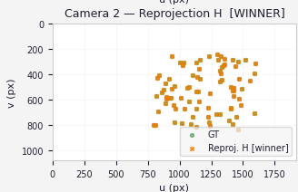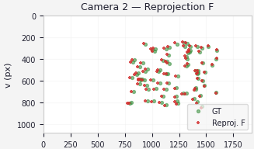
Principle
Reprojection consists of taking the ground truth 3D points, projecting them into camera 2 using the estimated pose (R, t), and comparing those projected positions with the actual observed 2D positions.
Panel | Points shown | How to read it
Camera 1 — image plane | Blue dots = ground truth projections in camera 1. | Reference view. Shows the spatial distribution of correspondences in the first image.
Camera 2 — Reprojection H | Green dots = ground truth positions. Orange = positions reprojected via H pose. | If it overlaps the green dots exactly, H has correctly estimated the pose. Title shows [WINNER] if H won.
Camera 2 — Reprojection F | Green dots = ground truth positions. Red = positions reprojected via F pose. | If it overlaps the green dots exactly, F has correctly estimated the pose. Title shows [WINNER] if F won.

Interpreting the overlap quality
Visual result | Interpretation
Perfect overlap | Pose estimation is excellent — error close to 0°.
Uniform offset | Rotation is well estimated but translation has a small error.
Scattered points | Pose is poorly estimated — too much noise, too many outliers, or wrong model selected.

4.4 ORB-SLAM score and ratio
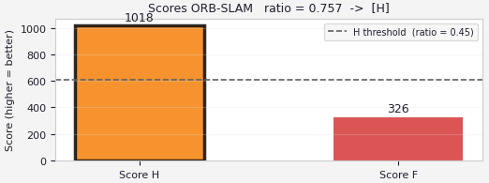
Score H — symmetric transfer error
For each correspondence (px1, px2), the transfer error is measured in both directions:
- Forward — project px1 via H into image 2, measure pixel distance to px2.
- Backward — project px2 via H⁻¹ into image 1, measure pixel distance to px1.
S_H = Σ max(0, 5.99 − d²_forward) + max(0, 5.99 − d²_backward)
The threshold 5.99 is the 95th percentile of a chi-squared distribution with 2 degrees of freedom (2D transfer error in the image plane).
Score F — Sampson distance
The Sampson distance measures how much each point pair violates the epipolar constraint x2ᵀFx1 = 0:
d²_sampson = (x2ᵀFx1)² / (‖Fx1‖²_top2 + ‖Fᵀx2‖²_top2) S_F = Σ max(0, 3.84 − d²_sampson)
The threshold 3.84 is the 95th percentile of a chi-squared distribution with 1 degree of freedom (the epipolar constraint is a scalar 1D constraint).
Ratio and decision
ratio = S_H / (S_H + S_F) if ratio > 0.45 → H selected (scene sufficiently planar) if ratio ≤ 0.45 → F selected
Why 0.45 and not 0.50? F has more degrees of freedom and can fit data well even in planar scenes. The asymmetric threshold deliberately gives H a slight advantage, since H is the correct model for planar scenes and should win even when F is competitive.

4.5 Rotation and translation errors
Rotation error (°)
Measures the minimal angle between the estimated rotation matrix and the ground truth:
err_R = arccos( (trace(R_est.T @ R_ref) − 1) / 2 )
Principle: any 3D rotation can be written as a rotation by angle θ around an axis (Euler's theorem). The trace of the relative rotation matrix gives this angle directly via trace = 1 + 2·cos(θ).
Value | Interpretation
0.000° | Perfect estimation.
< 1° | Very good estimation.
1° to 5° | Acceptable estimation.
> 5° | Degraded estimation.
Translation error (°)
Why degrees, not metres? The scale of the translation vector is not recoverable without metric ground truth. Only the direction of t can be evaluated:
u = t_est / ‖t_est‖ (unit vector of estimated direction)
v = t_ref / ‖t_ref‖ (unit vector of true direction)
err_t = arccos( |u · v| )
The absolute value |u · v| handles the sign ambiguity. + t and −t point in opposite directions but share the same |cos|.
Value | Interpretation
0.000° | Direction perfectly estimated.
< 5° | Very good directional estimation.
5° to 15° | Acceptable estimation.
> 15° | Direction poorly estimated.

5. Code Architecture

5.1 Project structure
camera-pose-estimation/
│
├── pipeline/ ← Orchestration and GUI
│ ├── core.py
│ ├── gui_tool.py
│ ├── visualize3d.py
│ └── score.py
│
├── simulation/ ← Camera parameters + homography
│ ├── camera_model.py
│ ├── projection.py
│ ├── homography.py
│ ├── dlt.py
│ └── scene_urban.py
│
└── eight_points/ ← 8-point
├── eight_point_agl.py
├── RANSAC.py
├── Retrieve_P.py
└── triangulation.py

5.2 Execution flow
The following sequence is triggered when Run is pressed:
Click Run (gui_tool.py)
│
▼
make_scene(cfg) ← core.py
│
├── Urban → generate_urban_scene() ← scene_urban.py
├── Planar → fixed Z, random XY
└── Non-planar → random XYZ in range
│
▼
project_points() + filter_visible() ← projection.py
(+ noise injection + outlier injection)
│
▼
run_pipeline(scene, cfg) ← core.py
│
├── Branch H ─────────────────────────────────────────────────────
│ RANSAC(s=4, score_H_RANSAC) ← RANSAC.py
│ homography(px1, px2) ← homography.py
│ score_H(H, px1, px2) ← score.py
│ decompose_H(H, K, plane_dist) ← homography.py
│
├── Branch F ─────────────────────────────────────────────────────
│ RANSAC(s=8, score_F_RANSAC) ← RANSAC.py
│ eight_point(px1, px2) ← eight_point_agl.py
│ score_F(F, px1, px2) ← score.py
│ get_R_t_from_epipolar(F, K) ← Retrieve_P.py
│ parallax(P2_all, K, px1, px2) ← Retrieve_P.py
│ find_scaling_factor(...) ← Retrieve_P.py
│
└── ratio = S_H / (S_H + S_F) → winner: H or F
│
▼
_show_single(scene, res, cfg) ← gui_tool.py
├── _draw_3d(...) ← visualize3d.py
├── _draw_image_cam1(...) ← visualize3d.py
├── _draw_image_cam2_H(...) ← visualize3d.py
├── _draw_image_cam2_F(...) ← visualize3d.py
└── _draw_score_bar(...) ← visualize3d.py

5.3 File-by-file description
pipeline/core.py
Central orchestration file. Contains:
- Config — dataclass holding all parameter default values.
- make_scene(cfg) — generates the full synthetic scene (3D points → projection → noise → outliers) and returns a dict: {pts3d, px1, px2, K, R_rel, t_rel, R1, t1, urban_colors}.
- run_pipeline(scene, cfg) — orchestrates H and F branches, computes scores, makes the model decision, returns errors.
- run_noise_sweep(cfg) — loops make_scene + run_pipeline over each σ level to produce the noise sweep data.
pipeline/gui_tool.py
Full GUI built with customtkinter and matplotlib. Contains:
- App — main class.
- Reusable widgets: EntryRow, SliderRow, TriRow, _SectionTitle.
- _tab_scene / _tab_cameras / _tab_optics / _tab_analyse — tab construction functions.
- _collect_config() — reads all widgets and builds a Config object.
- on_run() — launches the pipeline in a background thread to keep the UI responsive.
- _show_single() / _show_noise() — update the matplotlib canvas after a Run.
pipeline/visualize3d.py
All matplotlib drawing functions. Contains:
- _draw_3d() — main 3D view: point cloud, frustums, camera axes.
- _draw_frustum() — draws one camera frustum (pyramid + directional arrow).
- _draw_cam_axes() — draws the three local RGB axes on a camera.
- _draw_image_cam1/2_H/F() — reprojection panels in the image plane.
- _draw_score_bar() — comparative histogram S_H vs S_F with threshold line.
- _urban_T() — coordinate transformation function for the Urban view.
pipeline/score.py
Scoring functions used after RANSAC for the final computation on inliers:
- score_H(H, px1, px2) — symmetric transfer error, threshold 5.99.
- score_F(F, px1, px2) — Sampson distance, threshold 3.84.
simulation/camera_model.py
- get_K(fx, fy, cx, cy) — builds the 3×3 intrinsic matrix K.
- get_camera_pose(rx, ry, rz, tx, ty, tz) — builds R and t from Euler angles and translation vector.
simulation/projection.py
- project_points(pts3d, K, R, t) — projects 3D world points to 2D pixels via P = K[R|t].
- filter_visible(px, depth, w, h) — boolean mask removing points outside the image bounds or behind the camera.
simulation/homography.py
- homography(pts_src, pts_dst) — normalised DLT homography estimation (SVD on 2N×9 matrix A), minimum 4 correspondences.
- decompose_H(H, K, plane_dist, X_ref) — extracts (R, t) from H. If plane_dist is known (planar scene), returns t in metres; otherwise returns a unit vector. Cheirality test via X_ref.
- reprojection_error_H() — RMSE reprojection error for H.
simulation/dlt.py
- dlt(points_2d, points_3d) — estimates the 3×4 projection matrix P by normalised Direct Linear Transform, minimum 6 2D↔3D correspondences.
- extract_Rt_from_P(P, K) — extracts R and t from P via SVD decomposition of K⁻¹P.
simulation/scene_urban.py
Generates the Urban synthetic scene:
- _sample_box() — uniformly samples points on the 6 faces of a box, proportionally to each face area.
- _sample_tree() — cylindrical trunk (lateral surface) + flattened hemispherical dome (spherical coordinates, φ ∈ [0, π/2]).
- _sample_car() — two stacked boxes (body + roof) via _sample_box.
- generate_urban_scene(rng, n_points) — assembles the three objects, distributes points (55%/25%/20%), returns (pts3d, colors).
eight_points/eight_point_agl.py
Normalised 8-point algorithm with optimisation:
- normalize(points) — isotropic normalisation (centring + scale).
- linear_eq(points1, points2) — builds the N×9 matrix A of the system Af = 0.
- eight_point(pts1, pts2) — full algorithm: normalise → SVD → rank-2 enforcement → Levenberg–Marquardt optimisation → denormalise.
- min_alg_error(F0, A) — minimises algebraic error.
- residual_fun(e, A, state) — cost functionn.
eight_points/RANSAC.py
- RANSAC class — adaptive RANSAC. Iteration count N is updated dynamically as inliers are found:
N = log(1−p) / log(1−(1−ε)^s), with p = 0.99.
- score_H_RANSAC / score_F_RANSAC — same logic as score.py, used during RANSAC to rank candidate models.
eight_points/Retrieve_P.py
- get_R_t_from_epipolar(F, K) — computes E = KᵀFK, decomposes E by SVD to get t and two rotation candidates R1, R2 via the W matrix.
- P_estimation(t, R1, R2, K) — assembles the 4 possible projection matrices K[R|±t].
- parallax(P2_all, K, pt1, pt2) — triangulates points for each solution and selects the one with the most points at positive depth (cheirality test).
- find_scaling_factor(P2, K, pts1, pts2, pts3D) — estimates the scale factor by comparing triangulated inter-point distances to ground truth distances.
eight_points/triangulation.py
- triangulate(P1, P2, pts1, pts2) — linear triangulation by SVD: for each point pair, builds the 4×4 DLT system and solves it to obtain the homogeneous 3D point.

6. Known Limitations

Current limitations
- Synthetic data only. The tool works exclusively with generated scenes. No real image input or actual keypoint matching is implemented.
- Limited RANSAC control. The RANSAC toggle enables/disables outlier rejection, but inlier threshold and iteration count are not user-configurable from the GUI.

Potential improvements
- Real image support — integrate actual image loading with ORB/SIFT feature extraction and matching to test on real stereo pairs.
- Advanced RANSAC tuning — expose inlier threshold and maximum iteration count as GUI sliders.
- Multi-view extension — support more than two cameras and incremental structure-from-motion.
- Export of results — allow exporting all metrics and estimated matrices to a JSON or CSV file for batch analysis.
Camera Pose Estimation Tool — Handoff & User Documentation — May 2026

