HQAlign:
Input
A list of target sequences (up to ~100MB) as a fastA file
A list of reads (fastA or fastQ ok) which can have barcodes, linkers
A spreadsheet "HQAlign_settings" file that tells the system
Where to look for the reference and sequenc read files
What type of matches to collect
Quality of matches (length and mismatch tolerance)
How to handle reads that match more than once
What to output
Spreadsheet: genes/bins/bases with values for hits/coverage?
Simple output: list of matches, positions, incidence?
Pileup: text-based line-up window
Output:
A set of txt files. You can specify how the output files will look and what they will contain in your Spreadsheet settings file. Once produced, the text output can be browsed in a text editor, pasted or imported into a spreadsheet (libre office calc is my favorite spreadsheet) or manipulated with more code.

Here is my "Workflow" with HQAlign
1. Collect information about samples and barcodes/linkers
2. Collect file names for the reference file and sequencer output
3. Make a spreadsheet with your choices of
input sequence
reference sequences
how to deal with multiply-matching sequences
what info to report on each match
4. Run the program. If you are working with a version of python that has access to the module xlrd, you can do this using a setting spreadsheet in .xls format directly. The command line syntax is
python <HQAlign_Code File> <HQAlign_SettingsFile>
to run the example:
python HQAlignDR_110718.py HQAlignSettings_Sample_HQAlignDR.xls
this will give an error if you don't have the xlrd module installed in the python version you are using. In that case, you can copy the contents of the settings file to a text-only file (which we've done and called "HQAlignSettings_SampleHQAlignDR.txt"), and run the program as follows
python HQAlignDR_110718.py HQAlignSettings_Sample_HQAlignDR.txt

If you are still having trouble, you may want to be in "Safe Mode", meaning that a default "HQSheet.txt" in the directory will be used. If this still doesn't work, run the program in safe mode by first copying the text from the spreadsheet into a file named "HQAlign.txt", putting this file into the same directory as HQAlignDRSafe.py, and running HQAlignDRSafe.py in that directory python HQAlignDR_110718Safe.py HQAlignSettings_Sample_HQAlignDRSafe.txt

Limitations: HQAlign is very good for reference sequences up to about the size of the worm genome, although some features (e.g. base-by-base histograms of match length or sequences) will make a mess is you try to do them with more than a few dozen kilobases of sequences. In general, give anything a try. If it works or fails, tell the HQAlign-inc's dedicated development staff.
With a modest target (e.g., a handful of genes), a single Illumina GAII lane can be aligned in a few minutes. With a larger target, times increase due to the need to record many matches as text strings.
Spreadsheet Structure (HQSheet.txt or HQSheet.xls)
# Category | # Variable | # Value | # Description
# Description of Experiment | ExptDesc | JuliaTrypticTest | # A text description used to identify data for the entire experiment
# Reference Sequence | ReferenceFileName | mart_unigene.fa | # file with reference sequences, 'ask' to ask the user
# Sequencer Output | SampleDesc | TrypticTest | # Text Describing the individual sample
 | ReadFileName | s_7_sequence.txt | # 'ask' asks the user using a dialog box
 | StartBarcode | AGCG | # Barcode at start of sequence (e.g. 'GCAC'). '' means no barcode
 | EndLinker | CTGT | # Linker at end of sequence (e.g. 'GCACGGACCAGATTGA'). '' means no linker or not in sequence, can specify just a few bases at the beginning if these are unique in the linker, and this will require that only these match the linker
 | DataUpper | True | # TrueAll data is in upper case (also all nonstandard characters will be treated as "A". Setting this to false performs an upper casing and filtering of data for AacCGgTt
# Alignment Requirement | MinRead | 19 | # Minimal read length for analysis (Linker and Barcode lengths will be added to this value by HQAlign). Sequences shorter than this will not be tested for alignment
 | MaxRead | 999 | # Maximal analyzed length (Linker and Barcode lengths will be added to this value by HQAlign). HQAlign Ignores all bases beyond this point.
 | MaxMisMatch | 0 | # Maximum allowed mismatches. This can change between different lines in the batch file, in which case the value here needs to be the maximum value
 | MinMatch | 19 | # Minimum number of (non-linker non-barcode) matches, starting from the first base and going forward that must match, with fewer than "MM" mismatches interspersed
 | ExtensionOK | True | # True: Keep all reads meeting initial match criteria, allowing any number of downstream mismatches. False: count mismatches through the entire read (To require perfect match from start to end of read set Extension_OK to False and Max_MisMatch to 0)
 | RequireEndLinker | True | # True- Require the specified bases of the 3' linker to be present of the tag is ignored
 | Seed | 12 | # Seed length... this is the segment size that the program looks for as an initial perfect match. Odd things can happen if Seed*MM>MinRead
# Multiple matches to one tag? | MultipleMatchMode | UniqueChampionsOnly | # Settings for MultipleMatchMode. These can also be set in the BatchList below, with different setting for different lines in the batch list. In that case, put in the max value for Max Mismatch above
 |  |  | # FirstMatch ~ Return 1st match in reference file that meets match criteria
 |  |  | # FirstChampion ~ Return 1st match in reference file that (i) meets match criteria, and (ii) has the best match score
 |  |  | # AllMatches ~ Return all matches in reference file that meet match criteria
 |  |  | # AllChampions ~ Return all matches in reference file that (i) meet match criteria, and (ii) tie for best match score
 |  |  | # UniqueMatchesOnly ~ Return only matches in the reference file that (i) meet the match criteria and (ii) where no other sites match criteria
 |  |  | # UniqueChampionsOnly ~ Return only matches in the reference file that (i) have best match scores and (iii) where no other target sites have that score
 |  |  | # SuperHits_n ~ Return only matches in the reference file that (i) meet match criteria and (ii) where any other match to the query has at least n additional mismatches'''
# Collapse duplicate tags? | StartCollapse | False | # StartCollapse keeps only one instance on each strand for any given base (equivalent to start occurences rather than instances)
 | StartLenCollapse | False | # StartCollapse keeps only one instance on each strand for any given base (equivalent to start+end occurences rather than instances)
# Filter Reads? | TargetStart | None | # if defined then only sequence reads starting with that string will be considered. "None" to ignore
 | TargetLength | 0 | # if >0 then only sequence reads of that length (following barcode and linker trimming) will be considered. Zero to ignore
# Grouping of data for output? | TotalBin | False | # one bin that will be a summary of the total file
 | GeneBin | True | # do gene by gene summaries for each gene? Can be done as total, sense or antisense.
 | BinBin | False | # do segment by segment summaries for each gene?
 | BaseBin | True | # provide a base-by-base summary
 | Granularity | 30 | # how fine a granularity; 1 means that every base is recorded as a bin, 100bins of 100
# Make Tabular output file? | TabularOutput | True | # True to provide a detailed output file (non-exclusive alternative is SimpleOutput or Pileup, but this is required for all other output)
 | TabularOutputFileName | auto | # Output file name... auto is an automatically generated time-specific name
 | TransposeFile | True | # provides the output file in transposed format (horizontal to vertical shift)
##Info for each segment? | Bin_Name | True | # Output a column with the gene name for each bin
 | Bin_Size | False | # Output a column with the size of each bin
 | Bin_Start | False | # Output a column with the start of each bin
 | Bin_End | False | # Output a column with the end of each bin
 | Bin_Sequence | True | # Output a column with the sequence of each bin
 | Bin_Composition | False | # Output 4 columns with the sequence composition
##Start Positions? | StartSense | True | # Report the start of each sense match?
 | StartAntiSense | True | # Report the start of each AntiSense match?
 | StartTotal | False | # Report the start of every match?
##Dyad Positions? | DyadSense | False | # Report a hypothetical Dyad distribution, with Dyad being DyadOffset away from each start (sense reads)
 | DyadAntiSense | False | # Report a hypothetical Dyad distribution, with Dyad being DyadOffset away from each start (antisense reads)
 | DyadTotal | False | # Report a hypothetical Dyad distribution, with Dyad being DyadOffset away from each start
 | DyadOffset | 73 | # This is the distance between the beginning of a read and the relevant feature, e.g. 73 for a Nucleosome dyad
##End Positions? | EndSense | True | # Report the end of each sense match?
 | EndAntiSense | True | # Report the end of each antisense match?
 | EndTotal | False | # Report the end of each match?
##Coverage? | CoverageSense | True | # Report coverage by sense reads
 | CoverageAntiSense | True | # Report coverage by AntiSense reads
 | CoverageTotal | False | # Report coverage by total reads
 | VirtualSegmentLen | 0 | # This means the length of the insert will be used as the segment length for coverage (e.g. 147 for a nucleosome). If '0', actual length of read is used
##Size histograms? | SizeHistogramSense | False | # Report a sense size histogram for each bin
 | SizeHistogramAntiSense | False | # Report an antisense size histogram for each bin
 | SizeHistogramTotal | False | # Report an "all-hit" size histogram for each bin
 | Base1SizeHistogram | False | # Augments the size histogram to provide both size and first base (e.g. 22G versus 22A)
##Match spectra? | BaseMatchesSense | False | # Report a summary of matching and mismatching bases (sense hits) for each bin
 | BaseMatchesAntiSense | False | # Report a summary of matching and mismatching bases (antisense hits) for each bin
 | BaseMatchesTotal | False | # Report a summary of matching and mismatching bases (total hits) for each bin
 | ReadMatchesSense | False | # Report a summary of matching and mismatching reads for each bin (sense)-- Gets used for Pileup also
 | ReadMatchesAntiSense | False | # Report a summary of matching and mismatching reads for each bin (antisense)-- Gets used for Pileup also
 | ReadMatchesTotal | False | # Report a summary of matching and mismatching reads for each bin (antisense)-- Gets used for Pileup also
##Base/k-mer composition? | CompositionMatrix | False | # prepare a composition list for sites around each hit. Can be indexed (for each position) or non-indexed (one list)
 | CompositionCenterEnd | False | # False Centers on the end of each read, true on the beginning of each read.
 | CompositionIndexed | False | # True gives a composition for each position in the segment that is being analyzed. False gives a single composition for the whole segment.
 | CompositionTupleLen | 1 | # >1 for longer oligonucleotide queries (tuples)
 | Composition_Start | -25 | # how far upstream of a given match to start the composition window
 | Composition_End | 5 | # how far downstream of a given match to extend the composition window
# Make simple file of hits? | SimpleOutput | True | # True to provide a simple output file with the locations of each hit
 | SimpleOutputFormat | psl | # File formats for simple output
 |  |  | # 'hqall' gives a match by match output
 |  |  | # 'hqsum' aggregates matches for each position, outputting a sorted and summed list of hits (only for short reference sequences, below ~1MB)
 |  |  | # 'bed' UCSC-browser compatible bed file
 |  |  | # 'psl' Standard psl alignment output
 |  |  | # 'psls'. Standard psl format plus sequence
 | SimpleOutputFileName | auto | # FileName for simple output file "ask" asks in the program, and "auto" gives a name automatically
# Make “PileUp” file? | PileUp | True | # Generate a pileup file
 | PileUpFileName | auto | # PileUp file name... auto is an automatically generated time-specific name
 | PileSep | -1 | # minimum separation between entries in the pileup view of the alignment. -1 for a full pileup
 | KeepFullQuery | True | # True to add the full read for each match to the target (False allows the program to give just the segment that matches the target with <MaxMisMatch mismatches, i.e. the reads will effectively be truncated and ignored after that number of mismatches)
# Store index after run? | StoreIndex | True | # Keep an index based on the reference sequence? Speeds up subsequent runs with same refereence for reference sequence sets >5MB. Requires up to (or more than) 10x more disk space than the original file
 | IndexFilePath | auto | # Where to store the index. 'auto' will store the index in the same directory as the original reference sequence file (original file name+'.Seed-nn_MM-nn.hqref')
 | MinFreeGB | 5 | # To keep HQAlign from filling your hard drive. If the program thinks less than this amount of space will be available on the relevant storage drive after storing the index, it will avoid storing
# Debug and test features | ReGran | 1000000 | # How frequently to report the indexing process
 | ReportInterval | 100000 | # How often to report progress as the program is matching queries
 | StopAfterReference | 0 | # For trial runs, stop after a limited number of bases in the reference sequence file; 0~ keep going until finished
 | StopAfterQuery | 200000 | # For trial runs, stop after a limited number of queries (tags); 0~ keep going until finished
 | HQDump | False | # Dump Local Variables Into A file called 'dump.txt'
# BatchProcess | MultipleDataSets | True | # True takes a list of samples from the following table
#StartBatchTable
SampleDesc | StartBarcode | EndLinker | ReadFileName
JuliaSeq | AGCG | CTGT | s_7_sequence.txt
#EndBatchTable

Output examples:

1. SimpleOutput (a tab delimited list of matches, here imported into a spreadsheet [LibreOffice]). This can either be in a standard 'psl' format, a 'bed' format for the UCSC browser, or a HQAlign-specific format shown below, as instructed in the sheet.
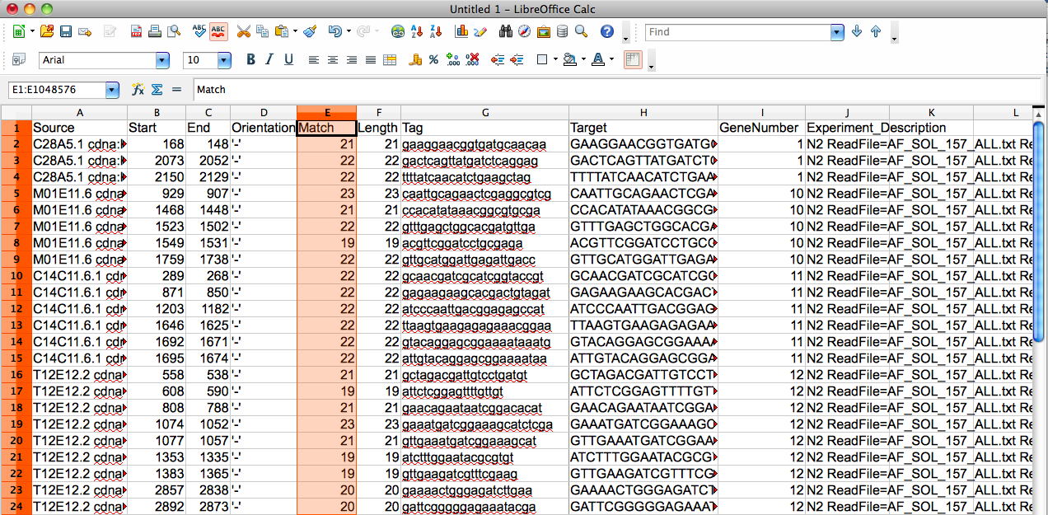
2. Pileup : A very simple graphic format that conveys the individual matches. Only useful for relatively short target sequences (tens of kilobases). Opening these files in a standard text editor gives a nice chance to browse through the sequences and alignments. For reference files with multiple sequences, a single pileup file with sequences one-on-top-of-another will be produced
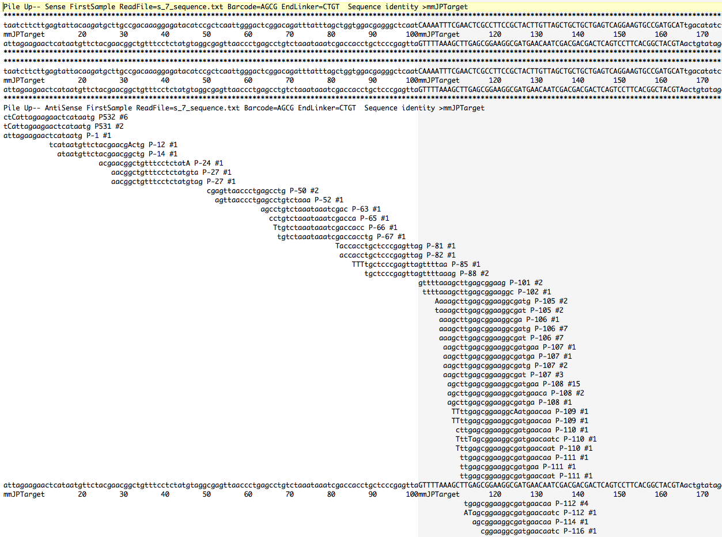
Full Tabular Output: Rows can be genes, bins of an arbitrary size, individual bases, the whole sequence at once, or a combination of several of these. Columns can be names, positions in the sequence, lengths, sequences, numbers of start and end sequences, information about base composition, information about mismatches, and a few other goodies.

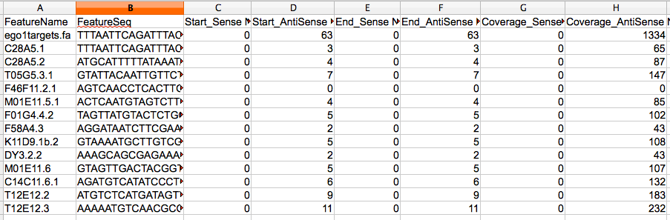

Revision History Starting 03/12:
New in version DA (03/12): Simple output can now be saved as 'psl' or 'bed' files. Also you can save time with a "reference index" for moderately large target datasets such as whole exomes or invertebrate whole genomes. HQAlign now works with Python 2.xx or 3.xx.
1/14
Inputs can now be gzipped files (fastq or fasta). Also sra files are taken as long as the fast-q dump can be located. Startbarcode can now be used to specify a set of bases to be simply removed from the 5; end of the read, using a set of N's. So if startbarcode is specified and is given as NNNNNN, the first six nucleotides in each read will be ignored.
Don't forget that a very fast way to run the program is using pypy, which precompiles Python. To do this, you will need to use HQALignDRSafe, which avoids many user interface features, also you'll need to save your instruction sheet in a file called HQAlign.txt in the same folder as that script. Under these conditions, running pypy HQAlignDRSafe.py from the terminal will do it's thing marvelously.
11/18
Fixed issues with reading Excel spreadsheets, compatibility with various python versions

