**Request for PS 7-Day Data Feed/ C. Maxwell 5-6-22**

PSOG is seeking to attain a new forecast data feed which includes data as portrayed below (for 670+ identified stations), using the NFDRSv4 Y model to replace the NFDRSv3 G model. This capability is requested by 5/31, per previous discussions between Chuck Maxwell and Matt Jolly.

**Example of current G-basis PS 7-Day OPS data feed from WFAS (one of many stations similarly formatted)….** (<https://www.wfas.net/nfdr/output/ndfd_predserv_fcst.txt>)

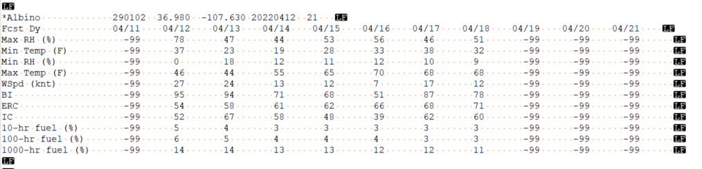

**For updated version (HAVE TO HAVE):**

* Y-model basis, otherwise same exact format and content as above
* All elements are from forecast daily RS NFDRS records
  + Max/Min RH and Temp apply to the prior 24-hour period (roughly 1300-1300)
  + **NICE TO HAVE**: Max/Min RH and Temp snapped to midnight-midnight

**Info below shows how data could be drawn from WIMS XML, with coding for a data file being produced using WIMS XML at 11 pm on April 23rd…**

Columns 2-8 (Day 1 > Day 7 NFDRS and point wx forecasts): **HAVE TO HAVE**

* NFDRS><https://famprod.nwcg.gov/wims/xsql/nfdrs.xsql?stn=290401&type=F&priority=&fmodel=16Y&sort=asc&ndays=7>
* WX>[https://famprod.nwcg.gov/wims/xsql/pfcst.xsql?stn=290401&type=F&start=**24-Apr-22**&ndays=7](https://famprod.nwcg.gov/wims/xsql/pfcst.xsql?stn=290401&type=F&start=24-Apr-22&ndays=7) (Bold would need to be based on system date relative, <+1> 4/24/22 in this example)

Column 1 (Yesterday – Day 0): **NICE TO HAVE**

* NFDRS><https://famprod.nwcg.gov/wims/xsql/nfdrs.xsql?stn=290401&type=N&priority=&fmodel=16Y&ndays=1>
* WX><https://famprod.nwcg.gov/wims/xsql/obs.xsql?stn=290401&type=O&ndays=1>

Note: If using WIMS XML, might need to use &priority= to get “the right Y model entry in the station catalog”.