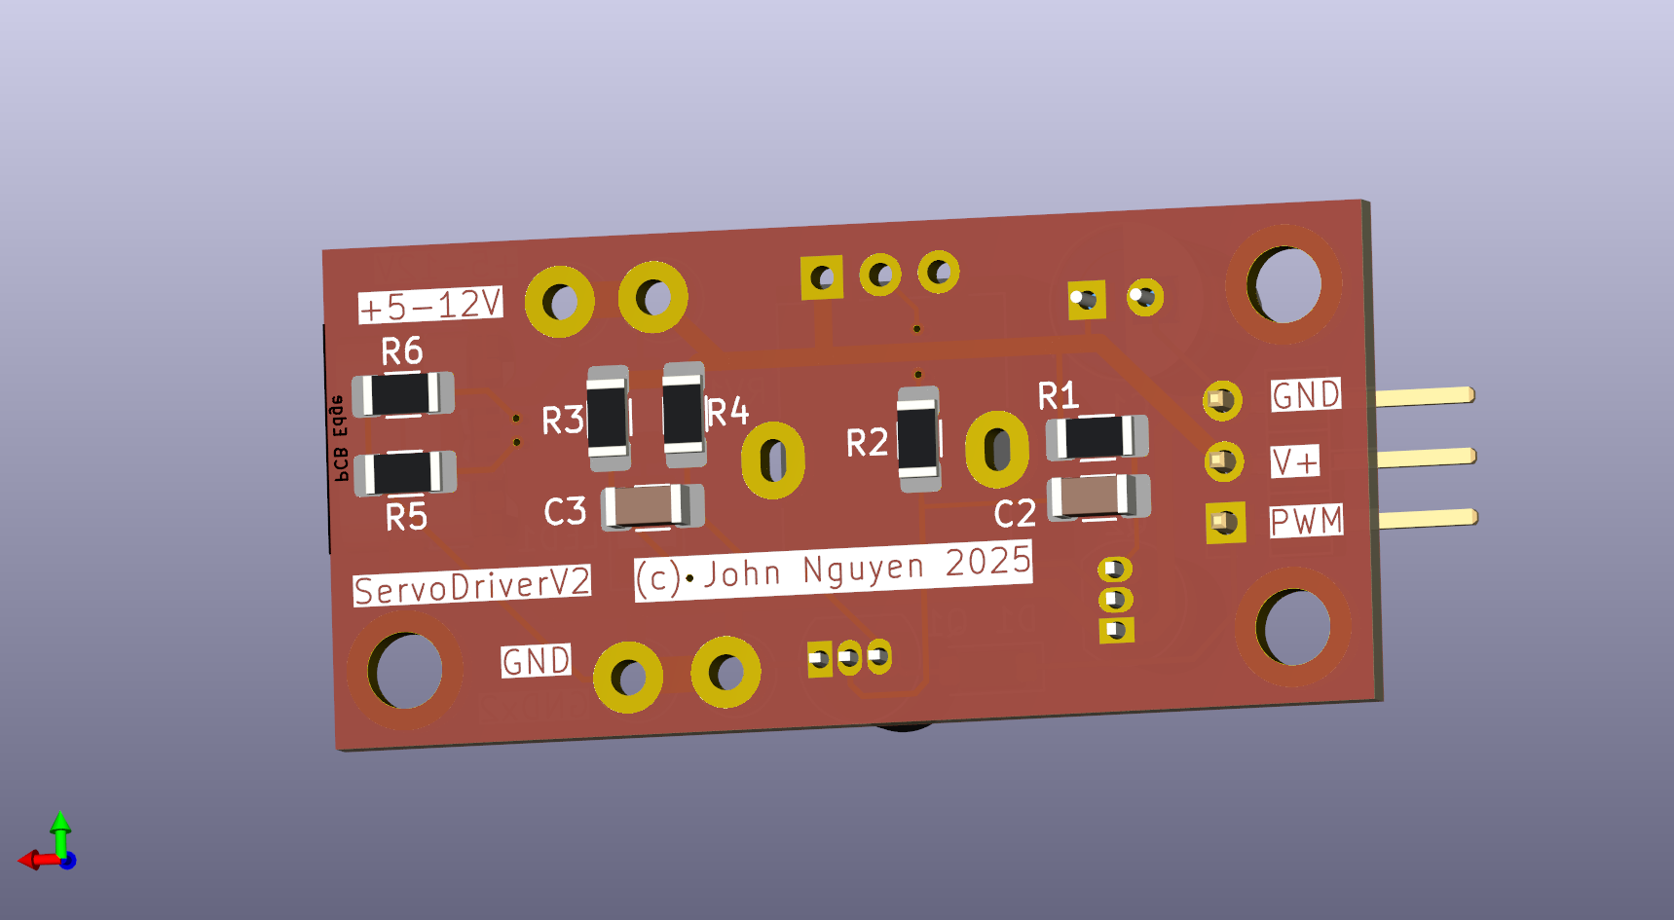
Servo Driver V2 Datasheet & Design Report
(c) John Nguyen 2025

Updated 1 May 2025

Summary
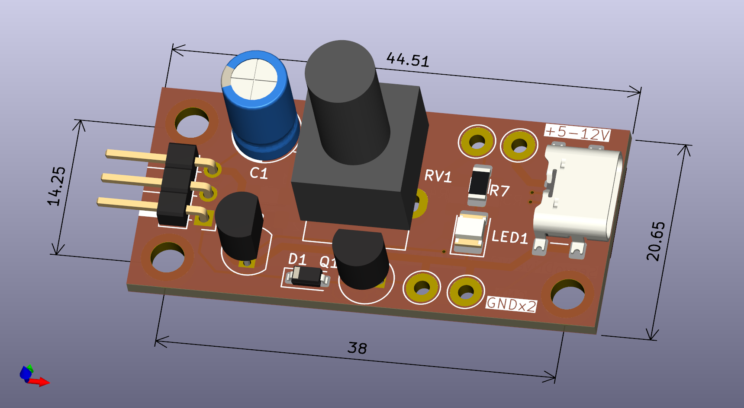
This is a low-cost driver board for standard servos accepting the 1-2ms PWM standard. It uses an adjustable square wave generator to produce the control signal. To reduce cost, the square wave generator uses discrete BJTs in an astable multivibrator configuration.
Power is supplied either through a standard USB-C Power Delivery port, or either of 2 pairs of through-hole test points. The through-hole test points are intended to carry significantly more current than the USB-C port, to allow multiple servo drivers to be chained together in series without overloading the bus. However, it is recommended to split the daisy-chain into multiple branches to limit the current through any individual driver.

Absolute Maximum Values
Property | Condition | Value
Supply Voltage |  | 5-12V DC
Maximum Continuous Bus Current (between test point vias) | 10 C rise  20 C rise | 3.0 A  4.0 A
Maximum Instantaneous Bus Current |  | 10.0 A
Maximum Continuous Servo Current | 10 C rise  20 C rise | 1.5 A  2.0 A
Maximum Instantaneous Servo Current |  | 5.0 A
Board Temperature |  | 0 °F / -18 °C (min)  120 °F / 49 °C (max)
Maximum Power Dissipation | 5 V | 400 mW (signal)

Operating Conditions
Property | Condition | Value
Typical LED Current | 5V  12V | 3 mA  10 mA
Typical LED Power Dissipation | 5V  12V | 15 mW  120 mW
Typical Signal Generator Current | 5V  12V | 8 mA  20 mA
Typical Signal Generator Power Dissipation | 5V  12V | 40 mW  240 mW
Output PWM Pulse Width |  | 1 ms (min)  2.5 ms (max)
Typical PWM Frequency |  | 40 Hz (min)  70 Hz (max)
PWM Output Impedance |  | 1 kΩ
PWM Output Capacitance |  | 0.47 μF

Power Bus Properties
Property | Condition | Value
Vcc-Vcc Test Point Resistance |  | 1.2 mΩ
Vcc-Vcc Test Point Power Dissipation | 1 A  3 A  4 A | 1.2 mW  11 mW  20mW
GND-GND Test Point Resistance |  | 1.2 mΩ
GND-GND Test Point Power Dissipation | 1 A  3 A  4 A | 1.2 mW  11 mW  20mW
Servo GND Bus Resistance |  | 20 mΩ
Servo GND Bus Power Dissipation | 500 mA  1 A  1.5 A  2 A | 5 mW  20 mW  45 mW  80 mW
Servo V+ Bus Resistance |  | 21 mΩ
Servo V+ Bus Power Dissipation | 500 mA  1 A  1.5 A  2 A | 6 mW  21 mW  48 mW  84 mW

Physical Board Dimensions
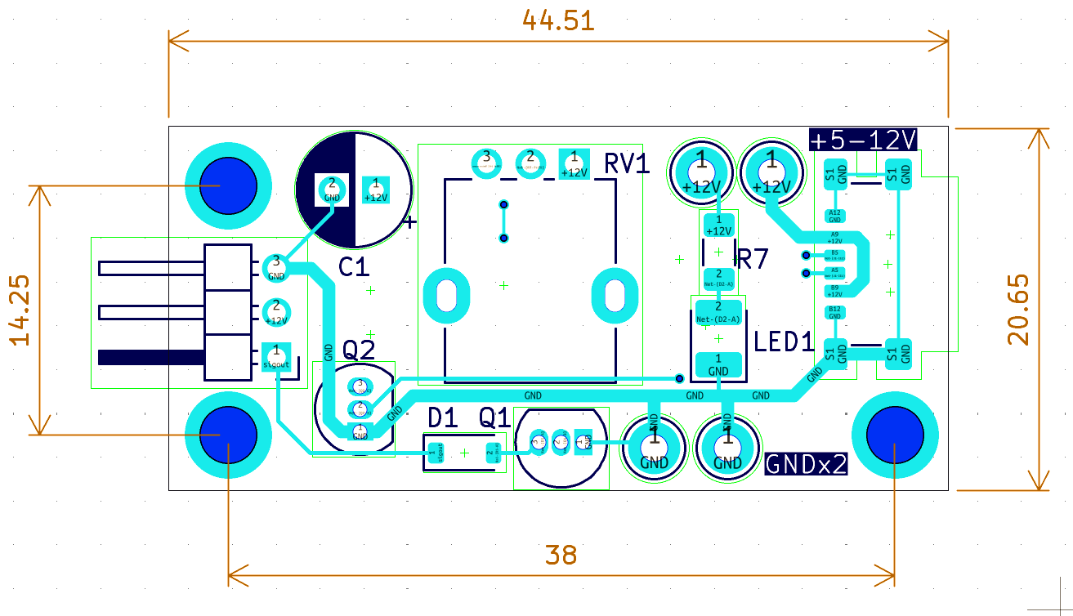

Board Area | 1.435 in²  925 mm²
Width | 0.813 in  20.65 mm
Length | 1.7524 in  44.51 mm
Mounting hole size | #4 (loose)  M3 (standard)

Bill of Materials
Component Type | Value | Qty
1206 Capacitor | 0.47uF | 2
¼” Electrolytic Capacitor | 33uF | 1
SOD-123 Diode | 1N4007 | 1
1210 LED | Yellow-green 20mA | 1
USB-C Female Connector | SMD 6-pin | 1
Header Pins | Right angle 3x horizontal | 1
TO-92 BJT | 2N3904 NPN | 2
1206 Resistor | 1K | 3
“” | 510 | 1
“” | 20K | 1
“” | 5.1K | 2
Potentiometer | RV09 Vertical 1K | 1

Circuit Diagram
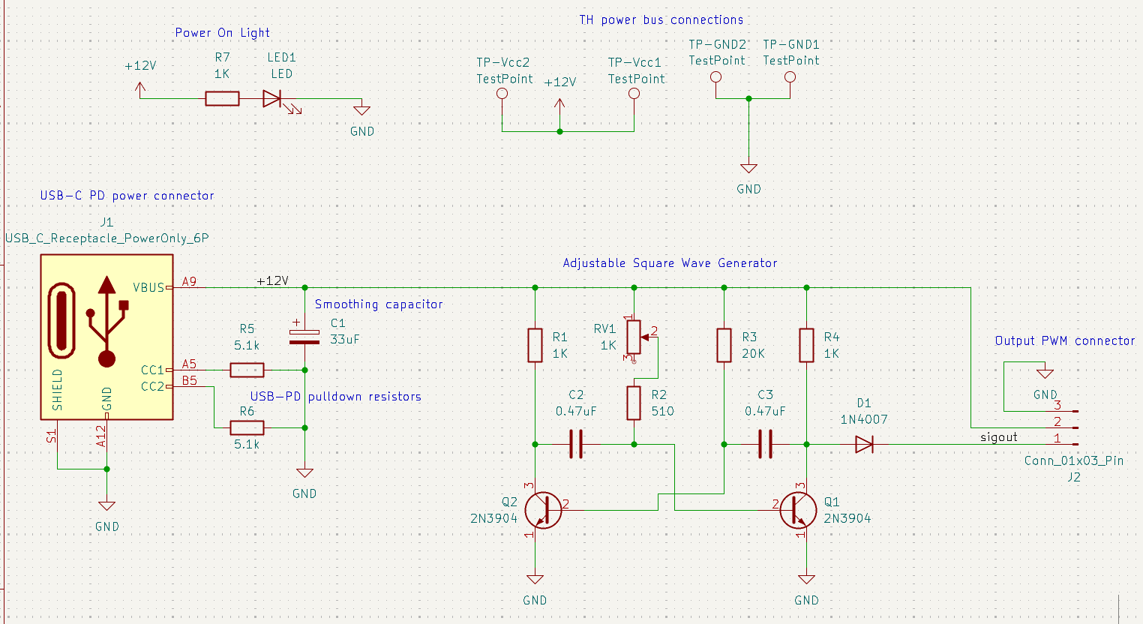
Power Supply
On the left we have the USB-C power delivery connector. The two 5.1k resistors tied to ground are the USB-Power Delivery pulldown resistors, which signal compatible USB devices to send power through more pins and provide up to 5A of current.
C1 is the smoothing capacitor, which takes the ripples out of poor quality power supplies and stabilizes the oscillator.
On the top right we have the 2 pairs of power and ground pins, which are in reality the through-hole test points you find on the board near the USB connector. These provide an easy way to solder up to 18 AWG wire directly to the board, providing a clean, low resistance, mechanically robust connection.
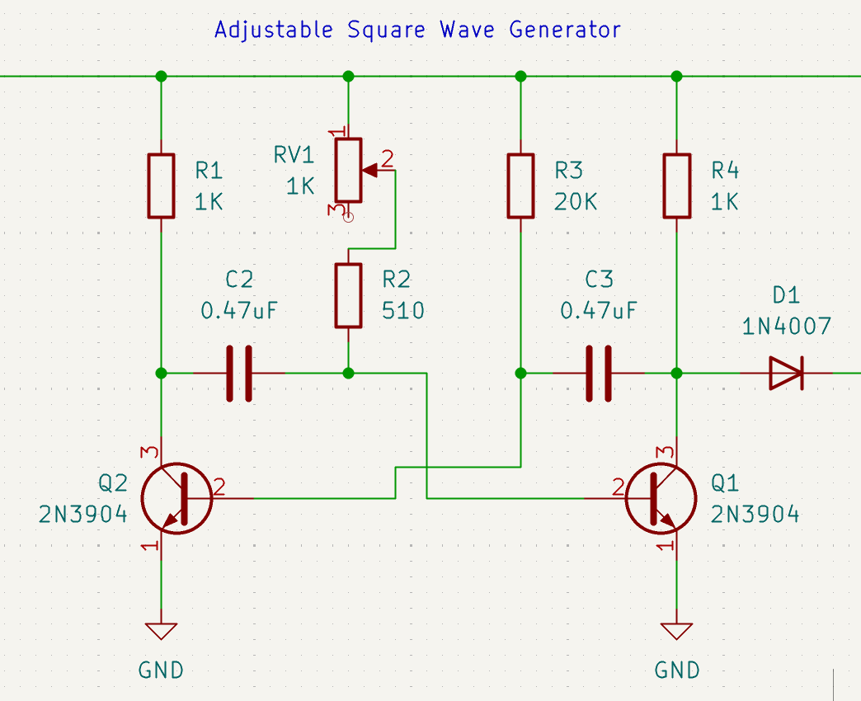
Signal Generator
The next section from R1 to Q1 is the astable multivibrator circuit. The network of resistors and capacitors connected to the two NPN transistors (Q1 and Q2) create a square wave generator.
The on-time of each side of the circuit is equal to R*C*pi. (though note that the output, taken from Q1 collector, actually sees the on-time of the opposite side of the circuit. When Q1 is active, its collector is pulled down to 0.7V).
As such, the off-time of the output signal is controlled by R3 and C3, which at 20K and 0.47μF is about 30 ms.
The on time of the output signal is variable, controlled by the potentiometer. As such the time constant is controlled by (RV1+R2) and C2. The minimum pulse width (RV1 ~~ 0) is given by R2*C2*pi, which is 0.75 ms, corresponding to just below one end of the R/C standard pulse width of 1-2ms. The maximum pulse width (RV1+R2)*C2*pi = 2.23 ms, just above the other end of the R/C standard pulse width. This puts the output of the oscillator in a comfortable range around the standard.

