

**INDIAN INSTITUTE OF TECHNOLOGY INDORE**

**LEAVE APPLICATION**

**PROCESSING**

USER MANUAL

**TEAM MEMBERS**

**NITISH KUMAR RAJ**

**ADITYA JAIN**

**GANESH RAJ KAILASH**

## COURSE DETAILS

**CS­258**

**SOFTWARE ENGINEERING**

**PROJECT GUIDE**

**DR. ABHISHEK SRIVASTAVA**

*ASSISTANT PROFESSOR AND*

*DEAN OF STUDENT AFFAIRS(DOSA)*

**Table of Contents**

1. Introduction…………………………………………….. 2

2. General Description……………………………………… 2

3. Specific Requirements………………………………… 3

4. Instructions……………………………………………… 3

5. Troubleshooting………………………………………….15

# 1. Introduction

This document is meant to serve as a user manual for the “Leave Application Processing” website for the IITI community in order to transform the leave application process completely online and paper­ free to a large extent.​The web portal is developed in order to make applying for leave at IIT Indore an easy and convenient process.

In this document, we try to explain the various functionalities the users can make use of and hence, benefit from this new system of leave application.

We aim to transform the existing system into a completely automated and online one and hence making it more efficient.

All staff members in the campus will have their accounts on the website. So a person who wishes to take a leave can apply for it by filling in and submitting the particular leave form, which is then forwarded to the necessary authorities. This eliminates the extra time required for logistics.

# 2. General Description

The product provides an easy platform for the user to apply for any type of leave easily. The users will be provided with login credentials, i.e., their username and password, by the system admin. The users are, then, required to sign into their accounts. They will have facilities to change/reset their password. The user will be able to view his/her own account and can review the number of leaves he/she has taken and the leave balance remaining for each leave category.

On applying for leave, via the leave application forms, the applications will be sent to special users known as the ​*Recommending Authority*​ and then the ​*Approving Authority.* ​The recommending authority can either suggest changes to the application and send it back to the applicant or can forward to the approving authority with their comments and recommendations. Once the application reaches the approving authority, they can either approve or reject it.

Users be required to fill in a joining application on returning from leave. The leave balance of the user will be updated accordingly.

## USER CLASSIFICATION

* **GENERAL USERS (THE APPLICANTS)**​: This category consists of all the people in IITI who can apply for leave (this is a super set that also includes all the classes below).

* **RECOMMENDING AUTHORITY**​: This category consists of people who

can be referred to by applicants for recommendation on the leave application.

* **APPROVING AUTHORITY**​: This category consists of people who will receive the leave application and can either approve or reject the same.

* **ADMINISTRATOR**:​ The administrator will manage the database, taking frequent backups, and manage all the leave balances. He would be required to keep the application up to date.

# 3. Specific Requirements

The user requires any browser with HTML5 capability (Internet Explorer 7 or equivalent or above) in order to use this product.

# 4. Instructions for user other then admin

### I. Logging into your account

The user can login using the username and password provided by the system admin. These login credentials are supposed to be entered at the login screen of the website , whichever the user deems fit for use.

*The website login page*

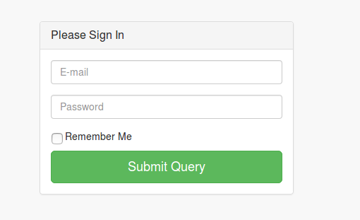

### II. Applying for leave

The user can apply for leave by clicking on the blue menu button provided at the bottom­right corner of the website. The user has to choose the type of leave and fill up the details of the leave application according to his/her specific requirements.

***Application form***

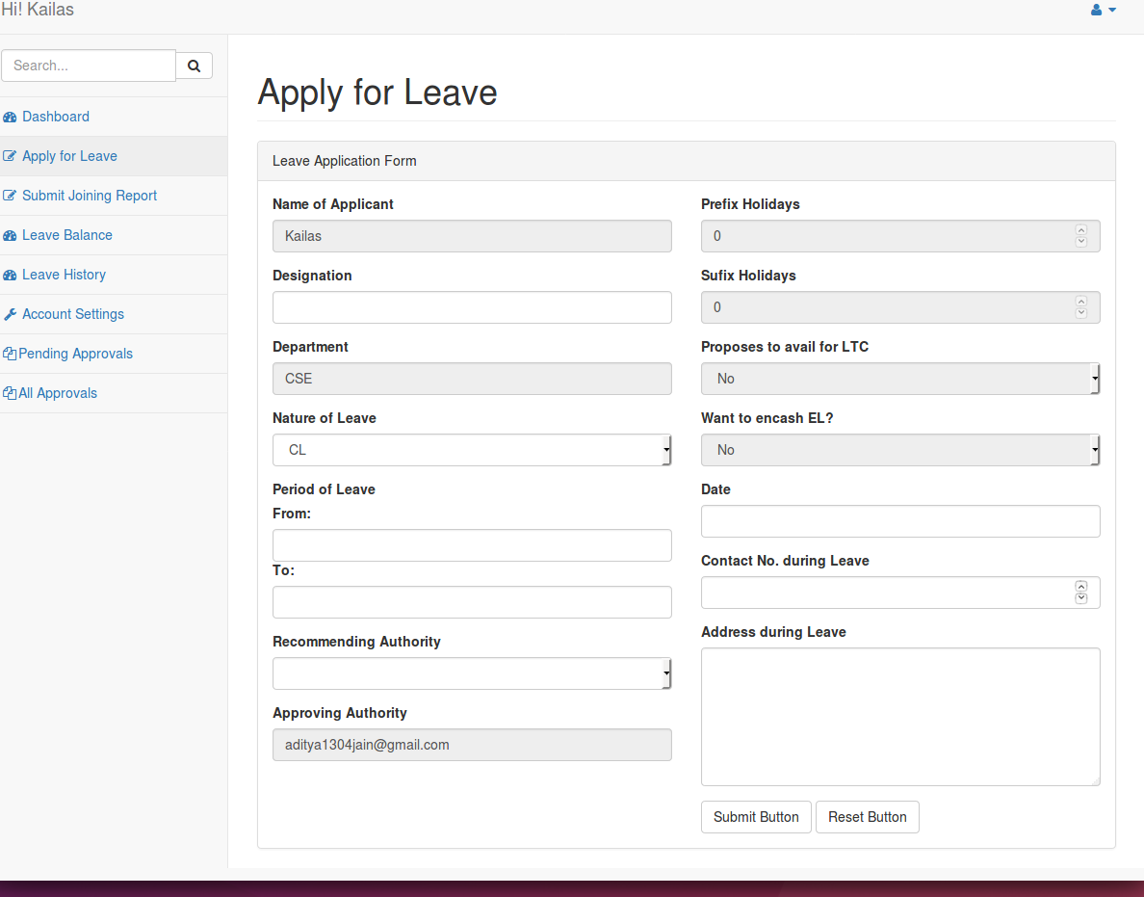

*Application form for OCL (Other than Casual Leave)*

*on the website.*

### III. Submit Joining Report

The user can submit joining report when they completed their respective leave

By clicking on (Submit Joining Report) icon which is shown below

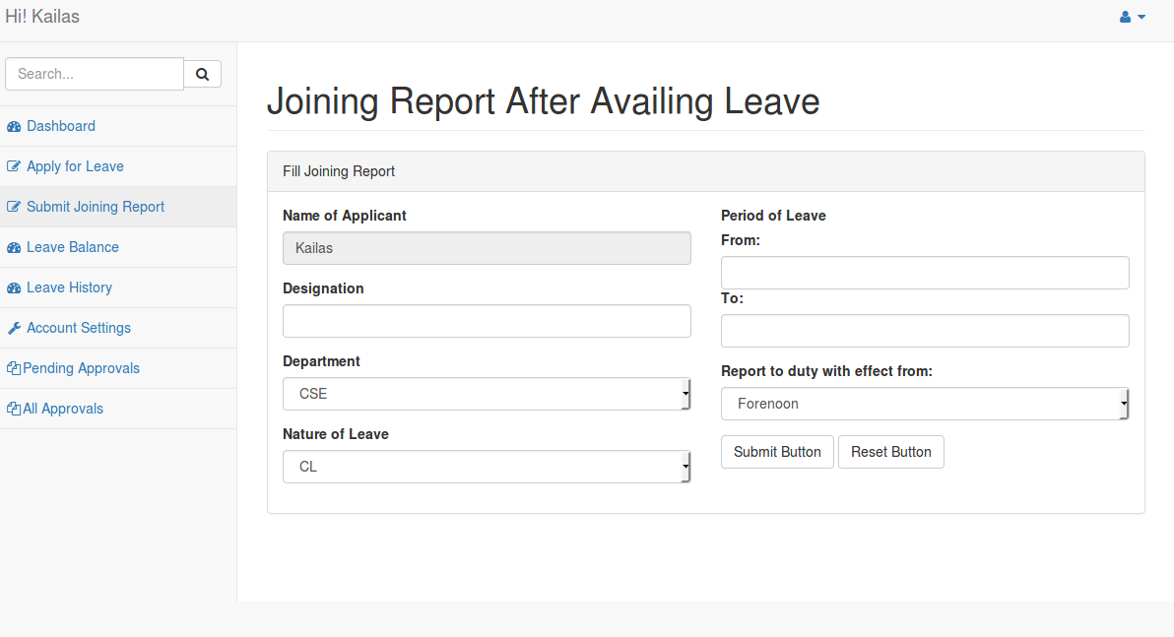

### IV. Leave Balance

User can check its leave balance by clicking on leave balance icon on its home page which is shown in figure below.

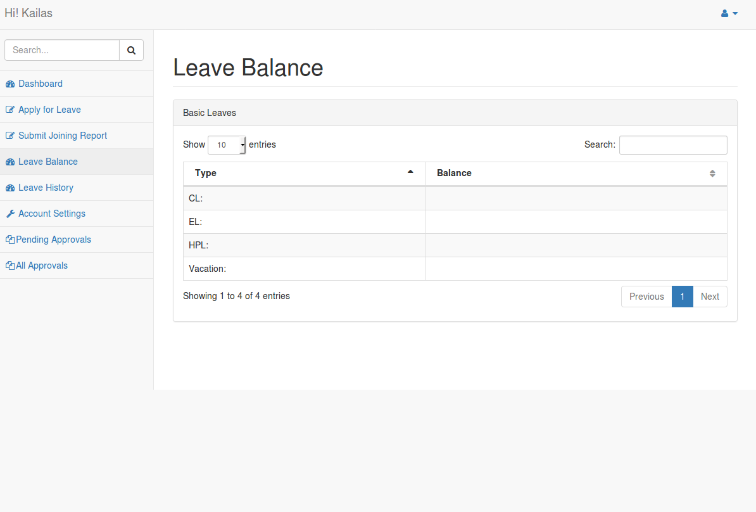

### V. Leave History

User can check its leave history by clicking on (leave history) icon .In

this user can see their application that he/she applied for leave by

clicking on Application id which is shown in figure which is given below.

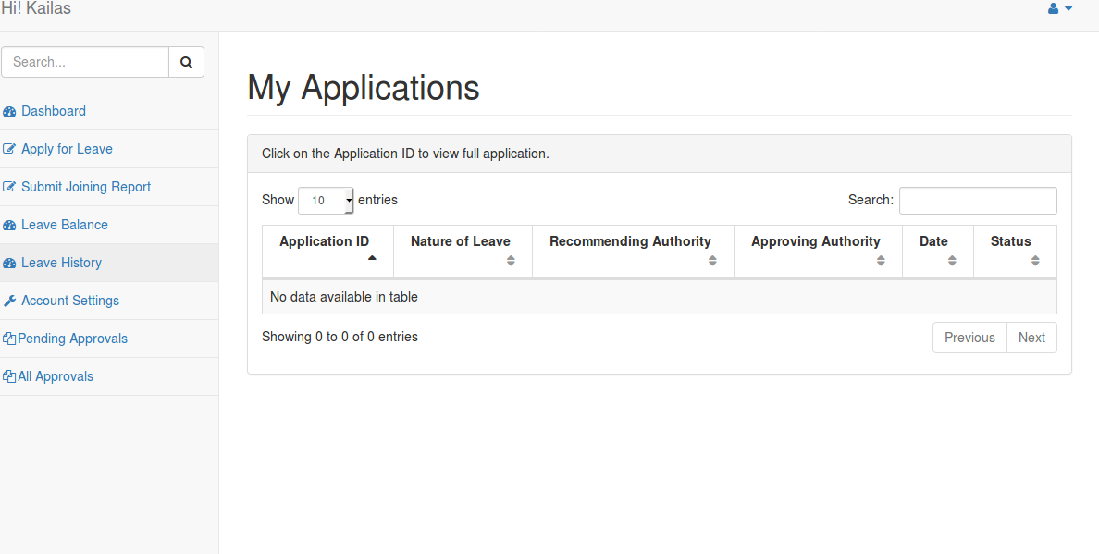

### VI. Account Setting

* CHANGE PASSWORD

The user can change their password whenever they need

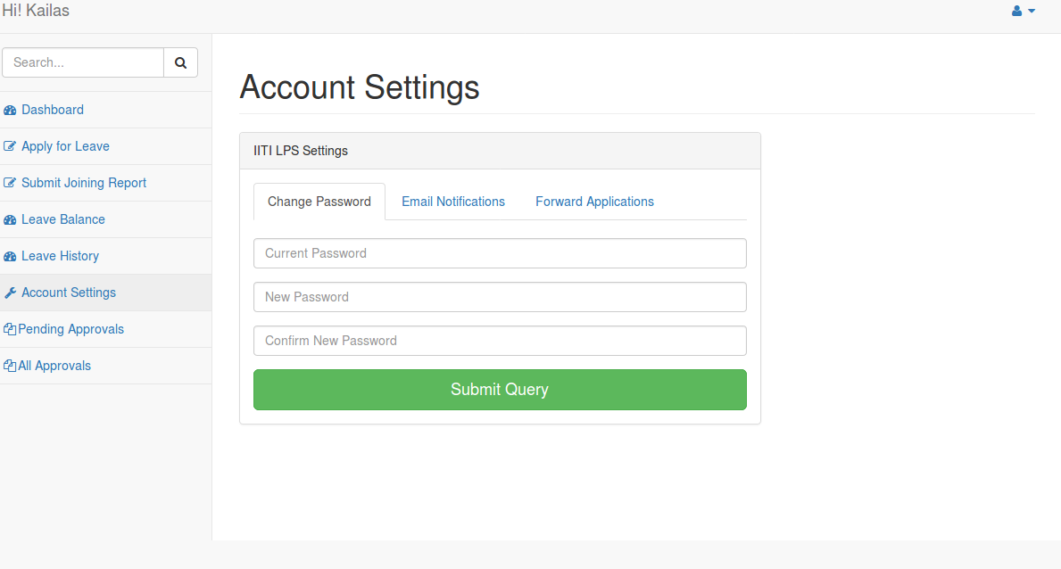

* Email Notification

User can enable or disable notification if he/she disable notification then they will not receive any

notifiction in their respective mail id and if he/she enable notification then they will receive all

notifiction in their respective mail id.by default notification will be enable.

Shown in figure

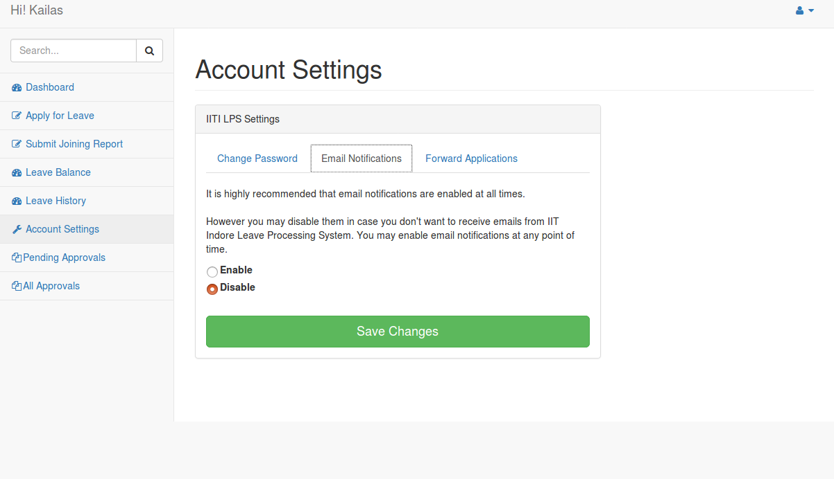

* Forward Application

User can forward the application being sent for approval from you to another approving authority

By selecting their name .

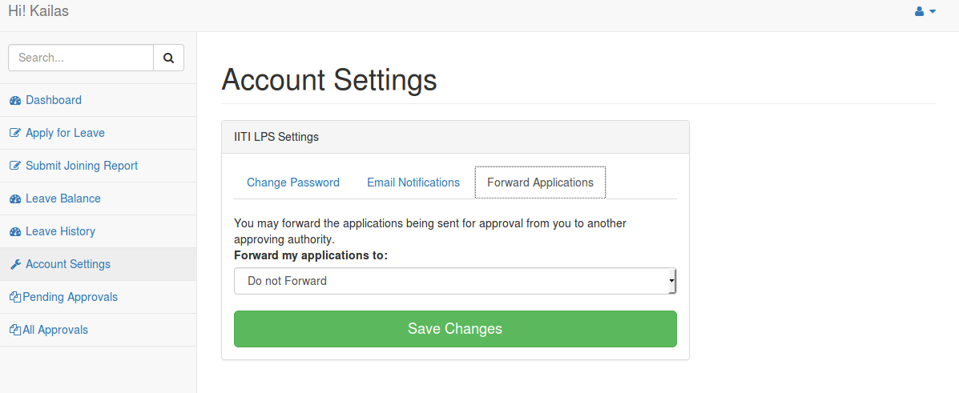

### VII. Pending Approvals

User can check status of applied application is approved or not .by clicking on

Pending approvals menu.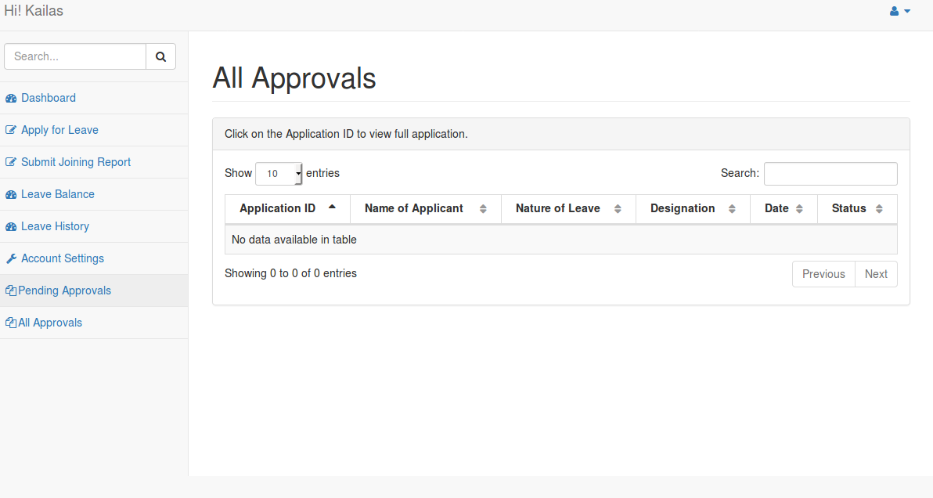

### VIII. LOGGING OUT

The user can easily log out of the application using the Logout option given on the website dropdown.

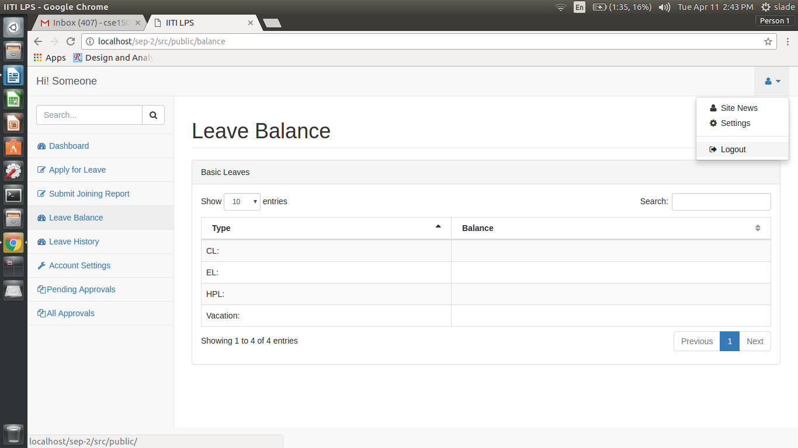

*Logout option, as displayed on the website.*

## **5. ADMINISTRATOR FEATURES**

The below features are exclusive only to the adiministrator along with the features of a general user.

**Viewing the list of all users and their details**

The admin can view the list of all users by clicking the All users button on the left sidebar.

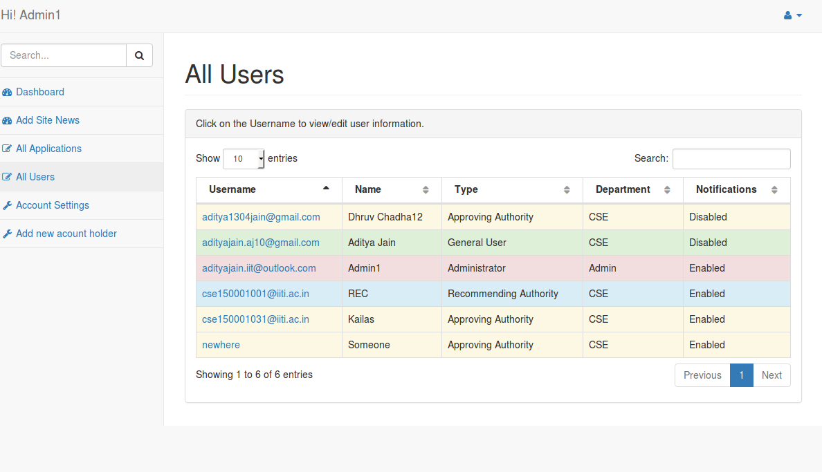

**Change login password**

The admin can change his/her account login password by clicking the account settings button from the left sidebar and then choosing the change password tab and then filling old and new passwords in respective bars.

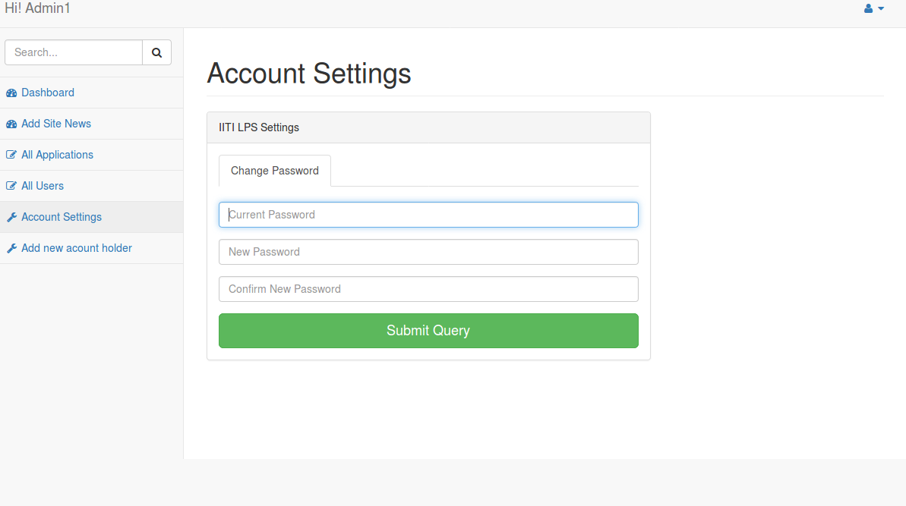

**Add new user**

The admin can add a new user by clicking on the Add new account holder button from the left sidebar and then filling the details of the new user to be added.

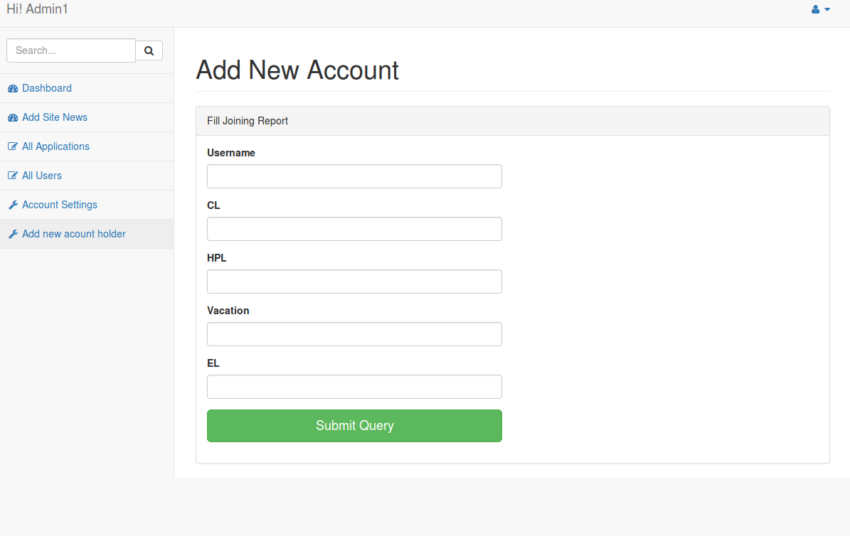

## 5. Troubleshooting

In case of any issues with the website, the user must contact the admin for assistance.