

**Student ID:** 2520796

**Course Lecturer:** Prof Carron Shankland

**Subject:** CSCU9N5 – Multimedia and HCI

**Word Count:** 5401

**Main HTML file:** logo.html

**Recommended browser:** Google Chrome

**Recommended Resolution:** 1920x1080

Content

1 Product Description: 3

2 Design: 4

2.1 Task Analysis: How to Sign Up 6

2.2 Storyboards 7

2.3 Differences Between the Storyboard and Prototype 23

3 Prototype Description 24

4 Usability Testing: 27

4.1 Security Testing (Not in current prototype) 31

4.2 Functional Testing (Not in current prototype) 32

4.3 Database Testing (Not in current prototype) 32

5 References 34

**List of Tables**

Table 1: Benefits and Gains 3

Table 2: User Personas 4

**List of Figures**

Figure 1 - Navigation Map 8

Figure 2- Storyboard Homepage 25

Figure 3- Prototype Homepage 25

# **Product Description:**

CS Academy is a free website that is accessible to everyone, no matter the age or the gender, and its purpose is to introduce people to Computer Science. It is mostly targeted to primary and secondary educated individuals with a keen interest on the digital world. Computer skills or background experience into Computing Science are not necessary as it gives people the opportunity to learn from scratch how multimedia and coding works, with a fun, animated and interactive way. It gives the user a variety of games and animations to play with whilst under some sections there are specific pages that allows the user to create his/her own animation either by hard coding on the Online Live Editor with HTML, CSS and JavaScript or with the Animator Editor, which is a template, and the user can draw pixels on the grid and make them move frame by frame with the control buttons. Moreover, in order to meet the client and user’s needs, CS Academy incorporates all the appropriate learning standards, such as, simple language and different level of tasks to make the best possible understanding. The website provides the user easy access to certain parts of the website by adding hyperlinks, pictures titles, colorful and easy navigation bar. Thus, the website’s aim is to be eye-catching, colorful, recognizable, and simple to navigate everywhere while at the same time to help the user learn to think creatively, reason systematically, and work collaboratively which there are essential skills for life in the 21st century.

Focusing on the users, Tables 1 and 2 show the benefits and gains and the user personas.

***Table 1: Benefits and Gains***

|  |  |  |  |  |
| --- | --- | --- | --- | --- |
| Users / Participants | Major Benefits | Attitudes | Win Conditions | Constraints |
| Students / Young People | Able to gain quality educations at home | Strongly Supportive | Usability, efficiency, performance | System should be easy to use and operate |
| Developer | Earn revenue by reaching more users | Strongly Supportive | Usability, extensibility and reliability | System should be made extensible for future purpose |

**Table 2: User Personas**

|  |  |  |  |  |  |
| --- | --- | --- | --- | --- | --- |
| Name | Age | Gender | Education | Computer Experience | How they will use the site |
| John | 20 | Male | University Student | Yes | Gain ideas about a possible project |
| Anna | 13 | Female | Student | No | Play with a fun and interactive way and learn at the same time |
| Marios | 15 | Male | Student | Yes | Expand his knowledge about computer science and getting introduced to coding |
| Joanna | 35 | Female | N/A | No | Fun way to spend time with her children and learn as the same time |

# **Design:**

**Level of Security:** The website uses / needs encryption and an implementation of the General Data Protection Regulation (GDPR) for when the user inserts their data to log in as well as the Payment Card Industry Data Security Standard (PCI DSS) for when the user is about to pay for anything in the website. Likewise, in general, the website has / needs a strong password, so no one can access the website in editor mode and delete or copy any details. Therefore, for the security reason, it needs to be used a long password with capital letters and numbers to make it more secure and hard for the hackers or anyone to crack.

**Images/Animations:** To meet the user needs, the underlying website shall be basic and very simple to use. Different elements of interactivity shall be added. This will make the website easier for the users to use as they will be able to find information easier. In addition, images next to the written content that relates to the content will be included. For example, when talking about each section, I will include a picture next to the content. However, if I could enable users to customize my website to their needs, then, I would only allow them to change the layout and or the background of the website in order to suit the client needs.

**Support:** Users often have questions or concerns about the website. So, a support page is also added in the blue prints of the designing plan. In the support page, the customers can talk to us through the chat, or can call us right away. However, the website provides contact information, an email address, so customers can email us with any questions using the Quick Contact that uses SMTP Client technology that sends an automatic email back to the user to confirm that we got the email. By doing this, the website will increase customers’ satisfaction by providing better service.

**Complexity of the Site:** The website is easy and simple to use with the tabs, buttons and navigation bar that link to each section. These will take the users to the different sections making it easy to move around on my website and find the information searched.

**Delivery of Content**: All the content produced shall be with accordance of the appropriate learning standards to meet the needs of the user. The information will be stored on the website to allow the user to access the data and all the information on the website will be clear and simple to read.

**Accessibility:** The website will be designed to meet the accessibility guidelines which will be devised by the Royal National Institute of Blind people (RNIB). The content will be clear and easily understood. There will be different kind of features like skip navigation links to help both the reader and the keyboard users. The underlying website will create skip navigation links which will allow them to jump directly to the main contain, as well as, will provide correctly structures and well title headings. The users can change the size of text and contrast of the website or use just the keyboard instead of mouse to navigate. Furthermore, there will be text transcripts which will make the audio information more accessible for the people who are deaf or hard of hearing. Correspondingly, the website should contain an option for the user to change language.

I will make sure the website is tidy, professional, and simple to convey the company’s image. The navigation will be straight forward and make it easy for the visitors to find the information they are seeking with one or two clicks. The content will speak directly to the target audience giving enough information about each section. Also, each page of the website will be optimized and set up in a way that makes it easy for the search engines to capture the information. This means the website will be very easy for the users to find the information of interest. Last but not least, the website will be secure, appropriate and safe for the user so that they can easily pay for any future subscription or online course sessions.

**Forum:** A forum is included into the website blue print designing plan and it will offer the online society an open discussion for specific topics where individuals post their comments and views to the thread. This is an excellent source of relevant information that the user may need and would not be able to find elsewhere. Also, the forum will include a FAQ, Feedback and Reviews section that people can see the experience of other users.

## **Task Analysis: How to Sign Up**

* Click “Start” button from CS Academy page.
* Click the Sign-Up button from navigation bar
* Click inside “First Name:” field
* Type First Name
* Click inside “Last Name:” field
* Type Last Name
* Click inside “Email Address:” field
* Type email
* Double-check email address
* Click inside “Password:” field
* Type password
* Double-check password
* Click “Get Started” button

## **Storyboards**

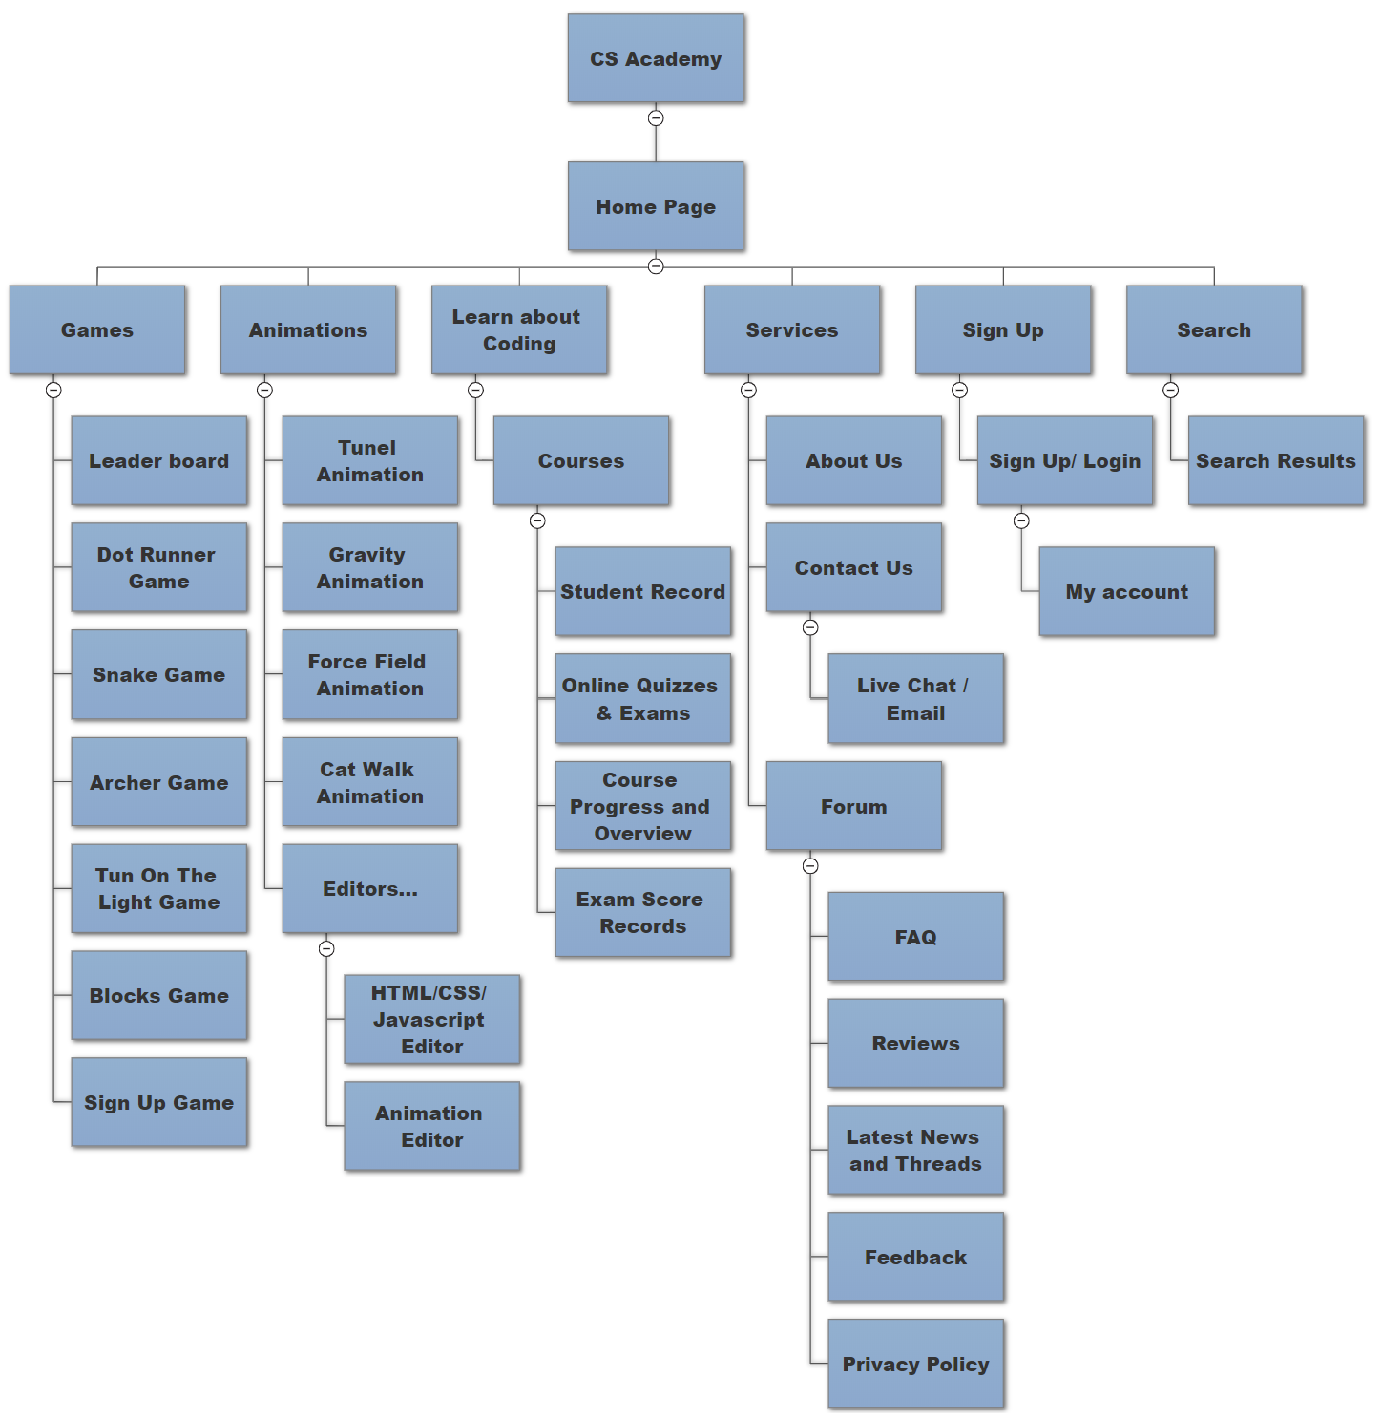

Figure 1 - Navigation Map

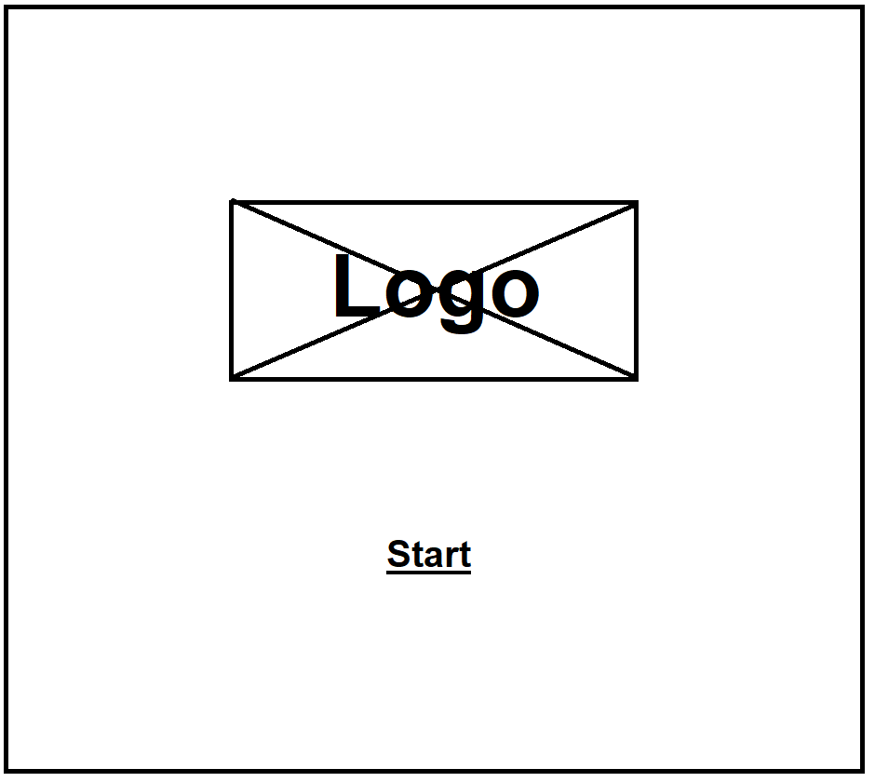

This is the very first page of the website. The user just needs to click the “Start” button to continue to the main homepage. The logo is animated and interactive based on the mouse movement.

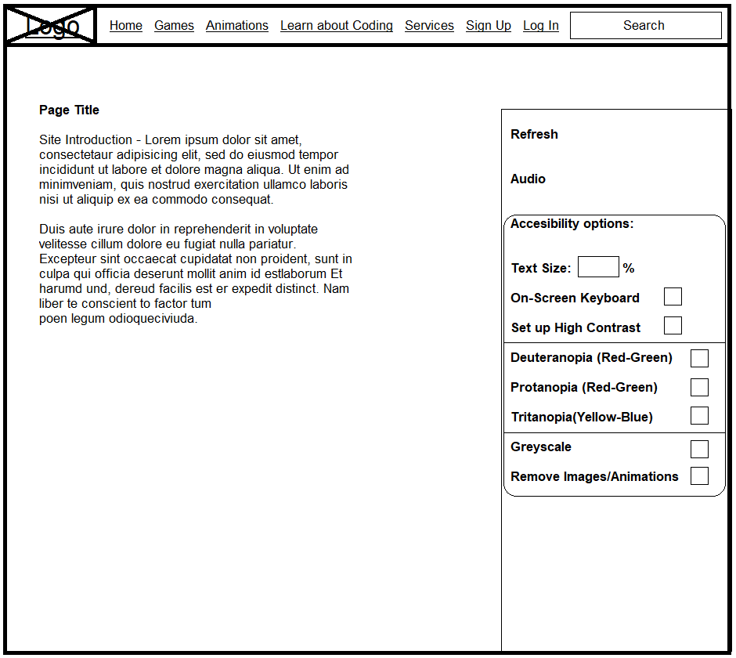

The homepages contain general information about the website. Therefore, the background is a non-interactive animation. The top navigation bar contains all the buttons for all the pages and it appears to every page, so the user can easily navigate everywhere easy and fast with just 2 or 3 clicks. However, the options from the right only appears when the user hover the mouse over it. These are some options for accessibility use.

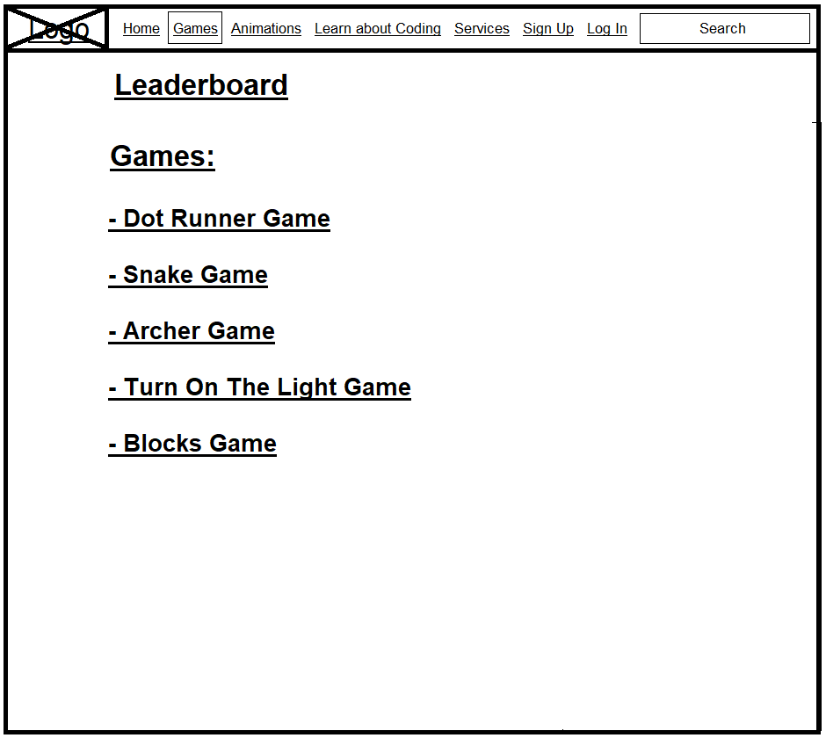

Under “Games” there are a variety of games to let the user spent his/her time playing, share their score and compete with the online community. However, we are planning soon to implement a Coding Playground so the Advanced or even the Beginner users can share their own ideas, projects, applications and games online, so the community can test and give ratings.

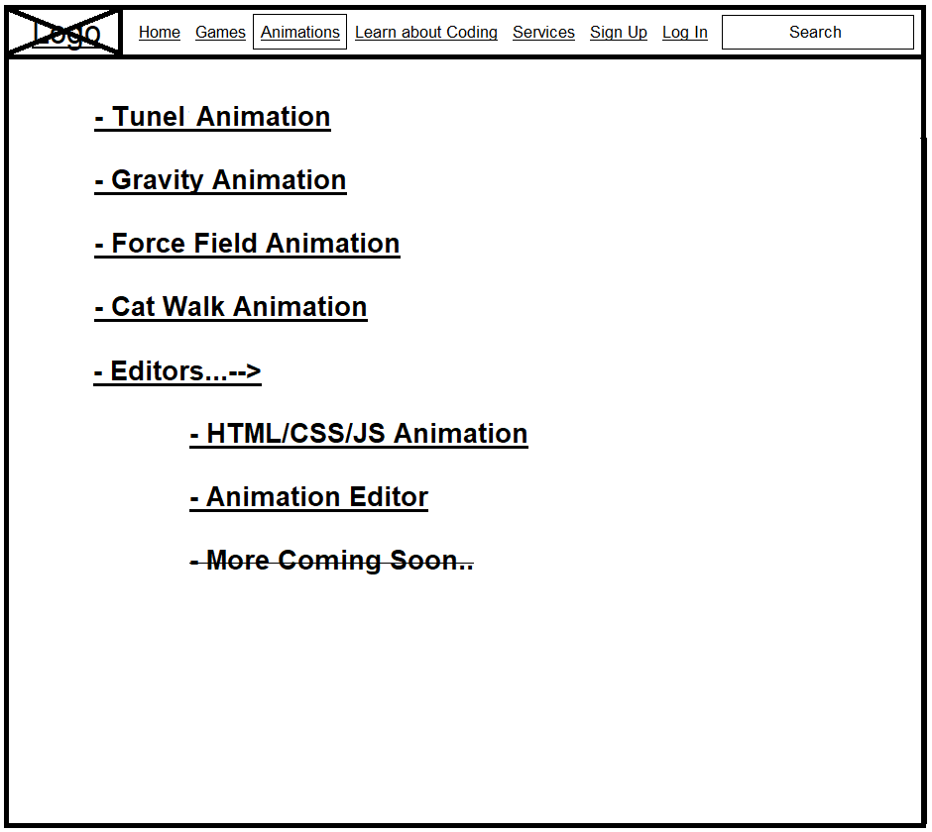

Under the “Animation” there are variety of sample animations so the user can explore and interact with. Furthermore, under the “Editors” there are 2 editors that the user can create his/her own animation either by HTML/CSS/Javascript live editor, or by drawing pixels into frames.

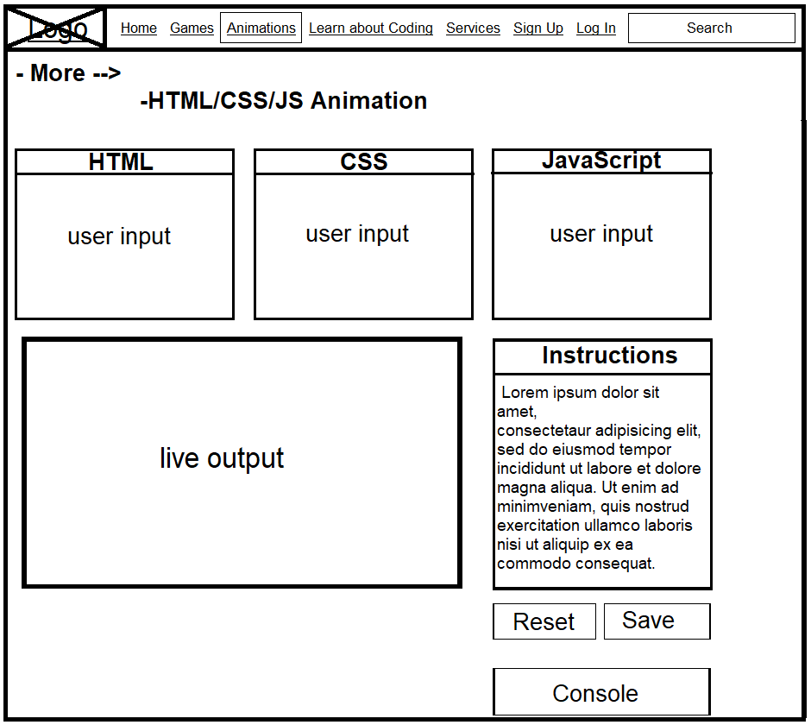

This page accommodates a live editor that the user (advanced or beginner) can create his/her own animations or even more. There are 3 input boxes for HTML, CSS, JavaScript, an Instruction label and 2 buttons. The Reset button resets all the boxes to default and the Save button downloads the HTML file created from the user. When the Save button is clicked, the content of the 3 input boxes is merged to a single HTML file.

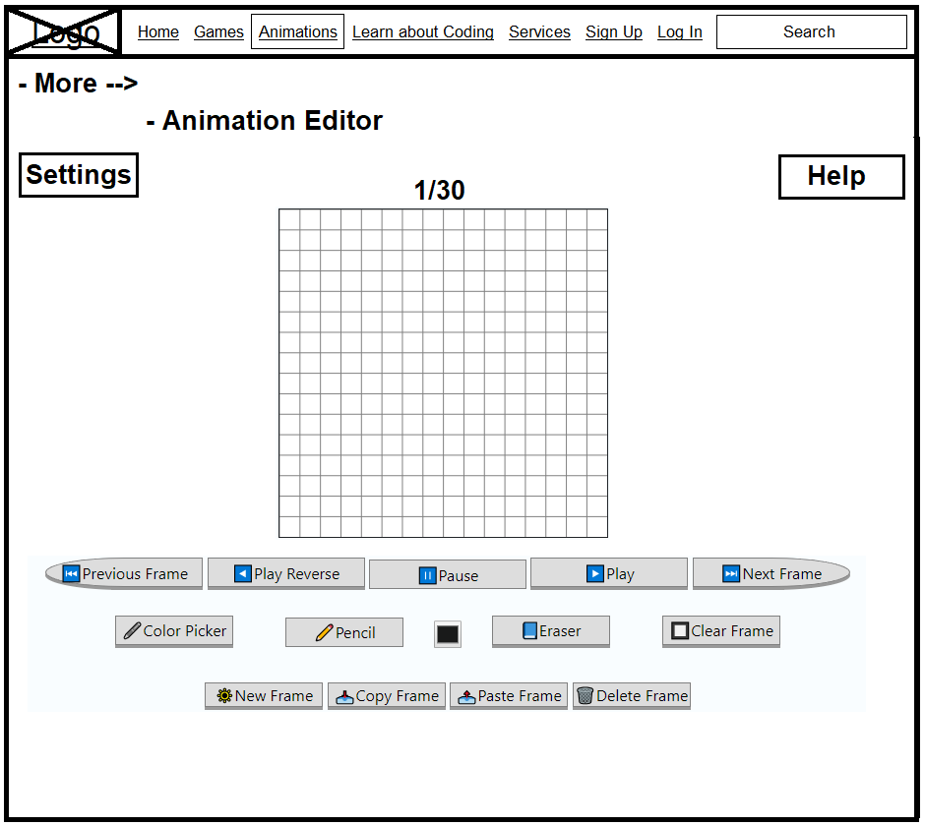

This page encompasses an Animator Editor with which the user can create animations by drawing pixels of any color on the grid, frame by frame and make them move fast enough forward or backwards through the controls.

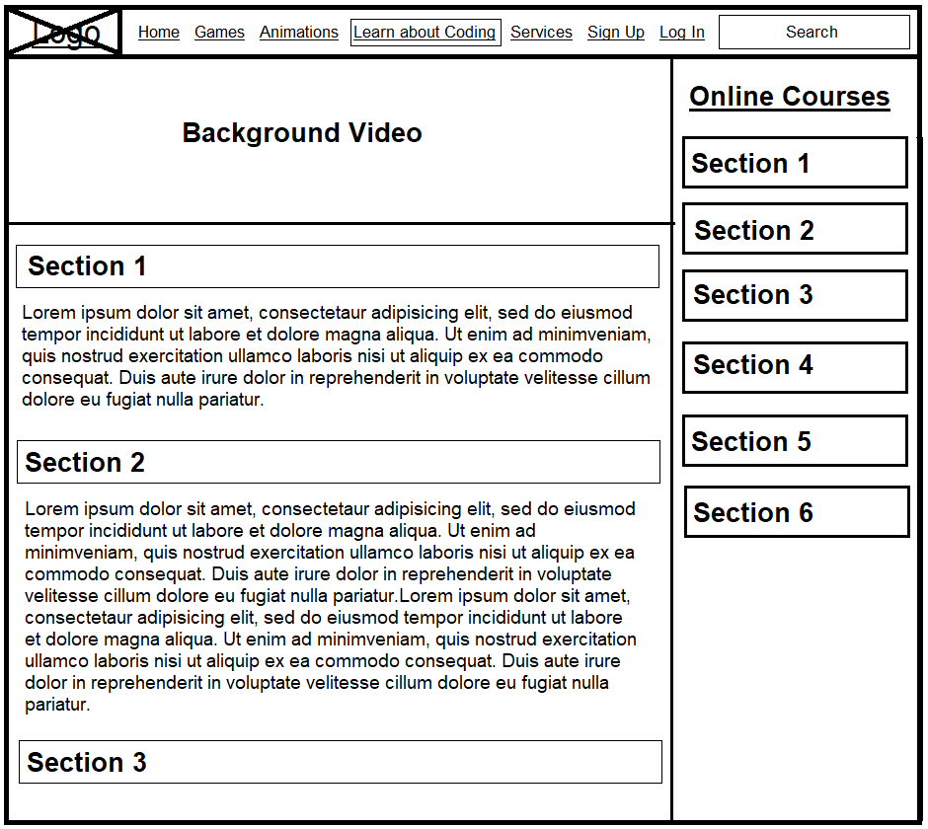

This is the theoretical part of the website. Each section holds information and answers the questions like “What is coding” “What is computing science” etc. The goal of this page is to inform the user advanced or beginner of what can be learned and how.

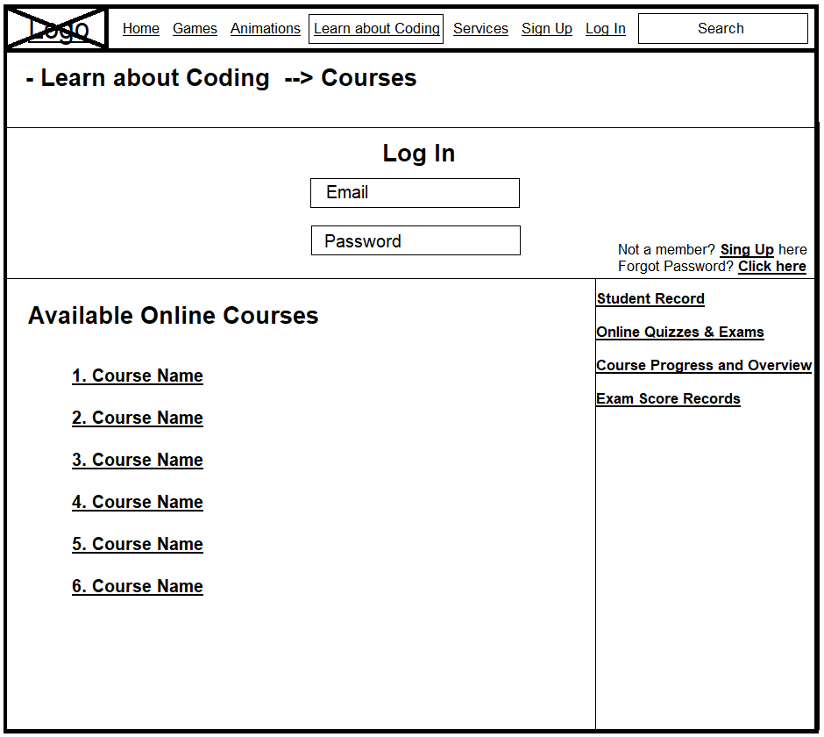

This page is not yet available in the prototype. However, there should be information and links about available courses and student account. To access this page, the user needs to Login first to continue.

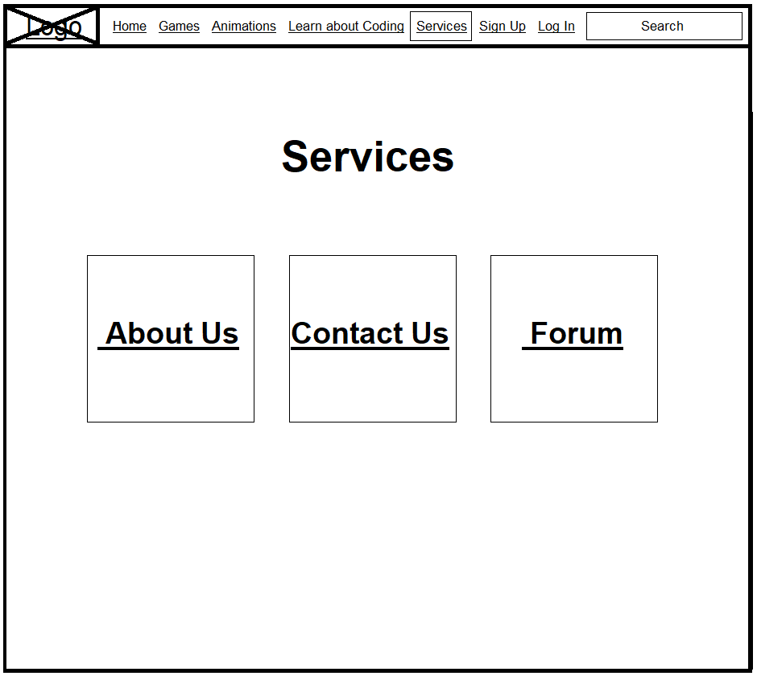

Moving on, this page tries to pass to the user important information such as why the underlying website was created, key contact information and a forum in which the user joins our community and is able to give feedback, exchange ideas with other people and peers and so on.

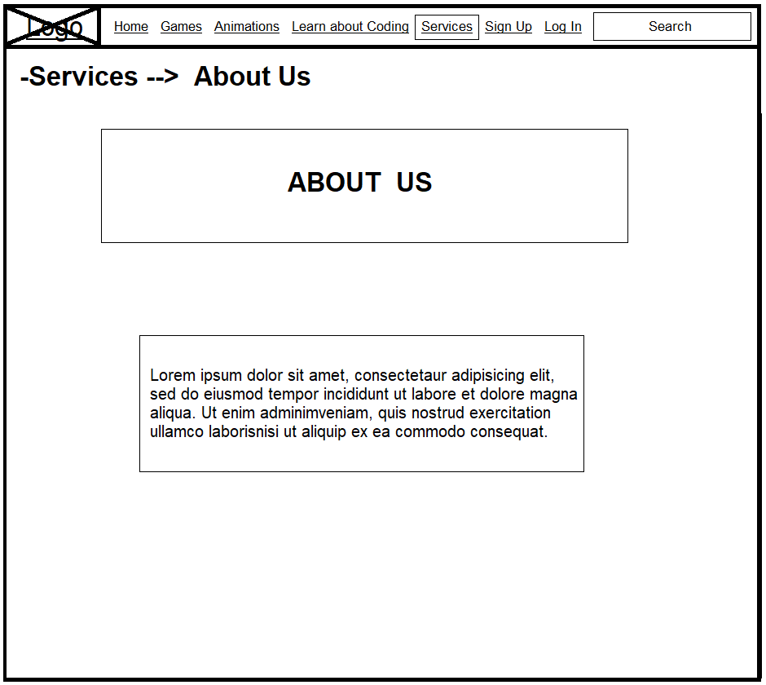The About Us page is simple and includes a brief paragraph of what is this website about and what is trying to deliver to the user.

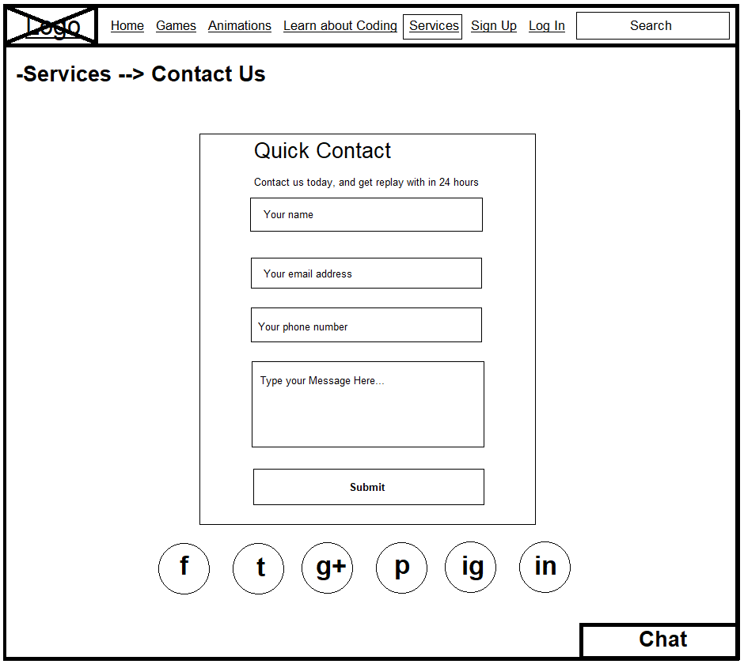

In the Contact Us page there is an interactive animation background with animated social media icons/links that let the user visit the social media pages of this website. Likewise, there is a form that the user can complete or just start a Live Chat session with an agent from the company.

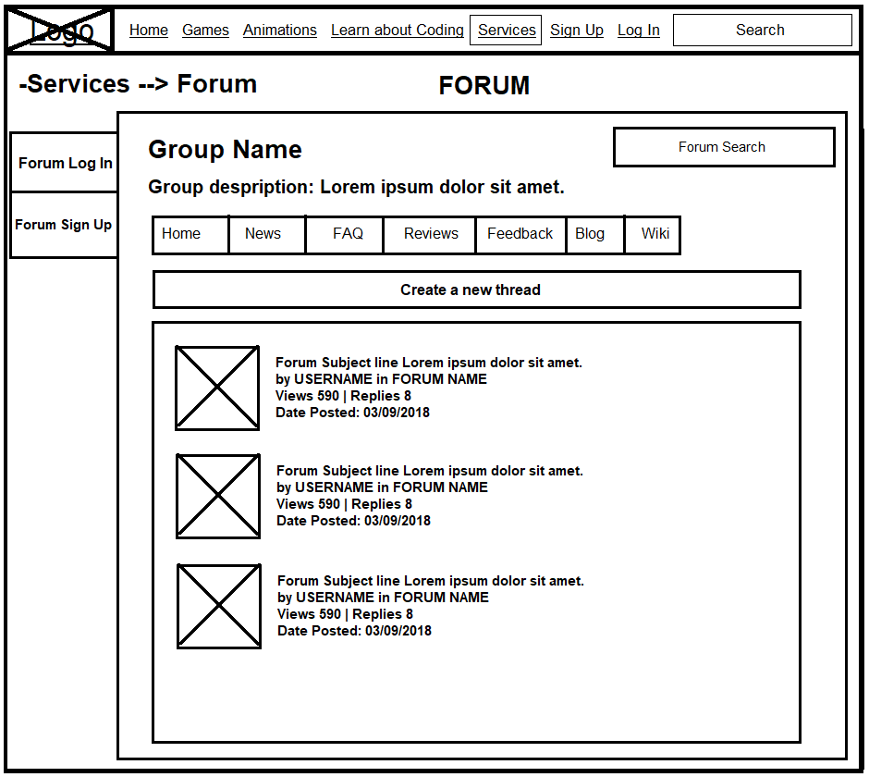

The Forum is a huge database or a message board with useful information about the website. People can discuss on this site and can hold conversations in the form of posted messages. There is a different Sign Up/Login form for the Forum.

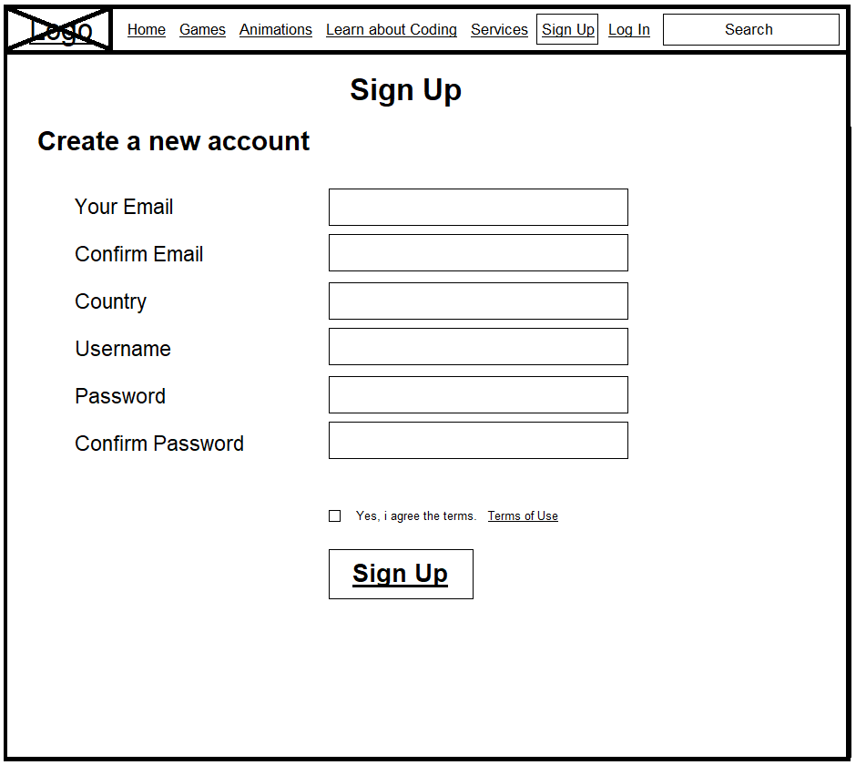

Things here are simple. The only thing a new user should do is to provide some personal information and give a password to create an account.

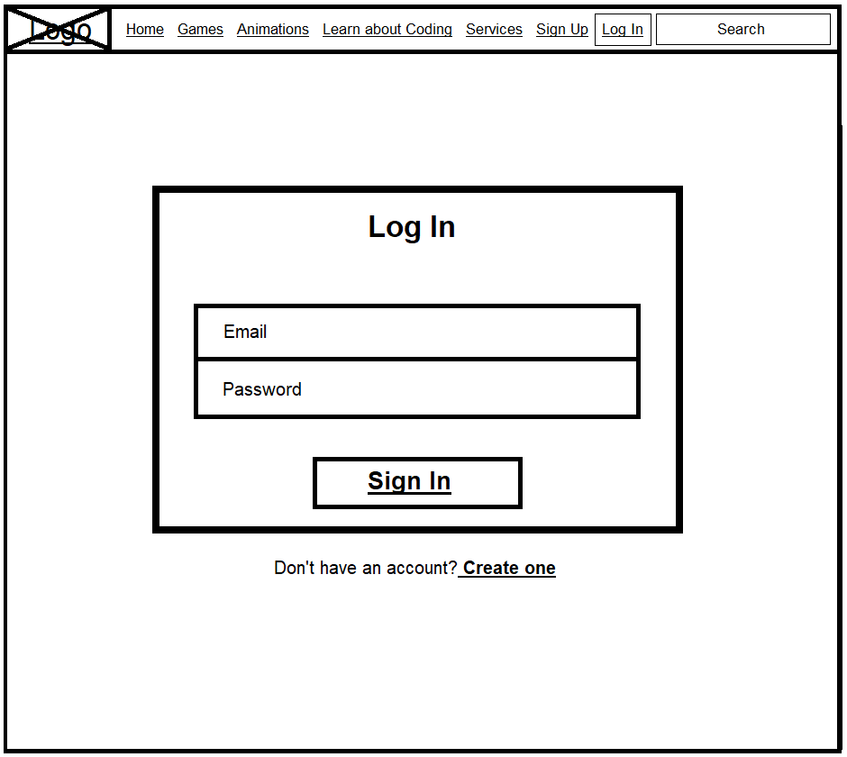

The user in the Login page makes use of the email and the password provided in the Sign-Up form. If the sensitive information given are identical to those of the registration form, then the Sign in button lets the user have full access to the website as well as his/her account.

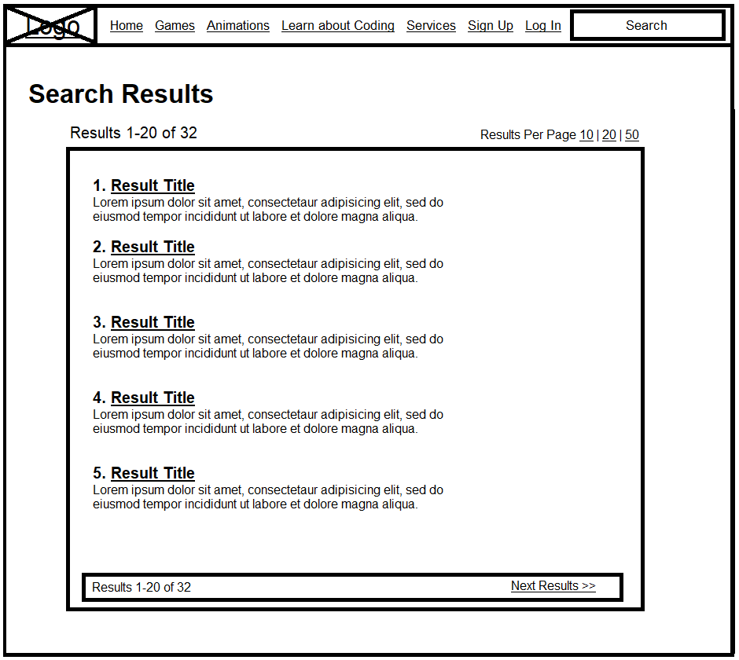

Last but not least, the Search page which displays the search results after a user search for something.

## **Differences Between the Storyboard and Prototype**

Two of the main phases that happen during a design process are the Storyboarding and Prototyping. To begin with, Storyboarding shows how a user might use the prototype or what the prototype mostly contains by demonstrating it. It is the skeletal framework of the product and it could be a handmade raw or a professionally designed sketch which happens way before the prototype. It is quick, cheap and easier to create and for the user to understand the core functionality of a website or app, whereas designers may use them to show the navigation flow among site screens with low cost.

On the other hand, Prototyping is closed to the final UX design [1]which basically is an idea of how the product is supposed to work. A prototype is the wireframe of the app, where all the elements are placed on a page and where the page is in the overall information architecture. The purpose is to find out if users find the layout and architecture intuitive. If it’s not, the UX designer finds the problem spots and remedies them. Prototypes can be hand sketched in the early stages but usually become more digitally refined with each testing iteration. In contrast to Storyboarding and wireframes, Prototypes are typically more **time-consuming and costly** to produce.  As Creative Bloq highlights *“Prototypes are critical to every project releasing a product into the wild, without prototyping and testing it with users first is just begging for failure.”* Thus, by spending some time on the prototyping phase, one can avoid additional work and misunderstandings.

As we can see from the figures below, the underlying Storyboard is black and white with no images, animations and not interactive at all whilst the Prototype is both very visual and interactive like the navigation bar with all the buttons, the features like Search box that allows the user to click into the field and type anything. Similarly, the user can adjust some of the options from the right like the volume of the music and the play button. From the Accessibility options we can see just right below the Audio controls, the user can tick the boxes to change the color, contrast, text size or even remove the images and animations. Secondly, the storyboard is just an example of how the prototype will look like in contrast to the prototype which is one stage before final product. This means that storyboard is like a simple presentation style and the structure can change anytime according to clients’ needs. If there would be no storyboard at all then the process of creating this product would be much more expensive and time consuming.

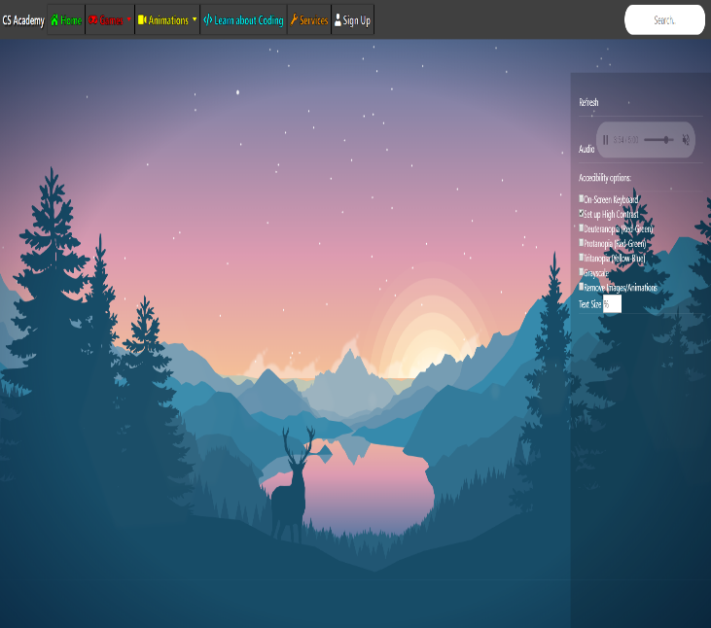

Figure 2- Storyboard Homepage

Figure 3- Prototype Homepage

# **Prototype Description**

* From the very first page (CS Academy) with the mouse interactive heading, the website needs to tell the visitor within 3 seconds what the site has to offer. The heading is one of the most important elements in a website.
* The website includes a visible navigation with a search box that it makes it simple and easy for the visitor to find what they are looking for.
* Information are easy to find, everything is tidy-up and relaxing to the eye of the user because of the properly aligned text, the contrast and the light background colors.
* All the “dead” links on this website were replaced by 404 not found page, for example the “Get started” button from Sign In, because to complete that task it is required further technology (PHP) to collect this kind of data from the user.
* In almost every page there is a tasteful animation to create visual interest to the user.
* Mini games are a good way to attract young people and let them spend more time on the website. It keeps the interest going and the page might get promoted from the users by inviting other friends to join them and play together.
* The website contains videos, audio clips and images to attract and increase the interaction of the user even more.
* Every page includes an appropriate title and a small browser tab icon (favicon).
* The website is usable on any screen resolutions, which means that any user with any device can use the website without any usability problems. In some cases (e.g. Games) if a user has a very tiny screen (e.g. Smartphone) the screen might go from horizontal to vertical and the navigation bar is responsive, so a little clickable “hamburger” menu will appear at the top left of the screen.
* To increase the interest of the website to the visitor, live editors with instructions are implemented, thus the beginner user will learn how to make some animations or even an advanced user can create big designs on the HTML Editor and some remarkable animations on the Animation Editor.
* FontAwesome is used on this website because it offers scalable vector icons and it is free. It is a visual way to help add meaning to elements. Likewise, it is saving valuable time because the developer doesn’t need to create and save these graphics by scratch.
* Bootstrap is used on this website. It is very customizable framework, it saves time and is easy to use. There are predefined design templates and classes that saves time from writing code. Alternative reasons of using it is the responsiveness, the compatibility, the great grid system, the documentation and the fact that it is an open source project.
* Similarly, as above, the reason of why jQuery is used on this website is that is an open source project as well which means is free to use. Additionally, jQuery is generally better for complex development and functionality with huge library. In comparison with JavaScript jQuery provides a great handling of all cross-browser issues and has endless tutorials.
* Below there are two tables presenting the frequently used elements/tags/styles/events on this website:

|  |  |
| --- | --- |
| **HTML** | **Usage** |
| <link rel="icon" | Browser tab icon(favicon) |
| <link rel="stylesheet" | Reference CSS files |
| data-src="data:image/png;base64 | Base64 encoded images become part of html and displays without loading anything |
| <canvas> | Canvas is used to draw graphics |
| <script src=*** | Reference JavaScript files |
| Bootstrap | Framework that includes HTML and CSS design templates |
| jQuery | JavaScript Framework/Library that simplifies HTML document traversing |
| font awesome | Font Awesome is a font and icon toolkit based on CSS and LESS |
| <title>Dot Runner</title> | This tag is required in all HTML documents and it defines the title of the document |
| Col - 12 | It’s a bootstrap’s grid system uses a series of containers, rows, and columns to layout and align content, also it’s fully responsive. |
| onclick="function()"> | The “onclick” event occurs when the user clicks on an element and it runs a specified line of code |
| <img src | This tag defines an image |
| <fieldset> | This tag is used to group related elements in a form. |
| <textarea> | This tag defines a multi-line text input control |
| <label> | This tag is used to put a display text on |
| <form> | This tag is used for creating a form for user input |
| <input> | The input tag specifies an input field where the user can enter data. |

|  |  |
| --- | --- |
| **CSS** | **Usage** |
| @keyframes | Specifies the animation code |
| @media | Used in media queries to apply different styles for different media types |
| Animation: | Makes possible to animate transitions from one CSS style configuration to another |
| Animation-duration: | Specifies the length of time an animation should take to complete one cycle |
| Background-color: | Sets the background color of an element. |
| Background-image: | Sets one or more background images for an element |
| Background-position: | Sets the starting position of a background image |
| Background-repeat: | Sets if/how a background image will be repeated |
| Background-size: | Specifies the size of the background images |
| Border: | Specifies the style of element’s border |
| Border-radius: | Sets border radius |
| Box-shadow: | Add shadow effect around element’s frame |
| Box-sizing: | Allow to include the padding and border in an element’s total width and height |
| Clear: | Specifies whether an element can be next to floating elements that precede it or must be moved down below them |
| Content: | Replaces an element with a generated value |
| Cursor: | Specifies which mouse cursor to display when the mouse pointer is over an element |
| Display: | Specifies if/how an element is displayed |
| Filter: | Applies graphical effects like blur or color shift to an element |
| Font-family: | Specifies a prioritized list of one or more font family names and/or generic family names for the selected element |
| Font-size: | Specifies the height of the font |
| Font-weight: | Specifies the boldness of the font |
| Height: | Used to set the height of an element |
| Margin: | Used to create space around elements |
| Mix-blend-mode: | Defines how an element’s content should blend with its background |
| Opacity: | Adds transparency to the background of an element |
| Overflow: | Specifies what should happen if content overflows an element’s box |
| Padding: | Used to generate space around an element’s content |
| Position: | Specifies the type of positioning method used for an element |
| Perspective: | Adjusts the position of a 3D element in relation to the user in order to provide a 3D perspective |
| Text-align: | Used for aligning the inner content of a block element |
| Top: | Specifies the vertical position of a positioned element |
| Transform: | Applies a 2D or 3D transformation to an element |
| Visibility: | Specifies whether an element is visible |
| Z-index: | Sets the stack order of specific elements. An element with greater z-index is always on the front of another element with lower z-index |

# **Usability Testing:**

Usability testing is a technique used to measure and evaluate how straightforward a website is to use. The tests occur with real users to measure how ‘practical’ or ‘spontaneous’ a website is and how simple it is for users to achieve their goals. Therefore, the usability test is a carefully constructed scenario where a user performs. Most people who set up a usability test fastidiously construct a situation in which an individual performs a listing of tasks that somebody who is using the website for the first time is probably going to perform. somebody else observes and listens to the one that is performing the tasks while taking notes.

Below is given the script with the tasks and questions that I gave to the person who used for the first time the website:

Hello, ______________. My name is 2920796 and I’m going to be walking you through this session today.

We are asking people to try to use our Website that we are working on, so we can collect data and can see whether it works and delivers as intended. Just to clarify we want to test the usability of the site, not you. You can’t do anything wrong here. Please feel free to let me know at any time if there’s something you like, dislike, if you’re confused, etc. I promise you won’t hurt my feelings.

First, I’m going to ask you to look at this web page.

Now navigate anywhere you want to the webpage and explore it for 1 minute.

Now I’m going to ask you to try doing some specific tasks. I’m going to read each one out loud.

We’ll learn a lot more about how well the pages work that way. And again, as much as possible, it will help us if you can try to think out loud as you go along.

1. Sent us an email
2. Sign Up
3. Change the gravity from the Gravity Animation
4. Find our page on Instagram
5. Play the Dot Runner Game
6. Change the settings from Light Background to Dark Background to the Animation Editor
7. Download the HTML file from editor
8. Mute the audio from Home page

Do you have any questions so far? I will let you explore the website for 5 minutes, and I will give you a questionnaire to complete based on your experience on this website.

| **Tester Name:** | Annita Tsiarta | **Date:** | 09/11/2018 |
| --- | --- | --- | --- |
| **Age:** | 23 | **Education:** | Postgraduate Student |
| **Genre:** | Female | **Computer Experience:** | Basic |

|  |  |
| --- | --- |
| Usability & User Experience | Tester Answers |
| What are the major issues which will make you leave the website? | The website is nice and easy to navigate, but, incomplete when it comes to parts like sign up or log in. Loved the logo, can’t stop playing with it. |
| How long are you willing to spend on a process before you get bored/frustrated/consider leaving? | I would spend 5 to 10 minutes on each process. |
| Is there important information missing from our key pages? | This is a new website and maybe it should be given some time to develop. It captures the basics of computer science. |
| Are you able to use our page control features easily? | Yes, I able to use most of the page features. But still needs improvement |
| Does our page load speed cause any issues with your site experience? | No, speed is fine. |
| At what stages do you exhibit anxiety during a user journey i.e. sign-up? | To the HTML editor because I didn’t know anything about HTML. After I read the Instructions, I was fine, and I was able to enjoy creating my own HTML. |
| Are you able to locate the button/action we want them to do on key pages? | Yes |
| What issues do you have when completing our web forms? | No issues, easy enough. Just an error message is appeared after clicking Sign Up or Log In. |
| What flexibility do you expect to have at specific parts of your user journey? | I don’t know. |
| What exactly is stopping you from doing what we want you to? | Privacy – Protection of data maybe |
| How can we make our website experience more intelligent to speed up how you interact with us? | I don’t know. |
| Did you find any bugs/design errors on the website? | The audio from home page sometimes plays instead of always, and the clicking sound from the index page is not working on Google Chrome. |
| Does the website work well on any of your devices? | Yes, but there are some minor issues on some pages with the responsive elements. |
| Staying on the Home Page, say what you think you can do on this site | Based on the Home Page and the animation I was expecting to listen a story. The background audio was a nice touch though. |
| From an overall view, say which similar companies or sites spring to mind if any | arkera.ie |
| From an overall view, say what sets this site apart from other similar sites | The animations and the extra interaction from the user |
| From an overall view, say who you think this site is aimed at? | Everyone, mostly young people |
| How easy was it to learn the controls from the mini games? How could this be improved? | Easy enough. The blocks game uses mouse and it would be easier with the use of arrows. |
| Is the web page correct without any spelling or grammatical errors? | Yes |
| All the text is properly aligned? | Yes |
| All the fields are properly aligned? | Yes |
| Is there enough space between field labels, columns, rows? | Yes |
| Are the buttons easy to understand with that format, color and size? | Yes |
| Home link is on every single page? | Yes |
| Are there any broken links or buttons? | No |
| Can the end user run the system without frustration? | Yes |
| Does the scroll bar appear only if required? | Yes |
| Is the page title displayed on each web page? | Yes |
| Is the side functional in different resolutions (eg 600x800 etc)? If not where? | To the Learn about Coding, there is a bottom scroll bar when the resolution is less than 1920x1080 |
| Is the website running and displaying properly in different browsers? (IE, Firefox, Chrome, Safari and Opera)? | This prototype of the website is running mostly on Chrome. Most of animations and elements are not displaying properly in different browsers. |
| Can users complete key tasks without answered questions? | Yes |
| Are you able to locate key features & functionality that the site provides? | Yes, but it would be easier to have the contact us and information about us in a more obvious place |

## **Security Testing (Not in current prototype)**

* Verify the web page which contains important data like password, credit card numbers, secret answers for security question etc should be submitted via HTTPS (SSL).
* Verify the important information (password, credit card numbers etc), should display in encrypted format.
* Verify password rules are implemented on all authentication pages (Registration, forgot password)
* Verify if the password is changed the user should not be able to login with the old password.
* Verify the error messages should not display any important information.
* Verify if the user is logged out from the system, the user should not be able to navigate the site.
* Verify to access the secured and non-secured web pages directly without login.
* Verify the “View Source code” option is disabled and should not be visible to the user.
* Verify the user account gets locked out if the user is entering the wrong password several times.
* Verify the cookies should not store passwords.
* Verify if, any functionality is not working, the system should not display any application, server, or database information. Instead, it should display the custom error page.
* Verify the SQL injection attacks.
* Verify the user roles and their rights. Eg, the requestor should not be able to access the admin page.
* Verify the important operations are written in log files, and that information should be traceable.
* Verify the session values are in an encrypted format in the address bar.
* Verify the cookie information is stored in encrypted format.
* Verify the application for Brute Force Attacks

## **Functional Testing (Not in current prototype)**

* Test all the mandatory fields should be validated.
* Test the asterisk sign should display for all the mandatory fields.
* Test the system should not display the error message for optional fields.
* Test that leap years are validated correctly & do not cause errors/miscalculations.
* Test the numeric fields should not accept the alphabets and proper error message should display.
* Test for negative numbers if allowed for numeric fields.
* Test division by zero should be handled properly for calculations.
* Test the max length of every field to ensure the data is not truncated.
* Test the pop-up message should display if the data reaches the maximum size of the field.
* Test that a confirmation message should display for update and delete operations.
* Test the amount values should display in currency format.
* Test all input fields for special characters.
* Test the timeout functionality.
* Test the Sorting functionality.
* Test the Privacy Policy & FAQ is clearly defined and should be available for users.
* Test if any functionality fails the user gets redirected to the custom error page.
* Test all the uploaded documents are opened properly.
* Test the user should be able to download the uploaded files.
* Test the email functionality of the system.
* Test to see what happens if a user deletes cookies while in the site.
* Test to see what happens if a user deletes cookies after visiting a site.
* Test all the data inside combo/list box is arranged in chronological order

## **Database Testing (Not in current prototype)**

* Verify the database name: The database name should match with the specifications.
* Verify the Tables, columns, column types and defaults: All things should match with the specifications.
* Verify whether the column allows a null or not.
* Verify the Primary and foreign key of each table.
* Verify the Stored Procedure
* Test whether the Stored procedure is installed or not.
* Verify the Stored procedure name
* Verify the parameter names, types and number of parameters.
* Test the parameters if they are required or not.
* Test the stored procedure by deleting some parameters
* Test when the output is zero, the zero records should be affected.
* Test the stored procedure by writing simple SQL queries.
* Test whether the stored procedure returns the values
* Test the stored procedure with sample input data.
* Verify the behavior of each flag in the table.
* Verify the data gets properly saved into the database after each page submission.
* Verify the data if the DML (Update, delete and insert) operations are performed.
* Check the length of every field: The field length in the back end and front end must be same.
* Verify the database names of QA, UAT and production. The names should be unique.
* Verify the encrypted data in the database.
* Verify the database size. Also test the response time of each query executed.
* Verify the data displayed on the front end and make sure it is same in the back end.
* Verify the data validity by inserting the invalid data in the database.
* Verify the Triggers.

# **References**

Js.foundation, J. (2016). *jQuery*. [online] Jquery.com. Available at: https://jquery.com/

Mark Otto, a. (2011). *Bootstrap*. [online] Getbootstrap.com. Available at: https://getbootstrap.com/

Scratch.mit.edu. (2003). *Scratch - Imagine, Program, Share*. [online] Available at: https://scratch.mit.edu/

W3schools.com. (1999). *W3Schools Online Web Tutorials*. [online] Available at: https://www.w3schools.com/

1. In UX design it is demonstrated the simplicity of the product after it has been developed.