CSCU9Y4 Programming Language Paradigms
Programming Languages Report

Drag and drop coding is the future

2520796

A report submitted in part fulfilment of the degree of
BSc (Hons) in Computer Science

Department of Computer Science
, University of Stirling

Spring 2018
Declaration
This report has been prepared based on my own work. Where other published and unpublished source materials have been used, these have been acknowledged.

Word Count:

Student ID: 2520796

Date of Submission:

Table of Contents
Abstract 4
Chapter 1: Introduction 5
1.1 Evolution of Coding 5
Chapter 2: Visual Programming 6
2.1 Advantages of Visual Programming 6
2.2 Disadvantages of Visual Programming 6
Chapter 3: Visual or Text-based programming languages as a beginner 7
3.1 Readability 7
3.2 Productivity 8
3.3 Technical knowledge 8
3.4 Syntax reduction 8
Chapter 4: Presentation issues 9
4.1 Figures, Charts and Tables 9
4.2 Source Code 9
Bibliography 10

Abstract
-200words

Introduction
What is the drag-and-drop? Drag and drop is the ability to move any objects from the graphical user interface (GUI) as windows, menus and icons with the mouse, touchpad, or other tracking devices. Drag-and-drop, point-and-click and cut-and-paste operations are the most highly used features of the modern GUIs as they can make computers easier to use for lot of people. [1] So, what are drag and drop programming languages? As the name proposes, is a visual interface where without knowing the sentence structure you can even now program a PC by dragging pieces of puzzle and fitting them out. When you have fitted the pieces accurately your program will execute or work. [2]

Evolution of Coding

The beginning of programming codes, as the vast majority of the software engineers know was never simple. It was the time when Pascal, COBOL, FORTRAN and Algol 60 used to write some methods for aided programs. The complexities were high with additional time consumption. The absolute most effective programming languages which were designed between the period 1960 and 1970 incorporate Simula, Speakeasy, C, Smalltalk, Prolog, and ML. In the later years of coding transformation, more thought was given on the processor speeds for compilers. The intention was to give an interface that could expand the strategies of accumulation. The year was around 1990 when the world continuously ventured into the innovation of the Internet. Luckily, the web gave a stage to the programming languages. The programming scene saw the creation like useful languages like Ada, Java, Python, Ruby, Visual Basic, and PHP and considerably more were currently dealing with the programming ideas. With such an extensive amount hand based coding ideas, to start with, the programming structure today is moving to another example which is called as low coding. Meaning, the software engineers or any business won't have to handle with the complexities of coding. This is a methodology that limits the association of hand coding and lifts up the conveyance of programming applications just with drag and drop. To construct a low-code or no-code application isn't just speedier yet in the meantime financially savvy, and low tedious. In this way, to finish up, coding a program for any module isn't a dreary undertaking of hand based programming any longer with a stage like SCOCU. [3]

Visual Programming
Visual basic, Visual C++, App Inventor, Scratch, LabView and more are examples of the visual programming languages. These languages give extremely straightforward coordinated advancement condition IDE to make PC programs. The IDE furnishes the software engineer with a wide range of apparatuses that are utilized as a part of utilization as GUI. The software engineer can make program effortlessly and quickly.

Advantages of Visual Programming

- These languages are very easy to understand and use them.
- These languages give numerous build-in objects that can be utilized as a part of building up the new projects. New objects can likewise be made.
- Visual programming reduces programming bugs and improve the quality of code.
- The UI can be composed effortlessly by utilizing mouse. The segments are set on the fundamental interface part like structures. These parts can be resized and moved effortlessly.
- These languages give office to append code to every interface part. The joined code is executed when the client communicates with the interface segment.
- The clients can utilize the visual applications effortlessly. [4]

Disadvantages of Visual Programming

- These languages require PC with more memory, high storage of hard disk, and quicker processor.
- These languages must be executed on graphical working frameworks like Linux and windows.
- Visual Languages Aren't Extensible: This is the main disadvantage of visual programming. They capable to do limited things easily and fast but for more complex programs are excessively troublesome, or even impossible to accomplish.
- Visual Languages Generate Slow Code: Visual languages regularly creating slow code which is difficult to optimize.
- Visual languages and IDEs should be designed together: [4]

Visual or Text-based programming languages as a beginner

When using VPLs, it is generally simple for the kids to make simple programs and games, there are typically build-in materials and libraries for creating basic programs in the language conditions. Then again, when using TPLs, it is important to begin from getting ready illustrations with a specific end goal to make games. [6]

Readability

For somebody simply beginning with programming, Scratch for example is significantly more readable. The blocks on Scratch are anything but difficult to think about what they do, even if someone never seen Scratch before. With the C++ or Java for example, it is difficult to see instantly what's happening. "What's an iostream? What is the “public static void main(String[] args) {“ What’s a “main()”?" It's not as clear as Scratch seems to be. [5] Fig.1
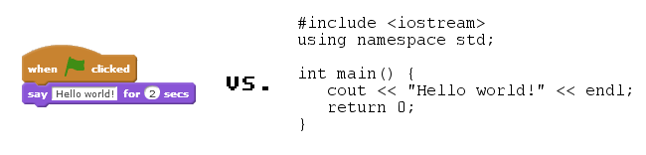
Fig.1

Documentation Effects

This category is an augmentation of Readability and it contains comments that, because of the fact that visual projects are so readable, a software engineer does not need to compose much extra documentation (at the end of the day, that the visual code is self-documenting). Also, it incorporates the related cases that visual code is sufficiently clear to give a decent correspondence system between individuals (e.g., between individuals from a programming group). [7]

Productivity

Professional developers are very worried about their productivity of how quick they can finish a task. For the expert, this is much more vital than the simplicity of taking in another language, since taking in a language is a beneficial speculation in the event that it brings about expanded productivity. Thus, this topic contains all cases ascribing changes in efficiency to visual programming, running from straightforward cases that "visual programming enhances development speed" to proclamations that mention particular programming undertakings. Truly, software engineers have been worried about genuine speed of coding, as was assessed in "lines of code every day" estimations used by extensive organizations to compare individual performance. [7]

Technical knowledge

At the point when the client is modifying with content based dialects, it's somewhat imperative to develop his insight into essential programming ideas first. Particularly if the client wants to learn other programming languages. If the user don't know what a loop, a Boolean or an array is (Fig.2), he might be in for a small world of misery. For a marginally more mind boggling programming language like C++, should have knowledge about headers, libraries, functions, dynamic memory management, and much more before he gets in too deep. But what do these words mean? How someone should understand these new and unfamiliar concepts? How would somebody can disclose these ideas to a 10-year-old kid or an extremely amateur developer and keep their interest? [5]
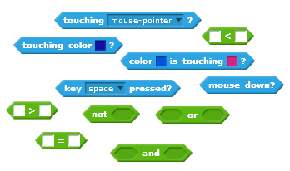
Fig.2

Syntax reduction

Visual programming gives flexibility from the details of programming language structure. For instance, some VPLs require less keywords and accentuation marks (braces and semi-colons, specifically). Also, some VPLs lessen the need to pronounce the same number of factors, by the use of wiring metaphors that can decrease the need to name transitional values. A few respondents said particular occurrences of lessened grammar as advantages of visual programming. [7]

Human Visual Capabilities
This topic incorporates asserts about how the human personality forms content and pictures. In these cases, respondents attested that human recognition and handling of the sort of outlines used as a part of VPLs is in a general sense distinctive to the observation and preparing of content. Illustrations incorporate the thoughts that the human cerebrum is improved for visual preparing; that the human mind reads pictures in "chunks", in this manner permitting a higher information data transmission than is conceivable with content; and that VPLs tap the underused right half hemisphere of the brain. These cases may be founded on suppositions about data preparing (the text is restricted because it must be lessened to a one-dimensional stream) or about encoding, as in a couple of cases that human memory for pictures is quicker or more precise than memory for words.[7]

Popularity index of programming languages

Most Popular Languages from 2002-2018
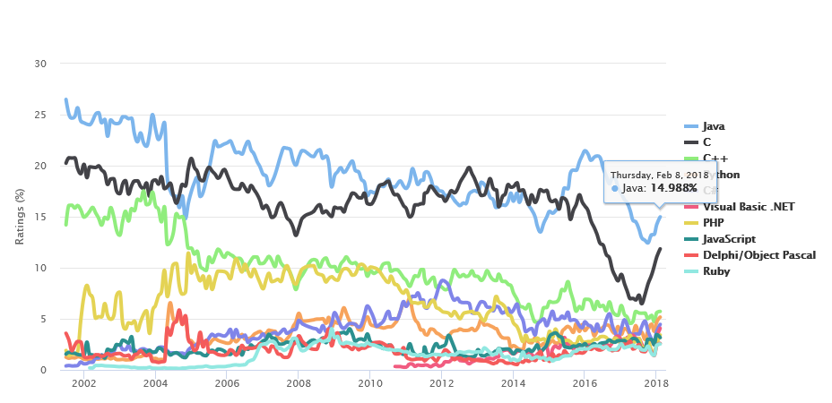
Fig.3

- Java
Java has been the main rival C as far as fame, sharing the main couple of spots. It won the "Programming dialect of 2015" award, and, according to Oracle, is effectively used by 9 million designers. [8]
- C
The C programming language has been positioned as the most well-known dialect on the planet in March 2015. The applications and constancy on C are relatively interminable, and it has dependably been one of the two most famous languages. [8]
- C++
C++ has been fluctuating between the third and the fifth place for most mainstream programming dialects for over 10 years. It is an establishment for a few programming languages, the primary programming decision for a large number of the most used desktop applications; a go-to decision for gadget drivers, game engines, audio/image preparing tools, embedded software and that's only the tip of the iceberg. [8]

Conclusion
Sure, Visual Programing Languages are unbelievably unjoyful, easy and attracted to the new software enthusiasts, especially when a middle school age kid see all that colours, blocks and puzzles and wants to experiment with them and create something without any knowledge of complex syntax. It’s a new way to allow new programmers introduce themselves to the software world and it’s a very good way to create 3D projects really fast. At the other hand, these are not for everyone, for a professional programmer developer, using Visual Programing Languages could be very limited of what he can do with the Text-Based Programing Languages. They are much more powerful and they are going to stay powerful even to the near future.

Bibliography
- Dave Cohen and Carlos Matos. Third Year Projects – Rules and Guidelines. Royal Holloway, University of London, 2013.

http://www.linfo.org/drag-and-drop.html [1]

https://medium.com/@niqabicodermum/five-drag-and-drop-programming-languages-to-learn-coding-9ab95fc8fd97 [2]

http://www.scocu.net/evolution-coding-difficult-coding-drag-drop/ [3]

http://www.learningall.com/define-visual-programming-advantages-and-disadvantages/ [4]

https://www.codingkids.com.au/blog/2017/7/16/visual-based-vs-text-based-programming-languages/ [5]

http://ieeexplore.ieee.org/document/7757571/?section=abstract [6]

https://www.cl.cam.ac.uk/~afb21/publications/ESP97-kirsten.html [7]

https://www.tiobe.com/tiobe-index/ [8]

http://statisticstimes.com/tech/top-computer-languages.php

https://www.linkedin.com/pulse/visual-based-vs-text-based-programming-languages-emily-de-la-pena

