Open Conexiones.exe

Input database path and connections number

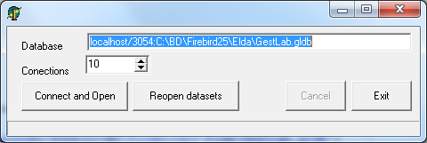

Click connect and open

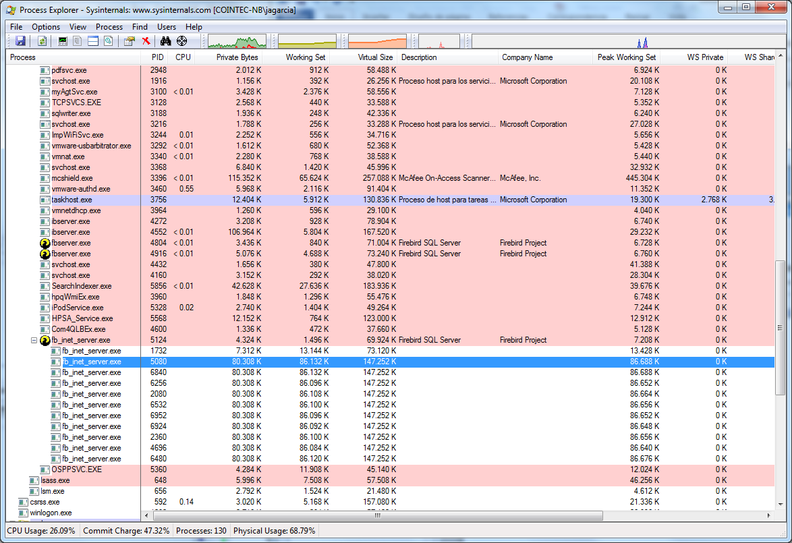

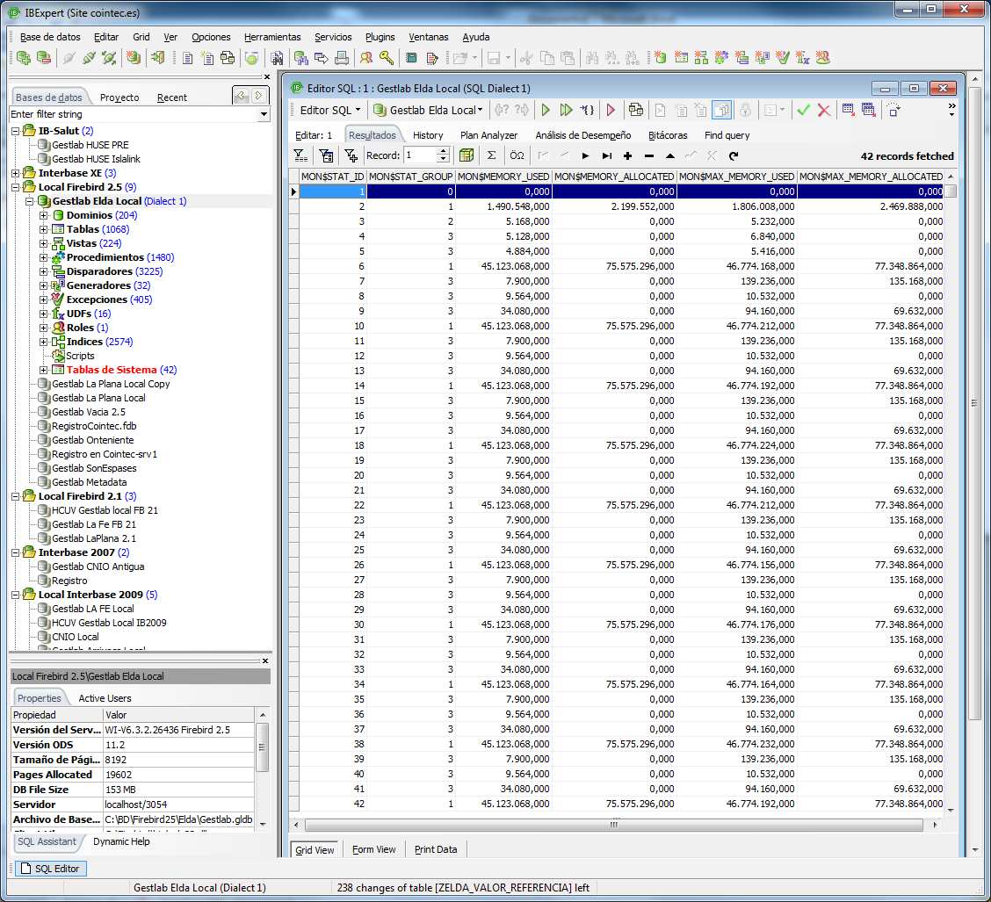

Wait some minutes and see how Working set is decreased.

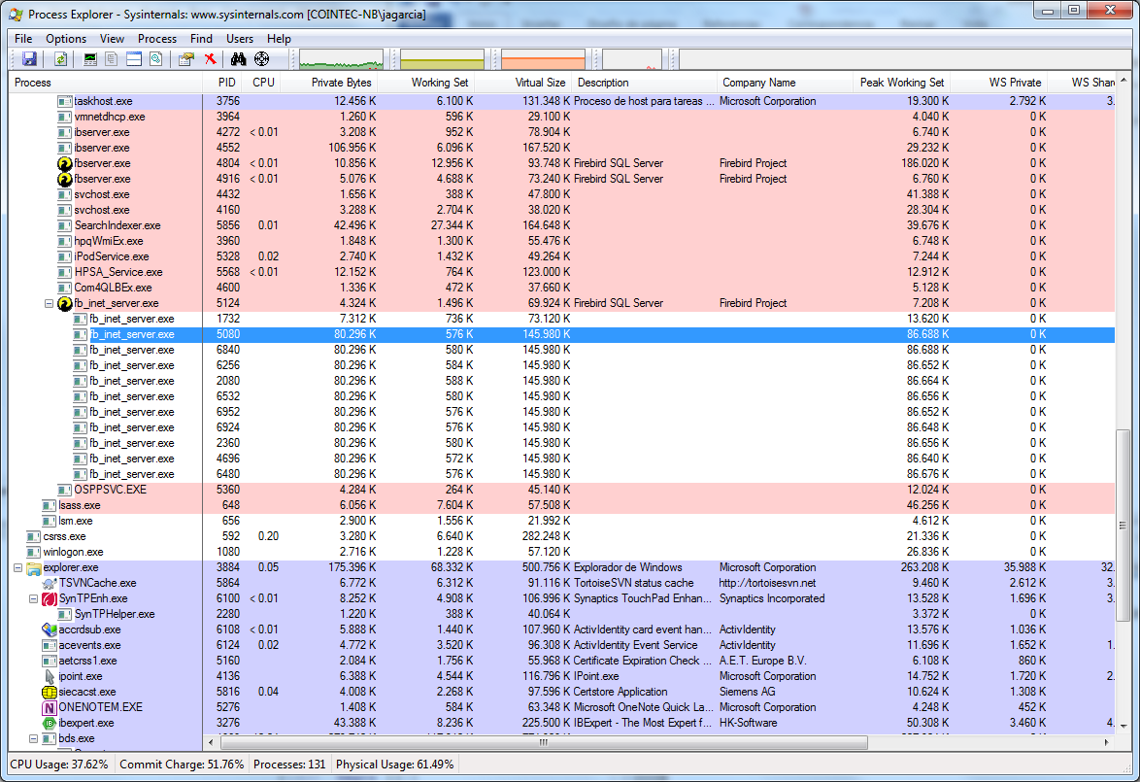

After that, I click again in Reopen DataSets and this is the new workingset

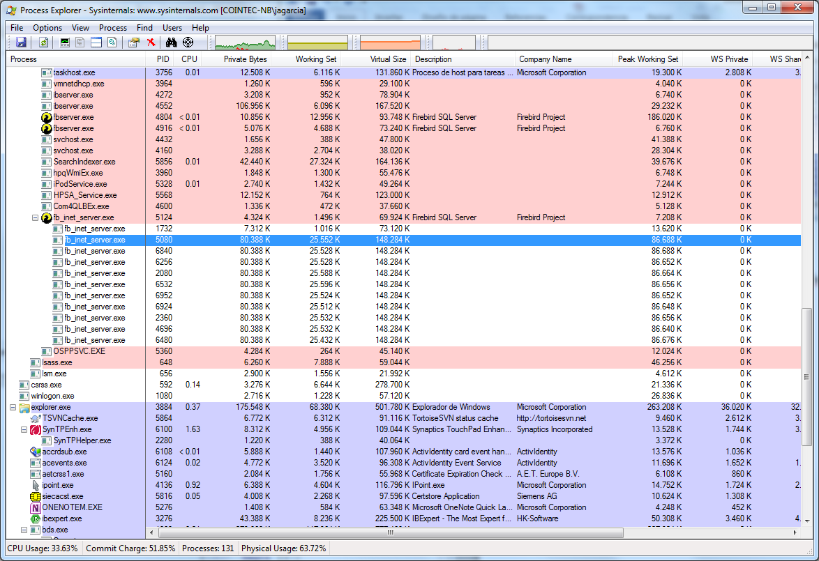

When working with my application, after this never uses a working set of more than 50 MB