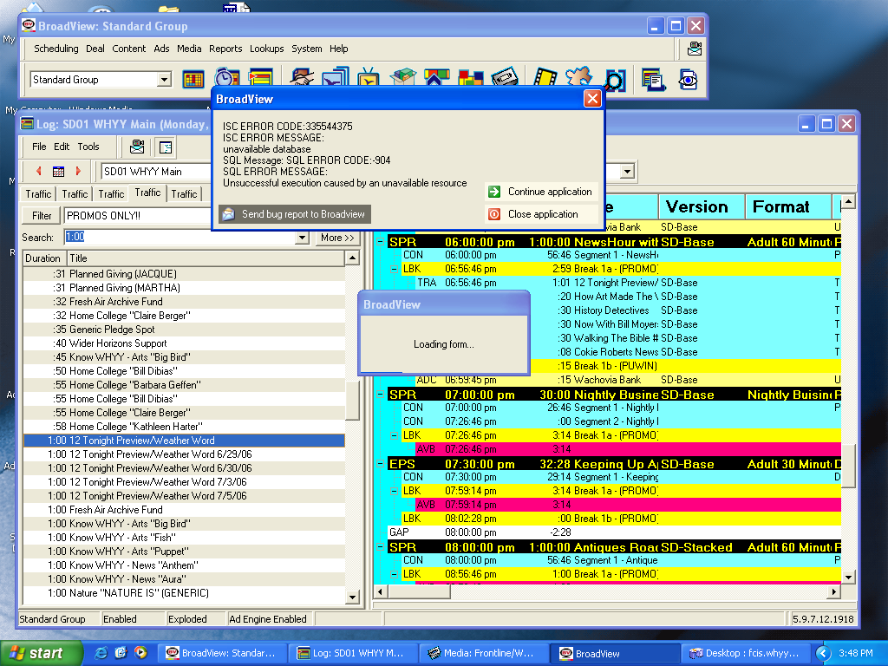

************** Exception Details **************
exception class : EOleException
exception message : ISC ERROR CODE:335544375ISC ERROR MESSAGE:unavailable databaseSQL Message: SQL ERROR CODE:-904SQL ERROR MESSAGE:Unsuccessful execution caused by an unavailable resource.
***********************************************

1 exception report(s) previously generated

Exception #1: (ESocketError) Windows socket error: An existing connection was forcibly closed by the remote host (10054), on API 'recv'

