**TechWear**

**Background**

In March 2023, you joined with two business partners to start a new company called TechWear, a privately-owned business that manufactures and sells upper-end, high-tech sportswear. TechWear’s primary product is a line of lightweight exercise clothes that contain a new, long-range RFID chip that captures the following information about the user based on personal data (age, weight, etc.) entered by the user:

* Heart rate
* Perspiration rate
* Calories burned
* Exercise efficiency (percent of capacity)

The chip is able to continuously send this information to a host device as far away as 15 miles. The clothes are also GPS enabled and able to track routes, distances and elevations.

**Assessing Accounts Receivable Collectability Risk**

TechWear sells its products to large distribution outlets, each of which is considered a major customer. In order to attract as many new customers as possible, the company grants its customers credit (i.e., sells its products on account) and allows customers 30 days to pay their accounts. After 30 days, accounts receivable are considered overdue, and the company sends customers overdue notices.

TechWear recently reached the end of calendar year 2023. You are eager to improve the company’s cash flow situation. As such, you asked your accounting team to prepare reports on the company’s collection of accounts receivable for its first 10 months of operation (March-December 2023). You will use these reports to assess the risk that some of TechWear’s accounts receivable may not ultimately be collected (i.e., “collectability risk”).

The reports were prepared in Microsoft Excel and can be viewed at the following link: <https://arizonastateu-my.sharepoint.com/:x:/g/personal/semett_asurite_asu_edu/EUEZL6p370VOmTIDC0fzG7UBeZ2zlu0ZIkus6q1KBbgmZw?e=SX7Hp1>

***Navigating the Reports***

You can navigate the different reports prepared by your accounting team by clicking on the tabs at the bottom of the Excel workbook (see figure below).

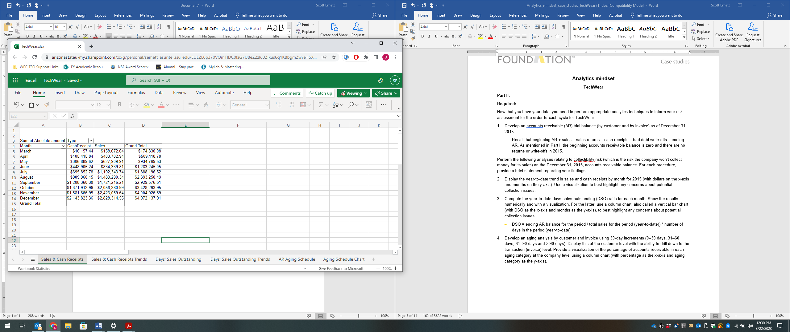

Clicking different tabs allows you to view the various reports.

You may need to click these arrows to see all the available tabs

Your team prepared the following reports:

1. **Sales & Cash Receipts Tab:** This table shows cumulative sales and cash receipts by month.
2. **Sales & Cash Receipts Trends Tab:** This figure shows cumulative sales and cash receipts by month.
3. **Days’ Sales Outstanding Tab:** This table calculates the company’s days’ sales outstanding (DSO) metric by month. Column B “DSO” contains the calculation of the DSO metric.
4. **Days’ Sales Outstanding Trends Tab:** This figure shows the company’s days’ sales outstanding (DSO) metric by month.
5. **AR Aging Schedule Tab:** This table displays the company’s aging schedule for its first 10 months of operations. The table shows details for each of the company’s customers. The “age” of an accounting receive is how long it has been outstanding.
6. **Aging Schedule Chart:** This chart shows the company’s accounts receivable balances by age category.

**Module quiz questions.** Note your answers to these questions, as they will be included in the module 14 quiz.

* Based on **reports 1 and 2** of the TechWear case, which of the following statements best describes the trend in sales and cash collections for TechWear's first 10 months of operations?

a. TechWear’s cash collections are not keeping up with sales, and this trend is more pronounced in the later months (September- December) than in the earlier months.

b. There is no trend in sales and cash collections for TechWear.

c. TechWear has collected cash much faster than it has generated sales.

d. TechWear’s cash collections are not keeping up with sales, and this trend is more pronounced in the earlier months (March-May) than in the later months (September- December).

* Based on **reports 3 and 4** of the TechWear case, which of the following statements about TechWear’s days’ sales outstanding (DSO) is true?

a. TechWear’s DSO ratio for July indicates that, as of July, the company collects its accounts receivable 64 times per year, on average.

b. Relative to the first three months of operations (March – May), TechWear’s DSO ratio has improved in more recent months (October – December).

c. TechWear’s DSO ratio for November indicates that, as of November, the company takes about 95 days to collect accounts receivable, on average.

d. During its first 10 months of operations, Techwear’s DSO ratio stays below the 30-day credit term that TechWear offers its customers.

* Based on **reports 5 and 6** of the TechWear case, what percentage of TechWear’s accounts receivable are overdue (i.e., more than 30 days old)? Round your answer to the nearest percent and state your answer as a whole number. For example, if the answer were 20% you would answer '20'.

_______________ %

* Based on **reports 5 and 6** of the TechWear case, which customer has the largest balance of overdue (i.e., more than 30 days old) accounts receivable?

a. Goodway

b. Cool Threads

c. Value Choice

d. Northern Lites