**Week 2**  
It would be difficult to impart imagination if you’ve never experience smtg new

Why vision

* High bandwidth channel – ex. You can see everything in one shot rather then listen one by one to whats next

**Week 3**

* Data variation not design ex. Two data from 2 sources
* Graphics should not mislead audience
* Ex of manipulating  
  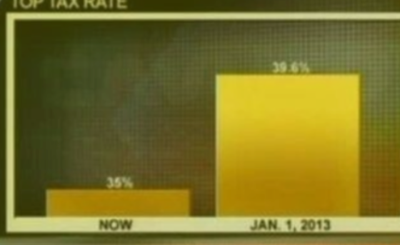the difference is not that far in actuality, so here its talking about integrity where we have to be honest with our data
* Data should not be change intentionally
* We need to avoid lie factor  
    
    
  A graph on a blue background

  Description automatically generated
* Can show the focus of the data by shading the gray area(not so important data).  
    
  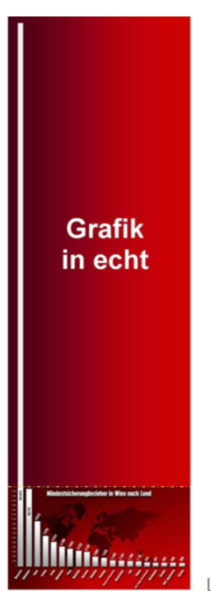
* cut the longest data in half
* And write the amount to show the big difference   
    
  A diagram of different colored circles

  Description automatically generated  
  - black is more popular but continue to drop throughout the years
* Make sure to communicate the important bit

(science workshop for students part)

* Assuming target that after workshop kids increase likeliness to like science so show real important number
* 68%... then use bar chart where grey is before workshop, blue is after
* Bored increased then must have further investigation ex. Children sit behind not listening, or they don’t understand, or they don’t have the equipment to participate in the workshop

Presentation

* Present for data purpose not accessories or design

: Try to reduce 3d charts and use 2d charts instead

* Avoid chart junk
* Aim for high data density
* Layering and separation of info
* Use different colour for the highest percentage
* Use animation  
    
  Layering Chart  
  A graph with colorful lines

  Description automatically generated with medium confidence

- COLOR SEPARATION and character, episode layering

Occlusion = blockage of data

Guidelines – Muzner

* Cognitive limitations – skills related to planning – decision making – and coping
* When use animation the audience can capture smtg but between animated and side to side view, chose which one is better, if want animation can pause n continue but troublesome because it needs to restart the animation if we missed a certain data, but since a lot of side to side can draw line chart and compare which data u want to see