MELO SPORTS PAYPAL PAYMENT API SEETINGS

1. How to get in PayPal payment settings app id details.

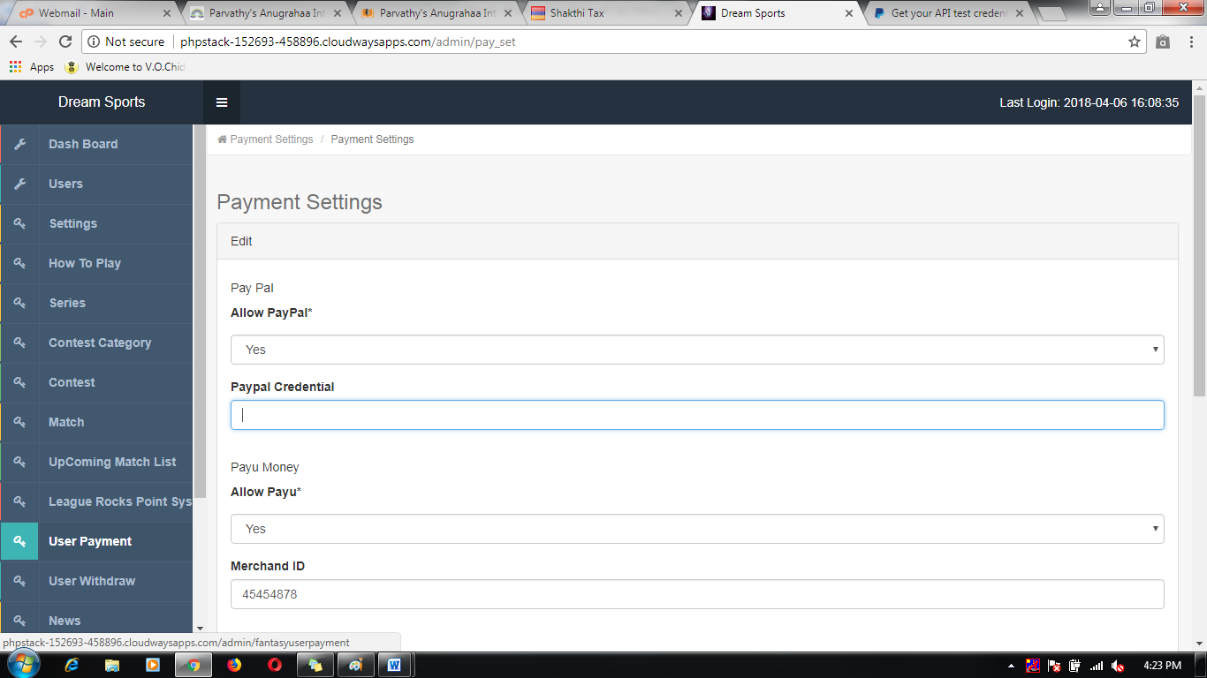

1. Visit PayPal payment developer site.

*Link:* [*https://developer.paypal.com/docs/classic/lifecycle/sb_credentials/*](https://developer.paypal.com/docs/classic/lifecycle/sb_credentials/)

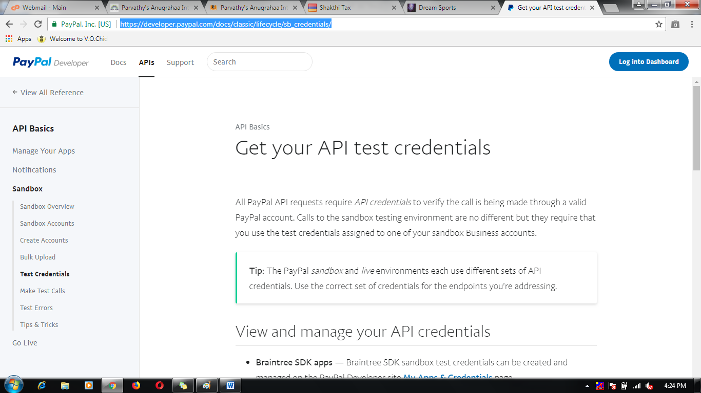

1. Register and login to PayPal account

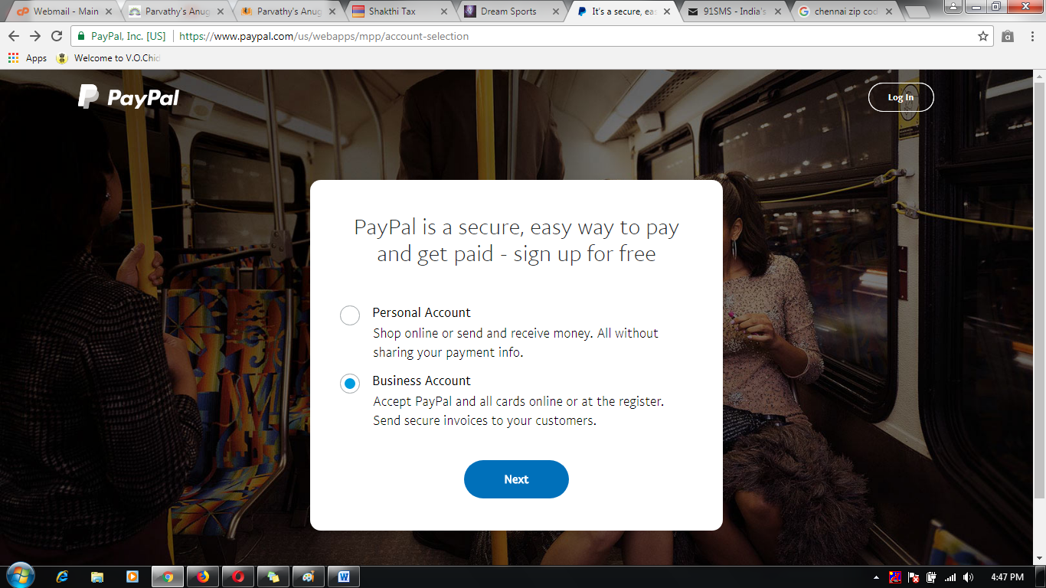

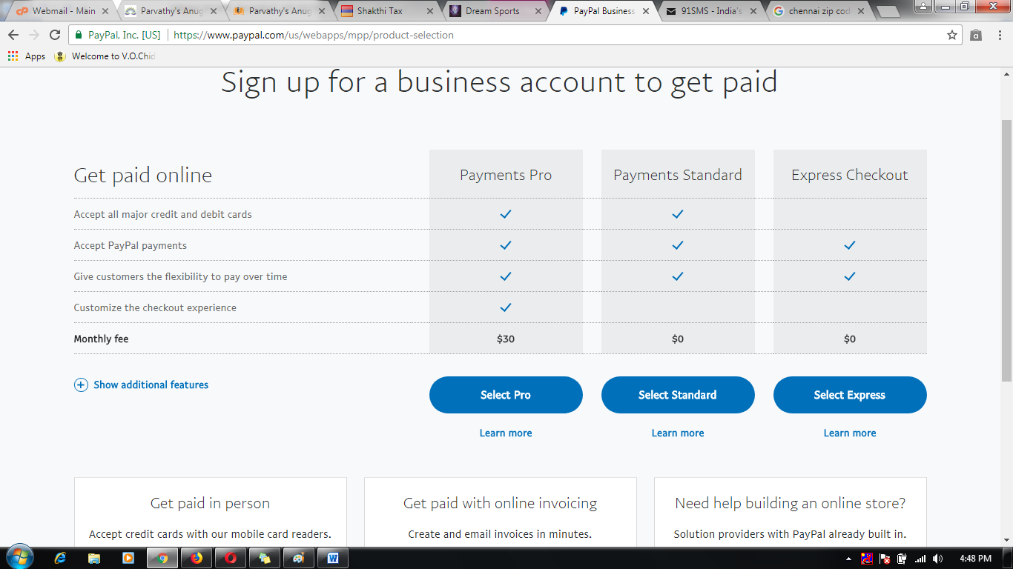

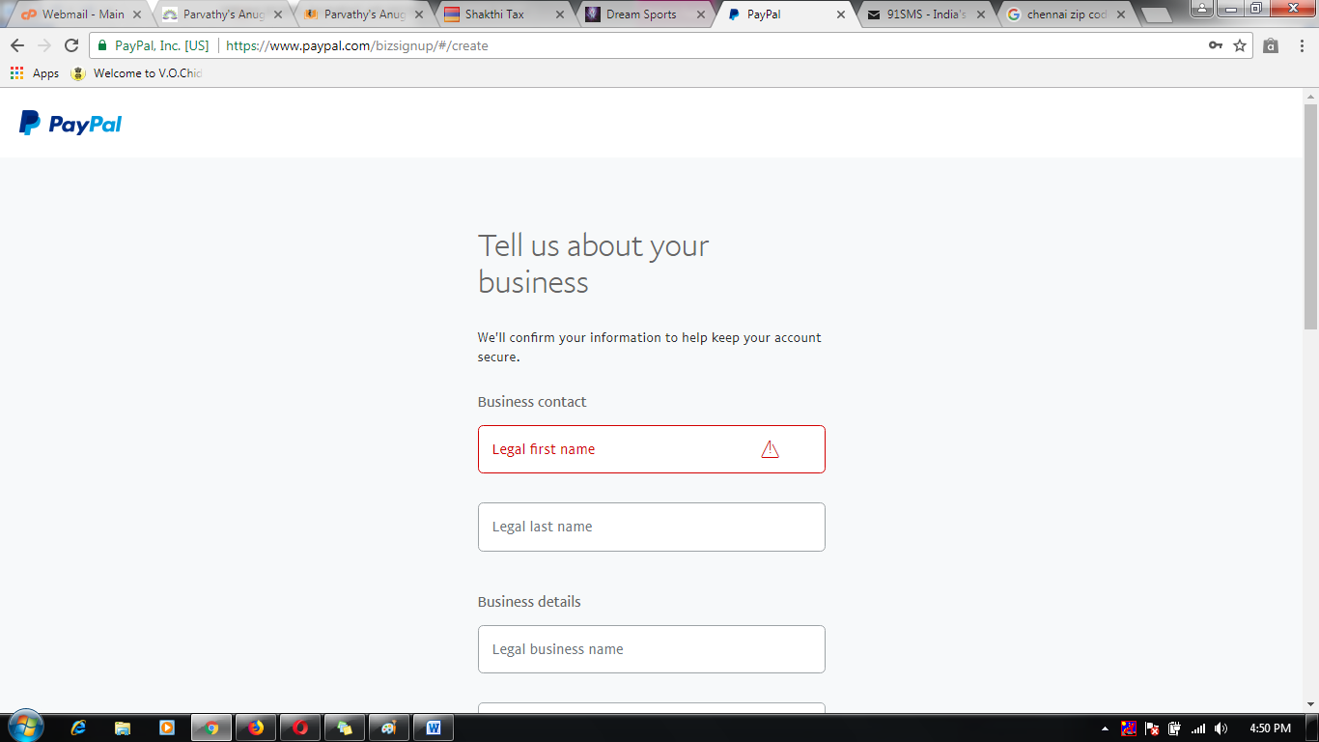

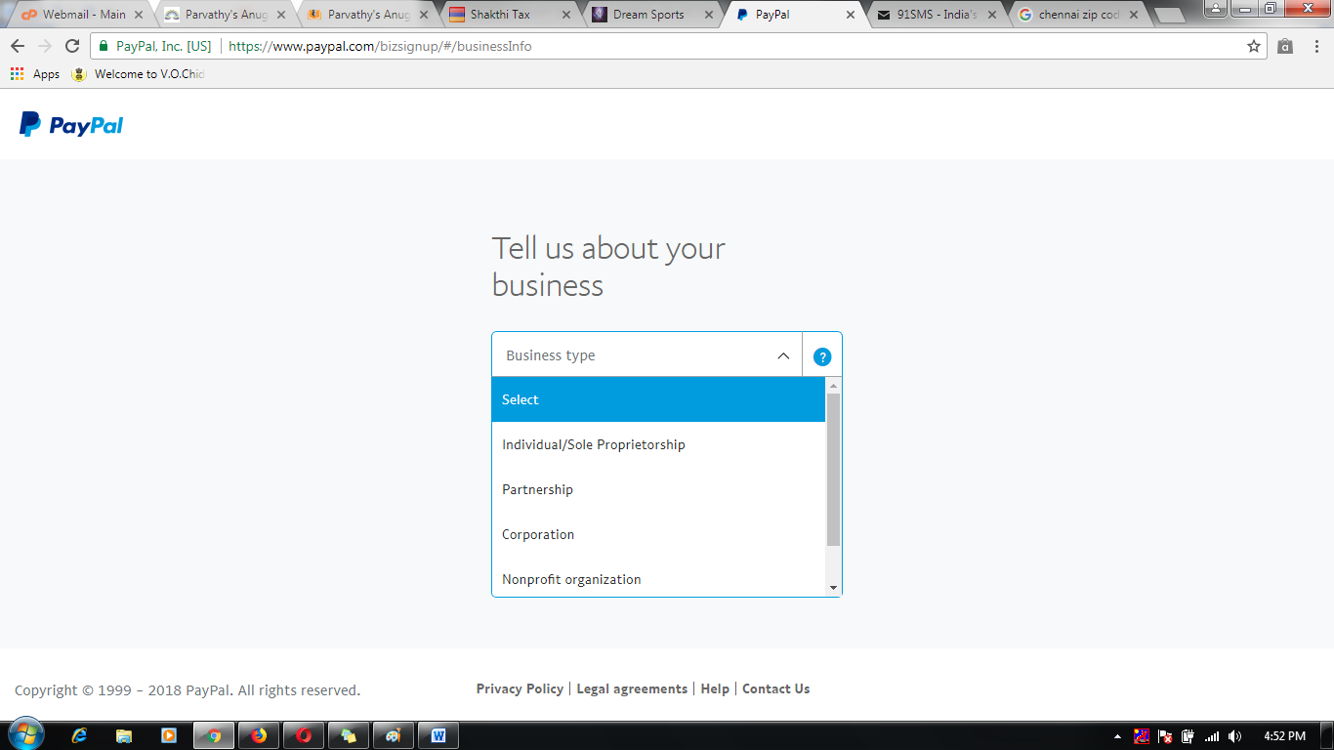

1. Successfully registered then to check it mail id.

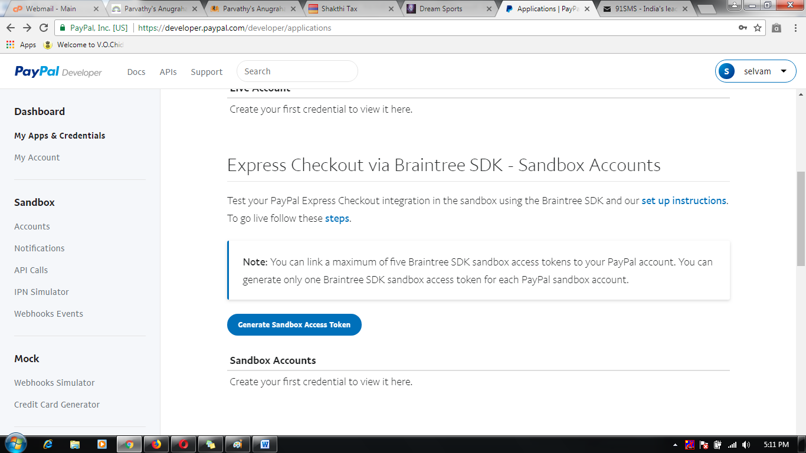

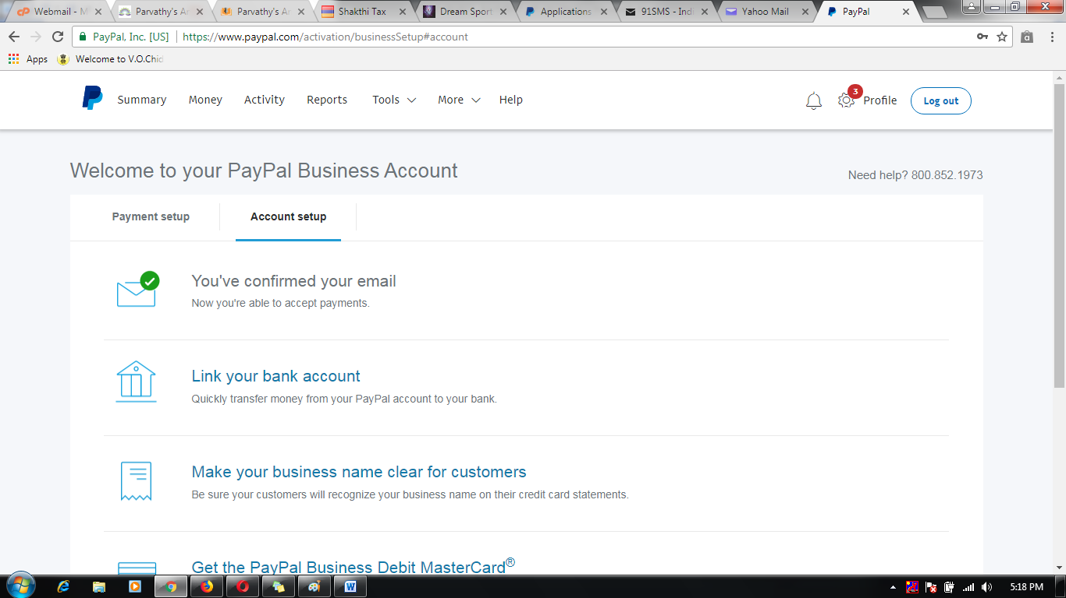

1. Take the mail id to apply the PayPal payment credential API settings.

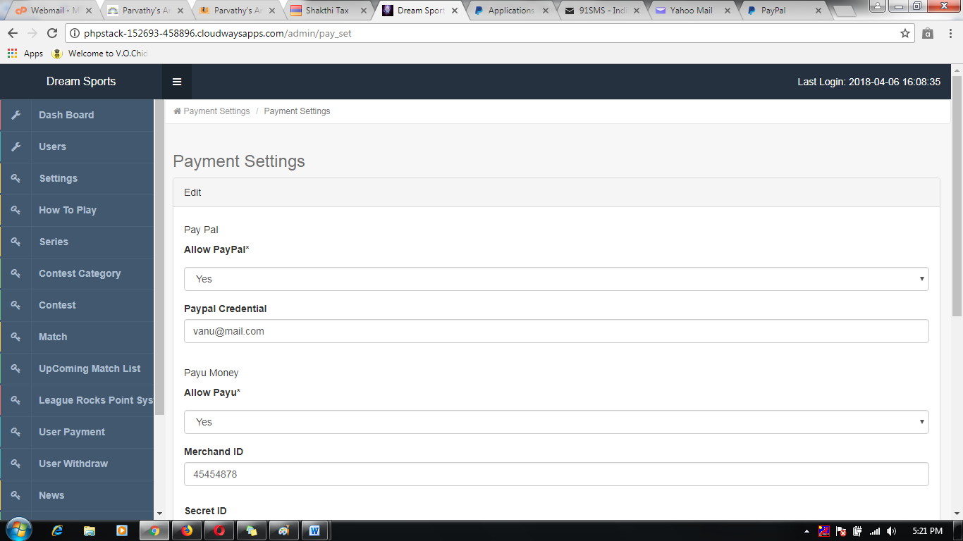

MELO SPORTS PAYU PAYMENT API SEETINGS

1. How to get in payu payment settings app id details.

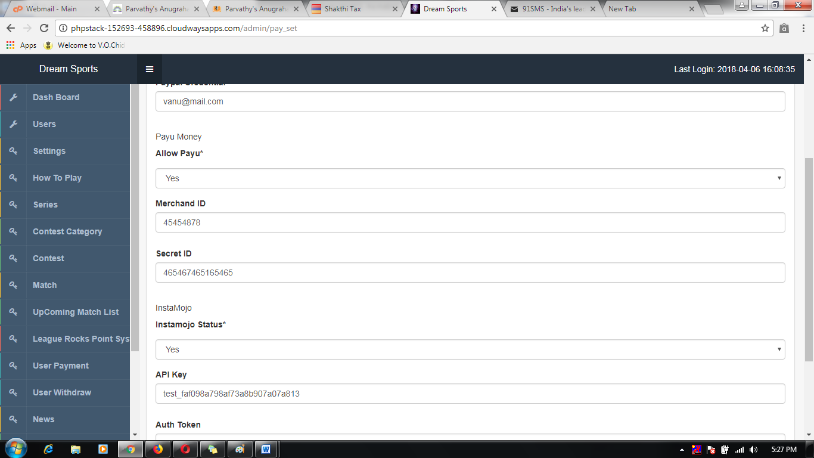

1. Visit payu payment developer site.

*Link:* [*https://www.payumoney.com*](https://www.payumoney.com)

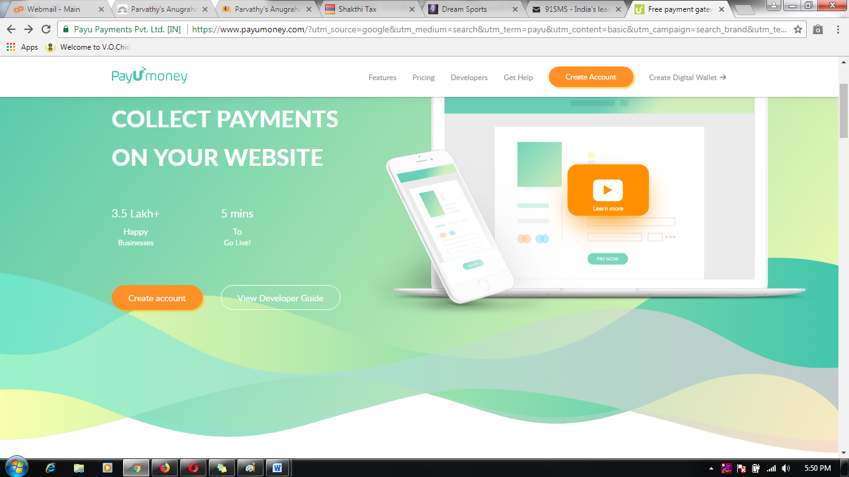

1. Register and login to PayPal account

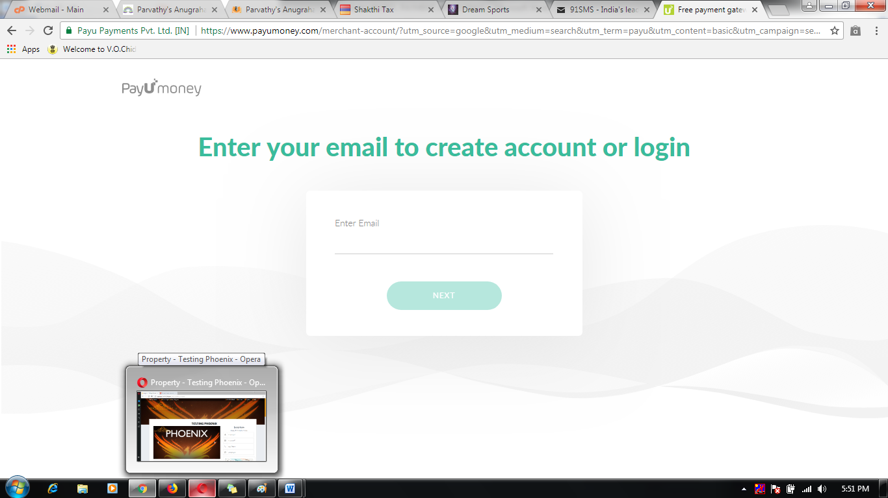

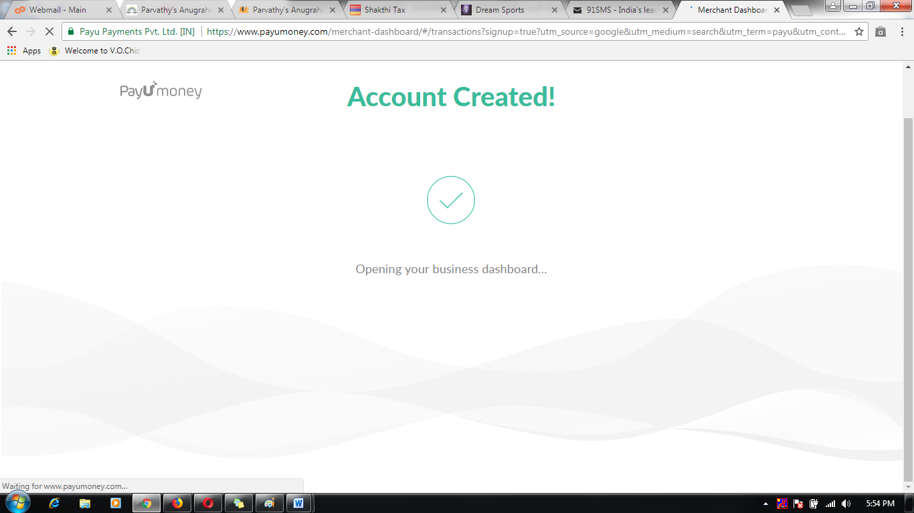

1. Successfully registered then to check it merchant id And Secret id details.

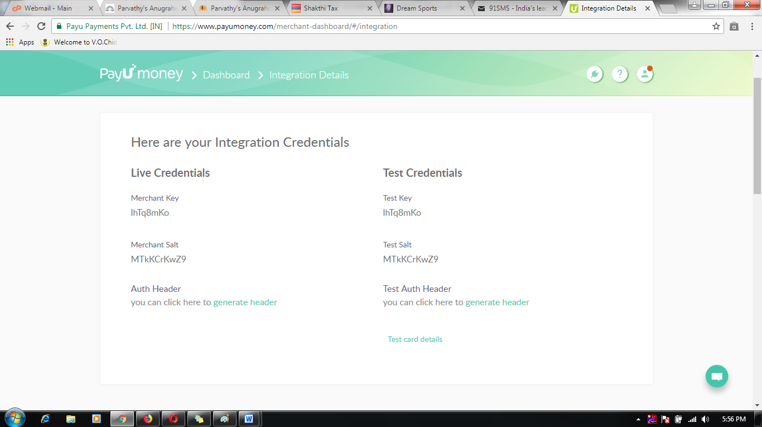

1. Take the mail id to apply the payu payment credential API settings.

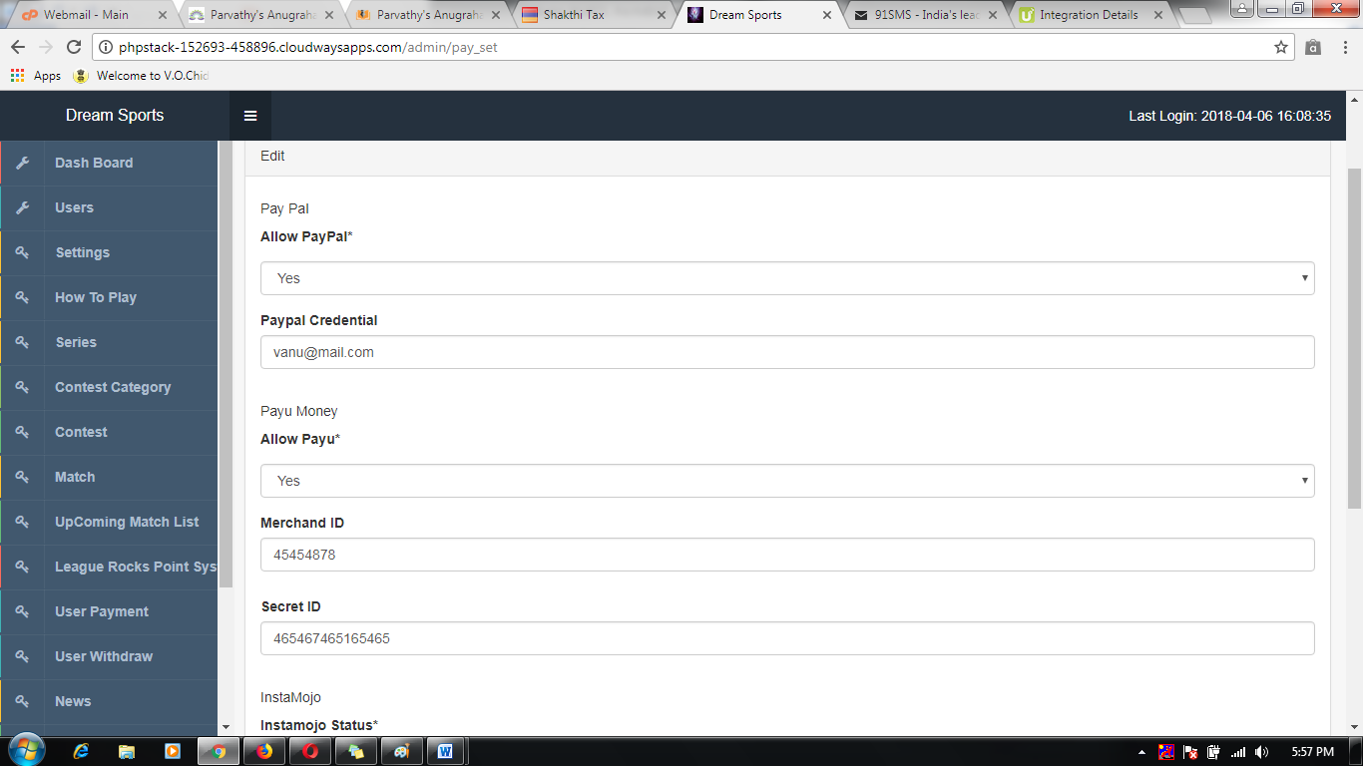

MELO SPORTS INSTAMOJO PAYMENT API SEETINGS

1. How to get in Instamojo peyment settings app id details.

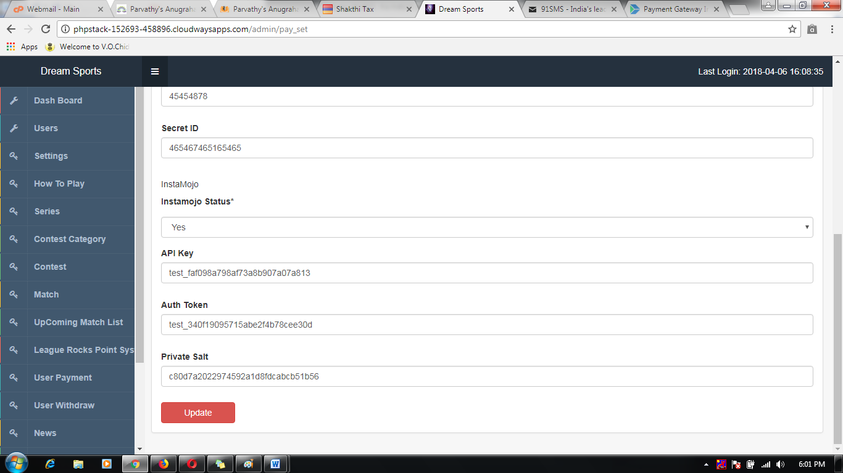

1. VisitInstamojo payment developer site.

Link: [*https://www.instamojo.com/developers/*](https://www.instamojo.com/developers/)

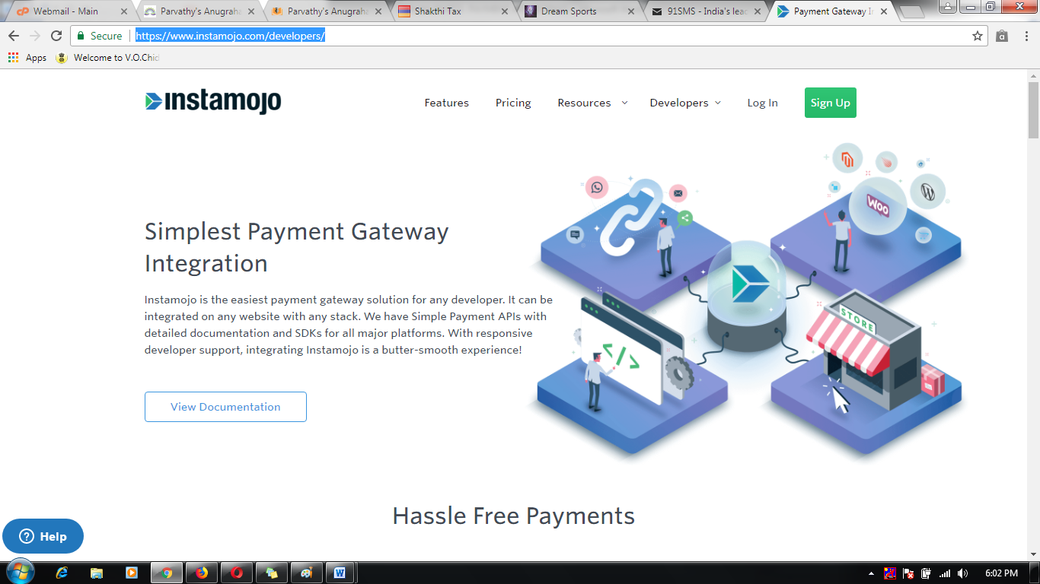

1. Register and login to Instamojo account

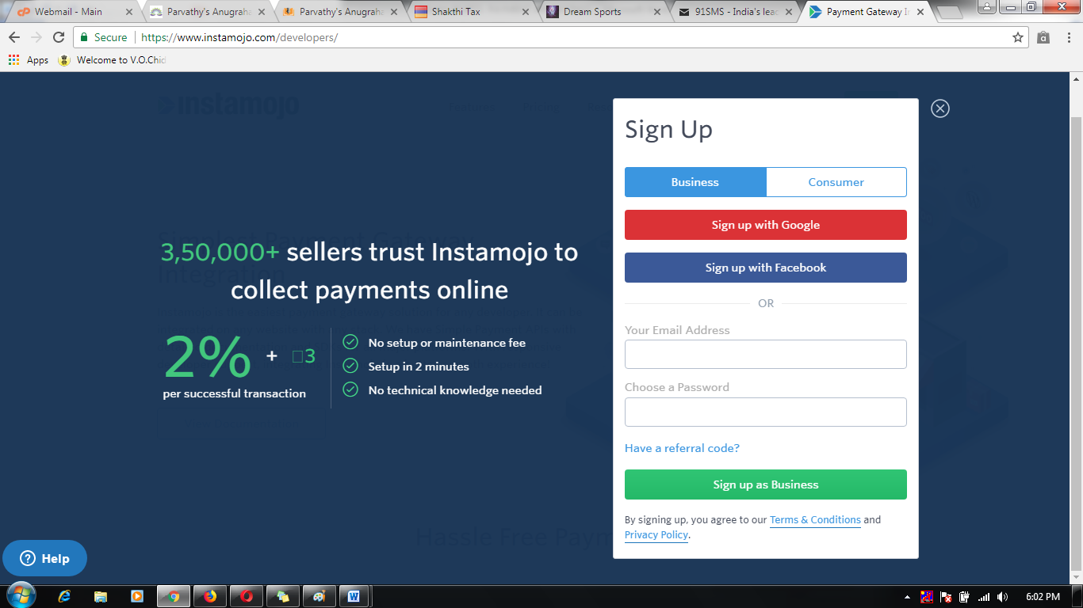

1. Successfully registered then to check it private id And Auth token id and private salt id details.

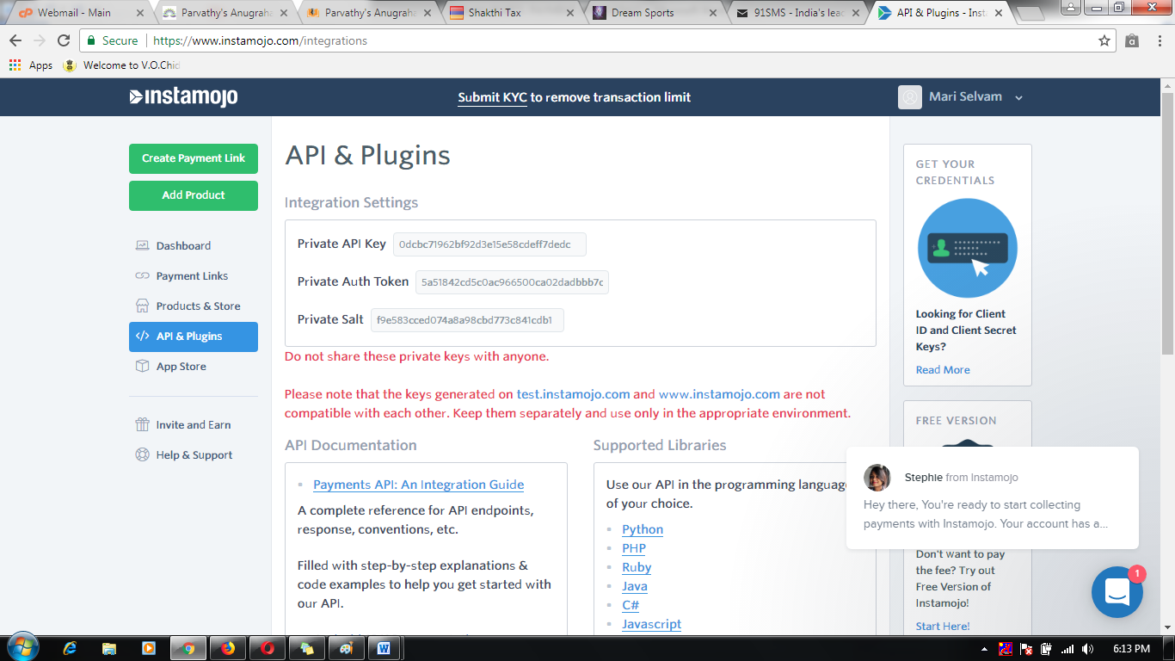

1. Take the mail id to apply the Instamojo payment credential API settings.

