MELO SPORTS 91SMS API SEETINGS

1. How to get in 91sms settings app id details.

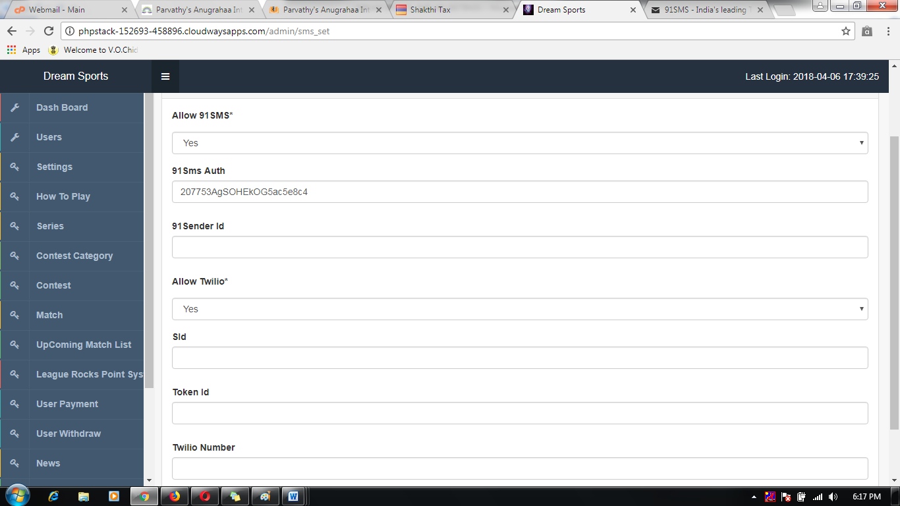

1. Visit 91sms developer site.

*Link:* [*http://www.91sms.in/*](http://www.91sms.in/)



1. Register and login to 91sms account

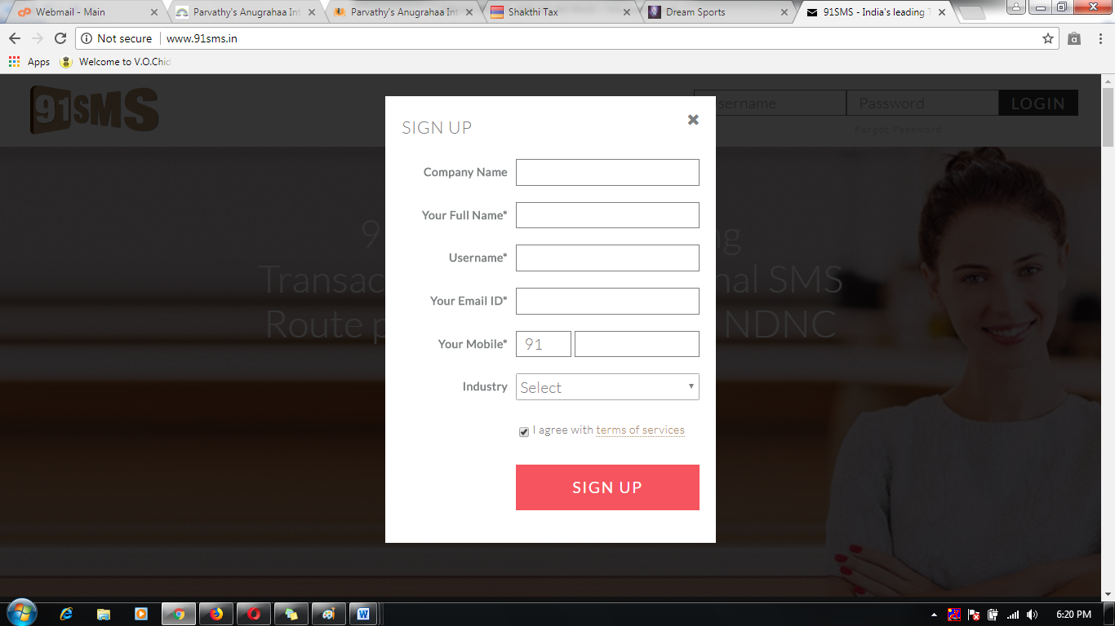

1. Successfully registered then to check it Auth id and sender id details.

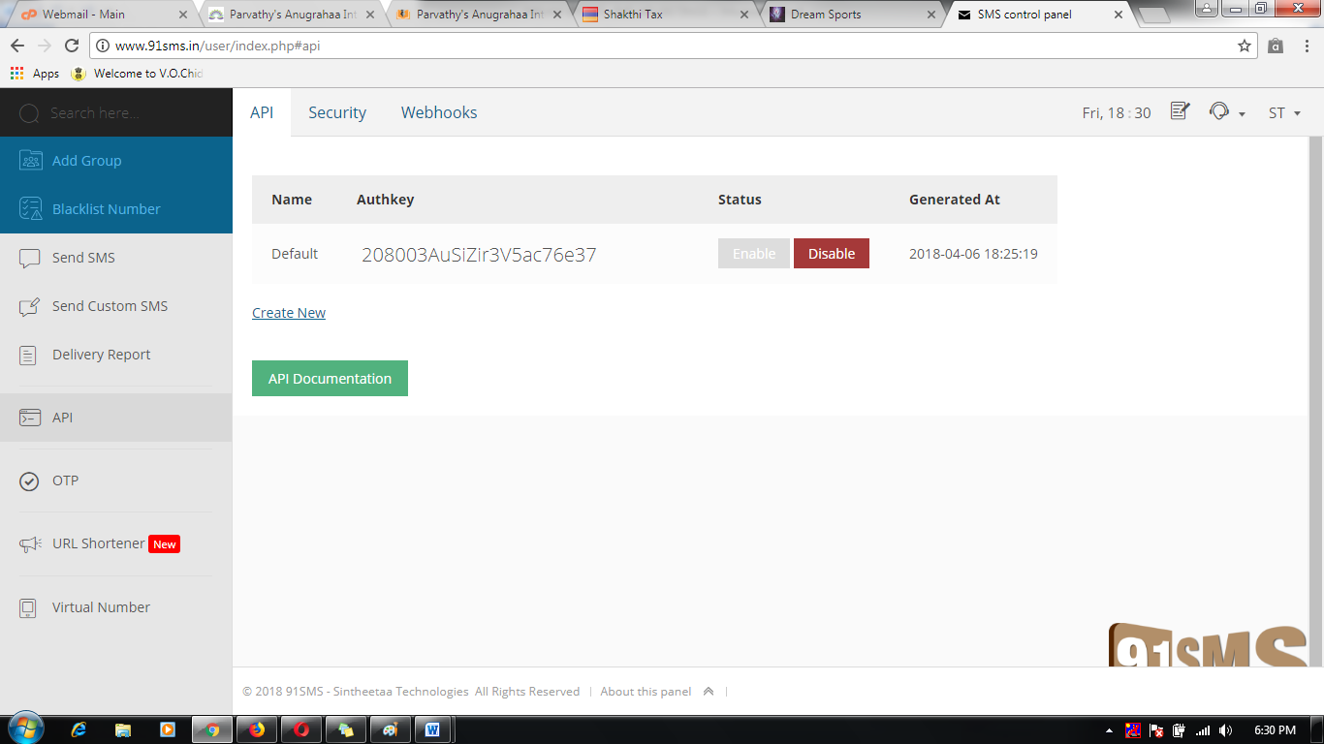

1. Take their id to apply the 91sms credential API settings.

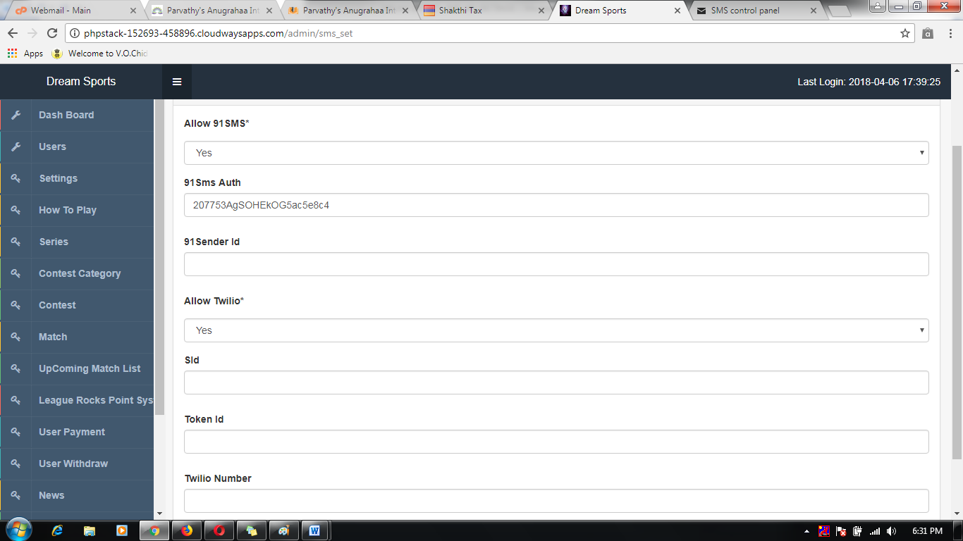

MELO SPORTS TWILIO SMS API SEETINGS

1. How to get in Twiliosms settings app id details.

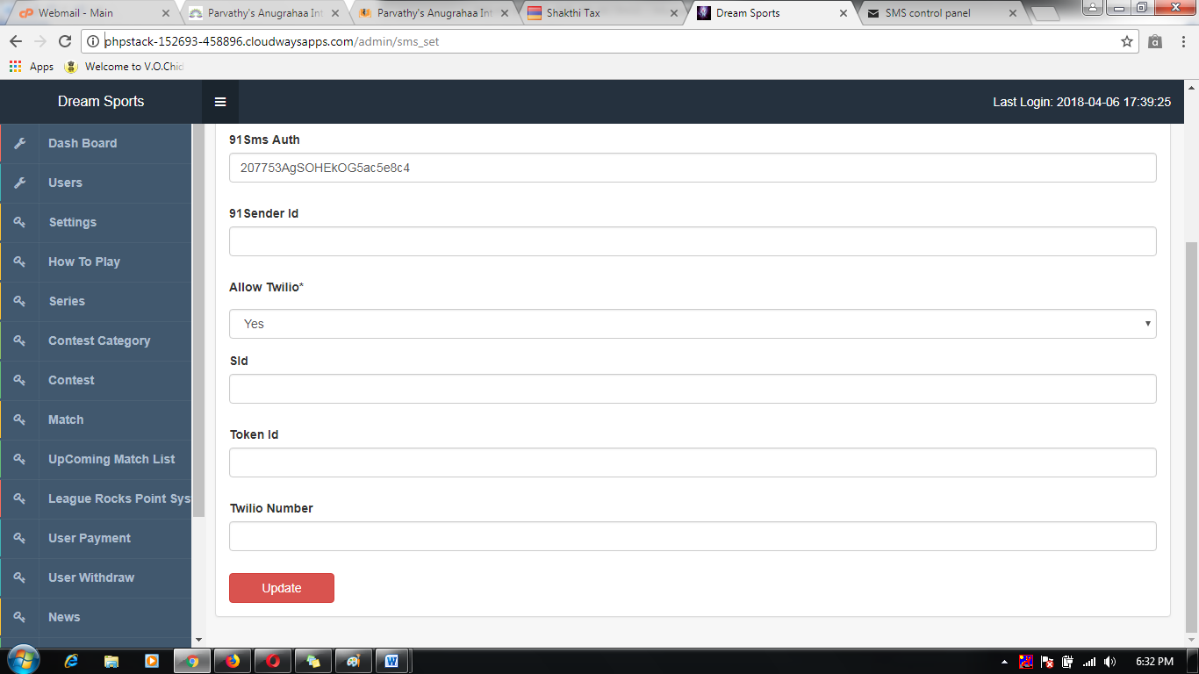

1. Visit Twiliosms developer site.

*Link:* [*https://www.twilio.com/docs/*](https://www.twilio.com/docs/)

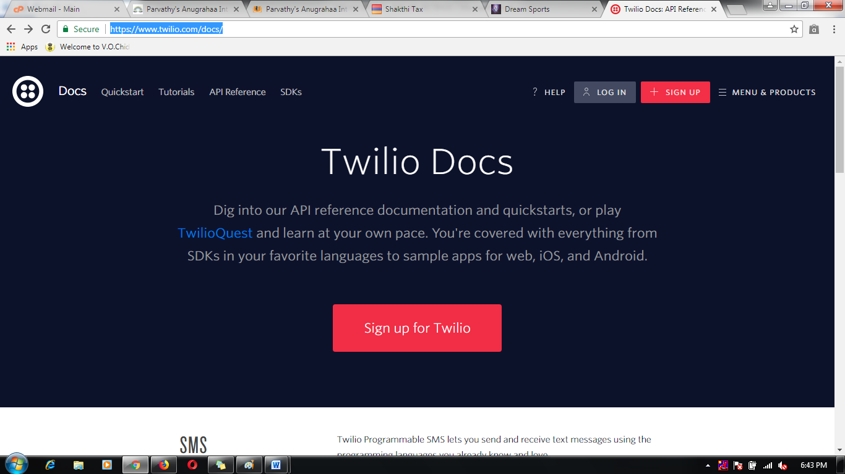

1. Register and login to Twiliosms account

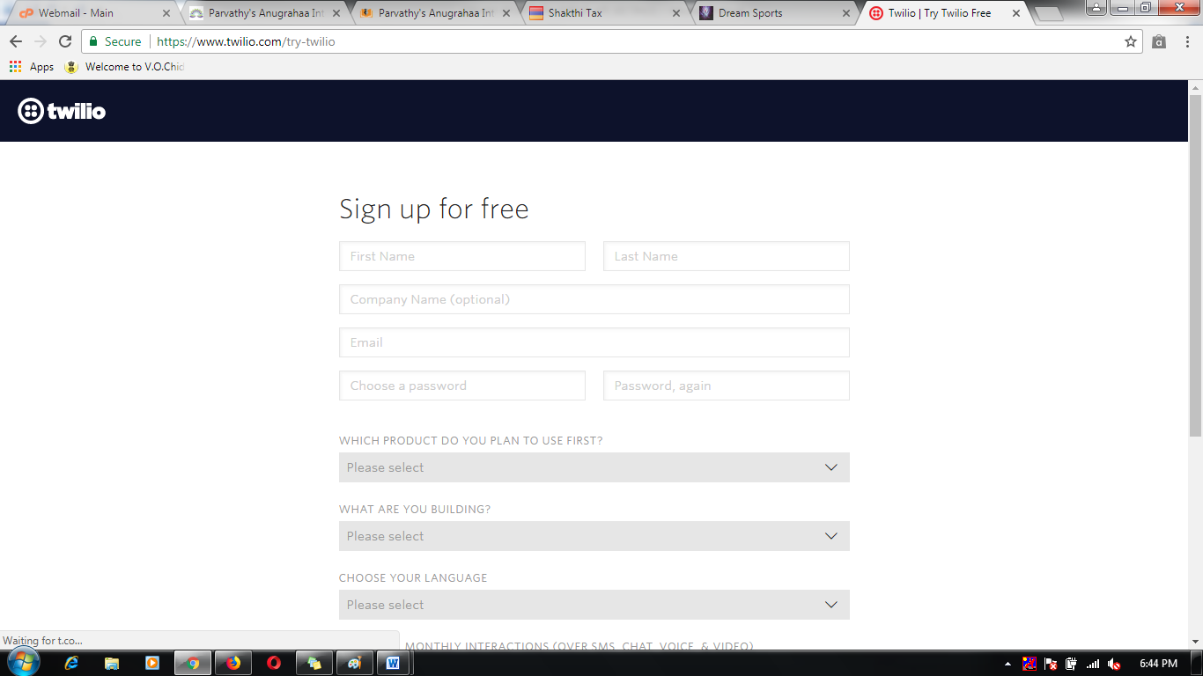

1. Successfully registered then to check it Token id Andtwilio id details.

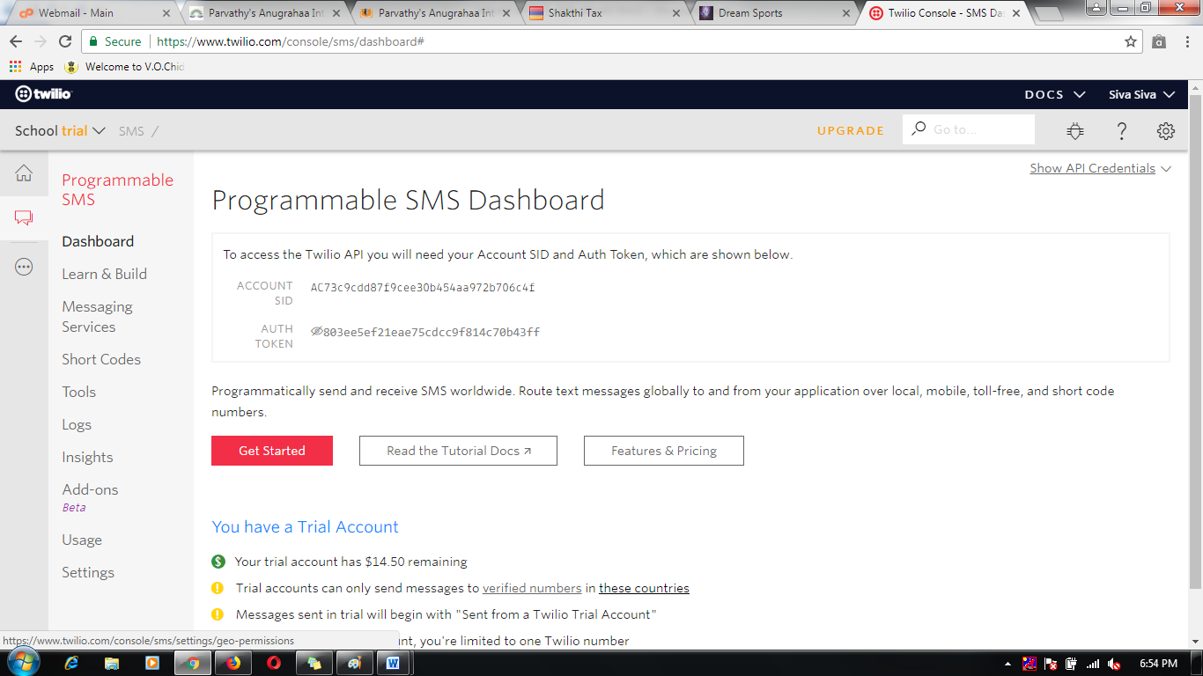

1. Take the are id to apply the Twiliosms credential API settings.

