Computer Science I RUNNING DUDE 2 Lab Value - 100

Lab Goal : This lab was designed to teach you more about the GridWorld case study.

Lab Description : Now that RunningDude has been written and tested, it is time to RunningDudeWorld. RunningDudeWorld will trap key presses to see which direction the RunningDude needs to go. RunningDudeWorld will set the direction of the RunningDude in the RunningDudeWorld each time an array key is pressed. A RunningDude will run in its current direction as far as it can go until an arrow key is pressed telling the RunningDude to change direction or until the RunningDude hits a wall.

Files Needed ::
RunningDude.java
RunningDudeWorld.java
RunningDudeWorldRunner.java
GridWorld Project

Sample Data :
none

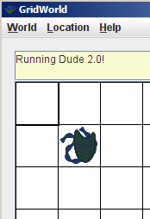
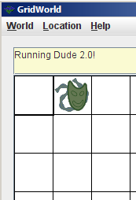
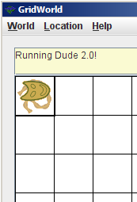
Sample Output :

