Introducing Firesand Auth Matrix Prototype: bridging the gap between Postman and Autorize

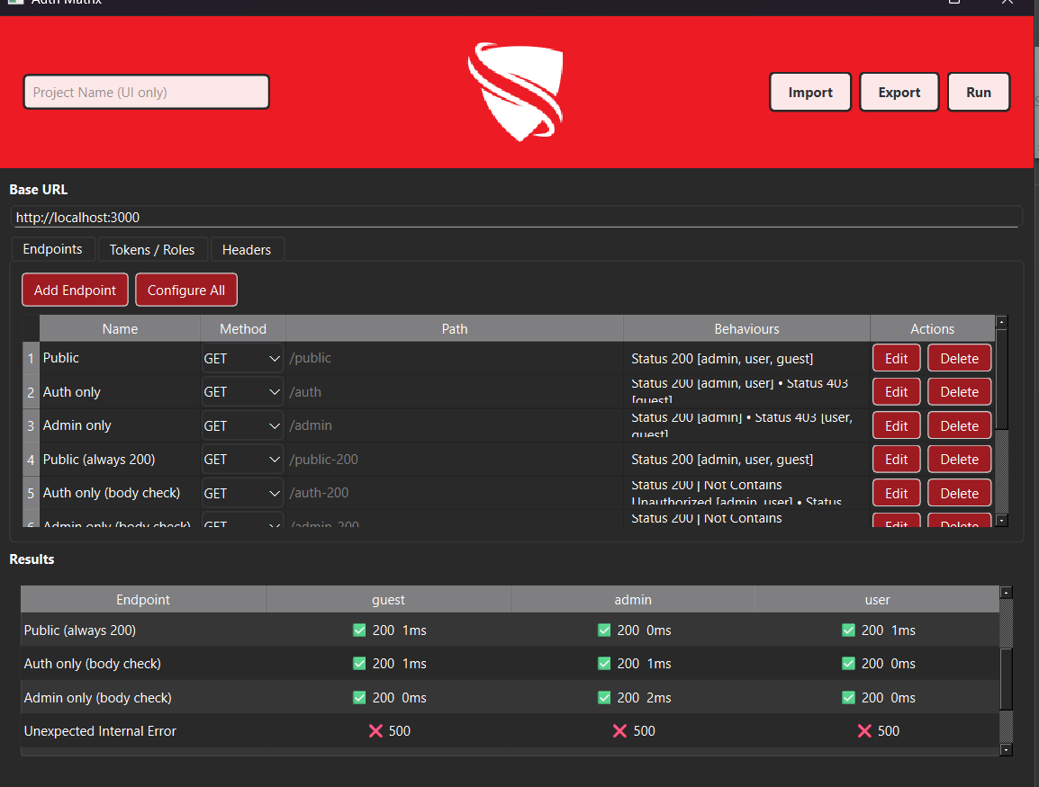

Authorization testing is one of those things every tester and developer knows is important but rarely enjoys doing. It is repetitive, easy to miss edge cases, and difficult to automate cleanly across roles.

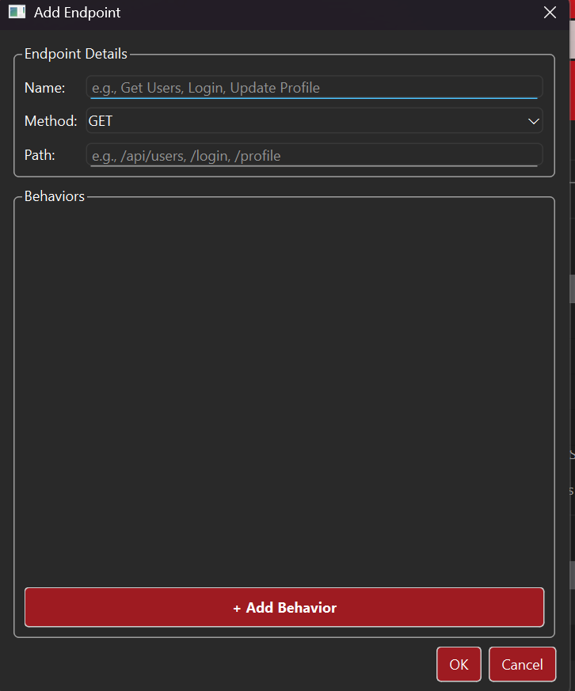
Postman can do it if you write scripts for every role and expected status code, but you either need a separate collection for each authorization level, or a custom script to switch tokens between roles.
Autorize in Burp Suite can do it live as you browse, catching real requests in motion. Both are powerful, but neither is built specifically for repeatable role-based access control testing.

Firesand Auth Matrix sits right in between. It is designed for one purpose: validating that each role in your API gets the responses it should, and nothing more.

You can import your existing Postman collections or a lightweight JSON spec, define the roles and their tokens once, and hit Run.
The tool fires every endpoint against every role, then displays the results in a clean matrix. A single unexpected 200 where a 403 should be stands out immediately.

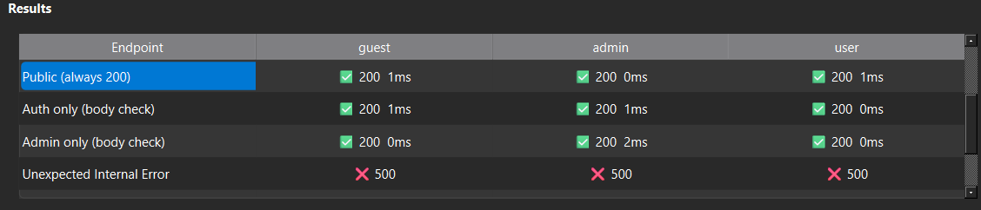

Compared to Postman, it removes the scripting overhead. Compared to Autorize, it adds structure, repeatability, and exportable results. It is quick enough for pentests, stable enough for regression checks, and visual enough for developers to interpret without extra tooling.
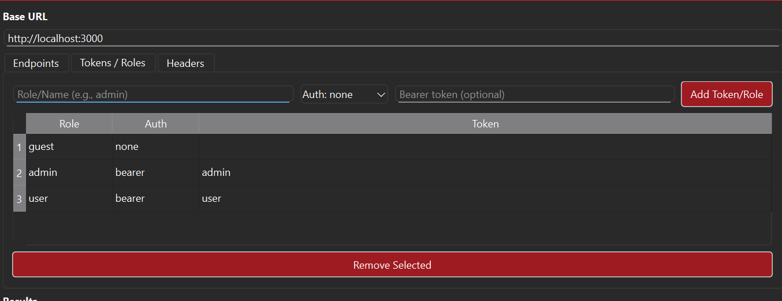

The tool was built at Firesand to speed up real API reviews, especially where there are multiple roles, environments, and token types. It helped us find subtle privilege leaks that would otherwise take hours to notice.

If you have ever swapped tokens manually in Postman or replayed the same requests in Autorize, this is the halfway point you probably wished existed.

