KING MONGKUT INSTITUTE OF TECHNOLOGY LATKRABANG

FACULTY OF ENGINEERING

ENGINEERING GROUP OF (**RAI : Section)**



01006702– PHYSICS -I LABORATORY

Lab Title :………………………………………….

**INSTRUCTED BY:** aSHAN KUDABALAGE

**NAME:** First name only (Supun,Ashan,Nalan,James)

**STudent ID:**

**GROUP NO:** BME 1/RAI 10

**DATE OF SUB.:** 21/08/2019

1. **Purpose**

Objective of your experiment : Write in Point form(Please refer the example)

1. **Summary of theory**

Summarize the Physics concepts (Henderson, n.d.) you have used in the lab – Write in point form

1. **Pre-Lab Exercises**

Complete the Pre-Lab exercises if you are given any in the lab sheet

* 1. **Exercises**

Complete the Exercises if you are given any in the lab sheet

1. **Procedure**

Write the procedure of the experiment in point form. Refer the example Lab

* 1. **Observations**

Write your Observations of the experiment in point form. Refer the example Lab

* 1. **Results**

Show the Results of your Experiment

* 1. **Calculations**

Example Calculation if any

1. **Conclusion**

Conclude your lab experiment using the results

1. **Discussion**

Write a point form discussion base on your observations, facts from theory and Recommendations for the lab experiment

# **References**

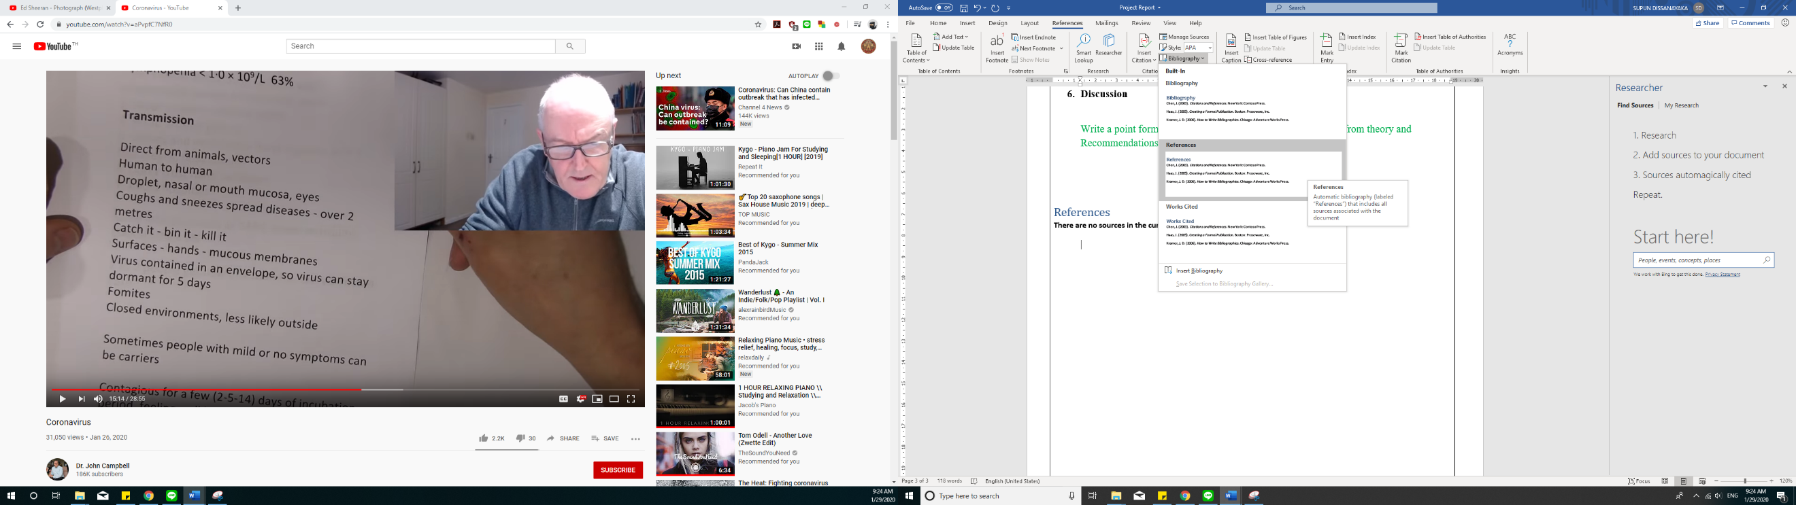For the Style of References follow the following style of the word – See the example given below

# References

Henderson, T. (n.d.). *the Physics Classroom*. Retrieved from the Physics Classroom: https://www.physicsclassroom.com/The-Laboratory