**Overall Build Introduction**

This custom build personal computer (PC) parts were made under a budget of 40,000. This PC excludes the peripherals such as the monitor, keyboard and mouse. Like any custom-built PCs, this model is highly modular meaning that the parts could be customized even further for the user’s workflow. To standardize the prices for all the parts in this system, the parts are chosen from only two retailers only (Advice and JIB). This PC focuses on the ability to do most common workflow for a PC such as gaming and productivity. This essay will focus more on the reasons why the parts in a lesser technical term because the numbers does not tell everything in real world usage.

**CPU (Central Processing Unit) Intel Core i5-13400F**

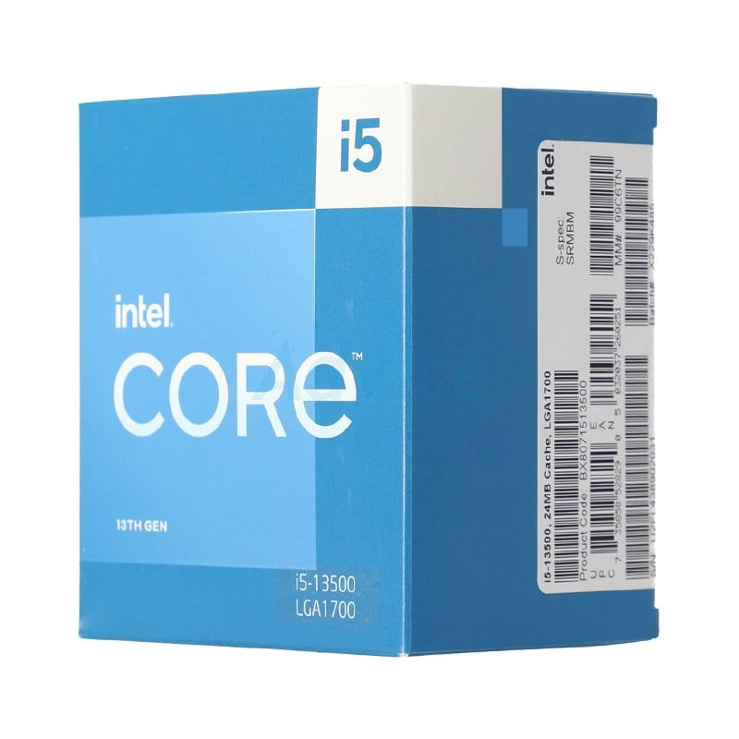

Technical Specifications

* <https://ark.intel.com/content/www/th/th/ark/products/230580/intel-core-i513500-processor-24m-cache-up-to-4-80-ghz.html>

Reasons to Pick this processor.

* This processor uses one of the newest technologies in the desktop CPU market. Including one of the most advanced CPU manufacturing process node of 10nm (called Intel 7) which provided more efficiency,
* In addition to the first point above, the Intel Core i5 contains 8 efficiency cores and 6 performance cores. This design allows for the CPU to use lesser power on IDLE or doing basic tasks such as watching YouTube or editing documents.
* The Performance cores of the core i5-13500 is 2.5GHz at base and 4.8GHz at boost which translates into a very competitive CPU in terms of price to performance compared to their competitor, the AMD Ryzen 5 7600. The performance cores are very competitive in terms of gaming
* The Ryzen 5 7600 is priced lower (at 9,150 Baht) than the i5-13500 (at 9,890) however the motherboard for the newer AM5 motherboard is higher than the last generation B660 motherboard which contains similar features to the current generation board (B760 Chipset).
* This CPU supports DDR4 ram which is becoming cheaper as the newer DDR5 is entering the market. Newer DDR5 does not impact too much on common tasks such as gaming.

Reference

* <https://www.youtube.com/watch?v=77Xdpmwh8S0&ab_channel=HardwareUnboxed>

**CPU Cooler (CPU Heatsink) ID COOLING SE-224-XTS BLACK**

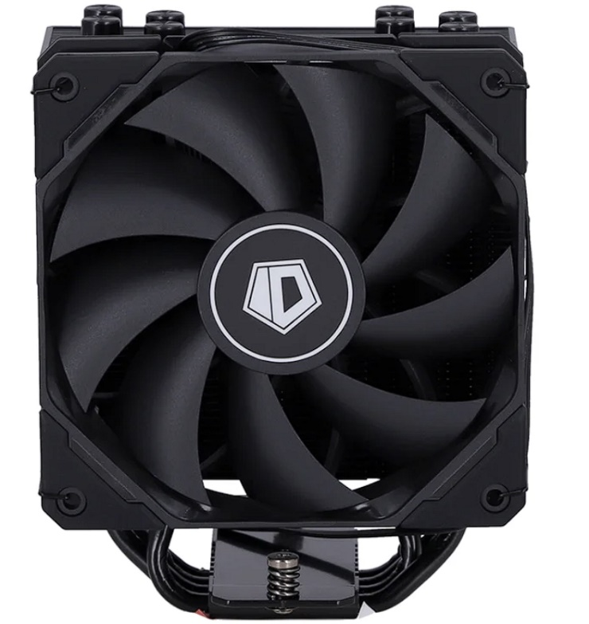

Reasons to pick this CPU cooler:

* The price is very low for a high-performance cooler at only 890 Baht. The 120mm fan on the CPU heatsink does make a good upgrade to the stock cooler (The cooler that came with the CPU).
* The CPU chosen was also very hot underload and requires this cooler in order to operate well and not thermal throttle too hard or make the system overheat. The design of the cooler also looks clean.
* The mounting mechanism is also very easy to install on your system which means that not too many setups are required.

**Motherboard MSI Pro B660M-P**

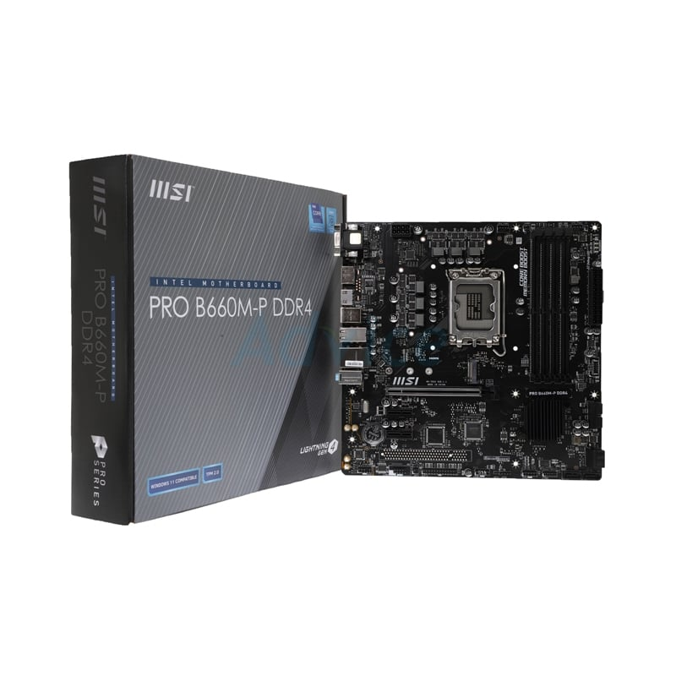

Specifications

* <https://www.msi.com/Motherboard/PRO-B660M-P-DDR4>

Reasons to pick this motherboard:

* This micro ATX motherboard with a mid-range chipset (Intel B660) is priced reasonably at 3,700 Baht. This motherboard contains four memory slots which is useful for upgrades later down the line. Mostly this part was chosen for the price.
* The VRM of this motherboard was sufficient for the CPU used for this system. The VRM does not heat up easily under sustained load.
* The motherboard does feature an M.2 PCIe gen 4 SSD slot which is also good for upgrades later down the line. The SSD chosen for this build is not a gen 4 SSD since the benefits are not much compared to their gen 4 counterparts. More will be explained later on the SSD section.
* Also worth mentioning is that this motherboard features a HDMI Port which could be useful in case of troubleshooting graphics card related problems.
* Although this motherboard is not a high-end model, the performance should be identical to the higher end chipset motherboard.
* This motherboard also contained 4 USB Type A 3.0 and 1 USB Type C 3.2 Gen 2 for peripherals which is enough for most people.

**RAM DDR4 Kingston Fury Beast (16GB, 3600MHz, CL17)**

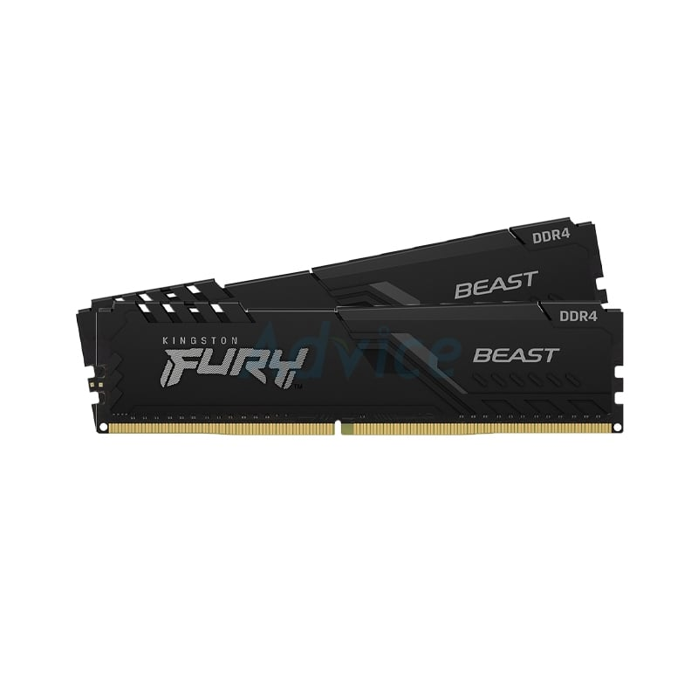

Reasons to buy this RAM kit:

* The price at 2,345 Baht is very cheap for a 16 GB kit of DDR4 3600MHz RAM. The reason why DDR4 was chosen instead of the newer and faster DDR5 is because of the most common task did not use that much bandwidth that DDR5 offers therefore, it is not necessary.
* The speed of this RAM kit is also very good for its price. Other RAM kits at this specification could cost up to 3500 Baht. The latency of this ram kit (timing) is also pretty good (CL 17).
* This RAM also came with an integrated heat spreader which helps the RAM cool itself easier with the natural airflow inside your PC.

References

* <https://www.youtube.com/watch?v=tN7Bv_adHs0&ab_channel=LinusTechTips>

**GPU (Graphics Processing Unit) - MSI RADEON RX 6750XT MESH 2X OC - 12GB GDDR6**

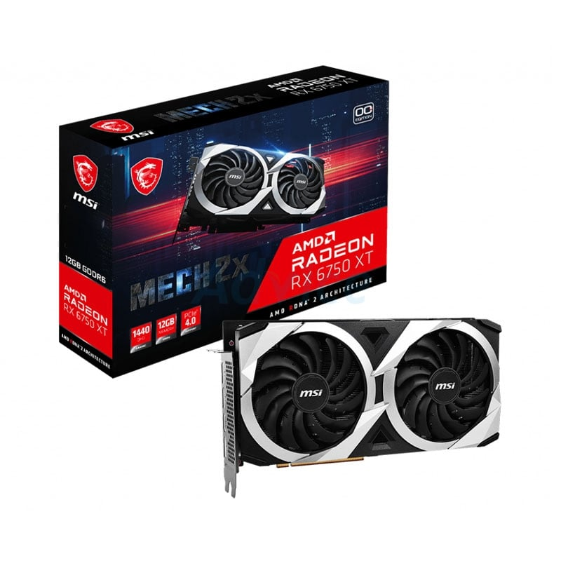

Specifications

* <https://www.amd.com/en/products/graphics/amd-radeon-rx-6750-xt>

Reasons to buy this Graphics card:

* This MSI model features a twin fan cooling design attached to a heatsink which helps the Graphics chip and its VRAM to be cool underload.
* Although this Graphics Card is not the latest generation, the performance still holds up well but as this price range, the older generation still holds a very good value and most people does not need the latest and the greatest hardware to satisfy th
* As mentioned above since this card have 16 GB of video memory combing with the processing power of the RX 6750XT, the graphics card could use to render games at a high resolution with high frame rates (such as 1440p at 100+ FPS in AAA titles). This also helps the graphics card to compute and do A.I training and Video Editing tasks too.
* The price of this Graphics also contributes to its value. At this price point, the Graphics card from NVIDIA that you can get is the RTX 3060Ti which was slower in both games and some productivity loads (see the references for more information). However, the RTX 3060Ti does have an upper hand when the games are rendered using Ray Tracing mode rather than the traditional rasterization rendering. (Around 5-15% faster in games depending on the render resolution)
* Although the performance of the Ray Tracing maybe lower than its competitors, the performance is not bad but usually Ray Tracing rendering have too much impact on performance and should not be used in most games that required a higher frame rate (FPS).

References

* <https://www.youtube.com/watch?v=Lg-TcVrh8rA&ab_channel=HardwareUnboxed>

**Storage WD Blue SN570 1TB M.2 PCIe Gen 3**

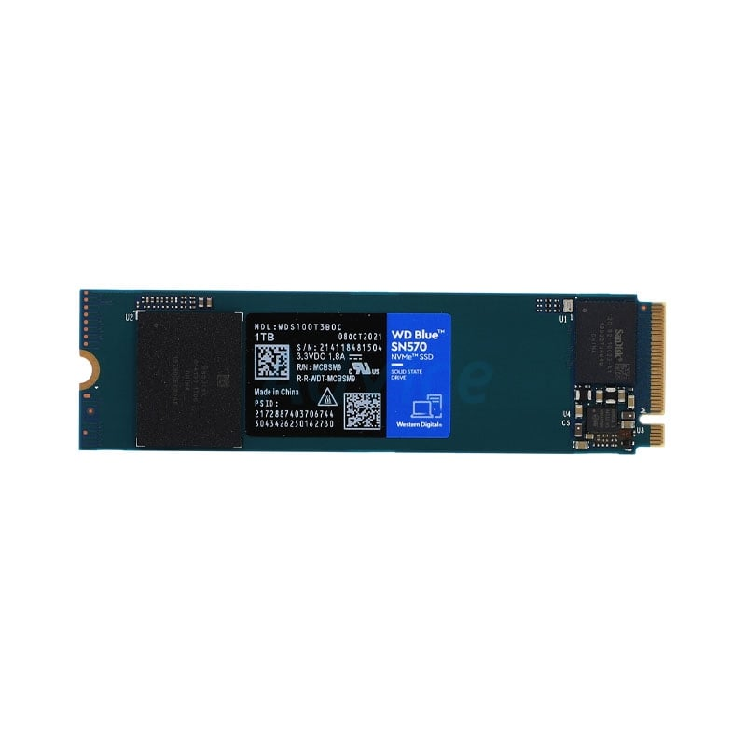

Specifications

* <https://www.westerndigital.com/th-th/products/internal-drives/wd-blue-sn570-nvme-ssd#WDS250G3B0C>

Reasons to buy this SSD:

* The price at 2940 Baht is very cheap for a 1TB M.2 NVMe SSD. Although the speed is not as high as the newer 4th generation ones, the performance in normal workload was not affected by the speed of the SSD. Usually, a 1 TB SSD with similar specifications or slightly higher ones are going for 3000+ Baht.
* Compared to traditional hard disk drives (HDD), the SSD is much faster which allows for a faster boot time (From PC turning off and booting to the operating system). Copying files and navigating around the operating system will be much snappier and smoother.
* The capacity of the SSD is very sufficient for an average person. According to personal experiences, a 1 TB of storage doesn’t really fill up even though many programs and games are installed in the system.

**PSU (Power Supply Unit) Corsair CV650 650W (80+ Bronze)**

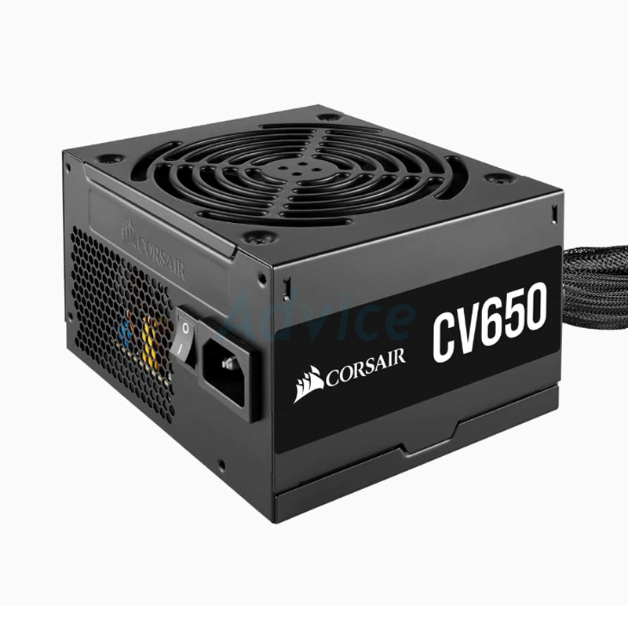

Specifications

* <https://www.corsair.com/us/en/Categories/Products/Power-Supply-Units/Power-Supply-Units-General-Purpose/CV-Series/p/CP-9020211-NA>

Reasons to buy this PSU:

* At 2,045 Baht, this power supply can supply up to 650W of power which is sufficient in both long terms and short terms of heavy usage. The reason why the 550W or lower models was not chosen is due to the fact that the Power Supply degrade overtime which means that it could supply less power. Having an overhead for the power supply will be better in the long term.
* This power supply unit have an 80+ Bronze rating which means that the PSU can supply power efficiently within load. Some power supply with this amount of wattage does exist but the quality is not that good. In addition, the said PSU usually doesn’t have 80 + certification.
* In terms of cables (which was attached to the PSU), it was black and high-quality meaning that it will not get broken easily. The aesthetics was also cleaner than the multi-colored ones.
* The cables given are also enough for most PC builds which contained more MOLEX and SATA Power cables for more expansion later. (This build does not use SATA drives)

**Case (ATX) NZXT H5 Flow (Black)**

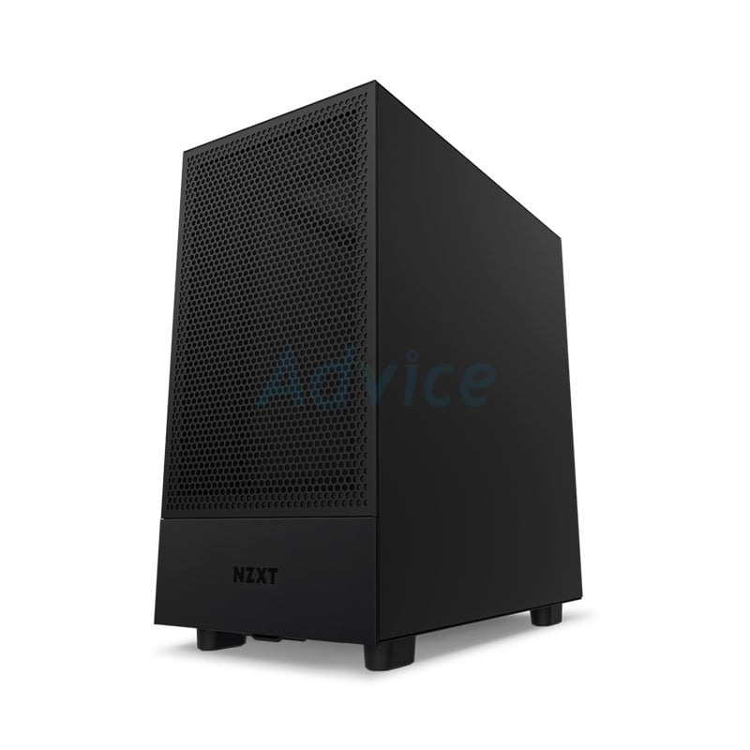

Reasons to buy this case

* This case is easy to build on since it contains large space and cable ties and routes for easier cable management. They also provided ventilation in the front, top and back of the case which could translate to a much more reliable thermal performance.
* In terms of I/O, this case features two USB Type A (One is 3.2 Gen 1 and another is 3.2 Gen 2) with a 3.5mm headphone and microphone jack. In terms of expandability this case features one 3.5- and 2.5-inch drive bays for HDD and SSD if needed. This case also supports up to 140mm fans and have support for radiator mounts if needed in the future. (This build uses air cooling)
* The build quality of this case is also very good since it uses SGCC Steel which is stronger than most cases in the market and also features a tempered glass side panel for aesthetic choice.

**Overall Build**

|  |  |  |  |
| --- | --- | --- | --- |
| **Parts** | **Name** | **Price** | **Link** |
| **CPU** | **Intel Core i5-13500** | **9890** | [**Advice**](https://www.advice.co.th/product/cpu/intel-1700/cpu-intel-core-i5-13500-lga-1700) |
| **Storage** | **WD Blue SN570 1TB PCIe Gen 3** | **2940** | [**Advice**](https://www.advice.co.th/product/ssd-solid-state-drive-/ssd-m-2-pcie-nvme-1-tb/1-tb-ssd-m-2-pcie-wd-blue-sn570-wds100t3b0c-nvme) |
| **Cooler** | **ID COOLING SE-224-XTS BLACK** | **890** | [**JIB**](https://www.jib.co.th/web/product/readProduct/56531/783/CPU-AIR-COOLER--%E0%B8%9E%E0%B8%B1%E0%B8%94%E0%B8%A5%E0%B8%A1%E0%B8%8B%E0%B8%B5%E0%B8%9E%E0%B8%B5%E0%B8%A2%E0%B8%B9--ID-COOLING-SE-224-XTS-BLACK) |
| **MB** | **MSI Pro B660M-P (DDR4)** | **3700** | [**Advice**](https://www.advice.co.th/product/mainboard/intel-1700-b660-ddr4/mainboard-1700-msi-pro-b660m-p-ddr4) |
| **RAM** | **16GB DDR4 Kingston Fury Beast 3600MHz** | **2345** | [**Advice**](https://www.advice.co.th/product/ram-for-pc/pc-ddr4-3600-/ram-ddr4-3600-16gb-8gbx2-kingston-fury-beast-kf436c17bbk2-16-) |
| **GPU** | **MSI RX6700XT 12GB GDDR6** | **13900** | [**JIB**](https://www.jib.co.th/web/product/readProduct/46798/2187/VGA--%E0%B8%81%E0%B8%B2%E0%B8%A3%E0%B9%8C%E0%B8%94%E0%B9%81%E0%B8%AA%E0%B8%94%E0%B8%87%E0%B8%9C%E0%B8%A5--MSI-RX6700XT-MECH-2X-OC-12GB-GDDR6) |
| **PSU** | **Corsair CV 650W 80+ Bronze** | **2095** | [**Advice**](https://www.advice.co.th/product/power-supply/-80plusbronze-600w-700w-/power-supply-80plus-bronze-650w-corsair-cv650-cp-9020236-na-) |
| **Case** | **NZXT H5 Flow** | **3095** | [**Advice**](https://www.advice.co.th/product/case/atx-nzxt/atx-case-np-nzxt-h5-flow-black-) |
| **Total** |  | **38855** |  |

**Notes**

* The link column contains the product page of the PC parts.
* The total cost of the system is 38,885 Baht
* This PC doesn’t include a monitor, keyboard and mouse.