Inhalt

Documentation sc2dsstats 2

Scan preview 3

Use sample data 3

Show graph 4

Graph mode 4

Vs commander 5

Filter 1 5

Filter 2 5

Info 6

Menu options 7

File->Options 7

File->Scan 7

File->Scan preview 7

File->Database 7

File->Save as .. 7

File->Reload Data 7

File->Log 8

File->Exit 8

# Documentation sc2dsstats

sc2dsstats is a C# WPF application to analyze your Starcraft 2 Direct Strike replays and generates a graph showing the win rate and damage output for each commander.

Welcome Screen

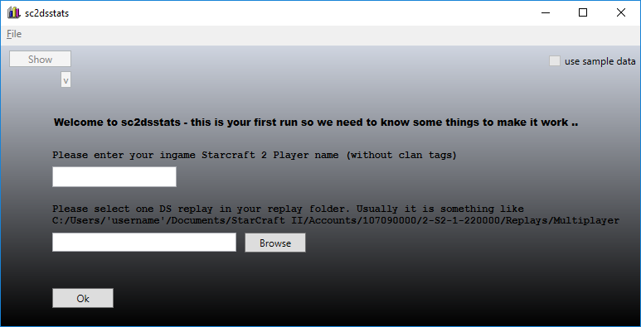

At the first start of the application you have to enter your Starcraft 2 player name and the directory path to the location of your Direct Strike replays.

## Scan preview

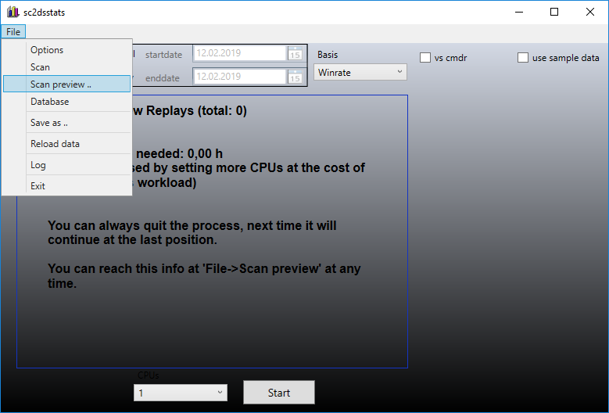

To be able to display your statistics we have to decode the replays and extract the required information. The very first run may take some time depending on the number of replays to analyze and the hardware you are running at. You can decrease the time needed by increasing the number of CPU Cores used at the cost of the computer workload.

After hitting the Start button a new window pops up with the Perl process decoding the DS-replays using the Python script s2_cli from s2protocol (<https://github.com/Blizzard/s2protocol>). These scripts are precompiled and tested for Windows 10 64Bit.

You can quit the process at any time (by closing the window) – it will resume at the latest position next time. During the run you can use the menu ‘File->Reload data’ to display the already computed replays.

## Use sample data

You can press the ‘use sample data’ checkbox to get some sample data you can work with. If you uncheck it your own data will be active again.

## Show graph

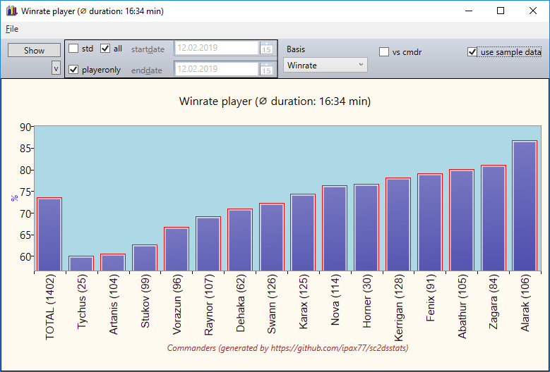

Pressing the Show button displays the graph. You can right-click on every visible graph to save it as a png-bitmap file to your file system. A left-click opens the graph in a new popup-window – from where you can drag & drop the graph as a bitmap image.

### Graph mode

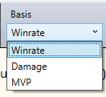

You can choose between win rate, damage and MVP statistics.

Winrate shows the win rate for each commander.

Damage shows the damage output for each commander dependant on game duration, army value or killed army value.

MVP shows the percentage of each commander being the one with the highest in game killed army value.

### Vs commander

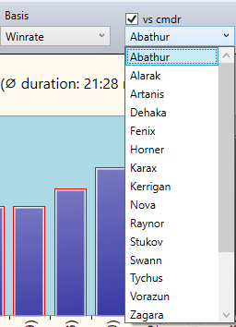If you click the ‘vs cmdr’ checkbox a combo box will be visible where you can choose one commander of interest. Then the graph switches into the vs mode where only the games of the selected commander are shown with the win rates vs each other commander.

This can be done in any graph mode (Winrate, Damage or MVP)

### Filter 1



You can filter (or not) the std-ds replays (playing Protoss, Terran or Zerg) by un-/checking the ‘std’ checkbox.

You can filter (or not) the player matchups only or all matchups in one replay by un-/checking the ‘playeronly’ checkbox (matchups are player1 vs player4, player2 vs player 5 and player3 vs player6).

By un-/checking the ‘all’ checkbox you can de-/activate the startdate and enddate combo box. Only replays between the given dates are shown in the graph.

### Filter 2

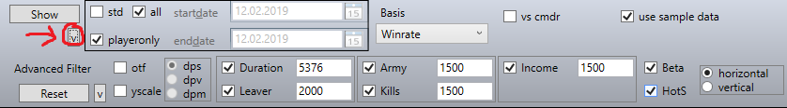

By checking the ‘yscale’ checkbox you can set the y-axes starting value to 0. Default is unchecked with dynamic y-axes values.

The dps, dpv and dpm radioboxes are only active while in damage-mode. Then you are able to switch between the damage calculations of killed army value / game duration (dps), army value / killed army value (dpv) and minerals collected / killed army value (dpm).

By checking the ‘Duration’ checkbox all games below the given gameloops are filtered out. 22.4 gameloops equals one real live second.

By checking the ‘Leaver’ checkbox all games with at least one player leaving the game before the given gameloops game end will be filtered out. 22.4 gameloops equals one real live second.

By checking the ‘Army’, ‘Income’ or ‘Kills’ Checkbox all games with at least one player being below the given value will be filtered out.

By Checking the ‘HotS’ or ‘Beta’ checkbox all games with their replay name containing HotS or Beta will be filtered out.

The Reset-button resets the Filter status to the default values.

#### Horizontal / Vertical

By clicking the horizontal or vertical raidoboxes you can switch the xy-axes.

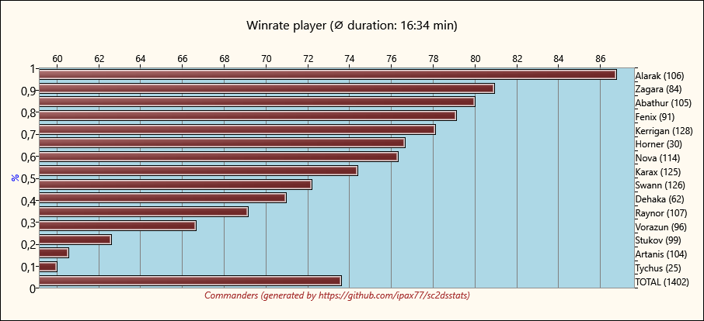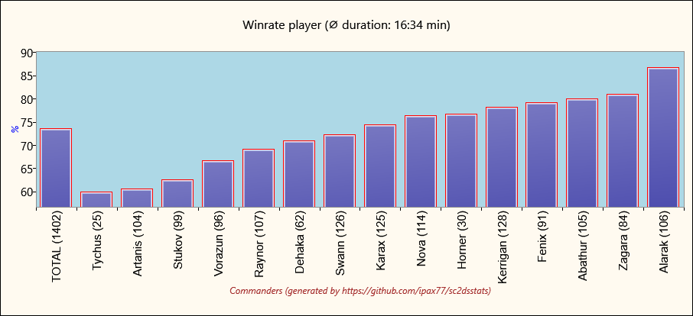

#### Otf

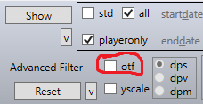

While the ‘otf’ checkbox is checked the replay-folder will be watched and every new detected DS-replay will be decoded and immediately shown in the graph.

### Info

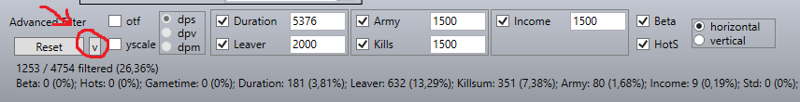

In the info section some information about filter status or scan process is shown.

## Menu options

### File->Options

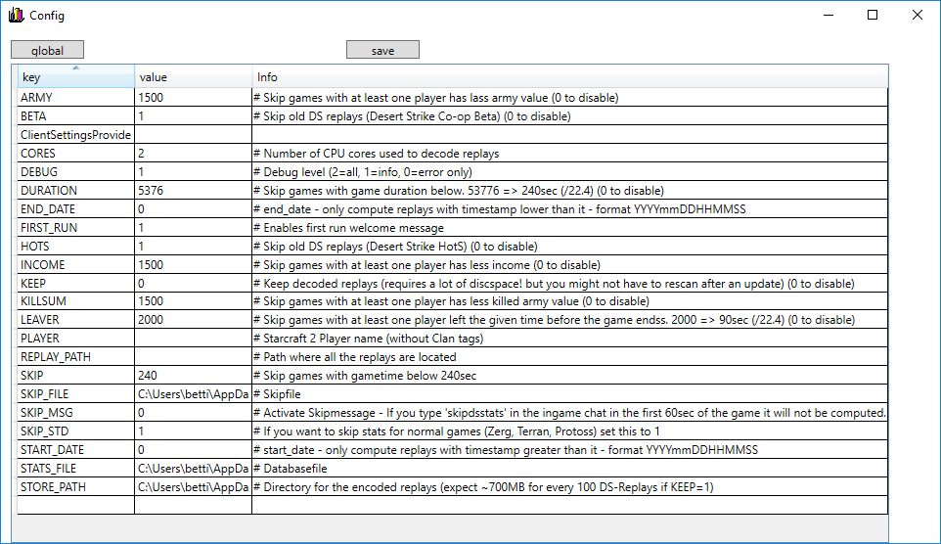

Here you can set the path to some application files and set the default filter values.

### File->Scan

Scans for new replays and decodes them.

### File->Scan preview

Scans for new replays and shows the preview information where you can (re)start the decoding process.

### File->Database

Shows a datagrid with all decoded replays included. You can right-click a replay to save the result to clipboard.

### File->Save as ..

Saves the current graph as bitmap to the given location.

### File->Reload Data

Reloads the data of all decoded replays (useful during a long scan process).

### File->Log

Shows the log file of the latest scan process.

### File->Exit

Closes all open windows and shuts down the application.