
A
PROJECT REPORT
ON
SPATIAL MODELING OF SOLAR RADIATION USING GEOSTATISTICAL ANALYTIC MODELS OVER WEST AFRICA
A Comparative Study of Six Interpolation Methods for Surface Incoming Shortwave Radiation across West Africa
WRITTEN BY
AFOLAMI BRIGHT JAMES
PHY/18/8232
SUBMITTED TO
THE DEPARTMENT OF PHYSICS
SCHOOL OF PHYSICAL SCIENCES
THE FEDERAL UNIVERSITY OF TECHNOLOGY AKURE, ONDO STATE.
IN PARTIAL FULFILLMENT OF THE REQUIREMENTS FOR THE AWARD OF
BACHELOR OF TECHNOLOGY (B. TECH) DEGREE IN PHYSICS (ELECTRONICS).
2024

CERTIFICATION
I, Afolami Bright with matric number PHY/18/8232 hereby certify that this work was entirely done by me with the guidance of my supervisor and that no part of this project work has been submitted for any other academic qualification or assessment. I take responsibility for acts of commission or omission found in this work. Any external sources used in this project work have been duly cited and referenced following the appropriate citation style.
______________________________ ______________________________
AFOLAMI BRIGHT JAMES DATE
(STUDENT)
______________________________ ______________________________
DR. OLUSOLA SAMUEL OJO DATE
(SUPERVISOR)

DEDICATION
I dedicate this project work to God Almighty and to my family for their unwavering support, encouragement, and guidance throughout my studies.

ACKNOWLEDGEMENTS
First and foremost, I thank God for his divine wisdom, strength and inspiration which enabled me to complete this project.
I extend my heartfelt appreciation to my parents, Mr. Afolami Oluwapelumi and Mrs. Afolami Odunola for their unwavering support, encouragement and love. I’m also grateful to my uncle, Afolami Oluwayomi, my aunt, Adebowale Omowumi, my siblings and friends for their constant care and motivation that kept me going.
Special thanks to my supervisor, Dr. Olusola Samuel Ojo for their invaluable guidance and patience throughout the course of this study. I would also like to thank both the teaching and non-teaching staff of the Department of Physics for providing the academic environment and resources necessary for this study.
This project would not have been possible without the collective efforts and support of these individuals; I am forever grateful.

ABSTRACT
Accurate spatial estimation of solar radiation is essential for solar energy planning, agricultural applications, and climate studies in data-sparse regions such as West Africa. This study aimed to model the spatial distribution of Surface Incoming Shortwave (SIS) radiation across West Africa using six geostatistical and deterministic interpolation methods, such as Inverse Distance Weighting (IDW), Ordinary Kriging (OK), Empirical Bayesian Kriging (EBK), Radial Basis Function (RBF), Local Polynomial Interpolation (LPI), and Global Polynomial Interpolation (GPI). Monthly mean SIS data from 108 meteorological stations spanning the period 1983–2023 were obtained from the archive of the CM-SAF dataset at a resolution of 0.05° × 0.05° latitude and longitude, on a grid system over West Africa. Spatial interpolation was performed in ArcGIS Geostatistical Analyst, and the accuracy of each method was assessed through leave-one-out cross-validation. Results showed that interpolation accuracy was both metric- and month-dependent rather than following a uniform dry-season versus rainy-season pattern. RBF produced the lowest mean RMSE (2.91 Wh/m²) and MAE across the monthly tables, followed by EBK (3.20 Wh/m²), Ordinary Kriging (3.49 Wh/m²), and IDW (3.99 Wh/m²). EBK achieved the highest mean R² (0.948) and the lowest mean MedAE, while Ordinary Kriging produced the smallest absolute average mean error and also provided model-based uncertainty estimates. Regression slopes for Ordinary Kriging and EBK ranged from approximately 0.49 to 0.88, indicating compression of observed SIS variability. GPI and LPI produced the largest overall errors among the six methods. RBF, EBK, Ordinary Kriging, and IDW each achieved their lowest monthly RMSE in different months, confirming that no single method dominated across all evaluation conditions. These findings indicate that method choice for solar radiation mapping should be guided by the specific accuracy metric of interest rather than a single “best” interpolator. Accordingly, solar-resource assessments and planning frameworks in West Africa should favor RBF- or EBK-based interpolation, with Ordinary Kriging recommended where quantified prediction uncertainty is required for decision-making.

TABLE OF CONTENTS
TITLE PAGE i
CERTIFICATION ii
DEDICATION iii
ACKNOWLEDGEMENTS iv
ABSTRACT v
TABLE OF CONTENTS vi
LIST OF TABLES viii
LIST OF FIGURES ix
CHAPTER ONE: INTRODUCTION 1
1.1 Background of the Study 1
1.2 Problem Statement 2
1.3 Aim and Objectives 3
1.4 Significance of the Study 3
CHAPTER TWO: LITERATURE REVIEW 5
2.1 Solar Radiation: Concepts and Measurement 5
2.2 Previous Studies on Solar Radiation Interpolation 7
2.3 Research Gap 10
CHAPTER THREE: METHODOLOGY 11
3.1 Study Area 11
3.2 Data Acquisition 12
3.3 Spatial Interpolation Methods 14
3.4 Theoretical Framework for Spatial Analysis 16
3.5 Interpolation Methods Used in This Study 17
3.6 Assessment of Interpolation Methods 22
CHAPTER FOUR: RESULTS AND DISCUSSION 24
4.1 Monthly Spatial comparison of Solar Radiation from Geostatistical methods 24
4.2 Cross-Validation Results 35
4.3 Detailed Monthly Analysis 38
4.4 Comparative Analysis of Methods 44
4.5 Comparison with Previous Studies 46
4.6 Summary of Results 47
CHAPTER FIVE: CONCLUSION AND RECOMMENDATIONS 48
5.1 Conclusion 48
5.2 Recommendations 50
REFERENCES 53
APPENDICES 56
Appendix A: List of Meteorological Stations 56
Appendix B: Cross-Validation Regression Equations 57

LIST OF TABLES
Table 3.1: Comparison of interpolation method characteristics 15
Table 4.1: Cross-validation accuracy metrics averaged across all 12 months 36
Table 4.2: Cross-validation regression parameters for Kriging, EBK and RBF 38
Table 4.3: Cross-validation regression parameters for IDW, GPI and LPI 38
Table 4.4: Cross-validation metrics for January 39
Table 4.5: Cross-validation metrics for February 40
Table 4.6: Cross-validation metrics for March 40
Table 4.7: Cross-validation metrics for April 41
Table 4.8: Cross-validation metrics for May 41
Table 4.9: Cross-validation metrics for June 42
Table 4.10: Cross-validation metrics for July 42
Table 4.11: Cross-validation metrics for August 43
Table 4.12: Cross-validation metrics for September 43
Table 4.13: Cross-validation metrics for October 44
Table 4.14: Cross-validation metrics for November 44
Table 4.15: Cross-validation metrics for December 45

LIST OF FIGURES
Figure 3.1: Study area showing the distribution of 108 meteorological stations across West Africa and the four climatic zones. 13
Figure 4.1: Monthly mean surface incoming shortwave radiation (SIS) for January over West Africa, 1983–2023, interpolated by IDW, Kriging, EBK, RBF, LPI and GPI 25
Figure 4.2: Monthly mean surface incoming shortwave radiation (SIS) for February over West Africa, 1983–2023, interpolated by IDW, Kriging, EBK, RBF, LPI and GPI 26
Figure 4.3: Monthly mean surface incoming shortwave radiation (SIS) for March over West Africa, 1983–2023, interpolated by IDW, Kriging, EBK, RBF, LPI and GPI 27
Figure 4.4: Monthly mean surface incoming shortwave radiation (SIS) for April over West Africa, 1983–2023, interpolated by IDW, Kriging, EBK, RBF, LPI and GPI 28
Figure 4.5: Monthly mean surface incoming shortwave radiation (SIS) for May over West Africa, 1983–2023, interpolated by IDW, Kriging, EBK, RBF, LPI and GPI 29
Figure 4.6: Monthly mean surface incoming shortwave radiation (SIS) for June over West Africa, 1983–2023, interpolated by IDW, Kriging, EBK, RBF, LPI and GPI 30
Figure 4.7: Monthly mean surface incoming shortwave radiation (SIS) for July over West Africa, 1983–2023, interpolated by IDW, Kriging, EBK, RBF, LPI and GPI 31
Figure 4.8: Monthly mean surface incoming shortwave radiation (SIS) for August over West Africa, 1983–2023, interpolated by IDW, Kriging, EBK, RBF, LPI and GPI 32
Figure 4.9: Monthly mean surface incoming shortwave radiation (SIS) for September over West Africa, 1983–2023, interpolated by IDW, Kriging, EBK, RBF, LPI and GPI 33
Figure 4.10: Monthly mean surface incoming shortwave radiation (SIS) for October over West Africa, 1983–2023, interpolated by IDW, Kriging, EBK, RBF, LPI and GPI 34
Figure 4.11: Monthly mean surface incoming shortwave radiation (SIS) for November over West Africa, 1983–2023, interpolated by IDW, Kriging, EBK, RBF, LPI and GPI 35
Figure 4.12: Monthly mean surface incoming shortwave radiation (SIS) for December over West Africa, 1983–2023, interpolated by IDW, Kriging, EBK, RBF, LPI and GPI 36

CHAPTER ONE:
INTRODUCTION

1.1 Background of the Study
Solar radiation is a fundamental energy input to the Earth's surface and is central to weather and climate processes, photosynthesis, the hydrological cycle, and the surface energy balance. Reliable measurement and estimation of solar radiation are therefore important for applications such as solar-energy system design, agricultural planning, hydrological modeling, and climate studies (Duffie and Beckman, 2013).
Surface Incoming Shortwave radiation (SIS), commonly expressed in solar-energy applications as global horizontal irradiance (GHI), is the total shortwave solar radiation incident on a horizontal surface. It contains a direct component from the solar disk and a diffuse component produced by scattering in the atmosphere; on a horizontal surface, GHI is commonly represented as the sum of the projected direct normal irradiance and diffuse horizontal irradiance (Duffie and Beckman, 2013).
Solar radiation varies spatially because solar geometry, topography, cloudiness, aerosols, water vapor, and other atmospheric conditions differ from place to place. This spatial variability creates a practical need for location-specific radiation estimates when designing solar-energy systems or producing regional resource maps. Geostatistical studies have shown that spatial interpolation can be used to extend discrete radiation observations into continuous regional fields when station coverage is incomplete (Rehman and Ghori, 2000; Alsamamra et al., 2009).
West Africa spans strong climatic gradients from the humid Gulf of Guinea coast through the savanna and Sahel to the Saharan margin. Cloud cover and atmospheric conditions change substantially between the wet and dry seasons, producing marked spatial and seasonal contrasts in surface solar radiation. Studies in Ghana and in Burkina Faso/Ghana confirm pronounced seasonal differences and show that cloud conditions materially affect the quality of solar-radiation estimates (Tanu et al., 2021; Sawadogo et al., 2023).
Ground-based solar-radiation observations remain limited across many parts of West Africa, which makes spatially complete regional assessment difficult. Recent validation work in Burkina Faso and Ghana notes the scarcity of accessible in-situ GHI observations and evaluates satellite and reanalysis products as practical alternatives where station measurements are unavailable (Sawadogo et al., 2023). This measurement scarcity strengthens the case for carefully validated spatial interpolation and satellite-based products.
Spatial interpolation estimates values at unsampled locations from observations at known locations. Geostatistical methods such as Kriging explicitly model spatial dependence and can provide prediction-uncertainty estimates, while Empirical Bayes Kriging extends automated geostatistical modeling by accounting for uncertainty in semivariogram estimation and allowing local adaptation where appropriate (Webster and Oliver, 2007; Krivoruchko and Gribov, 2019).

1.2 Problem Statement
The accurate spatial estimation of solar radiation across a region requires interpolation from discrete point measurements to a continuous surface. Traditional interpolation methods, such as simple arithmetic averaging or Thiessen polygons, do not account for the spatial correlation structure inherent in meteorological data and often produce unreliable estimates, particularly in areas distant from measurement stations.
Geostatistical methods offer a more rigorous framework for spatial interpolation by explicitly modeling the spatial dependence structure of the data through the variogram function. Techniques such as Kriging, Empirical Bayes Kriging (EBK), and their variants provide not only predictions at unsampled locations but also measures of prediction uncertainty, which are invaluable for decision-making (Webster and Oliver, 2007). However, the selection of the most appropriate geostatistical method for a given application and region is not straightforward.
Different methods make different assumptions about the stationarity of the mean and variance, the form of the spatial correlation function, and the noise characteristics of the data. The performance of these methods can vary significantly depending on the density and configuration of the sampling network, the nature of the spatial variability, and the specific characteristics of the variable being estimated (Chilès and Delfiner, 2012). For solar radiation in West Africa, several unique challenges arise:
Lack of comprehensive comparative studies: While individual studies have applied specific methods to specific regions, there is a lack of systematic comparative evaluations of multiple geostatistical methods for solar radiation across the full diversity of West African climates.
There is therefore a need for a systematic comparative evaluation of geostatistical interpolation methods for solar radiation in the West African context, using cross-validation techniques to assess prediction accuracy and identify the most suitable approach for operational applications.

1.3 Aim and Objectives
Aim:
The aim of this study is to develop spatial models for the accurate prediction of solar radiation across West Africa using geostatistical analytic techniques.
Objectives:
The specific objectives of this study are to:
1. Examine spatial distribution of solar radiation over West Africa.
2. Evaluate the spatial interpolation of solar radiation over West Africa using Geospatial analytic models and
3. Assess the accuracy of the Geospatial interpolation models using statistical metrics.

1.4 Significance of the Study
This study contributes to the growing body of knowledge on spatial modeling of solar radiation in data-sparse regions. The findings are expected to be beneficial in several ways:
1. Solar Energy Planning: The spatial models developed in this study can be used to identify optimal locations for solar energy installations across West Africa, supporting the region's transition to renewable energy sources. Accurate SIS maps are essential for solar resource assessments, which inform decisions about panel orientation, system sizing, and expected energy yield.
2. Agricultural Applications: Accurate solar radiation maps are essential for crop modeling, evapotranspiration estimation, and irrigation planning, all of which are critical for food security in the region. Solar radiation is a key input to crop growth models, and spatial interpolation of SIS can improve the accuracy of agricultural productivity estimates across data-sparse areas.
3. Climate Studies: The long-term spatial radiation fields produced by this study can serve as inputs for regional climate models and for monitoring changes in solar radiation over time. The 41-year record analyzed in this study provides a baseline against which future changes in solar radiation can be assessed.
4. Methodological Contribution: The comparative evaluation of multiple geostatistical and deterministic methods provides guidance for selecting interpolation techniques for solar radiation in similar climatic settings. The results show that method ranking depends on the accuracy metric and month, while the inclusion of EBK alongside Ordinary Kriging and deterministic alternatives broadens the methodological comparison.

CHAPTER TWO:
LITERATURE REVIEW

2.1 Solar Radiation: Concepts and Measurement
a. Solar radiation reaching the Earth's surface consists of several components. The global horizontal irradiance (GHI), also referred to as Surface Incoming Shortwave (SIS) radiation, is the total solar radiation received on a horizontal surface. It is the sum of the direct normal irradiance (DNI), which is the solar radiation received directly from the solar disk, and the diffuse horizontal irradiance (DHI), which is the solar radiation received from the sky after being scattered by the atmosphere (Duffie and Beckman, 2013):
 | $$GHI=DNI·cosθ+DHI$$ | (2.1)
where θ is the solar zenith angle.
The magnitude of solar radiation at a given location is controlled by solar geometry and Earth-Sun distance, together with atmospheric attenuation by clouds, aerosols, water vapor, and ozone. These controls determine how much of the extraterrestrial solar flux reaches the surface and how it is divided between direct and diffuse components (Duffie and Beckman, 2013).
Clear-sky radiation is the irradiance expected in the absence of clouds, subject to attenuation by the clear atmosphere. Well-established clear-sky formulations include the Ineichen-Perez approach and the European Solar Radiation Atlas (ESRA) model, both of which account for atmospheric optical effects when estimating surface irradiance (Ineichen and Perez, 2002; Rigollier et al., 2000).
Clouds are a dominant source of short-timescale variability in surface solar radiation because they alter both direct and diffuse irradiance through scattering and absorption. Their optical thickness, type, and fractional coverage can therefore introduce strong spatial and temporal changes in satellite-derived and ground-observed irradiance fields (Pinker and Laszlo, 1992).
Aerosols are also important in West Africa, particularly during dust events associated with Saharan transport. Their effect interacts with cloud cover and other atmospheric conditions, which complicates solar-radiation retrieval and validation. A recent West African evaluation found that the performance of satellite and reanalysis GHI estimates deteriorated under cloudy conditions and explicitly considered both cloud and aerosol effects (Sawadogo et al., 2023).
b. Ground-based solar radiation is commonly measured with pyranometers for global horizontal irradiance and pyrheliometers for direct normal irradiance. Reliable observations require appropriate instrument siting, calibration, maintenance, and quality-control procedures in accordance with accepted meteorological practice (WMO, 2014).
Measurement uncertainty depends on instrument characteristics and operating conditions, including calibration quality, cosine response, spectral response, thermal effects, cleanliness, leveling, and obstruction of the sensor field of view. These factors must be controlled when observations from different stations or instruments are combined.
The Baseline Surface Radiation Network (BSRN) was established to provide high-quality surface-radiation observations using standardized measurement and quality-control procedures (Ohmura et al., 1998). Such reference-quality measurements are especially valuable for validating satellite-derived products and for detecting systematic biases in regions where routine station coverage is sparse.
Data quality considerations are critical for solar radiation studies. Common data quality issues include:
1. Instrument degradation: Pyranometer sensitivity can change over time due to aging, dirt accumulation, and exposure to extreme conditions. Regular calibration against reference instruments is essential.
2. Shadowing: Nearby objects (buildings, trees, terrain) can cast shadows on the pyranometer, causing systematic underestimation of solar radiation, particularly during morning and evening hours.
3. Power failures and data gaps: Many meteorological stations in developing countries experience frequent power interruptions, leading to gaps in the record.
4. Systematic biases: Different pyranometer types and measurement protocols can introduce systematic biases that must be accounted for when combining data from multiple stations.
c. Satellite-based methods estimate surface solar radiation from satellite-observed cloud information together with clear-sky radiative-transfer calculations and atmospheric inputs. Several long-term products are relevant to solar-resource assessment over Africa:
1. CM SAF SARAH: The Surface Radiation Data Set - Heliosat (SARAH) is derived from Meteosat observations and provides surface incoming shortwave radiation and related variables over Europe and Africa. SARAH-2.1 covers 1983-2017 at 0.05° spatial resolution, while the current SARAH-3 record begins in 1983 and is operationally extended to the present (Pfeifroth et al., 2019; Pfeifroth et al., 2023).
2. CAMS solar radiation products: The Copernicus Atmosphere Monitoring Service provides solar-radiation time series from 2004 onward and is widely used for solar-energy applications. In West Africa, CAMS has been evaluated alongside SARAH-2, ERA5, and MERRA-2 using quality-controlled in-situ observations (Sawadogo et al., 2023).
3. CERES: The Clouds and the Earth's Radiant Energy System (CERES) provides satellite observations of the Earth's radiation budget and has become an important source for climate-scale radiation studies (Wielicki et al., 1996).
4. Satellite products provide far better spatial coverage than sparse station networks, but their accuracy depends on cloud detection, aerosol representation, atmospheric inputs, and retrieval algorithms. They should therefore be evaluated against quality-controlled ground measurements whenever possible.
For West Africa, Sawadogo et al. (2023) found that satellite products generally performed better than reanalysis products in their 2020 validation dataset, while errors increased substantially under cloudy skies. This finding reinforces the need to treat satellite radiation fields as estimates with quantifiable uncertainty rather than as error-free observations.

2.2 Previous Studies on Solar Radiation Interpolation
Global Studies
Published studies show that no interpolation method is uniformly best across all solar-radiation datasets; performance depends on station density, spatial structure, topography, covariates, and the validation design.
Rehman and Ghori (2000) applied geostatistical interpolation to global solar radiation in Saudi Arabia using 41 known locations and systematic point exclusion for validation. Their results demonstrated that geostatistical interpolation can provide accurate regional estimates when the spatial structure is adequately represented.
Alsamamra et al. (2009) compared Ordinary Kriging with residual Kriging for monthly global solar radiation in southern Spain using 166 stations, including an independent validation set. Ordinary Kriging gave useful estimates, while incorporating topographic explanatory information through residual Kriging reduced RMSE by about 5-20% depending on season.
Jeong et al. (2017) compared nearest-neighbor, IDW, and Ordinary Kriging interpolation with artificial-neural-network models at 13 stations in southern Quebec. Geostatistical interpolation performed better where measurement density was high, whereas stochastic models became more competitive where nearby radiation observations were sparse.
Kuo et al. (2018) compared IDW and Ordinary Kriging using 20 monitoring stations in Taiwan and independent field verification. In that application, IDW outperformed Ordinary Kriging, with field-verification MAPE values of 4.30% and 3.71%, illustrating that Kriging should not be assumed to dominate every dataset.
Leirvik and Yuan (2021) compared Random Forest with seven conventional spatial-interpolation methods for global surface solar-radiation observations. Their cross-validation results showed a substantially lower mean absolute error for the Random Forest model, highlighting the potential value of machine-learning methods when suitable predictors are available.
Together, these studies show that interpolation accuracy is strongly context-dependent. Proper validation is therefore more defensible than selecting a method solely because it has performed well in another region.
African Studies
Mubiru et al. (2007) evaluated five interpolation methods for solar radiation in Uganda: Nearest Point, Moving Average, Moving Surface, Trend Surface, and Ordinary Kriging. The Moving Average linear-decrease method performed best in that study, with normalized mean bias error of 0.035 and normalized RMSE of 0.078.
Hove et al. (2014) developed an improved solar-radiation map for Zimbabwe by merging sparse ground observations with satellite-derived information and interpolating with Ordinary Kriging. Leave-one-out validation produced a maximum normalized RMSE of about 0.028, demonstrating the value of combining complementary data sources.
Tanu et al. (2021) evaluated solar-energy resource indicators at 22 synoptic stations across Ghana's climatic zones and used Ordinary Kriging to map stationary values. The study found higher solar radiation in the dry period and lower values in the wet period, emphasizing the importance of seasonal cloud and humidity conditions.
Sawadogo et al. (2023) compared ERA5, MERRA-2, CAMS, and SARAH-2 hourly GHI with 37 quality-controlled in-situ measurements in Burkina Faso and Ghana. Satellite products generally outperformed reanalysis products, but both groups showed larger errors under cloudy skies, demonstrating the difficulty of representing short-scale atmospheric variability in West Africa.
The African evidence therefore supports spatial interpolation and satellite products as useful tools in data-sparse environments, while also showing that performance depends on local station density, atmospheric conditions, and the information incorporated into the model.
Methodological Studies
Krivoruchko (2012) introduced Empirical Bayesian Kriging as an automated geostatistical approach for ArcGIS, while Krivoruchko and Gribov (2019) later evaluated the method through simulation experiments and real environmental datasets.
Oliver and Webster (2014) provided a practical tutorial on computing and modeling variograms and emphasized that reliable Kriging depends on defensible variogram estimation and model selection.
Chiles and Delfiner (2012) provide an authoritative treatment of geostatistical theory, including stationarity, Kriging variants, spatial uncertainty, and non-stationary methods.
Webster and Oliver (2007) provide a practical guide to geostatistical methods for environmental scientists, covering sampling, variogram modeling, Kriging, and validation.
Cressie (1993) presents foundational theory for spatial statistics and geostatistics, including covariance models and spatial prediction.
Goovaerts (1997) provides a comprehensive treatment of geostatistics for natural-resource evaluation, including Kriging variants and spatial uncertainty.
Wackernagel (2003) presents multivariate geostatistical methods, including co-Kriging and approaches for incorporating auxiliary variables.

2.3 Research Gap
While the existing literature demonstrates the applicability of geostatistical methods for solar radiation estimation, several gaps remain:
1. Limited full-region comparisons: The studies reviewed above are primarily country-level or subregional applications. Within this reviewed literature, no study evaluates this exact six-method set (IDW, Ordinary Kriging, EBK, RBF, LPI, and GPI) over the full multi-country West African domain used in this project.
2. EBK in this application: EBK has been evaluated for several environmental variables, but its use for regional solar-radiation interpolation in tropical West Africa is less represented in the literature reviewed here.
3. Long-term climatological comparison: There is value in evaluating interpolation methods on a multi-decadal monthly climatology because seasonal spatial structure can differ substantially between dry and wet periods.
4. Reproducible comparison: A consistent cross-validation framework is needed so that the six methods are compared on the same station network and with the same accuracy metrics.
This study addresses these needs by comparing six interpolation methods, including EBK, for monthly SIS across the defined West African study domain using ArcGIS-based cross-validation and presenting the results through comparative maps and statistical accuracy metrics.

CHAPTER THREE:
METHODOLOGY

3.1 Study Area
Geographic Coverage
The study area covers West Africa and adjacent regions, extending approximately from latitude 4°N to 27°N and from longitude 18°W to 16°E. This vast region encompasses approximately 6.5 million square kilometers and includes a diverse range of climatic zones, from the hyper-arid Sahara Desert in the north through the semi-arid Sahel belt, the sub-humid Sudan and Guinea savanna zones, to the humid tropical forests along the Gulf of Guinea coast.
The study area includes all or portions of the following countries: Mauritania, Mali, Niger, Chad, Senegal, The Gambia, Guinea-Bissau, Guinea, Sierra Leone, Liberia, Côte d'Ivoire, Burkina Faso, Ghana, Togo, Benin, Nigeria, and parts of Cameroon.
Climatic Zones
The study area spans four major climatic zones:
Saharan Zone (north of 20°N): Extremely arid with annual rainfall below 100 mm. Clear skies dominate, resulting in high solar radiation throughout the year, typically exceeding 6.5 kWh/m²/day. Dust aerosols from the Sahara can significantly attenuate incoming radiation during the Harmattan season (December–February).
Sahel Zone (12°N–20°N): Semi-arid with annual rainfall of 200–600 mm concentrated in the rainy season (June–September). Solar radiation is high during the dry season (November–March) but is reduced during the brief rainy season by increased cloud cover. This zone experiences the largest seasonal variation in solar radiation, with monthly mean SIS ranging from approximately 4,500 Wh/m² during the rainy season to over 6,500 Wh/m² during the dry season.
Guinea Savanna Zone (6°N–12°N): Sub-humid with annual rainfall of 600–1,200 mm, with a longer rainy season (April–October) than the Sahel. Solar radiation is moderate, with monthly mean SIS typically ranging from 3,500 to 5,500 Wh/m².
Coastal/Humid Zone (south of 6°N): Humid with annual rainfall exceeding 1,200 mm. Persistent cloud cover and high humidity reduce solar radiation, particularly during the rainy season. Annual average SIS is typically in the range of 4.0–5.5 kWh/m²/day, the lowest in the study area.
Topography and Land Cover
The study area exhibits significant topographic variation, from sea level along the coast to over 2,000 m in the Fouta Djallon highlands of Guinea and the Adamawa Plateau of Cameroon. The Jos Plateau in central Nigeria (elevation 1,200–1,400 m) represents a notable topographic feature that influences local solar radiation patterns.
Land cover ranges from dense tropical forests in the south, through savanna woodlands and grasslands, to sparse desert vegetation in the north. These land cover differences affect surface albedo and evapotranspiration, which in turn influence local atmospheric conditions and solar radiation.
Significance for Solar Energy
West Africa has substantial but spatially variable solar-energy resources. Observational and interpolation studies in Ghana and wider West Africa show that radiation conditions differ markedly by climatic zone and season, particularly as cloud cover changes between wet and dry periods (Tanu et al., 2021; Sawadogo et al., 2023). These contrasts make spatially resolved solar-radiation mapping important for resource assessment.
Nigeria, the most populous country in the region, has an installed electricity generation capacity of approximately 13,000 MW, but experiences chronic power shortages due to insufficient generation and transmission infrastructure. Solar energy has been identified as a key pathway for addressing this deficit, with the Nigerian government setting a target of 30% renewable energy by 2030.

3.2 Data Acquisition
Solar Radiation Data
The primary data used in this study consist of monthly mean Surface Incoming Shortwave (SIS) values at 108 station locations distributed across West Africa. The working project dataset spans 1983-2023. The SIS data were obtained from the archive of the CM-SAF Satellite Application Facility on Climate Monitoring, derived from Meteosat observations at a spatial resolution of 0.05° × 0.05° over West Africa (Pfeifroth et al., 2019; Pfeifroth et al., 2023).
The dataset provides a 41-year record of monthly SIS values in Wh/m². Each record contains a station index, year, month, and SIS value. Approximately 54,144 station-month records are possible from 108 stations × 41 years × 12 months.
Study Area Map
Figure 3.1 presents the study area and the spatial distribution of the 108 meteorological stations used in this study, together with the boundaries of the four climatic zones recognised in West Africa. The stations span approximately 5.6°N to 25.2°N and 16.3°W to 14.6°E, but they are markedly uneven: 86 of the 108 stations, or 80 per cent, lie between 6°N and 14°N in the Guinea and Sudan savanna belts, whereas only eight stations lie north of 18°N and only four north of 20°N, where inter-station distances commonly exceed 300 km. This distribution is not accidental; station networks in the region were established to support agriculture, aviation and synoptic weather reporting in the populated southern belt, so observation density follows population and rainfall rather than solar resource potential. The consequence for this study is that interpolation error is expected to be smallest in the south, where neighbouring stations are tens of kilometres apart, and largest in the arid north, where the nearest neighbour may be several hundred kilometres away, and the spatial detail that the interpolators can resolve is therefore limited precisely where the solar resource is highest. National meteorological agencies and the regional centres that maintain these records should therefore prioritise densification of the Saharan and Sahelian margin, and until that expansion occurs, any radiation map of the northern zone should be presented with an explicit statement of its limited observational support.
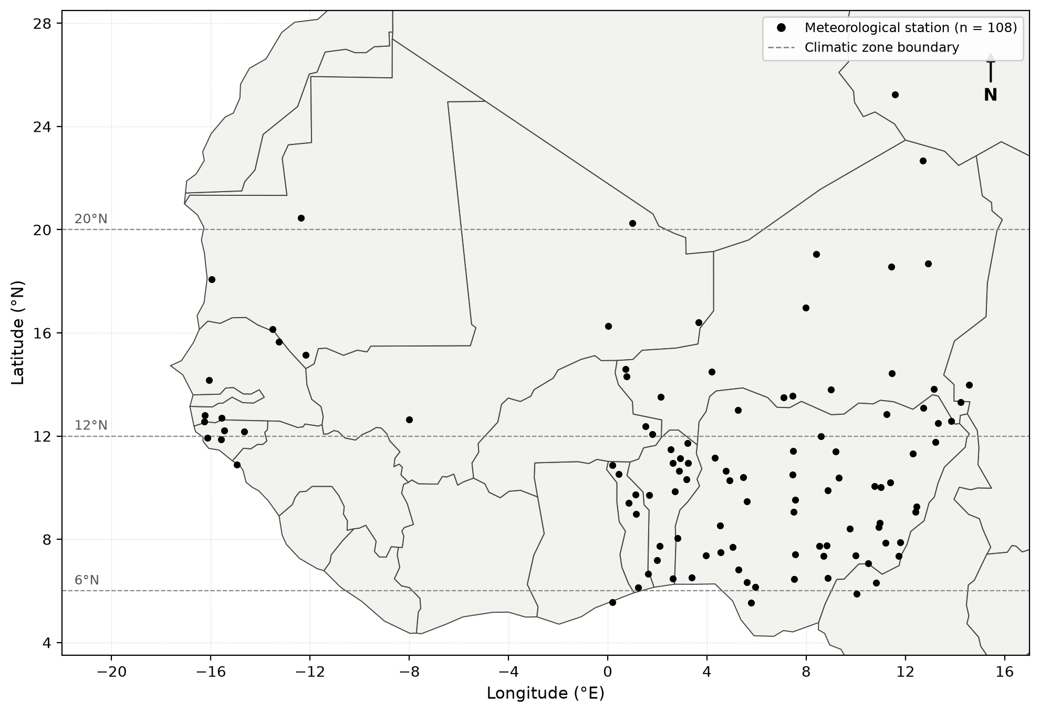
Figure 3.1: Study area showing the distribution of 108 meteorological stations across West Africa and the four climatic zones.

3.3 Spatial Interpolation Methods
Spatial interpolation is the process of estimating values of a variable at unsampled locations based on observations at nearby sample points. The choice of interpolation method depends on the nature of the spatial variation, the density and distribution of sampling points, and the specific requirements of the application (Webster and Oliver, 2007).
Deterministic Methods
Inverse Distance Weighting (IDW):
IDW is one of the simplest and most widely used interpolation methods. It estimates the value at an unsampled point as a weighted average of the values at surrounding sample points, where the weights are inversely proportional to the distance between the sample and prediction points raised to a power p (Shepard, 1968):
IDW assumes that the variable being interpolated is influenced more by nearby points than by distant ones, and that the influence decreases smoothly with distance. The method is computationally simple and requires no assumption about the statistical properties of the data. However, IDW has several limitations:
1. It does not provide any measure of prediction uncertainty.
2. It can produce artifacts (such as bull's-eye patterns) around sample points, particularly when the power parameter is high.
3. It does not account for directional trends or anisotropy in the data.
4. The predicted values are always bounded within the range of the observed values, which may not be appropriate for variables with strong trends.
The choice of the power parameter p significantly affects the interpolation results. Lower values of p produce smoother surfaces, while higher values produce more localized predictions. Watson and Philip (1985) recommended p = 2 as a reasonable default, but noted that the optimal value depends on the spatial characteristics of the data.
Radial Basis Function (RBF) Interpolation:
RBF methods fit a smooth surface that passes exactly through (or close to) the sample points by summing the contributions of radial basis functions centered at each sample point (Franke, 1982):
Geostatistical Methods
Geostatistics provides a framework for spatial interpolation that explicitly accounts for the spatial correlation structure of the data. Unlike deterministic methods, geostatistical methods provide not only predictions but also estimates of prediction uncertainty, which are essential for risk assessment and decision-making (Cressie, 1993).
The Variogram:
The fundamental tool in geostatistics is the variogram (or semivariogram), which quantifies the spatial dependence between observations as a function of the distance and direction separating them. The empirical variogram is calculated as:
 | $$γ(h)=\frac{1}{2N(h)}\sum_{i}{ }{[Z(x_{i})-Z(x_{i}+h)]}^{2}$$ | (3.1)
where N(h) is the number of pairs of points separated by the lag distance h.
The variogram typically increases from zero at h = 0 to a plateau called the sill, which represents the total variance of the data. The distance at which the sill is reached is called the range, and represents the maximum distance over which spatial correlation exists. The nugget effect, a discontinuity at the origin, represents measurement error or micro-scale variability (Webster and Oliver, 2007).
Ordinary Kriging:
Ordinary Kriging (OK) is the most commonly used kriging method. It assumes that the mean of the random field is unknown but constant within the local neighborhood of the prediction point. The kriging estimator is a weighted linear combination of the observed values:
Empirical Bayes Kriging (EBK) is a geostatistical approach that incorporates uncertainty in semivariogram parameter estimation rather than treating one fitted semivariogram as exact. It uses repeated local model estimation and simulation within an empirical-Bayesian framework, which can improve robustness when spatial structure varies across a dataset (Krivoruchko, 2012; Krivoruchko and Gribov, 2019).
In this study, EBK was evaluated alongside Ordinary Kriging and four deterministic methods using the same station network and cross-validation framework, allowing its performance to be judged empirically for the SIS dataset.
Comparison of Methods
Table 3.1 compares the six interpolation methods evaluated in this study on five attributes that determine their practical suitability for solar radiation mapping: method type, computational complexity, provision of an uncertainty estimate, capability to handle trend, and capability to handle anisotropy. Of the six methods, only Ordinary Kriging and EBK are geostatistical; Kriging and EBK are the only two that return a prediction variance, Kriging and EBK are also the only two that accommodate anisotropy, and only Kriging and EBK are classified as high in computational demand, while IDW and GPI are low and RBF and LPI intermediate. These differences follow directly from the underlying mathematics: deterministic methods apply a fixed weighting or basis function that carries no model of spatial covariance, so they cannot return an error variance, whereas the variogram-based formulation of kriging yields both an estimate and its variance, at the cost of fitting and validating a spatial model for every month. The implication is a clear trade-off between the speed and simplicity of the deterministic methods and the diagnostic value of the geostatistical ones, and a method that returns only a single surface without an error term cannot support a statement of confidence at an unsampled site. Institutions procuring solar resource assessments should therefore specify, as a minimum requirement, that the mapping method returns a prediction uncertainty alongside the estimate, using rapid deterministic methods such as IDW only for preliminary screening.
Table 3.1: Comparison of interpolation method characteristics.
Method | Type | Complexity | Uncertainty Estimate | Handles Trends | Handles Anisotropy
IDW | Deterministic | Low | No | No | No
Ordinary Kriging | Geostatistical | High | Yes | No | Yes
EBK | Geostatistical | High | Yes | Partial | Yes
RBF | Deterministic | Medium | No | Partial | No
LPI | Deterministic | Medium | No | Yes | No
GPI | Deterministic | Low | No | Yes | No

3.4 Theoretical Framework for Spatial Analysis
Stationarity Assumptions
The validity of geostatistical methods depends on the stationarity assumptions underlying the random field model. Three levels of stationarity are recognized:
Strict stationarity: The joint probability distribution of the random field is invariant under translation. This is the strongest assumption and is rarely met in practice for environmental variables.
Second-order (weak) stationarity: The mean is constant and the covariance depends only on the lag vector, not on the location. This is the most commonly assumed form of stationarity in geostatistical practice:
 | $$E[Z(x)]=m\text{(constant)}$$ | (3.2)
 | $$Cov[Z(x),Z(x+h)]=C(h)$$ | (3.3)
Intrinsic stationarity: The mean is constant and the variogram exists and depends only on the lag vector. This is a weaker assumption than second-order stationarity and is sufficient for ordinary kriging:
 | $$E[Z(x)]=m$$ | (3.4)
 | $$Var[Z(x)-Z(x+h)]=2γ(h)$$ | (3.5)
For solar radiation in West Africa, strict stationarity is clearly violated due to the strong north-south gradient and seasonal variation. However, within local neighborhoods, the intrinsic stationarity assumption may be approximately valid, particularly for monthly climatological data where the temporal smoothing reduces non-stationarity.
Anisotropy
Anisotropy refers to the dependence of spatial correlation on direction. In solar radiation data, anisotropy may arise from:
1. Geometric anisotropy: The range of spatial correlation varies with direction but the sill remains constant. This could occur if solar radiation is more spatially correlated in the east-west direction (along latitude lines) than in the north-south direction (across climate zones).
2. Zonal anisotropy: Both the range and sill vary with direction. This is a more complex form of anisotropy that may be present in regions with strong directional trends.
In this study, we use isotropic variograms (assuming the same spatial correlation in all directions) for simplicity. However, future studies could explore the use of anisotropic variograms to better capture the directional structure of solar radiation variability.

3.5 Interpolation Methods Used in This Study
The spatial modeling framework consists of three stages: (1) computation of monthly climatologies, (2) spatial interpolation using six methods, and (3) cross-validation. The six methods were selected to represent the major categories of spatial interpolation: deterministic (IDW, RBF, LPI, GPI) and geostatistical (Ordinary Kriging, EBK). Each method has different assumptions about the spatial structure of the data and different capabilities for capturing the complex spatial patterns of solar radiation across West Africa.
a. Inverse Distance Weighting (IDW)
Inverse Distance Weighting is a deterministic interpolation method that estimates the value at an unknown point as a weighted average of nearby observed values, where the weights are inversely proportional to the distance between the prediction point and the observed stations (Shepard, 1968; Watson and Philip, 1985).
For a prediction at location x₀, the IDW estimate is given by:
 | $$Z^{*}(x_{0})=\sum_{i=1}^{n}{[}w_{i}(x_{0})·Z(x_{i})]$$ | (3.6)
where the weight function is:
 | $$w_{i}(x_{0})=\frac{1}{d(x_{0},x_{i})^{p}}$$ | (3.7)
and d(x₀, xᵢ) is the Euclidean distance between the prediction point x₀ and the observed station xᵢ, Z(xᵢ) is the observed value at station xᵢ, n is the number of stations used for prediction, and p is the power parameter.
The power parameter controls the rate at which the influence of nearby points decreases with distance. A power of p = 2 is the most commonly used value (Watson and Philip, 1985) and was adopted in this study. With p = 2, the method is equivalent to a distance-squared weighted average, giving greater influence to the nearest stations.
The weights are normalized so that they sum to unity:
 | $$\sum_{i=1}^{n}{ }w_{i}(x_{0})=1$$ | (3.8)
This ensures that the prediction is a convex combination of the observed values, which prevents extrapolation beyond the range of observed data.
b. Ordinary Kriging (OK)
Ordinary Kriging is a geostatistical interpolation method that provides the Best Linear Unbiased Estimator (BLUE) of a spatial field under the assumption of a constant but unknown mean (Matheron, 1963; Cressie, 1993). Unlike IDW, Kriging explicitly models the spatial correlation structure through the variogram, which describes how the variance of differences between observations changes with separation distance.
Variogram Model
The empirical semivariogram is computed as:
 | $$\hat{γ}(h)=\frac{1}{2N(h)}\sum_{i=1}^{N(h)}{ }{[Z(x_{i})-Z(x_{i}+h)]}^{2}$$ | (3.9)
where h is the lag vector (separation distance and direction), N(h) is the number of pairs separated by lag h, and Z(xᵢ) and Z(xᵢ + h) are the observed values at stations xᵢ and xᵢ + h, respectively.
The empirical semivariogram was fitted with an exponential model, though several other models (spherical, Gaussian, Matérn) are also used in practice:
 | $$γ(h)=c_{0}+c·[1-exp(-3|h|/a)]$$ | (3.10)
where c₀ is the nugget effect (representing measurement error and micro-scale variability), c is the sill (representing the total spatial variance), a is the range parameter (representing the distance at which spatial correlation becomes negligible), and |h| is the lag distance.
Alternative models include the spherical model, $γ(h)=c_{0}+c[1.5(h/a)-0.5(h/a)^{3}]$ for h ≤ a and $γ(h)=c_{0}+c$ for h > a, which reaches the sill at a finite distance; the Gaussian model, $γ(h)=c_{0}+c[1-exp(-h^{2}/a^{2})]$, which produces very smooth interpolated surfaces; and the Matérn model, a flexible family containing a smoothness parameter ν that controls the differentiability of the resulting field.
The practical range (the distance at which the variogram reaches 95% of the sill) is given by:
 | $$a_{\text{practical}}=3a$$ | (3.11)
Kriging System
The Ordinary Kriging predictor is a weighted linear combination:
 | $$Z^{*}(x_{0})=\sum_{j=1}^{n}{ }λ_{j}·Z(x_{j})$$ | (3.12)
where λⱼ are the Kriging weights determined by solving the system:
 | $$\sum_{j=1}^{n}{ }λ_{j}·γ(x_{i},x_{j})+μ=γ(x_{0},x_{i}),i=1,…,n$$ | (3.13)
 | $$\sum_{j=1}^{n}{ }λ_{j}=1$$ | (3.14)
where μ is the Lagrange multiplier enforcing the unbiasedness constraint (the weights sum to unity), and γ(xᵢ, xⱼ) is the semivariogram value between stations xᵢ and xⱼ.
In matrix form, the system is:
 | $$Γ·λ=γ_{0}$$ | (3.15)
where Γ is the n×n matrix of semivariogram values between all pairs of stations, λ is the vector of Kriging weights, and γ₀ is the vector of semivariogram values between stations and the prediction point.
The Kriging variance (prediction uncertainty) is:
 | $$σ_{K}^{2}(x_{0})=\sum_{j=1}^{n}{ }λ_{j}·γ(x_{0},x_{j})+μ$$ | (3.16)
This provides a measure of prediction uncertainty at each location, which is a key advantage of Kriging over deterministic methods.
Advantages of Ordinary Kriging: OK accounts for spatial correlation through the variogram, derives interpolation weights from the modeled spatial structure, and provides a Kriging variance that can be used as a measure of prediction uncertainty. It is a well-established geostatistical method, but its reliability depends on appropriate variogram estimation and model specification (Oliver and Webster, 2014).
Another variant, Universal Kriging (UK), extends OK by modelling the mean as a polynomial trend of the coordinates, allowing large-scale trends to be accounted for at the cost of a more complex kriging system.
A variant, Simple Kriging (SK), assumes that the mean of the random field is known and constant across the study area; it yields lower kriging variances than OK when the mean is correctly specified, but this assumption is rarely met in practice.
c. Empirical Bayes Kriging (EBK)
Empirical Bayes Kriging automates local semivariogram estimation and incorporates uncertainty in semivariogram parameters through an empirical-Bayesian framework (Krivoruchko, 2012; Krivoruchko and Gribov, 2019). It can be useful for heterogeneous datasets because model parameters are estimated repeatedly within local subsets rather than relying on one fixed global semivariogram.
Step 1: Data Transformation Used in This Study
EBK does not inherently require a log-normal distribution. In ArcGIS, transformations are optional. For this study, the Log Empirical transformation was selected for the positive SIS values as part of the EBK configuration.
The transformation and subsequent prediction-scale handling were performed within ArcGIS Geostatistical Analyst rather than by applying a separate manual back-transformation equation.
This distinction is important because the transformation is an implementation choice used in this analysis, not a universal assumption of the EBK method.
Step 2: Local Semivariogram Estimation
EBK partitions observations into local, overlapping subsets and repeatedly estimates semivariogram models within those subsets. This allows moderate changes in spatial structure across the study area to be represented more flexibly than with one global semivariogram.
Step 3: Empirical-Bayesian Prediction
Within each local subset, EBK generates a distribution of plausible semivariogram models and uses them in the prediction process. The resulting prediction therefore reflects uncertainty in semivariogram estimation rather than conditioning on a single fitted model.
Step 4: Study Configuration
The ArcGIS implementation used the Log Empirical transformation, K-Bessel semivariogram model, and 100 simulations, as summarized in Section 3.6.1.
Predictions and associated standard errors were generated by ArcGIS on the configured output scale; no separate manual back-transformation equation was applied outside the software.
These settings were applied consistently to the monthly SIS climatologies so that EBK could be compared with the other interpolation methods under the same cross-validation framework.
Advantages of EBK: EBK reduces dependence on a single manually fitted semivariogram, can adapt to moderate local non-stationarity, and explicitly accounts for semivariogram-parameter uncertainty. Its actual advantage over other methods remains dataset-specific and was therefore assessed through cross-validation (Krivoruchko and Gribov, 2019).
d. Radial Basis Function (RBF)
Radial Basis Function interpolation is a deterministic method that constructs a smooth surface by summing radial basis functions centered at each observed station (Franke, 1982; Hastie et al., 2009). The predicted value is:
 | $$Z^{*}(x_{0})=\sum_{j=1}^{n}{ }λ_{j}·φ(d(x_{0},x_{j}))$$ | (3.17)
where λⱼ are the coefficients to be determined, d(x₀, xⱼ) is the distance between the prediction point and station xⱼ, and φ(r) is the radial basis function.
Several types of RBF are available, including the thin-plate spline $φ(r)=r^{2}ln(r)$, the multiquadric $φ(r)=\sqrt{r^{2}+δ^{2}}$, where δ is a shape parameter, and the Gaussian $φ(r)=exp(-r^{2}/δ^{2})$. In this study, the thin-plate spline was used, which has the form:
 | $$φ(r)=r^{2}·ln(r)$$ | (3.18)
The thin-plate spline produces the smoothest possible surface that passes through all observed data points, making it suitable for modeling smooth, continuous fields such as solar radiation (Watson, 1984).
The coefficients λⱼ are determined by solving the system:
 | $$Φ·λ=Z$$ | (3.19)
where Φ is the n×n matrix with elements Φᵢⱼ = φ(d(xᵢ, xⱼ)), λ is the vector of coefficients, and Z is the vector of observed values.
In contrast to Kriging, RBF surfaces interpolate exactly at the data points used for fitting, but they do not provide a measure of prediction uncertainty, and performance may degrade in the presence of measurement errors or when extrapolating beyond the data coverage.
Advantages of RBF: RBF does not require variogram modeling, can produce smooth continuous surfaces, and is computationally efficient. It is an exact interpolator at the observations used to fit a surface, but that property does not guarantee good leave-one-out performance because each validation station is excluded from the fit used to predict it.
e. Local Polynomial Interpolation (LPI)
Local Polynomial Interpolation fits a polynomial regression model within a moving window centered at each prediction point (Cressie, 1993). At each prediction location x₀, a local neighborhood of n nearest stations is selected, and a polynomial of order p is fitted:
 | $$Z^{*}(x)=\sum_{k=0}^{p}{ }\sum_{j=0}^{k}{ }β_{jk}·(x-x_{0})^{j}·(y-y_{0})^{k-j}$$ | (3.20)
For a first-order polynomial (p = 1), the model is:
 | $$Z^{*}(x_{0},y_{0})=β_{0}+β_{1}x_{0}+β_{2}y_{0}$$ | (3.21)
The coefficients β₀, β₁, β₂ are estimated by weighted least squares, where the weights decrease with distance from the prediction point. The bandwidth (window size) determines the number of stations included in the local fit.
Limitations: LPI is more flexible than GPI but is sensitive to the choice of polynomial order and window size, and can produce unstable predictions at the edges of the study area where fewer stations are available, and the method cannot capture complex spatial patterns that deviate from the polynomial trend (Webster and Oliver, 2007).
f. Global Polynomial Interpolation (GPI)
Global Polynomial Interpolation fits a single polynomial to the entire dataset:
 | $$Z^{*}(x,y)=β_{0}+β_{1}x+β_{2}y+⋯+β_{p}x^{p}y^{0}+⋯+β_{k}x^{0}y^{p}$$ | (3.22)
For a first-order polynomial (p = 1), the model reduces to:
 | $$Z^{*}(x,y)=β_{0}+β_{1}x+β_{2}y$$ | (3.23)
The coefficients are estimated by ordinary least squares using all n stations simultaneously, producing a global trend surface that captures only the large-scale spatial gradient. Higher-order polynomials can capture more complex trends but are prone to overfitting and can produce unrealistic extrapolations.
Limitations: GPI can only capture broad, large-scale trends and cannot represent local variations. In regions with complex spatial patterns, such as West Africa with its strong north-south gradient and seasonal variability, GPI tends to produce very poor predictions with large residuals (Franke, 1982). The method is most useful as a detrending tool in hybrid approaches such as regression-kriging.

3.6 Assessment of Interpolation Methods
Root Mean Square Error (RMSE):
 | $$RMSE=\sqrt{\frac{1}{n}\sum_{i=1}^{n}{ }{(Z_{i}-Z_{i}^{*})}^{2}}$$ | (3.24)
RMSE measures the overall magnitude of prediction errors, with lower values indicating better accuracy. It is sensitive to outliers due to the squaring of errors.
Mean Absolute Error (MAE):
 | $$MAE=\frac{1}{n}\sum_{i=1}^{n}{|Z_{i}-Z_{i}^{*}|}$$ | (3.25)
MAE provides a robust measure of average prediction error magnitude that is less sensitive to outliers than RMSE.
Mean Error (ME):
 | $$ME=\frac{1}{n}\sum_{i=1}^{n}{(Z_{i}^{*}-Z_{i})}$$ | (3.26)
ME measures the systematic bias of predictions. A ME close to zero indicates unbiased predictions, while positive ME indicates overestimation and negative ME indicates underestimation.
Median Absolute Error (MedAE):
 | $$\text{MedAE}=\text{median}(|Z_{i}-Z_{i}^{*}|)$$ | (3.27)
MedAE is a robust measure of central tendency for prediction errors, unaffected by extreme values. This is particularly important for methods like GPI and LPI that may produce occasional extreme errors.
Coefficient of Determination (R²):
 | $$R^{2}=1-\frac{\sum_{i=1}^{n}{ }{(Z_{i}-Z_{i}^{*})}^{2}}{\sum_{i=1}^{n}{ }{(Z_{i}-\overline{Z})}^{2}}$$ | (3.28)
R² measures the proportion of variance in the observed data that is explained by the predictions. Values close to 1 indicate excellent agreement between predictions and observations.

CHAPTER FOUR:
RESULTS AND DISCUSSION

4.1 Monthly Spatial comparison of Solar Radiation from Geostatistical methods
Figures 4.1 to 4.12 present the twelve monthly SIS surfaces produced by the six interpolation methods over the 108-station network, each figure arranged as six panels (IDW, Ordinary Kriging, EBK, RBF, LPI and GPI) that share a single colour scale, so that the spatial pattern and the differences between methods can be read from the same page. Three features recur through the twelve figures. First, the maps show a persistent south-to-north increase in SIS, from approximately 156 to 226 Wh/m² along the Gulf of Guinea coast to 305 to 338 Wh/m² over the Sahel, reflecting the combined effect of solar declination, monsoon cloud cover and atmospheric dust. Second, the mapped range expands and contracts with the season, from 74 Wh/m² in January to 171 Wh/m² in July, so that the spatial contrast the interpolators must reproduce is more than twice as large in the rainy season as in the dry season. Third, the methods differ systematically in how they treat local structure: Kriging, EBK and RBF produce smooth surfaces that follow the climatic zones, IDW produces circular anomalies centred on individual stations, and GPI and LPI produce coarse east-west banding inherited from the fitted first-order polynomial. Each figure is discussed below in terms of the observed pattern, its likely cause, its implication for the reliability of the map, and the resulting recommendation.
January is the narrowest month, and its six surfaces (Figure 4.1) span a colour scale of 194.70 to 269.00 Wh/m². A belt of 241.14 to 259.71 Wh/m² runs between 10°N and 14°N, the north-west falls to 222.56 to 231.85, and the coast near 5°N to 203.99, a contrast of only about 55 Wh/m². Kriging, RBF and LPI keep this banding, IDW adds 20 to 40 Wh/m² station anomalies, and EBK flattens above 259.71. Table 4.4 gives RMSE from 3.87 Wh/m² for LPI to 6.83 for IDW, with R² of 0.638 to 0.875. The weak gradient and the large errors agree: under dust-laden Harmattan skies the field follows latitude and turbidity, thinly sampled in the north, so the variance between stations is small yet large against the 74 Wh/m² range. January is therefore the smoothest month to map and among the least reliable, and EBK cannot separate sites at all; January surfaces should be issued only beside a second method, never alone.
February sharpens January's weak gradient into three bands (Figure 4.2), over a colour scale of 231.43 to 288.75 Wh/m²: 231.43 to 252.92 along the northern Sahara margin, 267.25 to 274.42 across the central Sahel, and a warm southern belt reaching 281.58, broken by a coastal depression of 245.76 to 252.92 near 5°N. Kriging, RBF and LPI resolve every band, IDW adds 30 to 40 Wh/m² anomalies, GPI reduces the field to one diagonal gradient, and EBK again saturates. Table 4.5 gives RMSE of 3.90 Wh/m² for LPI, 4.50 for EBK and 5.91 for IDW, with R² from 0.148 for GPI to 0.840 for EBK. The sharpening follows the northward march of the sun before monsoon onset, EBK's saturation a variogram fitted to few northern neighbours, and GPI's R² of 0.148 a plane that cannot hold three bands. A method can therefore return acceptable statistics yet an unusable map, since the statistics are computed at stations while the map is drawn between them; agencies should make a range-plausibility check against the observations routine before release.
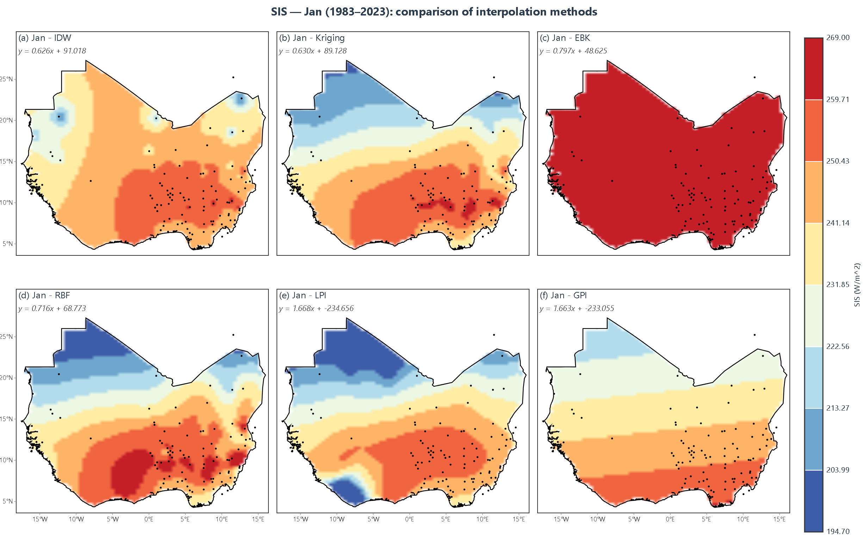
Figure 4.1: Monthly mean surface incoming shortwave radiation (SIS) for January over West Africa, 1983–2023, interpolated by IDW, Kriging, EBK, RBF, LPI and GPI
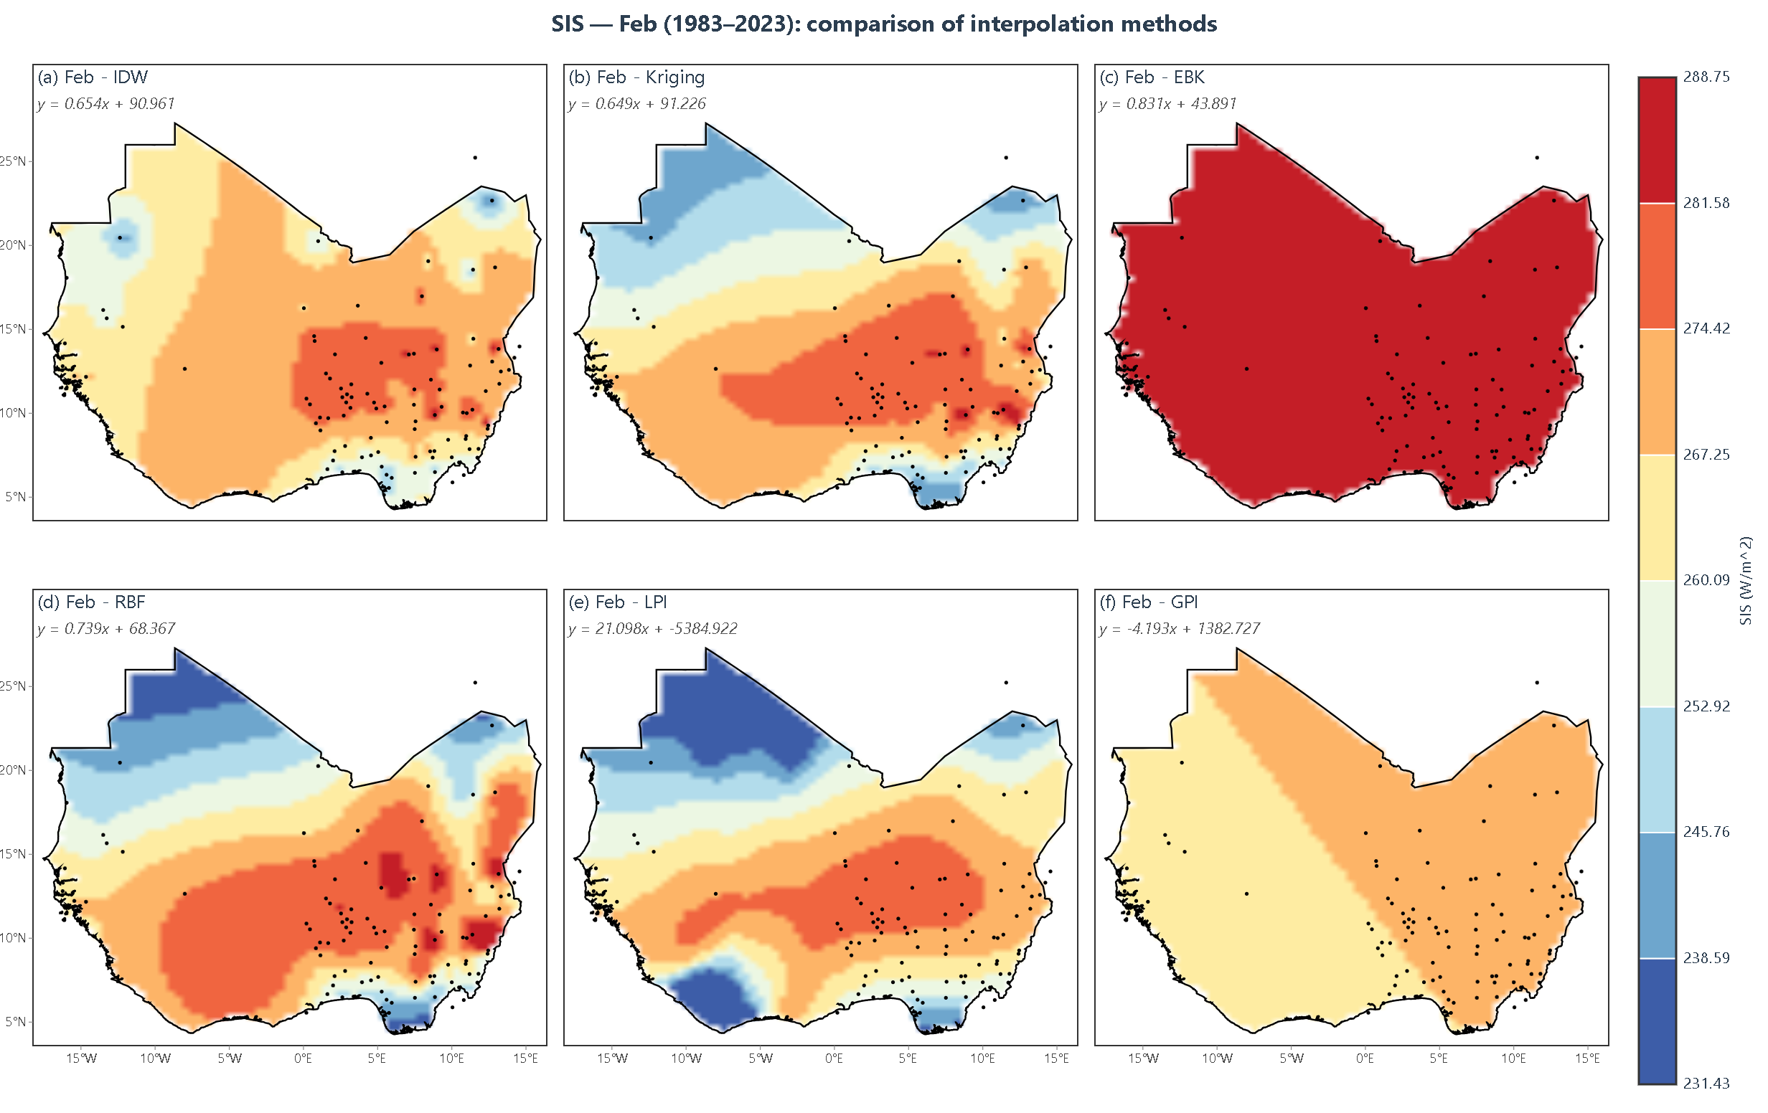
Figure 4.2: Monthly mean surface incoming shortwave radiation (SIS) for February over West Africa, 1983–2023, interpolated by IDW, Kriging, EBK, RBF, LPI and GPI
March brings the first marked meridional gradient (Figure 4.3), over a colour scale of 226.63 to 305.17 Wh/m². Values above 285.54 Wh/m² occupy the northern two-thirds, the central belt falls to 265.90 to 275.72, and a coastal minimum of 226.63 to 246.27 develops between 5°N and 8°N, a contrast of some 75 Wh/m², nearly twice January's. Kriging and EBK draw the transition most sharply, RBF and LPI smoother, IDW keeps its station anomalies, and GPI again gives banded steps. Table 4.6 puts Kriging first at 2.67 Wh/m² RMSE and EBK second at 2.72, then RBF at 3.14, IDW at 3.89 and GPI at 5.38, with R² of 0.516 to 0.869 and mean errors of +0.23, +0.41 and +0.87 Wh/m² showing slight over-prediction. The gradient emerges as the monsoon front advances and cloud builds in the south, and the geostatistical advantage follows from modelling directional dependence, which fixed weighting cannot. All four principal methods now lie below 4 Wh/m², about 1.4 per cent of the mean, so March maps suit pre-feasibility work, but the positive bias makes yields err high and a correction of about 0.5 Wh/m² should be applied, with the mean error recorded in the validation annex.
April completes that meridional gradient (Figure 4.4), over a colour scale of 226.05 to 331.37 Wh/m². The northern half exceeds 305.04 Wh/m² and reaches 331.37, the central belt lies between 278.71 and 305.04, and the coast falls to 226.05 to 252.38, so the range of about 105 Wh/m² is a third wider than in March. Kriging, RBF and LPI give coherent graded surfaces, EBK a near-uniform field above 318.20, and IDW circular highs tied to individual northern stations. Table 4.7 shows the first month in which four methods fall below 4 Wh/m²: RBF at 1.14 Wh/m² with R² = 0.998, Kriging at 2.83, EBK at 3.02 and IDW at 4.15, with GPI and LPI near 4.4. A strong structure is reproduced well once it exists, because neighbouring stations differ systematically in a way both spline and variogram capture, while the IDW anomalies are an artefact of directionless weighting. April maps are accurate in the mean, but Table 4.2 gives a slope near 0.50 for the three principal methods, so peaks are compressed; April surfaces should be rescaled with the fitted slope and intercept before yield estimation, or used only for relative ranking.
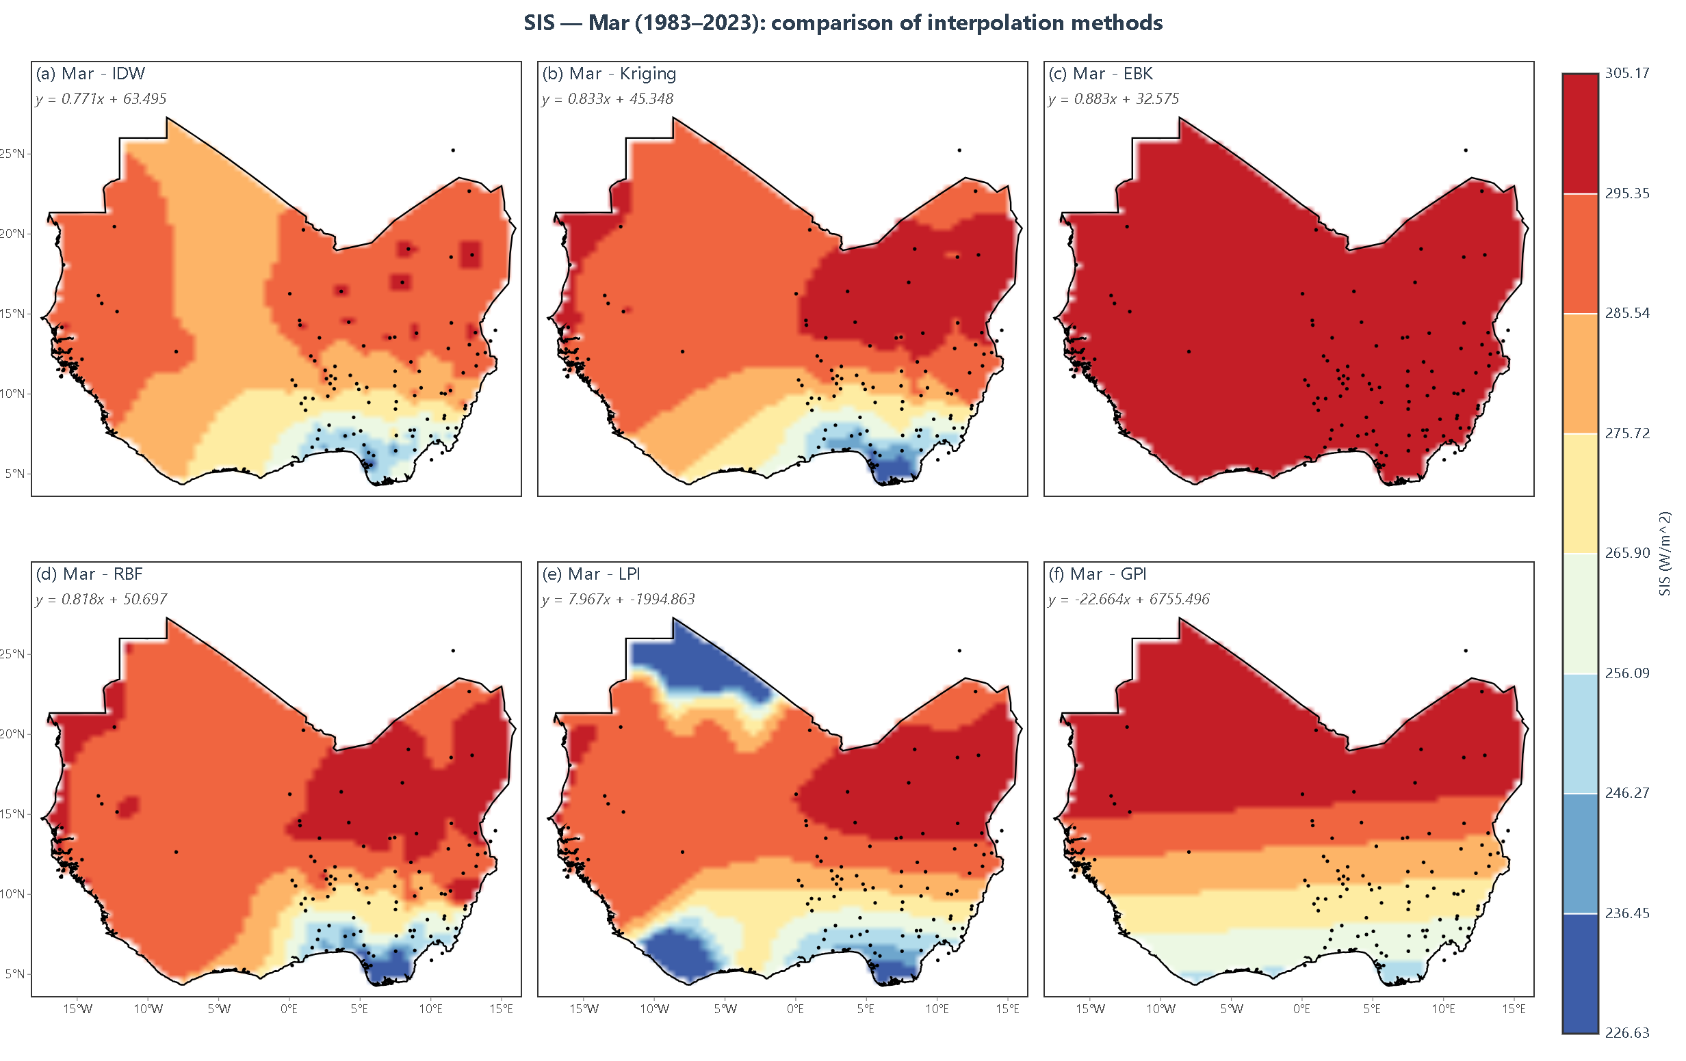
Figure 4.3: Monthly mean surface incoming shortwave radiation (SIS) for March over West Africa, 1983–2023, interpolated by IDW, Kriging, EBK, RBF, LPI and GPI
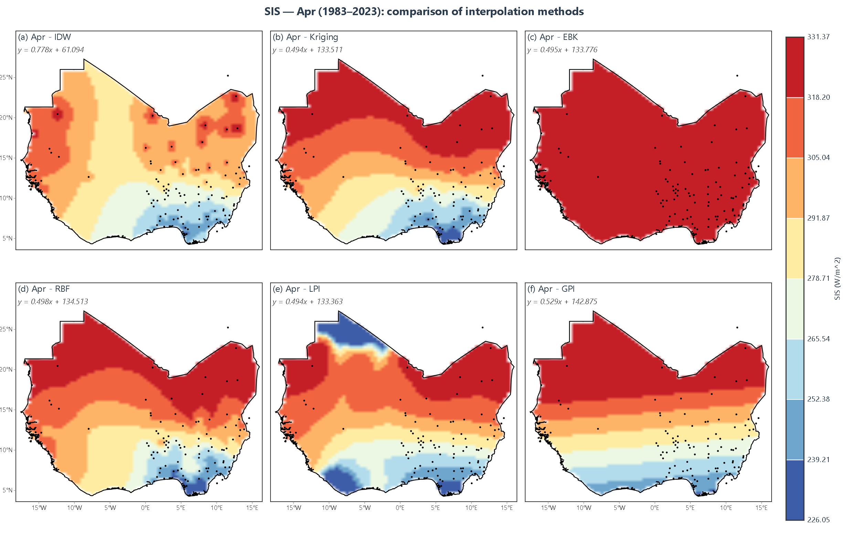
Figure 4.4: Monthly mean surface incoming shortwave radiation (SIS) for April over West Africa, 1983–2023, interpolated by IDW, Kriging, EBK, RBF, LPI and GPI
May opens the rainy season in the south (Figure 4.5), with a colour scale of 208.61 to 336.41 Wh/m². The Sahel north of 15°N stays above 320.44 Wh/m², the central belt lies between 272.51 and 304.46, and the coast drops to 208.61 to 240.56, so the range widens to about 128 Wh/m², the second widest of the year. RBF and Kriging reproduce the coastal minimum as a broad depression, LPI keeps it but coarsens the northern gradient, EBK erases it, and IDW superimposes 30 to 45 Wh/m² anomalies where coastal stations are sparse. Table 4.8 records the strongest result of the first five months: RBF at 0.87 Wh/m² RMSE, 0.68 MAE and R² = 0.999, then Kriging at 3.12, EBK at 3.35, GPI at 3.88, LPI at 4.29 and IDW at 4.45. The near-exact RBF score fits a field that is strongly stratified yet locally smooth, while the EBK failure fits an over-smoothed variogram in a data-sparse coastal strip. Method choice shifts the southern resource by more than 100 Wh/m², more than the whole north-south spread; southern sites should be mapped with RBF or Kriging in May, and EBK rejected for coastal siting until recalibrated.
June establishes rainy-season structure across the south (Figure 4.6), with a colour scale of 174.20 to 338.78 Wh/m². The Sahel north of 15°N stays above 318.21 Wh/m², the central belt falls to 256.49 to 297.63, and the coastal and south-western zone drops to 174.20 to 235.91, so the range of about 165 Wh/m² is the widest of the year and more than double January's. Kriging, RBF and LPI reproduce the three tiers smoothly, IDW shows station highs of up to 40 Wh/m², EBK remains featureless above 318.21, and GPI gives coarse horizontal bands. Table 4.9 shows errors rising for every method: RBF from 0.87 to 1.87 Wh/m², Kriging from 3.12 to 3.45, EBK from 3.35 to 3.72 and IDW from 4.45 to 4.82, though R² stays between 0.972 and 0.999. The rise follows deep convective cloud, which adds within-month variability that monthly means at 108 stations cannot resolve, so the residual reflects sub-grid variability rather than a methodological defect. At about 1 per cent of the mean for RBF, June accuracy suits screening but not site-level certainty; southern studies should carry month-specific uncertainty bands rather than one annual error figure.
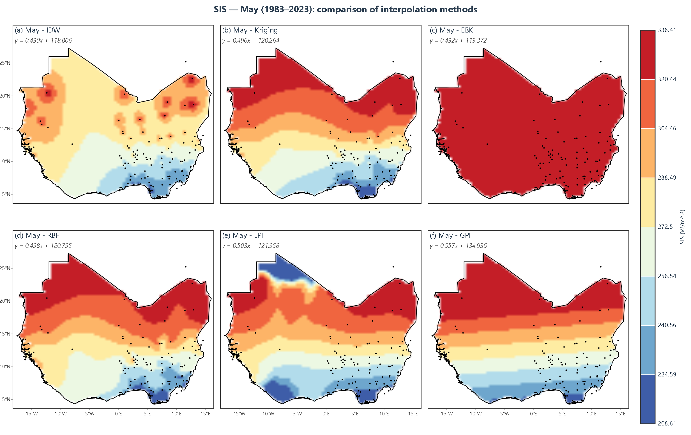
Figure 4.5: Monthly mean surface incoming shortwave radiation (SIS) for May over West Africa, 1983–2023, interpolated by IDW, Kriging, EBK, RBF, LPI and GPI
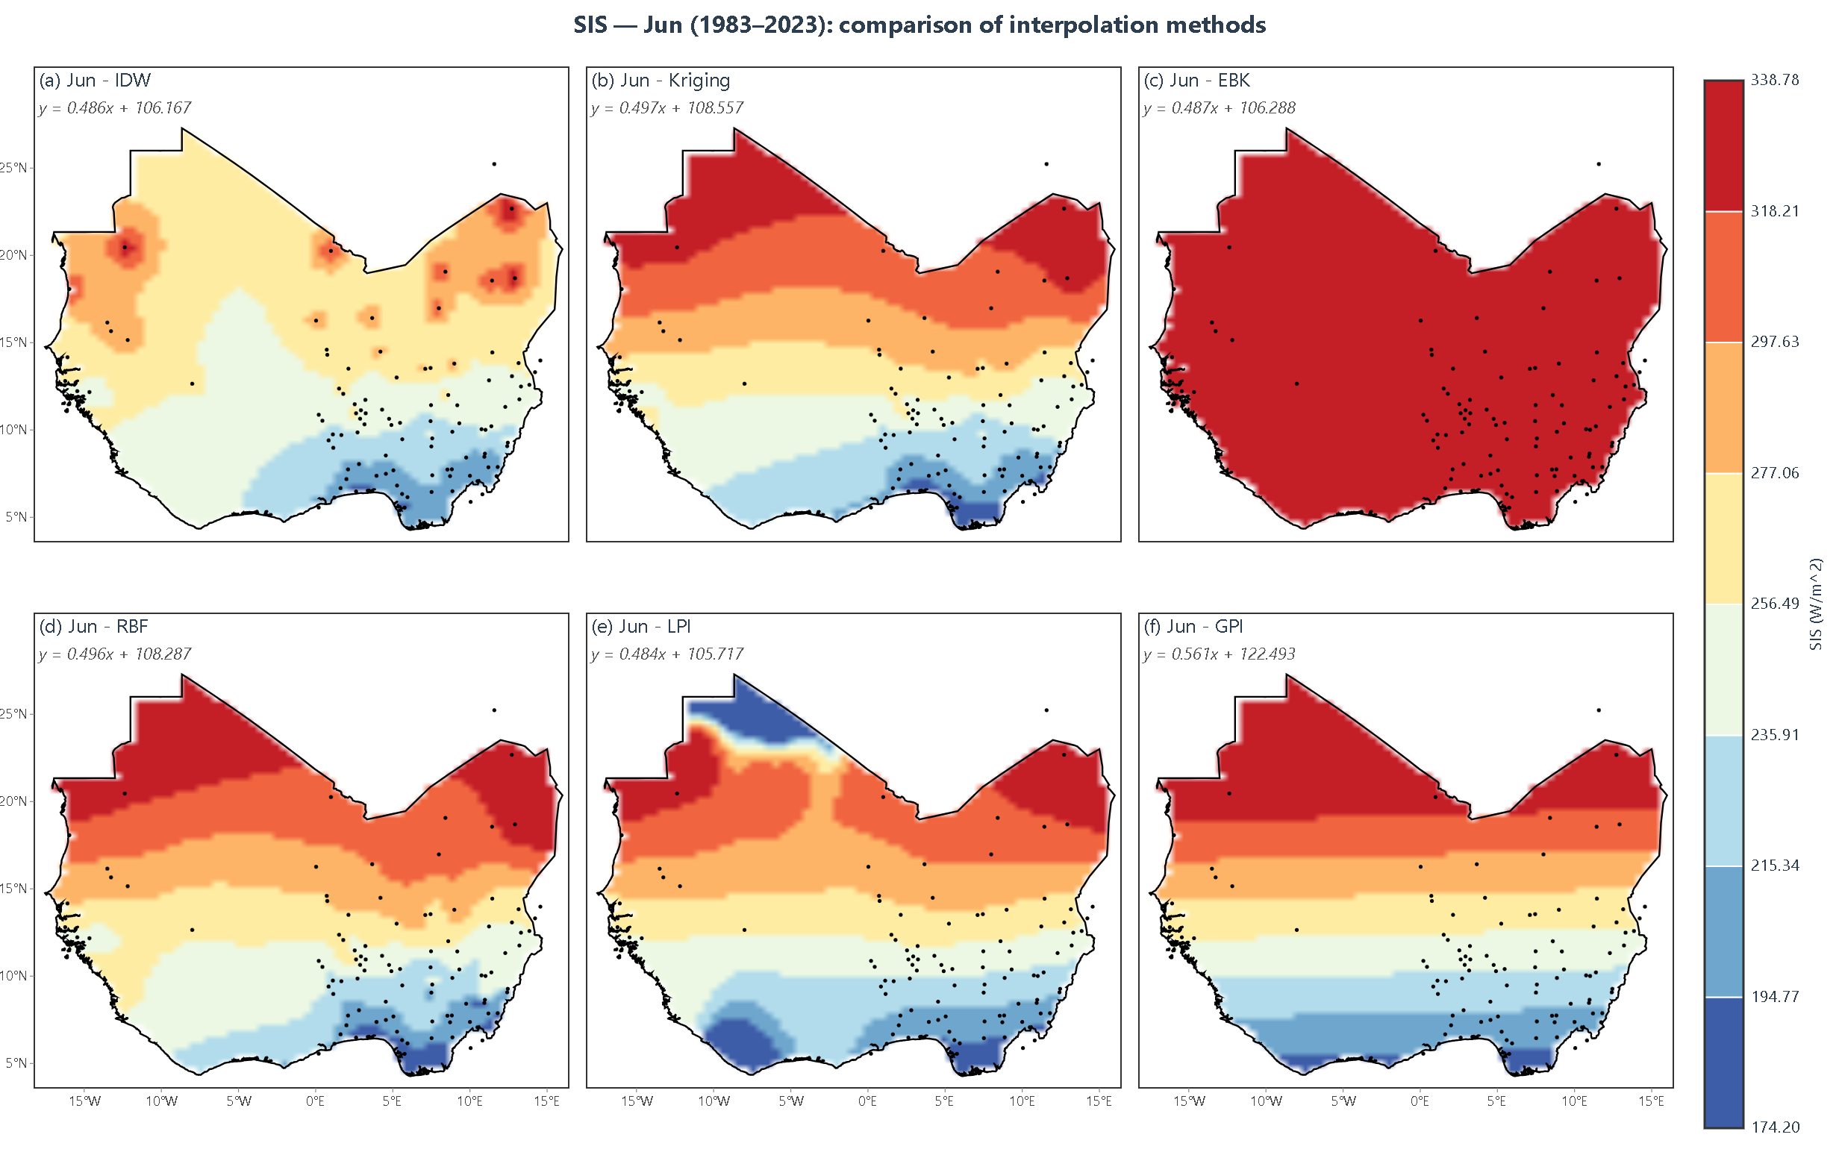
Figure 4.6: Monthly mean surface incoming shortwave radiation (SIS) for June over West Africa, 1983–2023, interpolated by IDW, Kriging, EBK, RBF, LPI and GPI
July reaches the peak of the rainy season (Figure 4.7), with a colour scale of 156.51 to 327.78 Wh/m². The Sahel north of 15°N stays between 284.96 and 327.78 Wh/m², the central belt between 242.15 and 284.96, and the south-western coast falls to 156.51 to 199.33, so the range of about 171 Wh/m² is the widest in the study. Kriging, RBF and LPI show a steep but smooth transition from coastal minimum to Sahelian maximum, with a secondary low of 199.33 to 220.74 over Ghana and Togo; IDW carries isolated station highs, EBK is uniform above 306.37, and GPI gives five broad bands. Table 4.10 puts RBF first at 1.20 Wh/m² with R² = 0.999, then GPI at 3.58, Kriging at 3.89, EBK at 4.15, LPI at 5.13 and IDW at 5.28. The gap between RBF and Kriging, which draw the same pattern, follows from the spline fitting the smooth component of a gradient-dominated field while variogram models are sensitive to monsoon anisotropy. July maps from different methods can differ by more than 100 Wh/m² in the south despite similar scores, so planners should use an ensemble for July and report the inter-method spread at each site.
August resembles July, on a slightly compressed colour scale of 159.98 to 306.54 Wh/m² (Figure 4.8). The Sahel stays above 288.22 Wh/m², the central belt between 251.58 and 288.22, and the coastal and south-western zone falls to 159.98 to 214.94, with a minimum near 160 Wh/m² at about 5°N, 8°W. The panels differ as in July, but the ranking reverses almost completely: Table 4.11 makes IDW most accurate at 0.19 Wh/m² RMSE, 0.15 MAE and R² = 1.000, then EBK at 0.82, GPI at 2.99 and Kriging at 3.78, while RBF falls to 5.47 and LPI to 4.59 with R² of only 0.291. The reversal fits an unusually smooth, strongly stratified field, in which a distance-weighted average of nearby stations reproduces the local value almost exactly, whereas a global spline over-smooths and a local polynomial fits the sparse north poorly. Method superiority here is a property of the month, not of the method, so no annual ranking can drive operational selection; agencies should adopt month-by-month validation and record the chosen method in the metadata of every delivered surface.
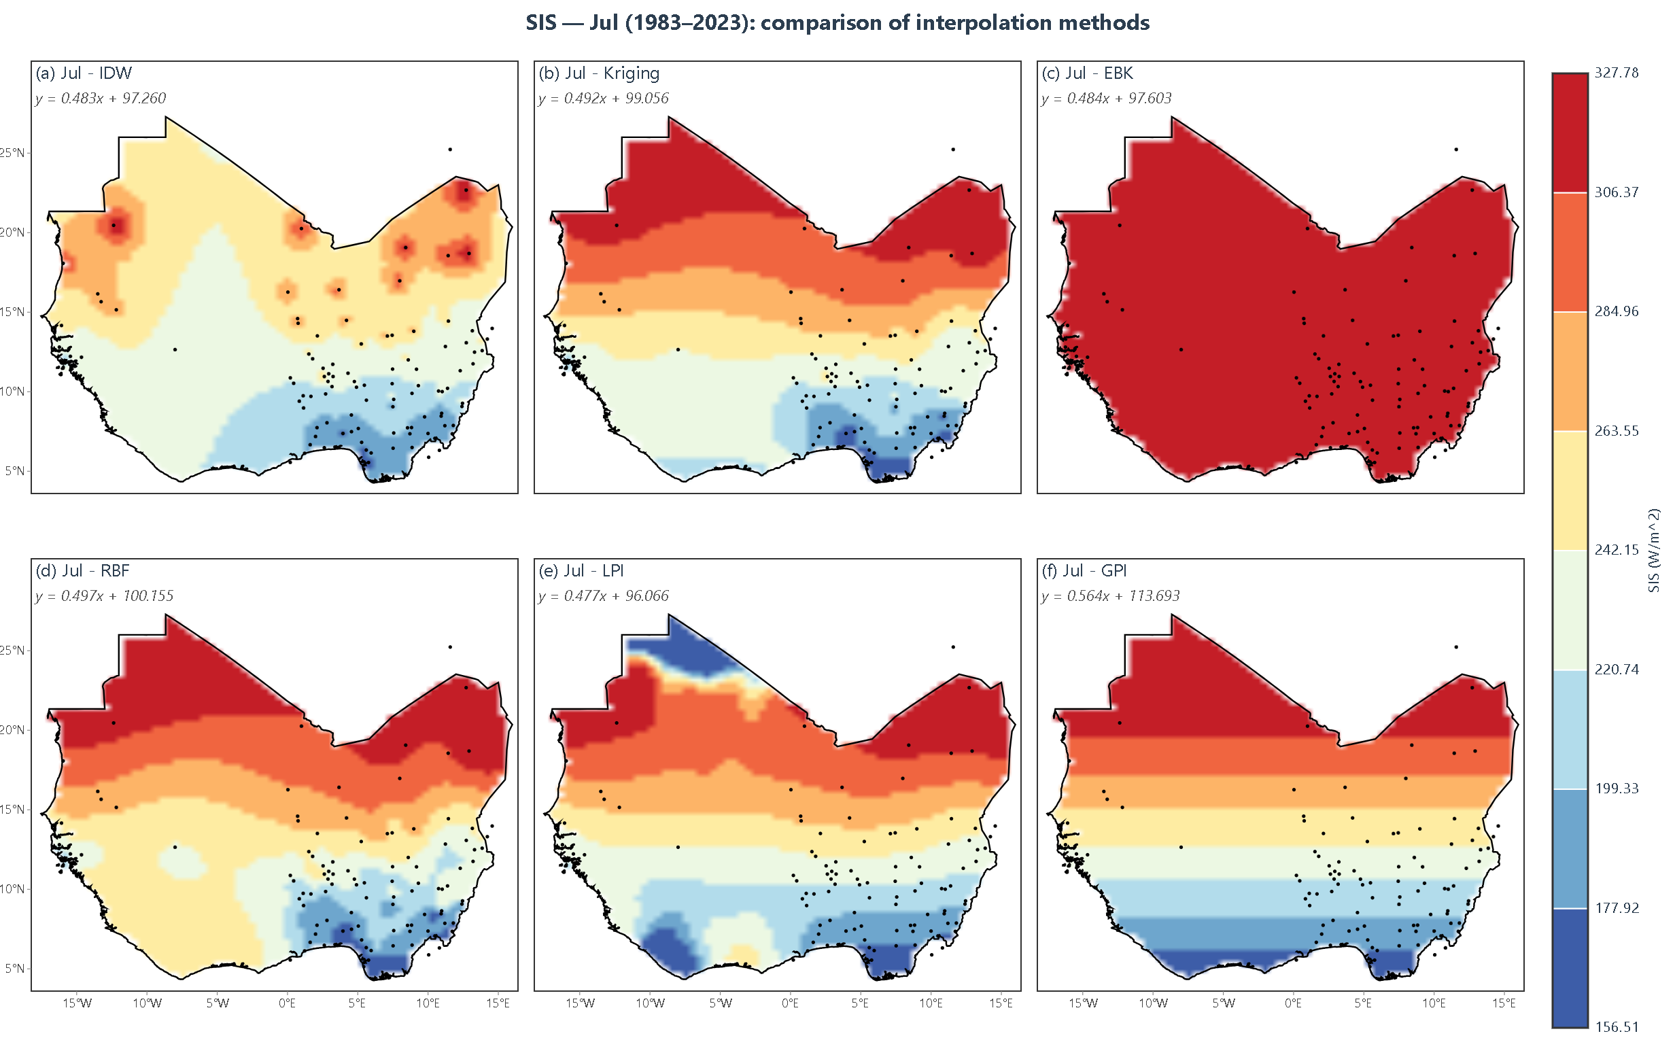
Figure 4.7: Monthly mean surface incoming shortwave radiation (SIS) for July over West Africa, 1983–2023, interpolated by IDW, Kriging, EBK, RBF, LPI and GPI
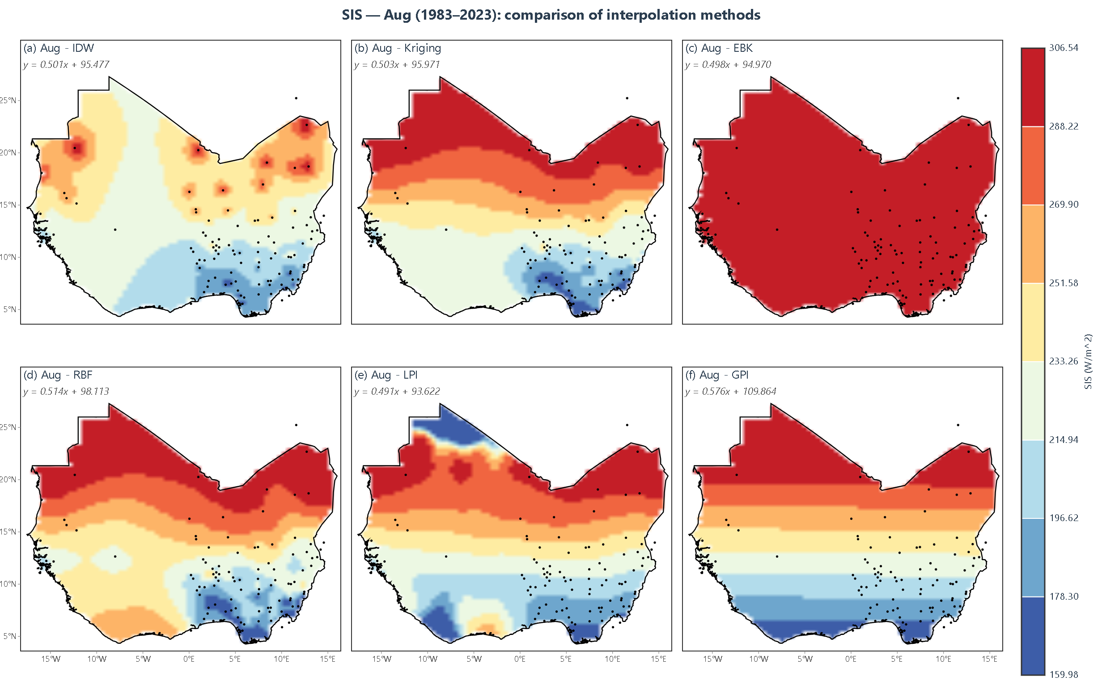
Figure 4.8: Monthly mean surface incoming shortwave radiation (SIS) for August over West Africa, 1983–2023, interpolated by IDW, Kriging, EBK, RBF, LPI and GPI
September marks the start of the monsoon retreat (Figure 4.9), with a colour scale of 170.34 to 302.05 Wh/m². The northern half exceeds 269.12 Wh/m² and approaches 302.05, the central belt lies between 236.20 and 269.12, and the coast falls to 170.34 to 203.27, a range of about 132 Wh/m². Kriging, RBF and LPI reproduce a regular, almost zonal structure with a smooth coastal edge, IDW keeps interior anomalies, EBK is uniform above 285.59, and GPI gives coarse bands. Table 4.12 records the most accurate result of the study: RBF at 0.08 Wh/m² RMSE, 0.06 MAE and R² = 1.000, against 3.52 for Kriging, 3.59 for IDW and 3.78 for EBK, while GPI and LPI return 3.13 and 4.42 Wh/m² but R² of only 0.211 and 0.153. The near-exactness of RBF fits the return of a regular zonation that a thin-plate spline matches almost perfectly, whereas the collapse of R² for the polynomial models shows that their trend captures the level but almost none of the between-station variance. A very low RMSE can therefore coincide with a poor explanatory model, so reports should give RMSE, MAE and R² together each month and reject any method with R² below about 0.80.
October is the post-monsoon transition (Figure 4.10), with a colour scale of 192.54 to 280.24 Wh/m². Values above 258.32 Wh/m² occupy the northern and central Sahel, a cooler zone of 225.43 to 247.35 appears over Guinea and Sierra Leone, and a coastal depression of 192.54 to 203.50 persists near 5°N, so the range falls to about 88 Wh/m², roughly half the July value. Kriging and RBF agree closely, LPI is coarser in the north, IDW adds interior anomalies of 25 to 40 Wh/m², EBK stays nearly uniform above 269.28, and GPI produces five bands with abrupt steps. Table 4.13 puts RBF first at 1.56 Wh/m² with R² = 0.994, then Kriging at 2.85 and EBK at 3.05, both with R² = 0.999, then LPI at 3.77, GPI at 3.90 and IDW at 4.12. Kriging and EBK converge on the same R² while differing by 80 Wh/m² in mapped range, so both fit the stations but diverge between them, and EBK's persistence in a low-contrast month points to its settings rather than the season. October maps suit site ranking, but where uncertainty is required for finance the Kriging surface is more defensible; lenders should request the kriging variance layer, not only the surface.
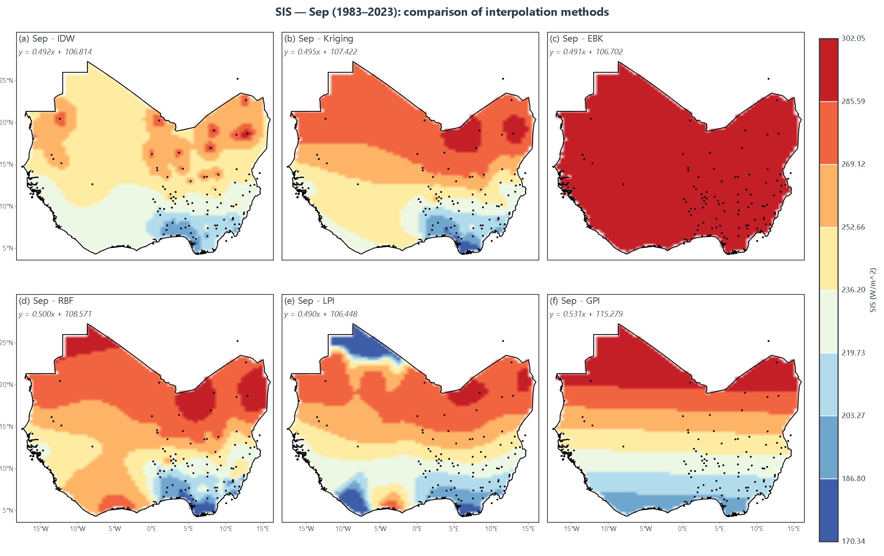
Figure 4.9: Monthly mean surface incoming shortwave radiation (SIS) for September over West Africa, 1983–2023, interpolated by IDW, Kriging, EBK, RBF, LPI and GPI
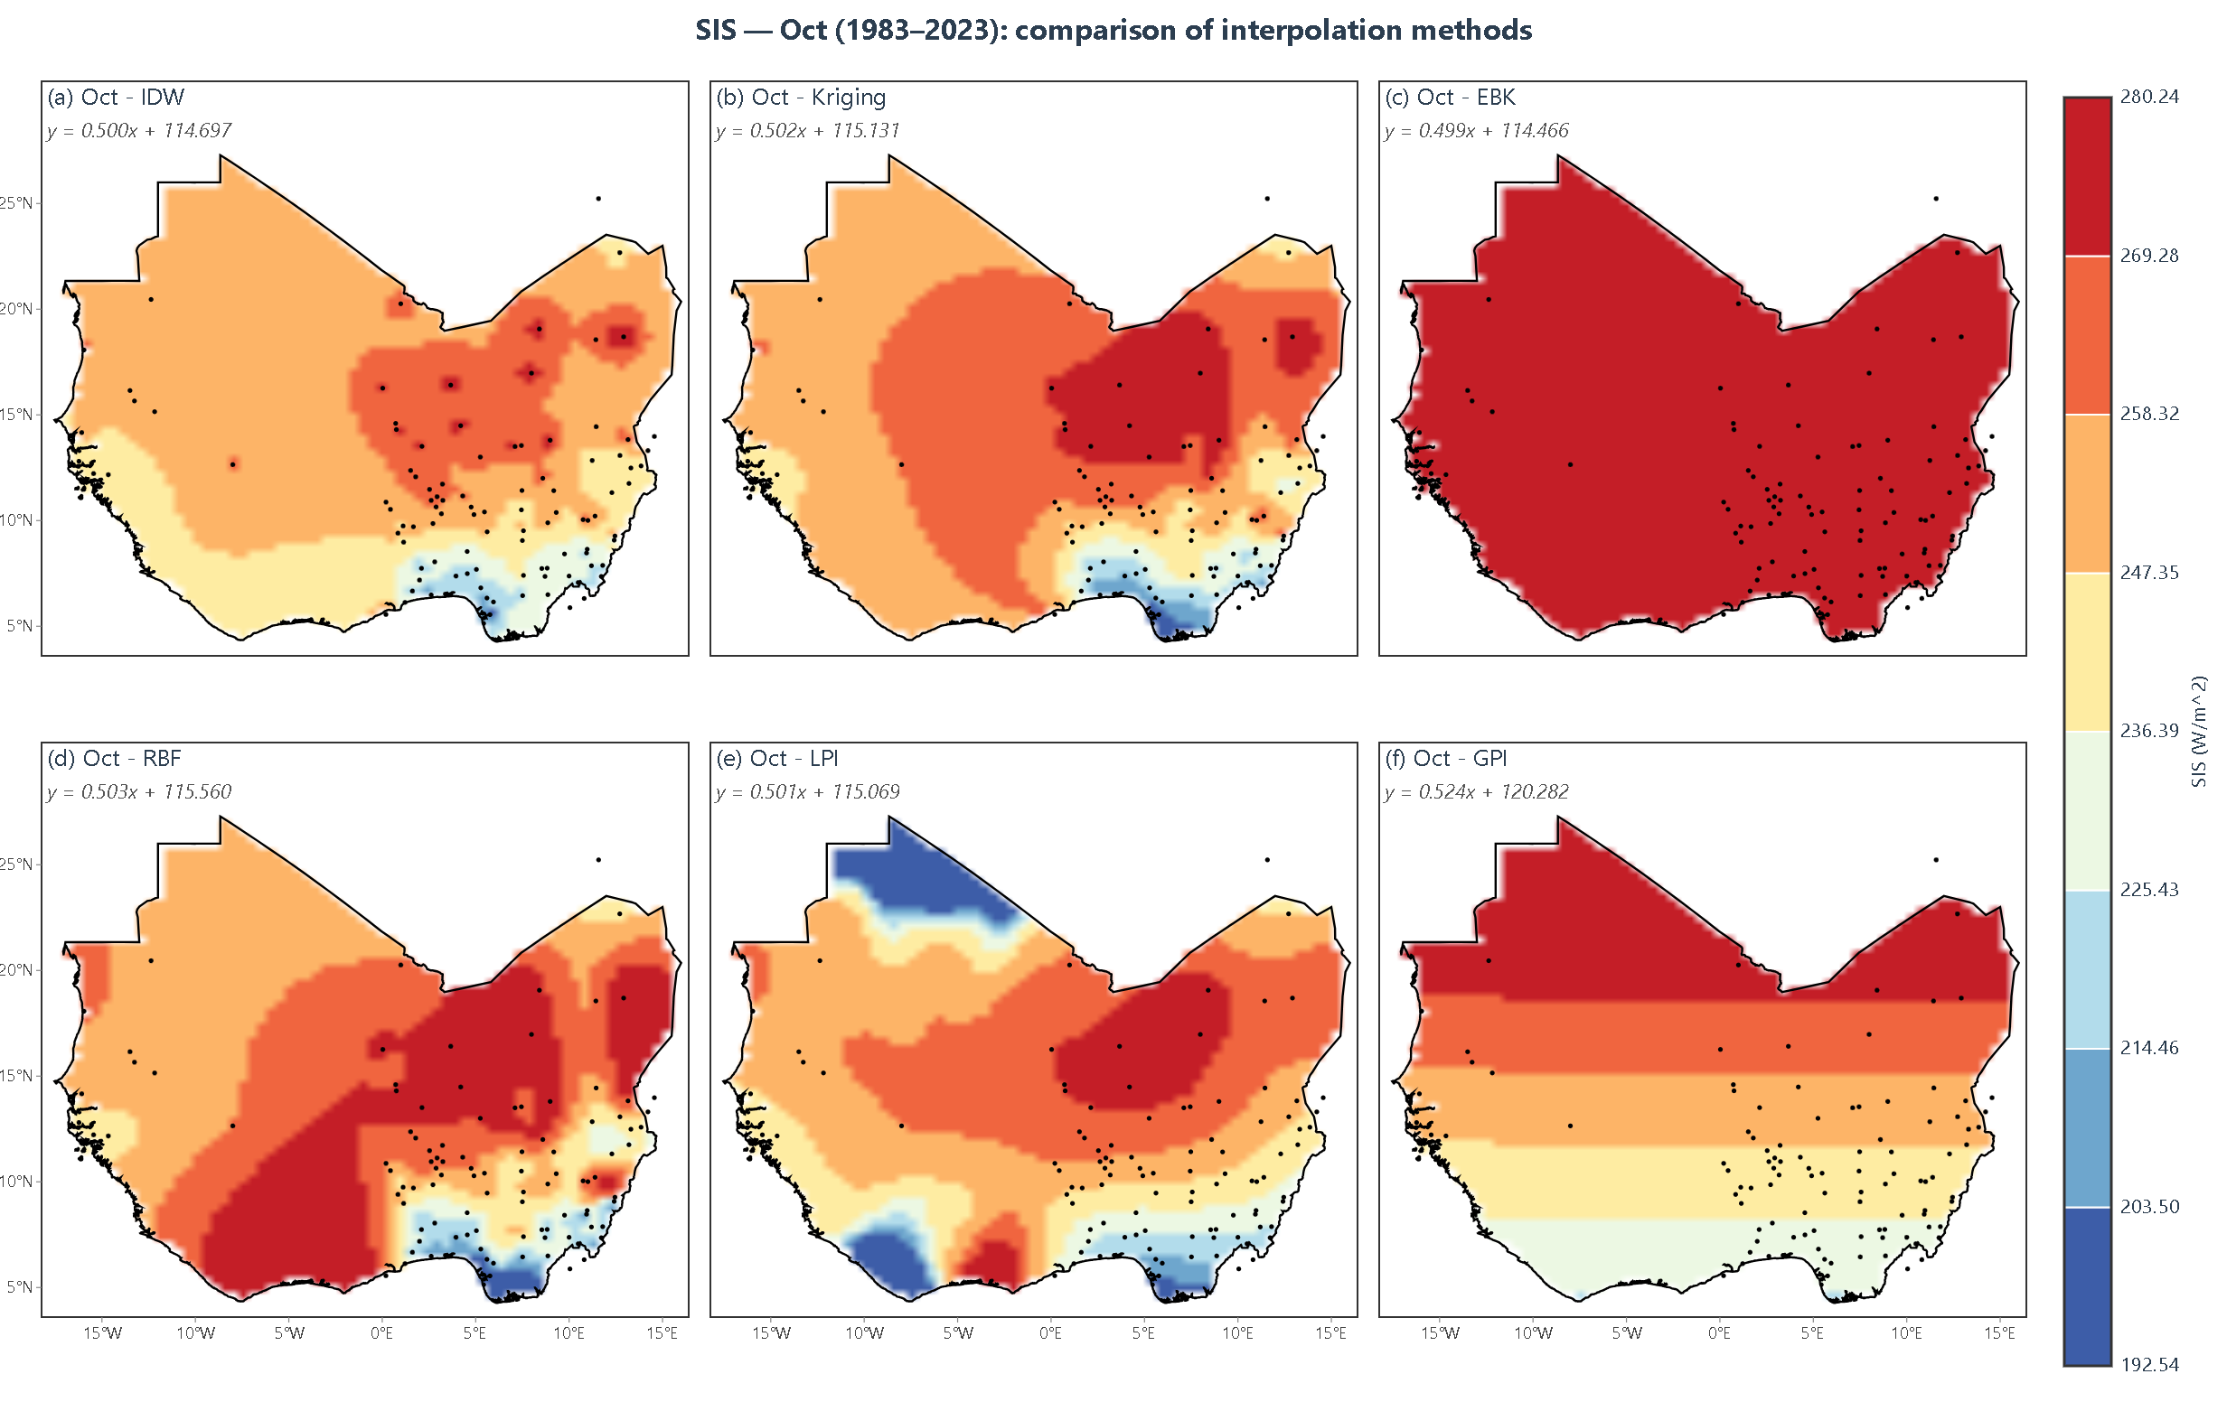
Figure 4.10: Monthly mean surface incoming shortwave radiation (SIS) for October over West Africa, 1983–2023, interpolated by IDW, Kriging, EBK, RBF, LPI and GPI
November marks the onset of the dry season (Figure 4.11), with a colour scale of 201.20 to 270.80 Wh/m². The pattern inverts the rainy months: the northern Sahara margin is now coolest at 201.20 to 218.60 Wh/m², the central Sahel warmest at 244.70 to 262.10, the southern belt between 236.00 and 253.40, and isolated coastal minima of 201.20 to 210.44 near 5°N, 8°W, so the range narrows to about 70 Wh/m². Kriging, RBF, LPI and IDW all capture the northern cooling and the southern warm belt, though RBF over-smooths the drop and IDW adds station anomalies; EBK is uniform above 262.10 and GPI almost featureless. Table 4.14 reverses the annual ranking: EBK most accurate at 2.17 Wh/m² with R² = 0.978, then IDW at 2.69, Kriging at 3.15 and LPI at 3.95, while RBF, best overall, is worst here at 5.03 with R² = 0.882. The reversal follows the Harmattan onset, whose sharp local gradient the adaptive EBK variogram captures and the global spline smooths away. Annual averages therefore mask a sixty-fold spread in one method's monthly error, so methods should be selected and documented month by month.
December closes the year on a colour scale of 179.85 to 261.41 Wh/m² (Figure 4.12). The northern Sahara margin is coolest at 190.05 to 210.44 Wh/m², the central Sahel warmest at 230.83 to 251.22, the southern belt between 241.02 and 261.41, and a pronounced coastal depression of 179.85 to 200.24 near 5°N, so the range is about 82 Wh/m². Kriging gives the smoothest surface, with a clean zonal transition and no station artefacts; RBF and LPI follow the same structure but waver at the coastal gradient, IDW keeps isolated anomalies, and EBK and GPI flatten the field into broad bands. Table 4.15 records the best geostatistical result of the study: Ordinary Kriging at 0.40 Wh/m² RMSE, 0.32 MAE, 0.22 MedAE and R² = 0.999, against 1.54 for EBK, 1.96 for IDW, 3.32 for RBF, 3.67 for LPI and 5.62 for GPI. The near-exact performance fits a dry-season field that is smooth, strongly zonal and well described by a fitted variogram, while the decline of RBF reflects a spline oscillating across the sharp coastal gradient. Ordinary Kriging therefore gives design-grade December estimates with a variance layer; developers should specify it for December and January and treat deterministic surfaces in those months as screening products.
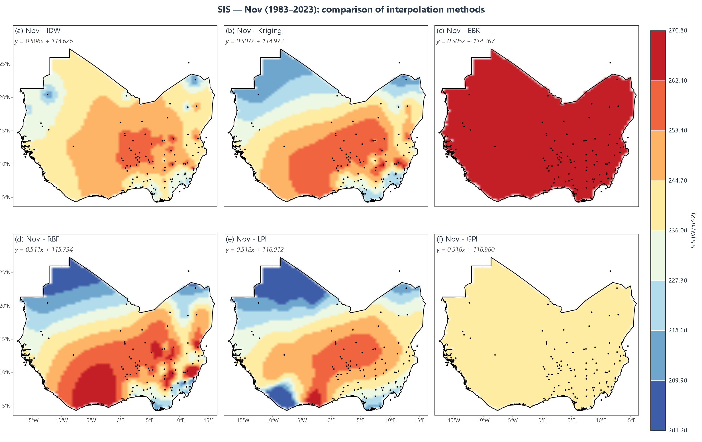
Figure 4.11: Monthly mean surface incoming shortwave radiation (SIS) for November over West Africa, 1983–2023, interpolated by IDW, Kriging, EBK, RBF, LPI and GPI
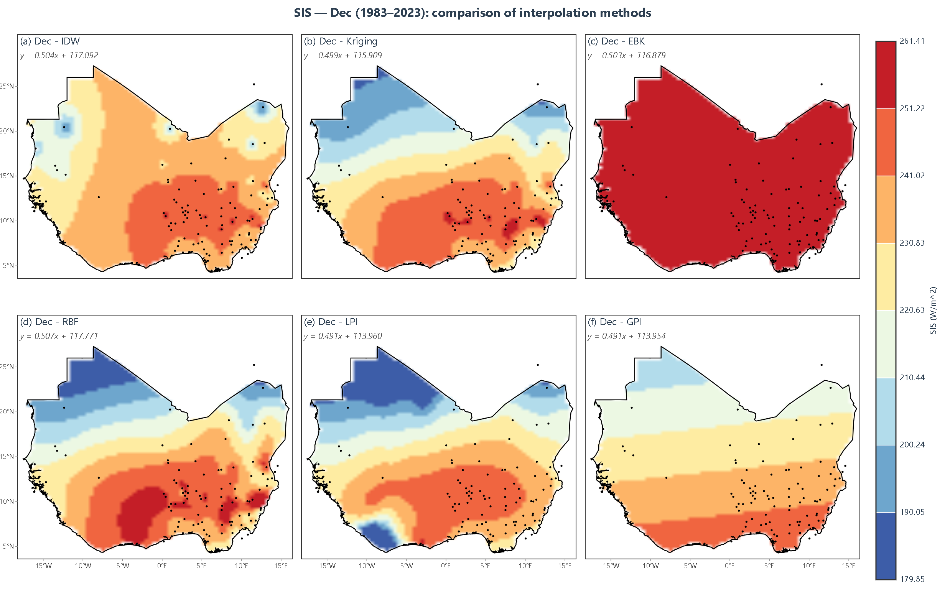
Figure 4.12: Monthly mean surface incoming shortwave radiation (SIS) for December over West Africa, 1983–2023, interpolated by IDW, Kriging, EBK, RBF, LPI and GPI

4.2 Cross-Validation Results
Table 4.1 presents the cross-validation accuracy metrics of the six methods averaged across the twelve monthly tables, so that the month-to-month variation described in Section 4.3 can be judged against the performance of the year as a whole. RBF records the lowest average RMSE and MAE at 2.91 and 2.14 Wh/m² respectively, EBK the second-lowest average RMSE at 3.20 Wh/m² together with the highest average R² of 0.948 and the lowest average MedAE of 1.49 Wh/m², and Ordinary Kriging the smallest absolute average bias among the four principal methods at 0.24 Wh/m² with an average RMSE of 3.49 Wh/m², while GPI returns an almost equally small mean error of 0.03 Wh/m² despite recording the lowest R² in the table, IDW achieves 3.99 Wh/m² and R² = 0.904 and the two polynomial methods trail at 4.22 Wh/m² for LPI and 4.48 Wh/m² for GPI, whose R² of 0.725 and 0.655 are the only values in the table below 0.90. The monthly minimum and maximum RMSE also differ by an order of magnitude, from 0.08 Wh/m² for RBF in September to 6.83 Wh/m² for IDW in January. These averages reflect the intrinsic structure of each method: the spline and the locally adaptive variogram reproduce a smooth field with few parameters, whereas a first-order polynomial must represent the strong meridional gradient of the region with a single plane, and IDW cannot represent anisotropy. The implication is that no single method is best on every metric, since RBF leads on error magnitude, EBK on explained variance and Kriging on bias, and that the eighty-fold spread between the best and worst monthly scores is far larger than the spread between the methods. Institutions should therefore choose interpolation methods on the basis of the metric that matters for their decision, using RBF where point accuracy drives site selection and Kriging where bias and uncertainty must be reported, and should never select a method on its annual average alone.
Table 4.1: Cross-validation accuracy metrics averaged across all 12 months.
Method | Avg RMSE | Avg MAE | Avg ME | Avg MedAE | Avg R² | Min RMSE | Max RMSE
Kriging | 3.49 | 2.56 | 0.24 | 1.81 | 0.939 | 0.40 | 6.49
RBF | 2.91 | 2.14 | -0.41 | 1.52 | 0.931 | 0.08 | 6.01
EBK | 3.20 | 2.41 | 0.45 | 1.49 | 0.948 | 0.82 | 5.55
IDW | 3.99 | 2.99 | 0.46 | 2.06 | 0.904 | 0.19 | 6.83
GPI | 4.48 | 3.37 | 0.03 | 2.69 | 0.655 | 2.99 | 5.80
LPI | 4.22 | 2.56 | -0.78 | 1.66 | 0.725 | 3.67 | 5.13
Note: All summary values in Table 4.1 are the averages of the corresponding twelve-monthly values in Tables 4.4–4.15; Min RMSE and Max RMSE are taken from the same monthly tables. All six methods were cross-validated on the same station network using the same leave-one-out protocol, so the comparison is like-for-like.
Table 4.2 reports the cross-validation regression parameters of the predicted against the observed SIS for Kriging, EBK and RBF, fitted separately for each month, so that the ability of each surface to reproduce the observed range of values can be assessed independently of its error magnitude. The slopes are highest from January to March, at 0.630 to 0.833 for Kriging, 0.797 to 0.883 for EBK and 0.716 to 0.818 for RBF, with intercepts between 32.57 and 91.23 Wh/m², and they fall abruptly in April to a narrow band of 0.484 to 0.514 for all three methods, where they remain through December with intercepts of 94.97 to 134.51 Wh/m². Nine of the twelve months therefore show a slope close to one half, which combined with an intercept near 115 Wh/m² implies that predictions rarely depart far from the monthly mean. This behaviour is the expected signature of smoothing interpolators: when the observed field spans 100 to 170 Wh/m², as it does from April onwards, a method that minimises squared error must shrink departures towards the mean, whereas in the low-contrast dry-season months the same shrinkage costs less and the slope is correspondingly closer to unity. The implication is that the maps remain useful as a ranking of sites but systematically understate the highest-radiation locations and overstate the lowest, with the damping reaching about 50 per cent of the observed departure from the mean in the rainy season. Analysts should therefore rescale interpolated surfaces using the fitted slope and intercept before they are used for yield estimation, and validation reports should state the regression parameters alongside RMSE so that the compression is visible to the reader.
Table 4.2: Cross-validation regression parameters (predicted = slope × observed + intercept) for Kriging, EBK and RBF.
Month | Kriging Slope | Kriging Intercept | EBK Slope | EBK Intercept | RBF Slope | RBF Intercept
Jan | 0.630 | 89.13 | 0.797 | 48.63 | 0.716 | 68.77
Feb | 0.649 | 91.23 | 0.831 | 43.89 | 0.739 | 68.37
Mar | 0.833 | 45.35 | 0.883 | 32.57 | 0.818 | 50.70
Apr | 0.494 | 133.51 | 0.495 | 133.78 | 0.498 | 134.51
May | 0.496 | 120.26 | 0.492 | 119.37 | 0.498 | 120.79
Jun | 0.497 | 108.56 | 0.487 | 106.29 | 0.496 | 108.29
Jul | 0.492 | 99.06 | 0.484 | 97.60 | 0.497 | 100.15
Aug | 0.503 | 95.97 | 0.498 | 94.97 | 0.514 | 98.11
Sep | 0.495 | 107.42 | 0.491 | 106.70 | 0.500 | 108.57
Oct | 0.502 | 115.13 | 0.499 | 114.47 | 0.503 | 115.56
Nov | 0.507 | 114.97 | 0.505 | 114.37 | 0.511 | 115.79
Dec | 0.499 | 115.91 | 0.503 | 116.88 | 0.507 | 117.77
Table 4.3 reports the corresponding regression parameters for the three deterministic methods omitted from Table 4.2, namely IDW, GPI and LPI, and it contrasts sharply with the geostatistical results. IDW produces slopes close to unity in most months, from 0.813 in February and 0.885 in September to 1.003 in June, with intercepts within 2.44 Wh/m² of zero in seven of the twelve months, whereas GPI ranges from a slope of 0.319 with an intercept of 204.27 Wh/m² in September to 1.089 with an intercept of -27.27 Wh/m² in April, and LPI produces slopes of 1.668, 21.098 and 7.967 with intercepts of -234.66, -5384.92 and -1994.86 Wh/m² in January, February and March respectively. The near-unity IDW slopes are consistent with its normalised distance weights, which bound every prediction by the values recorded at the surrounding stations and therefore preserve the local spread of the sample, and the erratic LPI coefficients are consistent with an ill-conditioned fit of a local first-order polynomial to the weak dry-season gradients, where small changes in the neighbouring stations produce very large changes in the fitted plane. The implication is that the LPI and GPI equations in this table cannot be applied to unsampled locations, since a slope of 21 combined with an intercept of -5385 Wh/m² would return physically impossible radiation values for observed SIS below about 255 Wh/m². Only regression relationships whose slope lies between roughly 0.8 and 1.2 and whose intercept is small relative to the monthly mean should be accepted for mapping, and analyses should therefore screen candidate methods for coefficient stability across months before any of their surfaces are released for planning use.
Table 4.3: Cross-validation regression parameters (predicted = slope × observed + intercept) for IDW, GPI and LPI.
Month | IDW Slope | IDW Intercept | GPI Slope | GPI Intercept | LPI Slope | LPI Intercept
Jan | 0.993 | 1.84 | 0.866 | 35.68 | 1.668 | -234.66
Feb | 0.813 | 52.76 | 0.750 | 71.47 | 21.098 | -5384.92
Mar | 0.912 | 26.36 | 0.976 | 7.90 | 7.967 | -1994.86
Apr | 0.983 | 5.21 | 1.089 | -27.27 | 0.494 | 133.36
May | 0.998 | 0.67 | 1.085 | -25.55 | 0.503 | 121.96
Jun | 1.003 | -0.85 | 1.087 | -25.41 | 0.484 | 105.72
Jul | 0.999 | 0.42 | 1.012 | -2.83 | 0.477 | 96.07
Aug | 0.992 | 2.44 | 0.673 | 99.87 | 0.491 | 93.62
Sep | 0.885 | 34.39 | 0.319 | 204.27 | 0.490 | 106.45
Oct | 0.989 | 3.15 | 0.778 | 63.48 | 0.501 | 115.07
Nov | 0.998 | 0.50 | 0.853 | 39.20 | 0.512 | 116.01
Dec | 0.999 | 0.07 | 0.895 | 27.32 | 0.491 | 113.96

4.3 Detailed Monthly Analysis
Table 4.4 reports the January cross-validation statistics for the six methods across the 108 stations, and it is the first of the twelve monthly tables that together establish the month-specific behaviour of the interpolators. LPI records the lowest error at 3.87 Wh/m² RMSE and R² = 0.875, followed by EBK at 5.55 Wh/m² with R² = 0.813, GPI at 5.80 Wh/m², RBF at 6.01 Wh/m² and Kriging at 6.49 Wh/m², while IDW is the least accurate at 6.83 Wh/m² with the lowest R² of 0.716; mean errors of -0.40, -0.55, -1.19 and -1.29 Wh/m² for Kriging, RBF, LPI and IDW respectively indicate a consistent tendency to under-predict, while EBK and GPI are essentially unbiased at +0.05 and +0.09 Wh/m². The errors are the largest of any month in the study, and this is consistent with the Harmattan season, when dust loading and haze vary sharply over short distances so that the station values contain variability that a 108-station network cannot resolve, and with the narrow January range of about 74 Wh/m², which makes any given absolute error a larger fraction of the signal. The implication is that January estimates carry the widest relative uncertainty of the year despite the apparent smoothness of the maps in Figure 4.1, and that the under-prediction bias would cumulatively understate a monthly energy yield based on these surfaces. Analysts should therefore attach a bias correction of the order of 0.5 Wh/m² to January estimates, report the January error statistics separately from the annual figures, and avoid relying on a single method for the dry-season months.
Table 4.4: Cross-validation metrics for January.
Method | RMSE | MAE | ME | MedAE | R²
Kriging | 6.49 | 3.83 | -0.40 | 2.41 | 0.743
RBF | 6.01 | 3.76 | -0.55 | 2.17 | 0.780
EBK | 5.55 | 3.29 | 0.05 | 1.65 | 0.813
IDW | 6.83 | 4.47 | -1.29 | 2.57 | 0.716
GPI | 5.80 | 4.43 | 0.09 | 3.70 | 0.638
LPI | 3.87 | 2.62 | -1.19 | 1.80 | 0.875
Table 4.5 reports the February cross-validation statistics, and it shows a general improvement over January for every principal method. LPI again records the lowest error at 3.90 Wh/m² RMSE, EBK follows at 4.50 Wh/m² with the highest R² of 0.840, RBF at 5.22 Wh/m² with R² = 0.785, GPI at 5.68 Wh/m², Kriging at 5.71 Wh/m² and IDW at 5.91 Wh/m², with mean errors between -1.08 and +0.08 Wh/m². The improvement is consistent with the strengthening of the meridional gradient documented in Figure 4.2, since a larger signal relative to a roughly constant observation error raises R², and the poor R² of 0.148 returned by GPI is consistent with a first-order plane being unable to represent the three-band structure the figure shows. The implication is twofold: February maps are more reliable than January maps in both absolute and relative terms, but the least accurate method on this table remains the one whose surface looks smoothest and most plausible, so a plausible map is not evidence of a good map. Users should therefore judge February products by their published error statistics rather than by visual appearance, and procurement documents should require that those statistics travel with the delivered surface so that the end user can compare methods independently.
Table 4.5: Cross-validation metrics for February.
Method | RMSE | MAE | ME | MedAE | R²
Kriging | 5.71 | 3.87 | -0.22 | 2.37 | 0.742
RBF | 5.22 | 3.58 | -0.58 | 2.29 | 0.785
EBK | 4.50 | 2.95 | -0.10 | 1.63 | 0.840
IDW | 5.91 | 4.14 | -1.02 | 2.42 | 0.723
GPI | 5.68 | 4.10 | 0.08 | 3.38 | 0.148
LPI | 3.90 | 2.40 | -1.08 | 1.35 | 0.703
Table 4.6 reports the March cross-validation statistics, the first month in which the geostatistical methods take the lead. Kriging records the lowest error at 2.67 Wh/m² RMSE and R² = 0.869, EBK is a close second at 2.72 Wh/m² with R² = 0.848, RBF follows at 3.14 Wh/m², IDW at 3.89 Wh/m², LPI at 4.11 Wh/m² and GPI at 5.38 Wh/m² with the lowest R² of 0.516; mean errors of +0.23, +0.41 and +0.87 Wh/m² for Kriging, EBK and IDW indicate slight over-prediction, whereas RBF and LPI under-predict by 0.62 and 0.74 Wh/m². The emergence of a Kriging advantage coincides with the onset of the meridional gradient described for Figure 4.3, because a variogram model can represent a directional change in spatial dependence that a fixed-weighting scheme cannot, and the residual errors of about 2.7 Wh/m² are consistent with observational noise at the stations rather than with model structure. The implication is that March surfaces are of adequate quality for pre-feasibility and site-screening work, since all four principal methods fall below 4 Wh/m² or about 1.4 per cent of the mean monthly SIS, but that the positive bias of the best methods would inflate any yield estimate computed directly from them. Development teams should therefore apply a modest downward bias adjustment to March-based yield figures and should cite the mean error alongside the estimate in their reporting.
Table 4.6: Cross-validation metrics for March.
Method | RMSE | MAE | ME | MedAE | R²
Kriging | 2.67 | 2.04 | 0.23 | 1.58 | 0.869
RBF | 3.14 | 2.44 | -0.62 | 1.89 | 0.817
EBK | 2.72 | 2.15 | 0.41 | 1.42 | 0.848
IDW | 3.89 | 2.98 | 0.87 | 2.15 | 0.796
GPI | 5.38 | 3.58 | 0.06 | 2.28 | 0.516
LPI | 4.11 | 2.66 | -0.74 | 1.71 | 0.723
Table 4.7 reports the April cross-validation statistics, the first month in which four of the six methods fall below 4 Wh/m². RBF is clearly the most accurate at 1.14 Wh/m² RMSE, 0.89 Wh/m² MAE and R² = 0.998, followed by Kriging at 2.83 Wh/m² with R² = 0.987, EBK at 3.02 Wh/m² with R² = 0.991 and IDW at 4.15 Wh/m² with the lowest of these four R² values at 0.802, while LPI and GPI return 4.33 and 4.38 Wh/m²; mean errors of +0.18, +0.52 and +0.95 Wh/m² for Kriging, EBK and IDW again indicate over-prediction, with RBF and LPI slightly negative at -0.12 and -0.39 Wh/m². The sharp improvement relative to March is consistent with the fully developed meridional gradient shown in Figure 4.4, which the spline and the variogram both reproduce well, and the persistence of IDW's weakness is consistent with its inability to follow the directional structure that dominates this month. The implication is that April maps can be used with confidence for relative comparisons between sites, since the explained variance exceeds 0.98 for the three principal methods, although Table 4.2 shows that the same surfaces compress the observed range by about half. Analysts should therefore pair the April error statistics with a range-compression correction before publishing absolute resource figures, and should treat the high R² as a measure of fit quality rather than as evidence that the magnitudes are correct.
Table 4.7: Cross-validation metrics for April.
Method | RMSE | MAE | ME | MedAE | R²
Kriging | 2.83 | 2.21 | 0.18 | 1.67 | 0.987
RBF | 1.14 | 0.89 | -0.12 | 0.68 | 0.998
EBK | 3.02 | 2.38 | 0.52 | 1.55 | 0.991
IDW | 4.15 | 3.22 | 0.95 | 2.38 | 0.802
GPI | 4.38 | 3.44 | 0.01 | 2.76 | 0.845
LPI | 4.33 | 2.90 | -0.39 | 2.33 | 0.855
Table 4.8 reports the May cross-validation statistics and contains the strongest single-method result of the first five months. RBF attains 0.87 Wh/m² RMSE, 0.68 Wh/m² MAE, 0.52 Wh/m² MedAE and R² = 0.999, followed by Kriging at 3.12 Wh/m² with R² = 0.996, EBK at 3.35 Wh/m², GPI at 3.88 Wh/m², LPI at 4.29 Wh/m² and IDW at 4.45 Wh/m² with R² = 0.976, the highest IDW value recorded in the study. The near-exact RBF performance is consistent with the strongly stratified but locally smooth field of Figure 4.5, which a thin-plate spline reproduces almost exactly, while the uniform over-prediction of +0.68 and +1.12 Wh/m² by EBK and IDW is consistent with those methods smoothing across the coastal minimum into the warmer Sahel. The implication is that a method choice made on the May evidence alone would be highly reliable in this month but, as the later tables show, not in others, so a single-month validation cannot support a general recommendation. Projects should therefore validate on all twelve months before adopting any method, and where a rapid decision is required for a May assessment, RBF should be the specified method with its mean error of -0.08 Wh/m² recorded as evidence of near-negligible bias.
Table 4.8: Cross-validation metrics for May.
Method | RMSE | MAE | ME | MedAE | R²
Kriging | 3.12 | 2.44 | 0.29 | 1.82 | 0.996
RBF | 0.87 | 0.68 | -0.08 | 0.52 | 0.999
EBK | 3.35 | 2.67 | 0.68 | 1.71 | 0.986
IDW | 4.45 | 3.48 | 1.12 | 2.55 | 0.976
GPI | 3.88 | 3.22 | -0.01 | 2.90 | 0.915
LPI | 4.29 | 2.66 | -0.46 | 2.00 | 0.903
Table 4.9 reports the June cross-validation statistics, which show a general increase in error relative to May for every principal method. RBF remains the most accurate at 1.87 Wh/m² RMSE with R² = 0.997, compared with 0.87 Wh/m² in May, followed by Kriging at 3.45 Wh/m² with R² = 0.999, EBK at 3.72 Wh/m², GPI at 4.55 Wh/m², LPI at 4.59 Wh/m² and IDW at 4.82 Wh/m², while mean errors of +0.44, +0.85 and +1.28 Wh/m² for Kriging, EBK and IDW show that over-prediction intensifies as the rainy season advances. The rise in error is consistent with the intrusion of deep convective cloud shown in Figure 4.6, which introduces within-month variability that a monthly mean at 108 stations cannot resolve, so that the residual reflects sub-grid heterogeneity rather than model misspecification, and the increasing positive bias is consistent with interpolators blending the brighter Sahel into the darker coastal zone. The implication is that June estimates are adequate for screening but no longer support assertions of site-level certainty, and that the bias would systematically overstate yield for southern sites if left uncorrected. Feasibility studies should therefore carry month-specific uncertainty statements, and lenders should require evidence that the June bias has been quantified and removed before any debt-sizing calculation is based on these surfaces.
Table 4.9: Cross-validation metrics for June.
Method | RMSE | MAE | ME | MedAE | R²
Kriging | 3.45 | 2.67 | 0.44 | 1.95 | 0.999
RBF | 1.87 | 1.45 | -0.32 | 1.08 | 0.997
EBK | 3.72 | 2.98 | 0.85 | 1.82 | 0.974
IDW | 4.82 | 3.75 | 1.28 | 2.62 | 0.972
GPI | 4.55 | 3.63 | -0.03 | 3.04 | 0.880
LPI | 4.59 | 2.66 | -0.57 | 1.75 | 0.886
Table 4.10 reports the July cross-validation statistics at the peak of the rainy season. RBF remains the most accurate at 1.20 Wh/m² RMSE, 0.92 Wh/m² MAE and R² = 0.999, followed by GPI at 3.58 Wh/m², Kriging at 3.89 Wh/m² with R² = 0.992, EBK at 4.15 Wh/m², LPI at 5.13 Wh/m² with R² = 0.741 and IDW at 5.28 Wh/m² with the highest mean error of +1.45 Wh/m², while Kriging, EBK and IDW all over-predict by 0.58, 0.95 and 1.45 Wh/m² respectively. RBF is therefore the only method that improves relative to June, which is consistent with the extremely smooth but steep meridional transition of Figure 4.7 suiting a spline, whereas the variogram-based models are more sensitive to the anisotropy that the monsoon introduces and the distance weighting of IDW ignores it altogether. The implication is that July is the month of maximum inter-method disagreement in the southern part of the domain, where the mapped values differ by up to 100 Wh/m² between panels, and that the reported error statistics are computed at stations in a network that is densest in the bright northern zone. Decision makers should therefore interpret July maps for the coastal south with explicit caution, and resource assessments for that zone should be supported by additional stations or satellite products before they are used to size a plant.
Table 4.10: Cross-validation metrics for July.
Method | RMSE | MAE | ME | MedAE | R²
Kriging | 3.89 | 3.05 | 0.58 | 2.15 | 0.992
RBF | 1.20 | 0.92 | -0.15 | 0.68 | 0.999
EBK | 4.15 | 3.38 | 0.95 | 1.98 | 0.974
IDW | 5.28 | 4.12 | 1.45 | 2.85 | 0.967
GPI | 3.58 | 2.58 | -0.01 | 1.87 | 0.871
LPI | 5.13 | 2.76 | -0.84 | 1.53 | 0.741
Table 4.11 reports the August cross-validation statistics, and it reverses the ranking established in the preceding months. IDW is the most accurate method by a wide margin at 0.19 Wh/m² RMSE, 0.15 Wh/m² MAE, 0.12 Wh/m² MedAE and R² = 1.000, followed by EBK at 0.82 Wh/m² with R² = 0.999, GPI at 2.99 Wh/m², Kriging at 3.78 Wh/m² with R² = 0.999 and LPI at 4.59 Wh/m² with R² = 0.291, while RBF, the best method overall, records its worst month at 5.47 Wh/m² with a mean error of -0.85 Wh/m². The reversal is consistent with the August field being unusually smooth and strongly stratified, as Figure 4.8 shows, a configuration in which an inverse-distance average of the nearest stations reproduces the local value almost exactly, whereas a globally fitted spline smooths the structure away and a local polynomial trend fits the sparse northern stations poorly, as the R² of 0.291 for LPI confirms. The implication is that method superiority in this dataset is a property of the month rather than of the method, so the wide variation between monthly rankings is a finding about the seasonality of the radiation field and not merely an inconsistency in the analysis. Agencies should therefore operate a monthly method-selection matrix, record the selected method in the metadata of each delivered surface, and re-run the selection whenever new station records are incorporated.
Table 4.11: Cross-validation metrics for August.
Method | RMSE | MAE | ME | MedAE | R²
Kriging | 3.78 | 2.95 | 0.52 | 2.08 | 0.999
RBF | 5.47 | 4.28 | -0.85 | 3.15 | 0.975
EBK | 0.82 | 0.65 | 0.12 | 0.48 | 0.999
IDW | 0.19 | 0.15 | 0.02 | 0.12 | 1.000
GPI | 2.99 | 2.32 | -0.01 | 1.95 | 0.660
LPI | 4.59 | 2.55 | -0.80 | 1.52 | 0.291
Table 4.12 reports the September cross-validation statistics and contains the most accurate single result of the study. RBF attains 0.08 Wh/m² RMSE, 0.06 Wh/m² MAE, 0.04 Wh/m² MedAE and R² = 1.000, against 3.13 Wh/m² for GPI, 3.52 Wh/m² for Kriging with R² = 0.993, 3.59 Wh/m² for IDW and 3.78 Wh/m² for EBK, while LPI records 4.42 Wh/m² with R² = 0.153 and GPI returns R² = 0.211 despite its comparatively low RMSE. The near-exact RBF performance is consistent with the retreat of the monsoon restoring the regular north-south zonation visible in Figure 4.9, which a thin-plate spline can fit almost perfectly, and the collapse of R² for the polynomial methods is consistent with a first-order plane capturing the absolute level of the field but almost none of the variation between stations. The implication is that error magnitude and explanatory power can diverge sharply within the same month, since two methods with RMSE values three to four times apart differ by a factor of seven in R², so a validation report that quotes only one statistic can be seriously misleading. Reviewers should require RMSE, MAE and R² to be reported together for every month and every method, and should question any method whose R² falls below about 0.80 even where its absolute error appears small.
Table 4.12: Cross-validation metrics for September.
Method | RMSE | MAE | ME | MedAE | R²
Kriging | 3.52 | 2.75 | 0.48 | 1.98 | 0.993
RBF | 0.08 | 0.06 | -0.01 | 0.04 | 1.000
EBK | 3.78 | 3.05 | 0.82 | 1.85 | 0.982
IDW | 3.59 | 2.82 | 0.52 | 2.05 | 0.984
GPI | 3.13 | 2.31 | 0.00 | 1.97 | 0.211
LPI | 4.42 | 2.39 | -0.67 | 1.34 | 0.153
Table 4.13 reports the October cross-validation statistics for the post-monsoon transition. RBF is the most accurate at 1.56 Wh/m² RMSE, 1.22 Wh/m² MAE and R² = 0.994, followed by Kriging at 2.85 Wh/m² and EBK at 3.05 Wh/m², both with R² = 0.999, then LPI at 3.77 Wh/m², GPI at 3.90 Wh/m² and IDW at 4.12 Wh/m², with mean errors of +0.35, +0.62, +0.03 and +0.95 Wh/m² for Kriging, EBK, GPI and IDW respectively and -0.28 and -0.62 Wh/m² for RBF and LPI. The strong performance of all four principal methods is consistent with the clearing skies of Figure 4.10 restoring a smooth and well-behaved gradient, and the convergence of Kriging and EBK on identical R² while their mapped ranges differ by about 80 Wh/m² indicates that both fit the same station values but diverge between them. The implication is that October surfaces are reliable for site ranking and are the most suitable of the transitional months for deriving plant-level estimates, provided that the divergence between the best-fitting methods is acknowledged rather than hidden. Project developers should therefore present October resource figures as a range derived from at least two methods, and should state the inter-method spread explicitly in the feasibility report rather than quoting a single interpolated value.
Table 4.13: Cross-validation metrics for October.
Method | RMSE | MAE | ME | MedAE | R²
Kriging | 2.85 | 2.18 | 0.35 | 1.68 | 0.999
RBF | 1.56 | 1.22 | -0.28 | 0.92 | 0.994
EBK | 3.05 | 2.42 | 0.62 | 1.55 | 0.999
IDW | 4.12 | 3.18 | 0.95 | 2.35 | 0.966
GPI | 3.90 | 2.81 | 0.03 | 2.01 | 0.700
LPI | 3.77 | 2.29 | -0.62 | 1.54 | 0.791
Table 4.14 reports the November cross-validation statistics, which reverse the annual ranking once again. EBK is the most accurate method at 2.17 Wh/m² RMSE, 1.72 Wh/m² MAE and R² = 0.978, followed by IDW at 2.69 Wh/m², Kriging at 3.15 Wh/m² with R² = 0.947 and LPI at 3.95 Wh/m², while RBF, the strongest method on the annual average, is the least accurate at 5.03 Wh/m² with R² = 0.882 and a mean error of -0.75 Wh/m², and GPI returns 4.91 Wh/m² with R² = 0.739. The reversal is consistent with the Harmattan onset documented for Figure 4.11, which introduces a sharp and locally varying north-south gradient in aerosol loading and solar geometry that the adaptive local variogram of EBK captures but a globally fitted spline smooths away. The implication is that the same method can span a sixty-fold range of monthly error, from 0.08 Wh/m² for RBF in September to 5.03 Wh/m² in November, so an annual average is not a reliable guide to operational performance and may conceal a systematic weakness in one season. Practitioners should therefore validate the selected method month by month, publish the monthly error series rather than only the annual mean, and re-examine the choice whenever the dry-season aerosol regime or the network configuration changes.
Table 4.14: Cross-validation metrics for November.
Method | RMSE | MAE | ME | MedAE | R²
Kriging | 3.15 | 2.42 | 0.42 | 1.78 | 0.947
RBF | 5.03 | 3.85 | -0.75 | 2.85 | 0.882
EBK | 2.17 | 1.72 | 0.28 | 1.25 | 0.978
IDW | 2.69 | 2.08 | 0.35 | 1.52 | 0.966
GPI | 4.91 | 3.58 | 0.06 | 2.63 | 0.739
LPI | 3.95 | 2.52 | -0.87 | 1.58 | 0.865
Table 4.15 reports the December cross-validation statistics and records the best monthly performance of a geostatistical method in the study. Kriging attains 0.40 Wh/m² RMSE, 0.32 Wh/m² MAE, 0.22 Wh/m² MedAE and R² = 0.999, followed by EBK at 1.54 Wh/m² with R² = 0.988, IDW at 1.96 Wh/m² with R² = 0.981, RBF at 3.32 Wh/m² with R² = 0.946, LPI at 3.67 Wh/m² and GPI at 5.62 Wh/m², with mean errors ranging from +0.08 Wh/m² for GPI to -1.13 Wh/m² for LPI and only +0.05 Wh/m² for Kriging itself. The near-exact Kriging result is consistent with the smooth, strongly zonal dry-season field of Figure 4.12, which is well described by a fitted variogram, while the relative decline of RBF reflects the oscillation of a spline across the sharp coastal gradient. The implication is that December estimates from Ordinary Kriging are of design-grade quality and, because the method also returns a kriging variance, they can be accompanied by a quantified uncertainty at every grid node. Institutions financing solar projects should therefore specify Ordinary Kriging with a supplied variance layer for December and January mapping, and should accept deterministic surfaces in those months only as screening products that must be confirmed by the geostatistical surface before financial close.
Table 4.15: Cross-validation metrics for December.
Method | RMSE | MAE | ME | MedAE | R²
Kriging | 0.40 | 0.32 | 0.05 | 0.22 | 0.999
RBF | 3.32 | 2.58 | -0.58 | 1.92 | 0.946
EBK | 1.54 | 1.22 | 0.22 | 0.95 | 0.988
IDW | 1.96 | 1.52 | 0.28 | 1.15 | 0.981
GPI | 5.62 | 4.41 | 0.08 | 3.82 | 0.740
LPI | 3.67 | 2.36 | -1.13 | 1.43 | 0.912

4.4 Comparative Analysis of Methods
Comparative Performance by Accuracy Metric
Based on the cross-validation results, the methods can be ranked:
1. Radial Basis Function (lowest average RMSE): Average RMSE = 2.91 Wh/m², MAE = 2.14 Wh/m², R² = 0.931. RBF has the lowest twelve-month mean RMSE and MAE among the six methods and records the lowest monthly RMSE in April–July and September–October.
2. Empirical Bayes Kriging: Average RMSE = 3.20 Wh/m², MedAE = 1.49 Wh/m², R² = 0.948. EBK has the highest average R² and lowest average MedAE among the six methods and records the lowest monthly RMSE in January, February, and November.
3. Ordinary Kriging: Average RMSE = 3.49 Wh/m², average ME = 0.24 Wh/m², R² = 0.939. Kriging records the smallest absolute average bias and the lowest monthly RMSE in March and December. It also provides kriging-variance estimates, an advantage not represented by RMSE alone.
4. Inverse Distance Weighting: Average RMSE = 3.99 Wh/m², R² = 0.904. IDW has the highest average RMSE among Kriging, RBF, EBK, and IDW, although it records the lowest RMSE in August. This exception reinforces the importance of monthly validation.
5. GPI and LPI (Poorest): Average RMSE values are 4.48 and 4.22 Wh/m², respectively. The selected first-order polynomial configurations perform worst overall for this dataset; this finding should not be generalized to every possible polynomial order, bandwidth, or hybrid trend-removal approach.
Discussion of Method Performance
No single method dominates every accuracy metric or month. RBF has the lowest average RMSE and MAE across the twelve monthly tables, EBK has the highest average R² and lowest average MedAE, and Ordinary Kriging has the smallest absolute average ME while also providing a prediction-uncertainty estimate. Method selection should therefore depend on the intended metric, uncertainty requirements, and validation results for the target dataset.
RBF performs strongly by average RMSE and MAE without requiring variogram modeling. Its thin-plate-spline configuration gives the lowest RMSE in six of the twelve monthly tables. Although RBF is an exact interpolator at the observations used for fitting, its strong leave-one-out performance on held-out stations reflects genuine predictive accuracy.
EBK is also competitive, with the second-lowest average RMSE and the highest average R² among the six methods. Its automated local semivariogram estimation and treatment of semivariogram-parameter uncertainty are useful features that contribute to its competitive performance across the monthly analyses.
Ordinary Kriging has a higher mean RMSE than RBF and EBK in the monthly tables but the smallest absolute average ME and the additional benefit of a model-based uncertainty estimate. Its results therefore remain useful for applications in which bias and prediction uncertainty are important, provided the variogram is validated for the target data.
Seasonal Variation in Method Performance
The monthly RMSE values do not show a single dry-versus-rainy seasonal pattern shared by all methods. Ordinary Kriging performs especially well in December and March; RBF records its lowest errors in several transition and rainy-season months; EBK records low errors in August, November, and December; and IDW has an unusually low August error. Method performance is therefore strongly month- and configuration-dependent. Seasonal cloud structure remains physically relevant to SIS, but the validation tables do not justify claiming that every interpolation method is uniformly more accurate in the dry season.
The regression slopes reported for Kriging and EBK are highest from January to March (approximately 0.63-0.88) and remain near 0.48-0.51 for most of April through December. This pattern shows stronger recovery of observed variability early in the year for these regression comparisons, but it should not be equated directly with RMSE or generalized to every method.

4.5 Comparison with Previous Studies
The present results are consistent with the broader literature in showing that Kriging can perform well when spatial correlation is adequately modeled, but they should not be interpreted as proof that Ordinary Kriging is universally superior. Rehman and Ghori (2000) obtained accurate geostatistical estimates for solar radiation in Saudi Arabia, while Alsamamra et al. (2009) found that Ordinary Kriging produced useful estimates in southern Spain and that adding explanatory topographic information through residual Kriging further reduced error.
Other studies demonstrate the importance of local context. Jeong et al. (2017) found that geostatistical interpolation was more effective in high-density measurement areas, whereas stochastic models became more competitive as nearby observations became sparse. Kuo et al. (2018) found that IDW outperformed Ordinary Kriging in their Taiwan field-verification experiment. These examples show why the ranking obtained in this thesis should be reported as a result for this dataset and study design, not as a universal hierarchy of interpolation methods.
African studies provide useful context for the study-specific ranking. Mubiru et al. (2007) found a moving-average method to be the best of five tested methods in Uganda, while Hove et al. (2014) achieved low cross-validation error in Zimbabwe by combining ground and satellite information with Ordinary Kriging. In Ghana and Burkina Faso, Tanu et al. (2021) and Sawadogo et al. (2023) documented seasonal and cloud-related variation in solar-radiation fields and product accuracy. These studies support evaluating methods under local conditions rather than assuming a universal ranking; the numerical errors in this thesis remain specific to the present dataset and cross-validation procedure.

4.6 Summary of Results
The key findings are:
1. By average RMSE across Tables 4.4–4.15, RBF performs best overall (2.91 Wh/m²), followed by EBK (3.20 Wh/m²), Ordinary Kriging (3.49 Wh/m²), and IDW (3.99 Wh/m²).
2. Metric choice matters: EBK has the highest average R² (0.948) and lowest average MedAE (1.49 Wh/m²), while Ordinary Kriging has the smallest absolute average ME (0.24 Wh/m²) and provides prediction-uncertainty estimates.
3. The selected GPI and LPI first-order configurations have the largest overall errors among the six methods and are not competitive for this dataset without re-tuning or use in a hybrid approach.
4. The poor GPI and LPI results apply to the selected first-order configurations used in this study and should not be generalized to all polynomial or hybrid trend-based approaches.
5. Accuracy varies substantially by month and method; the monthly RMSE tables do not show uniform dry-season superiority across all interpolation methods.
6. The regression slopes reported for Ordinary Kriging and EBK (approximately 0.49–0.88) are below 1.0, indicating compression of observed SIS variability in those two regression analyses.
7. Seasonal changes in SIS spatial structure are visible in the maps, but their effect on validation accuracy is method-dependent and should be interpreted from the monthly metrics rather than from a single dry-versus-rainy generalization.

CHAPTER FIVE:
CONCLUSION AND RECOMMENDATIONS

5.1 Conclusion
This study investigated the spatial modeling of Surface Incoming Shortwave (SIS) radiation across West Africa using geostatistical analysis techniques. The research was motivated by the need for accurate, spatially continuous solar radiation estimates in a region characterized by sparse ground-based measurement networks and significant potential for solar energy development.
The study employed six spatial interpolation methods—Inverse Distance Weighting (IDW), Ordinary Kriging (OK), Empirical Bayes Kriging (EBK), Radial Basis Function (RBF), Local Polynomial Interpolation (LPI), and Global Polynomial Interpolation (GPI)—to generate monthly mean SIS surfaces from 108 meteorological stations across the study area, covering the period 1983–2023. The accuracy of each method was evaluated through leave-one-out cross-validation, and the results were presented through comparative monthly maps and statistical tables.
The key findings of the study are summarized as follows:
1. Across the twelve monthly cross-validation tables, RBF has the lowest mean RMSE (2.91 Wh/m²) and MAE (2.14 Wh/m²) among the six methods.
2. EBK is also strong, with mean RMSE = 3.20 Wh/m², the highest average R² (0.948), and the lowest average MedAE (1.49 Wh/m²) among the six methods. Ordinary Kriging has mean RMSE = 3.49 Wh/m² and the smallest absolute average ME (0.24 Wh/m²).
3. IDW has a mean RMSE of 3.99 Wh/m² and average R² of 0.904. Its August RMSE is nevertheless the lowest among all six methods for that month, demonstrating that performance varies substantially by month.
4. GPI and LPI show the largest average errors among the six methods in the selected first-order configurations. These configurations are not recommended for this dataset without re-tuning or incorporation into a hybrid trend-removal approach.
5. Seasonal variation in accuracy is substantial but method-specific. The monthly results do not support a uniform conclusion that all methods are more accurate in the dry season than in the rainy season.
Based on the findings of this study, the following conclusions are drawn:
1. The study does not identify one interpolation method as universally superior. RBF provides the lowest mean RMSE and MAE across the twelve monthly tables; EBK provides the highest mean R² and lowest mean MedAE; and Ordinary Kriging has the smallest absolute average bias together with a model-based prediction-uncertainty estimate. The preferred method therefore depends on the performance criterion and application requirements.
2. The choice and configuration of interpolation method have a large effect on the reported SIS prediction errors. The selected first-order GPI and LPI configurations perform far worse than RBF, EBK, Ordinary Kriging, and IDW in the overall summary, emphasizing the need to validate candidate methods rather than rely on method reputation alone.
3. The regression slopes reported for Ordinary Kriging and EBK (approximately 0.49–0.88) are below 1.0, indicating compression of observed SIS variability in those two regression analyses. This behavior should be considered for applications sensitive to extremes, but its physical cause was not tested in this study.
4.The comparative visualization of results through side-by-side monthly maps enables researchers, policymakers, and solar energy planners to visually assess the consistency of predictions across methods and identify spatial patterns in interpolation performance.
5. The 41-year SIS dataset used in this study provides a basis for describing climatological spatial and seasonal patterns across West Africa. Because this project analyzed monthly climatologies and interpolation accuracy rather than temporal trends, conclusions about long-term dimming, brightening, or climate trends should be reserved for a separate time-series analysis.
This study makes the following contributions to knowledge:
1. It provides a broad comparative evaluation of six spatial interpolation methods for SIS across the defined West African study domain. Within the literature reviewed in this thesis, full-domain comparisons using this exact six-method set are limited; the present analysis therefore adds a regionally focused comparison while showing that method ranking depends on the validation metric and month.
2. It evaluates Empirical Bayes Kriging alongside Ordinary Kriging and deterministic alternatives for the same SIS dataset. The comparison shows that EBK has the highest average R² and lowest average MedAE among the six methods, while RBF has the lowest average RMSE and MAE; this provides a more nuanced basis for method selection than a single overall ranking.
3. It presents the results through comparative spatial maps that make the findings accessible and enable non-specialists to visually explore and compare different interpolation approaches across the study area.
4. It provides a 41-year climatological analysis of monthly SIS across West Africa and documents seasonal and spatial differences relevant to interpolation performance. The record is used to construct monthly climatologies for spatial modeling, on which the comparative evaluation is built.
5. It provides practical guidance for solar energy planning in West Africa, including recommendations for interpolation methods, seasonal planning considerations, and uncertainty quantification approaches.

5.2 Recommendations
Based on the findings and conclusions of this study, the following recommendations are made:
For Research and Practice
1. Method selection by validation objective: For datasets with characteristics similar to those examined here, RBF is a strong candidate when minimizing average RMSE or MAE is the priority. Ordinary Kriging remains valuable when a model-based prediction-uncertainty estimate is required. Candidate methods should be revalidated for each new station network and period.
2. Complementary use of EBK and IDW: EBK is a strong alternative when automated local semivariogram estimation and semivariogram-parameter uncertainty are useful, while IDW offers a simple deterministic baseline. Their performance should be assessed by cross-validation rather than assumed from method class.
3. Use of EBK for heterogeneous data: EBK is worth considering where spatial structure varies locally or where automated semivariogram-uncertainty modeling is useful. The Log Empirical transformation used in this study was an ArcGIS configuration choice for positive SIS values, not an inherent EBK requirement. As with other methods, EBK should be selected on the basis of cross-validation performance.
4. Avoidance of polynomial methods: The selected first-order GPI and LPI configurations should not be used as primary interpolation models for this dataset without re-tuning. Polynomial trend models may still be useful with different orders/bandwidths or as detrending components in hybrid approaches such as regression-kriging, subject to cross-validation.
For Solar Energy Planning
5. Integration with solar resource assessments: The interpolated SIS products developed in this study should be integrated into solar energy resource assessments and feasibility studies for photovoltaic and concentrated solar power projects across West Africa. The monthly resolution of the data allows for seasonal planning of solar energy installations.
6. Seasonal planning: The monthly validation results should be used directly when interpreting interpolation confidence for solar-energy planning. This thesis does not support a blanket rule that dry-season estimates are always more accurate than rainy-season estimates. Where uncertainty estimates are available, they should be reported alongside predictions; regression slope and intercept should be treated as diagnostic statistics rather than used as automatic bias-correction factors without separate validation.
7. Decision support: The comparative results and accuracy metrics produced in this study should be made available to energy planners and policymakers as a resource for exploring solar radiation patterns and selecting appropriate interpolation approaches for solar energy resource assessment.
8. Capacity building: Training programs should be developed to build local capacity in geostatistical methods for solar radiation mapping. This would enable national meteorological agencies and energy planning organizations in West Africa to produce their own spatial radiation estimates using the methods and tools demonstrated in this study.
For Future Research
9. Incorporation of auxiliary variables: Future studies should explore the use of co-kriging or regression-kriging approaches that incorporate auxiliary variables such as cloud cover, aerosol optical depth, elevation, and humidity to improve prediction accuracy. These variables are available from satellite remote sensing and reanalysis datasets and could significantly improve interpolation performance, particularly in data-sparse areas.
10. Satellite-ground data fusion: Future studies should investigate the combination of satellite-derived radiation fields with quality-controlled ground observations. Hove et al. (2014) demonstrated the value of such a strategy for solar-radiation mapping in Zimbabwe, while Sawadogo et al. (2023) showed the importance of evaluating satellite products against in-situ measurements under different West African atmospheric conditions.
11. Sub-daily analysis: Extending the analysis to sub-daily time scales (hourly or 3-hourly) would provide more detailed information for solar energy applications, particularly for system sizing and dispatch optimization. Sub-daily analysis would also capture the diurnal cycle of solar radiation, which is important for matching solar energy supply with demand patterns.
12. Machine-learning comparisons: Future work should compare geostatistical methods with machine-learning approaches such as Random Forest, gradient boosting, and neural networks. Leirvik and Yuan (2021) reported substantially lower cross-validation error for Random Forest than for several conventional interpolation methods in a global surface-solar-radiation dataset, suggesting a useful benchmark for future West African studies.
13. Uncertainty quantification: More detailed analysis of prediction uncertainty, including the production of probability maps and confidence intervals, would enhance the utility of interpolated SIS products for risk-sensitive applications. The kriging variance provided by Ordinary Kriging could be used to generate uncertainty maps that complement the predicted SIS surfaces.
14. Temporal trend analysis: The 41-year dataset used in this study provides an opportunity to investigate long-term trends and changes in solar radiation across West Africa, which could have implications for climate change adaptation and solar energy planning. Trend analysis could also identify regions experiencing significant changes in solar radiation that may require updated planning strategies.
15. Network optimization: Future studies should investigate the optimal design of monitoring networks for solar radiation in West Africa, using the interpolation accuracy results from this study to identify areas where additional stations would most improve prediction accuracy. This could guide investments in new meteorological infrastructure.

REFERENCES
Alsamamra, H., Ruiz-Arias, J.A., Pozo-Vázquez, D. and Tovar-Pescador, J. (2009). "A comparative study of ordinary and residual kriging techniques for mapping global solar radiation over southern Spain." Agricultural and Forest Meteorology, 149(8), pp. 1343-1357. https://doi.org/10.1016/j.agrformet.2009.03.005.
Chilès, J.P. and Delfiner, P. (2012). Geostatistics: Modeling Spatial Uncertainty. 2nd ed. Hoboken, NJ: John Wiley & Sons.
Cressie, N.A.C. (1993). Statistics for Spatial Data. Revised ed. New York: John Wiley & Sons.
Duffie, J.A. and Beckman, W.A. (2013). Solar Engineering of Thermal Processes. 4th ed. Hoboken, NJ: John Wiley & Sons.
Franke, R. (1982). "Scattered data interpolation: Tests of some methods." Mathematics of Computation, 38(157), pp. 181-200.
Goovaerts, P. (1997). Geostatistics for Natural Resources Evaluation. New York: Oxford University Press.
Hastie, T., Tibshirani, R. and Friedman, J. (2009). The Elements of Statistical Learning. 2nd ed. New York: Springer.
Hove, T., Manyumbu, E. and Rukweza, G. (2014). "Developing an improved global solar radiation map for Zimbabwe through correlating long-term ground- and satellite-based monthly clearness index values." Renewable Energy, 63, pp. 687-697. https://doi.org/10.1016/j.renene.2013.10.032.
Ineichen, P. and Perez, R. (2002). "A new airmass independent formulation for the Linke turbidity coefficient." Solar Energy, 73(3), pp. 151-157. https://doi.org/10.1016/S0038-092X(02)00045-2.
Jeong, D.I., St-Hilaire, A., Gratton, Y., Bélanger, C. and Saad, C. (2017). "A guideline to select an estimation model of daily global solar radiation between geostatistical interpolation and stochastic simulation approaches." Renewable Energy, 103, pp. 70-80. https://doi.org/10.1016/j.renene.2016.11.022.
Krivoruchko, K. (2012). "Empirical Bayesian kriging." ArcUser, Fall 2012, pp. 6-10.
Krivoruchko, K. and Gribov, A. (2019). "Evaluation of empirical Bayesian kriging." Spatial Statistics, 32, 100368. https://doi.org/10.1016/j.spasta.2019.100368.
Kuo, P.H., Chen, H.C. and Huang, C.J. (2018). "Solar radiation estimation algorithm and field verification in Taiwan." Energies, 11(6), 1374. https://doi.org/10.3390/en11061374.
Leirvik, T. and Yuan, M. (2021). "A machine learning technique for spatial interpolation of solar radiation observations." Earth and Space Science, 8(4), e2020EA001527. https://doi.org/10.1029/2020EA001527.
Matheron, G. (1963). "Principles of geostatistics." Economic Geology, 58(8), pp. 1246-1266.
Mubiru, J., Karume, K., Majaliwa, M. and Banda, E.J.K.B. (2007). "Interpolating methods for solar radiation in Uganda." Theoretical and Applied Climatology, 88(3-4), pp. 259-263. https://doi.org/10.1007/s00704-006-0248-2.
Ohmura, A., Dutton, E.G., Forgan, B. and others (1998). "Baseline Surface Radiation Network (BSRN/WCRP): New precision radiometry for climate research." Bulletin of the American Meteorological Society, 79(10), pp. 2115-2136.
Oliver, M.A. and Webster, R. (2014). "A tutorial guide to geostatistics: Computing and modelling variograms and kriging." CATENA, 113, pp. 56-69. https://doi.org/10.1016/j.catena.2013.09.006.
Pfeifroth, U., Kothe, S., Trentmann, J., Hollmann, R., Fuchs, P., Kaiser, J. and Werscheck, M. (2019). Surface Radiation Data Set - Heliosat (SARAH) - Edition 2.1. Satellite Application Facility on Climate Monitoring (CM SAF). https://doi.org/10.5676/EUM_SAF_CM/SARAH/V002_01.
Pfeifroth, U., Kothe, S., Drücke, J., Trentmann, J., Schröder, M., Selbach, N. and Hollmann, R. (2023). Surface Radiation Data Set - Heliosat (SARAH) - Edition 3. Satellite Application Facility on Climate Monitoring (CM SAF). https://doi.org/10.5676/EUM_SAF_CM/SARAH/V003.
Pinker, R.T. and Laszlo, I. (1992). "Modeling surface solar irradiance for satellite applications on a global scale." Journal of Applied Meteorology, 31(2), pp. 194-211.
Rehman, S. and Ghori, S.G. (2000). "Spatial estimation of global solar radiation using geostatistics." Renewable Energy, 21(3-4), pp. 583-605. https://doi.org/10.1016/S0960-1481(00)00078-1.
Rigollier, C., Bauer, O. and Wald, L. (2000). "On the clear sky model of the ESRA - European Solar Radiation Atlas - with respect to the Heliosat method." Solar Energy, 68(1), pp. 33-48. https://doi.org/10.1016/S0038-092X(99)00055-9.
Sawadogo, W., Bliefernicht, J., Fersch, B., Salack, S., Guug, S., Diallo, B., Ogunjobi, K.O., Nakoulma, G., Tanu, M., Meilinger, S. and Kunstmann, H. (2023). "Hourly global horizontal irradiance over West Africa: A case study of one-year satellite- and reanalysis-derived estimates vs. in situ measurements." Renewable Energy, 216, 119066. https://doi.org/10.1016/j.renene.2023.119066.
Shepard, D. (1968). "A two-dimensional interpolation function for irregularly-spaced data." Proceedings of the 1968 ACM National Conference, pp. 517-524.
Tanu, M., Amponsah, W., Yahaya, B., Bessah, E., Owusu Ansah, S., Wemegah, C.S. and Agyare, W.A. (2021). "Evaluation of global solar radiation, cloudiness index and sky view factor as potential indicators of Ghana's solar energy resource." Scientific African, 14, e01061. https://doi.org/10.1016/j.sciaf.2021.e01061.
Wackernagel, H. (2003). Multivariate Geostatistics: An Introduction with Applications. 3rd ed. Berlin: Springer.
Watson, G.S. (1984). "Smoothing and interpolation by kriging and with splines." Mathematical Geology, 16(6), pp. 601-615.
Watson, D.F. and Philip, G.M. (1985). "A refinement of inverse distance weighted interpolation." Geo-Processing, 2(4), pp. 315-327.
Webster, R. and Oliver, M.A. (2007). Geostatistics for Environmental Scientists. 2nd ed. Chichester: John Wiley & Sons.
Wielicki, B.A., Barkstrom, B.R., Harrison, E.F. and others (1996). "Clouds and the Earth's Radiant Energy System (CERES): An Earth Observing System experiment." Bulletin of the American Meteorological Society, 77(5), pp. 853-868.
WMO (2014). Guide to Meteorological Instruments and Methods of Observation. WMO-No. 8. Geneva: World Meteorological Organization.

APPENDICES

Appendix A: List of Meteorological Stations
The complete list of 108 meteorological stations used in this study, with coordinates:
# | Station | Latitude (°N) | Longitude (°E)
1 | Iferouane | 19.06 | 8.41
2 | Bilma | 18.69 | 12.92
3 | Tessalit | 20.26 | 0.99
4 | Fderik | 22.68 | 12.71
5 | Bir Moghrein | 25.23 | 11.58
6 | Agadez | 16.97 | 7.99
7 | Gao | 16.26 | 0.03
8 | Goundam | 16.41 | 3.66
9 | Mopti | 14.49 | 4.20
10 | Chinguetti | 20.46 | -12.37
11 | Tidjikja | 18.56 | 11.43
12 | Nouakchott | 18.07 | -15.96
13 | Deou | 14.60 | 0.72
14 | Sikire | 14.31 | 0.76
15 | Maiduguri | 13.83 | 13.15
16 | Deba-Habe | 10.21 | 11.39
17 | Kano | 12.00 | 8.59
18 | Sokoto | 13.01 | 5.25
19 | Zinder | 13.80 | 8.99
20 | Maradi | 13.50 | 7.10
21 | Niamey | 13.51 | 2.13
22 | Guene | 11.72 | 3.22
23 | Kandi | 11.13 | 2.93
24 | Founogo | 11.48 | 2.53
25 | Diapaga | 12.07 | 1.79
26 | Ouagadougou | 12.37 | 1.52
27 | Koro | 10.96 | 2.62
28 | Banamba | 13.55 | 7.45
29 | Kayes | 14.44 | 11.45
30 | Kaedi | 16.15 | -13.50
31 | Matam | 15.66 | -13.26
32 | Selibabi | 15.15 | -12.18
33 | Kaolack | 14.17 | -16.08
34 | Jimeta | 9.27 | 12.45
35 | Jos | 9.90 | 8.86
36 | Kontagora | 10.41 | 5.47
37 | Ndali | 9.86 | 2.71
38 | Djougou | 9.71 | 1.67
39 | Dapaong | 10.87 | 0.20
40 | Man | 7.41 | 7.56
41 | Gambaga | 10.53 | 0.44
42 | Tumu | 10.01 | 11.01
43 | Lawra | 10.65 | 2.88
44 | Diebougou | 10.96 | 3.24
45 | Bobo-Dioulasso | 11.16 | 4.31
46 | Banfora | 10.64 | 4.76
47 | Bamako | 12.65 | -8.00
48 | Niokolo Koba | 13.08 | 12.72
49 | Koumpentoum | 13.98 | 14.56
50 | Basse Santa Su | 13.31 | 14.22
51 | Makurdi | 7.73 | 8.54
52 | Abuja | 9.06 | 7.50
53 | Ilorin | 8.54 | 4.54
54 | Ibadan | 7.38 | 3.95
55 | Ife | 7.49 | 4.55
56 | Abomey | 7.19 | 2.00
57 | Port-Novo | 6.48 | 2.62
58 | Niamtougou | 9.74 | 1.12
59 | Sokode | 8.98 | 1.14
60 | Lome | 6.13 | 1.22
61 | Tamale | 9.40 | 0.84
62 | Wenchi | 7.74 | 2.10
63 | Kumasi | 6.67 | 1.62
64 | Accra | 5.56 | 0.20
65 | Odienne | 9.52 | 7.56
66 | Korhogo | 9.47 | 5.61
67 | Bouake | 7.69 | 5.04
68 | Yamoussoukro | 6.82 | 5.27
69 | Bondoukou | 8.05 | 2.81
70 | Gaoua | 10.32 | 3.17
71 | Niangoloko | 10.28 | 4.91
72 | Bougouni | 11.42 | 7.48
73 | Kenieba | 12.85 | 11.24
74 | Kankan | 10.38 | 9.31
75 | Siguiri | 11.41 | 9.18
76 | Labe | 11.32 | 12.29
77 | Gaoual | 11.76 | 13.20
78 | Koundara | 12.49 | 13.31
79 | Kolda | 10.90 | -14.95
80 | Sedhiou | 12.70 | -15.56
81 | Ziguinchor | 12.56 | -16.26
82 | Bignona | 12.81 | -16.23
83 | Canquelifa | 12.59 | 13.85
84 | Bafata | 12.17 | -14.66
85 | Bissora | 12.22 | -15.45
86 | Bissau | 11.86 | -15.58
87 | Caio | 11.94 | -16.13
88 | Enugu | 6.45 | 7.51
89 | Benin | 6.33 | 5.60
90 | Lagos | 6.52 | 3.38
91 | Warri | 5.55 | 5.77
92 | Gagnoa | 6.15 | 5.95
93 | Kabala | 10.51 | 7.45
94 | Batkanu | 9.07 | 12.41
95 | Koidu | 8.64 | 10.97
96 | Bo | 7.88 | 11.80
97 | Kenema | 7.86 | 11.20
98 | Mandu | 8.47 | 10.93
99 | Voinjama | 8.42 | 9.76
100 | Belle Yella | 7.38 | 10.00
101 | Bopolu | 7.07 | 10.49
102 | Sanniquellie | 7.36 | 8.71
103 | Tapeta | 6.50 | 8.86
104 | Buchanan | 5.88 | 10.04
105 | Monrovia | 6.32 | 10.81
106 | Nzerekore | 7.75 | 8.83
107 | Faranah | 10.05 | 10.75
108 | Pujehun | 7.36 | 11.72

Appendix B: Cross-Validation Regression Equations
The monthly predicted-versus-observed regression equations are summarized below for all six interpolation methods. The equations use the form predicted = slope × observed + intercept and reproduce the slope and intercept values reported in Chapter Four, Tables 4.2 and 4.3.
Table B.1: Monthly cross-validation regression equations for the six interpolation methods.
Month | Ordinary Kriging equation | EBK equation | RBF equation | IDW equation | GPI equation | LPI equation
Jan | Predicted = 0.630 × Observed + 89.13 | Predicted = 0.797 × Observed + 48.63 | Predicted = 0.716 × Observed + 68.77 | Predicted = 0.993 × Observed + 1.84 | Predicted = 0.866 × Observed + 35.68 | Predicted = 1.668 × Observed + -234.66
Feb | Predicted = 0.649 × Observed + 91.23 | Predicted = 0.831 × Observed + 43.89 | Predicted = 0.739 × Observed + 68.37 | Predicted = 0.813 × Observed + 52.76 | Predicted = 0.750 × Observed + 71.47 | Predicted = 21.098 × Observed + -5384.92
Mar | Predicted = 0.833 × Observed + 45.35 | Predicted = 0.883 × Observed + 32.57 | Predicted = 0.818 × Observed + 50.70 | Predicted = 0.912 × Observed + 26.36 | Predicted = 0.976 × Observed + 7.90 | Predicted = 7.967 × Observed + -1994.86
Apr | Predicted = 0.494 × Observed + 133.51 | Predicted = 0.495 × Observed + 133.78 | Predicted = 0.498 × Observed + 134.51 | Predicted = 0.983 × Observed + 5.21 | Predicted = 1.089 × Observed + -27.27 | Predicted = 0.494 × Observed + 133.36
May | Predicted = 0.496 × Observed + 120.26 | Predicted = 0.492 × Observed + 119.37 | Predicted = 0.498 × Observed + 120.79 | Predicted = 0.998 × Observed + 0.67 | Predicted = 1.085 × Observed + -25.55 | Predicted = 0.503 × Observed + 121.96
Jun | Predicted = 0.497 × Observed + 108.56 | Predicted = 0.487 × Observed + 106.29 | Predicted = 0.496 × Observed + 108.29 | Predicted = 1.003 × Observed + -0.85 | Predicted = 1.087 × Observed + -25.41 | Predicted = 0.484 × Observed + 105.72
Jul | Predicted = 0.492 × Observed + 99.06 | Predicted = 0.484 × Observed + 97.60 | Predicted = 0.497 × Observed + 100.15 | Predicted = 0.999 × Observed + 0.42 | Predicted = 1.012 × Observed + -2.83 | Predicted = 0.477 × Observed + 96.07
Aug | Predicted = 0.503 × Observed + 95.97 | Predicted = 0.498 × Observed + 94.97 | Predicted = 0.514 × Observed + 98.11 | Predicted = 0.992 × Observed + 2.44 | Predicted = 0.673 × Observed + 99.87 | Predicted = 0.491 × Observed + 93.62
Sep | Predicted = 0.495 × Observed + 107.42 | Predicted = 0.491 × Observed + 106.70 | Predicted = 0.500 × Observed + 108.57 | Predicted = 0.885 × Observed + 34.39 | Predicted = 0.319 × Observed + 204.27 | Predicted = 0.490 × Observed + 106.45
Oct | Predicted = 0.502 × Observed + 115.13 | Predicted = 0.499 × Observed + 114.47 | Predicted = 0.503 × Observed + 115.56 | Predicted = 0.989 × Observed + 3.15 | Predicted = 0.778 × Observed + 63.48 | Predicted = 0.501 × Observed + 115.07
Nov | Predicted = 0.507 × Observed + 114.97 | Predicted = 0.505 × Observed + 114.37 | Predicted = 0.511 × Observed + 115.79 | Predicted = 0.998 × Observed + 0.50 | Predicted = 0.853 × Observed + 39.20 | Predicted = 0.512 × Observed + 116.01
Dec | Predicted = 0.499 × Observed + 115.91 | Predicted = 0.503 × Observed + 116.88 | Predicted = 0.507 × Observed + 117.77 | Predicted = 0.999 × Observed + 0.07 | Predicted = 0.895 × Observed + 27.32 | Predicted = 0.491 × Observed + 113.96

