# RocketMQ简介

# 安装

## 普通安装

### Windows下面安装

1. 从rocketmq官网下载需要的安装包，下载地址：<http://rocketmq.apache.org/release_notes/release-notes-4.7.0/>
2. 配置环境变量

|  |  |  |
| --- | --- | --- |
| 变量名 | 变量值 | 示例 |
| ROCKETMQ_HOME | Rocketmq的bin文件夹所在目录 | D:\learnsoftware\rocketmq4.7 |

1. 启动Name Server

|  |
| --- |
| > cd bin  > start mqnamesrv |

效果如下：

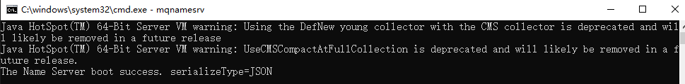

1. 启动Broker

> start mqbroker -n localhost:9876



产生的日志在：用户目录\logs\rocketmqlogs 中

1. 测试发送和接受消息

配置环境变量

|  |  |
| --- | --- |
| 变量名 | 变量值 |
| NAMESRV_ADDR | localhost:9876 |

* 发送消息

> start tools org.apache.rocketmq.example.quickstart.Producer

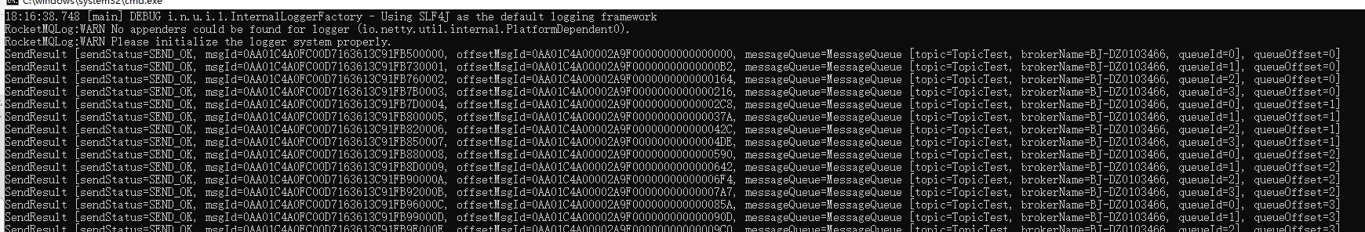

* 接受消息

> start tools org.apache.rocketmq.example.quickstart.Consumer

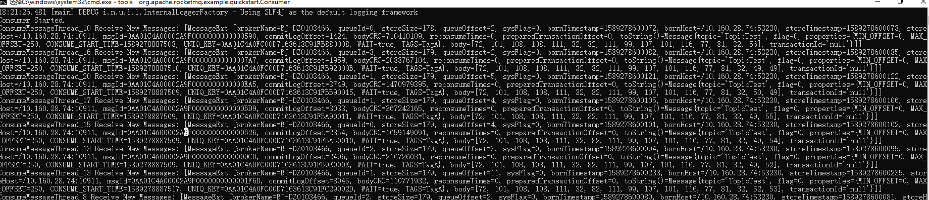

1. 关闭Broker

> start mqshutdown broker

1. 关闭Name Server

> start mqshutdown namesrv

## Docker安装

# 常见问题

### 存储空间满了

|  |
| --- |
| Exception in thread "main" org.apache.rocketmq.client.exception.MQClientException: Send [3] times, still failed, cost [517]ms, Topic: test_ttt_topic, BrokersSent: [BJ-DZ0103466, BJ-DZ0103466, BJ-DZ0103466]  See http://rocketmq.apache.org/docs/faq/ for further details.  at org.apache.rocketmq.client.impl.producer.DefaultMQProducerImpl.sendDefaultImpl(DefaultMQProducerImpl.java:586)  at org.apache.rocketmq.client.impl.producer.DefaultMQProducerImpl.send(DefaultMQProducerImpl.java:1223)  at org.apache.rocketmq.client.impl.producer.DefaultMQProducerImpl.send(DefaultMQProducerImpl.java:1173)  at org.apache.rocketmq.client.producer.DefaultMQProducer.send(DefaultMQProducer.java:214)  at com.firewolf.simple.SyncProducer.main(SyncProducer.java:35) |

解决办法： 清理空间，或者更改路径

### 没有topic路由

|  |
| --- |
| Exception in thread "main" org.apache.rocketmq.client.exception.MQClientException: No route info of this topic, test_ttt_topic1  See http://rocketmq.apache.org/docs/faq/ for further details.  at org.apache.rocketmq.client.impl.producer.DefaultMQProducerImpl.sendDefaultImpl(DefaultMQProducerImpl.java:610)  at org.apache.rocketmq.client.impl.producer.DefaultMQProducerImpl.send(DefaultMQProducerImpl.java:1223)  at org.apache.rocketmq.client.impl.producer.DefaultMQProducerImpl.send(DefaultMQProducerImpl.java:1173)  at org.apache.rocketmq.client.producer.DefaultMQProducer.send(DefaultMQProducer.java:214)  at com.firewolf.simple.SyncProducer.main(SyncProducer.java:35) |

* 可能是由于连接不上nameserver，检查配置；
* 不能自动创建topic，可以配置成自动创建（不建议），或者手动创建topic