EXERCISE 11

- Count the number of employees who have been with Bignet for four or more years.
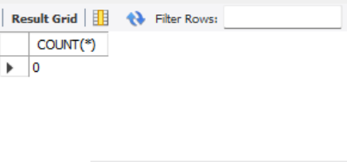
- Count employees based on their ages.
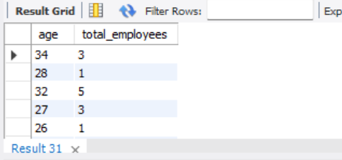
- Modify that above so that the ages are listed in a descending order.
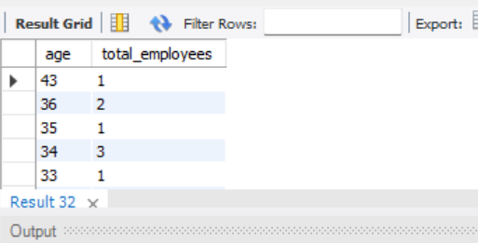
- Find the average in different departments(titles).
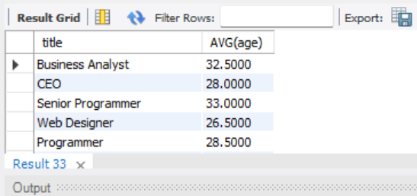

- Change the above statement so that the data is displayed in a descending order of averages ages.
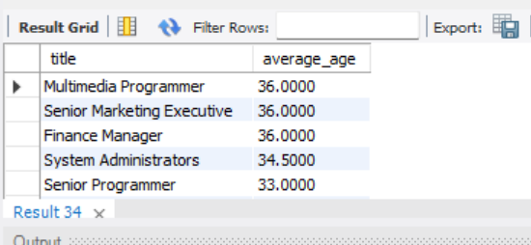

- Find the list the percentage perk (perk/salary * 100) for each employee with the % perks sorted in a descending order.
