Exercise 6
- Order all employees on the basis of the salary they draw.
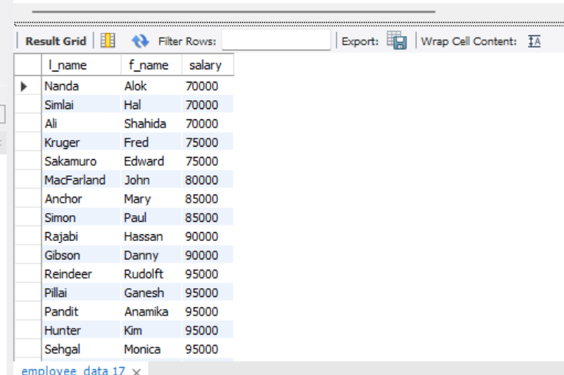
- List all employees in descending order of their year of service.
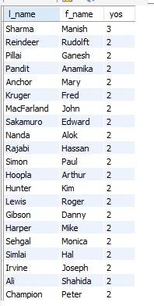
- What does the following statement display?
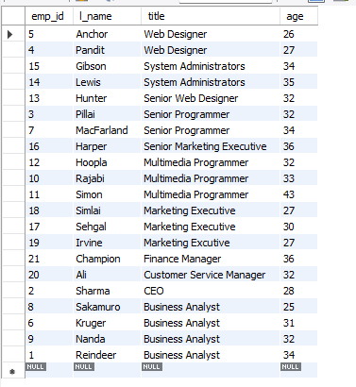
- Display employees (last names followed by first names) who hold the title of either “Programmer” or “Web Designer” and sort their last names alphabetically.
