Exercise 10
- Display the sum of age of employees working at Bignet.
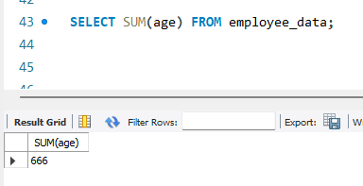
- How would you calculate the total of years of service the employees of Bignet have in the company?
SELECT SUM(yos) FROM employee_data;
- Calculate the sum of salaries and the average age of employees who hold “Programmer” title.
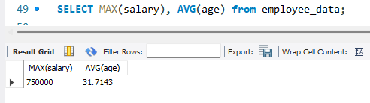
- What do you understand from the following statement?
select (SUM(perks) / SUM(salary) * 100) from employee_data
It will compute the total of perks relative to total salary.
