Nama : M. Firman Nailul Autor
Kelas : TI – 1C

Latihan 1:
- Pseudocode
ALGORITMA TarifParkir
DEKLARASI
jam : int
tarif : int

DESKRIPSI
INPUT jam
IF jam <= 2 THEN
tarif ← 2000
ELSE
tarif ← 2000 + ((jam - 2) × 1000)
END IF

OUTPUT tarif

SELESAI

- FLOWCHART

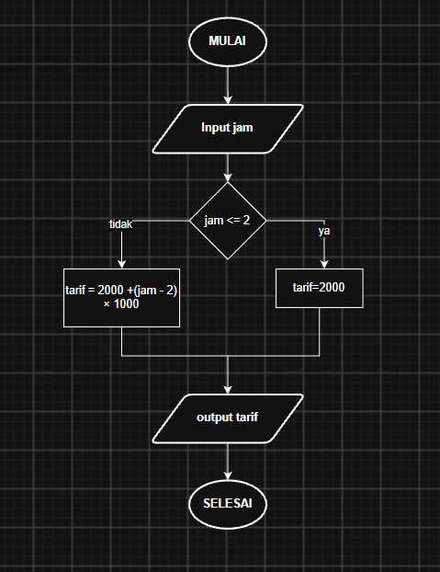

- PROGRAM JAVA

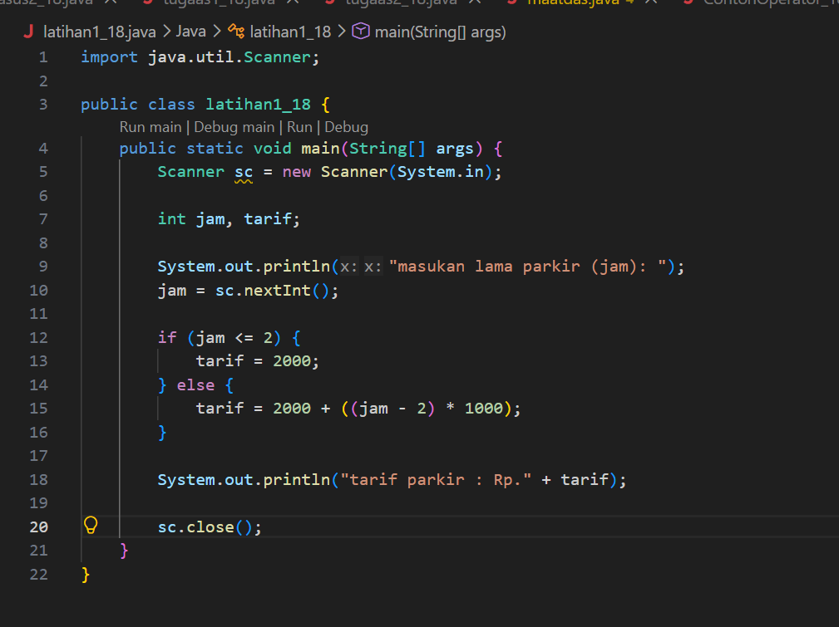

Latihan 2:

Pseudocode:
SWITCH (kode)
CASE 1:
OUTPUT "Legalisir Ijazah - Loket A"
CASE 2:
OUTPUT "Surat Keterangan Aktif Kuliah - Loket B"
CASE 3:
OUTPUT "Pembayaran UKT - Loket C"
CASE 4:
OUTPUT "Pengajuan Cuti Akademik - Loket D"
DEFAULT:
OUTPUT "Kode layanan tidak valid"
END SWITCH

Flowchart:
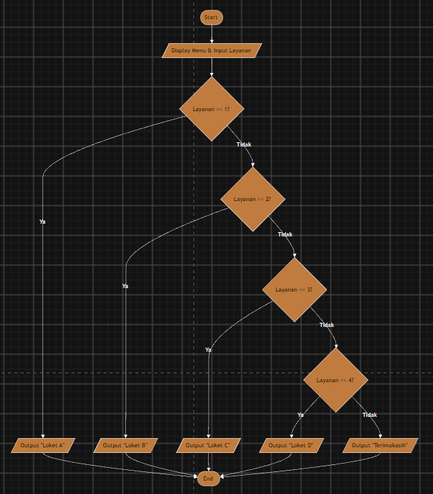
Program Java:
import java.util.Scanner;

public class TugasAntrianPresensi_18{
public static void main(String[] args) {
Scanner sc = new Scanner(System.in);

int kode;

System.out.println("Masukan Kode Layanan : ");
kode = sc.nextInt();

switch (kode) {
case 1:
System.out.println("Layanan Legalisir Ijazah");
System.out.println("Loket: Loket A");
break;

case 2:
System.out.println("Surat Keterangan Aktif Kuliah");
System.out.println("Loket: Loket B");
break;

case 3:
System.out.println("Pembayaran UKT");
System.out.println("Loket: Loket C");
break;

case 4:
System.out.println("Pengajuan Cuti Akademik");
System.out.println("Loket: Loket D");

default:
System.out.println("Kode Layanan Tidak Valid");
}
sc.close();
}
}

