

FIRMITY FACILITY AUTOMATION

  - www.firmity.in
COVERED IN THIS FEATURE LISTING:
1. Helpdesk / Complaint Management
2. Facility Management (including Visitor Management)
3. Assets & Spares Management
4. Checklists / Task Management
5. Inventory and Vendor Management
6. Executive Analytics Dashboard

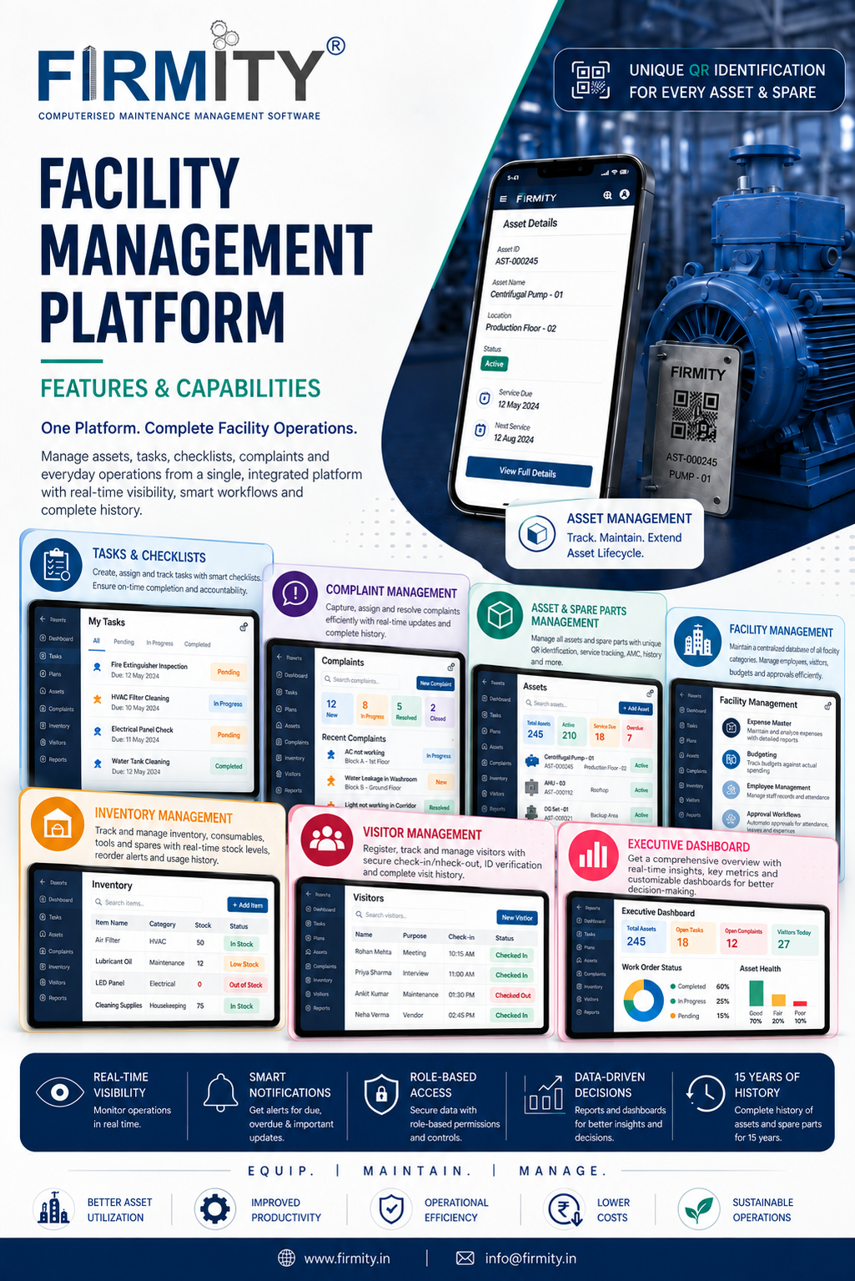

Helpdesk / Complaint Management — Feature Listing

1. QR-Based Complaint Registration
- Every QR code is mapped to a specific location or area.
- When an employee or guest scans the QR code, the associated location is automatically identified and populated in the complaint form.
- The user can raise a complaint by providing:
  - Complaint description
  - Photograph of the affected area
  - Complaint category
  - Priority
  - Mobile number
- The mobile number is optional.
- If a mobile number is provided, the user receives a unique tracking ID via SMS.
- Users can subsequently track the status of their complaint using the tracking ID without requiring a system login.
- The tracking interface provides the current status and relevant complaint information.
2. Workflow-Based Ticket Assignment
- Complaint categories are mapped to the appropriate job categories and responder groups.
- Multiple responders/workers can be configured under the same category.
- Once a complaint is raised, the configured workflow identifies the appropriate responder group based on the complaint category and priority.
- The Facility Manager or Supervisor can assign the ticket to an individual worker within the relevant responder group.
- The Facility Manager has the authority to manually reassign tickets whenever required.
- Assignment is not dependent on the responder’s location, shift, or availability.
- The module supports a defined escalation hierarchy for unresolved or SLA-breached complaints.
3. End-to-End Ticket Lifecycle
Open → In Progress → On Hold → Resolved → Closed
- Open: The complaint has been registered and is awaiting action.
- In Progress: The assigned worker/responder is actively working on the complaint.
- On Hold: Work on the complaint is temporarily paused. The SLA timer is also paused while the ticket is on hold.
- Resolved: The Facility Manager verifies the completed work and marks the complaint as resolved.
- Closed: The Supervisor closes the resolved ticket.
- A ticket can be reopened if the issue remains unresolved or recurs.
- Tickets do not automatically close after a predefined period.
4. Resolution & Mandatory Evidence
- The worker/responder must provide a resolution remark before the complaint can be resolved.
- A post-resolution photograph is mandatory as evidence of completed work.
- Resolution evidence is mandatory for all complaint categories.
- The system does not require responders to record the time spent on a complaint.
- The workflow provides management with documented evidence of the action taken before resolution and closure.
5. SLA Management & Escalation
- SLAs are configured based on complaint category and priority.
- The system supports both:
  - Response SLA
  - Resolution SLA
- SLA calculations follow the working hours configured for each property.
- When a ticket is placed On Hold, its SLA timer is paused.
- If the configured SLA is breached, the ticket is automatically escalated.
- Escalation is triggered only after the SLA has been breached; there is no automatic escalation merely because the SLA deadline is approaching.
- SLA breaches and escalations generate appropriate notifications.
6. Notifications & Alerts
SMS and in-app notifications are triggered for defined complaint events.
Event | Notification Recipient
Complaint raised | Facility Manager
Ticket assigned | Supervisor
Ticket resolved | Facility Manager
Ticket closed | Facility Manager & Supervisor
SLA breached | Relevant escalation recipients
Ticket escalated | Relevant escalation recipients
7. Complaint Tracking
Employees and guests can track complaints without requiring access to the full Firmity platform.
Mobile Number → Tracking ID → Complaint Status
The tracking mechanism provides visibility into the current status of the complaint and relevant ticket information.
Comments & Communication
- Each complaint/ticket includes a comment section for communication and updates during the ticket lifecycle.
- Comments are maintained as part of the ticket’s activity/history.
- The system records the user and timestamp associated with each update.
- Comments provide a complete communication trail alongside status, priority, visibility, assignment, and other ticket changes.
8. Dashboard & Reporting
A dedicated Helpdesk dashboard provides management with visibility into complaint volumes, resolution status, SLA performance, escalations, and operational trends.
Key reports and metrics include:
- Total Complaints
- Open Complaints
- Resolved Complaints
- Closed Complaints
- Overdue Complaints
- Complaints by Category
- Complaints by Location
- Escalated Complaints
- Reopened Complaints
- Turn Around Time
- SLA Tracking
- Custom Escalation Hierarchy
- Multi-level Escalation
- Complaints Transfer
- URL-based Complaints Portal
- QR-Based Complaints Portal
9. Complaints Helpdesk Work Flow:
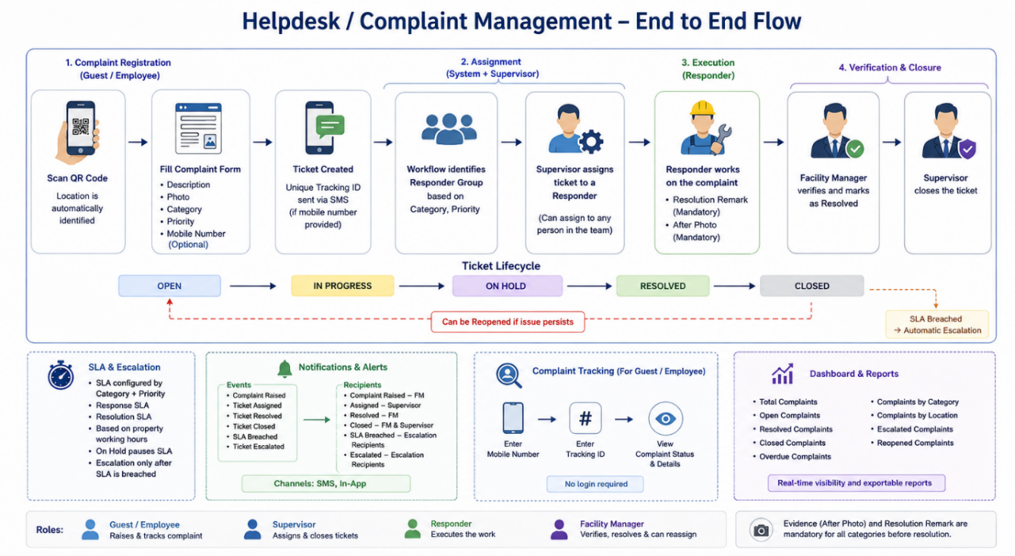
Complaint Management Hierarchy:
Guest / Employee
Raises and tracks the complaint
↓
Workflow Engine
Identifies the appropriate responder group based on category and priority
↓
Facility Manager / Supervisor
Assigns the ticket to the appropriate worker
↓
Worker / Responder
Executes the assigned work and submits resolution remarks and mandatory evidence
↓
Facility Manager
Verifies the completed work, marks the ticket as resolved, and can reassign tickets when required
↓
Supervisor
Closes the resolved ticket

Checklists / Task Management — Feature Listing
1. QR-Based Task & Checklist Access
- Each QR code is associated with a specific task and contains the task name.
- Scanning the QR code opens the associated task directly.
- The task view provides all information associated with that task, including:
  - Task name
  - Location
  - Checklist
  - Associated assets
  - Other task-related information
- The QR code is location-based, allowing the system to verify that the task is being performed at the appropriate location.
- Users can also access their assigned tasks directly through their portal, without scanning the QR code.
- Once a task/checklist has already been completed, scanning its QR code displays the task/checklist as completed.
2. Checklist Configuration
- Checklists are created and configured by the Facility Manager.
- Checklist templates can be created and modified as required.
- Checklists support different types of responses, including:
  - Yes / No
  - Remarks
  - Photo capture
- Individual checklist items can be configured as mandatory.
- Checklist items can support different response formats rather than being limited to simple completion.
- Checklists do not require multiple sections.
3. Task Categorization
- Tasks are organized into configurable categories and sub-categories.
- Categories determine the nature of the task and can be used to establish the appropriate assignment and execution workflow.
- Different task categories can have different checklist requirements.
4. Scheduled & Recurring Tasks
- Tasks can be configured with recurring frequencies.
- Supported frequencies can include:
  - Once a day
  - Twice a day
  - Weekly
  - Monthly
  - Other configured frequencies
- Tasks can have defined:
  - Start date
  - Due date
  - Start time
  - End time
  - Frequency/occurrence
  - Reminder
- The system automatically generates the next occurrence of a recurring task.
- Tasks can be aligned with configured shifts.
- If a scheduled task is not completed within its defined period:
  - It becomes Overdue
  - The Facility Manager is notified.
5. Task Assignment
- Tasks are assigned by the Facility Manager.
- Tasks are assigned to individual workers, rather than teams.
- Assignment can be based on the configured task category.
- The Facility Manager can reassign tasks when required.
- Supervisors do not independently assign tasks.
- The system supports category-based task allocation to ensure the appropriate worker handles the activity.
6. Task Execution
The worker or supervisor can execute the task either by:
Scanning the task QR code
or
Opening the assigned task from their portal.
When executing the task:
- The associated checklist is displayed directly.
- The user completes the required checklist items.
- Mandatory items must be completed before submission.
- Remarks can be entered where required.
- Photos can be captured as evidence.
- The system records:
  - Person performing the task
  - Date
  - Time
  - Location
  - QR code/task
  - Checklist
  - Completion status
- Location validation ensures that the task is being performed at the designated location.
7. Evidence-Based Checklist Execution
Checklist items can require users to provide evidence.
For example:
Fire Extinguisher Available?
→ No
→ Enter remark
→ Capture photograph of the area
Creates an auditable record of inspection findings, deficiencies, remarks and photographic evidence.
Photos can therefore be used to document exceptions, deficiencies, or other relevant conditions.
8. Failed / Negative Checklist Items
When a checklist item receives a negative response such as No:
- The user enters a remark explaining the issue.
- The user captures a photograph of the affected area where applicable.
- The failed item is moved into Actionable.
- The Facility Manager is able to identify actionable items requiring follow-up.
A failed checklist item does not automatically create a separate task or Helpdesk complaint.
9. Actionable Items
The system distinguishes between routine checklist completion and issues requiring action.
Normal checklist item
→ Completed
Failed checklist item
→ Remark + Evidence
→ Actionable
Failed checklist items are recorded as Actionable items for management follow-up without creating separate tasks automatically.
10. Task Status & Monitoring
The Task dashboard provides visibility into the overall task workload, including:
- Total Tasks
- Completed
- Actionable
- Pending
- On Hold
- Overdue
Tasks can be searched, filtered, viewed and exported.
Calendar/Planner view for recurring and scheduled activities.
11. Task Details & Associated Assets
A task can have associated assets, with asset information available directly within the task.
The task can display:
- Asset details
- Asset ID
- Asset brand
- Last service
- Next service
- Asset photograph
- Asset QR code
Links task execution directly to the associated asset and its service information.
12. FM Remarks & Communication
- FM Remarks provide a dedicated communication channel between the Facility Manager and Supervisor.
- The remarks maintain the communication history associated with the task.
- The communication is timestamped and retained as part of the task record.
- Images and other attachments can be added to the communication.
- Workers do not have access to FM Remarks.
- There is no separate worker-comment communication channel.
13. Checklist Review / Correction
There is no formal approval workflow.
The workflow is:
Task Assigned → Checklist Executed → Checklist Submitted/Completed
If a checklist requires correction, only the incorrect checklist items need to be corrected rather than requiring the entire checklist to be completed again.
14. Audit Trail & Historical Records
The system maintains historical records of checklist/task execution, including:
- Task
- Checklist
- Worker/responder
- Location
- Date
- Time
- Completion status
- Checklist responses
- Remarks
- Photographic evidence
- Associated assets
- Relevant task communication
Maintains a complete historical record of task and checklist execution.
15. Reporting & Compliance
The existing platform already provides dedicated dashboards and reporting for task/checklist management.
These provide visibility into operational performance, including task completion, pending activities, actionable items, overdue tasks and other configured metrics.
Reports can be exported in:
- Excel
- PDF

Final Workflow
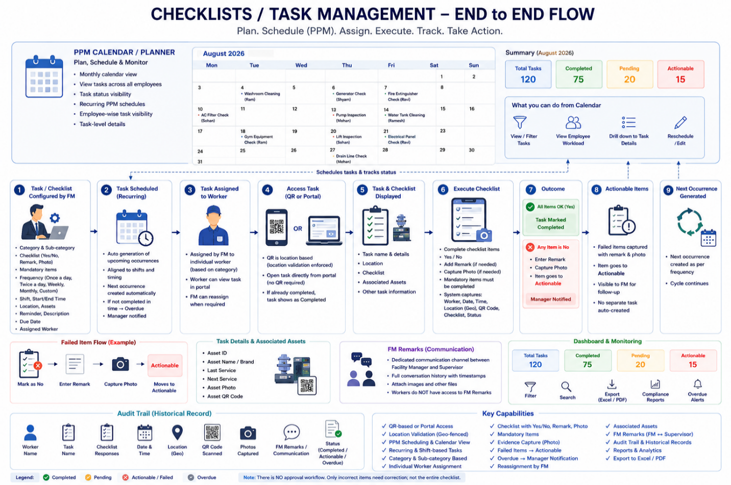
Task & Checklist Workflow:
Task Configuration by FM
↓
Category + Checklist + Frequency + Shift + Location + Worker
↓
Task Scheduled / Generated
↓
PPM Schedule / Calendar
↓
Worker/Supervisor Receives Task
↓
QR Scan OR Open Task from Portal
↓
Location Validated
↓
Task + Checklist + Assets Displayed
↓
Checklist Completed
↓
Yes → Complete
No → Remark + Photo → Actionable
↓
Task Completed
↓
Next Recurring Task Generated
↓
Dashboard / Reports / Audit History
And alongside the workflow:
FM ↔ Supervisor → FM Remarks + Attachments

Complete Assets & Spares — Feature Listing

1. Asset Master
Centralized Asset Database
- Centralized database of all assets
- Unique Asset ID
- Asset name
- Asset description
- Asset category/details
- Manufacturer
- Model
- Location
- Asset status
- Asset image
- Asset value
- Date of purchase
- Movable / non-movable classification
- Rentable / non-rentable classification
- Rented / non-rented status
- Service information
- Warranty information
- AMC information
- Asset-related documents
Asset Types
- Owned assets
- Rented assets
- Spare parts

2. Asset QR Code Management
Asset QR Codes
- Generate QR code for individual assets
- Download asset QR code
- QR code is unique to the asset
- QR-tagged physical assets can be scanned on-site
- QR scan provides access to the asset record
Role-Based QR Access
- QR scanning does not mean everyone can see the asset
- Access is controlled by roles and rights
- Authorized users such as:
  - Facility Manager
  - Supervisor
- Guests/random users cannot access protected asset information simply by scanning the QR
Asset QR Information
Scanning an authorized asset QR can expose the asset's complete available record, including:
- Asset identity
- Description
- Location
- Manufacturer
- Model
- Status
- Service information
- Warranty information
- AMC information
- Purchase information
- Asset value
- Asset image
- Documents
- Asset history
- Associated information
- Related actionable items
- Associated spare-part information where applicable

3. Asset Location Management
- Location assigned to each asset
- Asset-wise location visibility
- Assets can exist across different properties/locations
- Location forms part of the asset's master record
- Asset history can retain information about its lifecycle/movement

4. Asset Service & Maintenance
Service Information
- Last service date
- Next service date
- Service due date
- Service reminder
- Service status
- Service-overdue identification
Service Overdue Assets
- Dedicated Service Over Due Assets view
- Shows:
  - Asset ID
  - Asset name
  - Service due date
  - Available actions
- Overdue assets appear in asset-overdue notifications

5. Asset & PPM Relationship
- One asset can have multiple PPM tasks
- One task can be associated with multiple assets
- Existing assets can be selected while creating a PPM/task
- Asset-related PPM activity can become part of the asset's history
- Failed asset-related checklist items can generate an Actionable
- Actionable items remain linked to the relevant asset
- Resolution of the actionable item is recorded against the asset history

6. Asset History
Long-Term Asset History
- Complete asset lifecycle history
- 15 years of asset history provided to the client
- Historical service/maintenance records
- Historical actionable issues
- Historical resolutions
- Asset movement/history
- Check-in/check-out history
- Rental history where applicable
- Other recorded asset activities
Asset History Access
- Asset history can be opened from the asset record
- Historical records can be reviewed without losing previous records
- Supports long-term asset lifecycle tracking
15 Years of Asset History

7. Asset Check-In / Check-Out
- Asset check-in
- Asset check-out
- Track asset usage/movement
- Record issue/dispatch
- Record return
- Check-in/check-out history
- Asset movement history
Dedicated Asset Transfer and Check-In/Check-Out management.
8. Asset Transfer
- Transfer assets between locations/properties
- Track asset dispatch
- Track destination
- Track transfer status
- Asset movement records
- Asset transfer history

9. Rental Asset Management
Rented Assets
- Dedicated rented-assets section
- Identify rented assets
- Track rental status
- Rental location
- Rental expiry
- Manufacturer/vendor information
- Lease information
Rent-Out Management
Assets can be rented out with information such as:
- Asset name
- Asset ID
- Destination property
- Assignee
- Manufacturer
- Rental charges
- Security deposit
- Rent-out date
- Rent-out time
- Tentative return date
- Approved by
- Rental contract
- Asset image
Rental History
- Rent-out records
- Return records
- User/person responsible
- Dates and times
- Rental details
- Supporting images/documents
- Historical rental transactions

10. Asset Lifecycle Tracking
Firmity tracks the asset through its lifecycle:
Asset Creation → Deployment → Location → Service → Transfer → Check-in/Check-out → Rental → Maintenance → Issues → Resolution → Historical Record
Maintains a centralized record of the complete asset lifecycle.
11. Warranty Management
- Warranty date
- Warranty expiry
- Warranty documents
- Warranty card
- Warranty information linked to asset
- Warranty documentation accessible from asset record

12. AMC Management
AMC Details
- AMC information associated with asset
- AMC contract
- AMC documentation
- AMC service coverage
- AMC history
- AMC-related records
AMC History
- Historical AMC records
- Renewal information
- Service coverage history
- Supporting AMC documents

13. Asset Documentation
Documents/files can be associated with assets, including:
- Asset image
- Warranty document
- Warranty card
- AMC contract
- AMC documents/details
- Rental contract
- Invoice
- Other supporting documents
These documents remain associated with the relevant asset record.

14. Asset Images
- Upload asset image
- View asset image
- Asset image accessible from asset details
- Asset images can also form part of rental/service records
- Images can be associated with historical activities

15. Asset Notifications & Monitoring
- Service-overdue notifications
- Asset service due visibility
- Asset status visibility
- Upcoming service information
- Overdue asset identification
- Service-related monitoring

16. Asset Search & Filtering
Asset Master provides:
- Search by asset name
- Search by Asset ID
- Filtering
- Asset status filtering
- Asset categorization
- Export functionality

17. Asset Export
- Export asset records
- Export/filter asset information for operational reporting
- Download QR codes

18. Asset Status Management
Assets can be tracked based on their operational status, including:
- Active
- Inactive
- Servicing
- Other configured operational states
Status is visible directly in the Asset Master.

19. Spare Parts Management
Spare Parts Master
Spare parts are managed separately from the main asset database.
Each spare part can have:
- Spare Part ID
- Spare part name
- Type
- Associated asset
- Asset ID
- Serial number
- Vendor
- Quantity
- Status
- Purchase date
- Expiry date
- Value
- Backup/usage information
- Other configured spare-part details

20. Spare Part ↔ Asset Association
- Spare parts can be associated with an asset
- Asset ID can be recorded against the spare
- Identify which asset a spare belongs to
- Track spare parts independently while retaining the asset relationship
Example:
Inverter → Motor → Spare Part ID 238

21. Spare Part QR Codes
- Spare parts have their own QR codes
- Spare QR is separate from the Asset QR
- QR can identify the individual spare-part record
- Supports physical identification and traceability

22. Spare Part Inventory
- Spare-part quantity tracking
- Spare-part status
- Spare-part availability
- Spare-part records
- Associated asset tracking
- Vendor tracking
- Expiry tracking

23. Spare Part Lifecycle
Spare parts can be tracked through their lifecycle:
Spare Creation → Association → Inventory → Usage/Service → Status → Expiry → Historical Record

24. Spare Part History
- Historical spare-part records
- Spare-part activity/history
- Association with assets
- Historical maintenance/service relationship
- Long-term traceability
- 15 years of spare-part history provided to the client

25. Spare Part Vendor Management
- Vendor information
- Spare-part/vendor relationship
- Purchase information
- Quantity information
- Expiry information

26. Spare Part Status Tracking
Spare parts can have operational statuses such as:
- Active
- Inactive
- Servicing
- Other configured statuses

27. Spare Part Expiry Management
- Expiry date
- Expiry visibility
- Spare-part lifecycle monitoring
- Identification of parts approaching/at expiry

28. Asset & Spare-Part Traceability
Firmity provides traceability across:
Asset
→ Location
→ Service records
→ PPM/tasks
→ Actionables
→ Repairs
→ Documents
→ Spare parts
→ Transfers
→ Rentals
→ Historical records
And:
Spare Part
→ Spare ID
→ Asset
→ Vendor
→ Quantity
→ Status
→ Expiry
→ History

29. Role-Based Asset Security
Asset information is protected through the application's role/rights model.
QR access is governed by the application's role and rights model.
Physical QR access ≠ automatic data access.
A person may physically scan the QR on an asset, but the system determines whether that user has permission to view the underlying asset information.

30. Asset Management Dashboard / Operational Views
Operational Views:
- Asset Master
- Owned assets
- Rented assets
- Spare parts
- Service-overdue assets
- Upcoming services
- Asset transfers
- Check-in/check-out
- Asset history
- Rental history

31. Key Asset & Spares Capabilities
- Centralized Asset Master
- QR-Based Asset & Spare Identification
- 15-Year Asset & Spare-Part History
- Asset Service & PPM Tracking
- Service Overdue Monitoring & Notifications
- Asset Transfer & Check-In/Check-Out
- Rental Asset Management & History
- Warranty & AMC Management
- Spare Part Inventory & Asset Association
- Role-Based Access, Documents & Complete Lifecycle Traceability
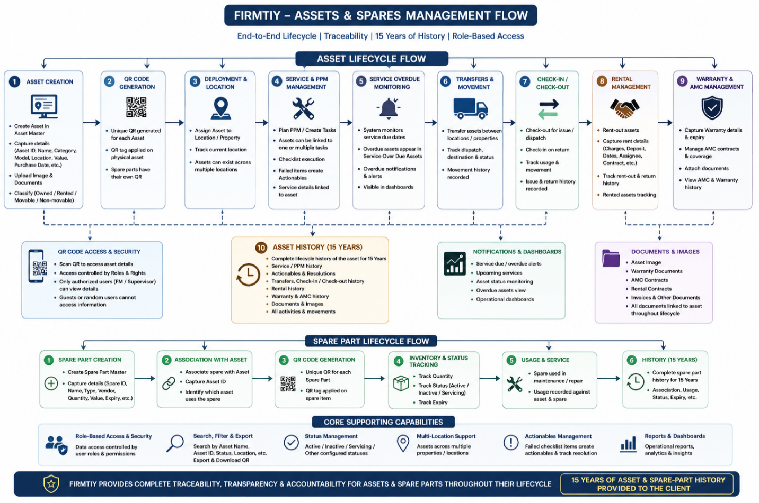
FACILITY MANAGEMENT — Feature Listing

1. Facility Member Management
- Facility member and employee master
- Employee code and employee profile
- Branch, client and property details
- Employment type
- Employee contact details
- Department and designation
- Reporting manager
- Gender and date of birth
- Father's name and mother's name
- Marital status and spouse details
- PAN and Aadhaar details
- Employee address
- Bank details
- Work history
- Employee document uploads
- Active and inactive employee records
- Add, search, view and export employee records
2. Employee Onboarding
- Employee personal details
- Employment details
- Branch, client and property assignment
- Department and designation
- Reporting manager
- Contact and address details
- Identification details
- Bank details
- Work history
- Document uploads
3. Employee Search & Transfer
- Search active and inactive employees
- Search by employee name
- Search by employee code
- Search by phone number
- Search by Aadhaar number
- Search by PAN number
- Search by UAN number
- Search by PF number
- Search by ESI number
- Search by bank account number
- Search by property ID
- Employee transfer
- Employee details by branch, client and property
4. Facility Location / LatLong
- Employee location records
- Latitude and longitude
- Location name
- Visit type
- Create location records
- Edit location records
- Delete location records
- Employee-wise location mapping

ATTENDANCE MANAGEMENT
5. Attendance
- Monthly attendance calendar
- Daily attendance status
- Present, absent and leave records
- Employee check-in time
- Employee check-out time
- Working hours
- Attendance status
- Holiday marking
- Month and year selection
- Attendance type selection
- Pending attendance records
- Approved/Rejected attendance records
- Employee attendance search
- Daily attendance export
- CSV export
- Employee-wise attendance details
6. Comp Off
- Employee-wise Comp Off records
- Comp Off balance/count
- Employee search
- View Comp Off details

LEAVE MANAGEMENT
7. Leave Master
- Create and maintain leave types
- Leave type and description
- Casual Leave (CL)
- Sick Leave (SL)
- Earned Leave (EL)
- Compensatory Off
- Edit leave types
- Delete leave types
8. Employee Leave
- Employee-wise leave allocation
- Leave type assignment
- Leave balance
- Financial year
- Employee leave records
- Create and maintain employee leave records
- Search employee leave records
9. Employee Leave Dashboard
- Employee-wise leave balance
- CL remaining
- SL remaining
- EL remaining
- Employee search
- Leave balance sorting
- Excel download
10. Leave Management
- Create leave requests
- Employee name
- From date and to date
- Leave type
- Leave reason
- Leave status
- Approval status
- Processed by
- Processed date
- Rejection remarks
- Approve/reject leave
- Search leave records

EXPENSE MANAGEMENT
11. Expense Master
- Create and maintain expense records
- Expense type
- Expense sub-type
- Date from and date to
- Debit amount
- Credit amount
- Description
- View expense details
- Edit expense records
- Delete expense records
12. Expense Type Master
- Create expense types
- Configure expense sub-types
- Multiple sub-types under an expense type
- View expense type configuration
- Edit expense types
- Delete expense types
- Search expense types
13. Expense Report
- Expense reporting

VISITOR MANAGEMENT
14. Visitor Management
- Visitor registration
- Visitor name
- Mobile number
- Address
- Purpose of visit
- Contact person
- Items being carried
- In time
- Out time
- Visitor approval/rejection
- Visitor status
- Meeting status
- Visitor details
- Visitor history
- Visitor search
- Date-range filtering
- Visitor export
15. Visitor Department Management
- Visitor department configuration
- Property-specific departments
- Branch head name
- Branch head mobile number
- Branch head email
- Department management

USER MANAGEMENT
16. Create New User
- Create system users
- User management

PAYROLL & REPORTING
17. Payroll Management
- Payroll Management
18. Reports
- Facility Management reports

VISITOR MANAGEMENT FLOW

Executive Overview
Firmity's Visitor Management Module is a comprehensive digital visitor management solution designed to streamline visitor registration, approvals, security verification, and record management across single or multiple properties. The module replaces manual registers with a QR-enabled workflow, provides a dedicated guard interface, and enables real-time approval notifications through integrated Email and SMS services.

Module Objectives
- Digitize visitor registration and gate operations.
- Provide QR-based self-registration for visitors.
- Enable manual visitor registration through a dedicated Guard Login.
- Automate visitor approval workflows.
- Improve security through visitor photograph capture and archival.
- Maintain centralized visitor records.
- Support multiple properties, gates, departments, and employee directories.
- Visitor meetings hours’ time tracking.

End-to-End Visitor Workflow
1. Visitor arrives at the designated property gate.
2. Visitor scans the property- and gate-specific static QR code or is registered manually by the guard.
3. Visitor selects the department.
4. The system automatically displays employees mapped to the selected department.
5. Visitor selects the contact person.
6. Visitor enters First Name, Last Name, Mobile Number, Address, Meeting Purpose and Assets Carrying.
7. Visitor photograph is captured using the guard's mobile device.
8. Visitor request is submitted.
9. Integrated Email and SMS notifications are sent to the designated employee/admin.
10. Host approves or rejects the visitor request.
11. If rejected or if the approval request expires, entry is denied.
12. Upon approval, the guard verifies the visitor and grants entry.
13. Visitor is checked out manually by the guard or by scanning the QR code again.
14. Visit history is archived for future reference.
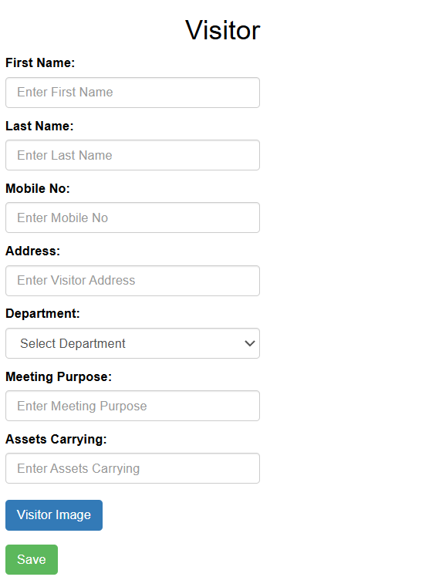

QR-Based Self Registration
- Static QR codes unique to every property, location, and gate.
- Mobile-friendly registration interface.
- Captures visitor name, mobile number, address, department, contact person, meeting purpose, assets carrying and photograph

.

Guard Management Portal
- Secure guard login.
- Manual visitor registration.
- Photo capture.
- Search previous visitors.
- View today's visitors.
- Manual check-out.
- QR-based check-out.
- Visitor history access.

Approval Workflow
- Automatic Email and SMS notifications.
- Approval/Rejection by designated employee or administrator.
- Expired requests are automatically invalidated.
- Rejected visitors are denied entry.

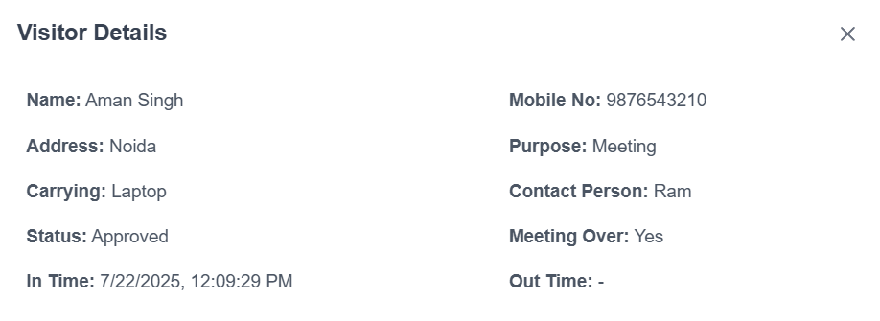

Department Master
- Create, edit, delete, activate and deactivate departments.
- Map department heads and employees.
- Automatic employee listing after department selection.

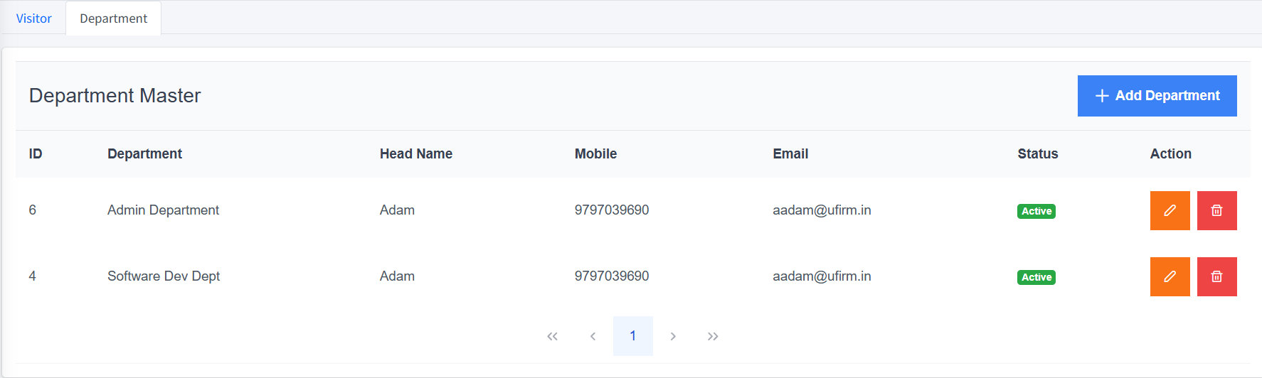

Visitor Dashboard
- Visitor list with ID, Name, Purpose, In Time, Out Time and Status.
- Search by visitor name, mobile number, department, contact person, status and date range.
- Export visitor records to Microsoft Excel.
- Visitor detail popup with photograph, address, purpose, carrying details, contact person, status, meeting over flag, in time and out time.

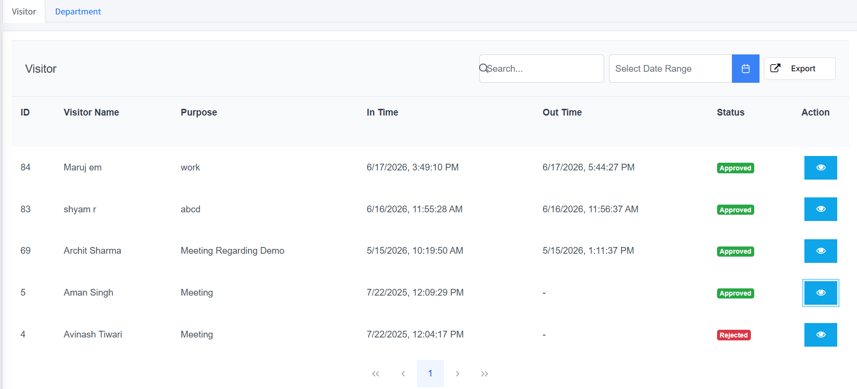

Multi-Property Support
- Independent QR codes for every property and gate.
- Separate visitor databases for each property.
- Separate guard logins.
- Separate department masters.
- Centralized administration across locations.

Security Features
- Visitor photograph encrypted saving.
- Digital approval workflow.
- Guard authentication.
- Digital visitor history.
- Real-time notifications.

Benefits for Solar Energy Corporation of India Ltd.
- Reduced paperwork and manual registers.
- Faster visitor processing at facility entrances.
- Enhanced security through photograph capture and digital approvals.
- Centralized searchable visitor records.
- Improved compliance and audit readiness.
- Efficient contractor, vendor and guest management.
- Scalable support for multiple facilities.

Key Features Summary
Feature | Capability
Visitor Registration | QR-based self-registration and guard-assisted registration
Notifications | Integrated Email and SMS
Approvals | Approve/Reject workflow
Photograph | Mobile photo capture and archive
Departments | Department and employee mapping
Search | Visitor history and advanced search
Reports | Excel export
Multi-Property | Supported
Check-out | Manual or QR-based

Suggested Screenshot Placement
Insert annotated screenshots after the relevant sections:
• Visitor Registration Screen
• Visitor Dashboard
• Visitor Details Popup
• Department Master
• Guard Registration Screen
• QR Registration Interface

Visitor Lifecycle Process Flow
Visitor Arrives
↓
Scan Property QR / Guard Registration
↓
Select Department
↓
Select Contact Person
↓
Enter Visitor Details
↓
Capture Photograph
↓
Submit Request
↓
Email & SMS Notification
↓
Approval / Rejection
↓
Guard Verification
↓
Visitor Entry
↓
Meeting Completion
↓
Manual / QR Check-out
↓
Visitor Archive
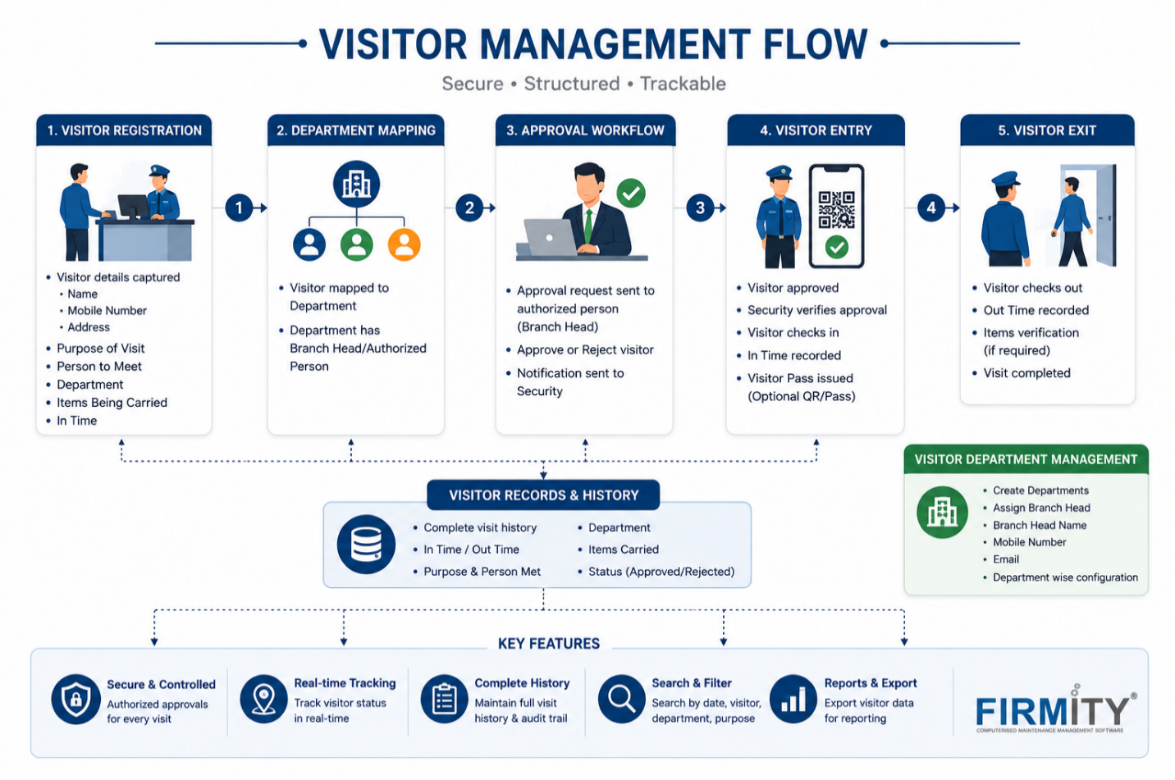

INVENTORY AND VENDOR MANAGEMENT — Feature Listing

Executive Overview
Firmity's Inventory Management module runs the full material lifecycle for a property or portfolio — from item cataloguing and vendor rate cards, through requisition, purchase, and receipt, to stock tracking and cross-property distribution. Every movement is logged, giving a complete, searchable audit trail from the moment an item is requisitioned to the moment it reaches the requesting store or site.

Module Objectives
- Digitize inventory cataloguing and item specification management.
- Maintain vendor-wise, contract-based rate cards.
- Automate the requisition-to-purchase-to-receipt workflow.
- Track stock levels in real time with automatic low-stock alerts.
- Maintain a complete, chronological, and auditable stock ledger.
- Enable item distribution across multiple stores, properties, or locations.
- Support both manual and bulk (Excel) stock operations.
- Centralize vendor, category, and specification masters for consistent data across the module.

End-to-End Inventory Workflow
- Admin or Supervisor identifies a stock requirement at the property or site level.
- Admin or Supervisor raises a requisition for the required item(s) and quantity.
- The system checks in-hand stock against the requisition and highlights the pending quantity.
- An authorized approver reviews the requisition — approve, re-raise, or reject.
- On approval, a Purchase Order is raised (or the item added to an existing PO) using the vendor's active rate card.
- The Purchase Order moves through approval — Pending Approval → Approved / Rejected.
- The approved PO is sent to the selected vendor for fulfillment.
- The vendor supplies the ordered items to the property or site.
- A Goods Receipt Note (GRN) is created against the PO, recording quantity received — fully or partially.
- Received quantity automatically updates the on-hand stock.
- Every stock movement — GRN receipt, requisition, handover, or adjustment — is recorded in the Stock Ledger.
- Item Distribution transfers received or available stock to the requesting store, property, or location.
- The system continuously compares on-hand quantity against the configured minimum threshold.
- A Low Stock alert is triggered automatically once quantity falls below the threshold, prompting a fresh requisition or PO.
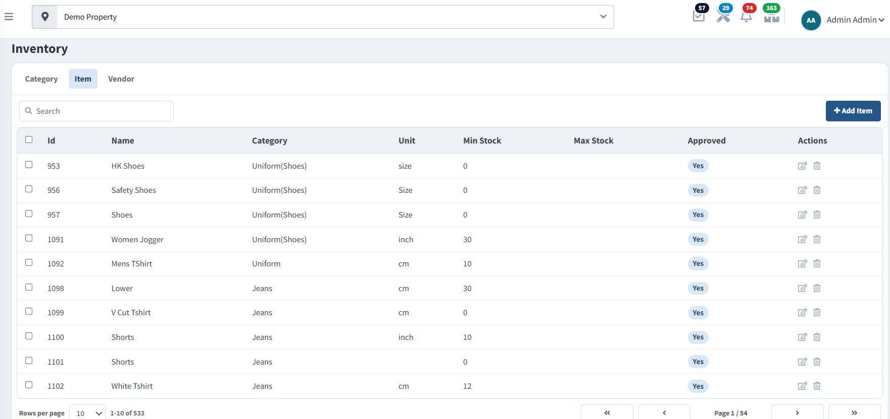

Module Navigation
All inventory sub-modules are accessible from a single left-hand navigation group, keeping master data, procurement, and stock operations organised under one menu.

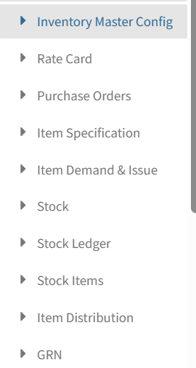
Inventory navigation — Master Config, Rate Card, Purchase Orders, Item Specification, Item Demand & Issue, Stock, Stock Ledger, Stock Items, Item Distribution, GRN

Item Categorization
- Inventory items are organized into categories and sub-categories (e.g., plant/greenery items grouped under Aglaonema Red, Areca Palm, Bougainvillea; other items under categories such as Clothes) for structured management.
- A category bar with a “More Categories” dropdown accommodates categories beyond the default pinned set.
- Items can be searched directly by name using the stock search bar.

Item Specification & Master Configuration
- Each item is defined with a specification, including variant attributes such as colour, size, and type (e.g., “HK Shirt — Red, Size 40 | Male”).
- Inventory Master Configuration allows items, categories, and specifications to be set up centrally before they can be requisitioned, ordered, or tracked in stock.
- The Item Specification Master lets an admin attach a Category, Gender, and one or more Specification fields (with their permitted values) to an item — the same structured attributes then appear wherever that item is requisitioned, ordered, or distributed.
- A minimum stock threshold can be configured per item; the system uses this to automatically flag items when stock runs low.
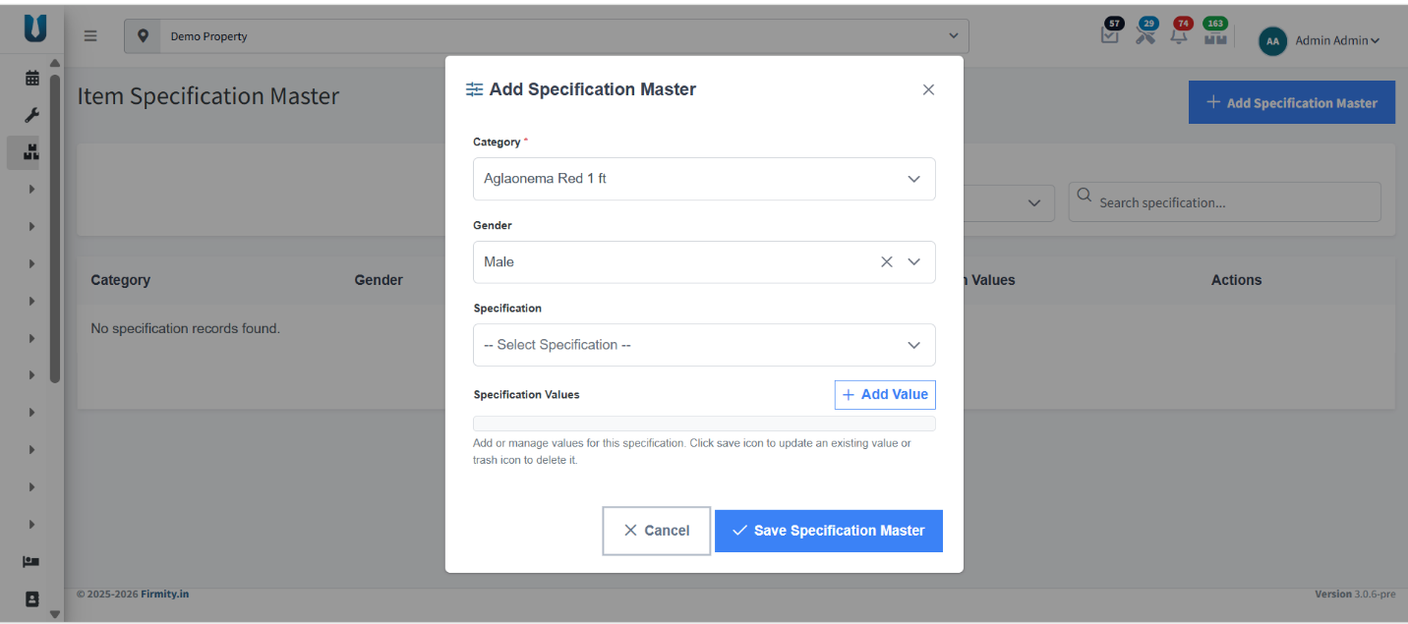
Add Specification Master — defining category, gender, and specification values for an item

Vendor-wise Rate Card
- Rate cards are maintained on a contract basis per vendor, with a defined validity period.
- Rates configured in the rate card are used when raising Purchase Orders against that vendor.
- Once a contract's validity period lapses, the rate card needs to be renewed or updated.
- Every approved vendor carries a full profile — contact person, phone, email, bank name, account number, IFSC, GST and PAN numbers, address, and website — with PAN, GST certificate, and brochure documents attached and viewable on demand.
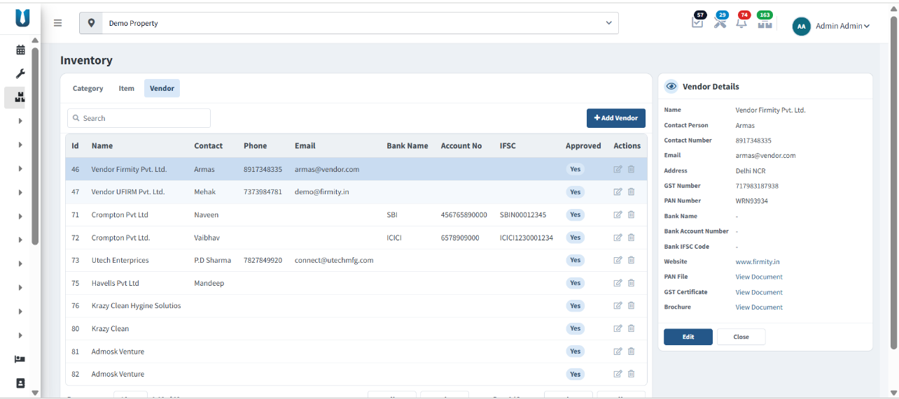
Inventory → Vendor — approved vendor list with bank, tax, and document details

Purchase Orders (PO)
- Summary cards give an at-a-glance view of Total Orders, Pending Approval, Approved, and Rejected POs.
- POs move through an approval workflow — Pending Approval → Approved / Rejected — and are organised under Pending and Processed tabs.
- Each PO records the property, vendor, order date, and amount.
- Authorised users can view, approve, or reject a PO directly from the list.
- POs can be searched by PO number or vendor, exported, and new POs raised via “New Purchase Order.”
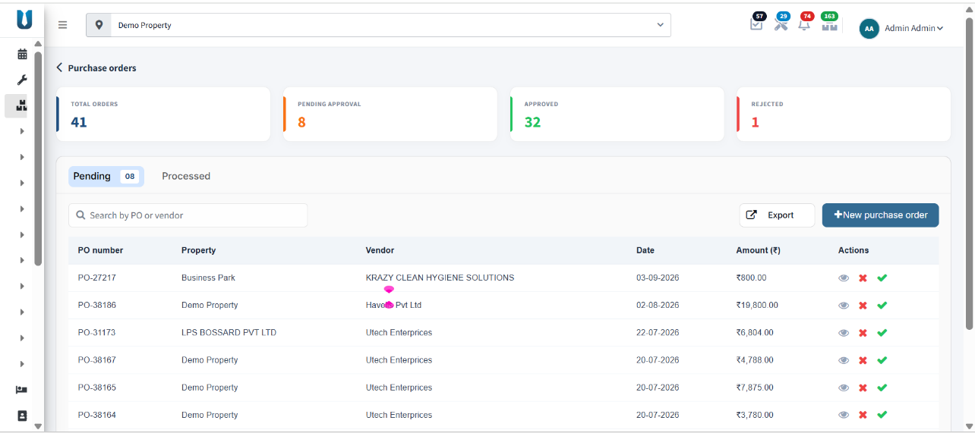
Purchase Orders — Pending tab, with approve/reject actions per PO
- Processed POs show live receipt progress as a percentage against the ordered quantity, alongside their Approved / Rejected status, and can be printed for records.
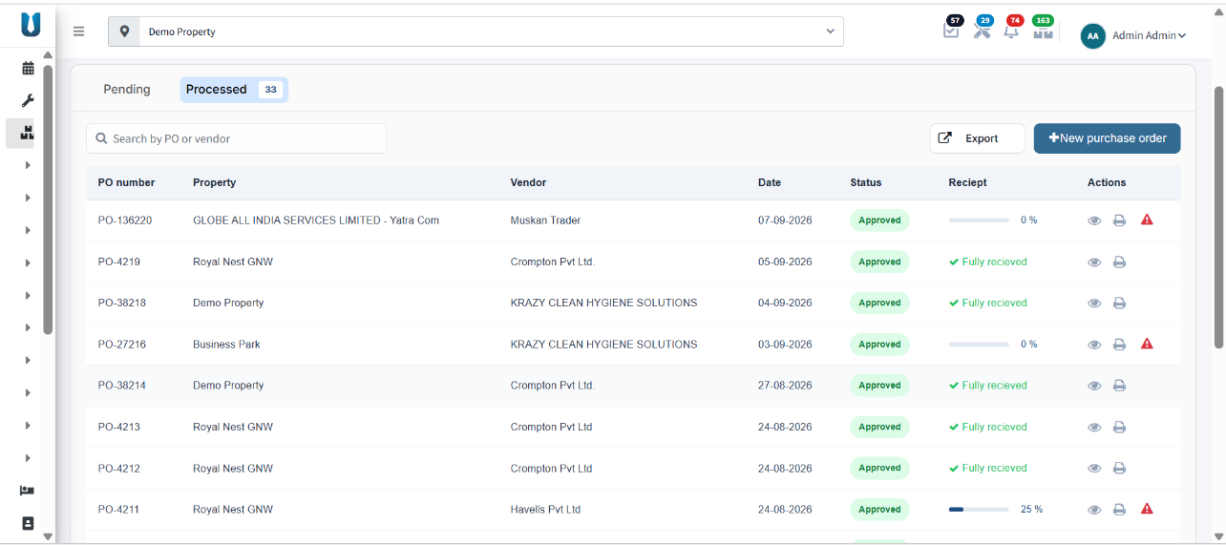
Purchase Orders — Processed tab, with receipt % and print action
- Creating a PO presents every rate-card item across approved vendors — with base price, GST, and per-unit rate — for one-click selection into the order.
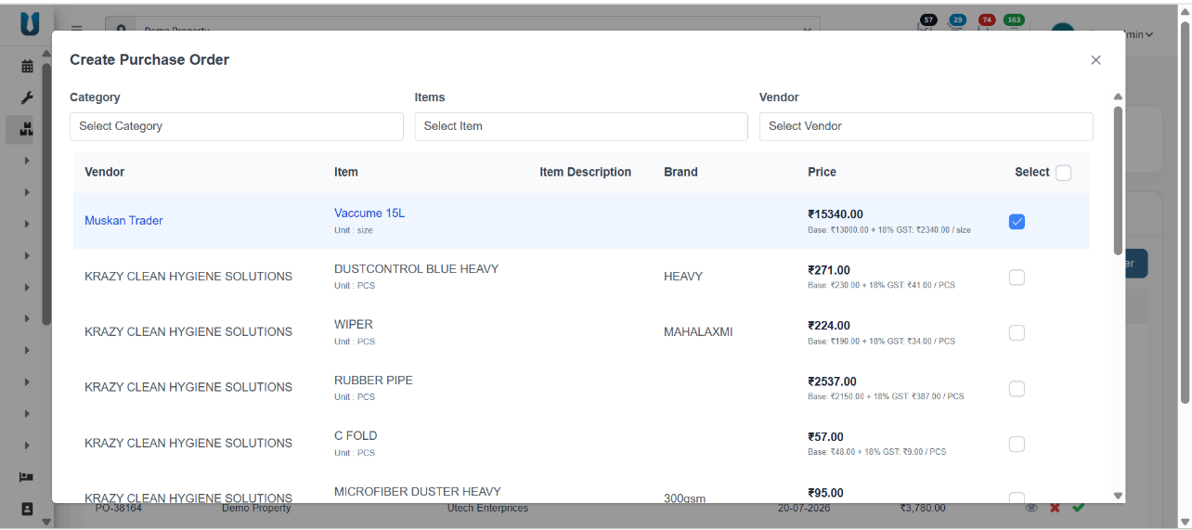
Create Purchase Order — selecting items and vendors from the live rate card

Requisition Management (Item Demand & Issue)
- Requisitions can be raised by the Admin or by the Supervisor at the property/site level.
- A requisition captures the demand for stock items, forming the basis for the subsequent purchase or issue of material.
- A Top 5 Frequently Requisitioned Items panel highlights the items raised most often historically, each with a one-click “Re-Raise” to quickly repeat a recurring demand.
- The Handover Against Demand list tracks every requisition line — requested quantity, in-hand stock, handed-over quantity, and pending quantity — with actions to approve, re-raise, reject, or convert straight into a Purchase Order.
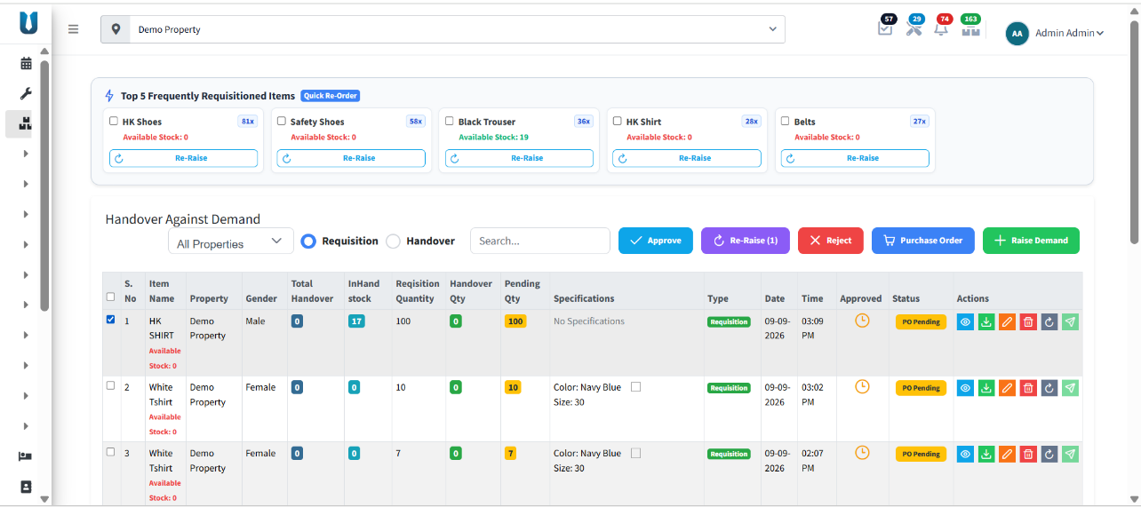
Item Demand & Issue — frequently requisitioned items and handover-against-demand tracking

Goods Receipt Note (GRN)
- A GRN is created against a specific Purchase Order, selected from a dropdown that auto-loads the ordered items.
- Each GRN records the Site Name and the person who Received the goods.
- For every item, the GRN tracks PO Qty, Previously Received, Pending, and GRN Qty — allowing a PO to be received across multiple partial deliveries.
- The GRN list displays GRN Number, PO Number, Site, Received-on date, Created by, Qty Received (against the ordered quantity), and Status — OK once fully received, or Pending Receipt while quantity remains outstanding.
- GRNs can be searched, exported, and new GRNs raised via “New GRN.”
- Stock received against a GRN is tagged with its source (e.g., a GRN reference number) in the stock-in records, so every unit in hand can be traced back to the delivery it arrived on.

Stock Management & Tracking
- The Stock Inventory screen shows the on-hand quantity for every item, with a visual stock-level bar per item.
- Each item's current quantity is tracked against its configured minimum threshold (e.g., “Quantity: 17 (Min: 30)”).
- Items are automatically flagged In Stock or Low Stock based on whether quantity has fallen below the configured minimum — enabling proactive replenishment.
- Stock can be updated manually (Add Quantity) or in bulk via Excel, using a downloadable format (Download Format / Upload Excel).
- Existing stock items can be edited or removed directly from the list.
- A dedicated Stock Items report filters by Requisition, Handover, or Both, over any date range, showing requisitioned, handed-over, and pending quantity per item with a full audit History for each line — exportable to Excel or PDF.
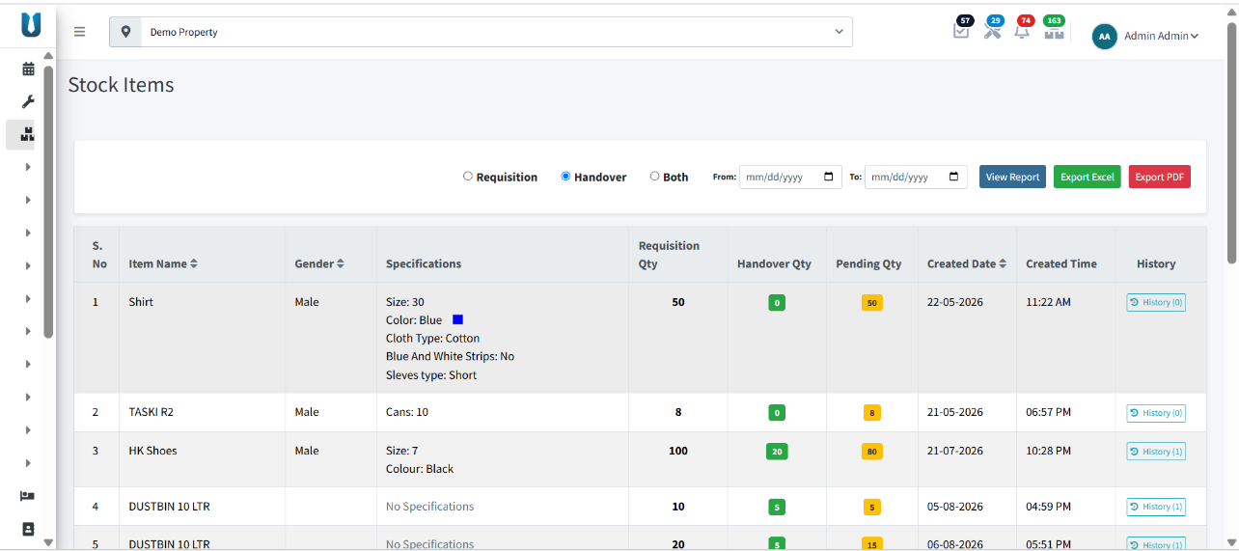
Stock Items — requisition vs. handover reporting with per-item history

Stock Ledger
- The Stock Ledger automatically records every stock transaction — receipts (via GRN), issues, and adjustments — providing a complete, chronological audit trail of inventory movement.
- Each ledger line shows brand, measurement unit, minimum stock, stock-in, requisitioned quantity, handed-over quantity, and running balance — with the item auto-flagged In Stock or Low Stock.
- Searchable in real time, so any item's full movement history can be pulled up instantly.
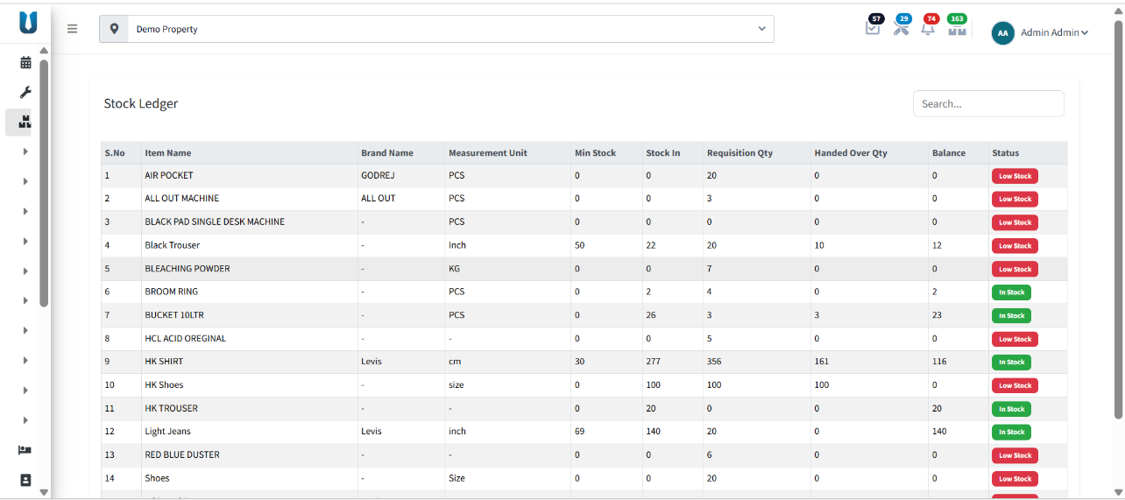
Stock Ledger — running balance and stock status per item

Item Distribution
- Item Distribution manages the transfer of stock items across multiple stores, properties, or locations from a central inventory.
- An Available Stock in Hand view lists every distributable item together with its source — Handover, GRN, or Bulk Upload — gender/specification detail, total inward quantity, and current in-hand stock, ready to be sent out with one click.
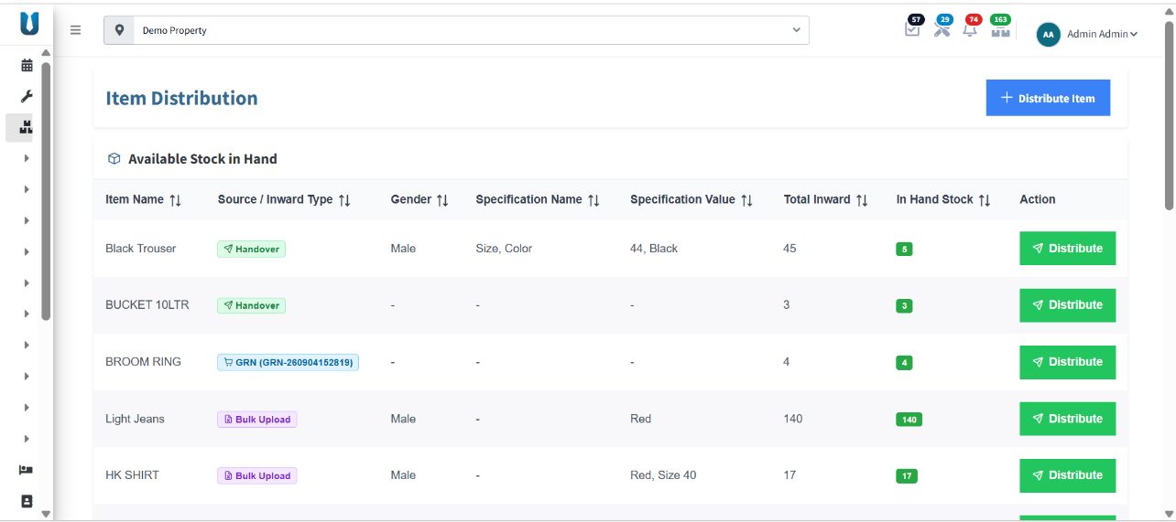
Item Distribution — available stock in hand, ready to distribute by source

Notifications & Alerts
- The system triggers a Low Stock alert automatically when an item's quantity falls below its configured minimum threshold.
- Notifications also cover Purchase Order events (pending approval, approved, rejected) and GRN events (pending receipt) to keep relevant stakeholders informed.
- Live counters in the top bar (tasks, complaints, notifications, and inventory alerts) mirror these events at a glance, without needing to open each module.

Audit & Control Features
- Full requisition-to-stock audit trail, cross-referenced through GRN receipts and the Stock Ledger.
- Purchase Order approval workflow prevents unauthorized procurement — every PO carries an approver, an approval state, and a timestamp.
- Vendor documents — PAN, GST certificate, and brochure — are stored and verifiable against every rate card in use.
- Minimum-stock thresholds enforce proactive replenishment rather than reactive stock-outs.
- Every stock-in is traceable to its originating source — GRN, Handover, or Bulk Upload.

Benefits for Facility & Procurement Teams
- Eliminates manual stock registers and spreadsheet-based tracking.
- Faster procurement cycle from requisition through to receipt.
- Reduced stock-outs through automated low-stock alerts.
- Full audit trail for compliance and vendor accountability.
- Centralized, multi-property inventory visibility.
- Scalable to additional stores, properties, and vendors as the portfolio grows.

Key Features Summary
Feature | Capability
Item Categorization | Category / sub-category grouping with direct item search
Specifications | Category, gender, and variant attribute mapping (colour, size, type)
Rate Cards | Vendor-wise, contract-based, validity-tracked pricing
Purchase Orders | Approval workflow, receipt-% tracking, printable, exportable
Requisitions | Admin/Supervisor raised, with quick re-raise on frequent items
GRN | Partial and multi-delivery receipt tracking against each PO
Stock Tracking | Manual and bulk (Excel) updates; In Stock / Low Stock flags
Stock Ledger | Full chronological, searchable audit trail
Item Distribution | Multi-store / multi-property transfer from central inventory
Notifications | Automatic Low Stock, PO, and GRN alerts

Inventory Requisition-to-Stock Process Flow
Requirement Identified
↓
Requisition Raised
↓
Requisition Approved
↓
Purchase Order Created (Vendor Rate Card)
↓
Purchase Order Approved
↓
Vendor Supplies Items
↓
Goods Receipt Note (GRN) Raised
↓
Stock Updated
↓
Stock Ledger Entry Logged
↓
Item Distributed to Store / Property
↓
Low Stock Alert (if threshold breached)
↓
Fresh Requisition Triggered
FIRMITY EXECUTIVE DASHBOARD — Feature Listing
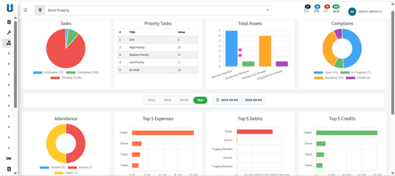

Executive Overview
Firmity's Executive Dashboard is a real-time operations command centre for a single property or an entire portfolio. It consolidates task status, asset health, complaints, staff attendance, expenses, and financial movement into one live screen — replacing the need to open separate modules for a daily status check. Every widget responds to a single date filter (Today / Week / Month / Year, or a custom range), so all figures on screen always describe the same reporting window.

Module Objectives
- Provide real-time visibility into task status across the property.
- Consolidate asset health and servicing status in a single view.
- Track complaint volume, ageing, and resolution stage.
- Monitor staff attendance alongside expense and financial movement.
- Surface priority and critical items automatically, without manual filtering.
- Support flexible date-range reporting — Today, Week, Month, Year, or a custom range.
- Reduce dependency on multiple modules for routine daily oversight.

End-to-End Dashboard Flow
- Admin/user logs into Firmity and lands on the Executive Dashboard for the selected property.
- Property or portfolio is selected from the location switcher.
- Dashboard loads live data for Tasks, Priority Tasks, Total Assets, and Complaints.
- Admin selects a reporting window — Today, Week, Month, Year, or a custom From/To range.
- All widgets refresh together to reflect the selected period.
- Admin reviews the Tasks chart for the Actionable, Completed, and Pending split.
- Admin cross-checks the Priority Tasks table for SOS, High, Medium, Low, and On Hold counts.
- Admin reviews Total Assets for Service Overdue and Upcoming Services.
- Admin reviews the Complaints chart for Open, In Progress, Resolved, and Closed counts.
- Admin reviews Attendance for the Present, Absent, and Leave split.
- Admin reviews Top 5 Expenses, Top 5 Debits, and Top 5 Credits for financial oversight.
- Notification counters and priority alerts direct the admin to items needing immediate action.
- Admin drills into the relevant module — Tasks, Assets, Complaints, or Inventory — to act on a flagged item.

Live Task Status
- Real-time visibility into assigned, ongoing, and completed tasks across the property.
- The Tasks widget breaks the task book into Actionable, Completed, and Pending, so managers instantly see the size of the pending backlog against work already closed.
- A companion Priority Tasks table ranks the backlog by urgency — SOS, High, Medium, Low, and On Hold — with a live count for each, surfacing what needs attention first.

Asset Health Overview
- Monitors the condition, service record, and performance of every asset at a glance.
- The Total Assets chart tracks four states — Service Overdue, Upcoming Services, Rented-Out Assets, and Checked-Out Assets — so overdue servicing is visible without opening the asset register.

Complaint Tracking
- Tracks complaint volume, resolution time, and pending issues from a single donut chart.
- Complaints are segmented into Open, In Progress, Resolved, and Closed, giving an immediate read on how much of the current complaint load is still unresolved.

Attendance and Expenses
- Reviews staff attendance and expense records in one dashboard.
- The Attendance donut splits the workforce into Present, Absent, and Leave for the selected period.
- Top 5 Expenses ranks the highest cost line items (e.g., cleaning consumables, diesel, petrol) for the period in view.

Performance & Financial Charts
- Analyzes productivity and efficiency through visual reports, alongside the property's financial movement.
- Top 5 Debits and Top 5 Credits chart the largest outgoing and incoming transactions side by side, so unusual spend or receipts stand out immediately.
- Every widget on the dashboard responds to the same date filter, keeping all metrics aligned to one reporting window.

Priority Alerts
- Surfaces instant notifications for critical and high-priority issues — SOS and High Priority items are pulled to the top of the Priority Tasks table rather than left buried in the general task list.
- Works alongside the notification bell and alert counters in the top bar, which track pending approvals, tasks, and complaints across the property in real time.

Data Accuracy & Control Features
- Every widget is bound to live property or portfolio data — nothing is a static snapshot.
- A single, uniform date-range filter keeps every metric aligned to the same reporting window.
- Dashboard figures reconcile with the underlying modules — Tasks, Assets, Complaints, and Inventory — so nothing shown on screen is out of sync with source records.
- Role-based access controls who can view portfolio-wide figures versus a single property.

Benefits for Property & Facility Management Teams
- Single-screen oversight without switching between modules.
- Faster identification of overdue tasks, assets, and unresolved complaints.
- Data-driven attendance and expense monitoring.
- Immediate visibility into financial movement — debits, credits, and top expenses.
- Supports quicker, better-informed decisions for property and portfolio managers.

Key Features Summary
Feature | Capability
Task Status | Actionable, Completed, and Pending, with priority ranking (SOS / High / Medium / Low / On Hold)
Asset Health | Service Overdue, Upcoming Services, Rented-Out, and Checked-Out tracking
Complaints | Open, In Progress, Resolved, and Closed tracking
Attendance | Present, Absent, and Leave breakdown
Financials | Top 5 Expenses, Top 5 Debits, and Top 5 Credits
Reporting Window | Today / Week / Month / Year / custom From–To range
Alerts | Real-time priority and notification counters

Executive Dashboard Usage Flow
Admin Logs In
↓
Select Property / Portfolio
↓
Select Reporting Window
↓
Review Tasks & Priority Tasks
↓
Review Asset Health
↓
Review Complaints
↓
Review Attendance & Expenses
↓
Review Financial Charts
↓
Priority Alerts Surface Critical Items
↓
Drill Into Relevant Module
↓
Action Taken

For Further Information:
Product: Firmity Facility Automation – ERP and Computerized Maintenance Management System
Website: www.firmity.in
Email: sales@firmity.in


