DISASTER MAPPING &
RELIEF MANAGEMENT SYSTEM

Project overview and step-by-step user guide
Every feature explained with screenshots taken from the running system
Final version | October 2026
PHP 8 + MySQL 8 web application for WampServer
Database System Lab project

Contents
1. Project overview 4
1.1 What the system does 4
1.2 Technology 4
1.3 The four live-tracking features 4
2. Installation and first start 5
3. Signing in, roles and passwords 6
3.1 Sign in 6
3.2 The three roles 7
3.3 Sign out and change your password 7
4. Finding your way around 8
5. Dashboard 9
6. Live Report 11
6.1 Warning signal indicator 11
6.2 Live disaster path 12
6.3 Real-time shelter capacity 14
6.4 Relief distribution tracker 15
6.5 What changes the Live Report 17
6.6 The original Live Report 18
7. Data Health 19
8. Disaster Report 21
9. Map 24
10. Search 25
10.1 Search everything 25
10.2 Search inside a table 25
11. Working with the tables 26
11.1 View, sort and export 26
11.2 Add a record 27
11.3 The system protects your data 28
11.4 Edit a record 30
11.5 Delete a record safely 31
11.6 The tables behind the live panels 32
12. Administration 35
12.1 Users (administrators only) 35
12.2 My account 35
12.3 Audit Log 36
13. Read-only users 37
14. Phone and tablet 39
15. Database design 40
15.1 Data model 40
15.2 The 22 tables 40
15.3 How the data stays correct 41
15.4 How the Live Report gets its data 42
15.5 Design decisions (methodology) 42
16. Security and quality checks 43
17. Backup, upgrade and troubleshooting 44
17.1 Back up the database 44
17.2 Upgrade from the earlier 20-table version 44
17.3 Start again from scratch 44
17.4 Common messages 44
Appendix A. Sample data 45
Appendix B. Files of the project 45

1. Project overview

1.1 What the system does
The Disaster Mapping & Relief Management System is a web application that helps an emergency control room record disasters, keep track of affected families, shelter them, hand out relief, and see the whole situation on one screen. It was built for the Khulna - Satkhira - Bagerhat coastal region of Bangladesh. Security and testing are described in section 16.
- Records disasters, the areas they hit, early warnings (with a warning signal number), damage, affected families, shelters, rescue organisations and relief stock.
- Tracks who is staying in which shelter, how many places are left, and which families have received relief.
- Shows a Live Report that refreshes itself every 5 seconds: warning signals, the live path of a cyclone on a map, shelter space and relief status.
- Protects the data with roles, an audit log, database rules (foreign keys, CHECK constraints, triggers) and a Data Health report.

1.2 Technology
Part | What is used
Web server and language | PHP 8.1+ (tested on 8.2) running under WampServer (Apache), or PHP's built-in server with start_server.bat
Database | MySQL 8 (InnoDB): 22 tables, foreign keys, CHECK constraints, 8 triggers
Screen | Plain HTML, CSS and JavaScript (no framework). Maps use Leaflet with OpenStreetMap tiles (internet needed for the map only)

1.3 The four live-tracking features
The newest part of the system adds four features to the Live Report, above the original report, which is unchanged. The Dashboard shows a short "Live status" summary of them. Each feature follows an exact rule, listed here and explained step by step in section 6.
Feature | Rule | Where
Warning signal indicator | Signal 1, 2, 3 = green "Normal"  Signal 4, 5, 6, 7 = orange "Danger"  Signal 8, 9, 10 = red "Severe Danger" | Live Report > Warning signals
Real-time shelter capacity | Places left = capacity minus people staying now.  More than 0 = green with the exact number.  0 = red "No space available". | Live Report > Shelter space
Relief distribution tracker | Normal = green with the number of people who received relief.  Shortage = red with both numbers: received and not received. | Live Report > Relief distribution
Live disaster path | Map with the observed track, the forecast, the current position and impact circle; lists of areas crossed now, in the path, passed. | Live Report > Live disaster path

2. Installation and first start
The system installs itself. You only copy the folder and open the address in a browser.
- Start WampServer and wait until its icon is green.
- Copy the whole folder disaster_and_relief_management into C:\wamp64\www\.
- Open config.php. WampServer's default MySQL user is root with an empty password, so normally nothing needs to change. Keep the database name as it is.
- Open http://localhost/disaster_and_relief_management/ in your browser.
- On the very first visit the system creates the database, the 22 tables, the 8 triggers and the sample data (a few seconds). No phpMyAdmin import is needed.
- The First run screen appears. Type a user name (3-50 letters, digits, dot, dash or underscore) and a password of at least 8 characters, repeat the password and click Create administrator.
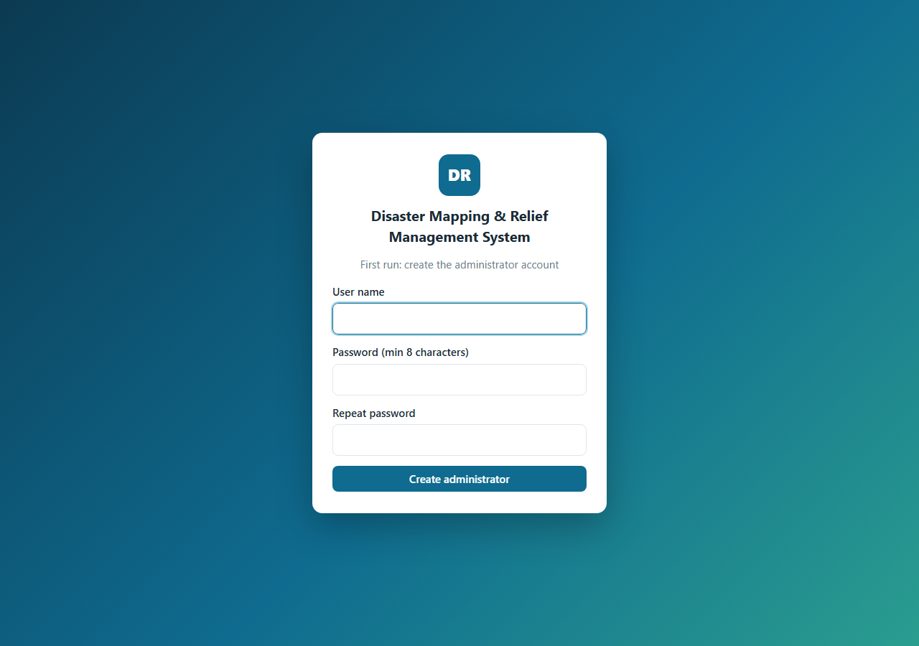
Figure 1. First-run screen: creating the administrator account.
Note
Without Apache you can double-click start_server.bat. It starts WampServer's MySQL and PHP's built-in server and opens http://127.0.0.1:8099/ . Edit the three paths at the top of the file if your WampServer versions differ.

Important
Only the first visitor can create the administrator. After that the screen is replaced by the normal sign-in page and new users are added by an administrator (section 12).

3. Signing in, roles and passwords

3.1 Sign in
- Open the system address. If you are not signed in you always land on the sign-in page.
- Type your User name and Password.
- Click Sign in. You arrive on the Dashboard.
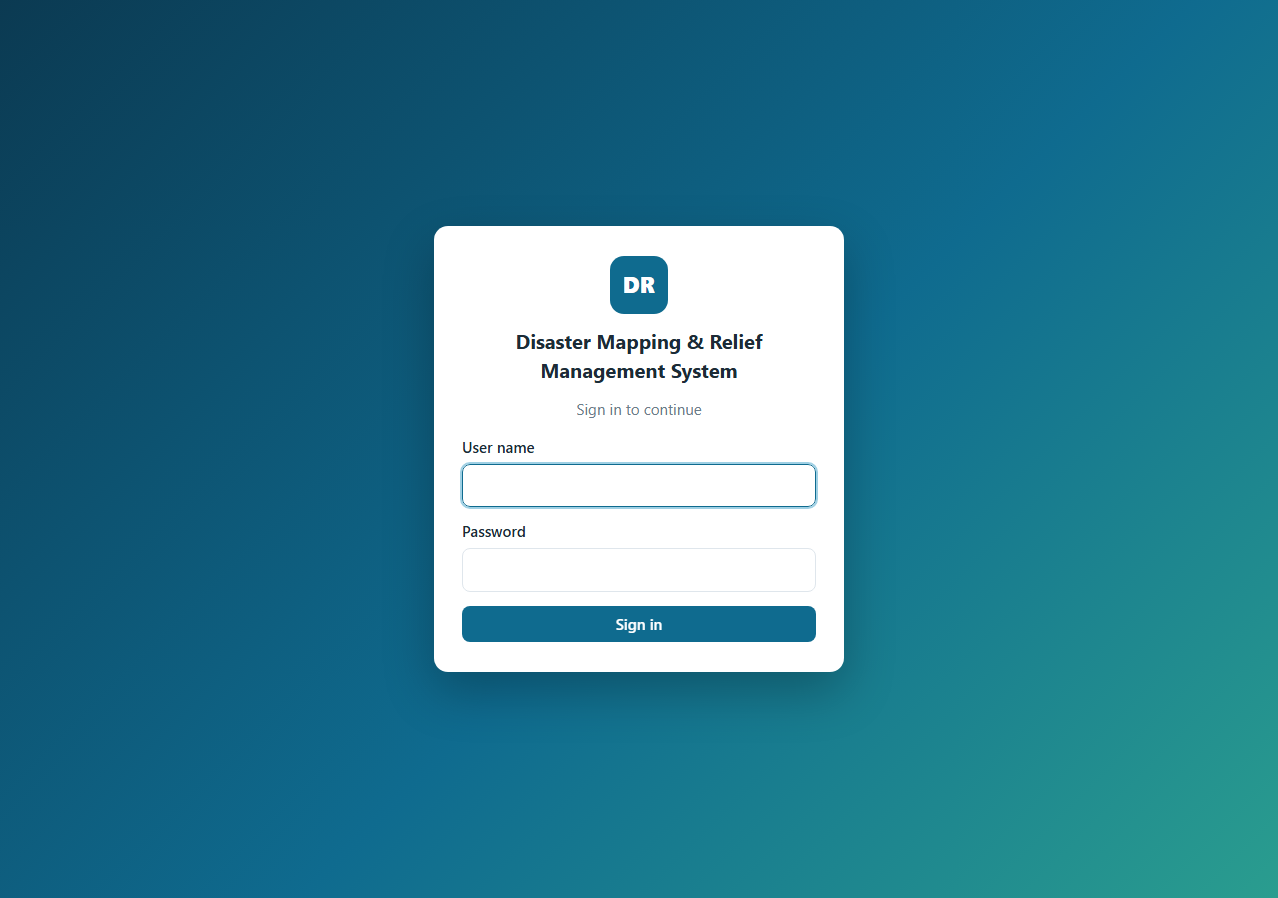
Figure 2. The sign-in page.
A wrong user name or password shows a red message and nothing else. After 5 wrong passwords the account is locked for 5 minutes ("Too many wrong passwords"); when the lock ends you get a fresh set of attempts. A session also ends by itself after 4 hours without any click.
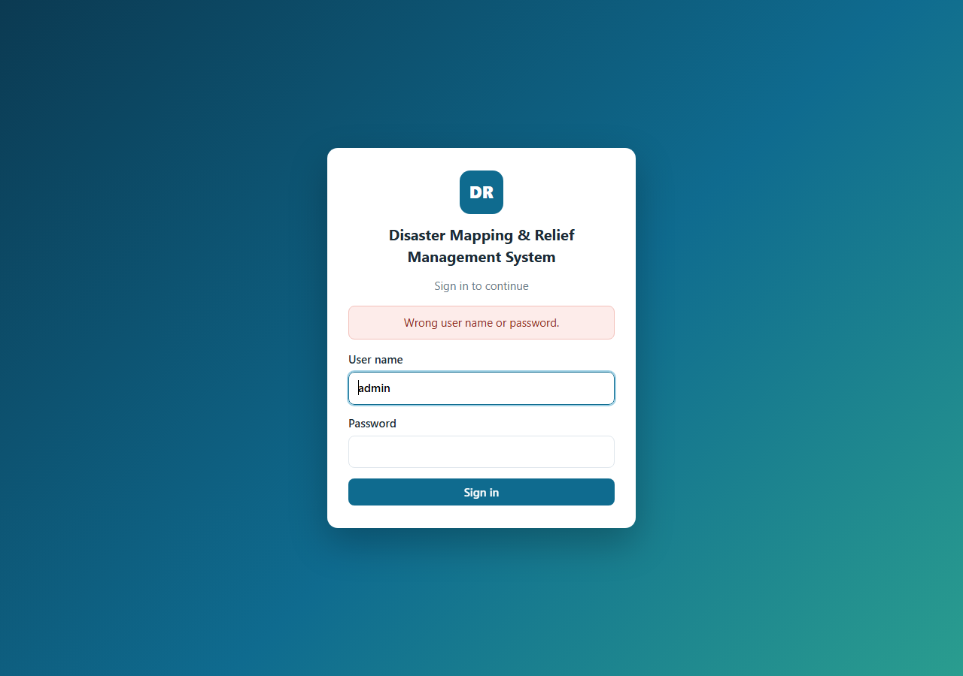
Figure 3. Message after a wrong password.

3.2 The three roles
Role | What the person can do | Cannot do
admin | Everything: view, search, export, add, edit and delete records (including disasters), and use the Users page | -
editor | View, search, export CSV, add, edit and delete records | Delete a disaster (it removes everything recorded under it); open the Users page
viewer | View, search, export CSV, open every report | Add, edit or delete anything

3.3 Sign out and change your password
- Click your name at the top right to open My account, enter the current password, the new password (8+ characters) twice and click Change password.
- Click Sign out at the top right when you finish, especially on a shared computer.

4. Finding your way around
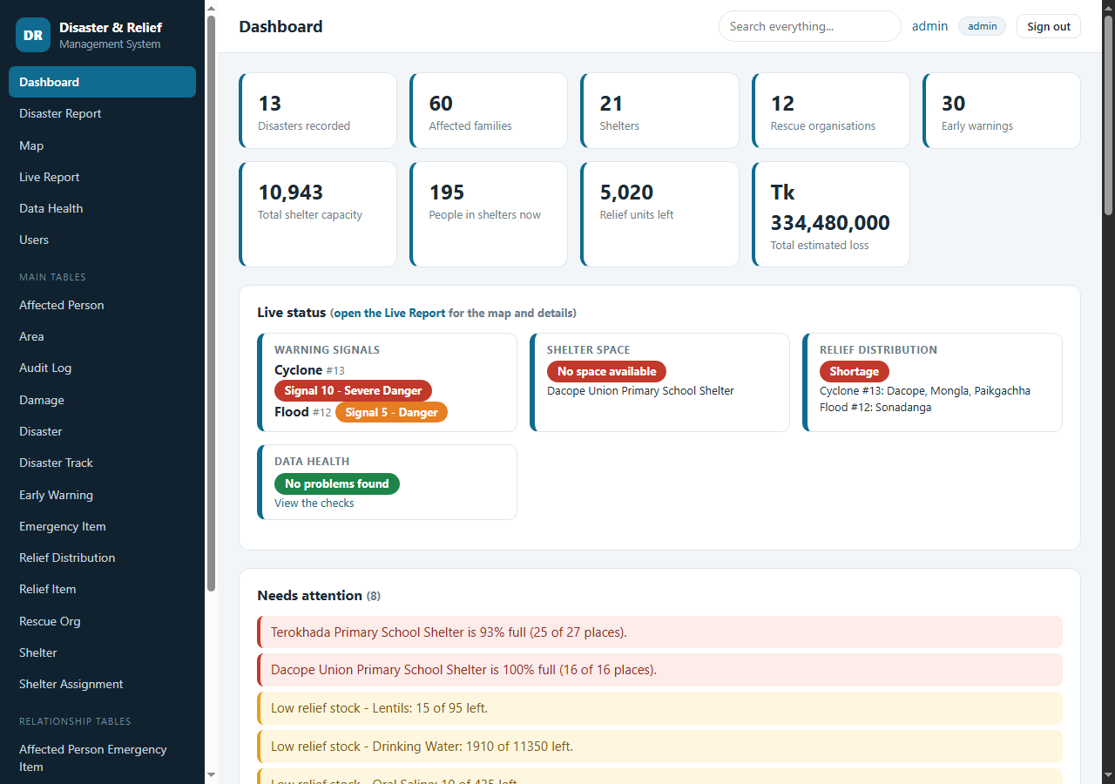
Figure 4. The main screen: menu on the left, title and search at the top, content in the middle.
Area | What it is for
Menu (left) | Dashboard, Disaster Report, Map, Live Report, Data Health and (administrators only) Users. Below them are the Main tables and the Relationship tables: one page for every table in the database.
Title bar (top) | The name of the page, the Search everything... box that searches every table, your name (click it for My account), your role and Sign out.
Content (middle) | The page itself. On a phone the menu is hidden behind the three-line button at the top left (section 14).

5. Dashboard
The Dashboard is the first page after sign-in. It answers "what is happening and what needs my attention?" at a glance.
- Click Dashboard in the menu.
- Read the number cards at the top. Click any card to open the table behind it.
- Read the Live status cards: warning signals of the active disasters, shelters with no space, relief shortages and data health. Click "open the Live Report" for the details.
- Read Needs attention. Red lines are urgent (a shelter 90% or more full), yellow lines are warnings (low relief stock, a high-risk area without a shelter, a disaster without a warning) and blue lines are notes (families staying more than 30 days). Click a line to open the related table.
- Scroll down for Disasters at a glance (click the number in the Report column for the full report of that disaster), Areas by risk level, Shelter occupancy bars and the list of all database tables.
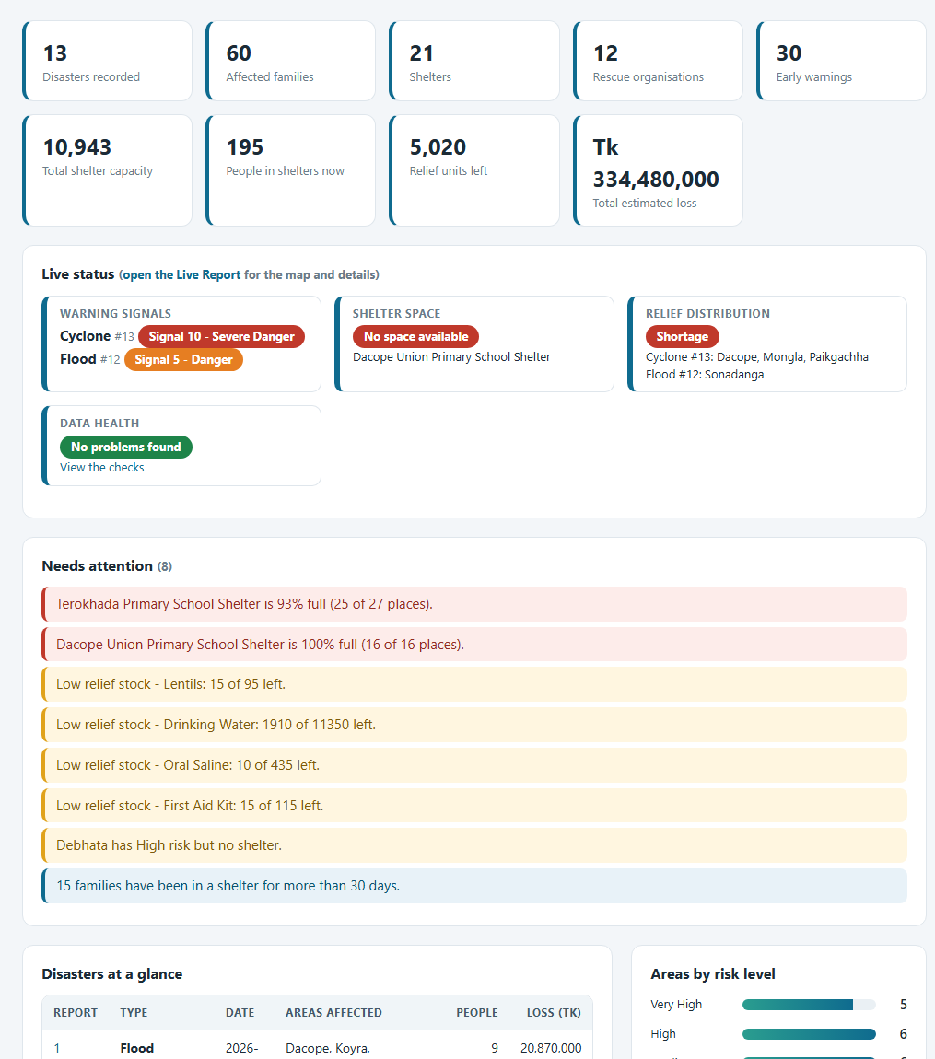
Figure 5. Dashboard: number cards, Live status and the Needs attention list.
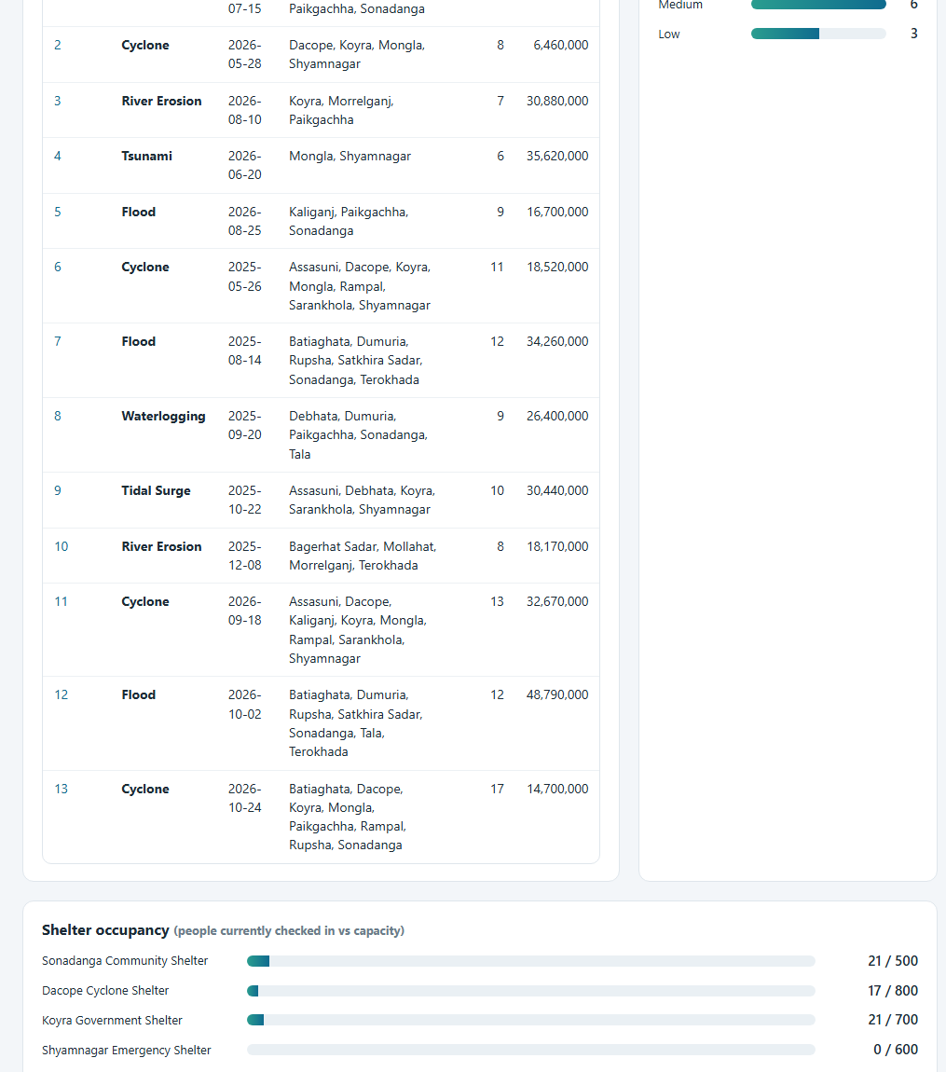
Figure 6. Dashboard (continued): disasters at a glance, risk levels and shelter occupancy.
Note
"Affected families" counts families (one record per family). The number of people in those families is shown on the Live Report as "People in those families". "Relief units left" adds the remaining stock of every relief item, whatever its unit.

6. Live Report
The Live Report is the control-room screen. It reads the database again every 5 seconds and redraws only the parts that changed, so it can stay open on a big screen. A green dot and "Live" show that the connection is working; "Last checked" shows the time of the last refresh. Refresh now forces an update and Print prints the page.
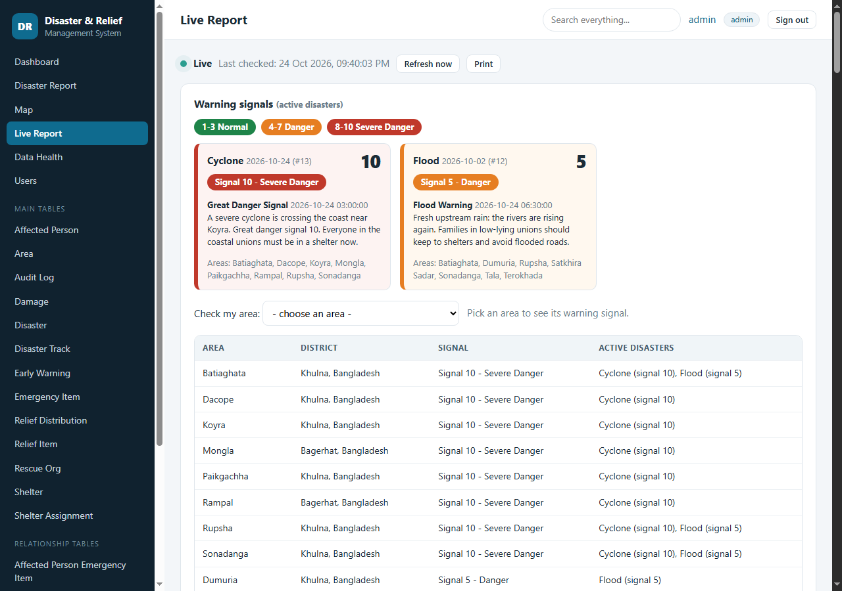
Figure 7. The Live Report opens with the Warning signals panel.

6.1 Warning signal indicator
Every disaster that is marked Active has a warning signal: the number of its latest early warning that has a signal number. The colour and the word follow this rule:
Signal | Colour and word | Meaning
1, 2, 3 | Green - Normal | Distant or low-level watch; no immediate danger
4, 5, 6, 7 | Orange - Danger | Danger: prepare, avoid risky areas, follow instructions
8, 9, 10 | Red - Severe Danger | Great danger: go to a shelter now
none | Grey - No signal | No warning with a signal number has been recorded

- Open Live Report. The first panel is Warning signals.
- Each active disaster has a card with a large signal number, a coloured badge ("Signal 10 - Severe Danger"), the text and time of the latest warning and the areas it affects. The badge always shows the word as well as the colour.
- To see one place, use Check my area: choose the area in the list. Its signal appears next to the list together with the disasters behind it. If no active disaster touches the area the answer is "No active disaster is affecting this area".
- The table below lists every area that an active disaster is hitting. An area takes the highest signal of the active disasters that affect it (Batiaghata is hit by the cyclone at 10 and the flood at 5, so it shows 10).
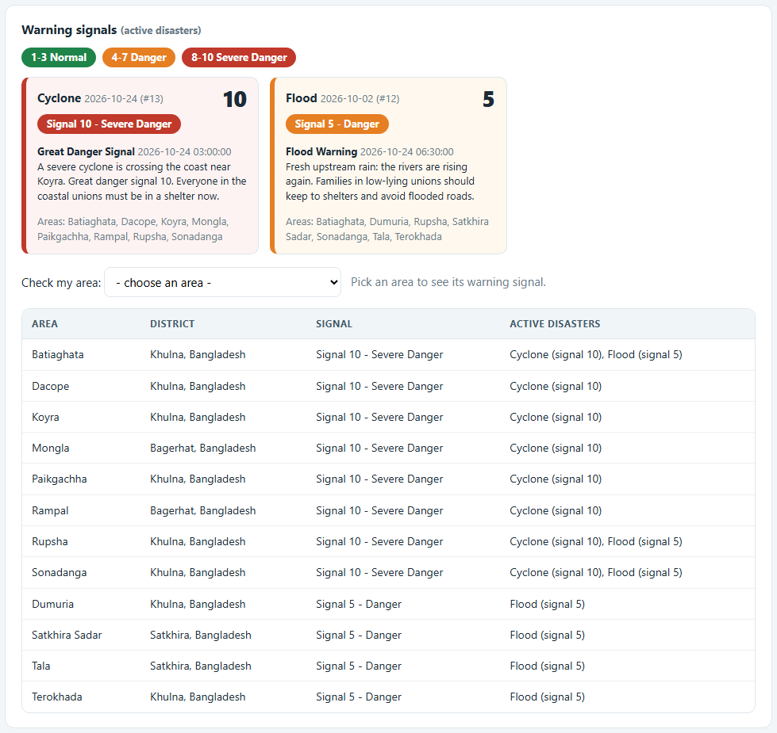
Figure 8. Warning signals: the cyclone is red (10), the flood is orange (5).
Figure 9. Check my area: the chosen area and its signal.

6.2 Live disaster path
This panel works like the tracking maps of weather services. It draws the movement of a disaster, such as a cyclone, from the Disaster Track table.
On the map | Meaning
Solid red line with dots | The observed (Actual) path so far
Dashed orange line, hollow dots | The forecast path with its predicted positions
Big red dot with a large circle | The current position (latest Actual point) and its impact radius in kilometres
Red circles with a name | Areas being crossed now: the area centre is inside the current impact circle
Orange circles | Areas in the forecast path: inside the circle of a forecast position
Grey circle | Areas the disaster has already passed: inside an earlier observed position
Faint green outlines | Other areas, not in the path

- Open Live Report and scroll to Live disaster path. The map zooms to the current position and the forecast when it first opens.
- Zoom and move the map with the mouse or the + and - buttons. Your view is kept when the map refreshes.
- Click a point to see its time, wind speed and radius. Click an area circle to see its risk level and whether it is being crossed.
- Read the lists under the map: Currently crossing, In the forecast path and Already passed, each with the distance in km from the current position.
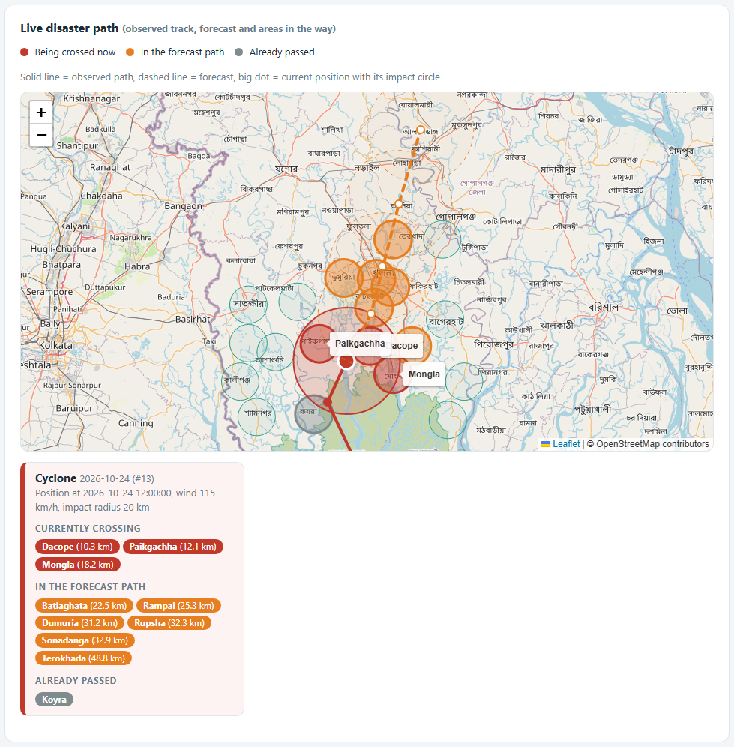
Figure 10. The cyclone path, the forecast and the areas in its way.
Note
The map needs an internet connection for the map tiles. Without it the page says so and the three lists still work.

6.3 Real-time shelter capacity
For every shelter the system calculates places left = capacity - family members who are staying now (a family is staying until its Check Out date is filled in). Nothing is stored, so the number is always current.
State | What the screen shows
At least 1 place left | Green card, green badge "N places left" with the exact number, and a fill bar
No place left (0) | Red card and badge "No space available"

- Open Live Report and scroll to Shelter space. All shelters are shown, shelters with space first.
- Use Area to show only the shelters of one area, and tick Only shelters with space to hide the full ones.
- To find the nearest shelter choose an area in Nearest to. Every card then shows its distance ("13.5 km away") and the closest shelters come first (shelters with space always before full ones).
- Click Use my location to measure from where you are. The browser asks for permission first; nothing is stored.
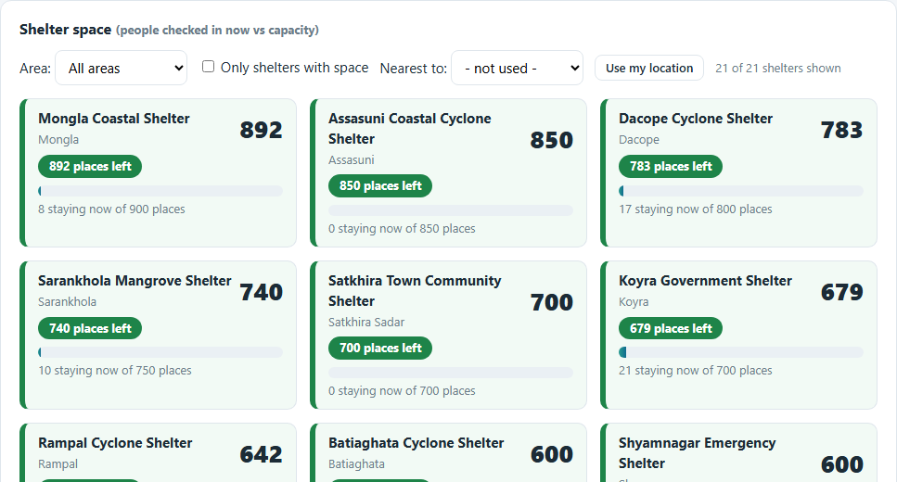
Figure 11. Shelter space: green cards with the exact number of free places.
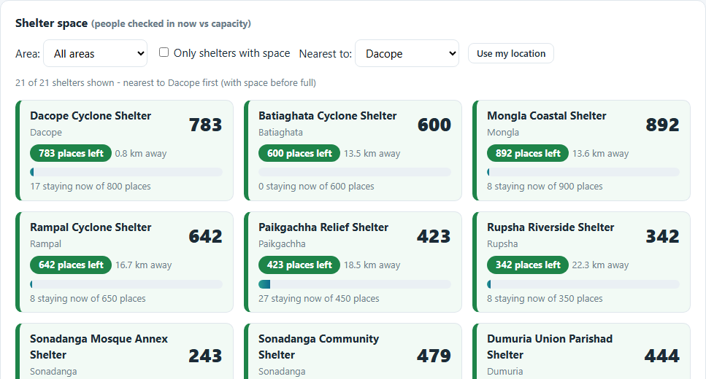
Figure 12. Nearest to Dacope: distances are shown and the nearest shelters come first.
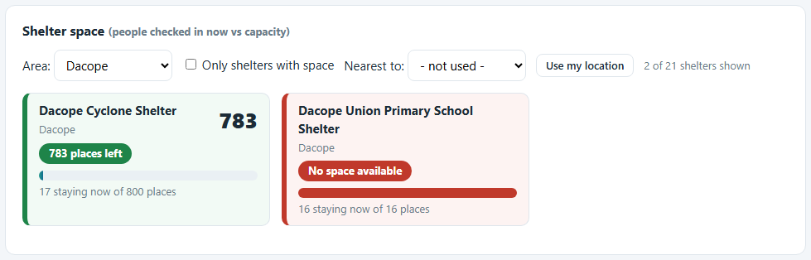
Figure 13. Area filter: the full school shelter is red with "No space available".

6.4 Relief distribution tracker
The tracker compares the families affected by each active disaster with the families that received relief. Families are grouped by their home area. Counts are in people (family members); the number of families is shown in small text.
State | What the screen shows
Relief on track (green) | Green badge and the number of people who have received relief, with a progress bar
Shortage (red) | Red badge and two numbers: people who received relief and people who have not received it, plus the reason

An area is in shortage when fewer than 80% of its affected people have received relief, or when a coordinator has set Relief Shortage = Yes on that disaster and area (Disaster Area table). Exactly 80% is still on track. A disaster is red when any of its areas is short.
- Open Live Report and scroll to Relief distribution.
- Each active disaster has an "All affected areas" card first, then one card per area, shortages first.
- Read the numbers: in a red card the left number is people who received relief and the right number is people who have not.
- Tick Only shortages to hide the areas that are on track.
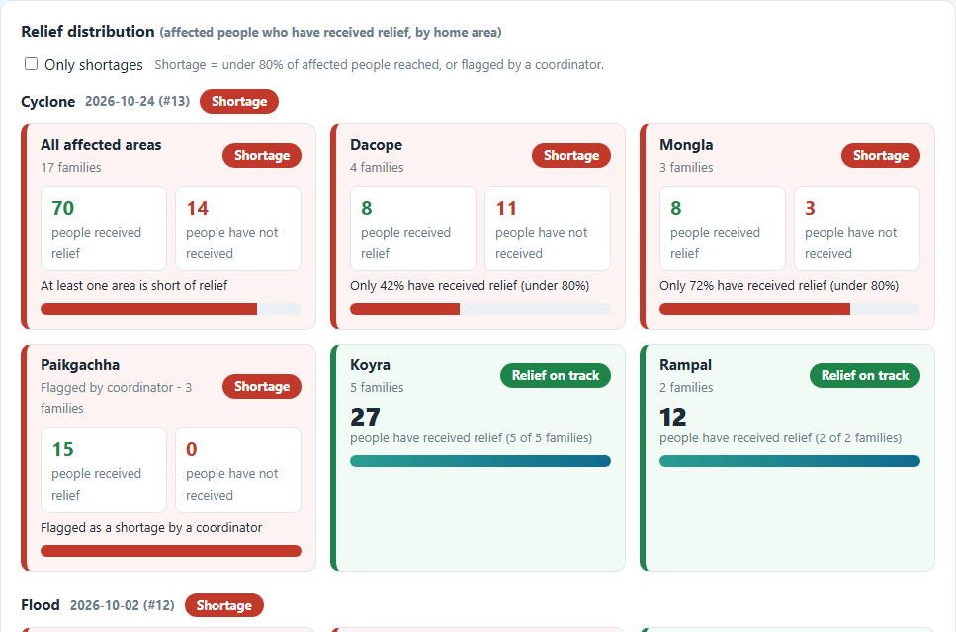
Figure 14. Relief distribution: red cards show received and not received; green cards show the received count.
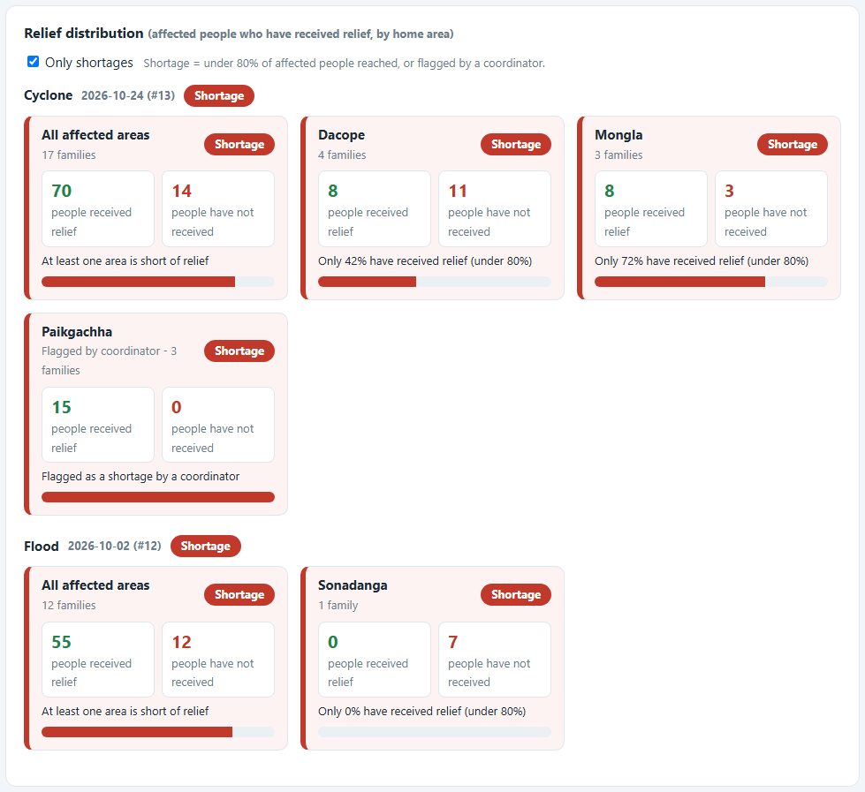
Figure 15. Only shortages ticked.

6.5 What changes the Live Report
Nothing has to be configured. Change the data in the table pages and the Live Report follows within 5 seconds.
I want to... | Do this
Change a warning signal | Early Warning > + Add record: choose the disaster, type the Alert Type, enter the Signal Level (1-10), the date and time and the message > Save record
End a disaster | Disaster > Edit: set Status to Ended. It leaves the signals, path and relief panels
Move the cyclone | Disaster Track > + Add record: disaster, time, Point Type (Actual or Forecast), latitude, longitude, impact radius in km, wind
Check a family into a shelter | Shelter Assignment > + Add record. Leave Check Out empty while they stay; fill it in when they leave
Record who received relief | Relief Distribution (what was given where), then Relief Recipient (which family received it)
Flag a shortage by hand | Disaster Area > Edit the row of that disaster and area: Relief Shortage = Yes

6.6 The original Live Report
Below the new panels the original report is unchanged: totals, a disaster-wise summary, areas by risk level, the shelter list with people in now, and the relief items with received, given and left.
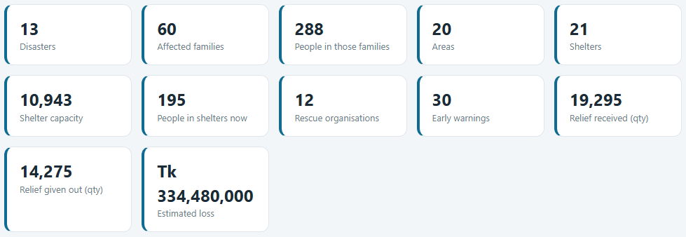
Figure 16. The original summary cards of the Live Report.

7. Data Health
Data Health reads the whole database and looks for records that contradict each other or are incomplete. It never changes anything. The Dashboard shows the number of problems.
- Click Data Health in the menu.
- The banner tells you if all checks passed. Every row is one check with a green OK or a coloured count.
- Error (red) means records contradict each other, for example a family staying in a shelter that does not belong to the disaster. Missing (orange) means information the live pages need is absent, for example an active disaster without a signal. Note (grey) is only worth a look, for example long stays or low stock.
- For a failed check the first records are listed. Click Open ... to go to the table, correct the records and reload the page.
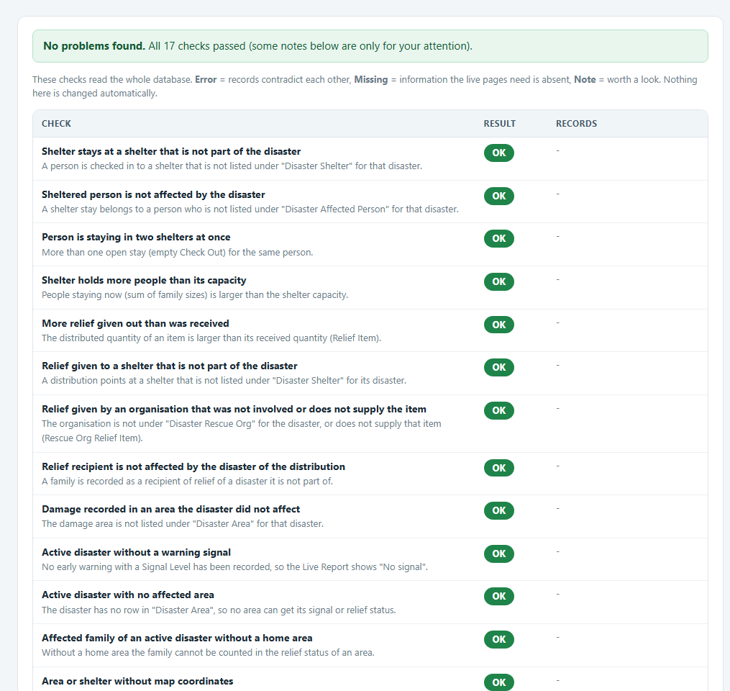
Figure 17. Data Health: the checks, all OK for the sample data.
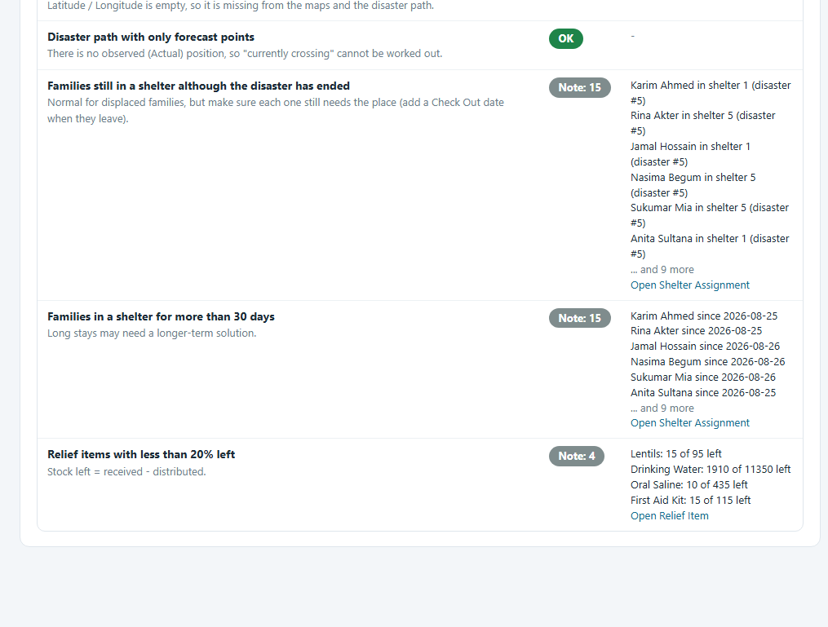
Figure 18. Data Health (continued): notes that deserve attention.
Note
The 17 checks cover: stays and distributions at shelters that are not part of the disaster, people in two shelters, shelters over capacity, relief given beyond the stock, recipients of the wrong disaster, damage in unaffected areas, active disasters without signal or area, families without a home area, missing coordinates, paths without an observed point, and three notes.

8. Disaster Report
The Disaster Report puts everything known about one disaster on a single printable page.
- Click Disaster Report in the menu (the latest disaster opens first), or click the number in the Report column of the Dashboard, or click Report on a row of the Disaster table.
- Choose another disaster in the Disaster list at the top. The page reloads by itself.
- Read the header: type, date, status (Active or Ended), the latest warning signal and the summary cards (areas hit, families, people affected, people still in shelters, estimated loss, relief units given).
- Scroll through the sections: Areas affected, Early warnings (each with its signal), Disaster path, Relief coverage by home area, Damage, Shelters used, Rescue organisations, Relief given out and Affected families.
- Click Print report to print it or save it as a PDF from the print dialog.
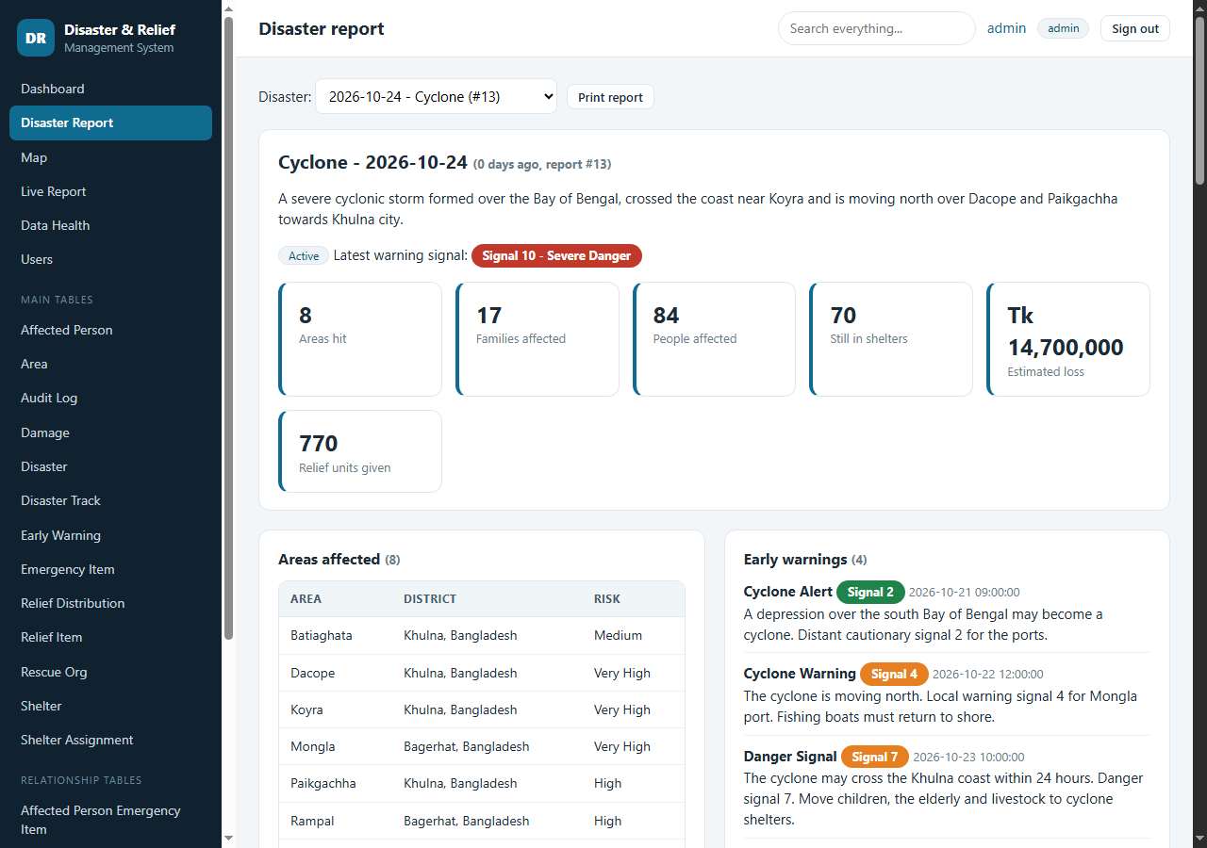
Figure 19. Disaster Report of the cyclone: header, signal and summary cards.
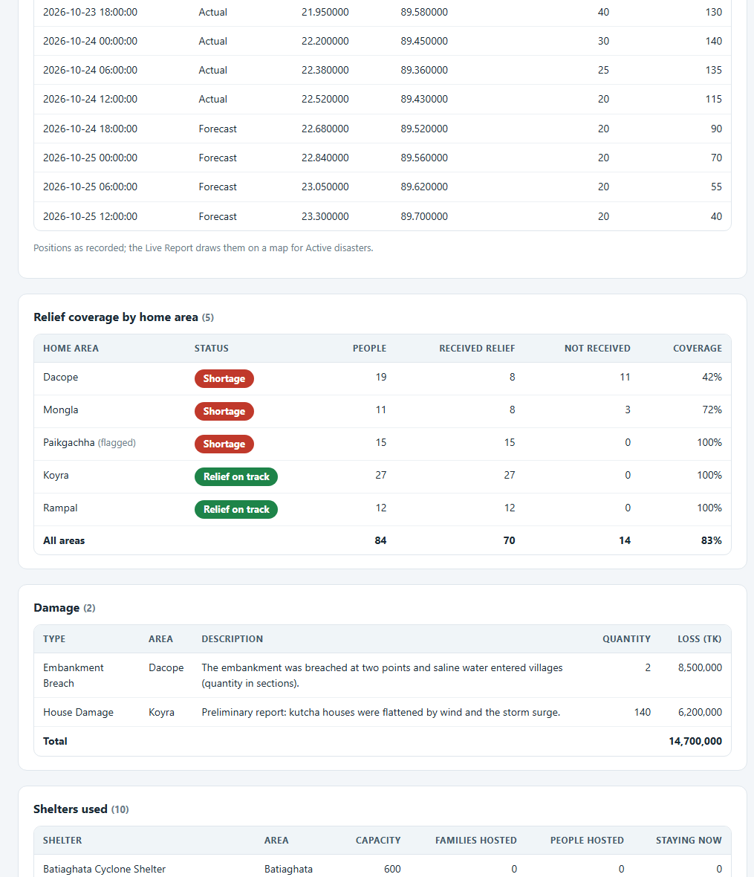
Figure 20. Disaster path points, relief coverage by home area and damage.
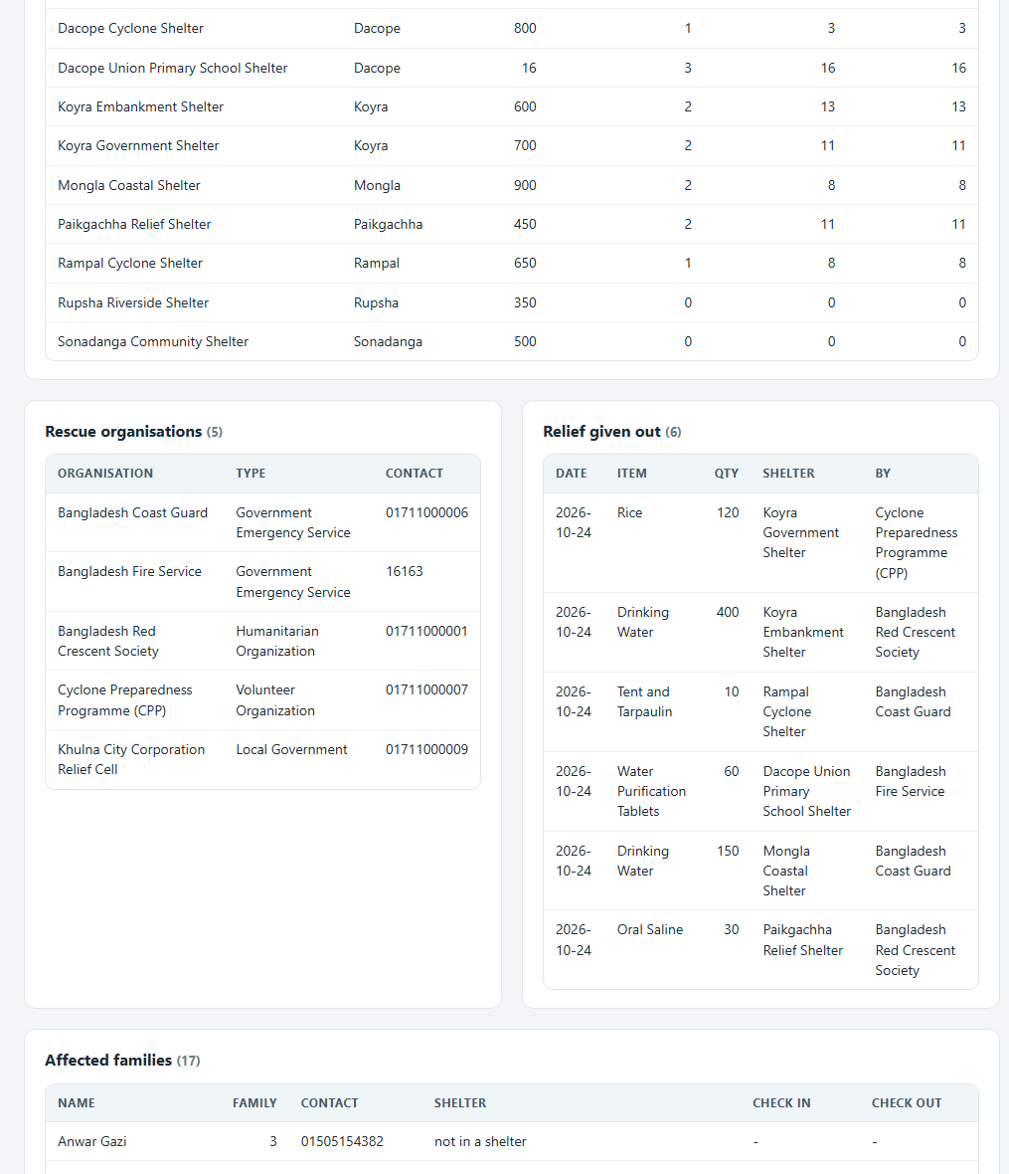
Figure 21. Shelters used, rescue organisations and relief given out.

9. Map
The Map page shows every area as a circle coloured by risk level and every shelter as a dot coloured by how full it is.
- Click Map in the menu.
- Read the legend: red = Very High risk, orange = High, yellow = Medium, green = Low. Shelter dots are green below 70% full, orange below 90% and red at 90% or more.
- Click a circle or a dot for a pop-up with details (location, risk, number of disasters, estimated loss, people staying).
- The tables under the map list the coordinates of every area and the occupancy of every shelter. Coordinates are edited in the Area and Shelter tables.
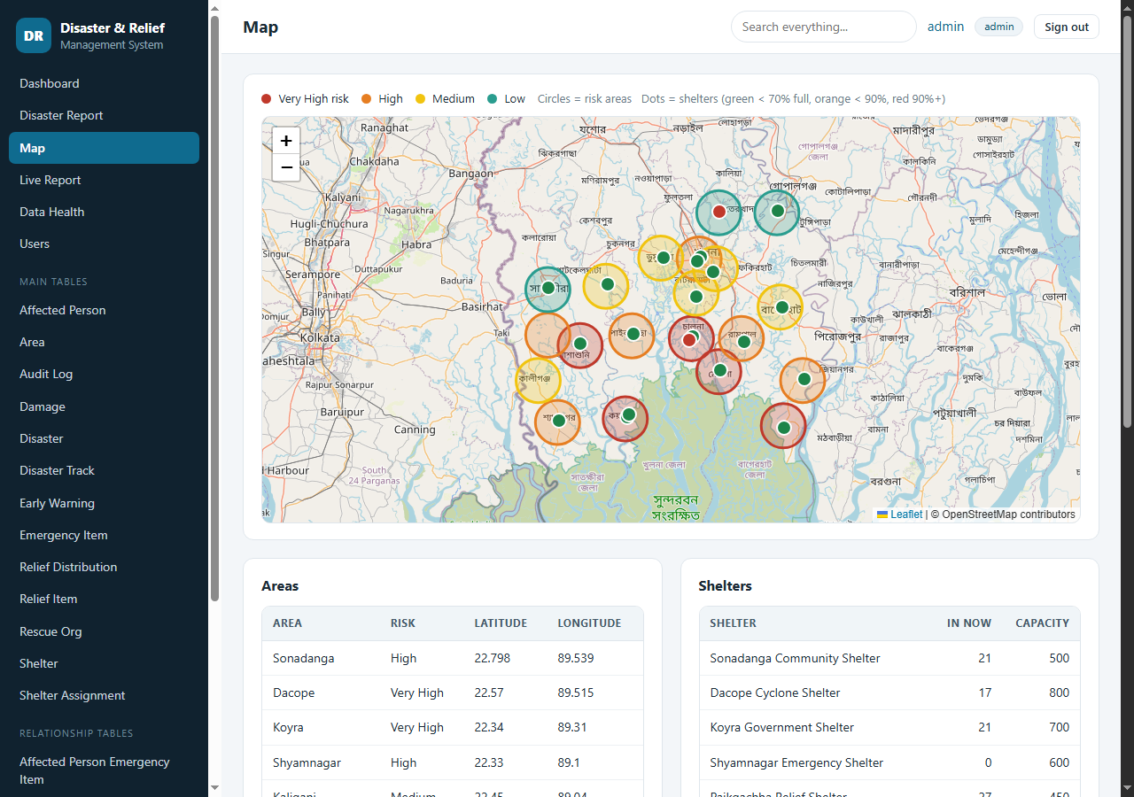
Figure 22. The risk and shelter map.

10. Search
There are two ways to search: one box for everything, and a search inside each table.

10.1 Search everything
- Type a name, phone number, area, shelter, organisation or item in Search everything... at the top and press Enter.
- The result page lists every table that has a match with the number of matches and the first records.
- Click Open in ... to see all matches inside that table.
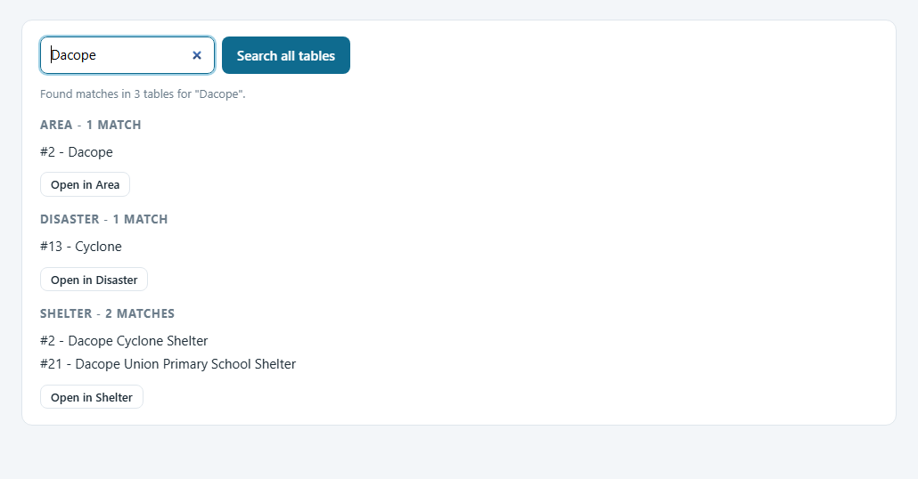
Figure 23. Search results for "Dacope" across all tables.

10.2 Search inside a table
Every table page has its own search: choose a column (or "All columns"), start typing and suggestions appear as you type, like a dictionary. Press Search to filter the table and Clear to remove the filter.
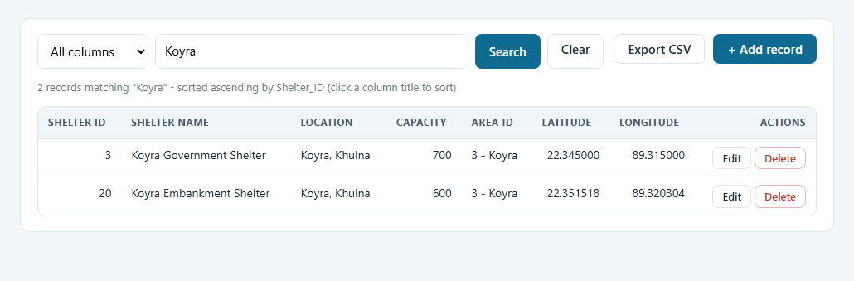
Figure 24. Searching the Shelter table for "Koyra".

11. Working with the tables
Every table of the database has a page, opened from the Main tables and Relationship tables lists in the menu. They all work the same way, so learning one means knowing all 21.

11.1 View, sort and export
- Click a table in the menu, for example Shelter.
- The line under the toolbar tells you how many records exist and how they are sorted.
- Click a column title to sort by it; click again to reverse (an arrow shows the direction).
- Use Prev and Next at the bottom: 20 records are shown per page.
- Click Export CSV to download every matching record (not only the page you see) as a file that Excel opens correctly.
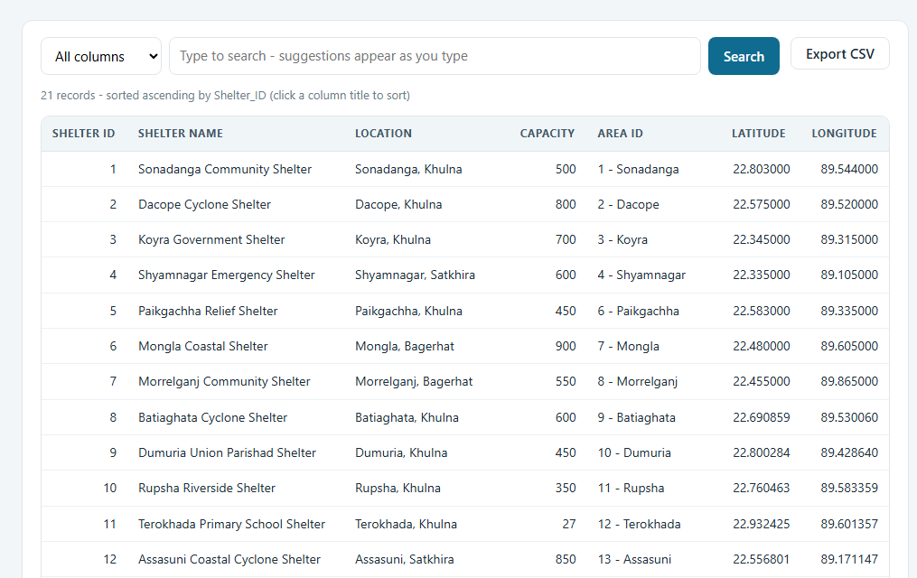
Figure 25. The Shelter table: toolbar, record count, sortable columns and the Edit / Delete buttons.
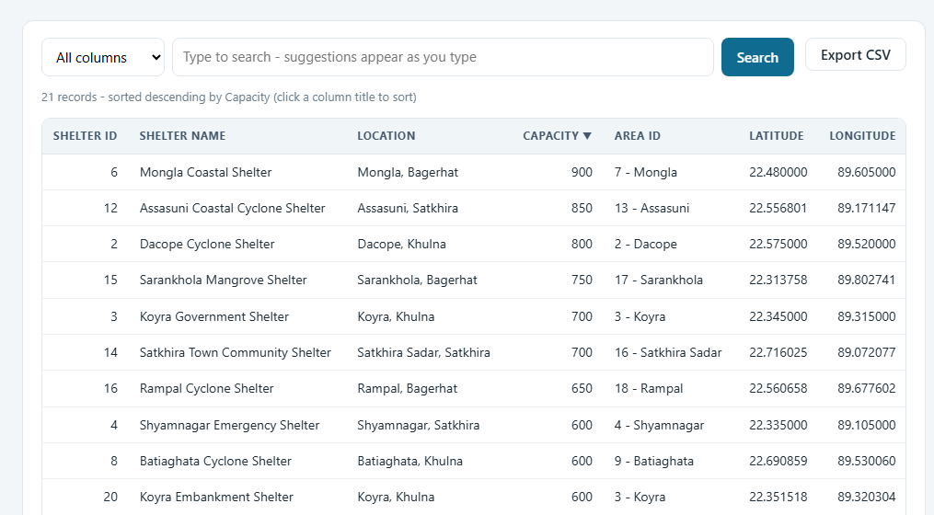
Figure 26. Sorted by Capacity, largest first.

11.2 Add a record
Example: add a new early warning with a signal number.
- Open Early Warning and click + Add record.
- Choose the Disaster from the list (lists show the ID together with a readable name, so you never type IDs).
- Type the Alert Type (for example "Cyclone Warning") and the Signal Level from 1 to 10. A red star marks required fields.
- Pick the Alert DateTime with the calendar and write the Message.
- Click Save record. You return to the list with a green message and the new record on top (sort by Alert ID, descending).
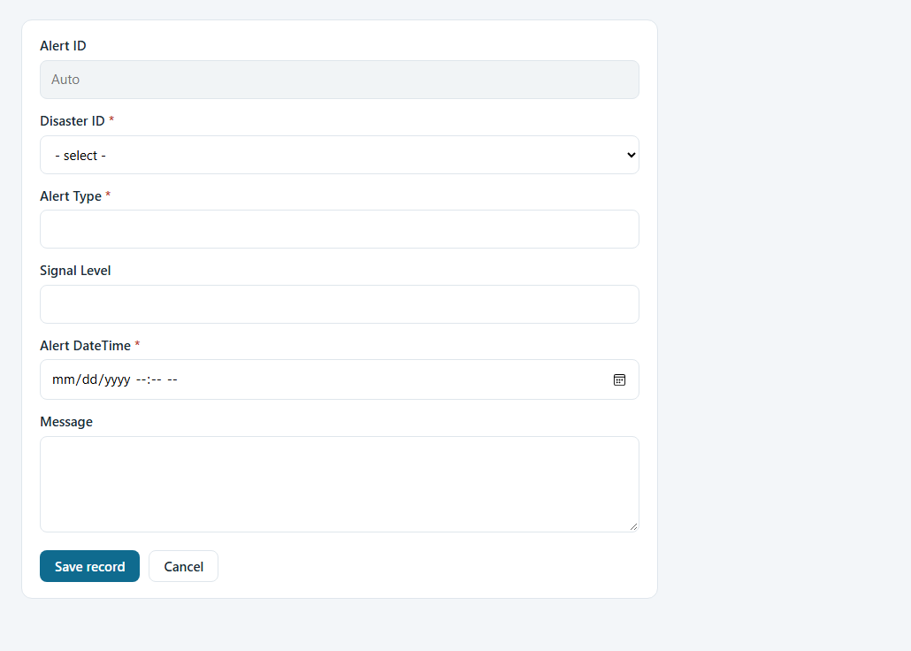
Figure 27. The Add record form of Early Warning.
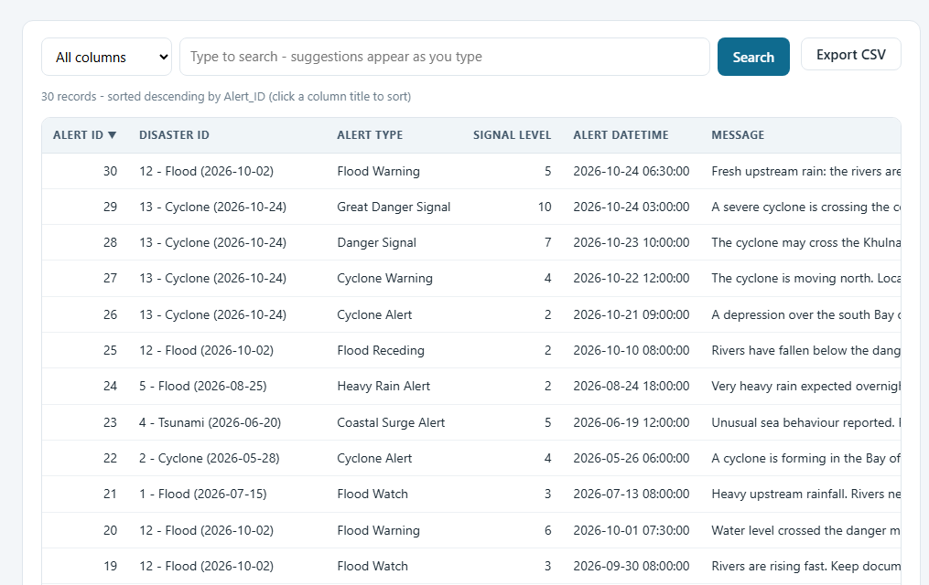
Figure 28. The new warning appears in the list.

11.3 The system protects your data
Some records are refused with a plain-language message and the form stays open with everything you typed, so you can correct it. Examples:
- Open Shelter Assignment > + Add record. Choose disaster 13, family 42 (3 people) and the full school shelter, then click Save record.
- The shelter is full, so the system answers: "The shelter would be over capacity: 16 staying now + 3 new > 16 places."
- Choosing a shelter that is not used for the disaster gives: "That shelter is not used for this disaster. Add it in Disaster Shelter first."
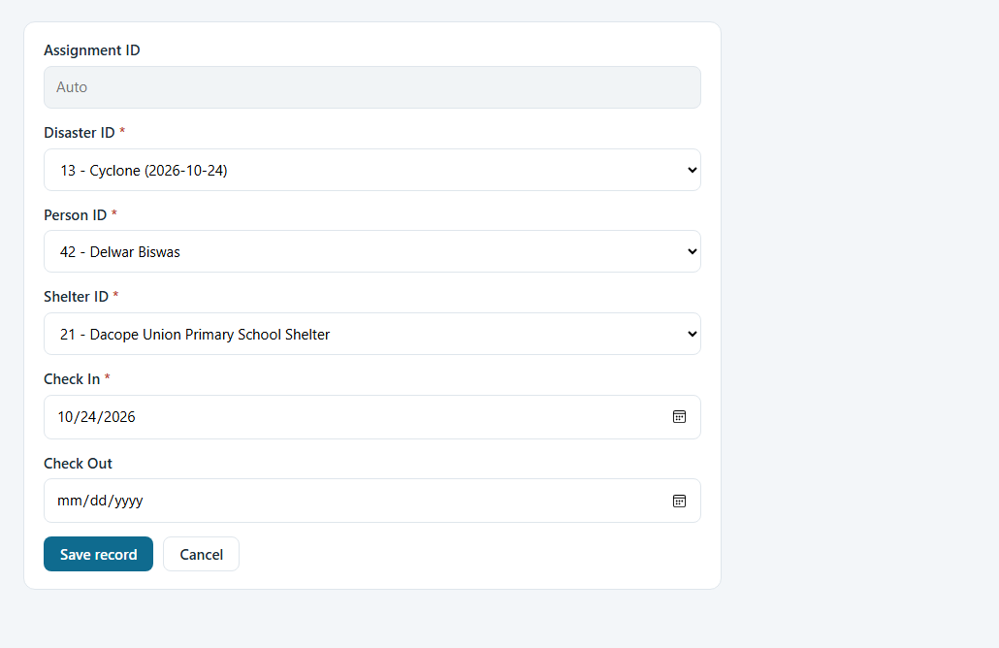
Figure 29. Checking a family into the full school shelter.
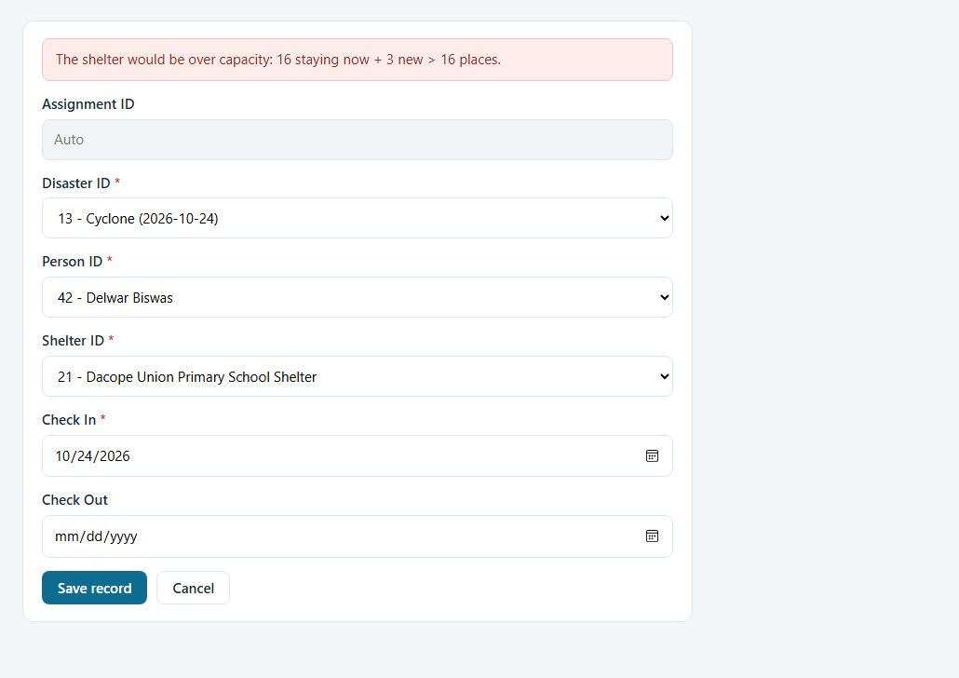
Figure 30. The capacity rule refuses the record.
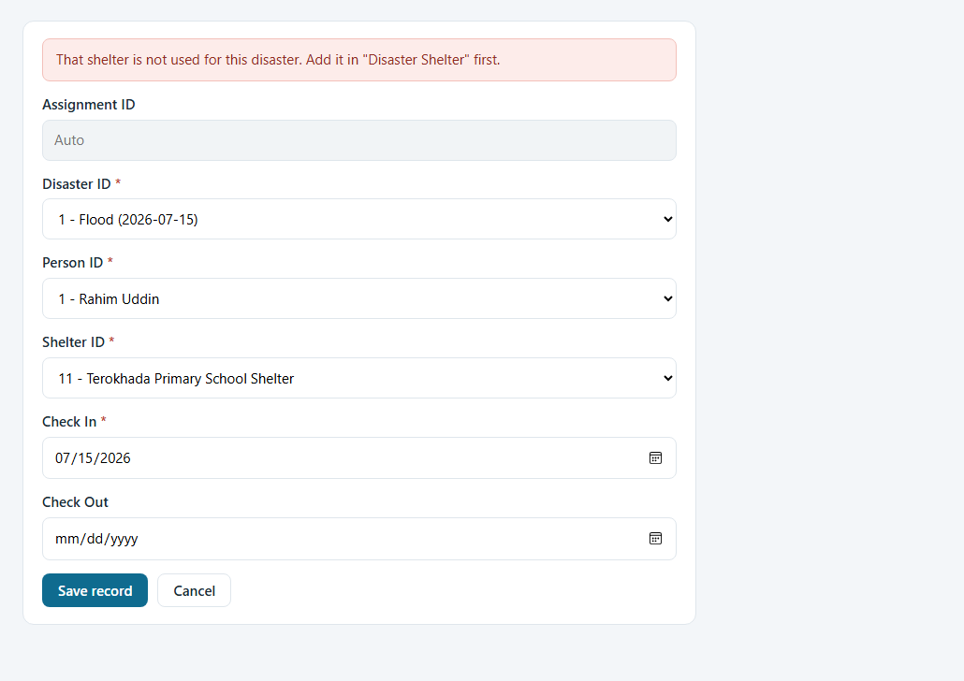
Figure 31. A shelter that does not belong to the disaster is refused.
Two layers of protection
The messages above come from the application rules. The links between a disaster, its shelters, families, organisations and areas are also enforced inside MySQL by triggers, so the data stays correct even if someone changes it in phpMyAdmin.

11.4 Edit a record
- Click Edit at the end of the row.
- Change the fields. The ID shown as "Auto" cannot be changed.
- Click Update record. The change is written to the Audit Log with the old and the new value.
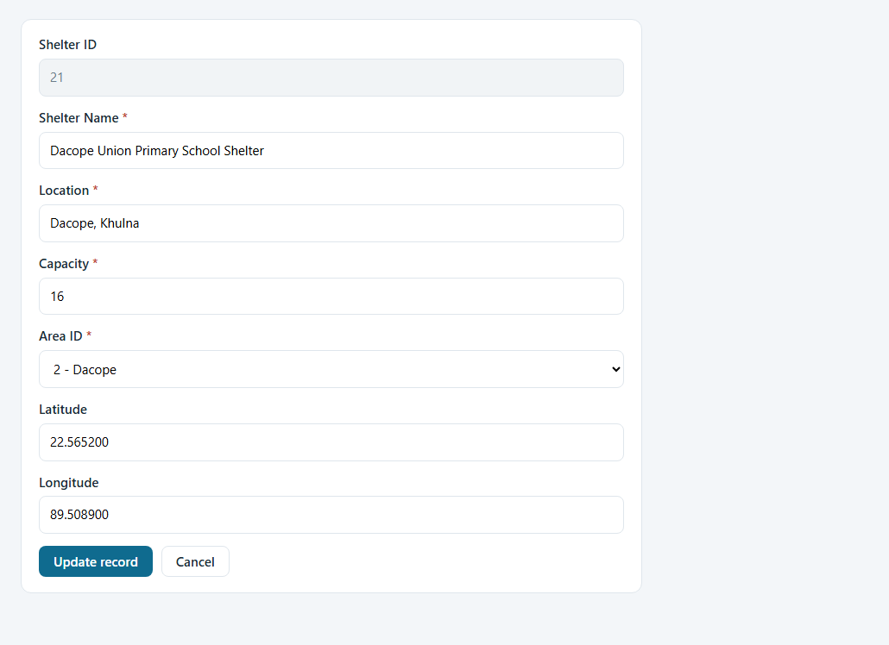
Figure 32. Editing a shelter.

11.5 Delete a record safely
- Click Delete at the end of the row. A confirmation page shows the record.
- Read the box Other records depend on it. It lists what the deletion would do: records that "will be deleted too", records that "will lose the link (field set empty)" and records that block the deletion.
- If nothing blocks it, click Yes, delete. If something blocks it the button is disabled: remove or move the dependent records first.
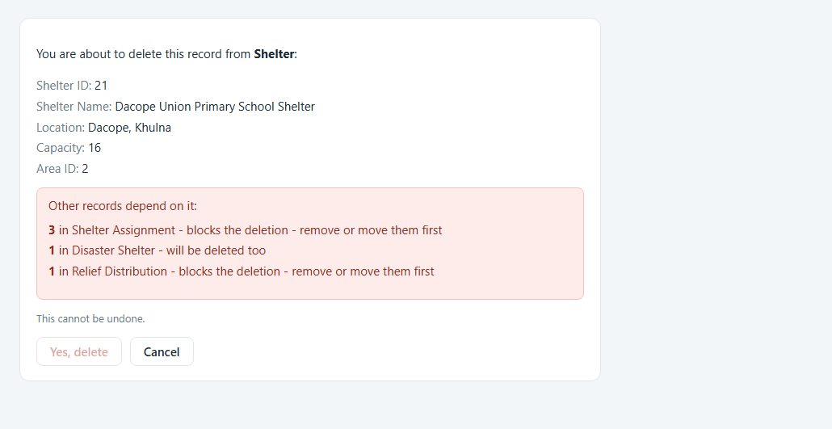
Figure 33. Delete confirmation for a record nothing depends on.
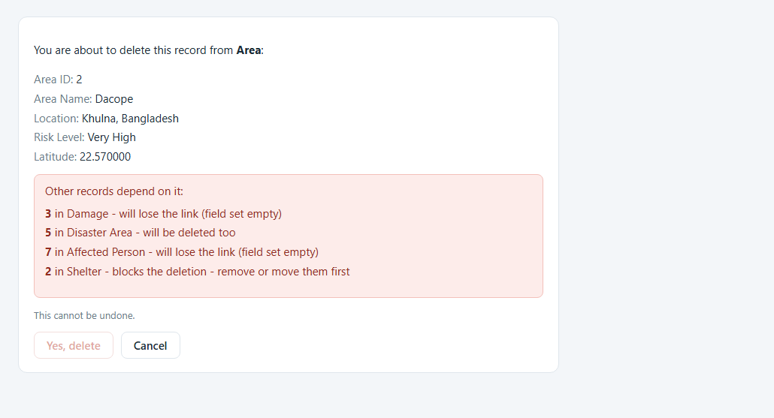
Figure 34. Deleting an area is blocked because two shelters belong to it.
Note
Only an administrator can delete a disaster, because that removes its warnings, damage, path, links and stays at once. Editors do not see the Delete button on the Disaster table.

11.6 The tables behind the live panels
Table | What it holds
Disaster Track | The path points of a moving disaster: time, Actual or Forecast, latitude, longitude, impact radius (km), wind speed
Relief Recipient | Which family received which relief distribution. A family with no row here counts as "not received"
Disaster Area | Which areas a disaster hit, with the Relief Shortage flag (No / Yes)
Early Warning | Warnings with the Signal Level (1-10, may be empty)

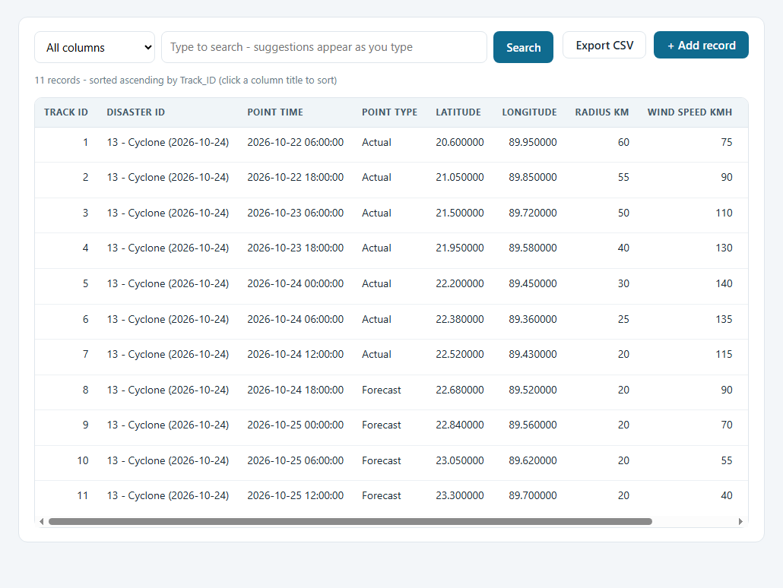
Figure 35. Disaster Track: the cyclone's observed and forecast positions.
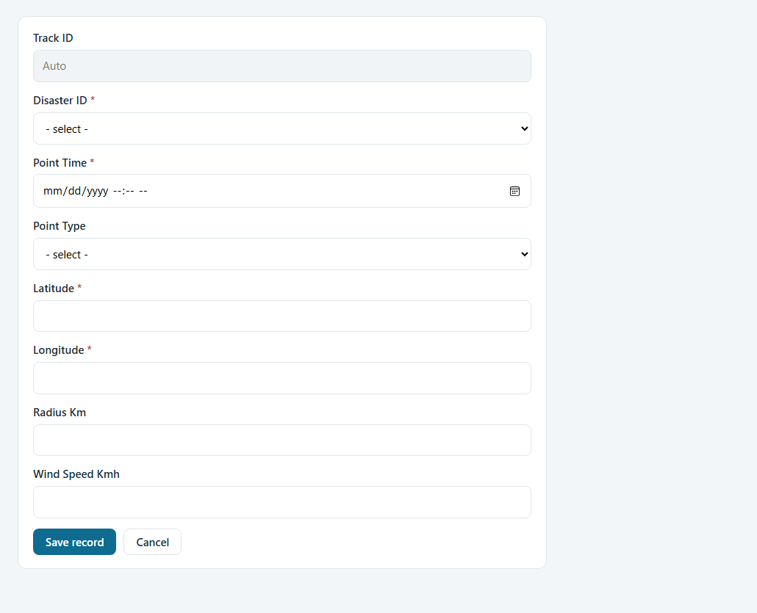
Figure 36. Adding a new path point.
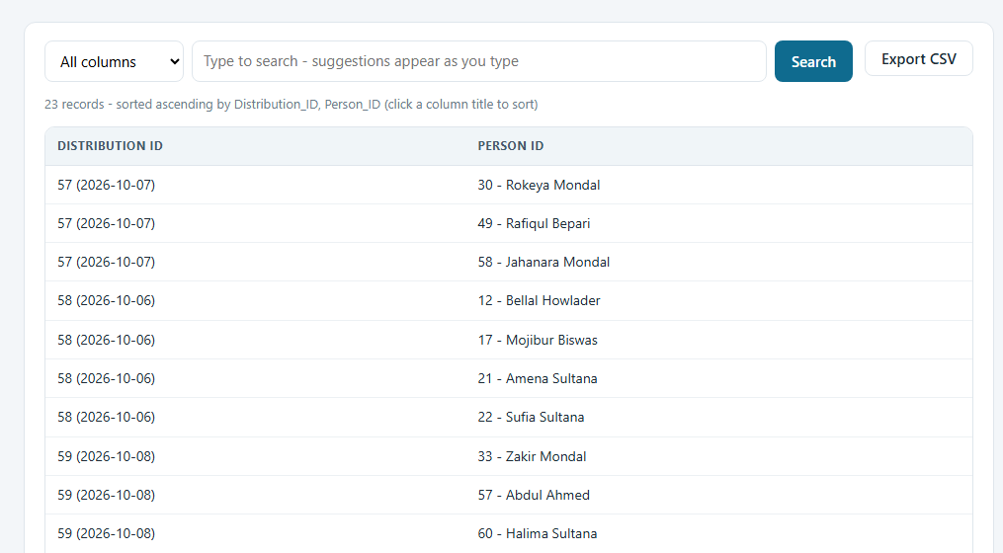
Figure 37. Relief Recipient: one row per family and distribution.
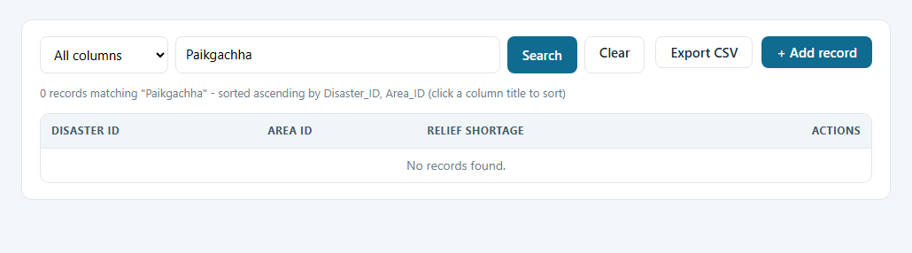
Figure 38. Disaster Area with the Relief Shortage flag (Paikgachha is flagged Yes).

12. Administration

12.1 Users (administrators only)
- Click Users in the menu. The table lists every account with its role and status.
- To add a person, fill Add a user (user name, password of 8+ characters, role) and click Add user.
- To change a role pick a new role in the list of that row; it is saved at once. You cannot change your own role, which protects you from locking everybody out.
- To set a new password type it in the row and click Reset password. This also removes a lock.
- To remove an account click Delete and confirm. You cannot delete yourself.
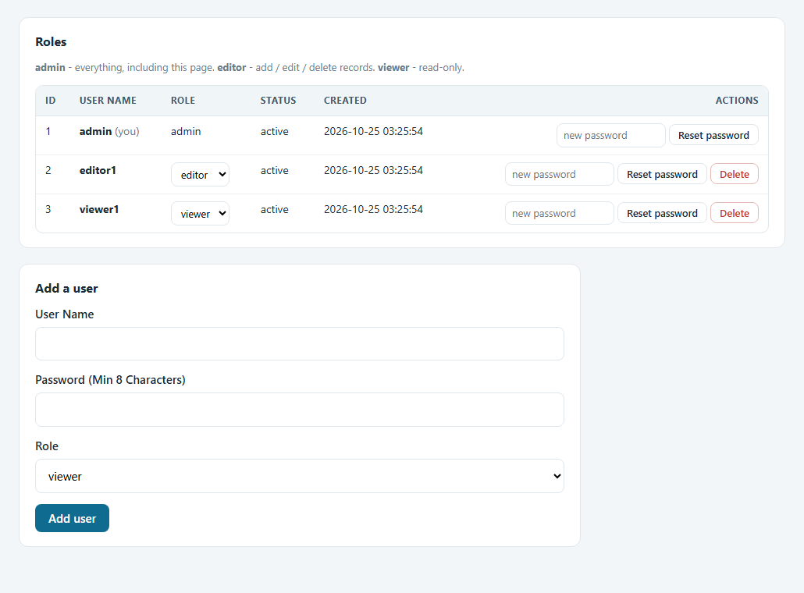
Figure 39. The Users page.

12.2 My account
Every user can change their own password here (click your name at the top right).
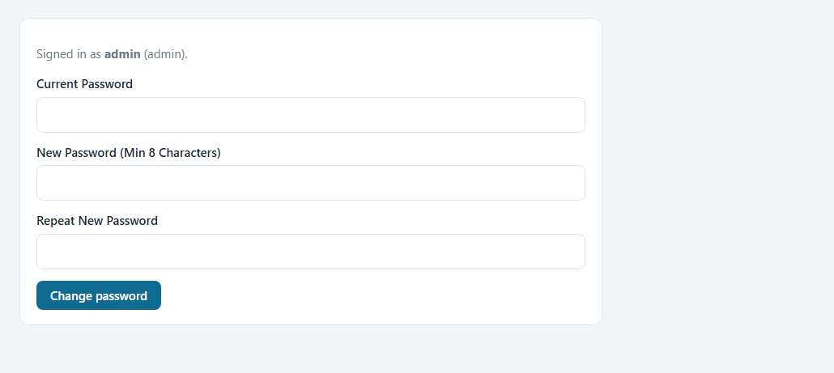
Figure 40. My account: change password.

12.3 Audit Log
The Audit Log records who added, edited or deleted what and when, with the details: all values of an added record, the old and new value of every changed field, and a copy of a deleted record. It can only be read, never edited.
- Open Audit Log from the Main tables list (newest entries first).
- Point the mouse at a Details cell to read the full text, or use Export CSV.
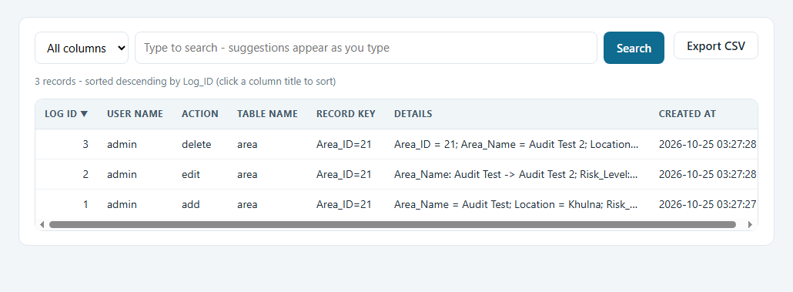
Figure 41. The Audit Log with the details of every change.

13. Read-only users
A user with the viewer role can look at everything and export, but cannot change data. The Add, Edit and Delete buttons are not shown, and trying to open an add form by address is refused with the message "Your account is read-only for this table." The Users page is not shown either.
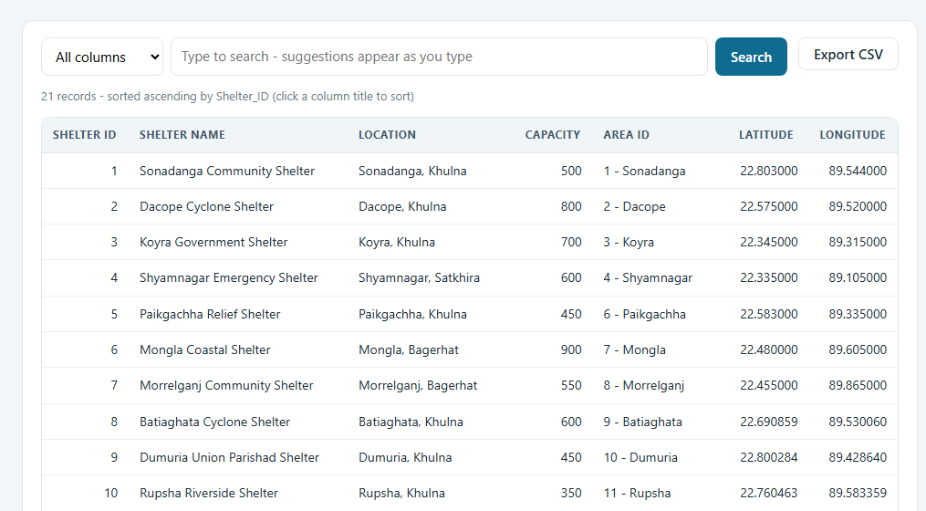
Figure 42. The Shelter table as a viewer sees it: no Add record button and no Actions column.
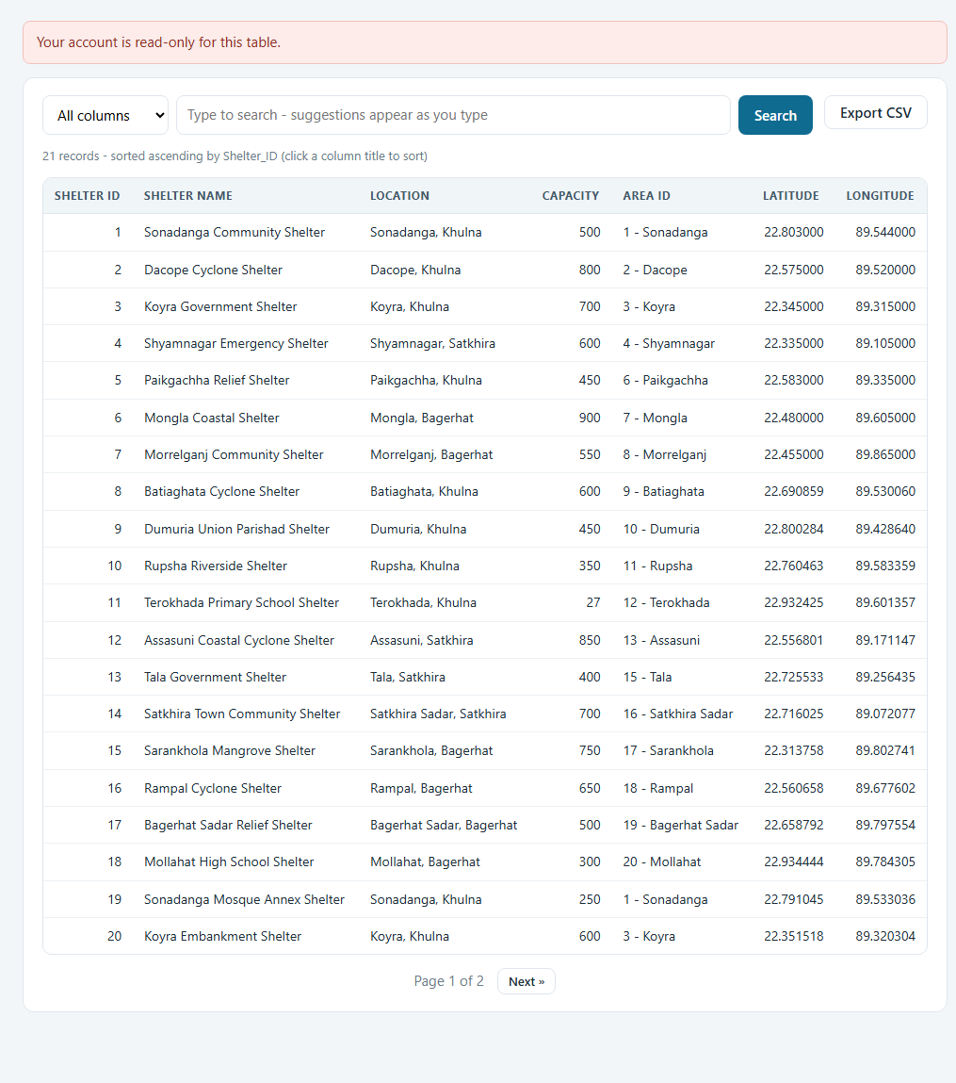
Figure 43. Opening an add form by address is refused.

14. Phone and tablet
All pages adapt to a narrow screen. The menu hides behind the three-line button at the top left, the cards stack in one column and wide tables scroll sideways inside their box instead of widening the page.
- Open the system address on the phone (use the computer's network address, for example http://192.168.0.10/disaster_and_relief_management/ when the phone is on the same network).
- Tap the three-line button to open the menu; tap a page.
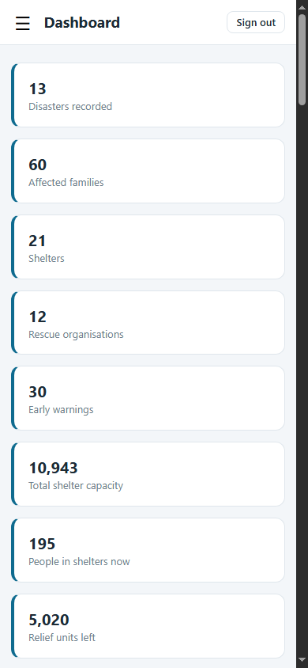  Figure 44. Dashboard on a phone. | 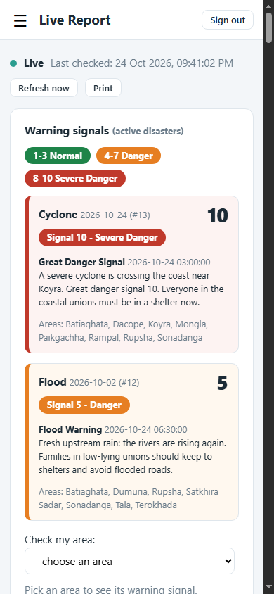  Figure 45. Live Report on a phone.

15. Database design

15.1 Data model
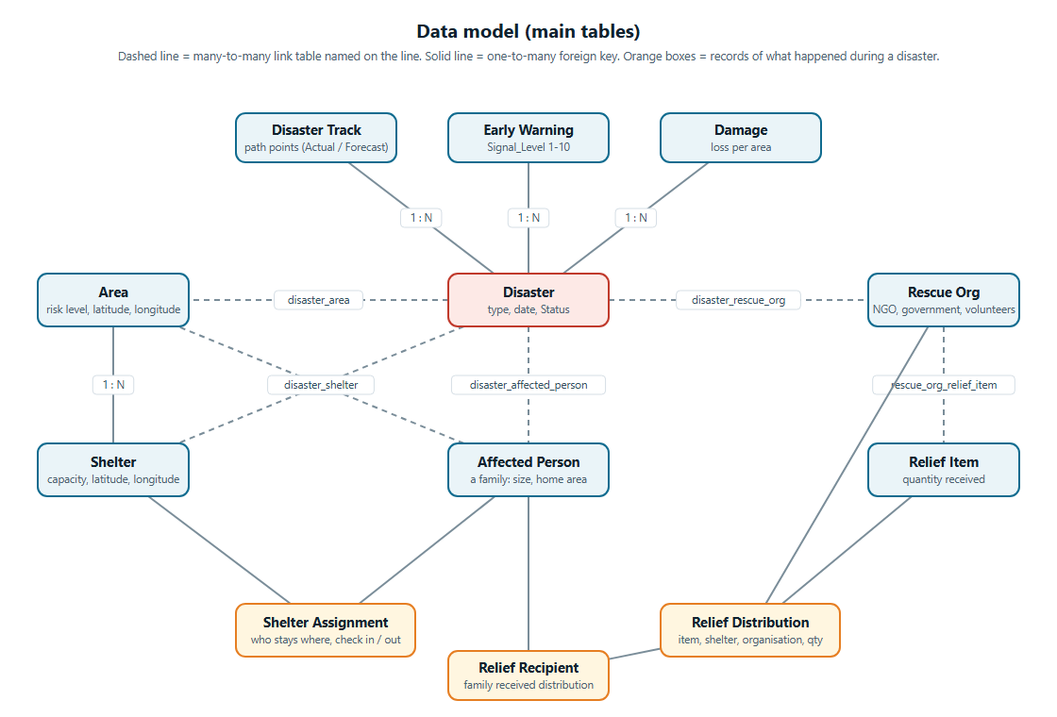
Figure 46. Main tables and how they are linked (diagram).

15.2 The 22 tables
Table | Kind | Purpose
disaster | Main | A disaster: type, date, description, Status (Active / Ended)
area | Main | A place: name, district, risk level, latitude, longitude
affected_person | Main | A family: name, family size, contact, home area
shelter | Main | A shelter: name, capacity, area, coordinates
rescue_org | Main | A rescue or relief organisation
relief_item | Main | A relief item and the quantity received
emergency_item | Main | Items a family or shelter needs
early_warning | Main | A warning: disaster, type, Signal_Level (1-10), time, message
damage | Main | Damage by disaster and area: type, quantity, estimated loss
shelter_assignment | Main | A family's stay in a shelter during a disaster (empty Check_Out = staying now)
relief_distribution | Main | Relief given: disaster, item, shelter, organisation, quantity, date
disaster_track | Main | Path points of a moving disaster
audit_log | Main (read-only) | Who changed what, with details
users | Hidden | Accounts, password hashes, roles, lock state
disaster_area | Relationship | Areas hit by a disaster; Relief_Shortage flag
disaster_shelter | Relationship | Shelters used for a disaster
disaster_affected_person | Relationship | Families affected by a disaster
disaster_rescue_org | Relationship | Organisations that took part
rescue_org_relief_item | Relationship | Which organisation supplies which item
relief_recipient | Relationship | Which family received which distribution
affected_person_emergency_item | Relationship | Items a family needs
shelter_emergency_item | Relationship | Items a shelter needs

15.3 How the data stays correct
Protection | What it does
Foreign keys | Every link points to a real record. The delete rule is chosen per link: CASCADE (children go too), SET NULL (the link is emptied) or RESTRICT (deletion is refused)
CHECK constraints | Capacity > 0, family size > 0, quantities >= 0, latitude -90..90, longitude -180..180, signal 1..10, impact radius > 0, check-out not before check-in
Triggers (8) | A stay or distribution must use a shelter of that disaster; a distribution's organisation must belong to the disaster; a stay's family and a relief recipient must be affected by that disaster; damage must be in an affected area
Application rules | Shelter capacity, one open stay per person, relief stock, and "the organisation supplies the item", with friendly messages
Calculated values | Places left, people staying, stock left and relief coverage are computed from the records, never stored, so they cannot drift
Data Health | Seventeen read-only checks that find any inconsistency that slipped in anyway

15.4 How the Live Report gets its data
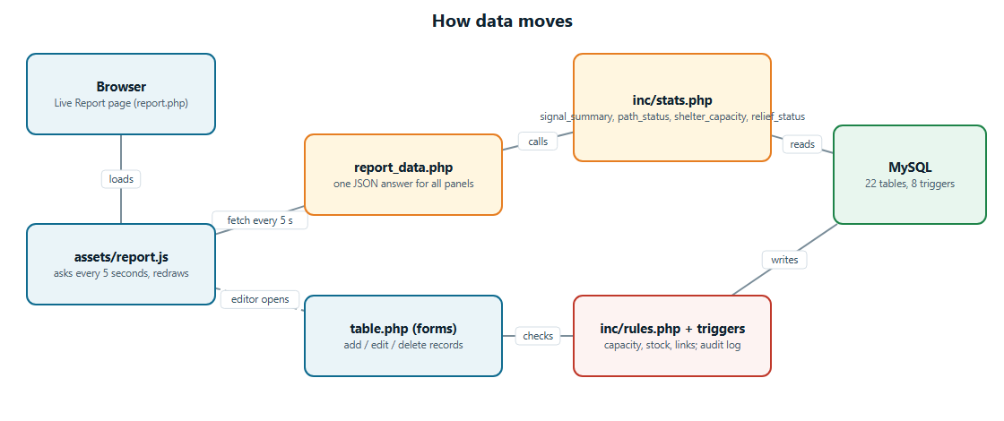
Figure 47. Data flow of the Live Report and of the forms.

15.5 Design decisions (methodology)
- One generic table page. It reads the columns, keys and foreign keys from MySQL's information_schema, so every table (and any table added later) gets list, search, sort, CSV export, add, edit, delete and a delete-impact check without extra code.
- Calculated, never stored. Places left, stock left and relief coverage are computed from the records with SQL. The Dashboard, the Live Report and the Map call the same functions (inc/stats.php), so their numbers can never disagree.
- Rules in layers. Foreign keys and CHECK constraints always apply; triggers guard the links between records; application rules give friendly messages for capacity and stock; Data Health finds anything that slipped through.
- Live without a framework. The Live Report asks one JSON address every 5 seconds and redraws only the panels whose data changed, so zoom and filters are kept.
- Path geometry. An area is "being crossed now" when the great-circle (haversine) distance from its centre to the current position is within that position's impact radius; forecast positions give "in the path" and earlier observed positions give "already passed".
- Safe upgrades. An older database is upgraded in place without touching existing rows, every step checks first so it can be repeated, and a test proves that an upgraded database equals a fresh install.

16. Security and quality checks
Before delivery the system was checked in three ways: automated tests, scripted attack attempts and a real browser. The results:
Check | Result
Automated smoke test (php tests/smoke.php) | 81 checks pass on both an upgraded and a fresh database, and with the limited MySQL user. They cover installation, constraints, the 7 trigger refusals, signal boundaries (3|4 and 7|8), the 80% relief rule, shelter space, path geometry, data health and role permissions
Not signed in | Every page redirects to sign-in; the live data and search endpoints answer 401
CSRF | A POST without or with a wrong token is rejected and nothing is saved
Roles | A viewer cannot add; an editor cannot delete a disaster or open Users; both confirmed on the server, not only by hiding buttons
SQL injection | Quotes and SQL fragments in the table name, search text, sort column and keys change nothing: values are bound parameters and names are checked against the real schema
Cross-site scripting | Script text saved in names and messages is shown as text on every page and on the map
Sign-in protection | Lock after 5 wrong passwords and automatic recovery; idle session ends after 4 hours (the 5-second refresh does not keep it alive)
Private files | config.php, SQL dump, README files, inc/ and tests/ cannot be downloaded (Apache .htaccess and router.php)
Browser | Every page loaded in a real browser with the Content-Security-Policy active: no console errors; phone layout has no sideways scrolling
Upgrade | An old 20-table database upgraded in place and a fresh install give identical tables, data and triggers, byte for byte; existing users and data are kept

17. Backup, upgrade and troubleshooting

17.1 Back up the database
- Open phpMyAdmin (http://localhost/phpmyadmin).
- Select the disaster_and_relief_management database and click Export.
- Keep the default (Quick, SQL) and click Export. Store the file safely; importing it into an empty database restores everything.

17.2 Upgrade from the earlier 20-table version
Just copy the new files over the old ones and open any page. The system detects the older database and upgrades it in place: new columns, new tables, triggers and (only if the data is still the original sample) new sample rows. Your records and users are kept. For this one time the MySQL user in config.php must be allowed to change tables (root is fine).

17.3 Start again from scratch
Drop the database in phpMyAdmin and reload the page. A new database with the sample data is created and the first-run screen asks for a new administrator.

17.4 Common messages
Message | What to do
Cannot reach MySQL | Start WampServer (green icon) or run start_server.bat; check host and port in config.php
MySQL refused the user name / password | Correct the user and password in config.php
The database is incomplete or from an older version | Back up what you need, drop the database in phpMyAdmin and reload
The database needs a one-time upgrade, but the MySQL user may not change tables | Put root in config.php, open any page once, then switch back to the limited user
The map library could not be loaded | No internet connection. Everything except the map tiles still works
Something went wrong | Technical details are in the PHP error log (C:\wamp64\logs\php_error.log)

Appendix A. Sample data
The system starts with fictional sample data so that every state of the Live Report can be seen immediately.
Data | Content
Disasters | 13: floods, cyclones, a tsunami, river erosion, tidal surge and waterlogging between May 2025 and October 2026. Two are Active: Cyclone #13 and Flood #12
Cyclone #13 (Active) | Latest warning signal 10 (red). 11 path points (7 observed, 4 forecast) from the Bay of Bengal to north of Khulna; 17 families; one school shelter that is exactly full; relief shortages in Dacope, Mongla and (flagged by hand) Paikgachha
Flood #12 (Active) | Latest warning signal 5 (orange). Sonadanga is short of relief; a nearly full shelter in Terokhada (25 of 27 places)
Places | 20 areas with coordinates and risk levels; 21 shelters; 12 rescue organisations; 16 relief items; 60 families

Appendix B. Files of the project
File or folder | Purpose
index.php | Sign-in and first-run screen
dashboard.php, report.php, health.php, disaster.php, map.php, search.php | The report pages
report_data.php, api.php | JSON for the Live Report and for search suggestions
table.php | The generic table pages (list, add, edit, delete, export)
users.php, account.php, logout.php | Users, own password, sign out
db.php | Connection, installer, in-place upgrade, SQL script runner
inc/ | boot.php (session, security, layout), meta.php (schema reader), stats.php (all calculations), rules.php, health.php, upgrade.php, triggers.sql
assets/ | style.css, app.js, report.js (Live Report), map.js, favicon.svg
disaster_and_relief_management.sql | The installation file: tables, sample data and triggers
router.php, start_server.bat | Run without Apache and keep private files private
tests/smoke.php | The 81 automated checks
README.md, README.txt | Short documentation (English, and Bangla with English summary)

