DR
Disaster Mapping & Relief Management System
Setup, user guide and methodology
PHP 8 + MySQL 8 web application
Database System Lab project (5-2 Term)
Document date: 15 October 2026

Contents
1 What this system does
A How to copy, run and improve the project
B Step-by-step tour with screenshots (sign-in to every feature)
C How the system works - methodology

Section 1 gives a short overview. Part A is for anyone who receives the disaster_and_relief_management folder and wants to run it on their own computer and change it. Part B walks through the finished application screen by screen. Part C explains the design and the reasons behind it.

1. What this system does
The Disaster Mapping & Relief Management System is a web application for recording and following a disaster response in the south-west coast of Bangladesh (Khulna, Satkhira and Bagerhat). It keeps one connected record of disasters, the areas they hit, early warnings, damage, the families affected, the shelters that host them, the organisations that rescue and help, and the relief items that are received and given out.
Main capabilities:
- Secure sign-in with three roles - admin, editor and viewer - and a first-run screen that creates the administrator (no default password).
- Dashboard with key numbers, a "Needs attention" list (shelters almost full, low relief stock, risky areas without a shelter, long stays) and shelter occupancy bars.
- Disaster report - a printable situation report for any single disaster.
- Map of risk areas and shelters, and a live report that refreshes itself every 5 seconds.
- Every table can be listed, searched (with suggestions), sorted, exported to CSV and - for editors and admins - added to, edited and deleted. A global search box searches all tables at once.
- Safety nets: database rules (no negative quantities, capacity above zero ...), business rules (a shelter cannot be over capacity, relief cannot exceed stock), a delete page that shows what else will be deleted, and an audit log of every change.
The database holds realistic sample data so that every page can be tried straight away:
Table | Rows | Table | Rows
disaster | 12 | shelter | 20
area | 20 | shelter_assignment | 99
affected_person | 60 | relief_item | 16
disaster_affected_person | 114 | relief_distribution | 60
disaster_area | 58 | rescue_org | 12
disaster_shelter | 60 | disaster_rescue_org | 66
early_warning | 24 | rescue_org_relief_item | 58
damage | 43 | emergency_item | 16
affected_person_emergency_item | 178 | shelter_emergency_item | 79
users, audit_log | created while using

Tested with: MySQL 8.4.7 and PHP 8.3.35 on Windows 10, using PHP's built-in web server and a real Microsoft Edge browser. The Apache-only .htaccess protection files could not be exercised in that setup; they are standard Apache 2.4 rules, but check them once on your own WampServer (see A8).

Part A - Copy, run and improve the project

A1. What you need
Item | Requirement
Web server + PHP | WampServer 3.3 or newer (Apache 2.4 + PHP 8.1 or newer). XAMPP or Laragon work the same way.
PHP extensions | mysqli and mbstring (switched on by default in WampServer and XAMPP).
Database | MySQL 8.0.16 or newer (CHECK constraints are enforced from 8.0.16). Built and tested on 8.4.7. MariaDB was not tested.
Browser | A current Edge, Chrome or Firefox.
Internet | Only for the Map page (map library and map tiles). Everything else works offline.

A2. Run it on your computer (about 5 minutes)
- Copy the folder. Copy the inner folder named disaster_and_relief_management - the one that contains index.php - into the web root. For WampServer this is C:\wamp64\www\, for XAMPP C:\xampp\htdocs\. You should now have C:\wamp64\www\disaster_and_relief_management\index.php.
- Start the servers. Start WampServer (or the XAMPP control panel) and wait until Apache and MySQL are running (WampServer's tray icon turns green).
- Set the MySQL login. Open config.php in a text editor. WampServer's root user has an empty password by default; XAMPP too. The file ships with the author's own password, so replace it (see the code box below).
- Open the application. In the browser go to http://localhost/disaster_and_relief_management/. If Apache uses another port, add it: http://localhost:8080/disaster_and_relief_management/. On this first visit the system creates the database, the 20 tables and the sample data by itself - no import in phpMyAdmin is needed.
- Create the administrator. The page says "First run: create the administrator account". Choose your own user name and a password of at least 8 characters. You are signed in and see the dashboard. There is no default password anywhere in the project.
- Add other people (optional). Admin > Users > Add a user, and pick a role (see Part B, step 21).
The line to change in config.php (for an empty root password use two single quotes):
'pass' => getenv('DRMS_DB_PASS') !== false ? getenv('DRMS_DB_PASS') : 'YOUR_MYSQL_PASSWORD',
Important: Give the folder to other people without your own config.php password, or let them overwrite it. config.sample.php shows the format. config.php is listed in .gitignore so it is never committed to Git.

A3. What is inside the folder
File / folder | Purpose
index.php | Sign-in page. On the very first visit also installs the database and creates the administrator.
dashboard.php | Home page: numbers, "Needs attention" list, disasters table, risk bars, shelter occupancy.
disaster.php | Printable situation report for one disaster.
map.php, assets/map.js | Map of areas and shelters (Leaflet + OpenStreetMap).
report.php, report_data.php, assets/report.js | Live report page, the JSON feed it reads, and its script.
table.php | The one page that handles every table: list, search, sort, export, add, edit, delete.
api.php | Search suggestions (JSON) while typing in a table's search box.
search.php | Global search across all tables.
users.php, account.php, logout.php | User administration (admin), change own password, sign out.
db.php | Database connection, first-run installer, helper functions q(), rows(), row1(), scalar().
config.php, config.sample.php | Database login (private) and an example of it.
inc/boot.php | Loaded by every page: error handling, session, roles, CSRF, audit log, page layout.
inc/meta.php | Reads table / column / foreign-key information from the database.
inc/stats.php | Shared summary queries and the "Needs attention" rules.
inc/rules.php | Business rules checked before saving (capacity, stock, same-disaster checks).
disaster_and_relief_management.sql | Schema, constraints and sample data (used by the first-run installer or phpMyAdmin Import).
create_db_user.sql | Creates a limited MySQL user for the application.
assets/ | style.css (look and feel), app.js (menu, search suggestions), report.js, map.js.
tests/smoke.php | Command-line self-test (27 checks).
.htaccess, inc/.htaccess, tests/.htaccess | Apache rules that stop browsers from reading configuration, SQL and source helper files.
README.txt | Short instructions in Bangla and English.

A4. Configuration and a safer database user
config.php returns five values: host, user, pass, name, port. Each can also come from an environment variable (DRMS_DB_HOST, DRMS_DB_USER, DRMS_DB_PASS, DRMS_DB_NAME, DRMS_DB_PORT), which is handy on a shared server. Keep name as disaster_and_relief_management, because the SQL file creates a database with exactly that name.
For anything more than a lab PC, do not let the web application use root:
- Open the application once as root so that the database is created.
- In phpMyAdmin > SQL, run create_db_user.sql (change the password inside first). It creates drms_app, who may only SELECT, INSERT, UPDATE and DELETE rows in this one database.
- Put drms_app and its password into config.php.

A5. Reset, back up and upgrade the database
- Start again with fresh sample data: in phpMyAdmin drop the database disaster_and_relief_management, then reload the application. It is rebuilt automatically.
- Back up: phpMyAdmin > Export > Quick > SQL, or mysqldump -u root -p disaster_and_relief_management > backup.sql.
- Safety rule: the installer only builds the database when none of the 20 tables exist. If some tables are missing (for example a database from an older version) it refuses and shows a message instead of overwriting anything. Back up what you need, drop the database and reload.

A6. Run the self-test
The test needs PHP on the command line. In WampServer PHP is in C:\wamp64\bin\php\php8.x.x\php.exe (use your own version number). From the project folder:
cd C:\wamp64\www\disaster_and_relief_management
C:\wamp64\bin\php\php8.3.28\php.exe tests\smoke.php
It prints one line per check and ends with "All checks passed." The 27 checks cover: all 20 tables exist; the foreign-key reader works; the CSRF check rejects empty tokens; the database refuses bad data (negative capacity, zero family size, negative stock, latitude out of range, check-out before check-in); the sample data is consistent (no shelter over capacity, no relief given out beyond stock, every shelter assignment belongs to a shelter and person of that disaster, nobody in two shelters at once); the business rules accept good input and refuse bad input; and the alert list works. The only data the test writes is rolled back. It cannot be started from a browser.

A7. How to improve and extend it
The project was written so that most changes are small. Recipes for the most common ones:

1. Add a new table
Create the table in MySQL (phpMyAdmin or by editing the .sql file for new installs). Reload any page: the table appears in the sidebar and immediately has list, search, sort, CSV export, add, edit and delete. Foreign keys become drop-downs, enum columns become choice lists, decimals get the right step, and NOT NULL columns are marked required. No PHP needs to be written. A table whose columns are all part of the primary key is listed under "Relationship tables".

2. Add a business rule
Open inc/rules.php. Add a block for your table inside check_rules() and return a plain-language message when the data is not acceptable. The message is shown on the form and nothing is saved. Example - do not accept a shelter check-in dated in the future:
if ($t === 'shelter_assignment' && $v('Check_In') > date('Y-m-d')) {
return 'The check-in date cannot be in the future.';
}

3. Add or change a "Needs attention" alert
Open inc/stats.php, function alerts(). Each alert is [level, text, link] where level is err (red), warn (yellow) or info (blue). The thresholds - 90% full, 20% stock left, 30 days - are plain numbers in that function.
$a[] = ['warn', 'Something needs a look', 'table.php?t=shelter'];

4. Add a column to an existing table
Run ALTER TABLE ... ADD COLUMN ... in phpMyAdmin. The forms, lists and exports pick it up at once. Also update disaster_and_relief_management.sql so that new installations get it.

5. Add a new page
Copy the pattern used by any small page such as account.php: load inc/boot.php, call guard() (or guard_admin()), do the work with the database helpers, then page_start(...) / HTML / page_end(). Add a link in the sidebar inside page_start() in inc/boot.php.

6. Change look, speed or roles
- Colours: the variables at the top of assets/style.css (--brand, --bg, ...).
- Live report speed: REFRESH_MS at the top of assets/report.js (milliseconds).
- Rows per page: $per in table.php.
- New role: add it to the Role enum of the users table, to ROLES in users.php, and decide in can_edit() / is_admin() (inc/boot.php) what it may do.

House rules for new code
- Always pass user input to the database as ? parameters through q(), rows(), row1() or scalar(). Never build SQL by joining text from the user. (A table or column name that comes from the URL must first be checked against the real list, as table.php does.)
- Escape everything printed into HTML with h().
- Every form that changes data needs the hidden csrf field, and the page must call csrf_ok() and can_edit() before writing.
- Write changes to the audit log with audit().

Ideas for the next version
- Send SMS or e-mail when an alert such as "shelter 90% full" appears.
- Import families from a CSV or Excel file; print shelter registers and relief receipts as PDF.
- Charts over time (people in shelters per day, relief given per week).
- Move the capacity and stock rules into database triggers so that other programs cannot bypass them.
- Bangla language interface; a mobile data-entry form for field workers.
- Automatic daily backup and an admin "Download backup" button.

A8. Troubleshooting
What you see | Likely cause and fix
"MySQL refused the user name / password in config.php" | The password in config.php is wrong. Fix it (empty string for no password).
"Cannot reach MySQL - is WampServer running" | MySQL is not started, or uses another port: set port in config.php.
"The database is incomplete or from an older version" | Some of the 20 tables are missing. Nothing was changed. Back up if needed, drop the database in phpMyAdmin, reload.
A white page "Something went wrong" | The real error is in the PHP error log (WampServer menu > PHP > php_error.log). Most often MySQL is down or config.php is wrong.
Map is empty / grey | No internet connection for the map library or tiles. The tables below the map still list every place.
config.php or .sql can be opened in the browser | Apache is ignoring .htaccess. In httpd.conf set AllowOverride All for the www folder and restart Apache.
Page not found | The folder was copied one level too deep or too shallow. index.php must be directly inside www\disaster_and_relief_management\.
Cannot sign in after 5 tries | The account is locked for 5 minutes. An administrator can reset the password on the Users page, which also unlocks it.

Part B - Step-by-step tour with screenshots
The screenshots were taken from the running application in a real browser, starting with an empty installation: the first visit, creating the administrator, and then every feature in turn. The sample data is the data that ships with the project. The examples use an administrator named admin; you choose your own name and password in step 2.

B1. Getting started

Step 1: First run: create the administrator account
The very first visit installs the database and asks you to create the administrator. There is no default password.
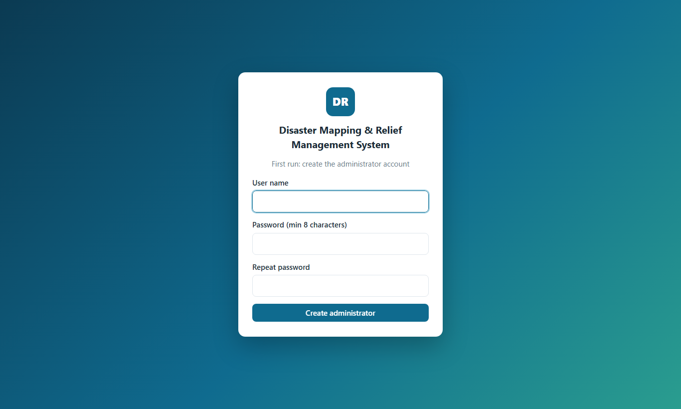
Figure 1. First run: create the administrator account

Step 2: Fill in the administrator details
Choose a user name and a password of at least 8 characters, then press "Create administrator".
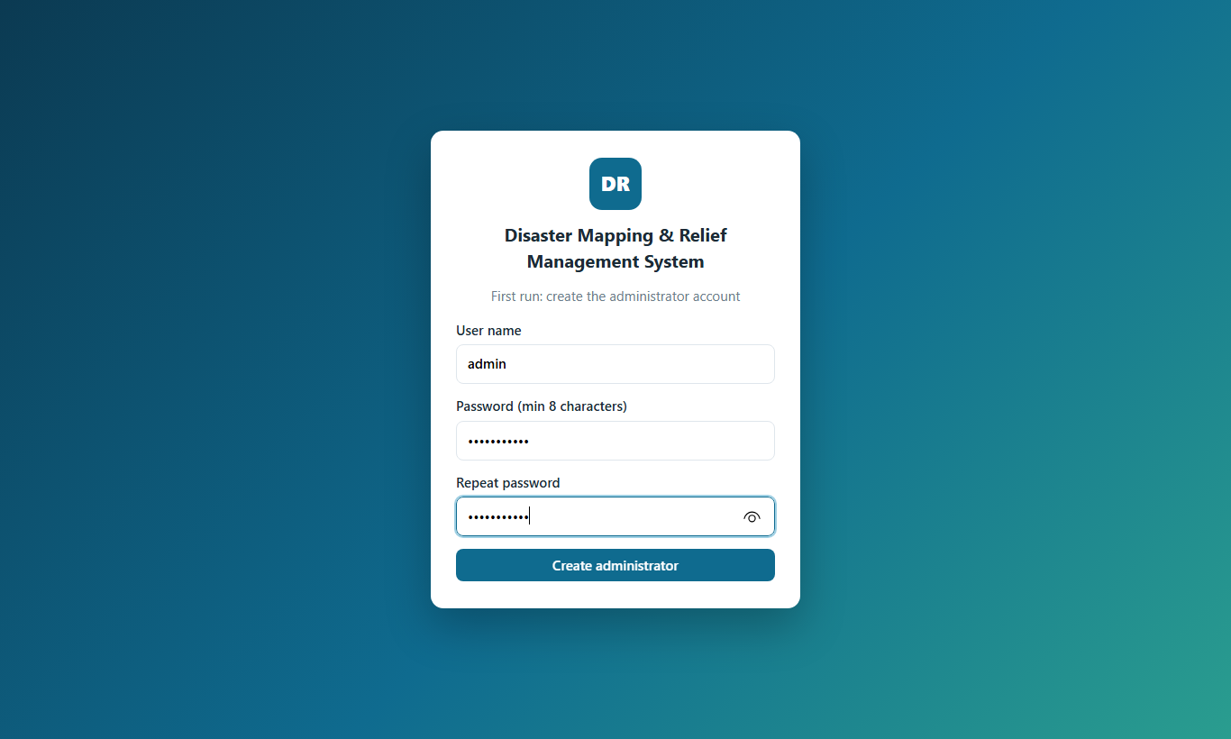
Figure 2. Fill in the administrator details

B2. The dashboard

Step 3: Dashboard
After signing in you land on the dashboard: key numbers, the sidebar with every table, and the search box at the top.
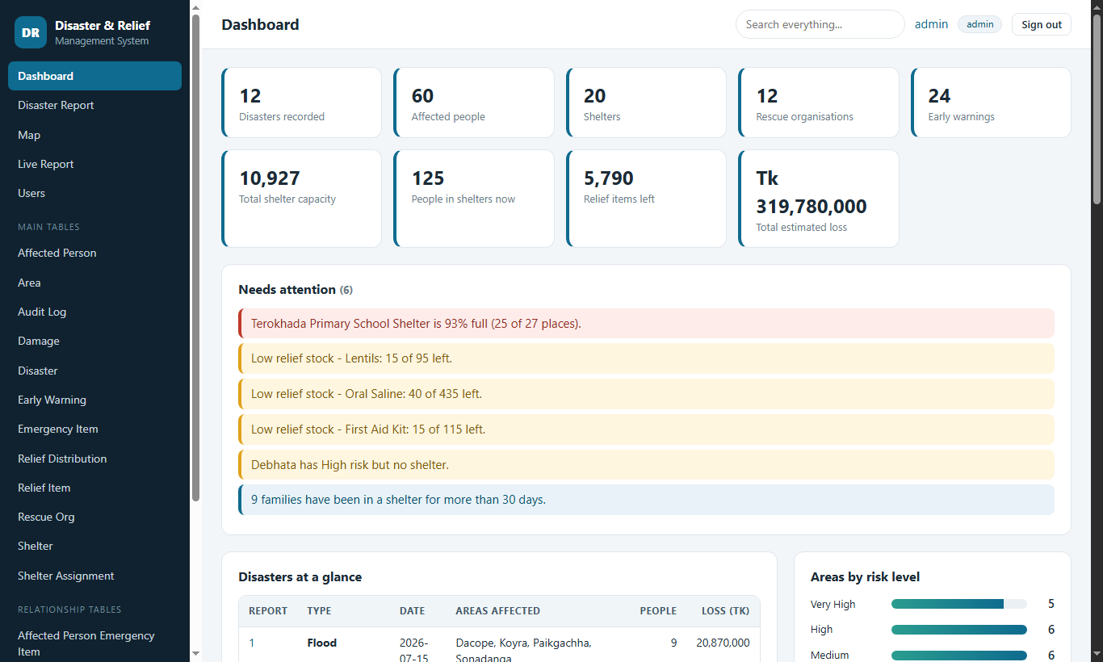
Figure 3. Dashboard

Step 4: Dashboard - "Needs attention" and disasters
The system warns about shelters that are almost full, relief items that are running out, risky areas without a shelter and long stays. Click a line to open the related table. The disasters table links to a full report for each disaster.
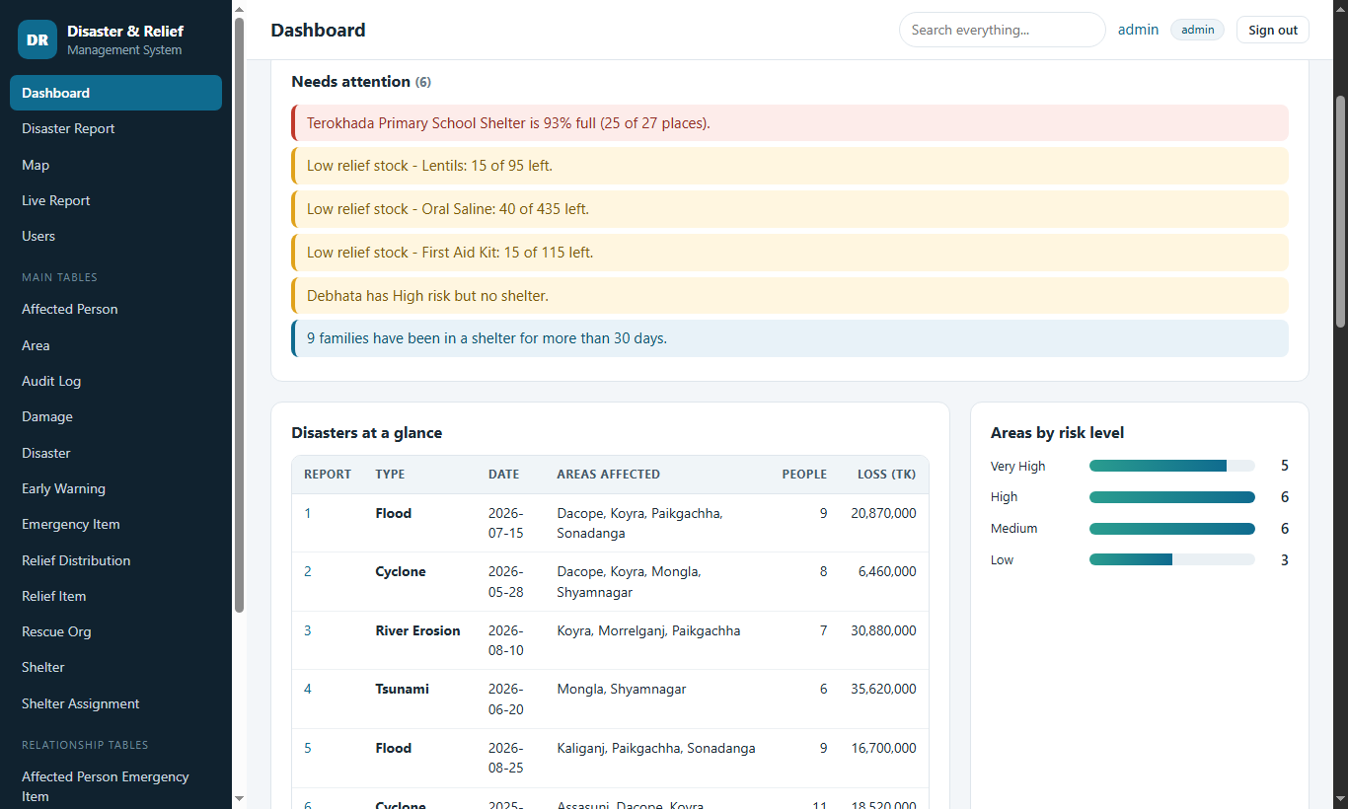
Figure 4. Dashboard - "Needs attention" and disasters

Step 5: Dashboard - shelter occupancy
Bars show how many people are in each shelter now compared with its capacity. Red bars are 90% full or more.
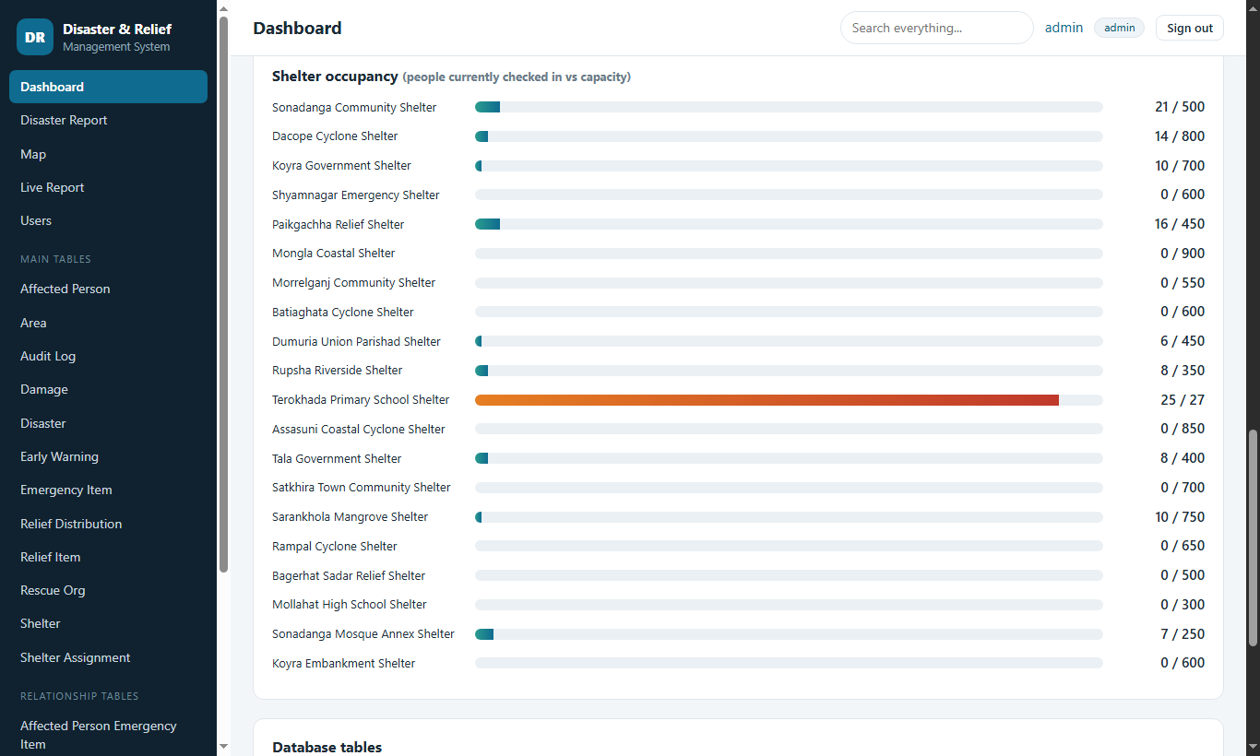
Figure 5. Dashboard - shelter occupancy

B3. Disaster report, map and live report

Step 6: Disaster report (top)
A one-page situation report for one disaster: areas, families, people still in shelters, estimated loss and relief given. Use the drop-down to switch disasters.
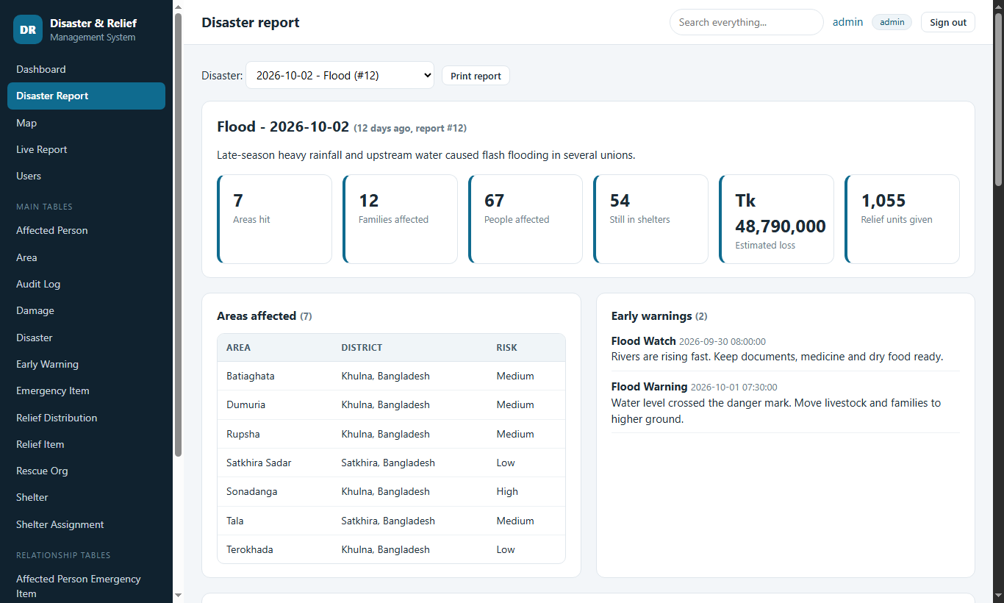
Figure 6. Disaster report (top)

Step 7: Disaster report (details)
Further down: early warnings, damage, shelters used, rescue organisations, relief given out and every affected family. "Print report" gives a clean paper copy.
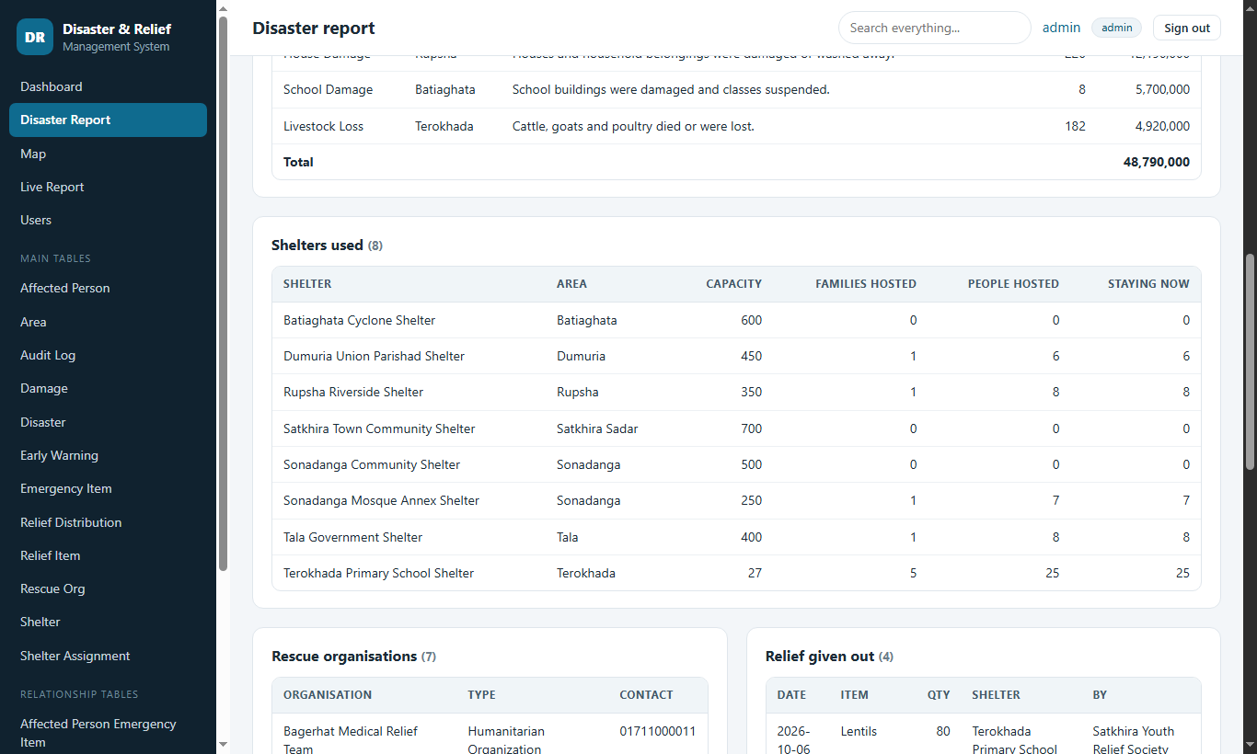
Figure 7. Disaster report (details)

Step 8: Map
Circles are risk areas coloured by risk level; dots are shelters coloured by how full they are. Click a circle or dot for details. (Needs an internet connection for the map tiles.)
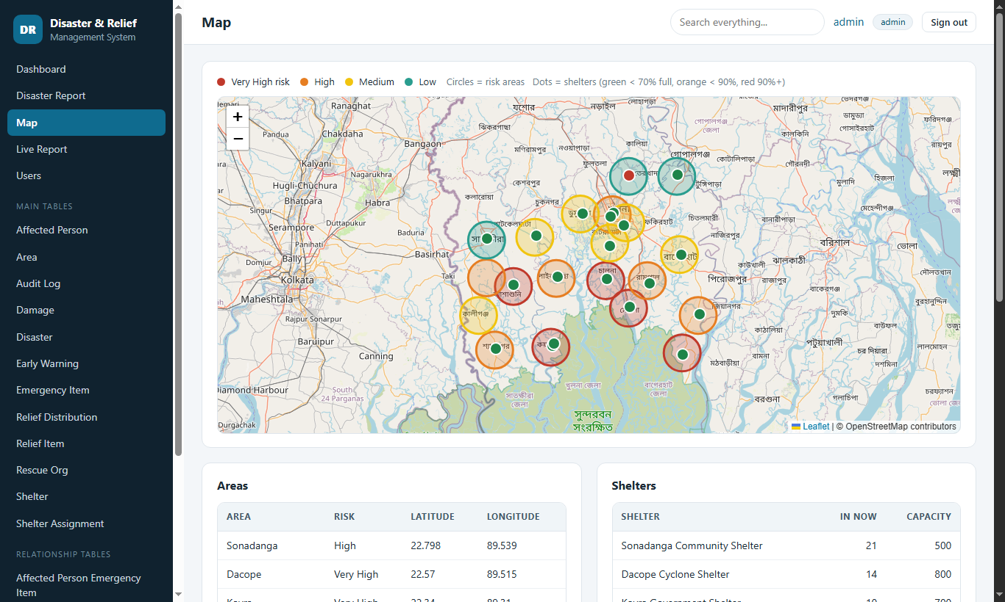
Figure 8. Map

Step 9: Live report
This page re-reads the database every 5 seconds. Change a record in another tab and the numbers here update on their own.
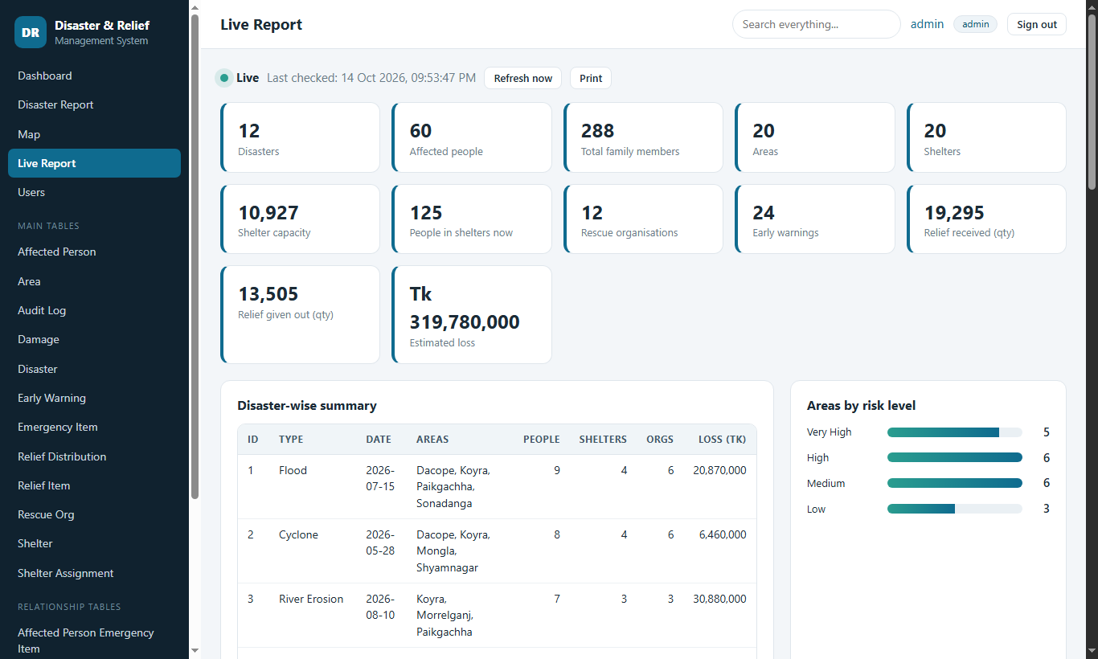
Figure 9. Live report

B4. Working with tables

Step 10: A table: list, search, sort and export
Every table has the same page: records 20 per page, a search box, "Export CSV", and (for editors and admins) "+ Add record" with Edit / Delete buttons.
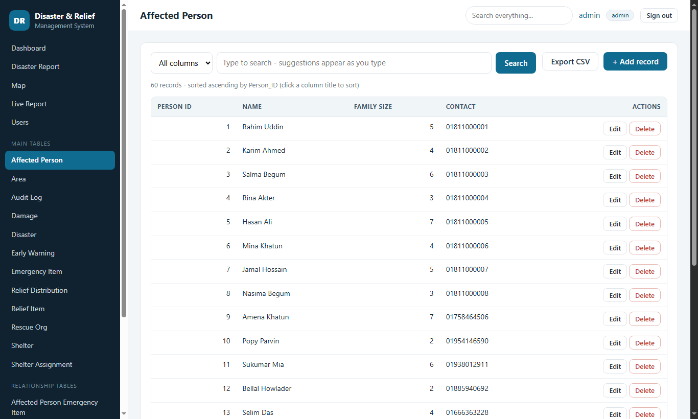
Figure 10. A table: list, search, sort and export

Step 11: Sorting
Click a column title to sort by it; click again to reverse. The arrow shows the current sort.
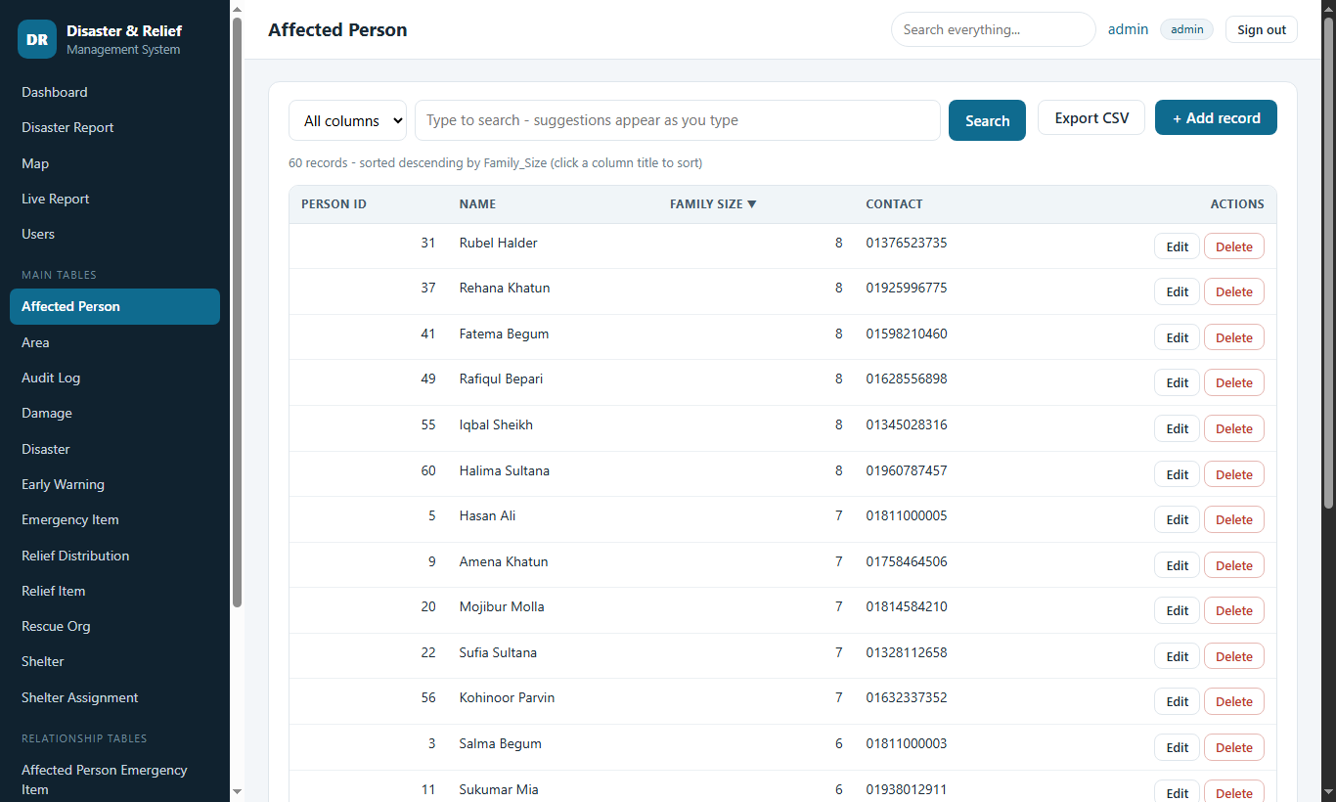
Figure 11. Sorting

Step 12: Search suggestions
While you type, matching words appear below the box (like a dictionary). Pick one to search for it, or choose a column in the left drop-down to search only there.
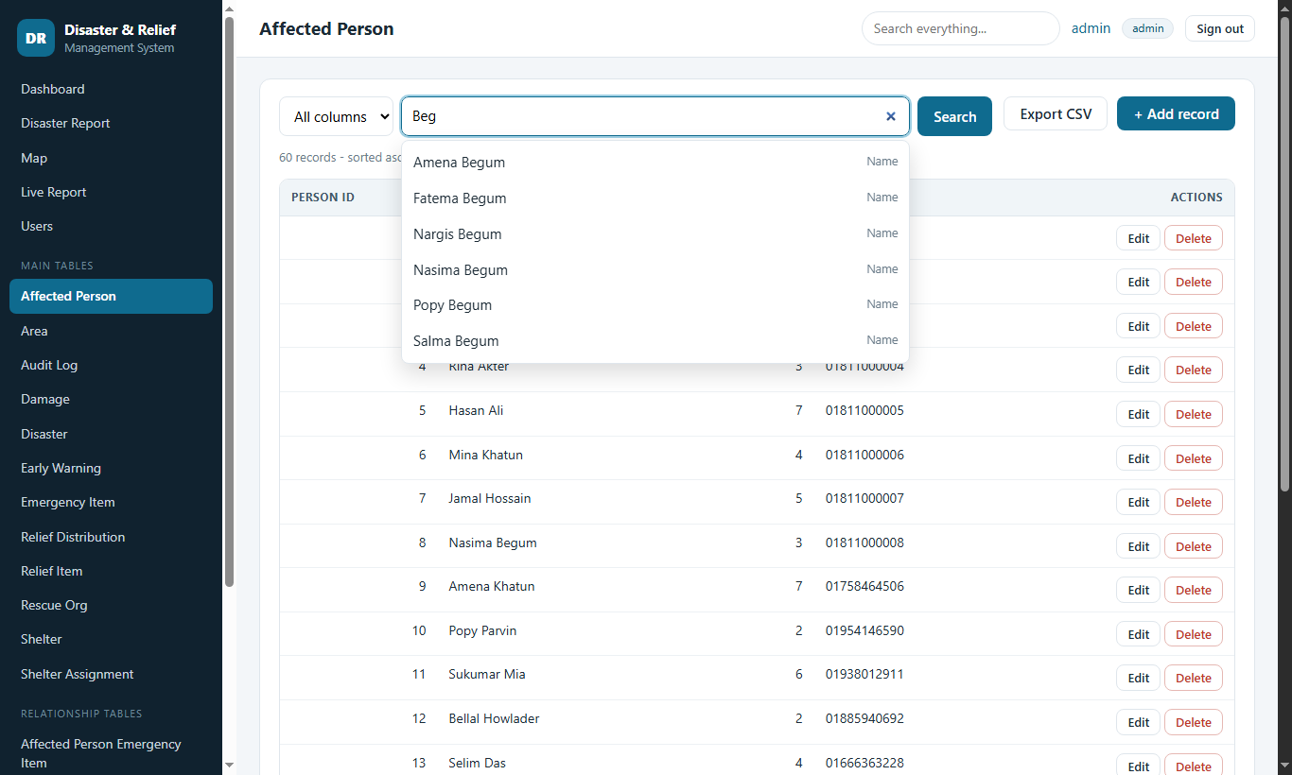
Figure 12. Search suggestions

Step 13: Search results
The list shows only the matching records and how many were found.
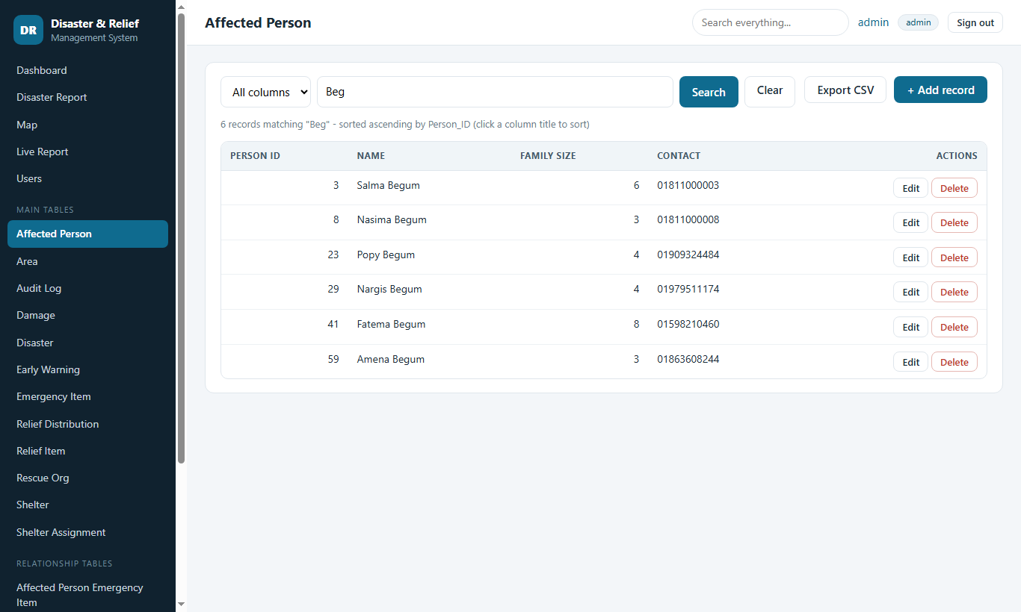
Figure 13. Search results

B5. Adding, editing and deleting records

Step 14: Add a record (shelter check-in form)
The form is built from the table itself: drop-downs for linked records, date pickers for dates, required fields marked with *.
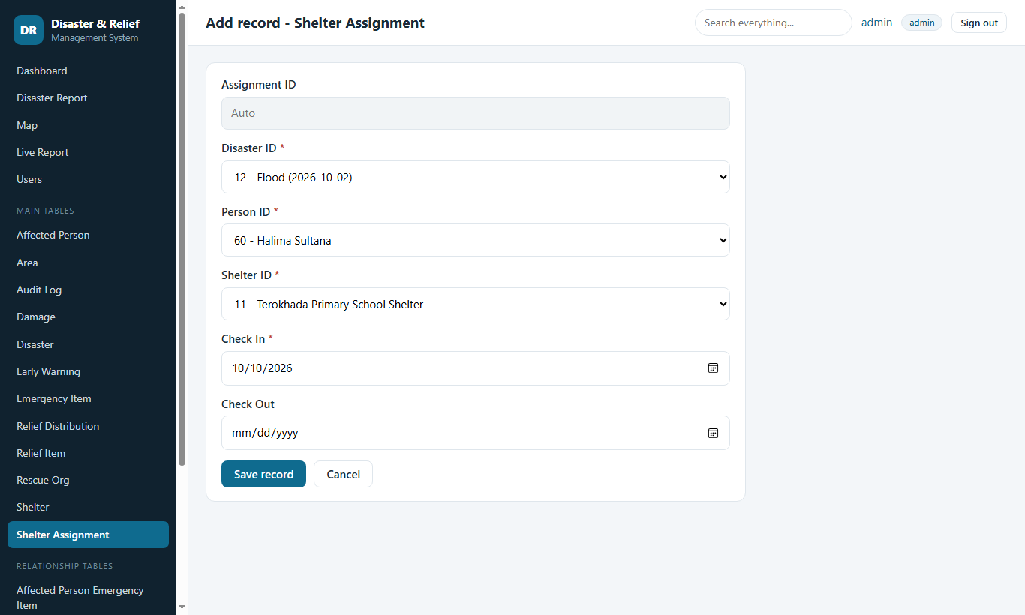
Figure 14. Add a record (shelter check-in form)

Step 15: The system protects the data
Business rules are checked before anything is saved. Here the family is already staying in another shelter, so the record is refused with a plain-language message and nothing changes. Other rules stop a shelter going over capacity, relief going beyond the stock, and links between records that do not belong to the same disaster.
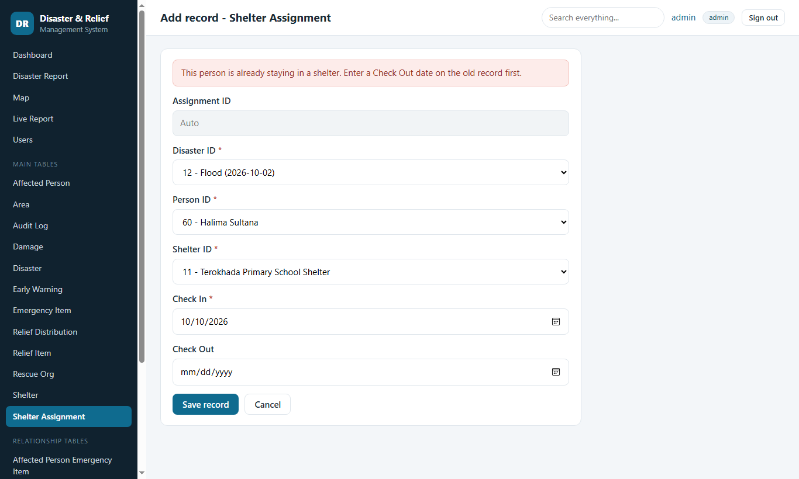
Figure 15. The system protects the data

Step 16: Record added
After saving, you return to the list with a green confirmation. The new record is found with the search box.
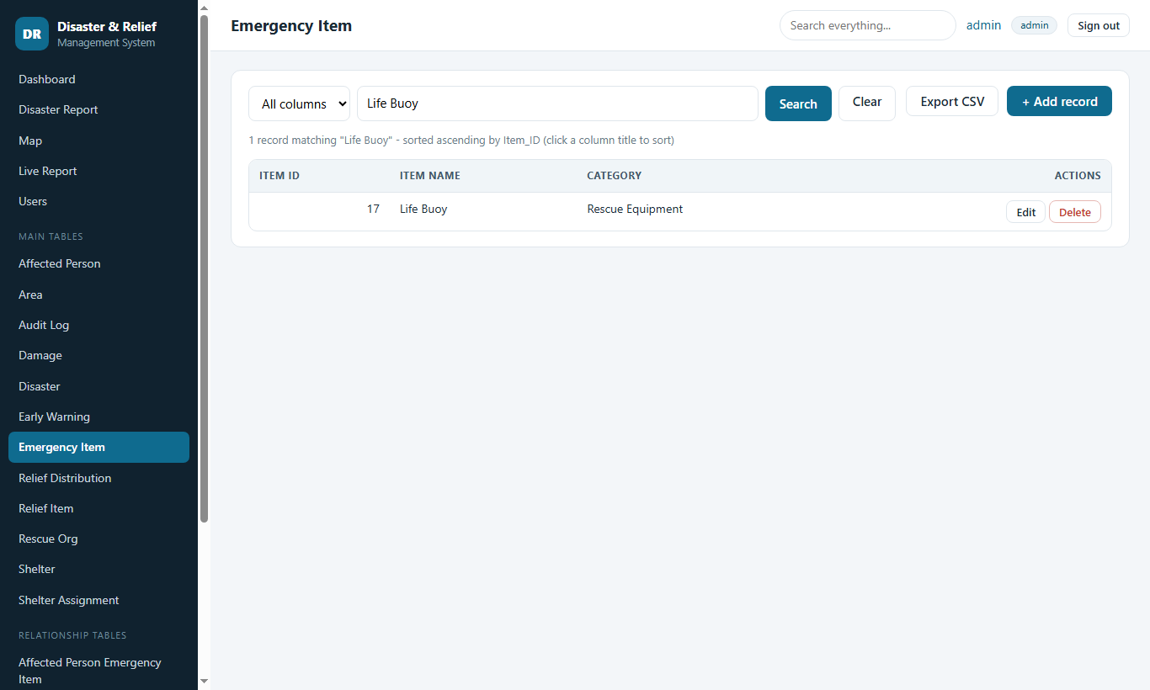
Figure 16. Record added

Step 17: Edit a record
Edit opens the same form filled with the current values. Change what you need and press "Update record".
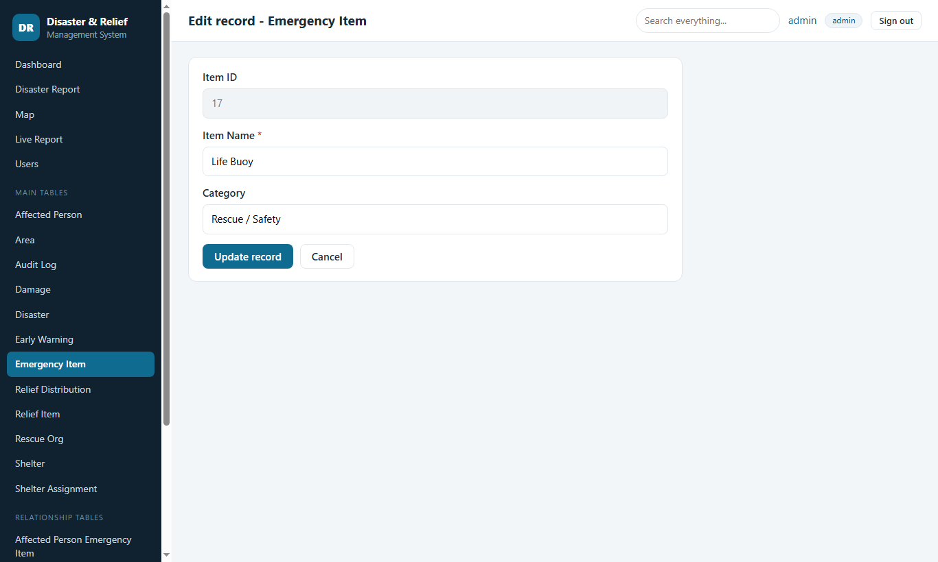
Figure 17. Edit a record

Step 18: Delete confirmation shows the impact
Before anything is deleted the system lists exactly what else would disappear (cascade), be unlinked, or block the deletion. Nothing is deleted until you press "Yes, delete".
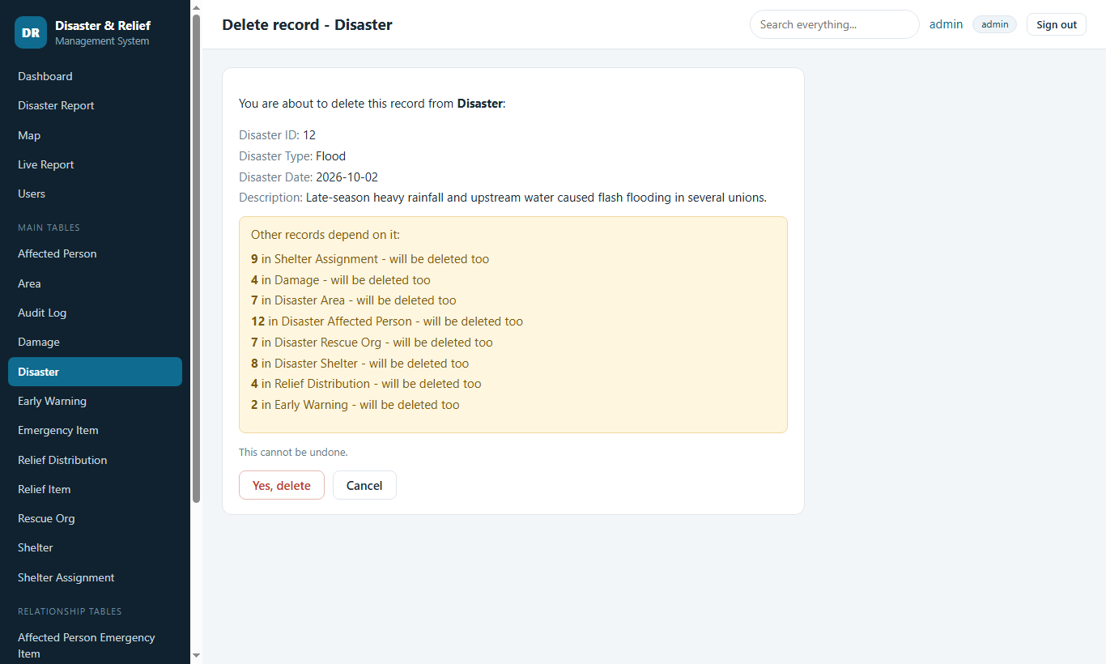
Figure 18. Delete confirmation shows the impact

B6. Audit log and global search

Step 19: Audit log
Every add, edit and delete is recorded with the user name and the record. The audit log cannot be changed from the web pages.
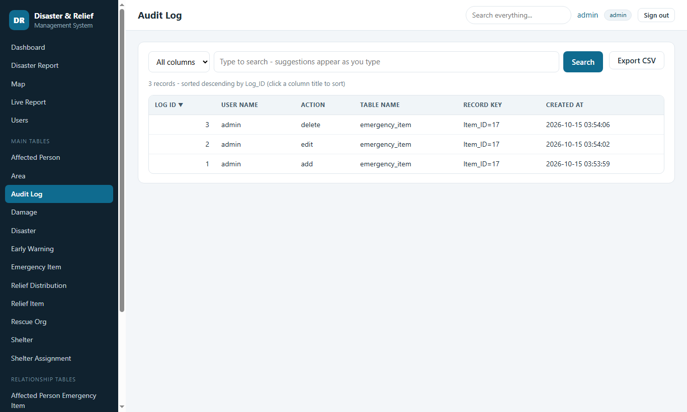
Figure 19. Audit log

Step 20: Search everything
The box at the top of every page searches all tables at once - names, phone numbers, places, descriptions.
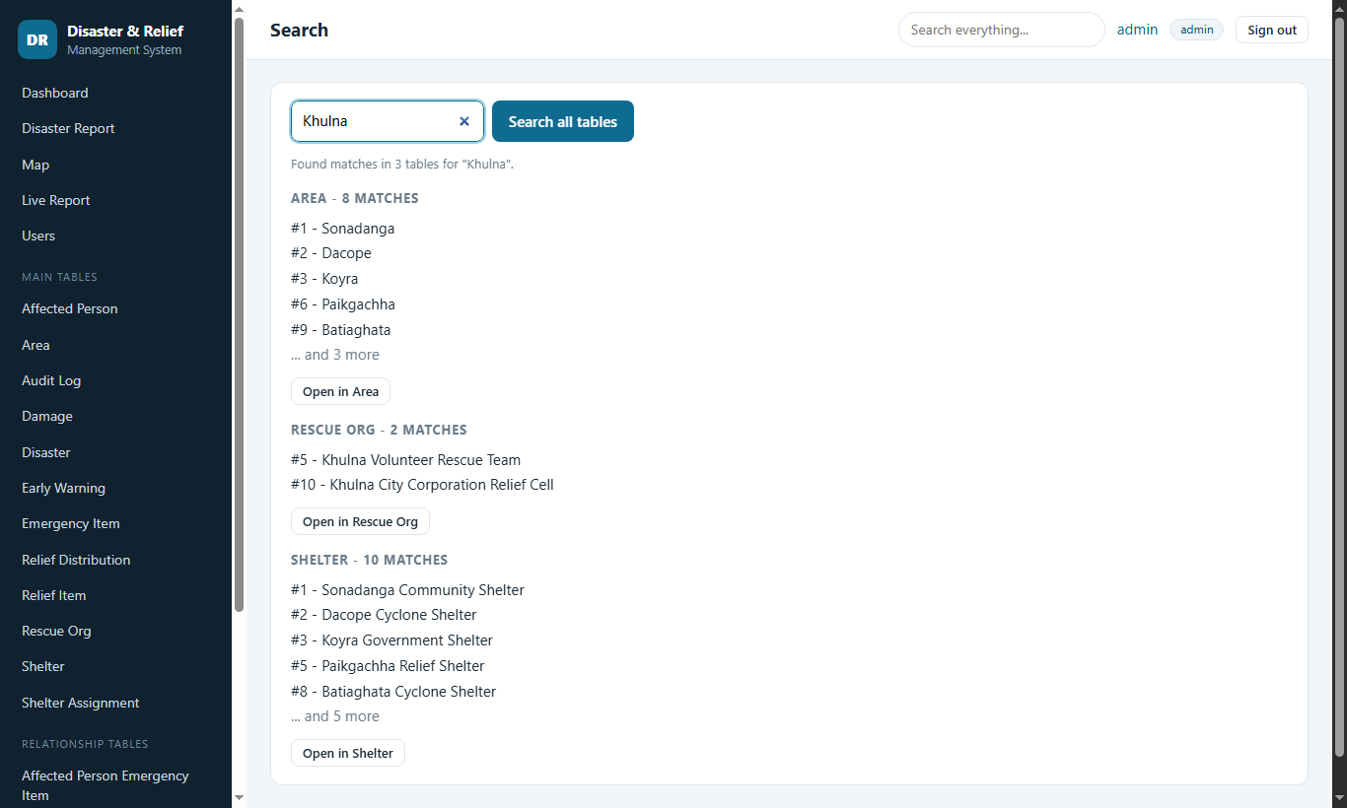
Figure 20. Search everything

B7. Users and accounts (administrator)

Step 21: Users page (administrator only)
Administrators create users and choose a role: admin (everything), editor (add/edit/delete records) or viewer (read-only). They can also reset passwords and delete users.
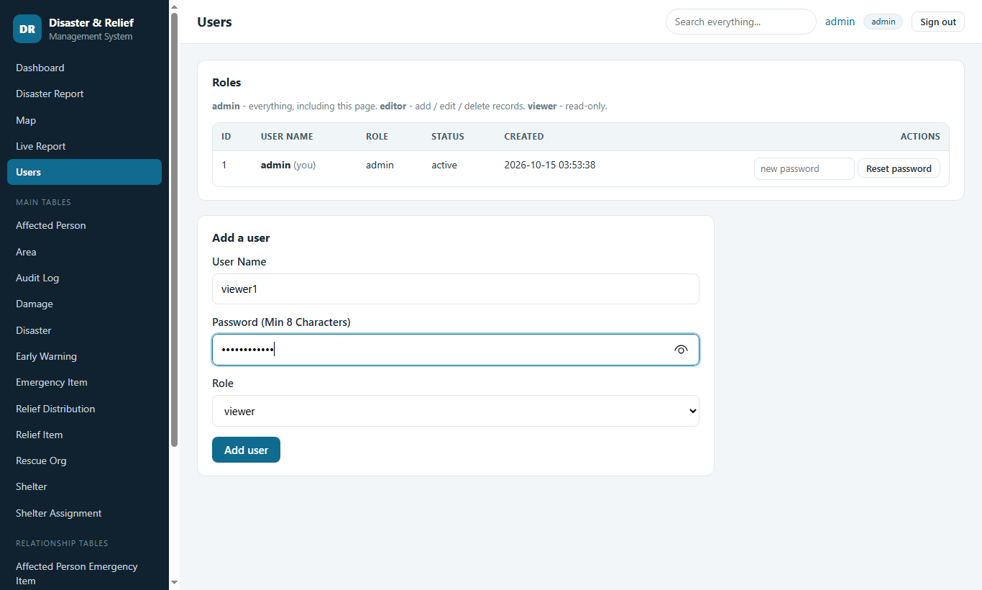
Figure 21. Users page (administrator only)

Step 22: User created
The new user appears in the list immediately.
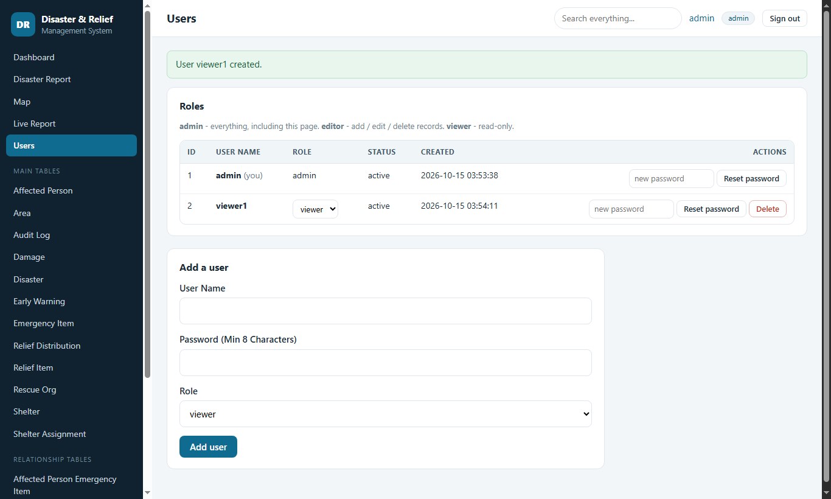
Figure 22. User created

Step 23: My account
Every user can change their own password here. Wrong passwords are limited: 5 failures lock the account for 5 minutes.
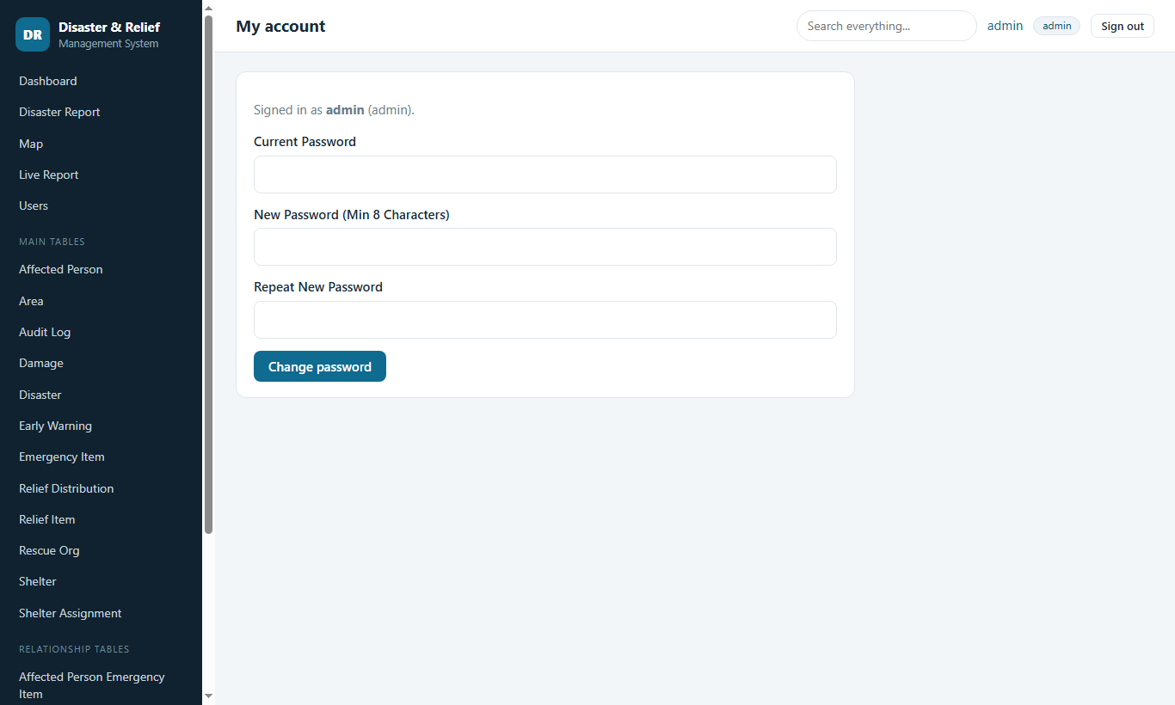
Figure 23. My account

B8. Signing in again, roles and small screens

Step 24: Sign in page
After the first run, this is the normal sign-in page.
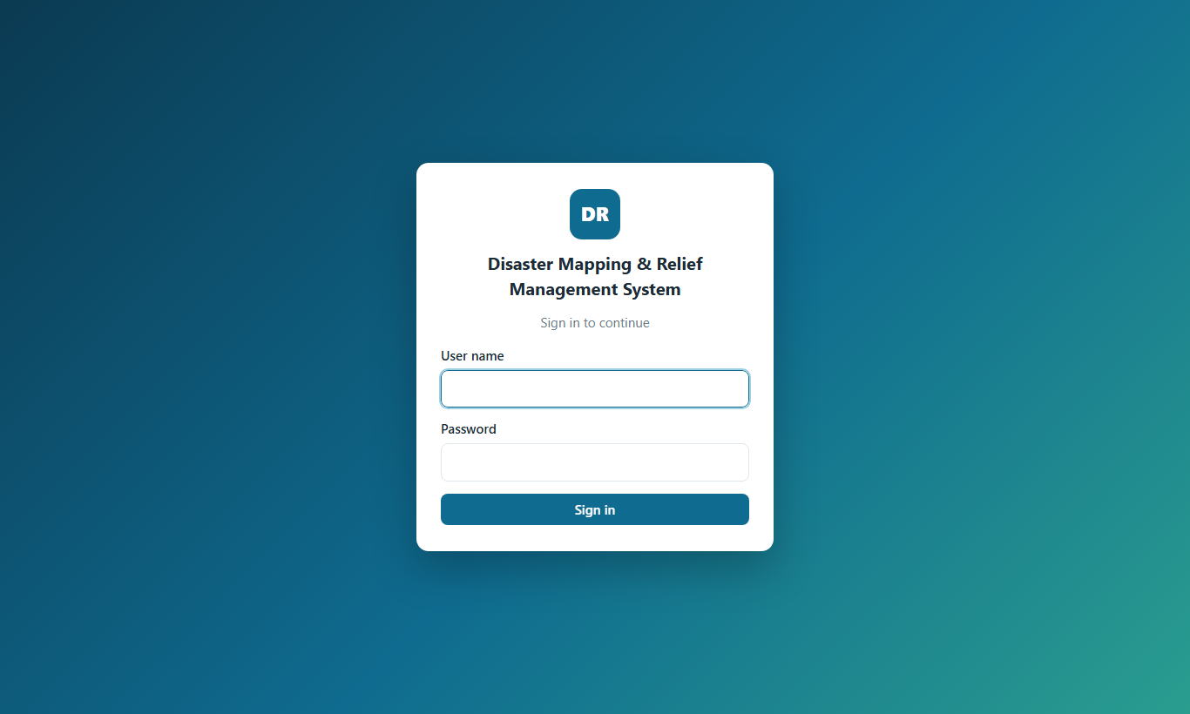
Figure 24. Sign in page

Step 25: Wrong password
A wrong user name or password gives the same neutral message, so nobody can guess which user names exist.
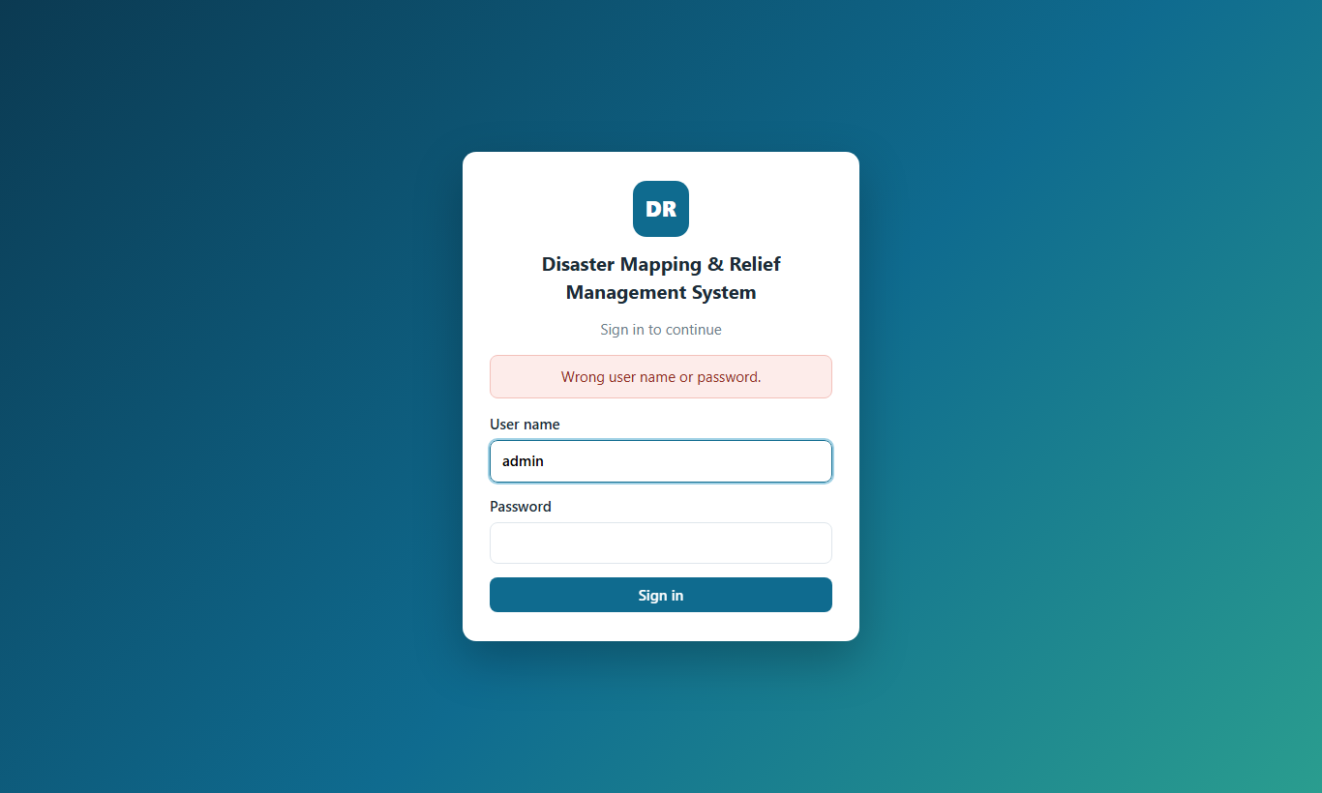
Figure 25. Wrong password

Step 26: A viewer sees read-only pages
Signed in as a viewer: there is no "+ Add record" button and no Edit / Delete column. Viewers can still search, sort and export.
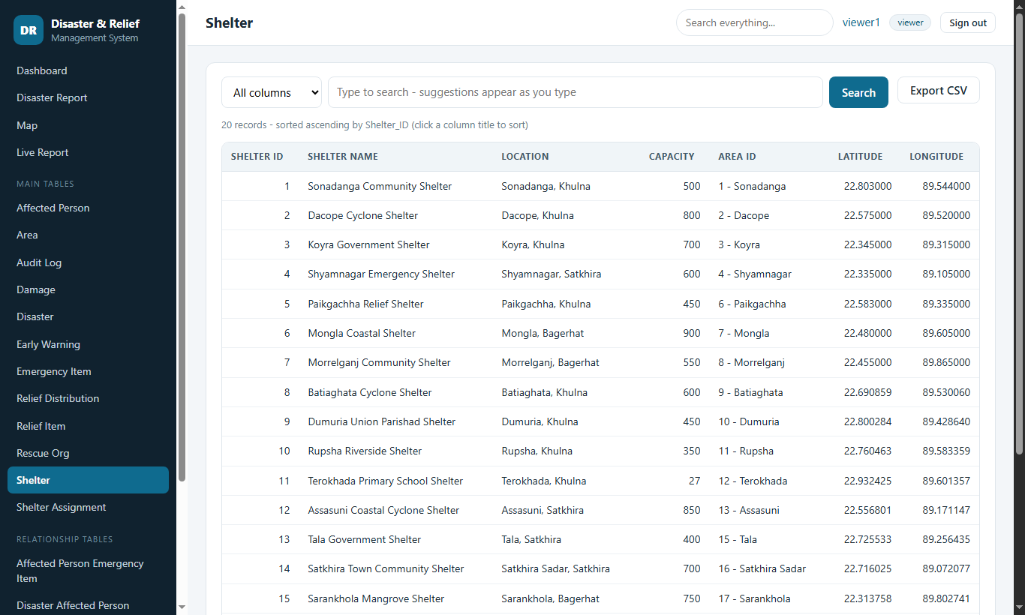
Figure 26. A viewer sees read-only pages

Step 27: On a phone
The layout adapts to small screens; the menu button opens the sidebar.
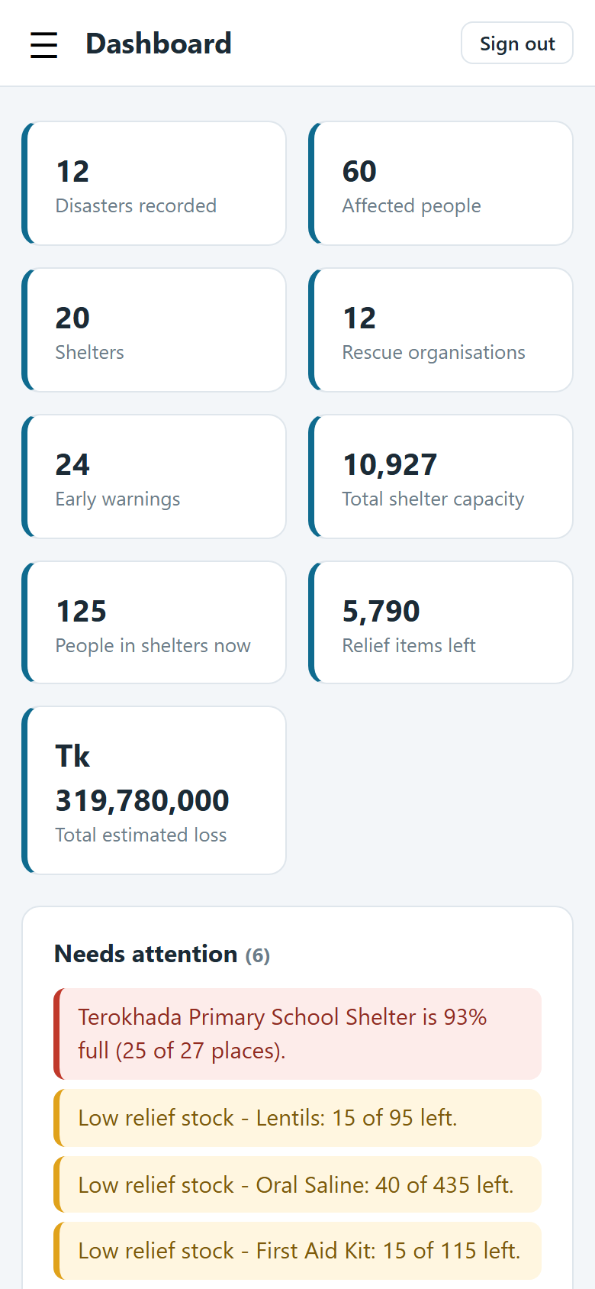
Figure 27. On a phone

Step 28: Phone menu
The sidebar lists every page and table.
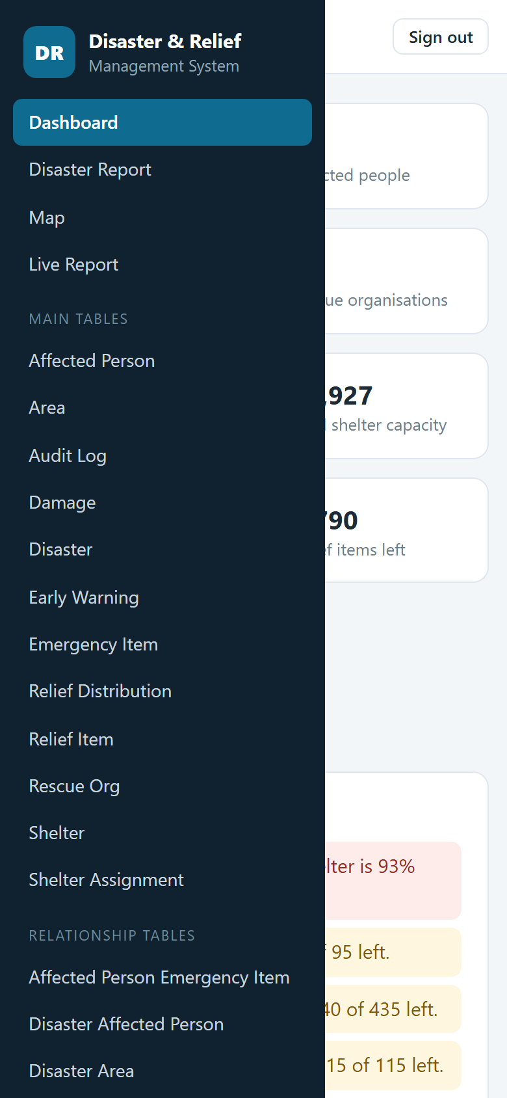
Figure 28. Phone menu

B9. Other features worth knowing
- Export CSV on every table downloads all matching rows (not only the current page); the file opens correctly in Excel, including Bangla text.
- Print report on the disaster report page prints a clean paper copy without the menu.
- Sign out is a button (not a link) so that another website cannot sign you out.
- Roles: editors have the same pages as admins except Users; viewers can only read, search, sort and export.

Part C - How the system works (methodology)

C1. Approach
The project follows a database-first method. The relational schema is designed first (entities, relationships, constraints), because in a disaster the correctness of the data matters more than the screens. The user interface is then built from the schema: the pages ask MySQL what tables, columns and relationships exist, and draw forms and lists from the answer. The result is a small code base in which the database is the single source of truth.
Design goals, in order: (1) data stays correct, (2) only authorised people can read or change it, (3) it is easy to run on a student PC with free software, (4) it is easy to extend.

C2. Architecture
A classic three-part web application with no framework: the browser shows pages and runs small scripts; PHP pages on Apache do the work; MySQL stores the data and enforces the rules that must never be broken.
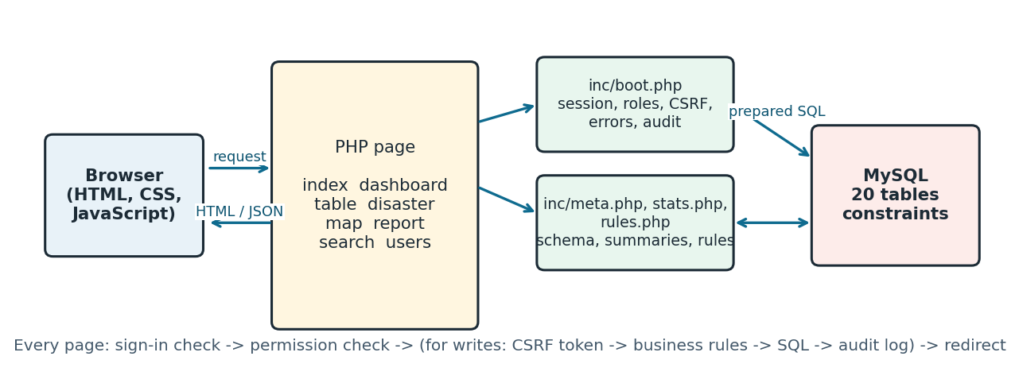
Figure 29. How a request travels through the system
Layer | Files | Responsibility
Pages | index, dashboard, disaster, table, map, report, search, users, account | Decide what to show; one file per screen.
Shared services | inc/boot.php | Session, signed-in user and role, CSRF token, error handler, audit log, page layout.
Schema reader | inc/meta.php | Reads tables, columns, keys and foreign keys from information_schema.
Summaries | inc/stats.php | The queries behind the dashboard, live report, map and alerts - written once, used everywhere.
Business rules | inc/rules.php | Capacity, stock and "same disaster" checks.
Data access | db.php | One connection, prepared statements only, first-run installer.
Browser scripts | assets/*.js | Menu, search suggestions, live refresh, map. Pages still work without them (except map and live report).

C3. The data model
The model has 20 tables: 18 for the response itself and 2 for security. A disaster is the hub. Many-to-many facts are stored in link tables whose primary key is the combination of both ids, so the same pair cannot be recorded twice.
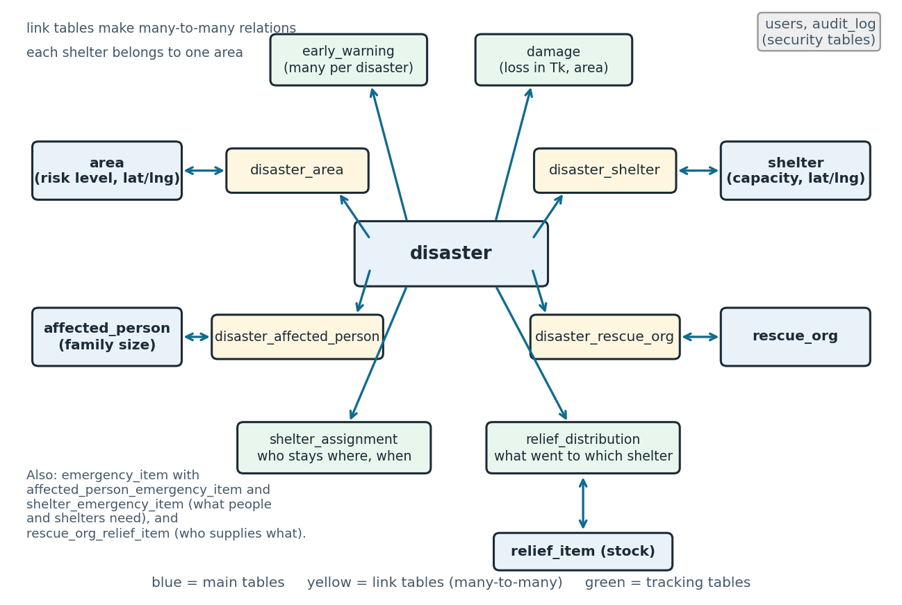
Figure 30. Overview of the data model
Group | Tables | What they record
Core entities | disaster, area, shelter, affected_person, rescue_org | The things that exist. A shelter belongs to exactly one area. A person row is a household with a family size and a contact number.
Many-to-many links | disaster_area, disaster_shelter, disaster_affected_person, disaster_rescue_org | Which areas, shelters, families and organisations took part in which disaster.
Events of a disaster | early_warning, damage | Several warnings per disaster; damage with a quantity, an estimated loss in Tk and the area where it happened.
Items | emergency_item, relief_item, affected_person_emergency_item, shelter_emergency_item, rescue_org_relief_item | What families and shelters need, the relief stock (Quantity = total received), and which organisation supplies which item.
Tracking | shelter_assignment, relief_distribution | Who stayed in which shelter and when (an empty Check Out means "staying now"); which relief item went to which shelter, from which organisation, on which date.
Security | users, audit_log | Accounts (password hash, role, lock-out counter) and the record of changes. Both are hidden or read-only in the generic pages.

Key definitions used in all reports
- People in a shelter now = sum of the family sizes of the assignments whose Check Out is empty.
- Shelter fullness = people in the shelter now / its capacity.
- Relief left = relief_item.Quantity - sum of all relief_distribution.Quantity for that item.
- Estimated loss = sum of damage.Estimated_Loss (Bangladeshi taka).

C4. Schema-driven pages (the central idea)
Instead of writing a form and a list for each of the 18 tables, one page (table.php) serves all of them. For every request it:
- checks that the table named in the address is in the list of real tables (so a table name can never be used to attack the database);
- reads the columns from information_schema in a single query (and caches them for the request);
- turns each column into a suitable input: AUTO_INCREMENT columns are shown as "Auto"; a column with a foreign key becomes a drop-down of "id - name" values read from the parent table; enum becomes a choice list; date and datetime get date pickers; decimals get the step that matches their scale (for example 0.000001 for coordinates); NOT NULL columns without a default are marked required; text columns get the right maximum length;
- builds the list with search (the same text is matched against every column, or one chosen column), sorting on any column, 20 rows per page and a CSV export of every matching row.
Consequence: a new table or column needs no new PHP. The sidebar, the dashboard table chips and the global search also read the same schema information.

C5. What happens on a request

Reading a page
- boot.php starts the session and installs the error handler (errors go to the log, never to the screen).
- guard() confirms that the session belongs to a user who still exists and re-reads that user's role from the database. Deleting a user or lowering a role therefore takes effect on the very next click.
- The page runs prepared SQL, builds HTML and escapes every value with h().

Changing data (add, edit, delete)
- The browser sends a POST with a hidden CSRF token.
- csrf_ok() compares it with the token in the session (an empty token never matches), then can_edit() checks the role and the table is not read-only (the audit log).
- check_rules() applies the business rules and, if one fails, the form is shown again with the message and what was typed.
- The SQL statement runs with parameters. If MySQL refuses it (duplicate, foreign key, CHECK rule) the error code is translated into a plain message; the technical text goes to the log.
- audit() writes who did what to which record.
- The server answers with a redirect (Post/Redirect/Get), so pressing Refresh never repeats the change; a green or red message is shown once.

Deleting safely
Delete is a two-step action. The confirmation page asks the schema which tables point at the record and counts the dependents, then states the effect of each foreign key: CASCADE ("will be deleted too"), SET NULL ("will lose the link") or RESTRICT ("blocks the deletion"). If something blocks, the delete button is disabled.

C6. Keeping the data correct - four layers
Layer | Examples | Where
1. Column rules | NOT NULL, UNIQUE names, ENUM risk levels, CHECK rules: capacity > 0, family size > 0, quantities >= 0, latitude -90..90, longitude -180..180, check-out not before check-in | MySQL (the .sql file)
2. Relationships | Foreign keys with CASCADE / RESTRICT / SET NULL: a shelter's area cannot be deleted while the shelter exists; deleting a disaster removes its own warnings and links | MySQL
3. Business rules | The shelter must belong to that disaster and the family must be affected by it; a family stays in only one shelter at a time; a shelter cannot go over capacity; relief cannot exceed the stock; the organisation must have taken part in the disaster and supply that item | inc/rules.php
4. Hints in the form | Required marks, number steps, date pickers, maximum lengths | Browser (convenience only - never trusted)

Layers 1 and 2 cannot be bypassed because they live inside the database. Layer 3 protects every change made through the web pages. Its limitation: two people saving at the same second could both pass the capacity check before either is stored (check-then-write). Database triggers are the stronger solution and are listed as future work.

C7. Security model
Threat | Protection
Anyone reading or changing the data | Sign-in with salted password hashes (password_hash). No default account: the first visitor creates the administrator. Three roles.
Guessing passwords | 5 wrong passwords lock the account for 5 minutes; the same neutral message for unknown users and wrong passwords; the same work is done for both so timing does not reveal user names.
SQL injection | All values go through prepared statements. Table, column and sort names from the address are checked against the real schema before use.
Cross-site scripting | Every printed value is escaped with h(). Map pop-ups are built with textContent.
Cross-site request forgery | A secret token on every form; sign-out is a POST with a token; the cookie is HttpOnly and SameSite=Lax (and Secure over HTTPS).
Stolen or fixed session | New session id at sign-in, strict session mode, own cookie name; deleted users are signed out immediately.
Leaking internals | Errors are logged, not displayed; config.php, .sql, .txt and inc/ are blocked by .htaccess; the test script refuses to run from a browser.
CSV formula injection | Exported cells that start with =, +, - or @ are prefixed so Excel treats them as text.
Over-powerful database account | create_db_user.sql gives the web application only SELECT, INSERT, UPDATE, DELETE.
Accountability | The audit log records every add, edit and delete, including user administration.

C8. Live report, alerts, search and map
- Live report. The page asks report_data.php (JSON) every 5 seconds. It redraws only when the data changed and flashes the changed cells. It does not poll while the tab is hidden, never sends two requests at once, and the server releases the session lock early so the page does not slow other requests.
- Needs attention. alerts() runs five simple queries: shelters at 90% or more, relief items with less than 20% left (or negative), High / Very High risk areas without a shelter, disasters without an early warning, and families in a shelter for more than 30 days.
- Search. The table search matches the typed text against every column (or one chosen column) with LIKE; the suggestions come from api.php, which returns up to 8 values, words that start with the text first. The global search repeats this over all tables.
- Map. Latitude and longitude are stored on areas and shelters. Circle colour = risk level; dot colour = how full the shelter is. If the map library cannot load, a message is shown and the tables beneath still list all places.

C9. How the sample data was prepared
The original sample data (8 areas, 7 shelters, 8 families, 5 disasters) was extended by a generator script to 20 areas, 20 shelters, 60 families and 12 disasters, with matching warnings, damage, shelter stays and relief distribution. Names, phone numbers and place names are typical for the region; coordinates are approximate; amounts are plausible but invented. The generator builds the data in an order that keeps it consistent, so the same rules that the application enforces hold in the sample data:
- a shelter is used by a disaster only if it is in an area that the disaster hit;
- a family is placed in a shelter only for a disaster that affected it, and only in a shelter used by that disaster;
- an organisation gives out only items it supplies and only in disasters it took part in;
- the stock of every relief item is at least what was given out, and three items are deliberately almost used up; one small shelter is almost full - so the alerts have something to show;
- no one is in two shelters at the same time; no shelter is over capacity.
The self-test (tests/smoke.php) re-checks all of these facts against the database, so they stay true if the data is changed.

C10. Testing method and results
Level | What was done | Result
Syntax | Every PHP file checked with php -l; every JavaScript file with node --check. | No errors
Database | The full .sql file was installed on a fresh MySQL 8.4.7 server (also through the application's own first-run installer). | Installs cleanly; 20 tables
Self-test | tests/smoke.php - 27 checks on tables, constraints, CSRF, data consistency, business rules and alerts. | 27 of 27 passed
Web pages | Every page and every table's list, add form and CSV export requested over HTTP; first-run setup; add / edit / delete with valid and invalid data; role restrictions including forged requests from a viewer; lock-out; password reset; live role change; deleted-user sign-out; sign-out rules; partial-database protection; search; disaster report; JSON feed. | All as expected; no PHP warnings in the log
Browser | A real Edge browser was driven through the whole tour in Part B (28 screenshots), including the map with live tiles and the phone layout. | Two display defects found and fixed (menu highlighting, wrapping of large numbers on phones)

Not covered: Running under Apache/WampServer itself (the .htaccess files), HTTPS, many users at the same moment, and very large data volumes. Two people changing the same shelter at the same second is the one known gap in the business rules (see C6).

C11. Limits and future work
- Business rules are checked in PHP, not in the database (see C6).
- Phone numbers, names and coordinates are not validated beyond their length and range.
- Reports are screens and print-outs; there is no PDF or Excel report builder yet.
- One database, one server; there is no offline mode for field workers.
- Passwords are the only sign-in factor; a second factor would be sensible for a real deployment.

End of document.

