Image Width (pixels):

# HandBot_Arm



| Analyzed File | handbot_arm v1 |
| --- | --- |
| Version | Autodesk Fusion 360 (2.0.10356) |
| Creation Date | 2021-07-07, 02:11:36 |
| Author | HandBot |

#### Project Properties

| Title | Studies |
| --- | --- |
| Author | USER |

## Simulation Model 1:1

### Study 1 - Static Stress

##### Study Properties

| Study Type | Static Stress |
| --- | --- |
| Last Modification Date | 2021-07-07, 02:09:42 |

#### Settings

##### General

| Contact Tolerance | 0.2 mm |
| --- | --- |
| Remove Rigid Body Modes | No |

##### Damping



##### Mesh

| Average Element Size (% of model size) | |
| --- | --- |
| Solids | 10 |
| Scale Mesh Size Per Part | No |
| Average Element Size (absolute value) | - |
| Element Order | Parabolic |
| Create Curved Mesh Elements | Yes |
| Max. Turn Angle on Curves (Deg.) | 60 |
| Max. Adjacent Mesh Size Ratio | 1.5 |
| Max. Aspect Ratio | 10 |
| Minimum Element Size (% of average size) | 20 |

##### Adaptive Mesh Refinement

| Number of Refinement Steps | 0 |
| --- | --- |
| Results Convergence Tolerance (%) | 20 |
| Portion of Elements to Refine (%) | 10 |
| Results for Baseline Accuracy | Von Mises Stress |

#### Materials

| **Component** | **Material** | **Safety Factor** |
| --- | --- | --- |
| Gripper Assembly:1/gear2:1 | Plastic | Yield Strength |

##### Plastic

| Density | 1.29E-06 kg / mm^3 |
| --- | --- |
| Young's Modulus | 709 MPa |
| Poisson's Ratio | 0.4 |
| Yield Strength | 30 MPa |
| Ultimate Tensile Strength | 40 MPa |
| Thermal Conductivity | 2.5E-04 W / (mm C) |
| Thermal Expansion Coefficient | 4.19E-05 / C |
| Specific Heat | 1750 J / (kg C) |

#### Contacts

#### Mesh

| **Type** | **Nodes** | **Elements** |
| --- | --- | --- |
| Solids | 59880 | 34949 |

#### Load Case1

##### **Solve result of this load case is out of date.**

#### Constraints

##### Fixed2

| Type | Fixed |
| --- | --- |
| Ux | Fixed |
| Uy | Fixed |
| Uz | Fixed |

###### Selected Entities

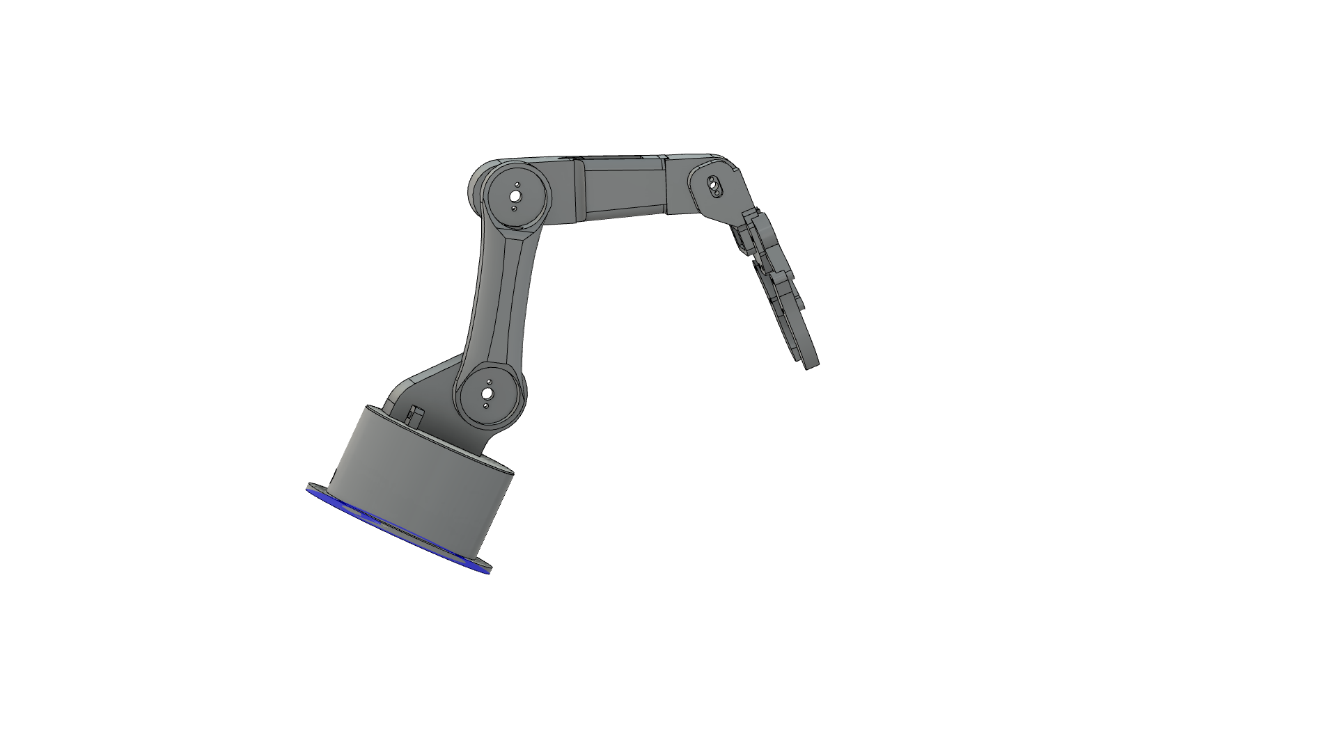

#### Loads

##### Force2

| Type | Force |
| --- | --- |
| X Value | 2.5 N |
| Y Value | -3 N |
| Z Value | 0 N |
| Force Per Entity | No |

###### Selected Entities

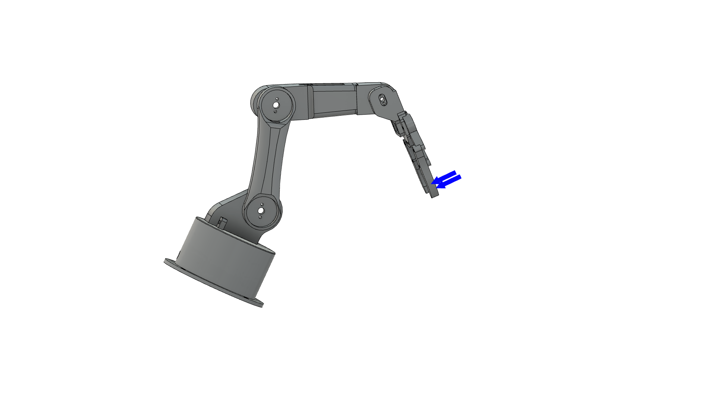

#### Results

##### Result Summary

| **Name** | **Minimum** | **Maximum** |
| --- | --- | --- |
| Safety Factor | | |
| Safety Factor (Per Body) | 15 | 15 |
| Stress | | |
| Von Mises | 5.25E-09 MPa | 2.073 MPa |
| 1st Principal | -0.2324 MPa | 1.276 MPa |
| 3rd Principal | -2.395 MPa | 0.2842 MPa |
| Normal XX | -1.606 MPa | 0.9453 MPa |
| Normal YY | -1.168 MPa | 1.15 MPa |
| Normal ZZ | -1.533 MPa | 0.6381 MPa |
| Shear XY | -0.7326 MPa | 0.5967 MPa |
| Shear YZ | -0.7095 MPa | 0.5063 MPa |
| Shear ZX | -0.5588 MPa | 1.035 MPa |
| Displacement | | |
| Total | 0 mm | 0.00704 mm |
| X | -0.00122 mm | 0.003836 mm |
| Y | -0.006136 mm | 2.716E-04 mm |
| Z | -4.278E-06 mm | 0.001162 mm |
| Reaction Force | | |
| Total | 0 N | 0.2045 N |
| X | -0.1212 N | 0.02896 N |
| Y | -0.03914 N | 0.1828 N |
| Z | -0.0699 N | 0.04026 N |
| Strain | | |
| Equivalent | 4.24E-14 | 1.67E-05 |
| 1st Principal | -3.611E-12 | 1.014E-05 |
| 3rd Principal | -1.79E-05 | 1.16E-13 |
| Normal XX | -6.794E-06 | 3.792E-06 |
| Normal YY | -4.936E-06 | 4.903E-06 |
| Normal ZZ | -5.466E-06 | 3.228E-06 |
| Shear XY | -9.07E-06 | 7.388E-06 |
| Shear YZ | -8.785E-06 | 6.269E-06 |
| Shear ZX | -6.918E-06 | 1.281E-05 |

##### Safety Factor

###### Safety Factor (Per Body)

0  8

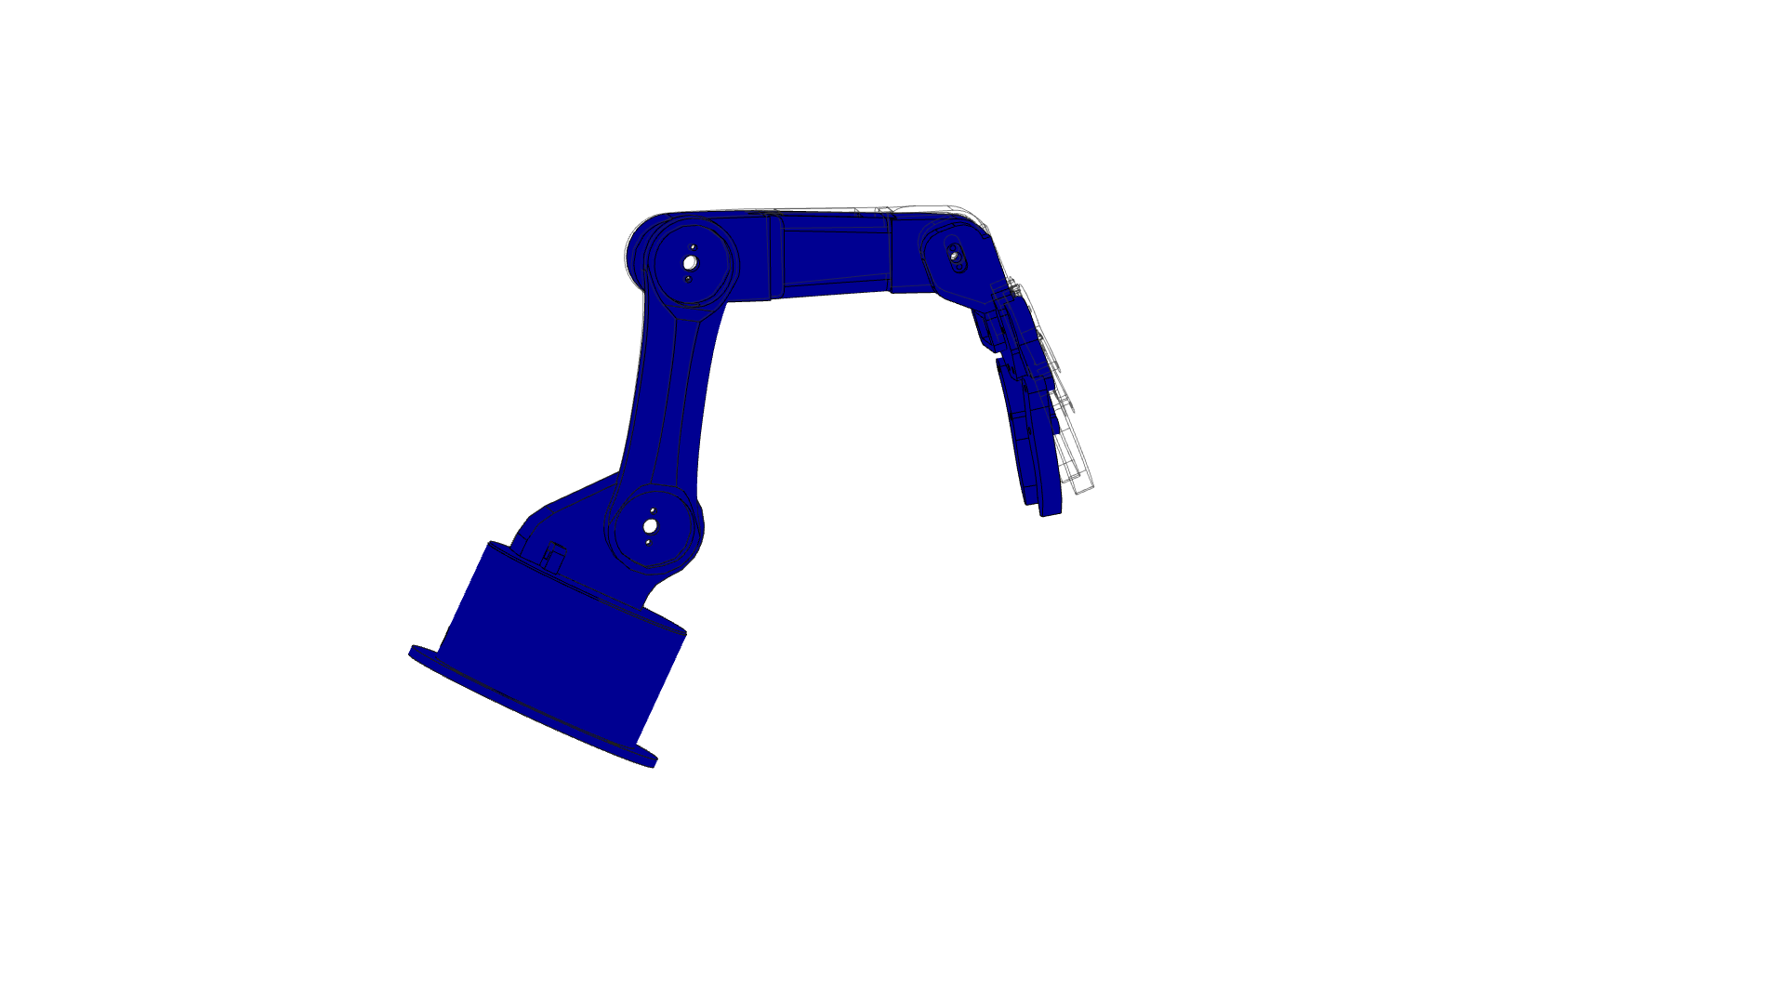

##### Stress

###### Von Mises

[MPa] 0  2.073

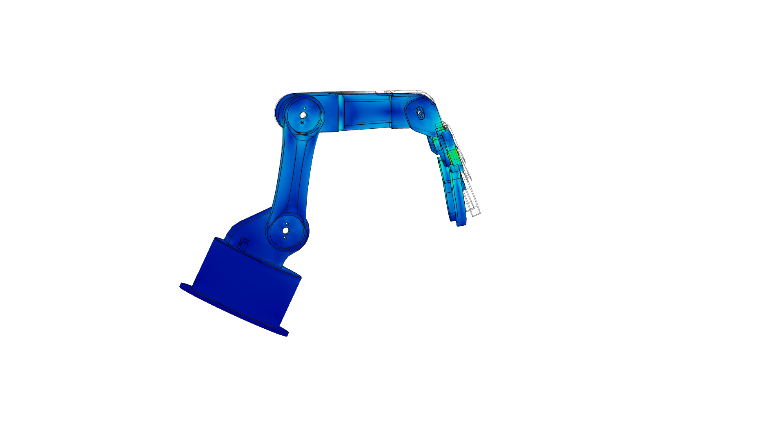

###### 1st Principal

[MPa] -0.232  1.276

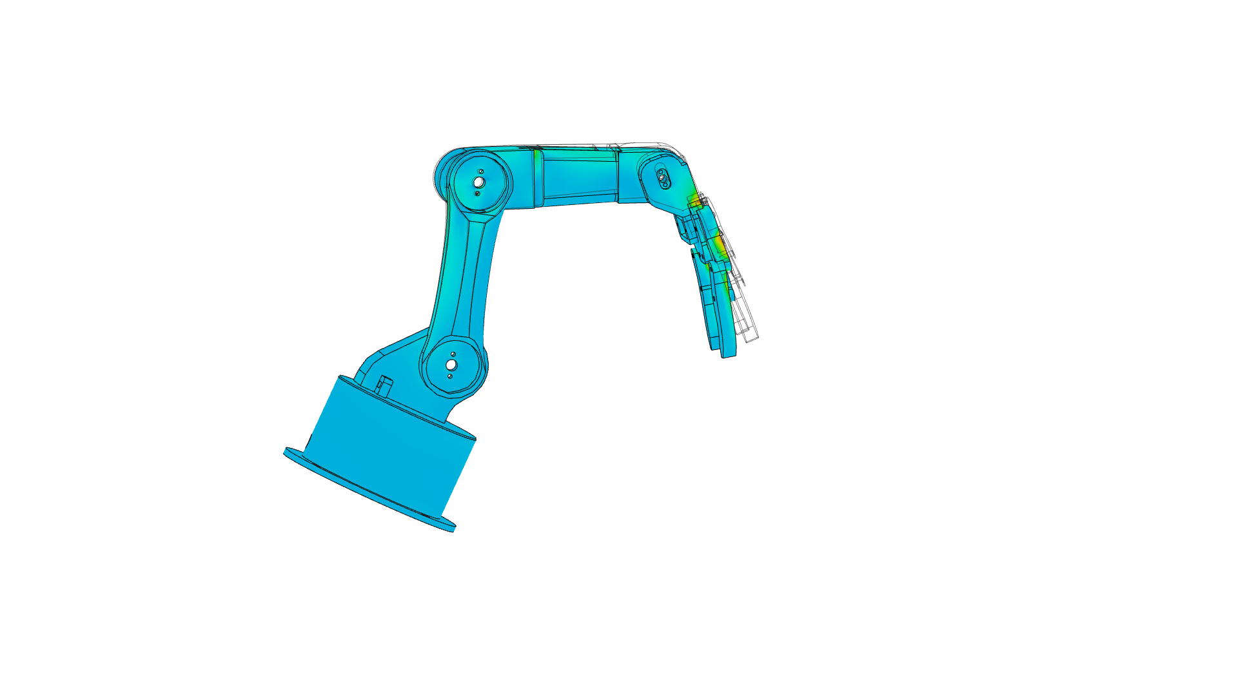

###### 3rd Principal

[MPa] -2.395  0.284

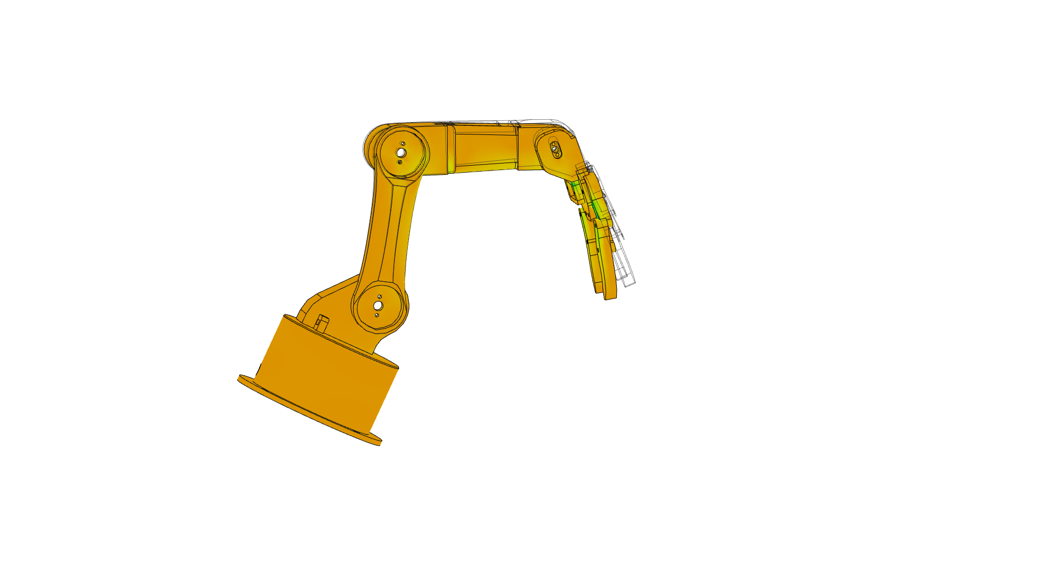

##### Displacement

###### Total

[mm] 0  0.00704

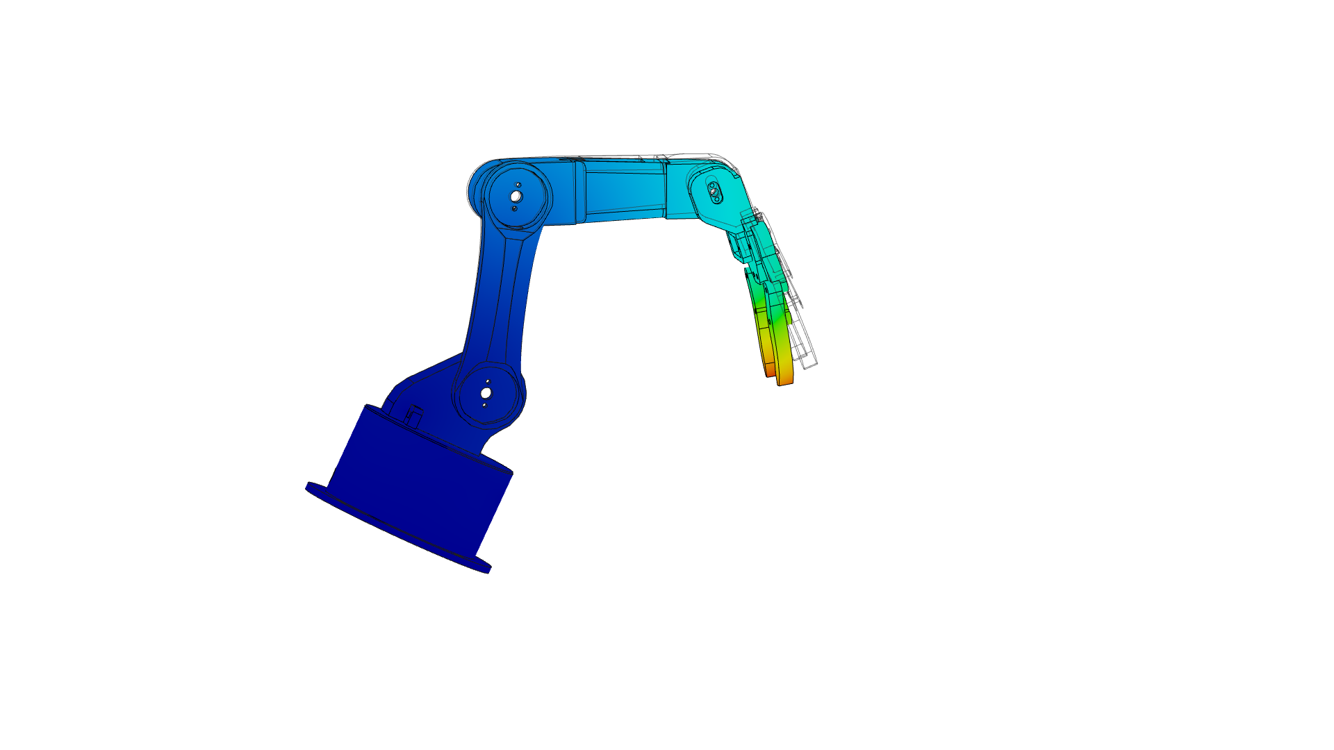

Image Width (pixels):