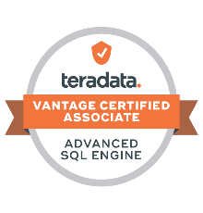
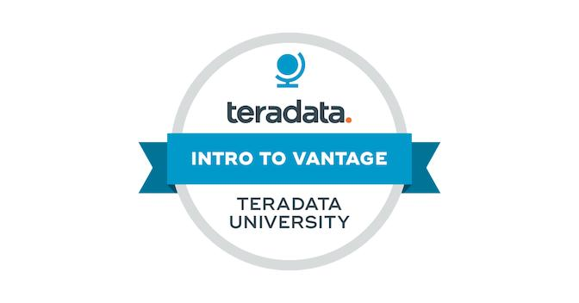 Firoz Ahmed
Email: ahmedfiroz.k@gmail.com
Mobile: +91 9513413602

Professional Summary

- Over all 7+ years of IT experience as software engineer which includes 6+ years of experience in Data warehousing projects as Teradata DBA.

- Good exposure in Teradata tools like Teradata Administrator, SQL Assistant, Viewpoint, Teradata Studio, Data Labs, DSA and TSET.

- Strong Experience in Teradata administration (creating tables, granting permissions, managing workloads, monitoring the system for performance) on a large Teradata database.

- Having good experience in Teradata Utilities like BTEQ, MLOAD, FLOAD, TPump and Fast Export, TPT, Data Labs.

- Involved in Performance Tuning of Queries of users facing spool and long running queries.

- Having good experience in UNIX.

- Teradata database Backup, Archive and Restore using ARC Main, Net vault, Veritas NetBackup, DSA, Data Mover.

- Experience of Production Support and problem resolution in a 24X7 environment.

- Error handling and troubleshooting of Teradata utilities (load and unload) for e.g. FastLoad, MultiLoad, FastExport, Tpump, Arc/Restore.

- Worked on Data Refresh activities from Production Environment to DEV, TEST Pre-Prod Environments.

- Code review and migrations to production.

- Active participation in Teradata upgrade/Patch activities and Following up of TAYS tickets.

- Having knowledge on Could Technologies.

- Result oriented, self-driven, highly motivated, smart and hungry to learn new technologies, methodologies, strategies and processes.

Technical Skills

Operating Systems : Unix, Suse Linux, Windows7/xp,10
Languages : SQL, UNIX Shell Scripting
Database : Teradata 13/14/15,16 and Oracle 9i /10g
Reporting Tool : Business Objects 3.1
Virtualization : VMware Horizon, Citrix
Teradata : PMON, Teradata manager, Teradata administrator,
TASM, Viewpoint, Teradata SQL Assistant, BTEQ, Fast Export, Fast
Multi Load, TPT, Data Labs.
Database Tools : Toad
Backup Tools : Veritas NetBackup, NetVault, Tara GUI, Teradata DSA
Ticketing Tools : BMC Remedy, TFS, Service Now, HP Service centre and Jira.

Experience Summary

- Working as Senior Database Engineer for Wipro Technologies, Hyderabad from June 2021 to till date.

- Worked as Database Specialist for HCL Technologies, Madurai from June 2018 to till date.

- Worked as Senior Engineer for Brillio Technologies Pvt Ltd, Bangalore from June 2017 to June 2018.

- Worked as Senior Software Engineer for Fujitsu Consulting India, Bangalore from Mar 2015 to Jun 2017.

- Worked as Software Engineer for Magna InfoTech, Pune from Jan 2014 to Dec 2014.

Education

- Master of Technology (M. Tech) in Computer Science from Jawaharlal Nehru Technical University, Hyderabad.

Certifications

- Completed Certification on Vantage Certified Associate.
- Completed Certification on INTRO TO VANTAGE.

Professional Profile
Project 5:
Client : Citi Bank
Project Name : Citi Global Support
Database : 16.x
Role : Teradata Production DBA
Team Size : 20

Project Description:
Merck Sharp & Dohme (MSD) outside the United States and Canada, is an American pharmaceutical company and one of the largest pharmaceutical companies in the world.
Responsibilities :
- Creating of physical data base objects (tables, Views, indexes, Procedures).
- Granting & revoking of objects Rights, system rights on Databases.
- Space Management for all the servers (DEV, SIT, PAT, COB, PROD).
- Sending Monthly DBA reports (CPU usage, Read I/O, Backup report)
- Performed optimizing tasks such as identifying high skew tables, collecting the recommended stats on high impact reports.
- Worked on Backup and Restore management. Created backup jobs using DSA.
- Developed Knowledge on Viewpoint portlets such as Alert viewer, Query monitor, BAR .
- Successfully handled user related issues independently.
- Ability to work individually on non-prod refresh and non-prod upgrade activities.
- Worked on various user incidents and provided resolution within SLA time.

Project 4:
Client : Merck
Project Name : Merck Sharp & Dohme (MSD)
Database : Teradata 15.x & 16.x
Role : Teradata Production DBA
Team Size : 4

Project Description:
Merck Sharp & Dohme (MSD) outside the United States and Canada, is an American pharmaceutical company and one of the largest pharmaceutical companies in the world.

Responsibilities:
- Working as a Teradata Production DBA in 24/7 environment.
- Creating Teradata objects like Databases, Users, Profiles, Roles, Tables, etc.
- Granting & Revoking of Object Rights, System Rights on Databases / Users / Roles.
- Reallocating Disk Space – Move Space.
- Creating profiles, roles when required.
- Tuning of the BTEQ/FLOAD/MLOAD Scripts for better performance.
- Taking backup using Teradata DSA (Data Stream Architecture).
- Taking care of Spool and long running queries.
- Participated on Patch and Upgrade activity.

Project 3:
Client : Walmart
Project Name : Walmart Enterprise Data warehouse (EDW)
Database : Teradata 15.x
Role : Teradata Production DBA
Team Size : 12

Project Description:
Walmart is the world's largest company by revenue—over US$500 billion, according to Fortune Global 500 list in 2018—as well as the largest private employer in the world with 2.3 million employees. Walmart has 11,277 stores and clubs in 27 countries, operating under 55 different names. Walmart Teradata has 7 production servers and 3 test servers. Database Size is very huge in size (22 PB).
Responsibilities:
- Production support with 24*7
- Handle JIRA tickets, Incidents, Work Orders, Change Requests (CRQs) etc.
- Work on User related issues, Access related issues, DB issues, Space issues etc.
- Handle Page requests for Job abends/issues and work with Application team/concerned team to fix the issues.
- Creation of Database objects, Roles, Profiles.
- Prepare implementation plan and participate in code reviews with Walmart DBAs for create/alter table, application id creation, Sandbox creation, secure access etc.
- Work on performance tuning on long running queries, high cpu/cpu skewed queries, spool out, skewed tables etc.

Project 2:
Project : BCBSNC (Blue Cross Blue Shield of North Carolina)
Client : BCBSNC
Database : Teradata14.x
O/S : Windows XP/2003 Server (Standalone and Bar servers), Citrix
Role : Teradata Production/Application DBA
Team Size : 6

Project Description:
Blue Cross and Blue Shield of North Carolina (BCBSNC) has offered its customers high quality health insurance at a competitive price and has led the charge toward better health.
Responsibilities:
- Working as a Teradata Production DBA in 24/7 environment.
- Experience using Teradata Administrator to Monitor and Manage Teradata Database.
- Creating Teradata objects like Databases, Users, Profiles, Roles, Tables, etc.
- Granting & Revoking of Object Rights, System Rights on Databases / Users / Roles.
- Reallocating Disk Space – Move Space.

- Generating system performance reports on daily and weekly basis.
- Creating profiles, roles when required.
- Execution of Adhoc Queries.
- Preparation of backup and restoration scripts and monitoring.
- Tuning of the BTEQ/FLOAD/MLOAD Scripts for better performance.
- Implemented MVC on the tables which is consuming more space and I/O.
- Working as ticketing POC and preparing change tickets for schedule implementations.

Project 1:
Client : IBM Vodafone
Project Name : Vodafone India Billing Project
Technology : Oracle and Unix
Role : Oracle Production DBA
Team Size : 6

Project Description:
This is a Vodafone billing project where we will collect data from bsnl poi’s through FTP’s and providing them in report format. Here we are doing Billing for only Incoming calls to BSNL from other operators.
Responsibilities:
- Collect the Data Feeds and produce a Technical Design Document.
- Analyse the requirements for the Data Feeds like configurable schedule, manual and automatic trigger mechanism, drop & reload history.
- Handling issues while collecting the data from client systems.
- Handling the performance issues while pushing the files from client system.
- Data Validation.

Personal Detail

Date of Birth : April 28th, 1986
Sex : Male
Marital Status : Married
Nationality : Indian
Language Proficiency : English, Hindi, Telugu, Urdu, Tamil and Kannada
Passport : Available

