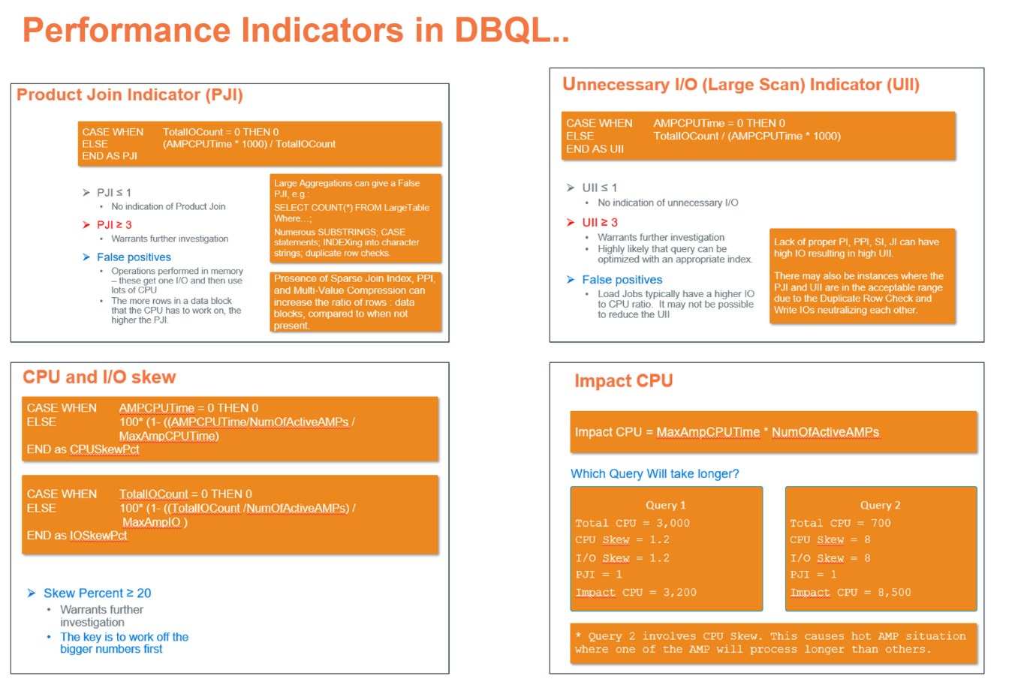
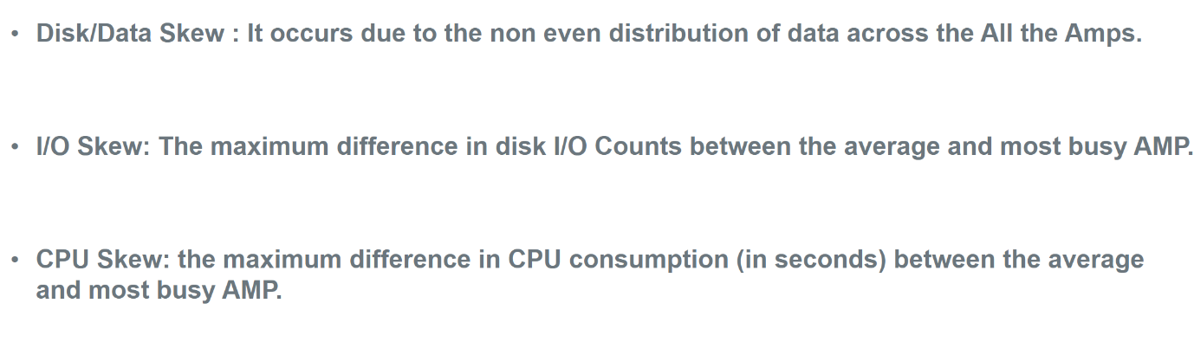

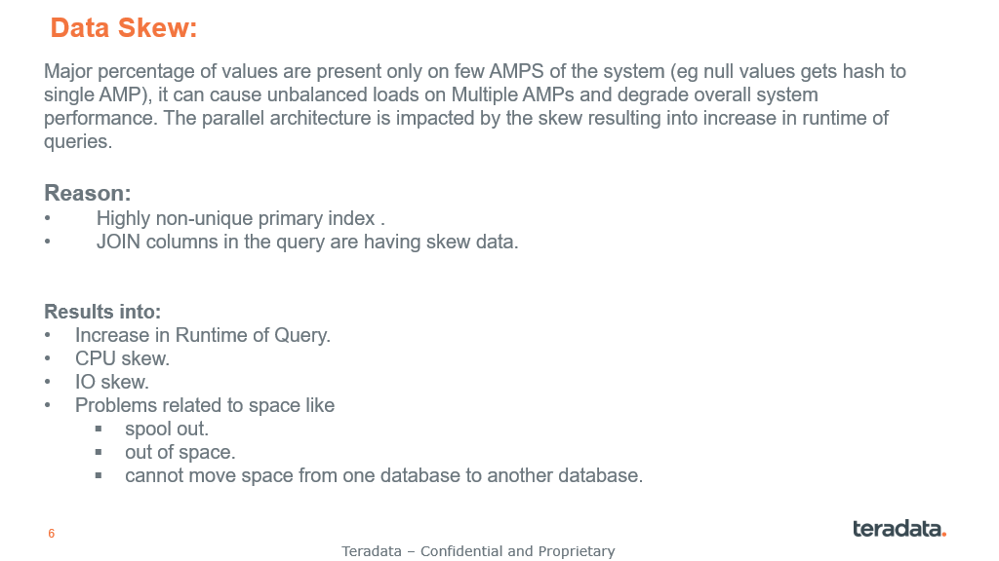
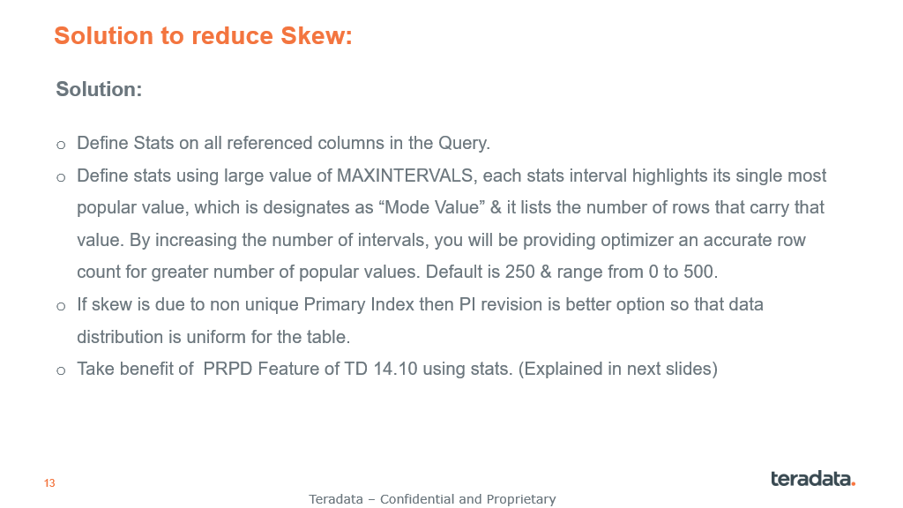

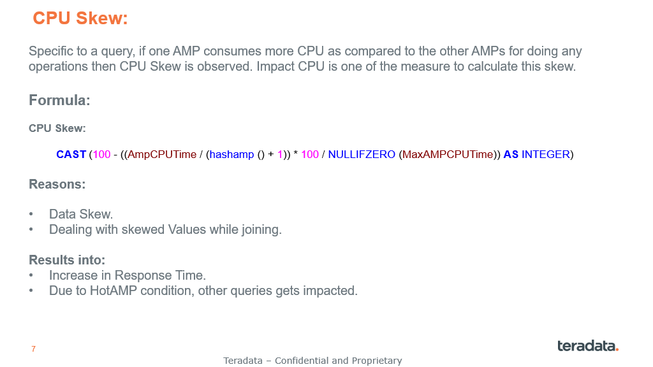

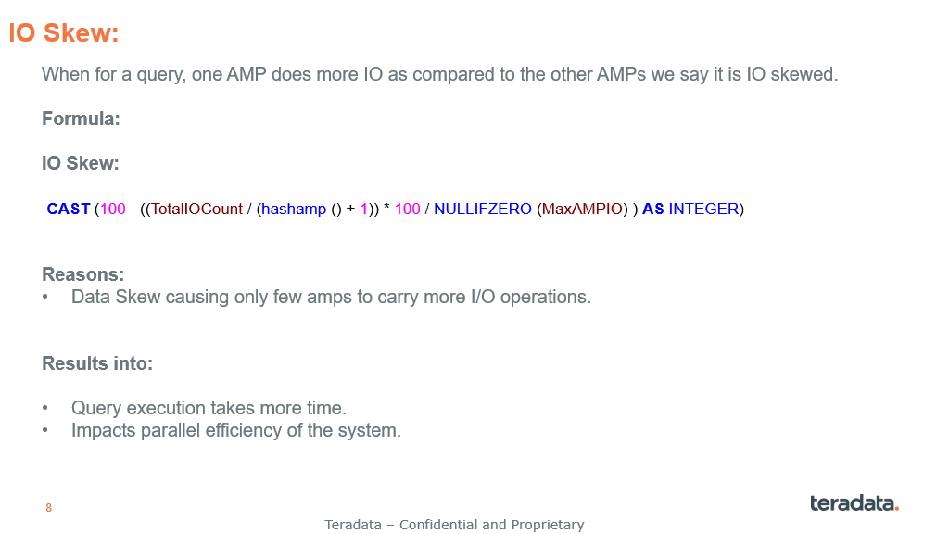
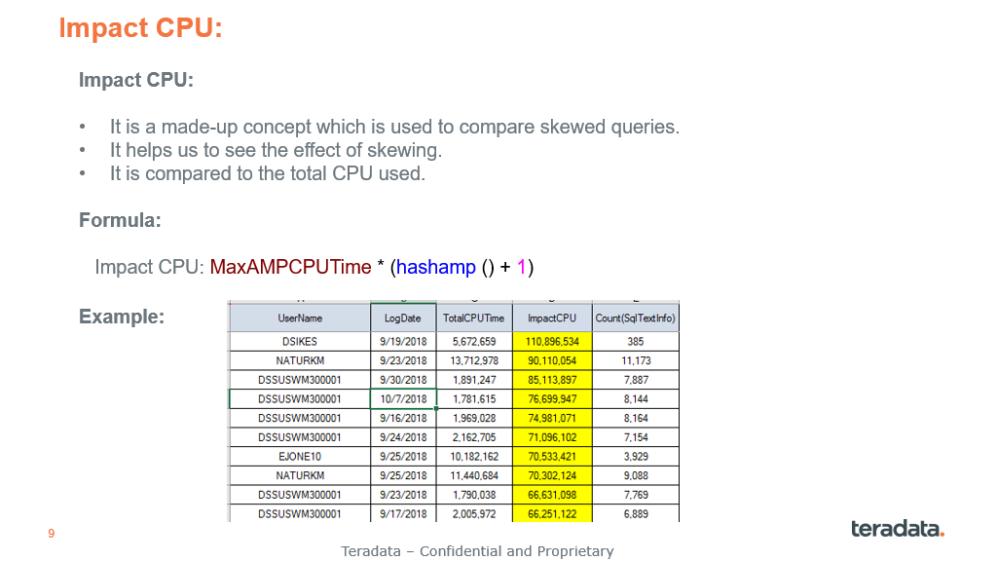

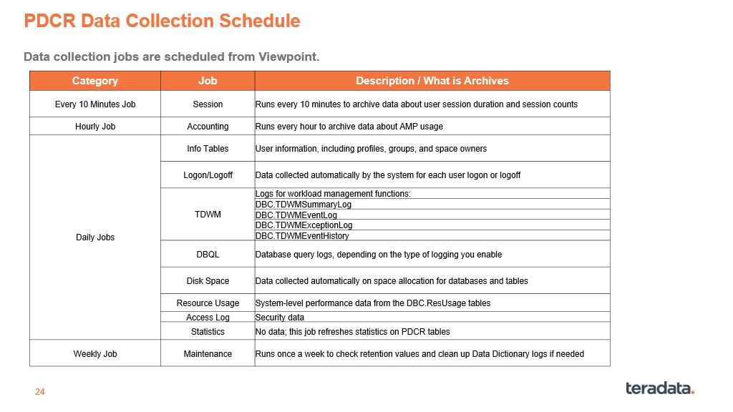
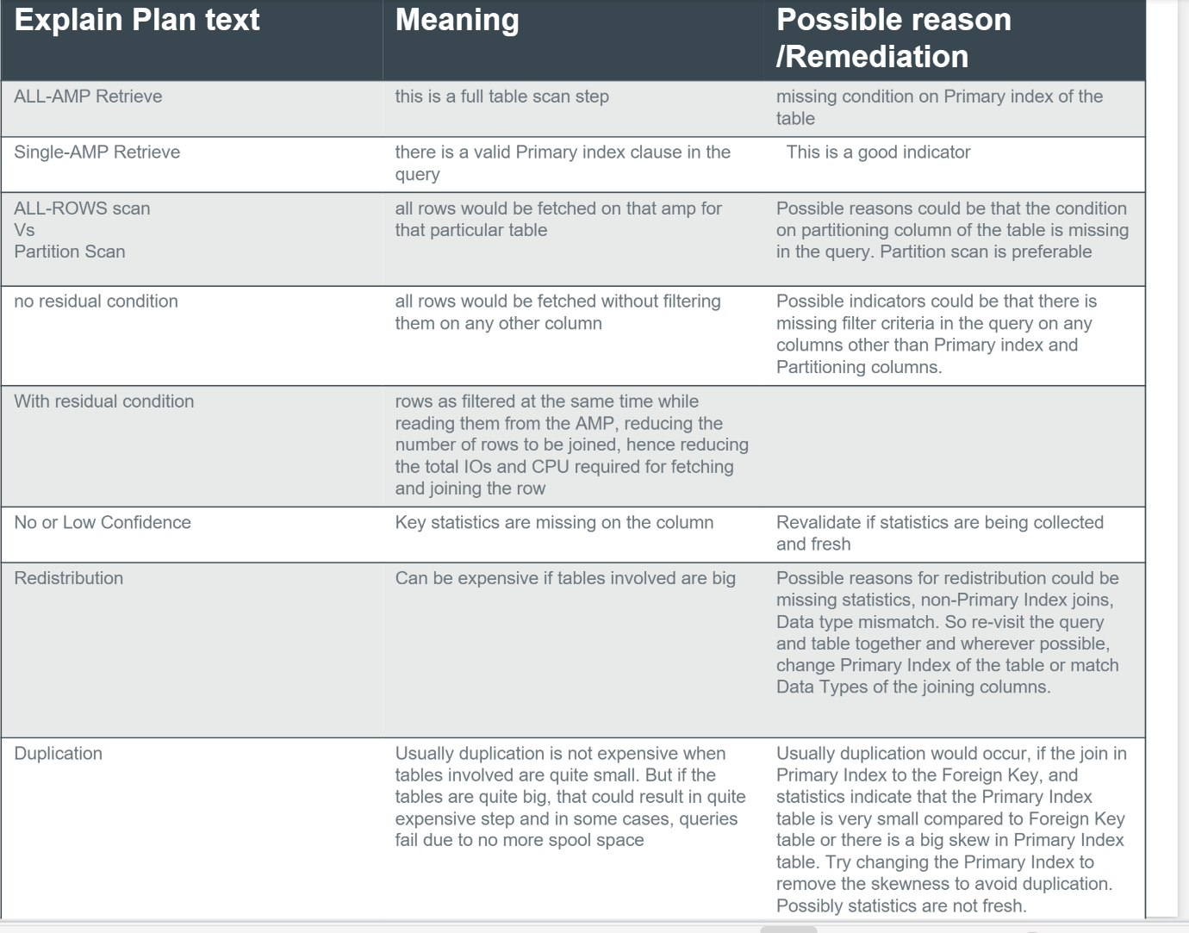
Product Join (PJI) --> Excessive CPU consumption compared to the IO
Large Scans(UJI) --> Excessive IO consumption to the CPU
CPU or IO Skew --> Ratio of average versus max CPU / IO
High Total CPU / IO --> High resource consumption for CPU / IO
Impact CPU / IO --> Effective CPU / IO when skew is applied to the total CPU / IO
Response Times --> Calculation of the execution time or user experience
Number of Rows --> Number of rows returned to the user
Gating Efficiency --> Ratio of the actual active execution time divided by total elapsed time
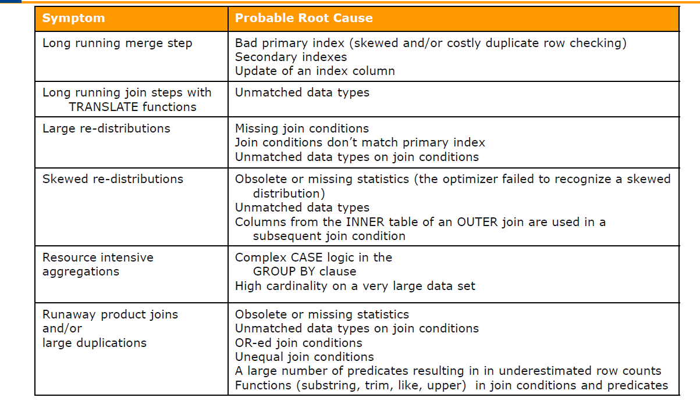
It attempts to predict future data by relying on historical data,
The Performance Indicators
Product Joining - Too Much CPU compared to IOs (PJI)
Large Scans - Too Much IO with Little CPU (UII)
CPU or IO Skewing (CPUSkw or IOSkw)
High CPU/IO resource consumption
Impact CPU (a measure of the Impact of Skewing)
Significant Response Time
High Volume of Rows Returned to User

CPU Optimization Tips:
Use partitions or indexes
Reduce data volume inside of derived tables (can use GROUP BY for example)
Use UNION ALL instead of UNION (duplicate consideration)
Use GROUP BY to eliminate duplicates
Convert SET tables to MultiSET.
Reduce number of functions used
Change PI of skewed tables
Statsb

IO Optimization Tips:
Use partitions or indexes
Use compression
Reduce data volume inside of derived tables (can use GROUP BY for example
Use UNION ALL instead of UNION

Missing statistics to be reviewed
Stale statistics to be reviewed
Unwanted statistics :Repeated statistics collection on table / column that shows no usage in DBQL (Object data) needs to be reviewed
Statistics missing on PARTITION keyword/ column
Stats on Index :Statistics are missing on Index columns
Multicolumn Stats :Statistics are collected on multiple column containing large varchars

Unused Object Removal : Review and Remove unused Tables, Secondary indexes, Join indexes, Users etc.
Multi-value compression : Analyze tables for MVC opportunity to reduce resource usage
Tables with more scope of Compression

Tables involved in large scan : Review large tables going for FTS for PPI/MLPPI opportunities
Improper PI : Use highly unique and frequently used column in join condition.
Skewed PI analysis: Review tables skewed
MULTISET oppournity : SET to MULTISET analysis
Review opportunities to reduce functions (TRIM, COALESCE, SUBSTRING, etc.) on columns especially in the WHERE clause
Avoid use of SELECT * : Remind users to use SAMPLE instead of SELECT * FROM for data samples , or select only required set of columns

Spool Space issue:
Ensure up-to-date statistics
Current statistics are essential so that the optimizer does not copy large amounts of data between the AMPs.

Choose a good Primary Index.
Choose a primary index for your tables that distributes the rows evenly across all AMPs.

Prevent “no more spool space” on the system level
Prevent the system from getting into a situation where spool space is no longer available (e.g., through a spool reserve database).

Release Spool Space as soon as possible
Drop Volatile Tables immediately when they are no longer needed.
Often you rely on this to happen automatically at the end of the session.
Not dropping the volatile tables immediately unnecessarily blocks spool space (and cylinders that Teradata could use as permanent space).

Use Multivalue Compression
Multivalue compression allows the optimizer to keep data blocks compressed in the main memory. Therefore, it is a suitable tool to reduce the required spool space. It makes sense, especially for large tables with few different values or wide columns.

Use the appropriate data types
Data types should be chosen to cover all domain values but do not require unnecessary space. If a BYTEINT is sufficient, then, e.g., we should define no INTEGER column because this needs four times as much space in the spool space (if the column was not compressed). Instead of a CHAR column, a VARCHAR column should be used to save spool space (again, this is relevant if the column was not compressed).

Primary Index Access instead of Full Table Scans
The workload should be designed so that primary index accesses dominate. Above all, UPI or USI access ensures that no spool space is required. Often the PDM is the best tool to prevent spool space problems. Row Partitioning helps to reduce full table scans to specific partitions.

Use the DATABLOCKSIZE parameter to create smaller data blocks
If our workload is primarily tactical, we can use smaller data blocks to prevent the spool needed.

Use columnar table design
If the access pattern is suitable columnar tables can reduce the needed spool space enormously because only needed columns have to be spooled. However, columnar tables must be analyzed precisely and adapted to the workload. We can also achieve a similar result by reducing the number of columns in a table (vertical partitioning).
There are seven different methods of management offered, as illustrated below:
• Methods regulated prior to the query beginning execution
• Session Limits can reject Logons
• Filters can reject requests from ever executing
• Arrival Rate Meter can defer requests by managing the number of requests admitted into
the system per specified time period
• System Throttles can pace requests by managing concurrency levels at the system level.
• Classification determines which workload’s regulation rules a request is subject to
• Workload-level Throttles can pace the requests within a particular workload by managing
that workload’s concurrency level
• Methods regulated during query execution
• Priority Management regulates the amount of CPU and I/O resources of individual requests
as defined by its workload rules
• Exception Management can detect unexpected situations and automatically act such as to
change the workload the request is subject to or to send a notification

