My Learning
Product Requirement Document

Item | Details
Author | Firstlight
Document Status | Requirement Review
Document Version | v1.0
Scope | Access to the user’s personal learning and accounts centre: study records, subscription summaries, in-app notifications, personal settings, FAQ
Language | English; the Portal UI and static content support both English and Chinese.

Version History
Version | Date | Notes
v1.0 | 14-08-2026 | Defines the scope, page structure, fields, status, jump, interface dependence and acceptance conditions for the first complete definition of My Learning.

Contents
1. Product Background, Objectives, and Scope 3
1.1 Objectives 3
1.2 Scopes and Cross-Module Boundaries 3
2. Information Architecture and Navigation Rules 4
3. User States, Access, and Data Definitions 5
3.1 Subscription / Entitlement States 5
3.2 Study Records and Progress Definitions 6
3.3 Notification and Email Rules 6
4. Functional Scope and Key Rules 7
4.1 Profile Rules 7
4.2 Boundaries for Stripe-Hosted Actions 8
5. Key CTA, Redirect, and Return-Routing Matrix 8
6. Page Requirements and Structure 10
6.1 My Learning Overview 10
6.2 My Subscription 12
6.3 Notification Center 13
6.4 Personal Settings 15
6.5 Help Center / FAQ 17
7. Functional Requirements 19
8. Data Interfaces, Tracking, and Non-Functional Requirements 21
8.1 Cross-Module Data Contracts 21
8.2 Event Tracking 22
8.3 Non-Functional Requirements 22
9. Acceptance Checklist and Open Items 23
9.1 Acceptance Checklist 23
9.2 TBD 23
Appendix A: Key Terms 24

1. Product Background, Objectives, and Scope
My Learning is the authenticated account center for Learning Guide. It gives users one place to see courses they have started, their current subscription, in-app notifications, profile, and the public FAQ, while delegating learning, billing, and authentication processing to the corresponding modules.

1.1 Objectives
- Enables users to quickly return to the courses they have started and to identify course-level learning progress and current Lesson.
- The status of interest in trial, subscription, cancellation, failure to renew fees and obsolescence is clearly presented and users are prevented from losing their learning paths due to unclear payment status.
- Provide traceable subscription / payment record entry and minimum necessary profile settings.
- The inclusion of FAQ notifications and disclosure in the individual centre reduces the cost of user searching for account information on different pages.

1.2 Scopes and Cross-Module Boundaries
Domain | My Learning Duty | Not Defined in This PRD
Study（Batch 2） | Displays course progress and provides quick access to the course. | Video / text player, Learning Point record, learning time collection, and continuity of course completion logic and learning progress.
Subscription | Displays the subscription summary, record, status and entry point to the hosting account action. | Set rules, trial eligibility, cancellation / restoration, failure to recover, upgrade, prices, taxes and payments, and the creation of a speech.
Order / Payment | Displays a record of successful payments / failure attempts to return. | Order creation, reconciliation of accounts, receipt generation, updating of payment methods, refunds, Stripe webhook.
User Registration | Images, nicknames, language and password modification portals are displayed. | Registration, log-in, email authentication, password security strategy, forget passwords, session strategy, and email changes.
Portal | Use harmonized Header, Footer, FAQ content and navigation rules. | Open page IA, Pricing, course details and full requirements for the release of Lesson.

2. Information Architecture and Navigation Rules
The account centre uses the "left navigation + stand-alone direct address" model: The user visualizes the content in My Learning, and each tier 1 item at the browser level has a separate URL. This will support direct access, such as refreshment, return, bookmarks and notification within stations.
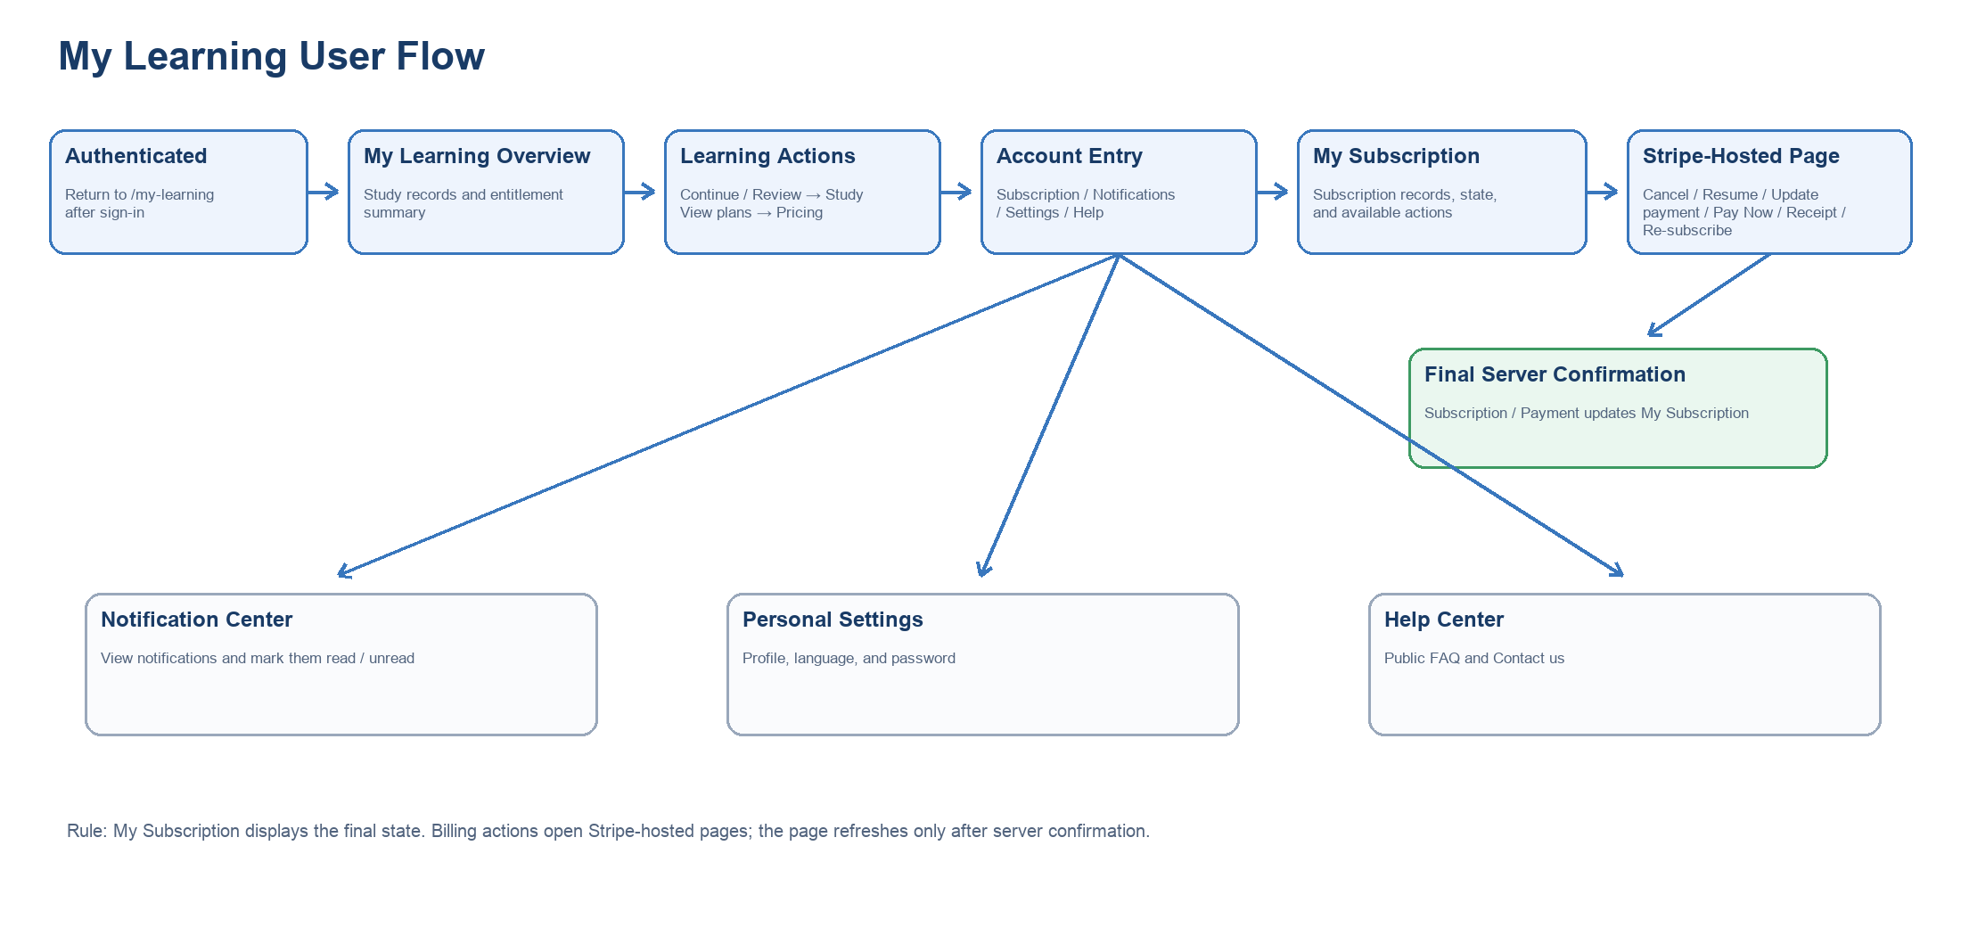
Figure 0 | My Learning User Flow
Flow note: My Subscription displays subscription state, records, and applicable actions only. Every subscription- or payment-related action opens a Stripe-hosted page. My Subscription refreshes only after the server confirms the final result. Plan selection remains within Pricing / Subscription.
Navigation Item | Recommended Route | Access | Notes
Overview | /my-learning | Authenticated | Default access: display only the user’s existing learning and account summary.
My Subscription | /my-learning/subscription | Authenticated | Learning Guide built its own subscription logs and operations portal, which is not replaced by a Stripe page.
Notification Center | /my-learning/notifications | Authenticated | list and single read / not read operation.
Personal Settings | /my-learning/settings | Authenticated | Image, nickname, language, password modification.
Help Center | /my-learning/help | Authenticated | The same set of public FAQs embedded in My Learning; service contact portals are independent of Help Desk.
The authentication door is closed without login user access to any / my-learning / * path, the system enters login / registration first; the authentication is successful and returns to the original target path. Header shows "My Learning" on the right after login, clicks into / my-Learing.

3. User States, Access, and Data Definitions

3.1 Subscription / Entitlement States
State | My Learning Display | Learning Visit and Master CTA
Registered users (no subscription) | Shows that there is no active subscription; existing study records remain visible. | Full Courses are unavailable; View plans → Pricing.
Trial Active | Displays Trial Active, plan scope, device entitlements, trial_end_at, and auto-renewal state. | Cancellation removes trial entitlements immediately. Before the original trial_end_at, the user may select Resume auto-renewal and continue to Stripe; after expiration, the user must re-subscribe.
Trial Canceled | Showcasing that the trial has been cancelled and that there is no effective learning interest. | Cancels the immediate loss of trial entitlement; automatic renewal can be restored before the original trial_end_at; resubscription after expiry.
Subscribed | Shows the scope of the program, PC / Mobile entitlement, AI points, validity, automatic renewal status and record. | reserves an entitlement before the deadline; restores the automatic renewal button to jump Stripe.
Cancelled (current cycle valid) | Displays the cancelled auto-renewal and current service deadline. | Keep an entitlement until the deadline; restoration of auto-renewal is done within My Subscription.
Continuation fee failed / grace processing | The presentation of payments is to be processed and does not show the countdown of the recovery period. | Retains an entitlement during the restoration period as defined in Subscription; update the payment mode / Pay Now → Stripe-hosted page.
Expired | Shows no valid subscription; historical records are maintained. | Official courses are not accessible; resubscription to Stripe-hosted Checkout.

3.2 Study Records and Progress Definitions
Rule | Definition
Create a Study Record | Study creates a Course study record when the user first opens the full Course learning page with a valid entitlement and starts Lesson 1. Merely viewing Course Detail or a Public Lesson does not create a full-Course study record.
List Scope | Overview displays all of the user’s already started Course, including ongoing, completed and currently unentitled history; does not display recommended courses.
Sort Order | Press Course for the first start of learning; the most recent Course is at the top.
Progress formula | Course progress = 100 per cent of the total length of time studied. Page shows only rounded integer percentages, with a minimum of 0 per cent and a maximum of 100 per cent, without decimals.
Video / Text Unanimously | The video is recorded for valid viewing hours returned by Study. Text learning is factored into the standard learning hours that Lesson configured in content management. Toggle video and text cannot accumulate the same content; the weight and completion rules are defined by Study.
Current | Each Course card displays the current / recently studied Lesson X; the value is returned by Study. Done Course shows 100% and 'completed'.
History | Keep Course, progress and current Leson information; no official entrance to study, CTA is changed to "See the package" and enters Pricing with the Course / Category context.

3.3 Notification and Email Rules
Type of notification | In-App Notification | Email | User control
Test & Subscription | Organisation | Trial Activated, Trial Canceled, Trial Payment Failed, Trial Expired, another e-mail; Trial Reactivated, Trial Conversion is only on site. | The user cannot close the transaction notification.
Product / Operation | Not in initial range. | Do not send marketing e-mails. | Follow-up functions are redefined.

4. Functional Scope and Key Rules
Scope | Start function | It's not on initial.
Overview | Account summary, all started Course, Course progress, current Lesson, go to study or view the meal. | Recommended courses, screening, manual scheduling.
My Subscription | Status summary, package / value / validity / payment or trial date as shown in the record, access to Stripe-hosted actions. | Payment, modification of payment modalities, refund or back-office management of orders is completed on this page.
Notification Center | Subscriptions and payments, six class Trial announcements; single read / not read. | All tags are read, notification search, notification details routing rules, notification preferences.
Personal Settings | Images, English nicknames, language, password changes. | Change the main email, cell phone login, social account binding, notification preferences.
Help Center | Account questions, payments and subscriptions, GroupStudy type FAQ; current page expands the answer. | Search, submission of worksheets, online customer service window, membership only.

4.1 Profile Rules
Field | Rule | Abnormal feedback
Heads. | JPG, PNG, WebP; single file maximum 5 MB; upload the rear square tailor; remove and restore the default header. | Format / size does not match and is not available.
Nickname | Required; English only; maximum 15 characters; special symbols not allowed; no one is required. | Saves prevalidation; does not pass highlighted fields and suggests rules.
Language | English / Chinese; default English. Switch Portal UI immediately after saving and last. | This does not affect the course body, video subtitles or the Stripe page that has been opened.
Password | Enter the current password, the new password and the confirmation password; forget password process when you forget the current password. | Password rules, authentication, session security and error semantic re-use UNSer Regulation PRD.
Registered Email | Displays the validated master account identifier; initialing is not in My Learning. | The changes to the email are a follow-up to the User Regulation.

4.2 Boundaries for Stripe-Hosted Actions
My Subscription is a Learning Guide self-created page; it does not process any sensitive payment information directly. Enter the Stripe-hosted page when the user clicks on the following actions, and then syncs and refreshs My Subscription by Subscription / Payment.
My Subscription operation | Stripe Target | Page Behavior Back
Cancel auto-renewal | Stripe Customer Portal：Cancel auto-renewal | Back to the current page, the service confirm and update to " Canceled (valid for the current cycle) "; a trial cancellation immediately ceases an entitlement.
Resume auto-renewal | Stripe Customer Portal：Resume auto-renewal | Return to the current page and update after confirmation by the service user as automatic renewal; Trial Canceled can be restored and not extended until the original trial_end_at.
Update payment method | An updated payment process for Stripe Customer Portal. | Return My Subscription; no direct assumption that the renewal has been successful.
Pay Now | Stripe-hosted restore payment page. | Success updates validity / state; failure retains payment status.
Receipt | Repeipt / Innovation. | View on a new window or Stripe page; failed to try not to provide Receipt.
Re-subscribe | Stripe-hosted Checkout, with the context of the historical subscription plan. | My Subscription; right landing confirmed by Subscription / Payment.

5. Key CTA, Redirect, and Return-Routing Matrix
The following CTA ID is a common index of products, UX, development, QA and tracking sites. Except as defined in this table, the content of the notice itself is not specified at the place of jump at the initial launch.
CTA ID / Location | Trigger Control | Target Page / Action | Permissions, parameters and returns
CTA-HEADER-ML-01 | Header：My Learning | /my-learning | Login only for user displays; enter Overview.
CTA-ML-NAV-01~05 | Left Navigator | Corresponding / my-learning / * Address | The same page account centre has a visual switch and updates the URL and browser history.
CTA-ML-OV-01 | Course: Continue learning | Full Course learning pages | Valid interest needs to be verified again; access to Pricing with no interest.
CTA-ML-OV-02 | Course: Review course | Full Course learning pages | Requires an effective interest; entering Price with Course context when no interest exists.
CTA-ML-OV-03 | Course: View plans | Pricing | Carry the source course / source category; default pre-selection for Category belongs to Course, but all Category and everything is visible.
CTA-ML-OV-04 | Learning list empty state: Browne hours | Courses | No login limit.
CTA-ML-SUB-01 | Manage subscription | /my-learning/subscription | Indoor switch, do not enter Stripe.
CTA-ML-SUB-02 | Cancel / Restart automatic continuation | Stripe Customer Portal: Cancel / Restore automatic renewal | Return routing / my-learning / subscription; end state refreshs with service-end confirmation. The right to immediate withdrawal is suspended on a trial basis and the formal fee is withdrawn to valid_to.
CTA-ML-SUB-03 | Update payment / Pay Now | Stripe-hosted page: Update payment / Pay Now | Return routing / my-learning / subscription; final status is determined by service-end confirmation.
CTA-ML-SUB-04 | Receipt | Stripe Receipt / Invoice | Only displays of successful payment records; external new window or hosted page.
CTA-ML-SUB-05 | Re-subscribe | Stripe Host | with historical scenarios; successfully returning / my-learning / subscription.
CTA-ML-NTF-01 | Mark as read / unread | Current Notification Center | Only update the status of this article; all tags are not supported.
CTA-ML-SET-01 | Information / Language Division Save | Current Standard | Shows a light hint successfully; switch UI immediately after the language is successful.
CTA-ML-SET-02 | Save new password | Current Standard | successful tip; failure to display by User Registration.
CTA-ML-HELP-01 | FAQ issues | Current Help Center | Expand / close the answer on the current page; do not jump.
CTA-ML-HELPDESK-01 | Bottom left: Contact us / Open support chat | Client service window | Call the customer window for Batch 3 Help Desk; do not enter Help Center and do not repeat the FAQ entrance.
CTA-HEADER-NTF-01 | Header：Notification | /my-learning/notifications | Visitor login / register and return to the notifying centre; login users enter directly.

6. Page Requirements and Structure
Each level 1 item is a stand-alone router page with the same Header, left navigation and Footer. The next UI phase can adjust the visual layout without changing the information architecture and functional compacts.

6.1 My Learning Overview
Field | Requirement
User Goal | Focus on a summary of personal accounts and all the learning that has begun.
Access | Signed-in users only.
Page Address | /my-learning
Page Modules / Displayed Information | Standard login Header; Left Navigator; User Summary (heading, nickname, certified email, current entitlement); Learning Content Area; Course Card; Bottom Left Contact us; Footer.
Interactions, States, and Navigation | The card presents cover, Course name, Category, small word profile, total Lesson number, current / latest Lesson X, integer progress, status and CTA. list. CTA is in progress; complete is Review course; no interest history is View plans. Contact us opens the Batch 3 Help Desk passenger service window; HelpCenter only maintains the left navigation portal.
Detailed Rule Owner | Learning logs, durations and the current Lesson return from Study; benefits return from Subscription; Help Desk customer support window defined by Batch 3; route and frame defined by My Learning.
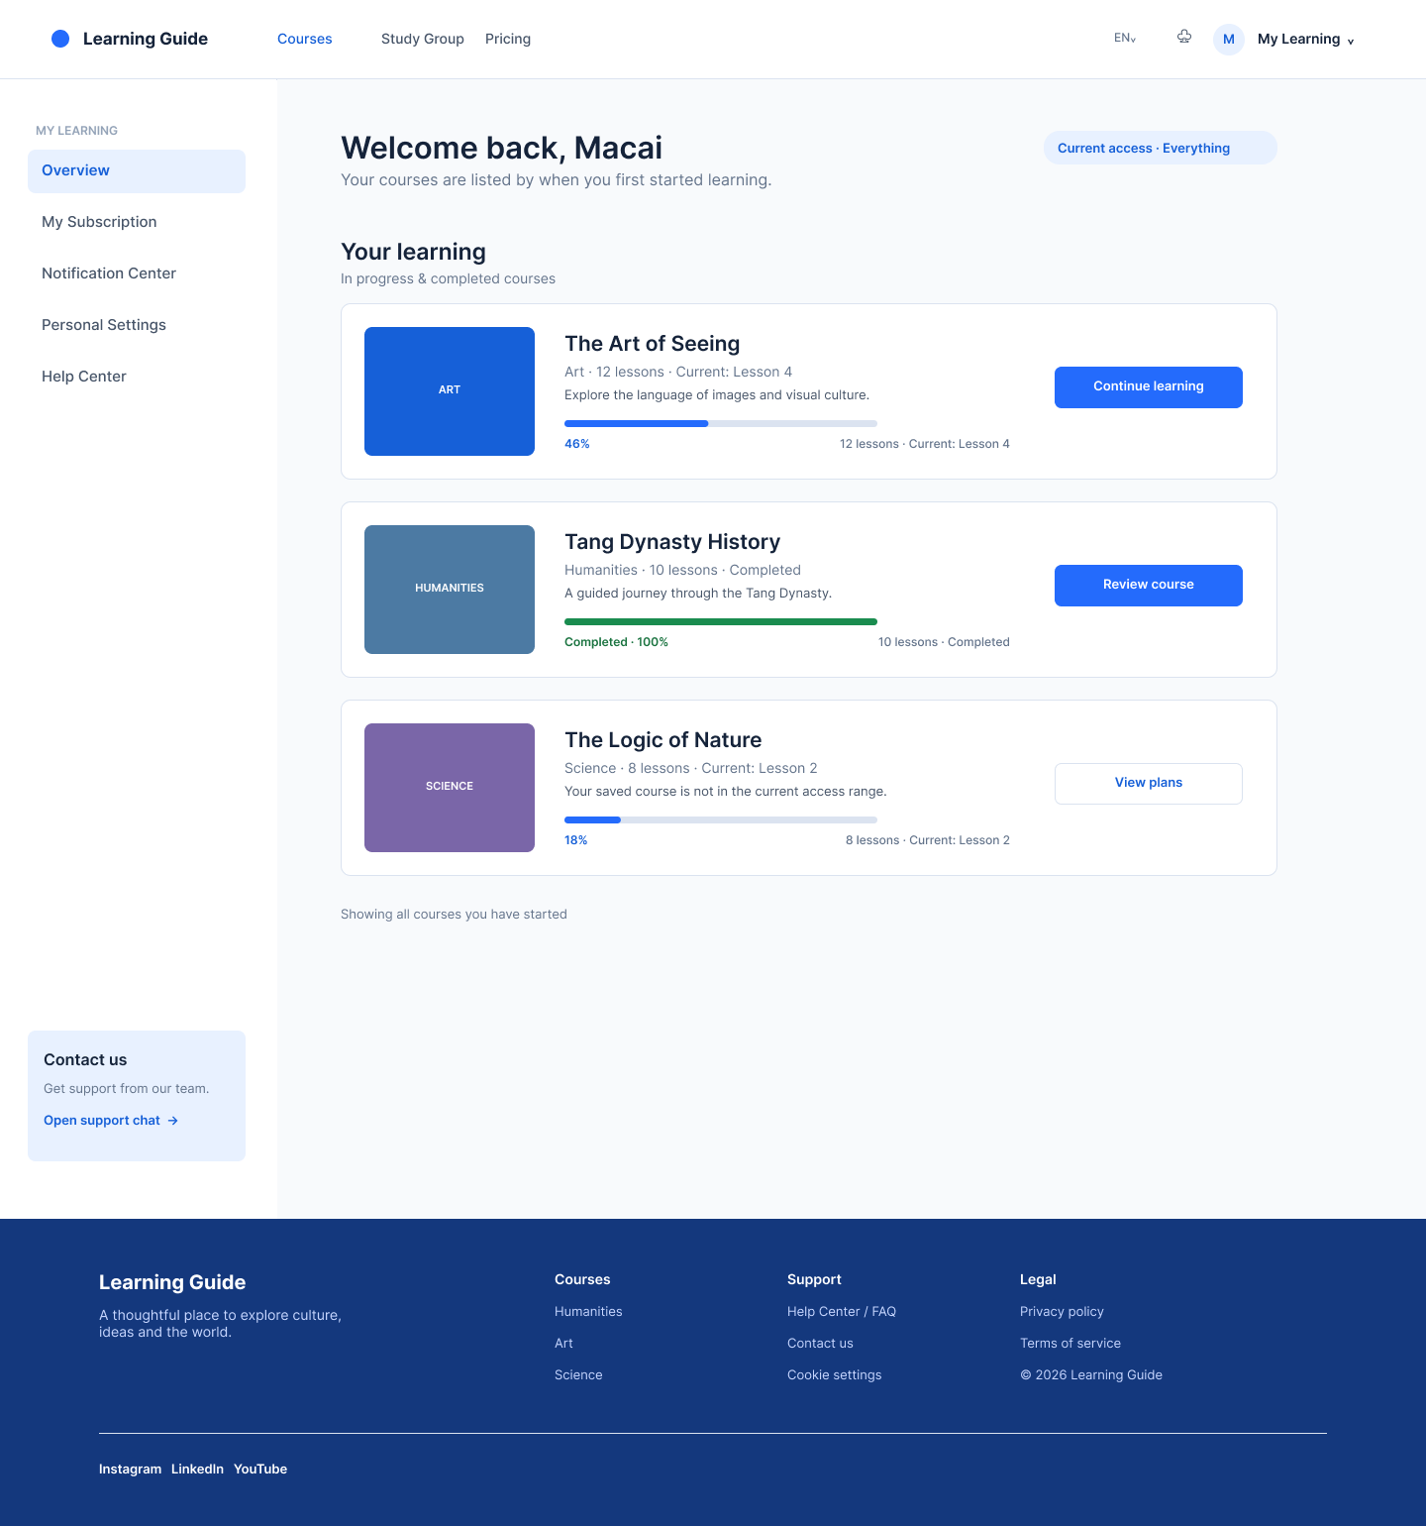
Figure 1 | My Learning Overview
The page shows the status of the three cards in progress, completed and currently unentitled history.

6.2 My Subscription
Field | Requirement
User Goal | View the subscription status of the user, the record of successful payments and the failure attempt, and enter a specific account operation.
Access | Signed-in users only.
Page Address | /my-learning/subscription
Page Modules / Displayed Information | Standard Login Header; Left Navigator; Summary of Current Interests; Four Columns of Subscription (Subscriptions, Amount, Valid Perud, Payment Date / Attempt Date); Status and Operations; Lower Left Point us; Footer.
Interactions, States, and Navigation | The current subscription status, the summary of current entitlements and the subscription / payment record are displayed on the page. Successful records provide Receipt; failed attempts to show Payment failed, No new period and resume operations, but do not provide Receipt. Cancel / restore auto-renewal, update payment methods, Pay Now, Receipt, Re-subscribe all jump to Stripe.
Detailed Rule Owner | Packages, status machines, order / payment lines, Stripe URLs and payment results are returned by Subscription, Order Management, Payment Management; the Help Desk passenger service window is defined by Batch 3.
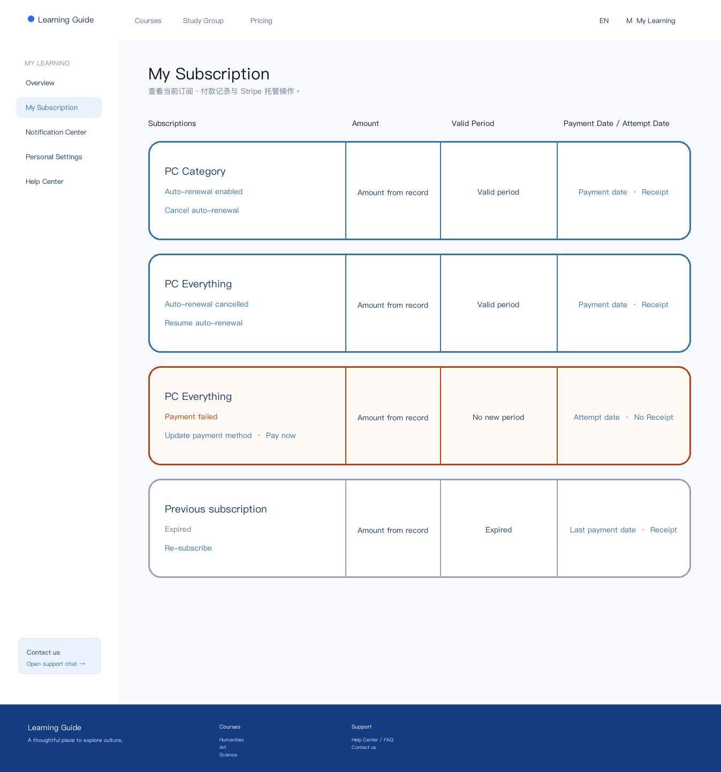
Figure 2 | My Subscription

6.3 Notification Center
Field | Requirement
User Goal | Check the account station to notify and manage each read state.
Access | Signed-in users only.
Page Address | /my-learning/notifications
Page Modules / Displayed Information | Standard Login Header; Left Navigator; List of Notifications; Each Article Title, Summary, Time, Type, Read / Unread and Single Switch; Empty Status; Bottom Left Contact us; Footer.
Interactions, States, and Navigation | Starts with only subscriptions and payments and six class Trial announcements. Unread items are cumulative in Header count; the user can mark read or not; not all tags are read. Do not define a jump in the click notification itself; content is only read on the current page. Bottom leftContact us opens the Batch 3 Help Desk customer support window.
Detailed Rule Owner | Notification generated events and mail sent by Subscription / Operating System; My Learning for list, read state and Header unreading; Help Desk support window defined by Batch 3.
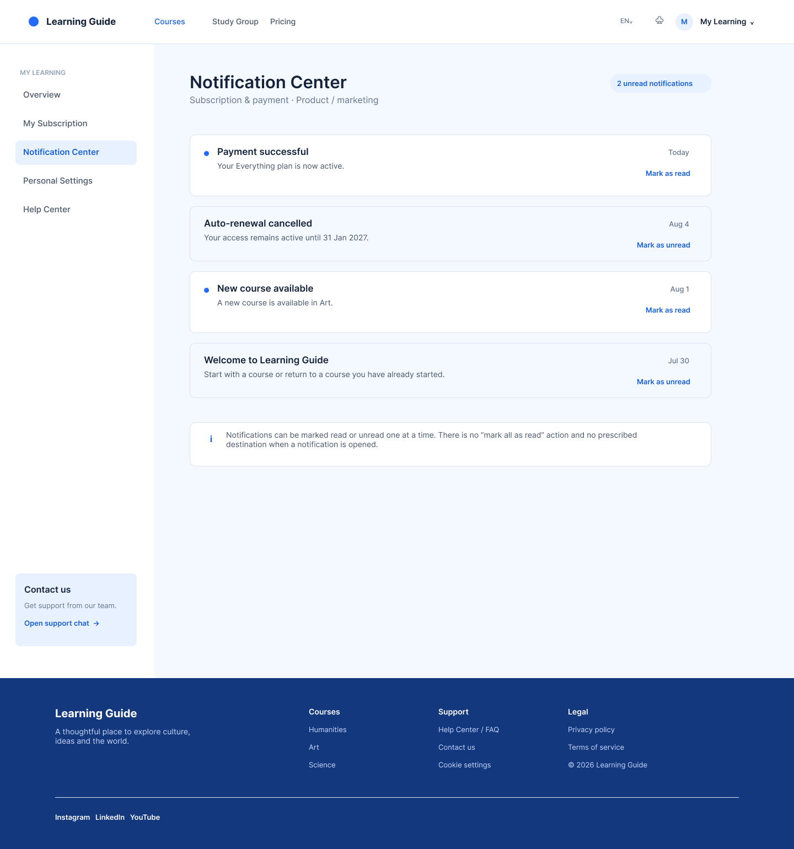
Figure 3 | Notification Center

6.4 Personal Settings
Field | Requirement
User Goal | Maintenance of profile, interface language and password.
Access | Signed-in users only.
Page Address | /my-learning/settings
Page Modules / Displayed Information | Standard login mode Header; left navigation; header area; nickname area; language area; password revision area; registered email display only; lower left corner Contact us; Foster.
Interactions, States, and Navigation | Headers are uploaded, replaced, removed according to rules; nicknames are pre-saved; Portal UI is switched as soon as language is saved; passwords are entered into the current password, new password and confirmation password. Each block is preserved independently. No notice preferences, and no changes to the main email are allowed here. Bottom leftContact us opens the Batch 3 Help Desk customer support window.
Detailed Rule Owner | Password rules, forget passwords, session security, upload storage defined by User Registration / Technical plan; Help Desk support window defined by Batch 3; My Learning definition interface and call boundaries.
The product / operational mail agreed to confirm only at the time of payment that it was not the first control item for Settings.
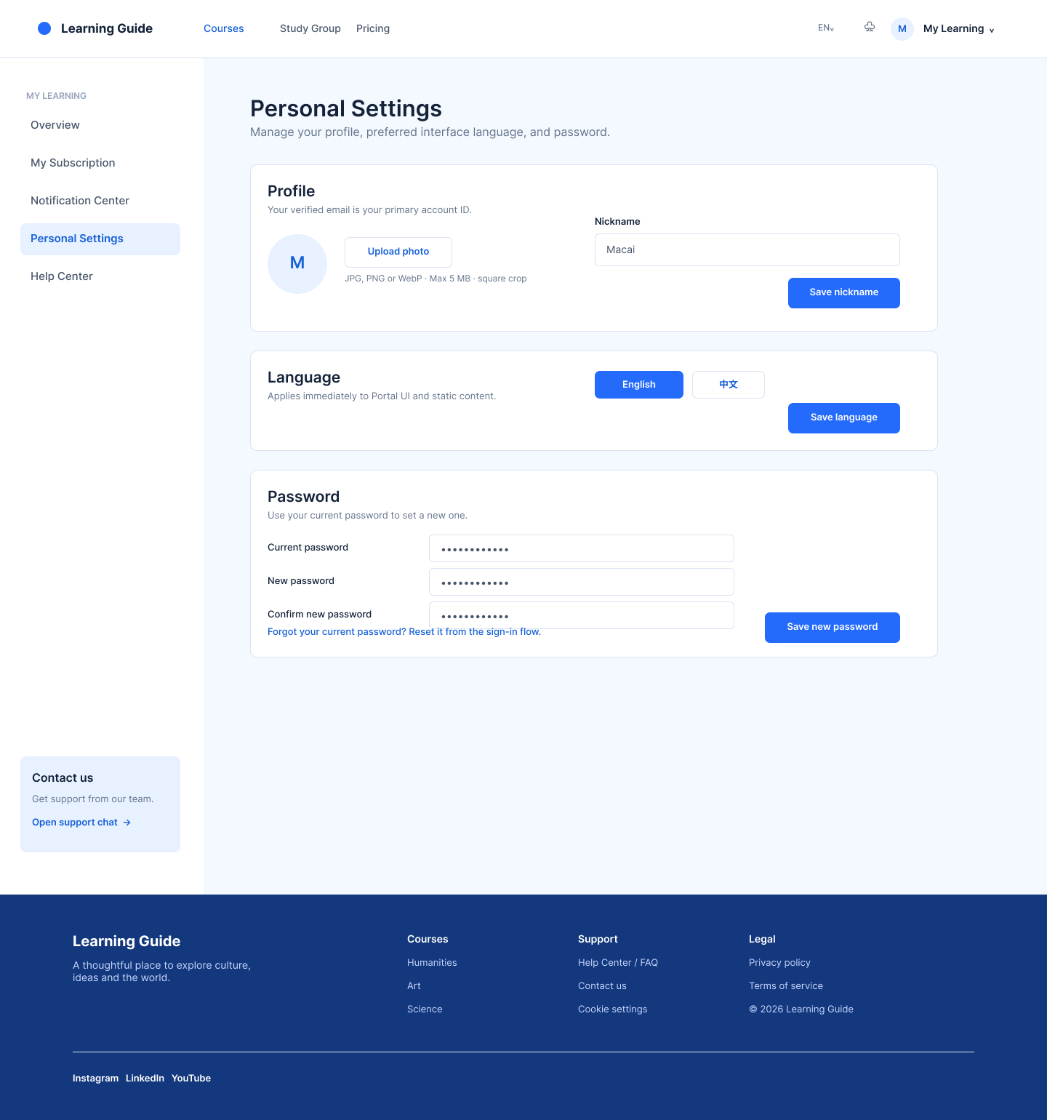
Figure 4 | Personal Settings

6.5 Help Center / FAQ
Field | Requirement
User Goal | • Self-help in obtaining answers to frequently asked questions within the account centre.
Access | My Learning only logs in; the same FAQ is also publicly accessible.
Page Address | /my-learning/help
Page Modules / Displayed Information | Standard Login Header; Left Navigator; Account Problems, Payments and Subscriptions; GroupStudy Three FAQ; Current Page accordion Opens; Bottom LeftContact us; Footer.
Interactions, States, and Navigation | Search, submission of worksheets, online passenger service windows or only login content are not supported. Either FAQ click to expand or close on the current page. Open FAQ to share the same operational configuration as the content, classification, sequence and answer in My Learning. Bottom left Contact us is the independent passenger service entrance, opening the Batch 3 Help Desk passenger service window, which does not belong to the FAQ module.
Detailed Rule Owner | Portal / Backoffice provides FAQ content sources; My Learning only provides embedded access to login; the Help Desk passenger service window is defined by Catch 3.
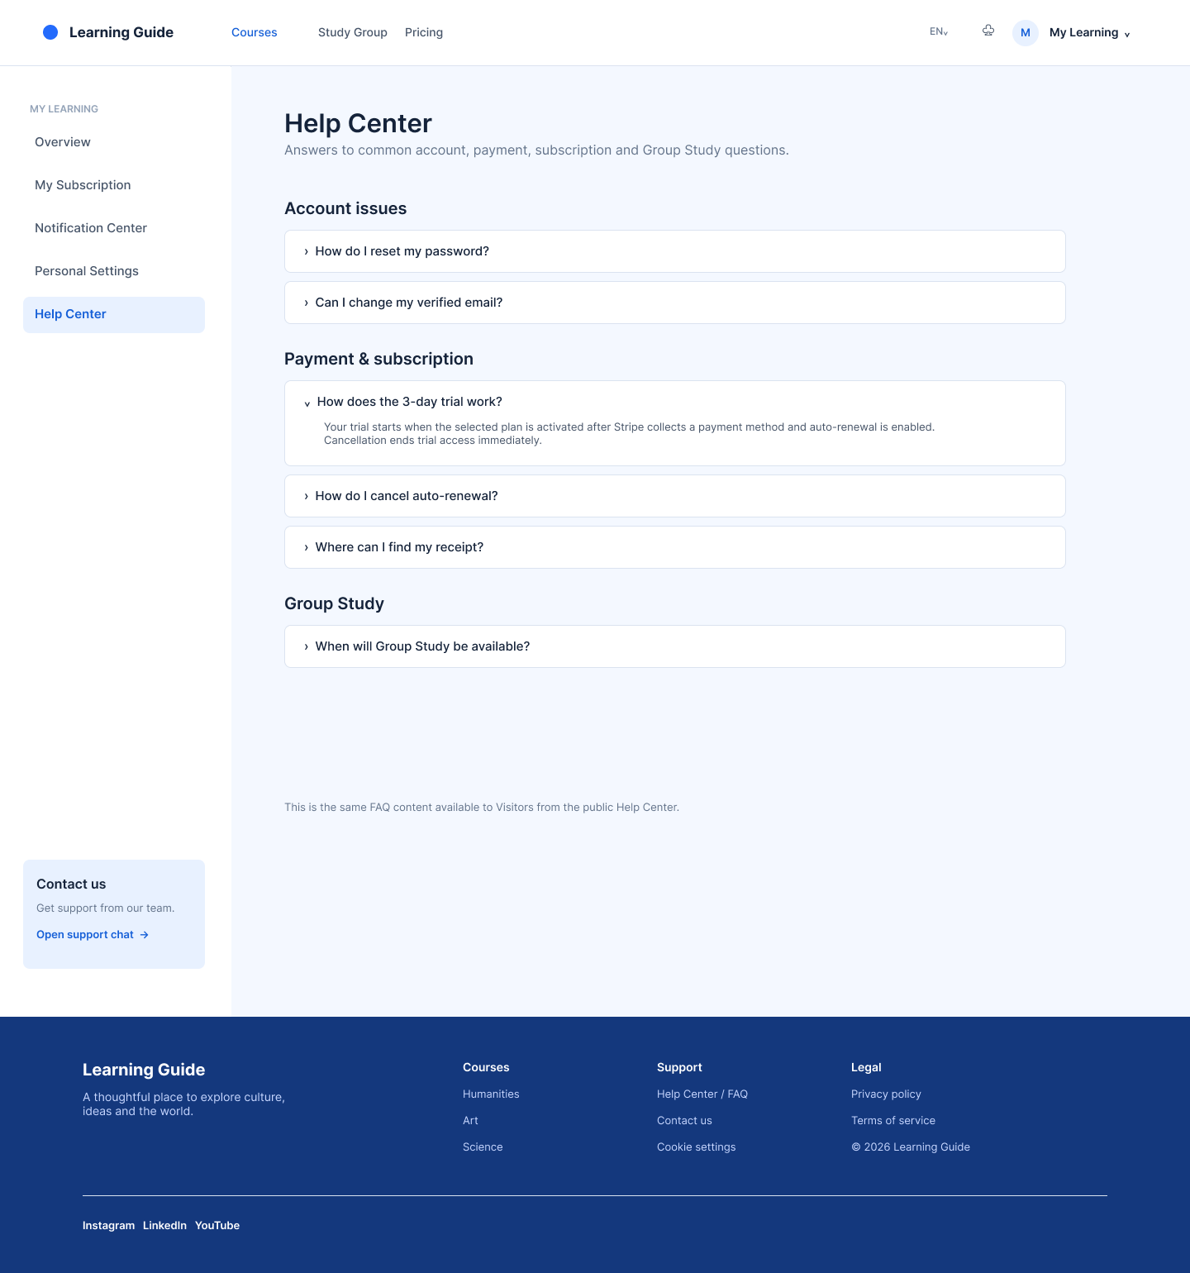
Figure 5 | Help Center / FAQ

7. Functional Requirements
ID | Priority | Requirements | The point of acceptance.
ML-FR-001 | P0 | Login user Header shows My Learning at the right; click into / my-learning. | Visitor does not show My Learning; all / my-Learing / * are protected by login doors.
ML-FR-002 | P0 | The left-hand navigation consists of Overview, My Subscription, Notification Center, Personal Settings, Help Center. | Click to switch the contents and update the independent URL; the item remains with the update.
ML-FR-003 | P0 | Overview displays only the Course that the user has started to study, and not the recommended course. | Show only empty and Browne lessons CTA when there is no learning record.
ML-FR-004 | P0 | Creates a Course learning record when you first open an entitlement full Course learning page and start at Lesson 1. | The course details and the public Lesson access do not create official study records.
ML-FR-005 | P0 | The learning list shows all the beginnings of the course, in reverse order of the first start. | Course retains ongoing, completed and unentitled history; no filter is provided.
ML-FR-006 | P0 | The Course card shows the cover, name, Category, short description, the total number of Lessons, current / latest Lessons, integer progress, status and CTA. | Progress shows only integers of 0-100; 100 per cent of Corse is complete.
ML-FR-007 | P0 | Course progress is calculated by the length of study and the total length of Course returned by Study. | Videos and texts use a single valid long definition and cannot be accumulated over time by switching.
ML-FR-008 | P0 | Effective entitlement users can access the full Course learning page from the Course card. | History with no valid entitlement to keep progress, CTA to Price with context.
ML-FR-009 | P0 | My Subscription displays current status and subscription / payment records. | The record shows at least the scope, amount, duration, date of payment or attempt, state and operation of the package.
ML-FR-011 | P0 | Cancelling / restoring auto-renewal, updating payment patterns, Pay Now, Receipt, and resubscription are all available on the Stripe-hosted page. | Safe return My Subscription; status refreshed with service-end final result. The right to immediate withdrawal is suspended on a trial basis and the formal fee is withdrawn to valid_to.
ML-FR-012 | P0 | Notification Center displays subscription / payment and six class Trial notifications. | Does not include product / business notifications or marketing mail preferences.
ML-FR-013 | P0 | Users can switch read / not read to single notifications. | Not all tags are read; initial undefined notification details jump.
ML-FR-014 | P0 | Header displays the number when there is an unread notification and hides it when it is not read. | Visitor does not show unread numbers; click notifications log in before returning to the notification centre.
ML-FR-015 | P0 | Personal Settings supports image, nickname, language and password changes. | Nickname must be filled, English only, maximum 15 characters, no special symbols allowed.
ML-FR-016 | P0 | Headers support JPG / PNG / WebP, maximum 5 MB, square tailoring and restoration of default. | Failure to meet the requirements is not communicated and the reasons are clear.
ML-FR-017 | P0 | Language is switched and sustained immediately after saving. | Only Portal UI / Static content is affected, without prejudice to course content, subtitles, or a Stripe page that has been opened.
ML-FR-018 | P0 | Password change requires the current password, new password and confirmation password. | Could not close temporary folder: %s
ML-FR-019 | P0 | HelpCenter reuses Open FAQ to display three types of answers and expands on the current page. | Visitors and login users see the same set of content; no search, worksheet or FAQ internal passenger service window.
ML-FR-020 | P0 | The bottom-left corner of the account centre shows Contact us / Open support bit. | CTA opens the Batch 3 Help Desk passenger service window; does not enter Help Center to avoid duplication with the left FAQ navigation.

8. Data Interfaces, Tracking, and Non-Functional Requirements

8.1 Cross-Module Data Contracts
Data Source | My Learning Consumer Field | Use
Subscription / Entitlement | access_state、trial_state、scope_type、scope_id、plan_type、device_access、ai_points_granted、auto_renew、trial_end_at、valid_from/to。 | User summary, Corse rights judgement, My Subscription status and CTA.
Order / Payment | record_id、purchase type、amount/currency、payment/attempt date、valid period、payment status、receipt URL、Stripe action URLs。 | My Subscription four columns of records, status and hosting operations entry.
Notification | notification_id、type、title、summary、created_at、read_at、delivery state。 | Notification Center and Header unread.
User Registration / Profile | user_id、verified_email、avatar URL、nickname、language preference。 | User summary and personal settings.
Backoffice / FAQ | category、question、answer、display order、publish status、language。 | Open with login, Help Center.

8.2 Event Tracking
Scope | Event
Header / Navigation | my_learning_opened、my_learning_nav_changed、notification_center_opened。
Overview | learning_overview_loaded、course_learning_continue_clicked、course_review_clicked、course_view_plans_clicked、browse_courses_clicked。
My Subscription | subscription_page_loaded、stripe_action_clicked（action_type）、receipt_clicked、payment_recovery_clicked。
Notifications | notification_read_toggled、notification_list_loaded。
Settings | avatar_uploaded、nickname_saved、language_changed、password_change_submitted/result。
HelpCenter / HelpDesk entrance | help_center_opened、faq_expanded（category/question_id）、help_desk_chat_opened。

8.3 Non-Functional Requirements
Domain | Requirement
Performance | The main content of My Learning under the normal network is displayed in 3 seconds; learning / subscription / notification data can be loaded independently, and failure of any data source does not block basic navigation.
Load and Error | The data load displays " Please wait a moment "; the failure displays recoverable tips and retry. Failures should not be erroneously displayed as 0% progress, unsubscribed or unnotified.
Security and privacy | My Learning only has login access; Stripe sensitive payment information cannot be stored at the frontend; Stripe jumps are based on service-end validation.
Accessibility | Interactive controls provide visible focus; information headers / course pictures provide alternative text; complete keyboard operability is not listed as P0.
Browsers and Devices | Desktop Web in range; support for Chrome, Safari, Edge, current and previous main versions; original App developed separately; mobile browser support to be determined.
Internationalization | Portal UI, Circular and FAQ support English / Chinese; English is default. The text and subtitles are provided independently by the content system.

9. Acceptance Checklist and Open Items

9.1 Acceptance Checklist
- Login users can enter My Learning from Header and access five independent URLs from the left navigation; failure to login access either path will verify and return to the original page.
- Overview lists only those Course that the user has started, including the completed Course; in reverse at the first start; each card shows current Lesson and no decimal Course progress.
- Course progress is shown according to effective learning time / total length, text learning is recorded according to the configuration criteria and video / text switching does not accumulate over time.
- The history of invalid entitlements Course is kept on the list but cannot enter the study page, and its CTA carries the Course context into Pricing.
- My Subscription displays the status and records in the LG built view; successful records have Receipt, failed without Receipt; only clear account actions enter Stripe.
- Notifications can be article-by-article marked read / not read; unread synchronised Header; not all marked read; subscription and payment mail mandatory.
- Personal Settings supports headers, English nicknames, languages and passwords according to the rules; does not show a notice preference and changes in the main email.
- Help Center is embedded in My Learning while maintaining the same public FAQ that Visitor can see; three types of content can be expanded on the current page; the bottom left corner of Contact us opens the Batch 3 Help Desk guest window and does not duplicate HelpCenter.

9.2 TBD
ID | Matters | Recommendation addressed
ML-TBD-001 | My Subscription records pages / loads more interactively when the number of pages is greater than a single page capacity. | At the frontend, use accessible break pages or " load more ", as determined during the UX design phase; historical records cannot be intercepted.
ML-TBD-002 | Text learning is configured with a time frame, a valid reading decision and video / text to recalculate. | Defined by Study PRD / Technical Program; the Course progress caliber of this document must be adhered to.
ML-TBD-003 | Stripe Customer Portal and the return of the actual URL on the / Receipt page. | Stripe configuration completed by Payment Management; controlled URL generated by service-end.
ML-TBD-004 | Multiple device sessions fail policy when password changes successfully. | Confirmed by User Regulation / Security Policy; does not affect the field and process on this page.
ML-TBD-005 | Move the browser support range. | Confirms with the overall Portal device policy; App does not belong to this PRD.

Appendix A: Key Terms
Term | Definition
My Learning | The individual centre modules after the Learning Guide login include Overview, My Subscription, Notification Center, Personal Settings and Help Center.
Course | A full course, consisting of several orderly Lessons; the learning progress is illustrated by Course.
Lesson | Modules in Course that can be learned independently; each section offers both video and text forms of learning.
Effective learning time | Learning time calculated and returned by Study that can be counted into the Course progress; accumulated indefinitely to avoid double viewing / reading.
Stripe Customer Portal | Stripe provides a hosting client account operating page to cancel / restore renewal fees, update payment patterns, view receipts, etc.
Stripe Checkout | Tripe provides a hosting subscription / disbursement closing page; My Learning can return routing to that page.

