Order Management
Product Requirement Document

Item | Details
Author | Firstlight
Document Status | Requirement Review
Document Version | v1.0
System portal | Teacher Web > Admin Settings > Order Management > Orders
Main roles | Admin user with order management privileges
External system | Stripe
System portal | Teacher Web > Admin Settings > Order Management > Orders

Version History
Version | Date | Notes
v1.0 | 14-08-2026 | The first edition of the Order Management Product Requirements Document: Order List, Regular Order Refund, Unusual Payment Resynchronisation and Page Prototype.

Contents
1. Product Background and Objectives 4
1.1 Background 4
1.2 Product objectives 4
1.3 Criteria for success 4
1.4 Terminology and definitions 4
2. Scope and boundaries 5
2.1 Definition of modules 5
2.2 In Scope 5
2.3 Out of Scope 5
2.4 Cross-modular responsibilities 5
3. Users and cross-module roles 6
4. Global operating rules 6
5. System, page and order process 7
5.1 Order Management Entry Process 7
5.2 Page List 7
5.3 Regular order refund process 7
5.4 Unusual payment orders re-synchronized process 8
5.5 LG Order Associated with Stripe Object 8
6. Functional requirements - List of purchase orders 8
6.1 Order queries and screening 8
6.2 Order List Prototype 9
7. Functional requirements - normal order details 9
7.1 Order Summary 9
7.2 Payment Information 10
7.3 Subscription Information 10
7.4 Activity History and Operations 10
7.5 Normal Order Detail prototype 11
8. Functional requirements - details of unusual payment orders 11
8.1 Abnormal summary 11
8.2 Express Payment Order Detail prototype 12
9. Functional requirements - Refunds synchronized with payment status 12
9.1 Full refund 12
9.2 Refund Conservation Model 13
9.3 Resynchronise Payment 13
10. Modelling of purchase orders and payment status 14
10.1 Separation of Status 14
10.2 Order status 14
10.2 Type of order versus sole operation 15
11. Abnormalities and recovery 15
12. Sites, indicators and statements 16
12.1 Core indicators 16
12.2 Operating events 16
13. Competence, security and non-functional needs 17
14. Acceptance and inspection standards 17
15. Dependence, risk, to be confirmed and appendix 17
15.1 Dependency 17
15.2 Risks 18
15.3 To be confirmed 18
15.4 Core data object recommendations 18

1. Product Background and Objectives

1.1 Background
Once the student subscription is launched, the Learning Guide backstage will automatically create an order, which will be synchronized with Payment (first access to Stripe), where an order management module will be required for all student orders, key connections to Stripe, only administrators can process refunds of orders and deal with abnormal payment orders that are inconsistent with the status of Stripe and LG.

1.2 Product objectives
- A uniform order list is provided to support orders, students, programs, payment status and time queries.
- The purchase plan, the amount, critical Stripe payment information and necessary subscription information are shown in the order details.
- Normal orders only provide full refunds for administrators only.
- The unusual payment order only provides Resynchronise Payment, rereading and updating payment status from Stripe.
- Repayment, renewal of payment methods, cancellation of subscriptions or manual adjustment of course entitlements are not provided in order management.

1.3 Criteria for success
- The administrator can access the Order Management > Orders from Admin Settings.
- The administrator can locate a normal or unusual order and view the necessary business and Stripe connection information.
- Eligible regular orders can be submitted in full and synchronized with the final refund results.
- Unusual payment orders can be reread from Stripe to state-of-the-art and record timing and results.
- Failures or unpaid orders do not provide a repayment entry in order management.

1.4 Terminology and definitions
Terminology | Definition
Normal Order | The payment status is the same as Stripe and there are no unusual payment orders that need to be handled by the administrator.
Exceptional Payment Order | Payment for purchase orders that have been processed for long periods of time, that are inconsistent with the LEG status, that Payment Event is not applied or synchronized.
Resynchronise Payment | LG Actively calls Stripe API to read the latest state of necessity for Checkout Session, PaymentIntent, Voice or Subscription and to update the LG order.
Refund | For eligible regular orders, a full refund request is submitted to Stripe.
Exception Flag | The system calculates an anomaly label based on payment status and synchronized results without replacing Order Status or Payment Status.

2. Scope and boundaries

2.1 Definition of modules
The module defines Order Management as the order operation module in Admin Settings. It uses LG Order as the main line of business, displays the necessary Stripe payments associated with subscriptions and provides the only limited management operation for different types of orders.

2.2 In Scope
- Order List: Search, filter, status label and order entry details.
- Normal Order Detail: Order Summary, little Payment Information, little Subscription Information, Activity History.
- Exceptional Payment Order Detail: LG versus Stripe payment status, recent sync results and causes of anomalies.
- Full refund of normal orders.
- The unusual payment order is read again from Stripe.

2.3 Out of Scope
- Repay or create a new Checkout Session in order management.
- Update payment pattern, cancel or resume subscription.
- Partial refund, refund for the remaining period or automatic calculation of the consumer value.
- Details of the benefits of the course, the manual modification or extension of the course.
- Balance, Payout and bank-to-account statements.
- Full passenger manifest, CRM or accounting ledger.

2.4 Cross-modular responsibilities
Module | Responsibilities
Order Management | Query orders, display critical association status, full refund, extraordinary payments synchronized.
Payment Management | Creates Stripe Checkout Session, receives and validates Stripe Evans, and maintains payment references.
Subscription Management | Students subscribe to self-help, cancellation, renewal and management of payment methods.
Pricing / Plan | Defines the product, the four subscription plans, the price, the scope of the purchase, the equipment entitlement and the AI points snapshot.
Course / Entitlement | After payment has been successful, courses and entitlements are open; independent access information is not displayed in this PRD.
Stripe | The source of external facts for the payment, the Invoice, Subscription and Refund.

3. Users and cross-module roles
Role | Competence/function
Order Administrator | Entering order lists and details; initiating refunds of normal orders; resynchronizing execution of unusual payment orders.
Teacher without Permission | Can't see or enter Order Management.
Student | This module is not directly used; re-payment is required to return the student purchase process.
System | Identification of abnormal orders, reading of Stripe status, ensuring synchronization and refunding operations, etc.
Stripe | Can not get folder: %s: %s

4. Global operating rules
Rule ID | Operational rules
BR-ORD-001 | The Order Management is located in the Admin Settings of Teacher Web, at the entry point of the Order Management > Orders.
BR-ORD-002 | Regular orders only show Refund; unusual payment orders only show Resynchronise Payment. Both operations cannot be displayed simultaneously.
BR-ORD-003 | Repayment is not part of order management. Failures or unpaid orders must be re-initiated by the student purchase process.
BR-ORD-004 | MVP only supports full refunds by administrators and not partial refunds. (Students cannot refund)
BR-ORD-005 | Payment Information only retains Payment Status, Payment Date, Checkout Session ID, PaymentIntent ID
BR-ORD-006 | The details of the order do not show bank cards, payment addresses or other non-essential payment information.
BR-ORD-007 | Subscription Information is shown only in automatic renewal orders and the most necessary fields are kept.
BR-ORD-008 | Refunds and resynchronisations must record the operator, time and end result.

5. System, page and order process

5.1 Order Management Entry Process
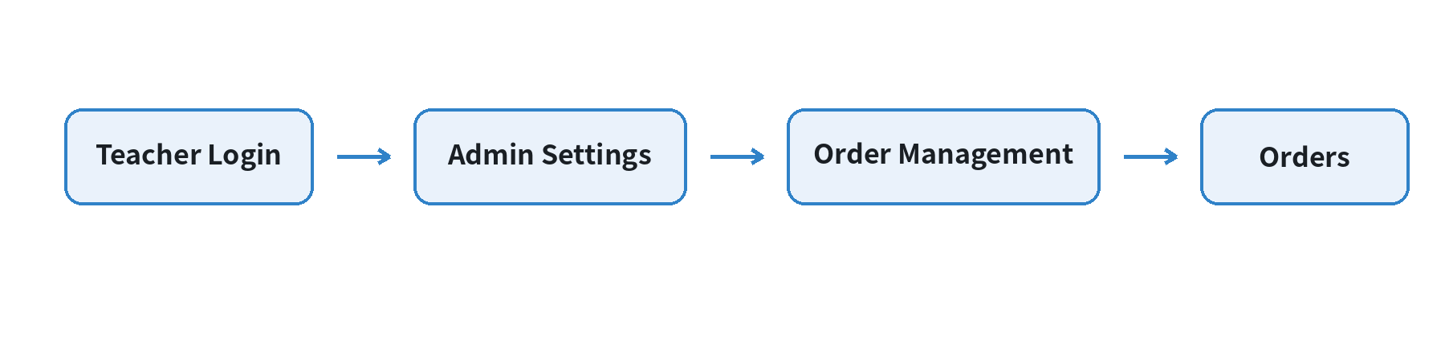
Figure 5-1 Organization Entry Process

5.2 Page List
Page ID | Page | System | Purpose
ORD-P01 | Order List | LG Teacher Web / Admin Settings | Query, screen normal and unusual orders.
ORD-P02 | Normal Order Detail | LG Teacher Web / Admin Settings | Look at the normal order, only the full refund.
ORD-P03 | Exceptional Payment Order Detail | LG Teacher Web / Admin Settings | Views the abnormal payment state, the only operation being to resynchronise.
ORD-P04 | Refund Confirmation Modal | LG Teacher Web / Admin Settings | The full refund is recognized on a second basis.

5.3 Regular order refund process
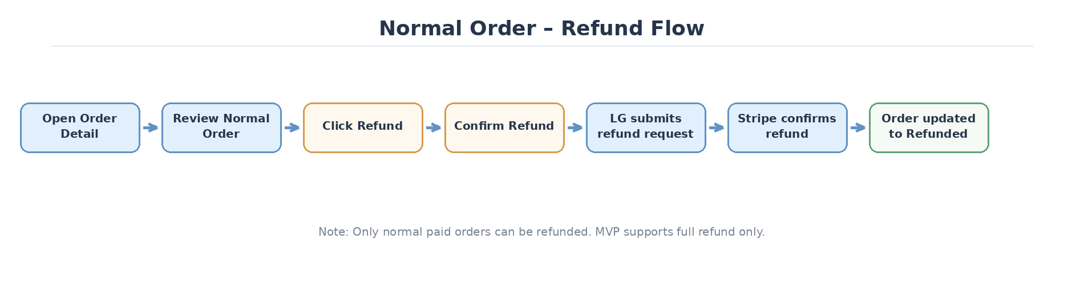
Figure 5-2 Regular order full refund process

5.4 Unusual payment orders re-synchronized process
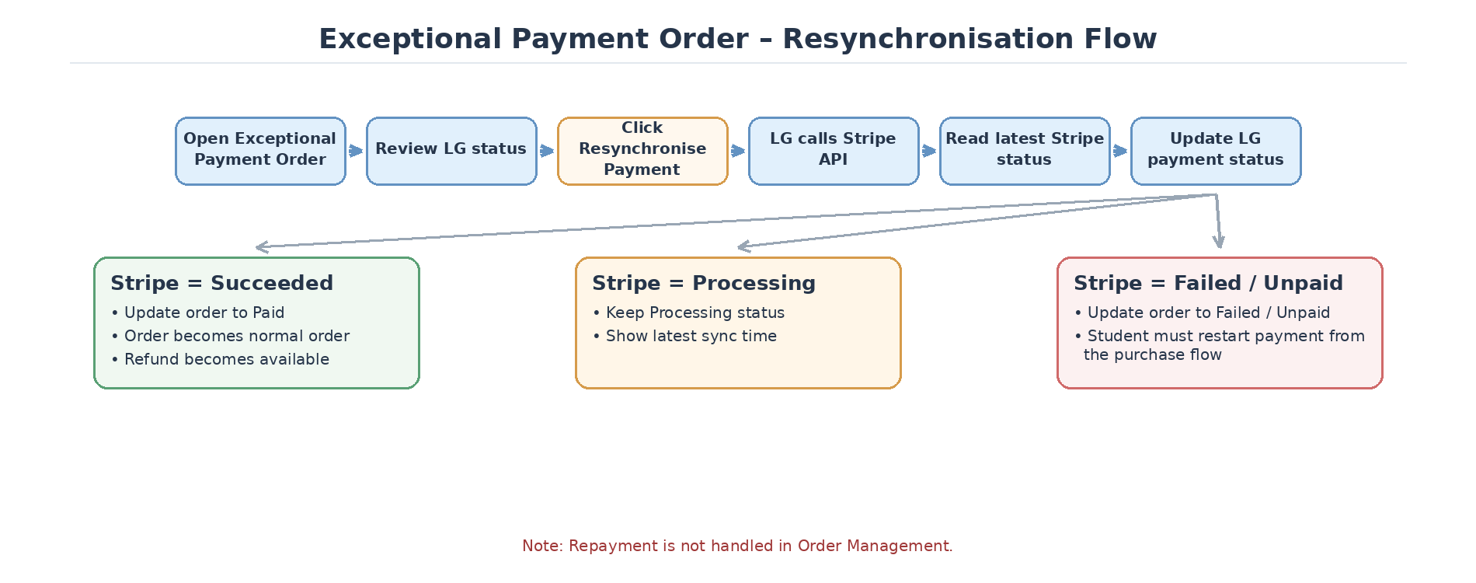
Figure 5-3 Unusual payment orders resynchronized process

5.5 LG Order Associated with Stripe Object
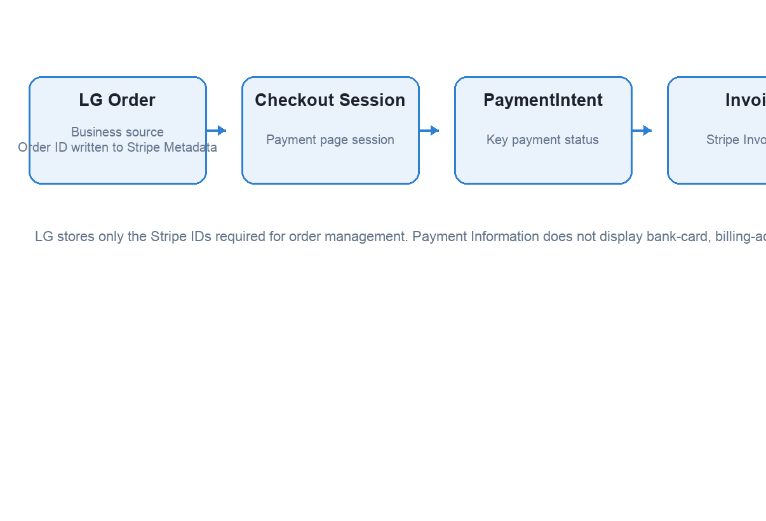
Figure 5-4 LG Order Relation to Stripe Key Object

6. Functional requirements - List of purchase orders

6.1 Order queries and screening
Demand ID | Priority | Requirements | Receiving and Inspection Point
ORD-FR-001 | P0 | This post is part of our special coverage Global Voices 2011. | Access is available to administrators with privileges; access is not visible and is not directly accessible to users without privileges.
ORD-FR-002 | P0 | Supports searching by Order ID or student email. | Enter the full or partial value and return the matching order.
ORD-FR-003 | P0 | Supports filtering by Payment Status, Subscription Status, Order Type / Exchange and Order Date. | Filter can be used in combination and cleared.
ORD-FR-004 | P0 | The list displays Order ID, Student, Project / Plan, Billing Type, Amount, Payment Status, Subscription Status, Order Date, Exception and View. | Fields are consistent with the order fact, fixed-term Subscription Status shows N/A.
ORD-FR-005 | P0 | The abnormal order displays a clear abnormal label. | At least cover Processing Too Long, Stripe / LG Status Mismatch, Payment Event Missing, Synchronization Failed.
ORD-FR-006 | P0 | The list does not directly provide refunds or resynchronisation operations. | The administrator must perform the operation after entering Order Detail.

6.2 Order List Prototype
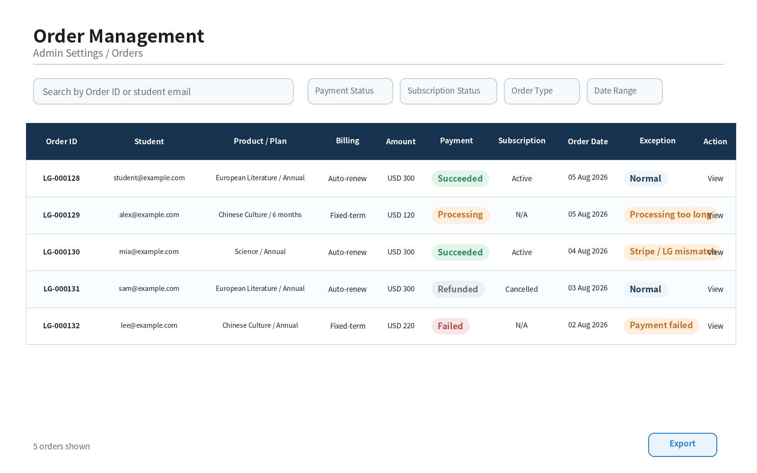
Figure 6-1 Order List page prototype

7. Functional requirements - normal order details

7.1 Order Summary
Demand ID | Priority | Requirements | Receiving and Inspection Point
ORD-FR-007 | P0 | Display Order ID, Student, Produc / Plan, Spope, Davis Access, AI Point Snapshot, Billing Type, Term, Amor Paid, Currency, Order Date and Order Status. | The administrator can confirm what the students have purchased, how much they have paid and the order cycle.
ORD-FR-008 | P0 | No separate display of Access Information. | The range of purchases, the level of access and the duration are expressed in Order Summer.

7.2 Payment Information
Demand ID | Priority | Requirements | Receiving and Inspection Point
ORD-FR-009 | P0 | Show only Payment Status, Payment Date, Strike Checkout Session ID, Type PaymentIntent ID | Information on bank cards, address of payment, country or other non-essential means of payment is not shown.

7.3 Subscription Information
Demand ID | Priority | Requirements | Receiving and Inspection Point
ORD-FR-011 | P0 | Automatic renewal orders show Subscription Status, Current Period, Next Billing Date, Auto-renewal Status and Stripe Subscription ID. | Field from Stripe / LG Sync Results.
ORD-FR-012 | P0 | Fixed-term orders do not show Subscription Information, or not available. | Cannot initialise Evolution's mail component.

7.4 Activity History and Operations
Demand ID | Priority | Requirements | Receiving and Inspection Point
ORD-FR-013 | P0 | Displays key activities such as order creation, Checkout Session creation, payment success and order renewal. | Timely presented, with concise information.
ORD-FR-014 | P0 | Regular and refundable orders are shown only as Refund. | Do not show Resynchronise Payment or repay.

7.5 Normal Order Detail prototype
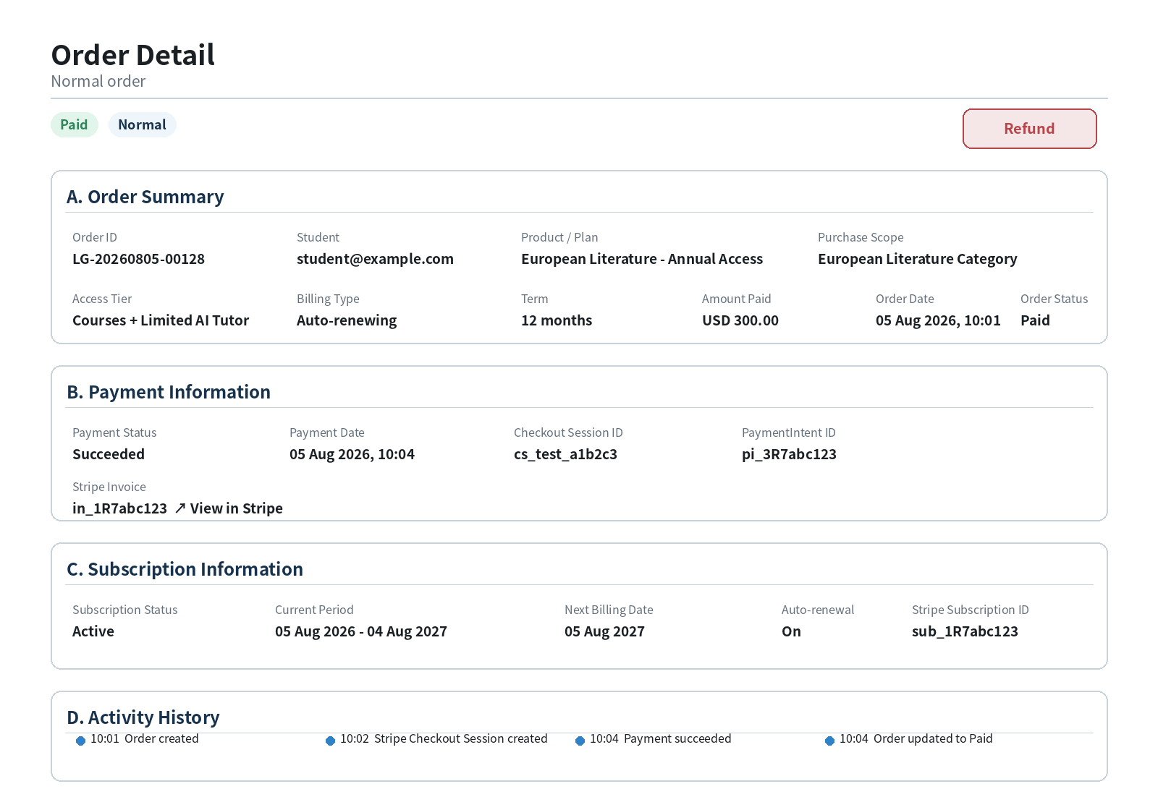
Figure 7-1 Normal Order Detail

8. Functional requirements - details of unusual payment orders

8.1 Abnormal summary
Demand ID | Priority | Requirements | Receiving and Inspection Point
ORD-FR-015 | P0 | On the top of the page, you can see the anomaly, Last Synchronist Time and Resynchronise Payment. | Administrators do not have to scroll to recognize current anomalies and available operations.
ORD-FR-016 | P0 | Payment Information displays LG Payment Status in rows with Latest Stripe Status. | Differences are visible when the status is inconsistent.
ORD-FR-017 | P0 | Displays Checkout Session ID, PaymentIntent ID, Last Synchronismed Time, Last Research and Fairure/Processing Reason. | Keep only the information required for positioning problems.
ORD-FR-018 | P0 | The unusual order only shows Resynchronise Payment. | Do not show Refund or repay.

8.2 Express Payment Order Detail prototype
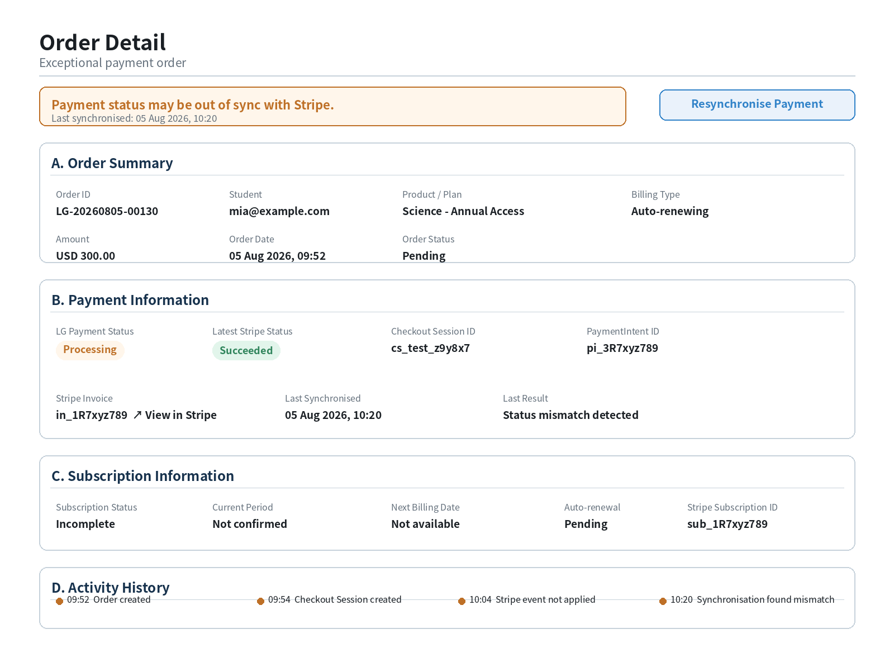
Figure 8-1 Executive Payment Order Detail

9. Functional requirements - Refunds synchronized with payment status

9.1 Full refund
Demand ID | Priority | Requirements | Receiving and Inspection Point
ORD-FR-019 | P0 | Refund is available only for regular orders of Payment Status = Succeded, which have not yet been refunded in full. | Hides or is not available if the button does not meet the condition.
ORD-FR-020 | P0 | Click Refund to open a second confirmation window. | The bullet window shows Order ID, Student, Produc and Read Only.
ORD-FR-021 | P0 | MVP only submits a full refund. | The refund is equal to the refundable original payment.
ORD-FR-022 | P0 | Call Stripe Refund API after submission and wait for final state. | After success, Order / Payment displays Refunded; if failed, keep the status and show errors.
ORD-FR-023 | P0 | Refund Operations Records Administrator, Time, Reason and Stripe Refund ID. | Audit records are searchable.

9.2 Refund Conservation Model
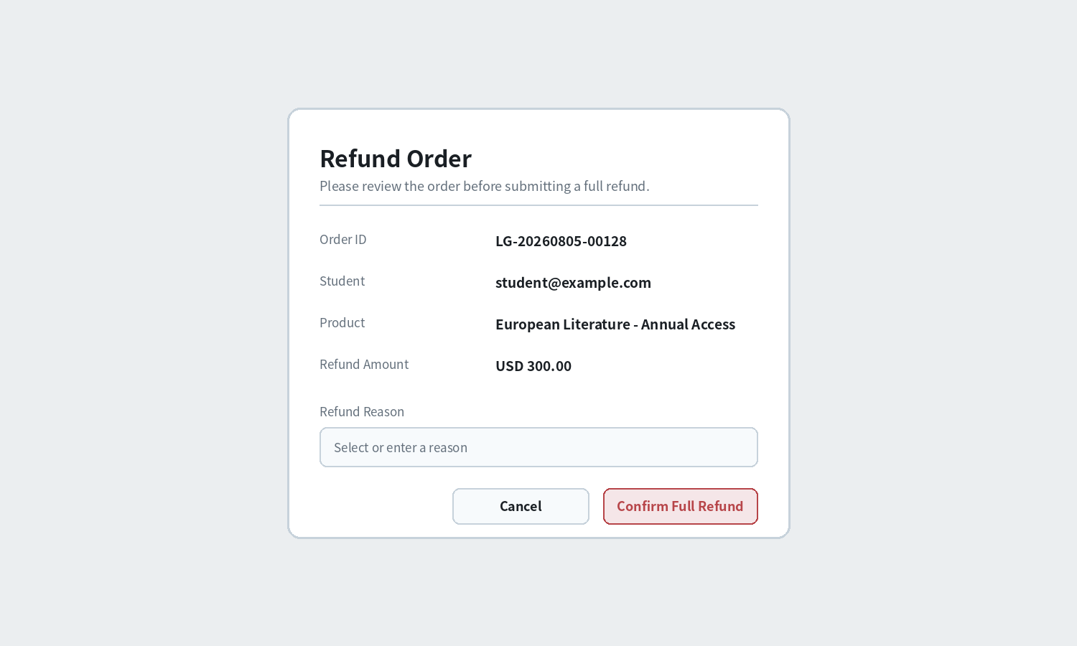
Figure 9-1 Refund Conservation Model

9.3 Resynchronise Payment
Demand ID | Priority | Requirements | Receiving and Inspection Point
ORD-FR-024 | P0 | Click on Resynchronise Payment to use the existing Stripe reference to read the latest status. | At least use Checkout Session, PaymentIntent, Invoice; read Subscription at automatic renewal.
ORD-FR-025 | P0 | If Stripe = Succeded, LG updates to Paid and converts the order into a normal order. | Refreshes the Resynchronise hide, displays Refund when the condition is met.
ORD-FR-026 | P0 | If Stripe = Production, keepProcessing and update the latest sync time. | The orders remained unusual and could be resynchronized again.
ORD-FR-027 | P0 | If Stripe = Failed / Unpaid, update the corresponding status. | The order management does not provide a repayment entry and prompts students to return to the purchase process.
ORD-FR-028 | P0 | Resynchronise operations, etc., and record results. | Duplication does not create new payments or duplicate business results.

10. Modelling of purchase orders and payment status

10.1 Separation of Status
State boundaries Order Status, Payment Status, Subscription Status and Exception Flag are different concepts. Exception Flag is used for operational recognition anomalies and is not a substitute for base state.

Object | State Example | Notes
Order Status | Created / Pending / Paid / Failed / Cancelled / Refunded | LG Orders Overall Business Status.
Payment Status | Requires Action / Processing / Succeeded / Failed / Expired /Refunded | Synchronizes the payments with Stripe.
Subscription Status | Incomplete / Active / Past Due / Cancelled | Automatic renewal orders only.
Exception Flag | Normal / Processing Too Long / Status Mismatch / Event Missing / Synchronisation Failed | Operating labels calculated by the system.

10.2 Order status

Object | Order Satus definition
Pending | Orders created but not yet paid, including not yet started to be paid, pending user operation or payment processing Medium
Paid | Payment has been successful and the order is in place.
Cancelled | Checkout Session Expired
Failed | Payment failed, user cancels payment
Refunded | Stripe confirmed completion of refunds

The logic of the map is as follows:
Payment Status = Not Started / Requires Action / Processing
→ Order Status = Pending

Payment Status = Succeeded
→ Order Status = Paid

Payment Status = Expired
→ Order Status = Cancelled

Payment Status = Failed / Cancelled
→ Order Status = Failed

Refund Status = Succeeded
→ Order Status = Refunded

The abnormal state does not directly change Order Status. For example:

Order Status = Pending
Payment Status = Processing
Exception Status = Processing Too Long

Other Organiser

Stripe Payment Status = Succeeded
→ Payment Status = Succeeded
→ Order Status = Paid
→ Exception Status = Normal

After a successful refund:

Stripe Refund Status = Succeeded
→ Payment Status = Refunded
→ Order Status = Refunded

10.2 Type of order versus sole operation
Order classification | Typical conditions | Unique Management Operation
Normal Order | Payment status is the same as Stripe, no payment abnormal. | Refund (only when the condition for refund is met)
Exceptional Payment Order | Processing, LG/Stripe is inconsistent, Event is not applied or sync failed. | Resynchronise Payment
Failed / Unpaid after Resync | Stripe eventually was Failed or Unpaid. | No repayment operation; students return to the purchase process.
Refunded Order | Stripe has confirmed the full refund. | Read only, no further refund.

11. Abnormalities and recovery
Unusual ID | scene | Treatment | Administrator Operations
EX-ORD-001 | Stripe shows success, LG is still presenting | Marks Status Mismatch. | Resynchronise Payment
EX-ORD-002 | Payment Event not applied | Mark Event Missing, keep the original Event record. | Resynchronise Payment
EX-ORD-003 | Processing Beyond Threshold | Marking Too Long. | Resynchronise Payment
EX-ORD-004 | Stripe API not available for the time being | Keeps the status quo and records the reasons for the sync failure. | Later, Resynchronise.
EX-ORD-005 | Refund request failed | The order was kept in Paid, showing the reason for the refund. | Again Refund (to confirm permission)
EX-ORD-006 | Invoice does not exist | Displays Not available, without blocking other order information. | None
EX-ORD-007 | Failure orders need to be repaid. | Do not create checkout in order management. | Students return purchase process

12. Sites, indicators and statements

12.1 Core indicators
Indicators | Definition
Order query success rate | The number of queries/ valid queries that successfully return the order list.
Number of unusual orders | Current Orders for Exception Flag NonNormal.
Resynchronise success rate | Number of times Resynchronise is successfully read and updated after / total operation.
Recovery time for non-conformity | Unusual recognition of the time when LG corresponds to Stripe status.
Refund success rate | Stripe ultimately confirms the number of refunded orders / the number of refunded orders submitted.
Refund processing time | Submit Refund to the final Refunded time.

12.2 Operating events
Events | Key fields
order_list_opened | admin_id, timestamp
order_searched | admin_id, filters, result_count
order_detail_opened | admin_id, order_id, order_classification
refund_requested | admin_id, order_id, amount, reason
refund_result_updated | order_id, stripe_refund_id, result
payment_resynchronised | admin_id, order_id, previous_status, stripe_status, result

13. Competence, security and non-functional needs
Demand ID | Requirements
NFR-ORD-001 | Only users with Order Management privileges can access the order list and details.
NFR-ORD-002 | Refund and Resynchronise Payment must verify permissions and order terms at the service end.
NFR-ORD-003 | Do not show or record the full bank card, CVC, billing address or Secret Key.
NFR-ORD-005 | Refunds and re-synchronisations must be made in such a way as to avoid duplication of refunds or duplicate processing.
NFR-ORD-006 | Audit records must be maintained for all fund operations and status modifications.
NFR-ORD-007 | The list of orders is frequently searched and returned within 3 seconds of normal data.
NFR-ORD-008 | When Stripe is temporarily unavailable, the LG page should be readable and clear errors provided.

14. Acceptance and inspection standards
Receiving and Inspection ID | Acceptance Criteria
AC-ORD-001 | The administrator can enter the order list from Techer Login > Admin Settings > Order Management > Orders.
AC-ORD-002 | The order list supports searching, filtering and abnormal labels and allows access to details.
AC-ORD-003 | The normal order details only show the necessary Payment Information and do not show bank card information.
AC-ORD-004 | Automatic renewal normal order only shows necessary Subscription Information.
AC-ORD-005 | The only operation for regular orders is Refund; the only operation for unusual payment orders is Resynchronise Payment.
AC-ORD-006 | The eligible regular orders can be fully refunded once and synchronized to Refunded.
AC-ORD-007 | Once the abnormal order is re-synchronized, it is updated to Paid, Processing, Failed or Unpaid according to the state of Stripe.
AC-ORD-008 | Failed / Unpaid orders do not appear at the repayment entrance.
AC-ORD-009 | All refunds and resynchronisations are recorded by administrator, time and results.

15. Dependence, risk, to be confirmed and appendix

15.1 Dependency
- Admin Settings Navigation and Permission System.
- Page Checkout Session, PaymentIntent and Subscription
- Order / Plan Data Model.
- Stripe Refund API syncs with events.
- Stripe Dashboard / Invoice access rights.

15.2 Risks
Risk | Response
LG does not match Stripe status for short periods | Use Exception Flog, Last Synchronised Time and Resynchronise Payment.
Administrator click refund | Service-end condition verification and processing, etc.
Unjustified threshold | Thresholds are configured and adjusted for data when you go online.

15.3 To be confirmed
- Profiting Too Long 's threshold for determination. (Recommendation: 1 hour)
- Refund Reason is mandatory. (Recommended: not required)
- The order list needs CSV Export as P0. (Recommendation: increase later for reconciliation)

15.4 Core data object recommendations
The Order Management data LG Order saves business snapshots and key Stripe ID; Exception Flag and Last Synchronised information is maintained separately. Order details do not copy all Stripe data.

Object | Key fields
Order | order_id, student_id, plan_id, scope_type, scope_id, device_access_type, ai_points_issued_snapshot, billing_type, term, amount, currency, order_status, order_date
Payment Reference | checkout_session_id, payment_intent_id, invoice_id, payment_status, payment_date
Subscription Reference | subscription_id, subscription_status, current_period_start, current_period_end, next_billing_date, auto_renewal
Exception State | exception_flag, exception_reason, last_synchronised_at, last_synchronisation_result
Refund | refund_id, order_id, stripe_refund_id, amount, reason, status, requested_by, requested_at

