Payment Management
Product Requirement Document

Item | Details
Author | Firstlight
Document Status | Requirement Review
Document Version | v1.0
System portal | Teacher Web > Admin Settings > Order Management > Orders
First payment gateway | Stripe
Future extendable gateway | PayPal, micro-credit payments and other payment services Business
Clear currency | USD

Version History
Version | Date | Notes
v1.0 | 14-08-2026 | The first edition of Product Requirements Document:.

Contents
1. Product Background and Objectives 4
1.1 Background 4
1.2 Product objectives 4
1.3 Criteria for success 4
1.4 Terminology and definitions 4
2. Scope and boundaries 5
2.1 Definition of modules 5
2.2 Scope 5
2.3 Scope External 5
2.4 Cross-modular responsibilities 6
3. Users and cross-module roles 6
4. Global operating rules 6
5. Systems, pages and processes 7
5.1 Page List 7
5.2 Management of end-entry and student payment processes 7
5.3 Use Case Map 8
6. Functional needs - payment settings 8
6.1 Competences and access points 8
6.2 Gateways 8
6.3 Configuration 9
6.4 Gateway vouchers and auditing rules 9
7. Functional requirements - Stripe payments Page 9
7.1 Checkout Session Create and Jump 9
7.2 Stripe Hostage Payments Page 10
7.3 Synchronization of payments 11
7.4 Data mapping 11
7.5 Student Return Experience 11
8. Payment status model 11
9. Page fields, interactions and prototypes 12
9.1 New Payment Gateway 12
9.2 Payment Configuration 14
9.3 Stripe Hostage Payments Page 15
10. Abnormalities and recovery 16
11. Sites, indicators and statements 16
12. Security and non-functional requirements 16
13. Acceptance and inspection standards 17
14. Dependency, risk and to be confirmed 17
14.1 Dependency 17
14.2 Pending confirmation 17
15. Registered business (non-product function) 17
15.1 Merchant Account Registration 17
15.2 Payment Method Activation 18
15.3 Parallel work 18
16. Appendix 18
16.1 Core data objects recommended 18

1. Product Background and Objectives

1.1 Background
Learning Guide needs to build a set of configured capacity to pay. The introduction of Stripe in the first phase may be followed by additional payments such as PayPal, China ' s payment modality, which gives priority to using WeChatPay and Alipay in Stripe. The current payment management consists of managing end-end payment settings and payment links for students to host payments pages from Plan.

1.2 Product objectives
- Allows users with Admin privileges to configure the payment gateway and select the payment gateway currently in use.
- Allows administrators to set default currency and payment alarm switches.
- Students choose Plan and click to pay to safely jump to the corresponding Stripe Checkout page.
- Sensitive information, such as payment card numbers, CVVs, is collected directly by Stripe, Learning Guide is not stored.
- Synchronize payment results through server-end Stripe Event to prevent duplicate payments and repeat courses.

1.3 Criteria for success
- Permissioned administrators can successfully create and save Stripe Gateway.
- The configured Stripe Gateway can be selected as the current gateway in the Consortium.
- Students click to pay to get to the right Stripe Checkout Session.
- The Stripe page displays the correct plan, amount, currency and billing.
- Up-to-date orders or repeated courses are not repeated when the same Stripe Event is duplicated.

1.4 Terminology and definitions
Terminology | Definition
Admin Settings | The management settings that users with Admin privileges enter through the icon drop-down menu at the Teacher end.
Payment Gateway | Payer connection configuration, P0 first supports Stripe.
Publishable Key | Stripe ' s publicly available front-end identifier; use is still determined by integrated plans.
Secret Key | Stripe service sensitive vouchers are not allowed to return to the browser or to display them explicitly.
Redirect URL | Stripe pays or cancels and returns the address of Learning Guide.
Stripe Checkout Session | Stripe-hosted payment session created for an order.
Payment Event | Stripe sends a payment status event to the Learning Guide service.

2. Scope and boundaries

2.1 Definition of modules
The payment management is responsible for payment gateway settings, payment default configurations, creation of Stripe Checkout Session, synchronization of payment results and payment of relevant references. Plan content, pricing strategy, order clients and course openings are the responsibility of the corresponding modules.

2.2 Scope
- The Payment portal for the Teacherend Admin Settings.
- Payment's Gateways and Configuration are two submenus.
- New Stripe Gateway and configure Gateway Name, Public Key, Secret Key, Direct URL and Header Image.
- Sets the Default Currency, the current Payment Gateway and Course payment alarm switches.
- Students click on Pay to create Stripe Checkout Session and jump to Stripe page.
- Process payments successfully, processed, failed and cancelled and synchronized with associated orders.

2.3 Scope External
- Plan grouping, course coverage, interview grade, promotion differential and complete preferential strategy.
- Full Order Management backstage.
- The rules governing the opening of courses and the calculation of the duration of studies (at the time of student subscription management, Payment is not responsible for the specific course entitlements of LG).
- Practical access to other gateways such as PayPal and Micro-Credit.
- Offline transfers, cash, instalments and manual deductions.
- Stores the full card number, CVC or wallet account voucher.

2.4 Cross-modular responsibilities
Module | Responsibilities
Pricing / Subscription | The service provider plan snapshot (plan id, scope type, scope id, decice access type, term months), Stripe Project/ Price mapping, amounts, currencies and subscription context.
Order Management | Creates and saves the Learning Guide Order and provides the Payment Management with the Order ID.
Payment Management | Creates Stripe Checkout Session, syncs the Stripe status and saves the payment object reference.
Stripe (for future access to other payments) | Manages the collection of payment information, validates the mode of payment and generates payments or subscriptions.
Course / Entitlement | The corresponding course visits are initiated or extended after the payment has been validated.

3. Users and cross-module roles
Role | Visits and duties
User with Admin permissions | Enter Admin Settings through the Teacher Portal menu; configure the gateway and Payment Construction.
Teacher without Admin permission | Payment Settings cannot be viewed or accessed directly.
Students | Select Plan, click to pay, finish the payment on Stripe page and return Learing Guide.
Customer Support / Operations | Query payment status in the relevant operating module; specific permissions are defined by Order Management.
System | Create Checkout Session, authenticate Stripe Event, execute the associated order etc.

4. Global operating rules
Rule number | Operational rules
BR-PAY-001 | Payment Settings is only visible to users with Admin privileges.
BR-PAY-002 | P0 supports Stripe first; the data structure must allow the subsequent addition of other payment gateway types.
BR-PAY-003 | Only one gateway within the P0 range was selected at the same time.
BR-PAY-004 | Secret Key saves only at the service end and cannot return expressly after saving.
BR-PAY-005 | The student side cannot modify the amount, currency, regulation or Price determined by the service.
BR-PAY-006 | Same Stripe Event can only be processed once.
BR-PAY-007 | The browser returns the successful page.
BR-PAY-008 | Course payment alarms are enabled by the switch corresponding to the Configuration.

5. Systems, pages and processes

5.1 Page List
Page Numbering | Page | From System | Use
PAY-P01 | Payment - Gateways | LG Teacher / Admin Settings | View the configured gateway and enter the new gateway.
PAY-P02 | New Payment Gateway | LG Teacher / Admin Settings | Configure Stripe vouchers, name, return address and Header Image.
PAY-P03 | Payment - Configuration | LG Teacher / Admin Settings | Sets the default currency, the current gateway and the payment alarm switch.
PAY-P04 | Stripe Checkout | Stripe Hosted | A summary of the purchases was displayed and payment information was collected.
PAY-P05 | Payment Result | LG Student Web | Show success, processing, failure or cancellation based on synchronized results; page design to be confirmed.

5.2 Management of end-entry and student payment processes
Management port entrance:
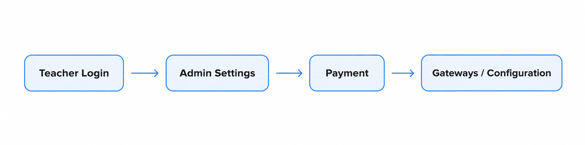

Student payment process:

The course must be open on the basis of a certified server end Stripe Event; the browser returns the page for user feedback only.

5.3 Use Case Map
Use Case Numbering | Name
UC-PAY-001 | Enter Payment Settings
UC-PAY-002 | New Stripe Gateway
UC-PAY-003 | Update
UC-PAY-004 | Create Strike Checkout Session for Student Orders
UC-PAY-005 | Completed payments and synchronized successful results
UC-PAY-006 | Processing payments, failure or cancellation

6. Functional needs - payment settings

6.1 Competences and access points
Requirement Number | Priority | Requirements | Receiving and Inspection Point
PAY-FR-001 | P0 | Shows only Admin Settings in the dropdown menu for users with Admin privileges. | Unauthorized users cannot see the portal and are denied direct access to URLs.
PAY-FR-002 | P0 | Provides Payment settings in Admin Settings. | Payment contains two submenus of Gateways and Configuration.

6.2 Gateways
Requirement Number | Priority | Requirements | Receiving and Inspection Point
PAY-FR-003 | P0 | Allows administrators to enter New Payment Gateway from Gateways. | New page successfully opened.
PAY-FR-004 | P0 | Provides mandatory Select Payment Gateway fields. | P0 Optional Stripe; field structure supports future addition of other service providers.
PAY-FR-005 | P0 | Allows the recording of Payment Gateway Name. | Saved by a name that can be used for selection and operation recognition.
PAY-FR-006 | P0 | Allows the entry of Publishable Key with Secret Key. | Secret Key encrypted, default masked and full value not returned.
PAY-FR-007 | P0 | Allows the entry of redirect URLs. | Only HTTPS addresses are allowed in the production environment.
PAY-FR-008 | P0 | Header Image is allowed to upload. | Verify the type and size of the file; specific limits to be confirmed.
PAY-FR-009 | P0 | Saves the gateway only when necessary fields are valid. | field; invalid configuration cannot be the current gateway.

6.3 Configuration
Requirement Number | Priority | Requirements | Receiving and Inspection Point
PAY-FR-010 | P0 | Allows administrators to select Default Currency. | Reopens the page to show the same value after saving.
PAY-FR-011 | P0 | Allows the administrator to select the current Payment Gateway. | Displays only saved and available gateways.
PAY-FR-013 | P0 | Provides Send Payment switches for course. | System saves the switch state and is read by the Course alarm process.
PAY-FR-014 | P0 | Apply configuration changes only after clicking on Update. | Unsaved changes do not affect the current valid configuration.
PAY-FR-015 | P0 | Disables the selection of configuration incomplete or unavailable Gateway. | Page displays an optional reason.

6.4 Gateway vouchers and auditing rules
Field / Behaviour | Rule
Gateway Type | Use stable service provider codes, such as STRIPE.
Gateway Name | Saves the display name defined by the administrator.
Publishable Key | Safe storage; display is confirmed by security assessment.
Secret Key | Encrypted saving; not writing logs; not returning browsers.
Redirect URL | Validate by environment and HTTPS white list.
Header Image | Saves references to managed media files.
Audit information | Records the creation time/ update, operator and non-sensitive field changes.

7. Functional requirements - Stripe payments Page

7.1 Checkout Session Create and Jump
Requirement Number | Priority | Requirements | Receiving and Inspection Point
PAY-FR-016 | P0 | After the student click Pay, Payment Management accepts the selected Plan and associated LG Order. | Service-end recalibration of Plan, amount, currency and Stripe Price maps.
PAY-FR-017 | P0 | Use the current Gateway to create Stripe Checkout Session. | Use the correct Stripe account, Checkout Mode and Price.
PAY-FR-018 | P0 | Writes business references such as LG Order ID to a permitted Stripe metadata. | Stripe turns out to be the right LG Order.
PAY-FR-019 | P0 | Moves students to Stripe-hosted page. | LG does not render card input boxes or save original payment vouchers.
PAY-FR-020 | P0 | Creates more than one valid session to prevent repeat click on Pay. | The same user operation generates up to one effective payment attempt.

7.2 Stripe Hostage Payments Page
Requirement Number | Priority | Requirements | Receiving and Inspection Point
PAY-FR-021 | P0 | Displays the name, amount and billing frequency of Plan provided by Stripe Product/ Price. | Displays the content of the student 's LG Plan.
PAY-FR-022 | P0 | Displays the entry for the project code when enabled. | The concession code is verified and applied by Stripe.
PAY-FR-023 | P0 | Show how payments are made according to accounts, currency, area and equipment. | No payment is available.
PAY-FR-024 | P0 | The necessary information is collected by Stripe, the name of the card holder, the country/region. | LG receives only a summary of the permitted mode of payment.
PAY-FR-025 | P0 | Automatic renewal Plan displays subscriptions and future deductions. | Students can see the clause of the continuous deduction before confirmation.

7.3 Synchronization of payments
Requirement Number | Priority | Requirements | Receiving and Inspection Point
PAY-FR-026 | P0 | Payment Event is verified using Stripe Webhook Security or approved certification mechanisms. | Event, which was not certified, did not modify the order and recorded the security log.
PAY-FR-027 | P0 | Syncs success, processing, failure and cancellation status to association LG Order. | The order payment status is the same as Stripe's current results.
PAY-FR-028 | P0 | The same Event ID uses treatments such as tarts. | Event does not duplicate payments, subscriptions or courses.
PAY-FR-029 | P0 | Stripe completes or cancels and returns the approved Learning Guide URL. | Returns to display the current state of safety on the page, but does not claim success in payment alone.
PAY-FR-030 | P0 | Browser displays documentation before the final Event returns. | Repayment is prohibited until the same payment attempt has been completed.

7.4 Data mapping
Learning Guide Object | Stripe Object/ Field | Use
Gateway ID | Stripe Account Configuration | Deciding on the documentation and environment used for the session.
Plan / Price Mapping | Product ID / Price ID | It was decided to show the amount and the fee.
LG Order ID | Metadata / Client Reference | Associated Stripe results with internal orders.
Payment Attempt | Checkout Session ID / PaymentIntent ID | Follow this payment attempt.
Subscription Reference | Stripe Subscription ID | Automatic renewal time association.

7.5 Student Return Experience
Payment Research page should support Payment Accessful, Payment Processing, Payment Failed and Payment Canceled. Page fields and jumps are confirmed by Subscription Management with Payment Management.

8. Payment status model
Payment Management saves service Attempt status synchronized with Stripe. Order, Subscription and Entitlement remain independent objects.
State | Client delivery version | Student Visible Behaviour
Created | LG Order has been created, not finished with Stripe Checkout. | Continues to enter or reopen the payment page.
Checkout Open | Tripe Checkout Session has been created and is available. | Pays or cancels on the Stripe page.
Processing | No final success or failure has yet been received. | Shows confirmation that duplicate payments are prohibited.
Succeeded | The certified Stripe Event confirmed payment success. | Show success and enter the follow-up course process.
Failed | Stripe confirmed that payment was unsuccessful. | Other Organiser
Cancelled / Expired | The student cancels payment or the session expires. | Returns Plan / Checkout and creates a new attempt.

The state boundary Payment = Succeded does not equal Order, Subscription and Entitlement to all completed. Subsequent modules must be processed and synchronized separately.

9. Page fields, interactions and prototypes

9.1 New Payment Gateway
Field / Control | Behaviour
Select Payment Gateway * | required; P0 selects Stripe.
Payment Gateway Name | Administrator customizes gateway names.
Publishable Key | Stripe Publishable Key。
Secret Key | sensitive fields; masked and used only at the service end.
Redirect URL | Learning Guide returns address.
Header Image | Uploads the image of the brand related to the gateway or the payment page.
Save | Verify and save Gateway.

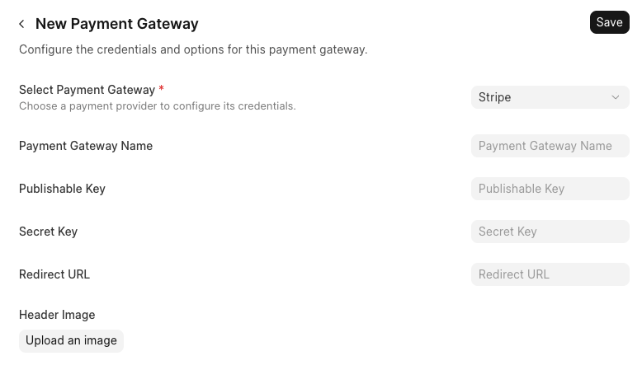
Figure 9-1 New Payment Gateway prototype reference

9.2 Payment Configuration
Field / Control | Behaviour
Default Currency | To fill in a drag frame; P0 fixed to USD.
Payment Gateway | Select from saved and available Gateway.
Send payment reminders for course | Could not close temporary folder: %s
Update | Keep this page change uniformly.

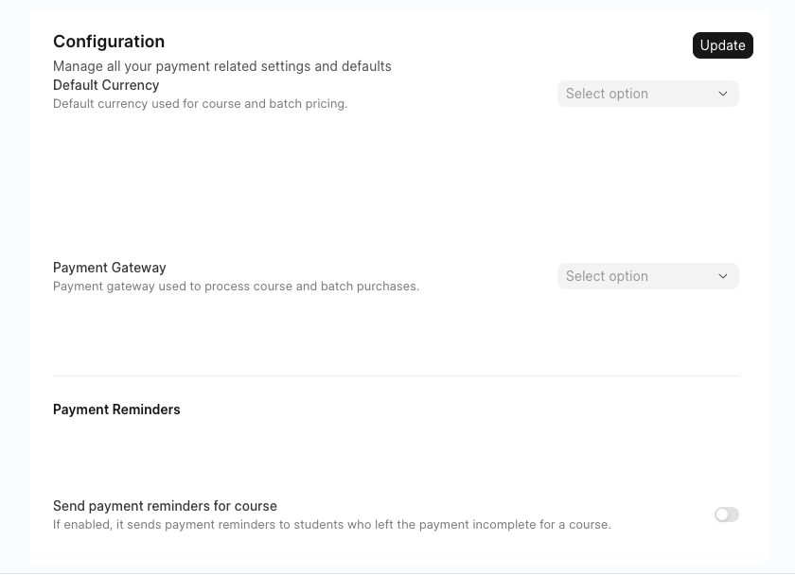
Figure 9-2 Pocket model reference

9.3 Stripe Hostage Payments Page
Regional | Sources and behaviours
Merchant / Header | Generated by Stripe account and brand configuration.
Order Summary | From Stripe Production, Price and Number.
Promotion Code | Displays only when Checkout Session is enabled.
Payment Methods | By account, region, currency, mode and equipment.
Payment Fields | By Stripe to collect and verify.
Subscription Consent | An ongoing withholding statement is displayed by Stripe under the automatic renewal mode.
Confirm Button | Create or confirm payments/ subscriptions in Stripe.

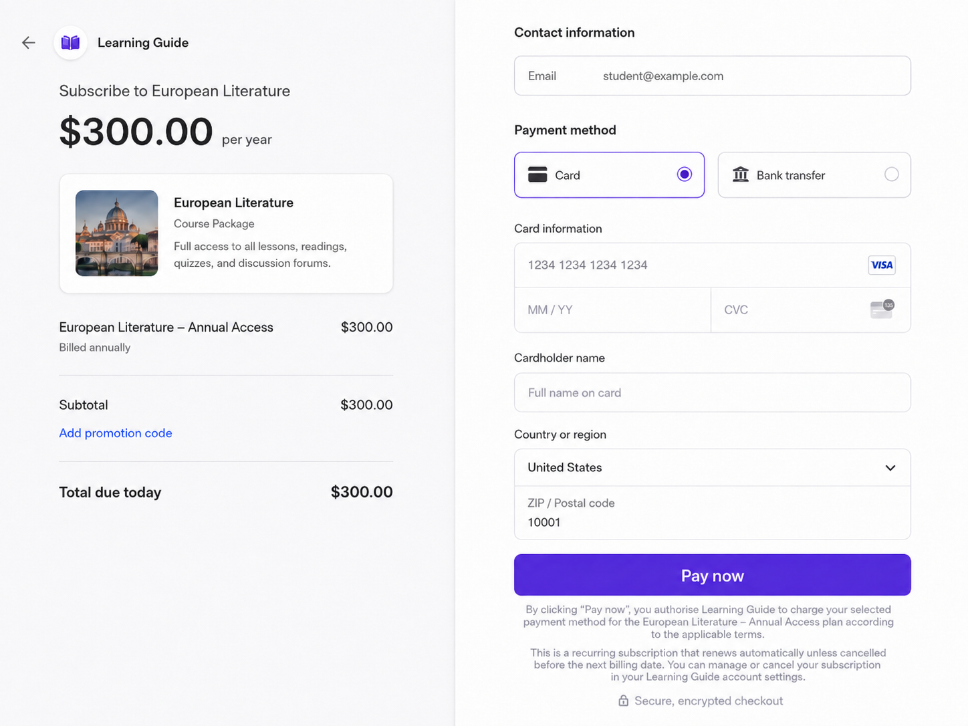
Figure 9-3 Stripe House CHeckout prototype reference

10. Abnormalities and recovery
Numbering | scene | Treatment | Head
EX-PAY-001 | User has no Admin permissions | Hide the entrance and refuse direct access. | Access Control
EX-PAY-002 | Stripe certificate invalid | Do not enable Gateway; displays a secure verification error. | Payment
EX-PAY-003 | Repeat Click Pay | Disable button and prevent the creation of a duplicate session. | Order / Payment
EX-PAY-004 | Skip Session Created | Orders remain unpaid; retryable error is shown and does not jump. | Payment
EX-PAY-005 | Students cancel | returns LG, does not produce successful payment; retry is allowed. | Payment
EX-PAY-006 | Browser returns before Event | Displays the documenting, waiting for confirmation from the service. | Payment
EX-PAY-007 | Repeat | Responds normally to Stripe, but business actions are not repeated. | Payment
EX-PAY-008 | Payment was successful but the course was not opened | Successful retention of payment; triggers re-testing or manual re-synchronization. | Order / Entitlement
EX-PAY-009 | Current Gateway Not Available | Stop creating new checkout and alert the administrator. | Payment

11. Sites, indicators and statements
Indicators | Definition
Checkout Session Create Success | The number of requests/ the number of requests for which a session was successfully created.
Checkout Completion Rate | Pay success / Checkout Session number opened.
Duration of payment confirmation | The session creation or payment starts with the final sync result.
Repeat Event Scale | Repeats the number of Stripe Event/ the total number of Event received.
Payment-to-Entitlement Delay | Pays the time to successfully validate the course.
Gateway configuration failure rate | Configure the number of saved or verified failures/ attempts to configure.

12. Security and non-functional requirements
- Use Streep to collect payment information, LG does not save original cards and CVC.
- Secret Key encrypted to save only for the service Payment Component.
- The signature must be verified before it is processed by Stripe Event, and mechanisms such as thorium are used.
- Test and production certificates, Gateway, Product, Price and Webhook Endpoint must be isolated.
- The production environment is fully HTTPS.
- The administrator 's configuration changes require that audit information be recorded, but not as specified by Secret Key.
- When Stripe is temporarily unavailable, the LG should show understandable errors and allow to try again later.

13. Acceptance and inspection standards
Numbering | Acceptance Criteria
AC-PAY-001 | Users with Admin privileges can access Admin Settings > Payment.
AC-PAY-002 | Payment contains Gateways and configration.
AC-PAY-003 | Effective Stripe Gateway can save and be selected as the current Payment Gateway.
AC-PAY-004 | DefaultCurrency and the reminder switch will remain open until they are saved.
AC-PAY-005 | Students click on the valid Plan Pay to get to the right Stripe Checkout Session.
AC-PAY-006 | The Stripe page displays the correct plan, amount, currency and billing.
AC-PAY-007 | Learning Guide does not receive or save full card numbers and CVCs.
AC-PAY-008 | Successfully verified Event only updates associated orders once.
AC-PAY-009 | Failure, cancellation or documentation does not result in duplicate payments or repeated courses.
AC-PAY-010 | Test certificates are completely isolated from production certificates.

14. Dependency, risk and to be confirmed

14.1 Dependency
- Admin permissions and Admin Settings Navigator.
- Plan definition and Stripe Production/ Price map.
- Order creates and orders status interfaces.
- Course / Entitlement interface.
- Stripe business account, environmental voucher, return address and Webbook Endpoint.

14.2 Pending confirmation
- The candidate and the initial default value (USD) for Default Currency.
- Time, frequency, channel for payment of alarm (24h, 1 time, system alarm + email alarm).

15. Registered business (non-product function)

15.1 Merchant Account Registration
Materials/ Conditions | Preparation
Company | Hong Kong company registration certificate, business register, company address.
Personnel | Certification of the identity and address of directors, account holders and final beneficiaries.
Bank | Hong Kong commercial bank account matching company name.
Website | Readable Learning Guide website, product and price description.
Policy | Times of Service, Private Policy, Refund Policy, contact information.
Statement of operations | Digital courses, KS, AI Tutor, delivery modalities, target areas and expected scale of transactions.

15.2 Payment Method Activation
- We'll start with Cards, Apple Pay, Google Pay.
- Apply for Alipay and WeChat Pay according to the target user; it cannot be assumed that the main account will be opened automatically after adoption.
- PayPal needs separate commercial accounts and integration as an independent complement.
- Automatic renewal costs require additional confirmation of the preservation of the mode of payment, off-session deductions and failure recovery.

15.3 Parallel work
Suggested parallel progress
Business opening/KYC | → | LG Product and Data Model | → | Checkout Integration | → | Payment modality approval | → | End-to-end testing | → | Live Online

The application for registration and payment of the account shall be initiated before the development of the payment is completed. The audit cycle is influenced by corporate materials, industry, website integrity, bank certification and risk assessment and is not entirely controlled by the development team.

16. Appendix

16.1 Core data objects recommended
PaymentGateway
- gateway_id / gateway_type / gateway_name
- publishable_key_reference / secret_key_secure_reference
- redirect_url / header_image_id / environment / status
- created_by / updated_by / created_at / updated_at
PaymentConfiguration
- default_currency / active_gateway_id
- course_reminders_enabled
- updated_by / updated_at
PaymentAttempt
- payment_attempt_id / order_id / gateway_id
- checkout_session_id / payment_intent_id / subscription_id
- amount / currency / status / created_at / updated_at

