Learning Guide Portal
Product Requirement Document

Item | Details
Author | Firstlight
Document Status | Requirement Review
Document Version | v1.0
Scope | Learning Guide end-user Web Portal, including Batch 1 entry points, pages, conversion flows, access gates, and cross-module conventions.
Language | English; the Portal UI and static content support both English and Chinese.
Time Zone and Currency Basis | Business dates use Asia/Hong_Kong; system timestamps are stored in UTC; the P0 settlement currency is USD.

Version History
Version | Date | Notes
v1.0 | 14-08-2026 | Client-deliverable version based on confirmed account, trial, subscription, device, AI, order, and payment rules; completes the flows, pages, wireframes, non-functional requirements, tracking, and cross-module interfaces.

Contents
1. Product Background, Objectives, and Scope 4
1.1 Portal Objectives 4
1.2 Quantitative Metrics and Definitions 4
1.3 Scope Boundaries 5
2. User States, Shared Rules, and Information Architecture 6
2.1 Portal-Visible States 6
2.2 Information Architecture and Page Inventory 7
2.3 Global Components and Configuration 8
3. Core User Flows and State Transfer 9
3.1 Public First Lesson to Trial / Subscription Flow 9
3.2 Protected Learning Entry Flow 10
3.3 Authentication and Safe Return-Routing Rules 11
4. Page Requirements and Structural Wireframes 11
4.1 Home 12
4.2 Courses 14
4.3 Course Detail 16
4.4 Public First Lesson 18
4.5 Sign-In, Registration, and Authentication 20
4.6 Pricing 20
4.7 Subscription Confirmation and Stripe Result Pages 21
4.8 My Learning 21
4.9 Full Course Learning Page 22
4.10 Study Group Introduction / Coming Soon 22
4.11 Help Center / FAQ 23
4.12 Privacy Policy, Terms of Service, and Cookie 24
4.13 404, Loading, and Content Failure 25
5. Portal Display Rules for Pricing, Trials, and Entitlements 26
5.1 Purchasable Plans and Display Fields 26
5.2 Cross-Page Commercial Notices 28
5.3 Portal Visibility of Trial States and Notifications 28
6. Analytics Tracking, Metrics, and Data Quality 29
6.1 Common Fields for All Portal Events 29
6.2 Portal Event Catalog 30
6.3 Data Quality and Reporting Requirements 32
7. Non-Functional Requirements 32
8. Cross-Module Relationships, Data Contracts, and Dependencies 34
8.1 Routing, State, and Responsibility Matrix 34
8.2 Key Interface Fields 35
8.3 Launch Dependencies and Open Configuration 36
9. Acceptance Checklist 36
Appendix A: Key Terms and State Names 37

1. Product Background, Objectives, and Scope
The Learning Guide Portal is the public entry point and protected-route shell through which end users access Learning Guide. It supports course discovery, the public first-lesson experience, authentication entry points, subscription-plan presentation, server-side entitlement gating, learning entry points, help content, and legal content. It does not redefine the business facts owned by payment, subscription, trial, authentication, or learning services.

1.1 Portal Objectives
- Provide a continuous journey in which Visitors learn about the product, browse courses, experience a public first lesson, proceed through authentication, Pricing, Subscription Confirmation, Stripe-hosted payment or trial activation, and enter learning only after server-side confirmation.
- Give signed-in users consistent entitlement decisions, prompts, CTAs, and safe return routing at every protected entry point.
- Provide an executable baseline of pages, events, fields, and acceptance criteria shared by frontend, backend, QA, operations configuration, and cross-module integration teams.

1.2 Quantitative Metrics and Definitions
Metric | Definition | Source Events
Public First-Lesson Registration Conversion | Unique user_ids that complete registration / unique Visitors to the public first lesson. | public_lesson_view、auth_success
Plan-Intent Conversion | Unique user_ids reaching Subscription Confirmation / unique Visitors to Pricing. | pricing_view、subscription_confirmation_view
Payment-Initiation Conversion | Unique user_ids for whom a Stripe-hosted redirect is successfully created / unique Visitors to Subscription Confirmation. | checkout_redirect_created
Entitlement-to-Learning Conversion | user_ids entering the full learning page for the first time after server-side entitlement confirmation / user_ids with successfully confirmed orders. | entitlement_activated、protected_route_allowed
Public-Content Engagement | Starts, completions, text/video switches, CTA clicks, and sharing behavior in the public first lesson. | public_lesson_*、cta_click

1.3 Scope Boundaries
Domain | Portal Responsibilities | Non-Portal Responsibilities / Rule Owner
Website and Pages | IA, Header/Footer, public pages, routing, loading/failure states, language, Cookie, and static content. | Publishing and back-office configuration of operational content: Course Management / Backoffice.
Authentication Entry | Display entry points, carry a safe return context, and route back after authentication. | Identity verification, account linking, sessions, and security policy: Registration & Authentication.
Conversion and Plan Presentation | Display server-returned purchasable plans, terms, devices, AI benefits, and action entry points. | Eligibility, discounts, upgrades, trial state, and subscription state: Subscription Management.
Payment Redirect | Receive a valid Checkout URL from the confirmation page and display the result page. | Stripe, payment methods, Webhooks, and refund execution: Payment Management.
Learning Access Gate | Use the final server-side Entitlement to allow entry or redirect to Pricing. | Playback, learning progress, AI consumption, and learning interactions: Study / AI services.
Back-Office Orders | Do not expose back-office entry points to students. | Customer service, operations, order administrator, and system administrator actions: Order Management.

2. User States, Shared Rules, and Information Architecture

2.1 Portal-Visible States
State | Definition | Portal Behavior and Primary CTA
Visitor | Not signed in. | Public browsing and Lesson 1 of a Course with Free First Lesson enabled are accessible; Pricing, confirmation, and full learning pages initiate authentication.
Registered | Authenticated, with no active trial or subscription entitlement. | May enter Pricing; the full-learning gate redirects to Pricing; signing in alone does not unlock other Lessons.
Trial Active | Payment-method setup and auto-renewal authorization have been completed after plan selection, and the trial remains within its original window. | Display the selected scope, device access, and AI benefits; allow access to the corresponding full courses.
Trial Canceled | Auto-renewal was canceled during the trial. | Immediately remove full-course entitlements; Resume is available within the original trial window and does not extend the trial.
Payment Grace | A three-calendar-day recovery period after the first trial charge fails. | Retain access until grace_end_at; My Subscription provides Update Payment Method / Pay Now.
Active Subscription | Paid entitlements are active. | Allow access to courses within scope; the course CTA is Start learning or Continue learning.
Cancel at Period End | Auto-renewal is off, but the current paid period has not ended. | Retain entitlements until valid_to; My Subscription provides Resume Auto-Renewal.
Expired | Entitlements have expired, or the recovery period ended without successful payment. | Disallow full learning; display Re-subscribe / Pricing.

2.2 Information Architecture and Page Inventory
Level | Page / Route | Access | Definition Depth in This Document
Public Discovery | Home /, Courses /courses, Course Detail /courses/:course_slug, Public First Lesson /courses/:course_slug/public-lesson | Visitors and signed-in users | Complete page requirements, wireframes, and tracking.
Authentication | /sign-in、/sign-up、/verify-email、/reset-password | Visitor | Entry, context, and return routing; authentication rules are defined in the Authentication PRD.
Commercial | Pricing /pricing、Subscription Confirmation /subscription/confirm、Stripe Hosted Page | Pricing and confirmation require sign-in; Stripe is a hosted page. | The Portal defines entry, presentation, and result routing; the Subscription and Payment PRDs define the business rules.
Account | My Learning /my-learning, Notification Center, Personal Settings, and Help entry | Signed-in users | Entry hierarchy and summary consumption; details are defined in the My Learning PRD.
Learning | /learn/:course_id | Matching active entitlement | Routing and gating; learning interactions are defined by Study.
Support and Static Pages | Study Group Coming Soon, Help Center /faq, Privacy Policy, Terms of Service, and 404 | Public | Complete page requirements, wireframes, and tracking.

2.3 Global Components and Configuration
Component | Shared Requirements | Configuration / Data Source
Header | Logo, Courses, Study Group, Pricing, language, Notification, Sign In/Sign Up or My Learning. When a Visitor clicks Notification, initiate authentication; after sign-in, show the unread count and open Notification Center. | Portal configuration, Authentication session, and Notification unread count.
Footer | Displayed everywhere except the full learning page; includes course categories, FAQ, Privacy Policy, Terms, Cookie Settings, contact email, and social links. | Operations / Legal configuration.
Course Card | Cover, title, Category, summary, duration, Lesson count, public-first-lesson indicator, and CTA; only published Courses may be displayed. | Course Management。
Cookie | On first visit, users may accept all Cookies, reject non-essential Cookies, or manage preferences; essential Cookies are always enabled; the Footer can reopen settings. | Consent state.
Language | English by default; the Portal UI and static content support English and Chinese; course bodies and subtitles are managed separately by the content system. | Language preference。
Server-Side Access Gate | Pages must not unlock content based on frontend state alone; every protected-route entry or refresh requests the final Entitlement. | Subscription / Entitlement services.

3. Core User Flows and State Transfer
The diagram below shows only Portal entry points, redirects, and state consumption. Server-side events from the respective services are the sole source of truth for order, payment, trial, subscription, and entitlement state changes.
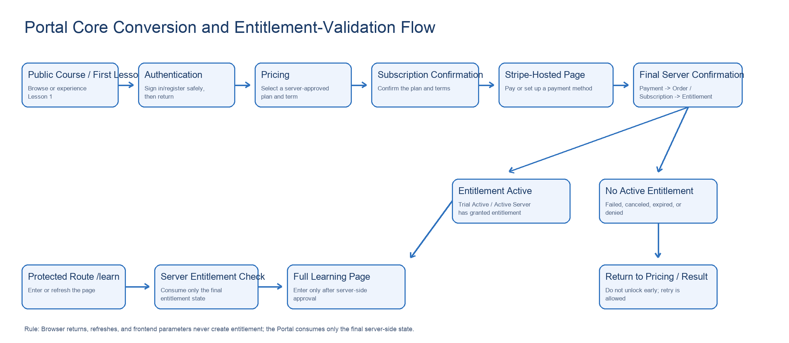
Figure 1: Portal Core Conversion and Entitlement-Validation Flow

3.1 Public First Lesson to Trial / Subscription Flow
Step | User Action | Portal Behavior | Downstream State / Constraint
1 | Browse Courses or open a public first lesson. | Display Lesson 1 when Free First Lesson is enabled; all other Lessons remain locked. | Course Management provides publishing status and the public-first-lesson toggle.
2 | Click Choose access plan / Start free trial. | A Visitor enters authentication; a signed-in user enters Pricing with source_course_id and source_category_id. | The return context stores only safe source and plan-selection information, with no Stripe data.
3 | Select a purchasable plan and a 6- or 12-month term in Pricing. | Display the four server-returned plan types, entitlements, and prices; then enter Subscription Confirmation. | Do not redirect directly to Stripe.
4 | Confirm after accepting auto-renewal and the applicable terms. | Disable duplicate submission and request creation or reuse of a valid order/payment attempt. | Trial users first complete Stripe payment-method setup and authorization; activation creates a USD 0 Trial Activation Order with no Receipt.
5 | Stripe returns success, failure, cancellation, or processing. | Redirect to the learning page or My Learning only after final server-side confirmation; return failures/cancellations to Pricing. | A browser return must never unlock access early.

3.2 Protected Learning Entry Flow
Trigger | Portal Handling | Result
Visitor accesses /learn/:course_id | Initiate authentication, then validate the Course-scope Entitlement after authentication succeeds. | Enter learning when entitled; otherwise enter Pricing.
Registered user accesses a full Course | Request the final Entitlement. | If no active entitlement exists, redirect to Pricing with source_course_id / source_category_id.
Trial Active / Active Subscription | Request the final Entitlement and Study record. | Display Start learning when no study record exists; display Continue learning when one exists.
Trial Canceled / Expired | Deny access to the full Course. | Display a recovery/re-subscription CTA; the public first lesson remains available according to its own toggle.
Payment Grace | Display the accessible state and a recovery reminder. | My Subscription directs the user to Update Payment Method / Pay Now; detailed recovery rules are defined by Subscription.

3.3 Authentication and Safe Return-Routing Rules
- P0 supports Email + Password, Google Sign-In, and WeChat Sign-In. user_id is the immutable cross-module primary key; Email and third-party nicknames are not business keys.
- A valid Return URL takes precedence over the default route; if no valid destination exists, route to /my-learning. Only allowlisted internal paths are accepted; external URLs are rejected.
- Return context may contain only source_course_id, source_category_id, plan_id, scope_type, scope_id, term_months, device_access_type, and source markers. It must not contain card numbers, CVC, Stripe client secrets, or writable price fields.

4. Page Requirements and Structural Wireframes
The wireframes include only Portal-owned pages and illustrate page hierarchy, fields, states, and key CTAs. Page wireframes and interaction details for Authentication, Pricing, My Learning, and the full learning page are defined in their respective module PRDs and are not duplicated in the Portal.

4.1 Home
Item | Requirement
User Goal | Understand Learning Guide and begin exploring.
Access | Public; Visitors and all signed-in states.
Page Modules / Displayed Information | Standard Header; three operations-configured carousel Banners; six fixed featured Courses; Why Us; learning-method introduction; testimonials; Footer.
Interactions, States, and Navigation | Banners auto-rotate every five seconds and support dot/manual navigation; each Banner has only one primary CTA. Only the CTA area of a featured Course opens details. AI capabilities are introduced here, but no AI session starts on this page.
CTA / Tracking Index | CTA-HOME-01 Explore courses；CTA-HOME-02 Free first lesson；CTA-HOME-03 Course detail。
Detailed Rule Owner | Portal; content is configured through Course Management / Backoffice.

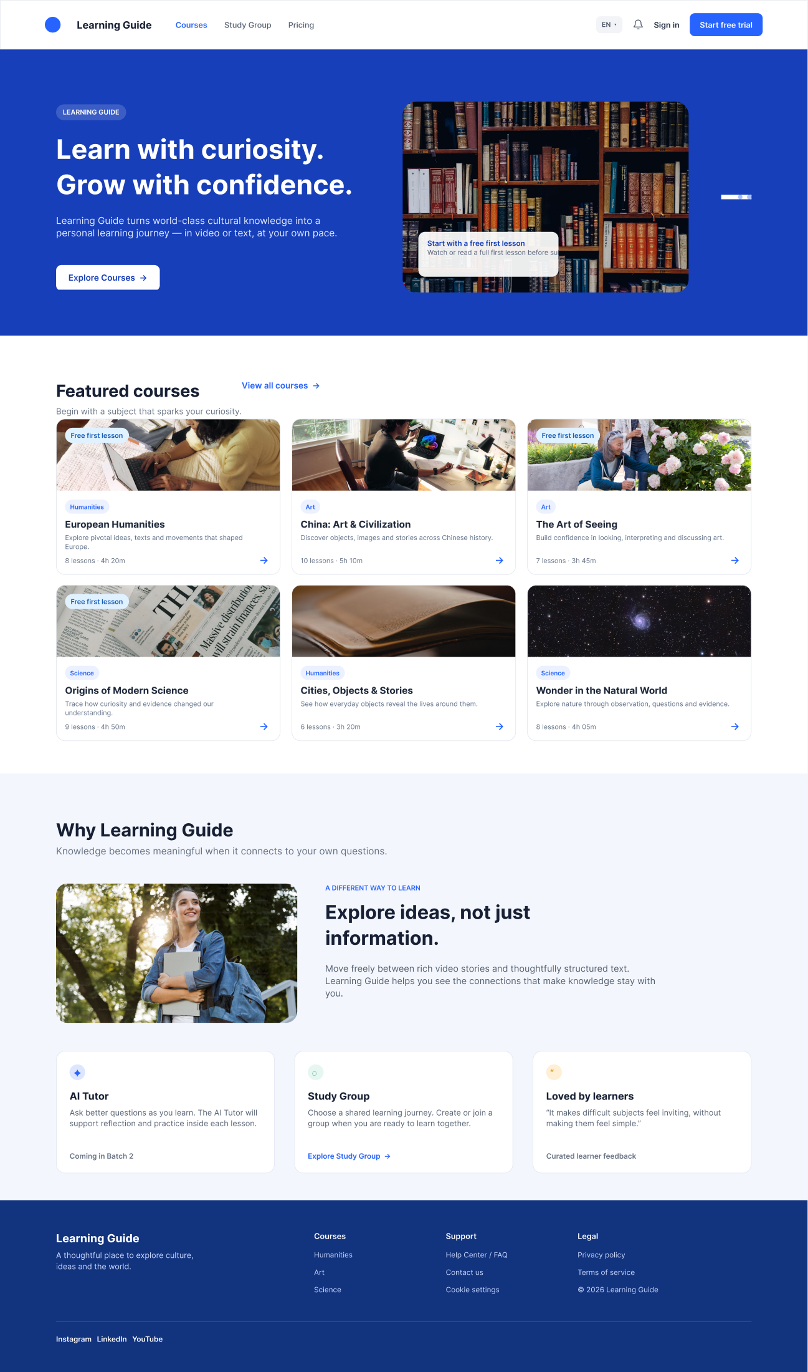
Figure 2: Home Page Structural Wireframe

4.2 Courses
Item | Requirement
User Goal | Browse all published Courses and available public first lessons.
Access | Public; Visitors and all signed-in states.
Page Modules / Displayed Information | Header; operations Banner at the top; Category filters; Course cards; learning-method description; Footer.
Interactions, States, and Navigation | Show all Courses by default; hide Categories with no published Courses. Course-card fields follow the global requirements. The public-first-lesson indicator is display-only; navigation occurs only when the corresponding CTA is clicked.
CTA / Tracking Index | CTA-COURSES-01 Top Banner; CTA-COURSES-02 Category Filter; CTA-COURSES-03 Course Detail.
Detailed Rule Owner | Portal; publishing, ordering, Banners, and public-first-lesson toggles are managed by Course Management.

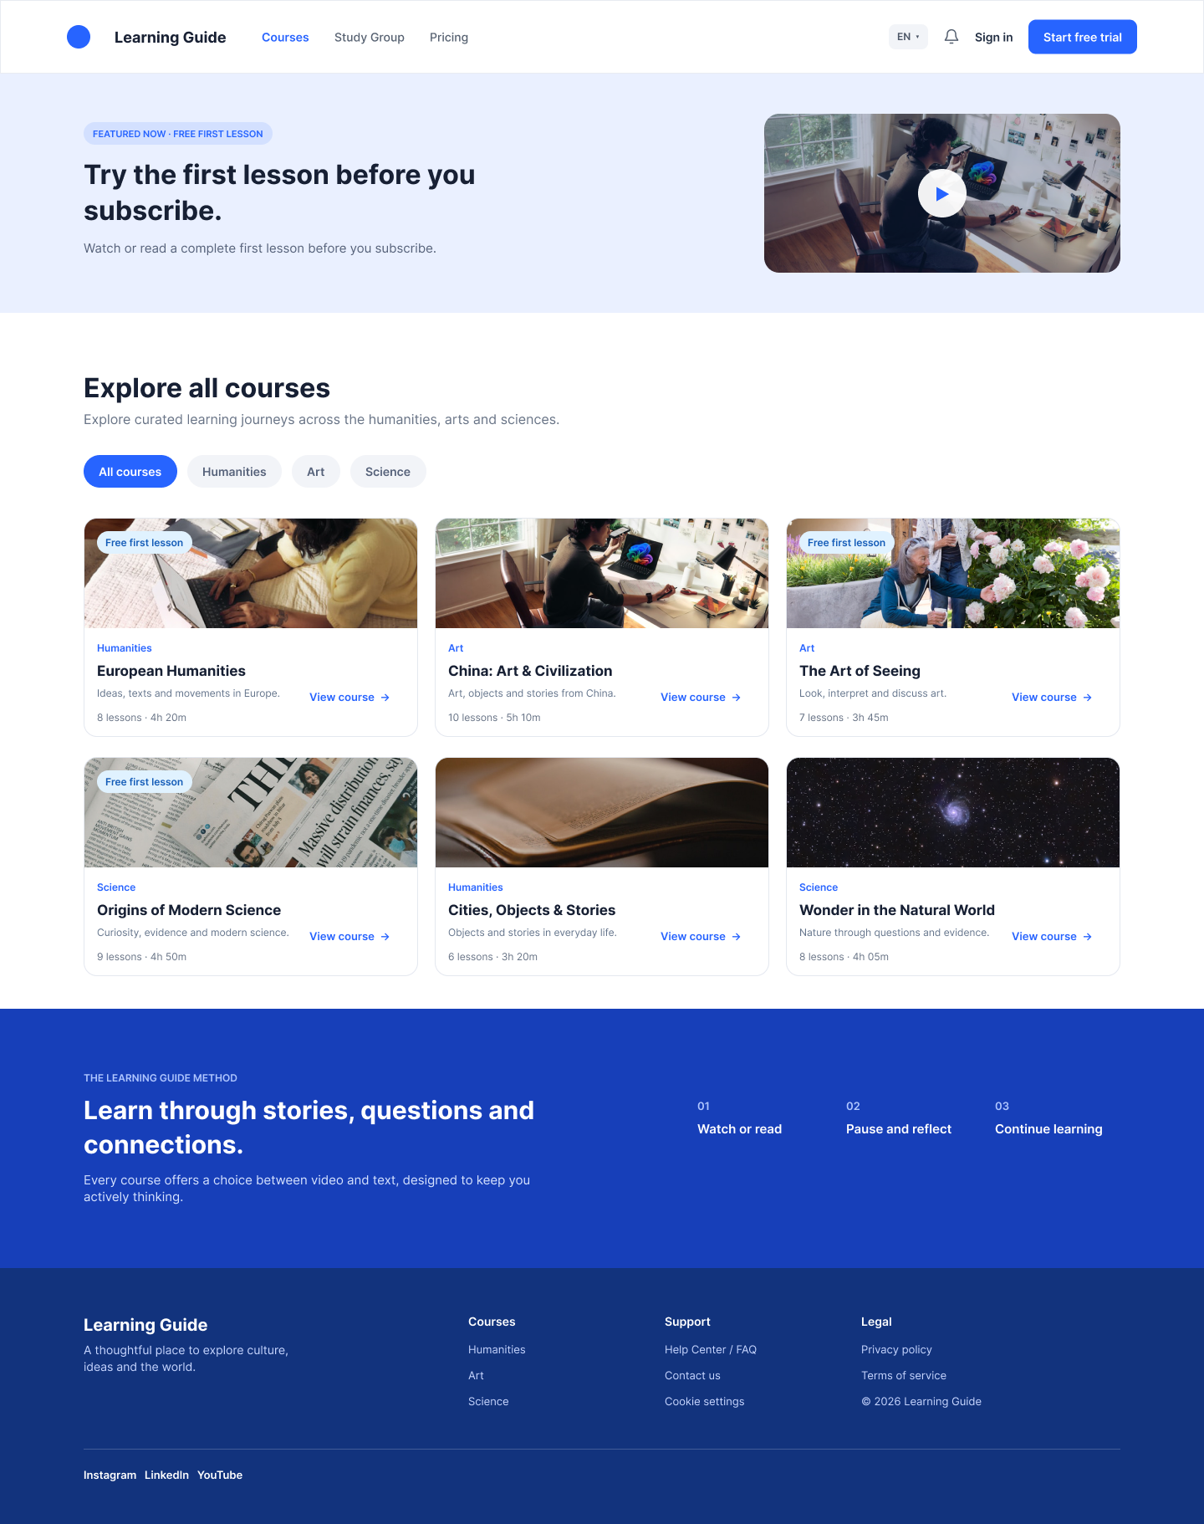
Figure 3: Courses Page Structural Wireframe

4.3 Course Detail
Item | Requirement
User Goal | Understand the Course value and decide whether to try, subscribe, or continue learning.
Access | Public; Visitors and all signed-in states.
Page Modules / Displayed Information | Course Banner (title, Category, language, estimated duration, state CTA); Overview; What you will learn; Exhibits; complete Lesson catalog; testimonials; recommended Courses; Footer.
Interactions, States, and Navigation | The catalog shows each Lesson's title, summary, duration, and Learning Point count. When the public first lesson is enabled, only Lesson 1 displays Try first lesson free. Active entitlements display Start / Continue learning based on the Study record.
CTA / Tracking Index | CTA-COURSE-01 Public Lesson；CTA-COURSE-02 Start/Continue；CTA-COURSE-03 Choose access plan。
Detailed Rule Owner | Portal; trial, subscription, and study records are provided by Visitor Trial, Subscription, and Study respectively.

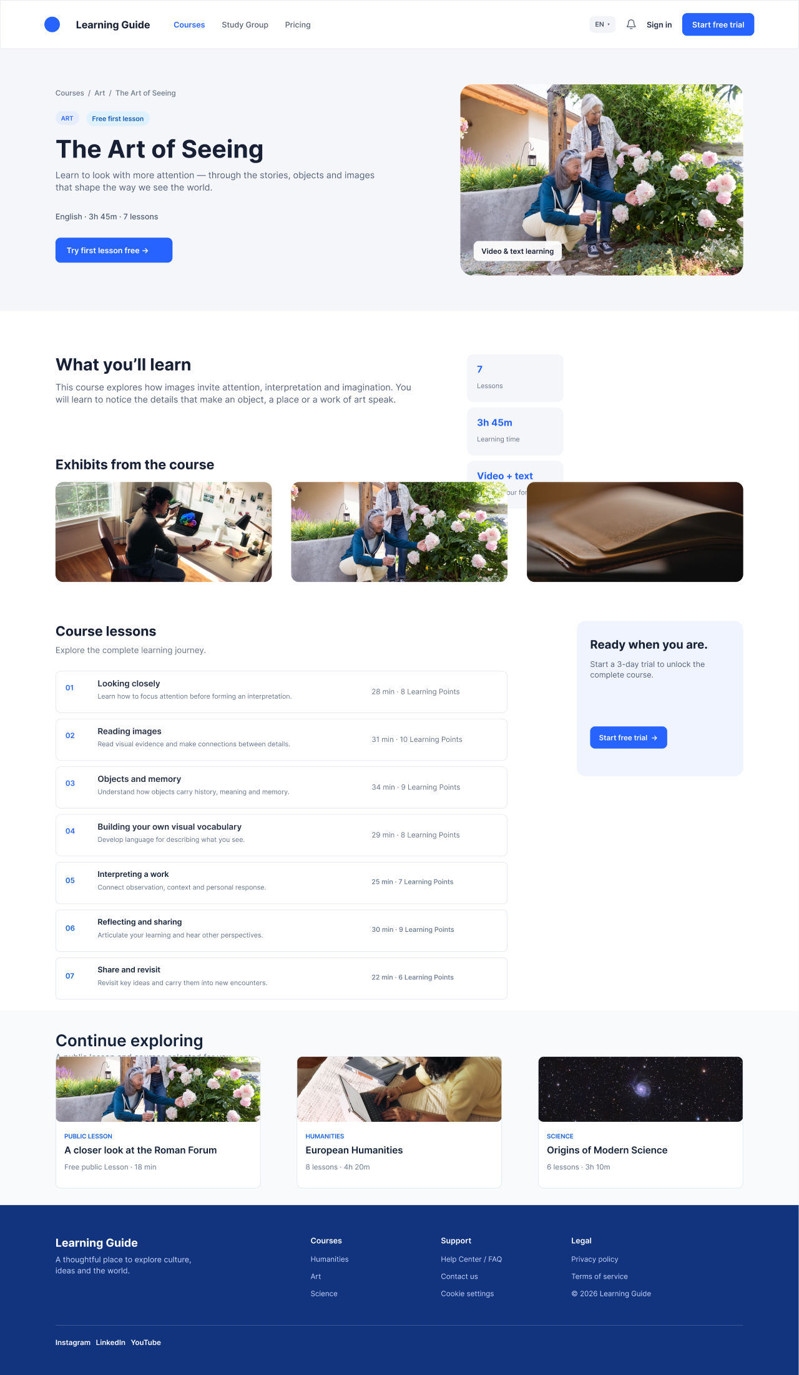
Figure 4: Course Detail Page Structural Wireframe

4.4 Public First Lesson
Item | Requirement
User Goal | Experience the complete enabled Lesson 1 of a Course and proceed toward a trial or subscription.
Access | Public; only the enabled Lesson 1 of that Course is open.
Page Modules / Displayed Information | Header, breadcrumbs, Course catalog, Lesson title, text/video toggle, player or text area, Copy Link, and plan prompt.
Interactions, States, and Navigation | Visitors can see Lesson titles and durations in the complete catalog but can enter only Lesson 1. Registration alone does not unlock other Lessons. Loading and failure states follow Section 8.
CTA / Tracking Index | CTA-PUBLIC-01 Choose access plan；CTA-PUBLIC-02 Copy Link；CTA-PUBLIC-03 Back to course detail。
Detailed Rule Owner | Portal + Visitor Trial; playback and text-learning details are owned by Study.

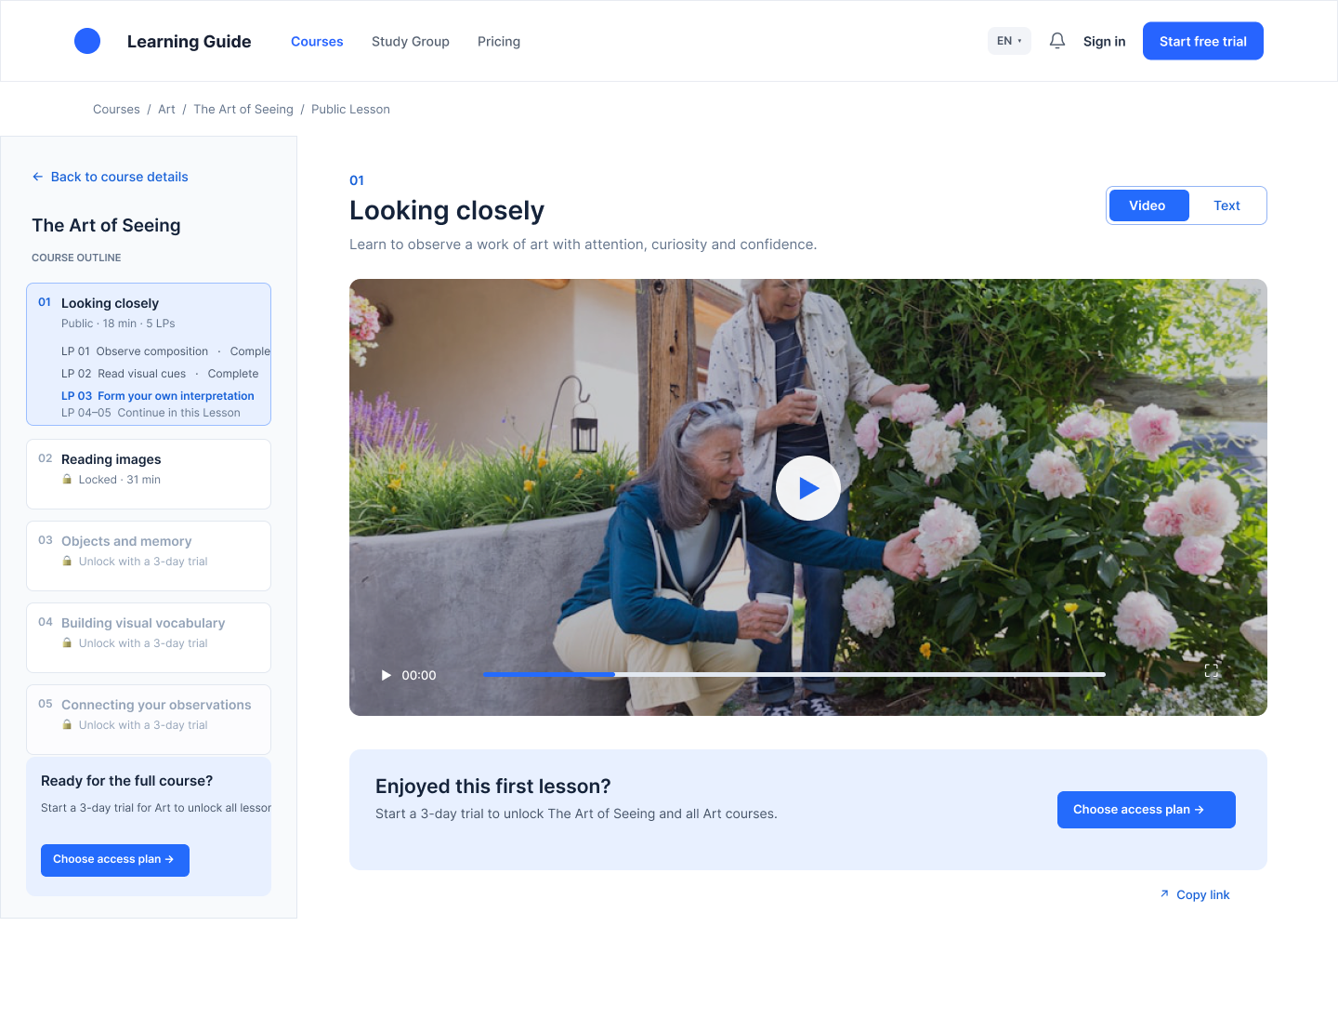
Figure 5: Public First-Lesson Page Structural Wireframe

4.5 Sign-In, Registration, and Authentication
Item | Requirement
User Goal | Create and access an account, then return safely.
Access | Visitor。
Page Modules / Displayed Information | Header; Email + Password; Google; WeChat; Forgot Password; email-verification and reset-confirmation states; safe return context; Footer.
Interactions, States, and Navigation | After successful authentication, return to a valid Return URL when available; otherwise route to /my-learning. Resolve Email, Google, and WeChat identity conflicts through Account Linking and do not create duplicate user_ids.
CTA / Tracking Index | CTA-AUTH-01 Email sign in/up；CTA-AUTH-02 Google；CTA-AUTH-03 WeChat；CTA-AUTH-04 Reset password。
Detailed Rule Owner | Registration & Authentication; the Portal defines only entry points and return routing.

See the Registration & Authentication PRD for page wireframes and interaction details.

4.6 Pricing
Item | Requirement
User Goal | Select a purchasable Course scope, device plan, and subscription term.
Access | Signed-in users only; Visitors return here after successful authentication.
Page Modules / Displayed Information | Header; term toggle; four purchasable plan types; entitlement summary; trial/auto-renewal explanation; upgrade, device, and multi-Course discount notices; Footer.
Interactions, States, and Navigation | Plans are limited to PC Course, PC Category, PC Everything, and Mobile Everything. Prices are returned by the server in USD. After selection, proceed to Subscription Confirmation. A Course-originated entry may carry a source recommendation but must not hide other purchasable plans.
CTA / Tracking Index | CTA-PRICING-01 Select plan；CTA-PRICING-02 Select term；CTA-PRICING-03 Continue to confirmation。
Detailed Rule Owner | Portal + Subscription; price, eligibility, discounts, upgrades, and state are owned by Subscription.

See the Subscription Management PRD for page wireframes and interaction details.

4.7 Subscription Confirmation and Stripe Result Pages
Item | Requirement
User Goal | Confirm the user's selection and auto-renewal authorization, redirect to Stripe, and display the final result.
Access | Signed-in users only; a valid server-side plan selection is required.
Page Modules / Displayed Information | Order summary, scope, device, AI, term, USD price, confirmation of auto-renewal and applicable terms, Confirm and continue, plus success/failure/cancellation/processing result messages.
Interactions, States, and Navigation | The confirmation page must not allow users to modify server-returned prices or eligibility. Confirm and continue is disabled immediately and is idempotent. Trial Activation and zero-dollar upgrades must not display a Receipt.
CTA / Tracking Index | CTA-CONFIRM-01 Confirm and continue；CTA-RESULT-01 Start learning；CTA-RESULT-02 Go to My Learning；CTA-RESULT-03 Back to Pricing。
Detailed Rule Owner | Subscription + Payment; the Portal owns page entry, non-sensitive return routing, and result states.

4.8 My Learning
Item | Requirement
User Goal | View entry points for the account, learning, subscriptions, notifications, help, and personal settings.
Access | Signed-in users only.
Page Modules / Displayed Information | Member Header; left navigation; account summary; continue learning; learning statistics; subscription summary; notification summary; Help entry; Footer.
Interactions, States, and Navigation | The Portal defines only the page hierarchy and entry points; final subscription, learning, and notification content and behavior are returned by the respective modules. Customer cancellation/resumption occurs within LG; Update Payment Method, Pay Now, Receipt, and Re-subscribe open Stripe-hosted pages.
CTA / Tracking Index | CTA-ML-01 Continue learning；CTA-ML-02 My Subscription；CTA-ML-03 Notifications；CTA-ML-04 Help。
Detailed Rule Owner | My Learning; the Portal consumes final state.

See the My Learning PRD for page wireframes and interaction details.

4.9 Full Course Learning Page
Item | Requirement
User Goal | Continue learning within active entitlement scope and display the current position.
Access | Users with an active Entitlement for the corresponding Course only.
Page Modules / Displayed Information | Member Header; breadcrumbs; Lesson / Learning Point catalog; video/text area; learning-capability entry points; progress and next Lesson; no Footer.
Interactions, States, and Navigation | Validate Entitlement on every entry or refresh. Accessing a Course outside the covered scope must redirect to Pricing. Playback, text, progress storage, and AI capabilities are defined by Study / AI services.
CTA / Tracking Index | CTA-LEARN-01 Start/Continue；CTA-LEARN-02 Next lesson；CTA-LEARN-03 Back to course detail。
Detailed Rule Owner | Study; the Portal defines only routing, gating, and information hierarchy.

See the Study module PRD for page wireframes and interaction details.

4.10 Study Group Introduction / Coming Soon
Item | Requirement
User Goal | Explain the future direction of group learning.
Access | Public; Visitors and all signed-in states.
Page Modules / Displayed Information | Header, mode introduction, use cases, Coming Soon, and Footer.
Interactions, States, and Navigation | This phase does not support creating, joining, payment, invitations, collaboration, content interaction, or marketing subscriptions. After future rules are defined, Create/Join entry points must authenticate first and return safely.
CTA / Tracking Index | CTA-GROUP-01 Learn more。
Detailed Rule Owner | Portal introduction page; Group Study functionality will be defined separately.

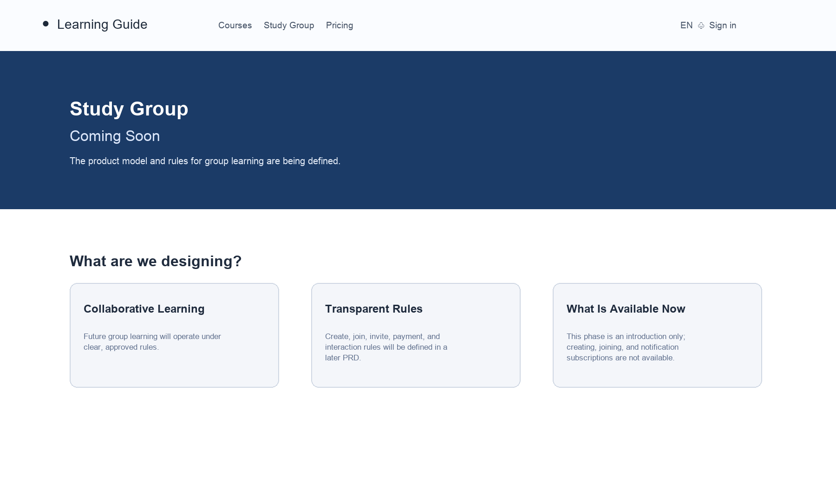
Figure 10: Study Group Coming Soon Page Structural Wireframe (Updated)

4.11 Help Center / FAQ
Item | Requirement
User Goal | Self-serve answers for account, trial, subscription, device, and learning-entry issues.
Access | Public; Visitors and all signed-in states.
Page Modules / Displayed Information | Header; three FAQ categories: Account & Authentication, Trial / Subscription / Payment, and Learning & Devices; in-page accordion expansion; Footer.
Interactions, States, and Navigation | No search, ticketing, customer-service submission, or marketing subscription. FAQ is accessible from the Footer and My Learning. FAQ answers are operations-configured and must not conflict with confirmed commercial rules.
CTA / Tracking Index | CTA-FAQ-01 FAQ category；CTA-FAQ-02 FAQ item expand。
Detailed Rule Owner | Portal; content is configured by Operations.

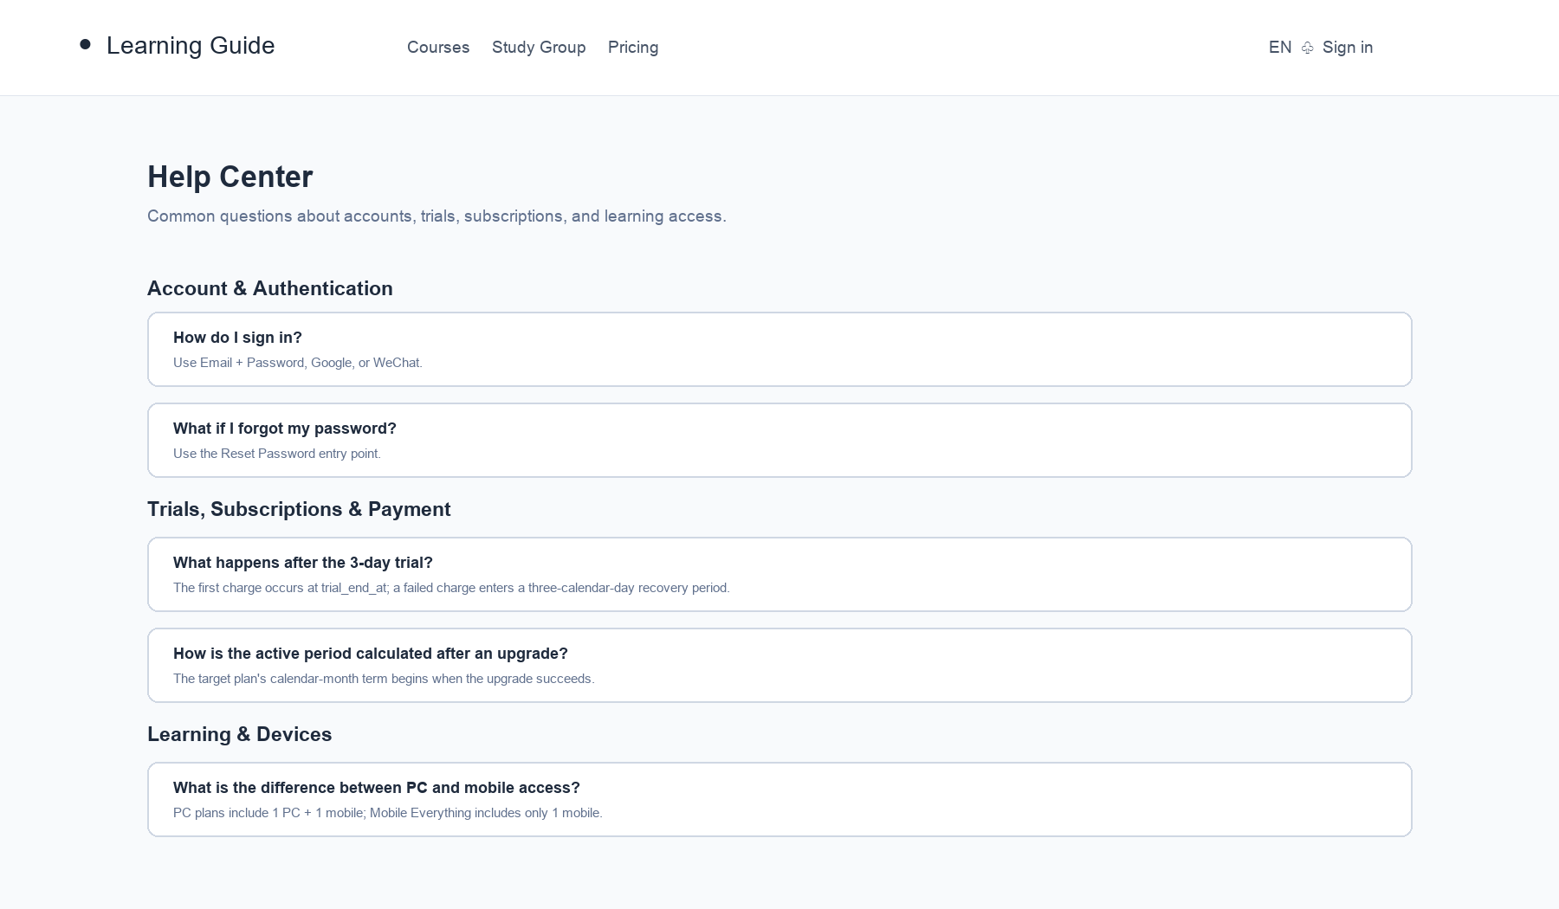
Figure 11: Help Center / FAQ Page Structural Wireframe (Updated)

4.12 Privacy Policy, Terms of Service, and Cookie
Item | Requirement
User Goal | Read approved bilingual legal content and manage Cookie preferences.
Access | Public; Visitors and all signed-in states.
Page Modules / Displayed Information | Header, breadcrumbs, title, last-updated date, language switcher, legal-content navigation, approved body copy, and Footer.
Interactions, States, and Navigation | There is no standalone refund page. Privacy, Terms, auto-renewal, refund, and Cookie copy must receive legal approval before launch; retain the content version and effective time for updates.
CTA / Tracking Index | CTA-LEGAL-01 Language；CTA-LEGAL-02 Cookie settings。
Detailed Rule Owner | Portal; content is provided by Business / Legal.

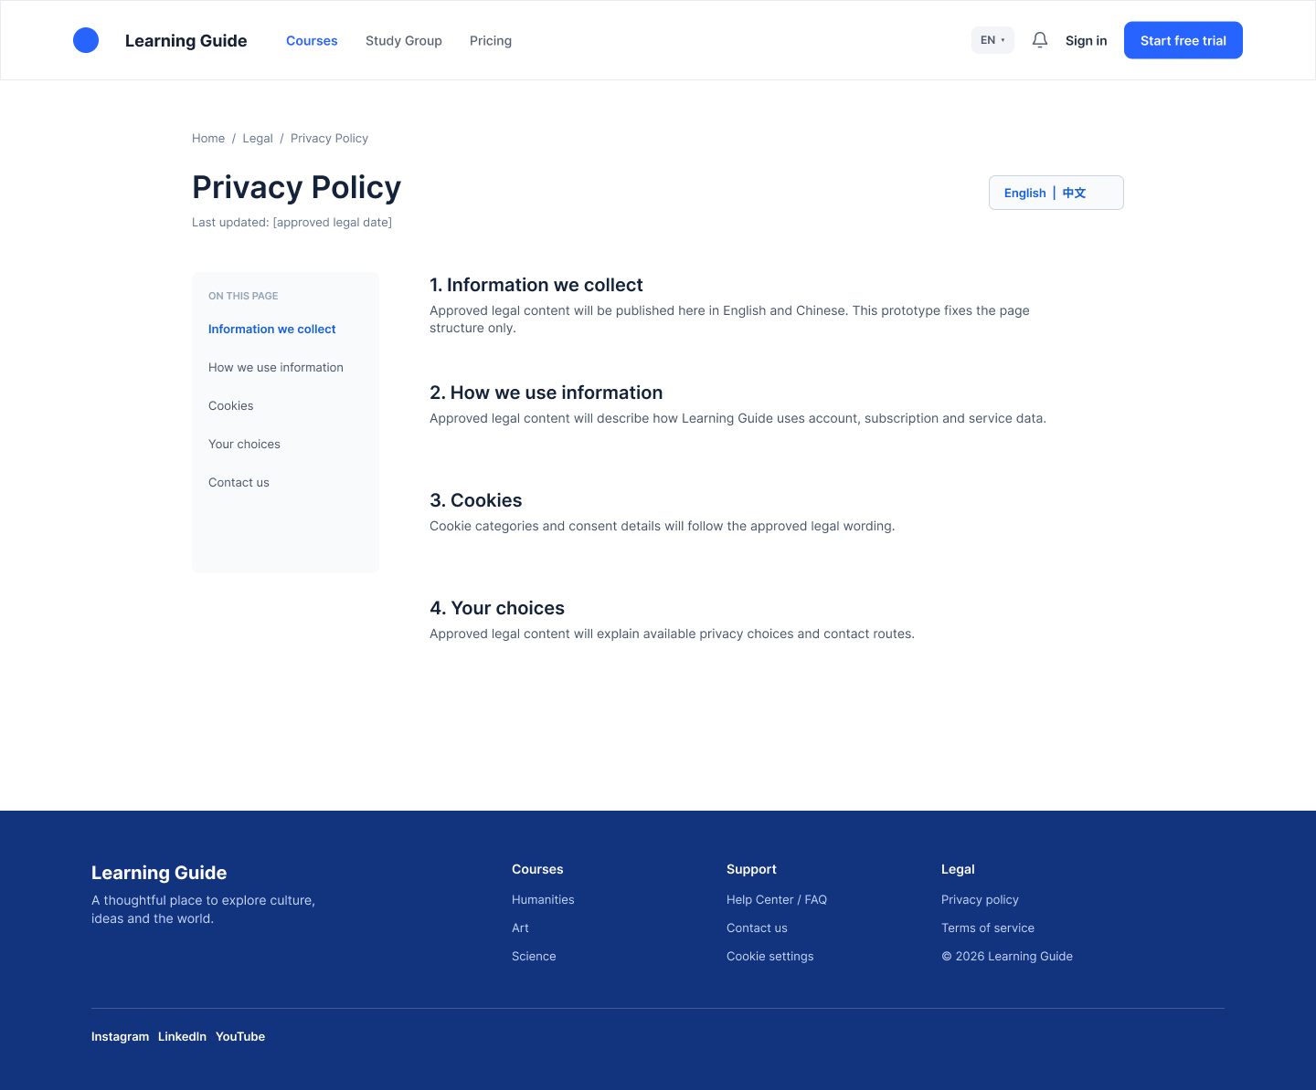
Figure 12: Legal Static-Page Structural Wireframe

4.13 404, Loading, and Content Failure
Item | Requirement
User Goal | Recover from invalid routes, network failures, or content errors.
Access | All users.
Page Modules / Displayed Information | Standard Header, concise error explanation, Retry, Back to Courses, and Footer (no Footer on learning pages).
Interactions, States, and Navigation | Invalid routes display 404; content failures display Retry and Back to Courses. Payment-processing and entitlement-confirmation states must never be rendered as success.
CTA / Tracking Index | CTA-ERROR-01 Retry；CTA-ERROR-02 Back to Courses。
Detailed Rule Owner | Portal; specific Payment/Subscription error codes are provided by downstream modules.

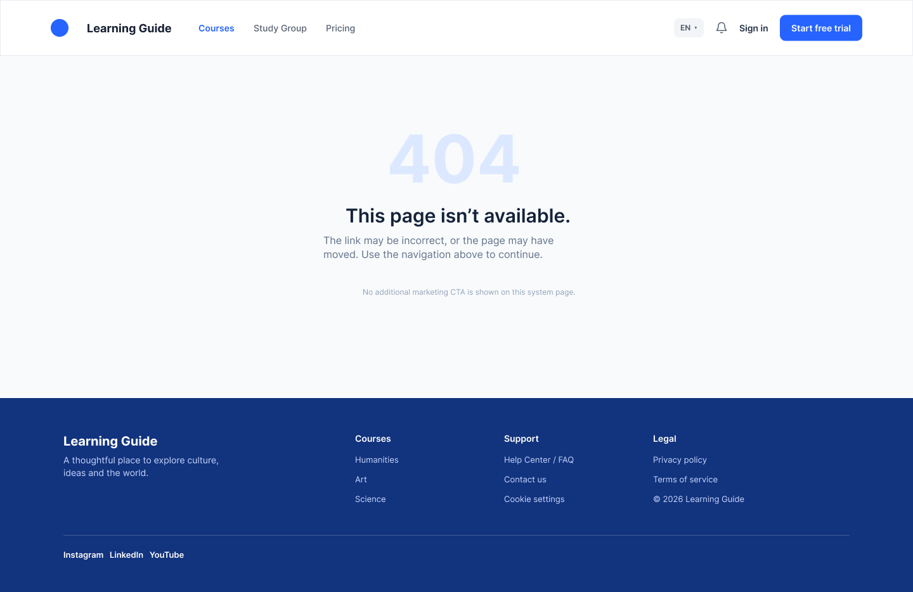
Figure 13: 404 Page Structural Wireframe

5. Portal Display Rules for Pricing, Trials, and Entitlements

5.1 Purchasable Plans and Display Fields
Plan | Scope | Devices and Capabilities | AI Points Display | Portal Display Requirements
PC Course | One specified Course. | 1 PC + 1 mobile; PC supports text, video, and full learning capabilities. | X。 | Support selecting multiple Courses in one transaction; conflicts with existing covered entitlements are resolved by the server.
PC Category | All Courses in a specified Category; Courses later published in that Category become dynamically accessible during the active period. | 1 PC + 1 mobile; PC supports text, video, and full learning capabilities. | Category Course-count snapshot x X. | Display the Category name, the Course-count snapshot basis, and a description of the dynamic Course scope.
PC Everything | All published Courses; Courses published later become dynamically accessible during the active period. | 1 PC + 1 mobile; PC supports text, video, and full learning capabilities. | 10,000。 | Explain the covered Category / Course scope and its dynamic-update basis.
Mobile Everything | All published Courses. | 1 mobile only; Study + audio; no AI. | 0。 | Mobile is a standalone purchase plan and is not presented as a purchasable Course or Category combination.

5.2 Cross-Page Commercial Notices
- Only 6- or 12-calendar-month terms may be selected. Prices display the server's current USD configuration. New purchases use the price effective for that year; auto-renewal and resumption of auto-renewal within the active period use the ongoing_renewal_price confirmed at purchase.
- When six PC Courses with the same term and no other promotion are purchased in one order, the lowest-priced Course is free. The free Course still receives full Course entitlements and X AI points.
- The Subscription service calculates all upgrade paths, credits, and new active periods. The Portal displays only server-returned eligible upgrade targets, credits, amounts due, and confirmation results. A USD 0 upgrade does not redirect to Stripe or display a Receipt.
- Customers cancel or resume auto-renewal in My Subscription. Update Payment Method, Pay Now, Receipt, and Re-subscribe open Stripe-hosted pages.

5.3 Portal Visibility of Trial States and Notifications
State / Notification | Page Display | CTA / Navigation
Trial Activated | My Learning / My Subscription displays trial expiry, selected plan, and entitlements. A USD 0 Trial Activation is marked as a trial and has no Receipt. | Start learning、Manage subscription。
Trial Canceled | My Subscription displays that auto-renewal is canceled and shows the original trial end time; full Course entry points are locked. | Resume Auto-Renewal (within the original window only).
Trial Reactivated | The resumed trial retains the original trial_end_at and does not extend the trial. | Start learning。
Trial Payment Failed / Payment Grace | Display the recovery-period deadline, a failure notice, and the current access state. | Update Payment Method、Pay Now。
Trial Conversion | Display the subscription and active period after the first payment succeeds. | View subscription / Start learning。
Trial Expired / Subscription Expired | Lock full-learning entry while keeping the public first lesson accessible. | Re-subscribe / Pricing。

6. Analytics Tracking, Metrics, and Data Quality
Tracking uses event_name, occurred_at_utc, anonymous_id (Visitor), user_id (after authentication), and correlation_id as shared linkage keys. Complete payment credentials, passwords, CVC, Stripe client secrets, and identifiable sensitive authentication tokens must never be written to event properties, logs, or URLs.

6.1 Common Fields for All Portal Events
Field | Requirement
event_name | Use stable snake_case names; do not create page-specific synonyms for the same business behavior.
occurred_at_utc | The client event time; critical server-side results use the server's UTC event time.
anonymous_id / user_id | Use anonymous_id before authentication; after authentication, link with user_id without overwriting the original anonymous-funnel linkage.
session_id、page_url、referrer、locale、device_type | Used for source, page, language, and device analysis. device_type describes the web-access device and is not the subscription device entitlement.
source_course_id、source_category_id | Pass only when a source page exists.
plan_id、scope_type、scope_id、device_access_type、term_months | Pass only for Pricing / Confirmation / Checkout events, using server-allowed values.
order_id、payment_attempt_id、subscription_id、entitlement_id、correlation_id | Pass only after the server has generated the value; used for cross-module tracing, deduplication, and reconciliation.
result / error_code | Use controlled enums; do not upload raw payment or identity-error details.

6.2 Portal Event Catalog
Event | Trigger | Key Properties | Owner
portal_page_view | The visible region of a public/protected page has rendered. | page_name、route、content_id、user_state。 | Portal。
banner_impression / cta_click | A Banner meets the impression threshold / the user clicks a CTA. | banner_id、cta_id、target_type、source_course_id。 | Portal。
course_card_view / course_card_click | A Course card is displayed / its CTA is clicked. | course_id、category_id、position、has_free_first_lesson。 | Portal。
public_lesson_view / public_lesson_start / public_lesson_complete | The public first lesson is entered, started, or completed. | course_id、lesson_id、mode、progress_bucket。 | Portal / Study。
auth_entry_click / auth_success / auth_failure | Authentication is initiated, succeeds on the server, or fails. | entry_source、provider、return_route、error_code。 | Authentication。
pricing_view / plan_selected / term_selected | Pricing is displayed, a plan is selected, or a term is selected. | Purchasable-plan set, plan_id, scope_type, scope_id, device_access_type, and term_months. | Portal / Subscription。
subscription_confirmation_view / checkout_redirect_created | The confirmation page is displayed or a Stripe-hosted redirect is created. | order_id、amount_usd、is_trial、is_upgrade、correlation_id。 | Subscription / Payment。
checkout_return_view | The result page is opened after returning from Stripe. | return_state、order_id、payment_attempt_id、correlation_id。 | Portal。
protected_route_allowed / protected_route_denied | The access gate allows / denies entry. | course_id、entitlement_id、denial_reason、destination。 | Portal / Entitlement。
notification_center_open / notification_read | Notification Center is opened / one notification is marked read. | notification_id、notification_type、created_at。 | My Learning / Notification。
cookie_consent_shown / cookie_consent_updated | Cookie preferences are displayed / updated. | consent_version, necessary, analytics, and marketing (marketing consent is not collected in this phase). | Portal。

6.3 Data Quality and Reporting Requirements
- Key conversion events must have a correlation_id or linkable user_id + order_id. Server-side payment, entitlement, and order events must support a 1:N relationship with Portal-initiated events.
- Checkout, trial activation, payment, and entitlement events must be idempotent. Repeated page loads, browser refreshes, or webhook replays must not count a business success more than once.
- Reports aggregate calendar days in the Asia/Hong_Kong business time zone; raw events and server timestamps remain in UTC. Store USD amounts separately as raw decimals and display-formatted values.

7. Non-Functional Requirements
Domain | Requirement | Acceptance Method
Performance | On a normal network, primary content on non-video Portal pages should appear within three seconds. Video start time depends on the final player service, but a loading state is required. | Performance tests for key public pages, Pricing, authentication entry points, and protected routes.
Availability and Fault Tolerance | While content loads, display "Please wait a moment." If content/the player fails, show an understandable error, Retry, and Back to Courses. Payment/entitlement processing must not display success. | Test network interruption, API timeout, downstream 4xx/5xx, and refresh scenarios.
Security | Allow only safe Return URLs; do not store or transmit complete payment credentials on the frontend; all protected routes rely on server-side Entitlement. | Test open redirects, unauthorized access, frontend plan/price tampering, and duplicate submission.
Privacy | Cookie preferences must be traceable. Tracking and logs must not contain passwords, sensitive payment data, or third-party tokens. Legal copy requires approval before launch. | Review event payloads, sample logs, and complete privacy-compliance acceptance.
Accessibility | Interactive controls have a visible focus state; informative images have alternative text; semantic headings and error messages are readable by assistive technology. | Check keyboard focus, image alt text, form labels, and error states.
Browsers and Devices | Support the current and previous major versions of Chrome, Safari, and Edge. This is a Web PRD; displaying mobile entitlements in a subscription does not define native App pages. | Browser regression and responsive-breakpoint testing.
Internationalization | English by default; Portal UI and static content support English and Chinese; dates, amounts, legal versions, and fallback language follow configuration. | Test English/Chinese content, long text, missing translations, and language switching.
Observability | Critical APIs, Checkout redirects, gate denials, and downstream asynchronous results must record correlation_id, a controlled error_code, and the source module. | Sample dashboards, alerts, and issue traces.

8. Cross-Module Relationships, Data Contracts, and Dependencies

8.1 Routing, State, and Responsibility Matrix
Portal Scenario | Requested / Consumed Data | Sole Source of Truth | Portal Output
Authentication and Return Routing | user_id、auth_state、provider、return_context。 | Registration & Authentication。 | Safe return route and source context.
Pricing Display | Purchasable plans, USD price, scope, device, AI, term, eligibility, and source recommendation. | Subscription / Pricing。 | Plan selection, confirmation entry, and tracking.
Trial / Paid Result | Final order, payment, subscription, and entitlement states. | Payment webhook → Order / Subscription / Entitlement。 | Result page, learning gate, and My Learning entry.
Full-Learning Gate | course_id, active entitlement, valid_to, and user study record. | Entitlement / Study。 | Allow learning or redirect to Pricing.
Notification Center | notification_id、type、title、created_at、read_at。 | Notification / My Learning。 | Unread badge, list entry, and mark-read request.
Operations Content | published state, Course/Category, Banner, FAQ, public-first-lesson toggle, and legal version. | Course Management / Backoffice / Legal。 | Public-page display and content-error state.

8.2 Key Interface Fields
Object | Minimum Fields Required by the Portal | Notes
Course / Public Lesson | course_id、course_slug、category_id、published、title、summary、duration、lesson_count、lesson_id、free_first_lesson_enabled。 | Only published Courses may appear; the public first lesson allows only an enabled Lesson 1.
Plan / Pricing | plan_id、scope_type、scope_id、device_access_type、term_months、currency、display_price、AI grant、eligibility、price_version。 | display_price is read-only; the Portal does not calculate amounts or eligibility.
Subscription / Entitlement | subscription_id、state、valid_from、valid_to、trial_end_at、grace_end_at、auto_renew、entitlement_id、covered_course_ids / scope。 | Use final state to determine UI and access gating.
Order / Payment | order_id、order_type、order_status、payment_status、payment_attempt_id、stripe_reference、amount_usd、is_receipt_available、correlation_id。 | Trial Activation and zero-dollar upgrades may have no PaymentIntent or Receipt.
Notification | notification_id、notification_type、channel、title、body_summary、created_at、read_at、deep_link。 | The Portal consumes in-app notifications; channel strategy is defined by Subscription / Trial.
Return Context | return_route、source_course_id、source_category_id、plan_id、scope_type、scope_id、term_months、device_access_type、source_event_id。 | Accept only allowlisted routes and controlled enums.

8.3 Launch Dependencies and Open Configuration
Dependency | Content to Confirm / Provide Before Launch | Responsible Module
Plans and Pricing | X value, USD prices for each plan/term, annual price version, Category-Course mappings, Stripe Price IDs, and whether an eligible trial is available. | Subscription / Pricing / Payment。
Authentication | Google / WeChat callback domains, credentials, review status, Email service, and safe Return URL allowlist. | Registration & Authentication。
Content and Operations | Course publishing, covers, FAQ, Banners, public-first-lesson toggles, and the effective versions of legal copy in English and Chinese. | Course Management / Backoffice / Legal。
Devices and App | Web device presentation and the native App launch schedule; this PRD does not define native App interfaces. | Product / Client。
Payment and Notifications | Stripe-hosted pages, Webhooks, trial notifications, payment-failure notifications, email templates, and delivery monitoring. | Payment / Subscription / Notification。
Learning Services | Course gating, learning progress, player, text content, and AI-point balance APIs. | Study / AI。

9. Acceptance Checklist
ID | Acceptance Criterion
AC-POR-01 | Visitors can access Home, Courses, Course Detail, enabled Free First Lessons, FAQ, Privacy Policy, and Terms of Service. Pricing and Subscription Confirmation require authentication.
AC-POR-02 | P0 authentication includes Email + Password, Google, and WeChat. Successful authentication performs safe return routing; if no valid destination exists, route to /my-learning.
AC-POR-03 | Pricing displays and allows selection of only four purchasable combinations: PC Course, PC Category, PC Everything, and Mobile Everything, with terms limited to 6 or 12 calendar months.
AC-POR-04 | Pricing does not redirect directly to Stripe. Every Checkout passes through Subscription Confirmation, and the Portal does not calculate price, discount, upgrade credit, or eligibility.
AC-POR-05 | PC plans display 1 PC + 1 mobile. Mobile Everything displays 1 mobile only, learning and audio, and no AI. AI-point display follows each plan's definition.
AC-POR-06 | Course / Category / Everything gates consume only the final server-side Entitlement. A successful browser return, refresh, or frontend parameter change never unlocks access early.
AC-POR-07 | Users in Trial Canceled or Expired states, and users with no entitlement, cannot enter full learning. The public first lesson remains available under its independent toggle. Payment Grace display and recovery entry points are correct.
AC-POR-08 | A USD 0 Trial Activation Order and zero-dollar upgrade display no Receipt. Receipts for successful paid records open a Stripe-hosted page.
AC-POR-09 | Tracking includes common fields, sensitive-data protection, a cross-module correlation_id, and the Portal event catalog; the data supports the metrics in Section 1.2.
AC-POR-10 | Loading, failure, 404, safe return routing, language, Cookie, Header/Footer, browser compatibility, and accessibility requirements pass acceptance on each page.

Appendix A: Key Terms and State Names
Term | Standard Definition
Course / Lesson / Learning Point | A Course consists of ordered Lessons; a Learning Point is an ordered progress unit within a Lesson.
Free First Lesson | A public experience independently enabled/disabled for Lesson 1 of a published Course. It is neither a standalone Course nor a trial.
Course / Category / Everything | Subscription scope types. Course means one specified Course; Category means one specified Category; Everything means all published Courses.
PC / Mobile | Subscription device-access types. A PC plan includes 1 PC + 1 mobile; a Mobile plan includes only 1 mobile.
Trial Active / Trial Canceled / Payment Grace / Expired | Standard trial and payment-recovery states visible in the Portal; specific transitions and time calculations are defined by Visitor Trial / Subscription.
Subscription Confirmation | The Learning Guide confirmation page between subscription selection and the Stripe-hosted page; it displays a read-only order summary, auto-renewal, and applicable terms.
Entitlement | The final server-calculated access right; the Portal consumes the result and does not derive it independently.
Receipt | A successful paid record links to a Stripe Receipt / Invoice; this does not apply to Trial Activation or a zero-dollar upgrade.
Calendar Month | A 6- or 12-month active period is calculated by calendar month in the Asia/Hong_Kong business time zone.

