Registration and Login Management
Product Requirement Document

Item | Details
Author | Firstlight
Document Status | Requirement Review
Document Version | v1.0
Scope | The current Web PRD; authentication and user id can be reused by the following original App page details are not defined in this document.
Login | Email / Google / WeChat
Main account identification | user id (invertible internal identifier)
Default Authentication Method | Email 6-digit verification code
Session Mode | Web session; secure cookie recommended

Version History
Version | Date | Notes
v1.0 | 14-08-2026 | Initial Learning Guide Registration & Authentication PRD. Includes Email, Google, WeChat, account linking, user data model and English wireframes/flowcharts.

Contents
1. General 4
1.1 Background 4
1.2 Product Objectives 4
1.3 P0 Success Criteria 4
1.4 Terminology and definitions 4
2. Scope and boundaries 5
2.1 Module Definition 5
2.2 Scope Internal 5
2.3 Scope External 5
2.4 Cross-modular responsibilities 6
3. Users and cross-module roles 6
4. Global Business Rules 6
5. System, page and authentication process 8
5.1 List of systems and pages 8
5.2 Trigger point 9
5.3 Use Case Mapping 9
6. Functional Requirements 10
6.1 Login/registration entry and Email recognition 10
6.2 Email New User Registration 10
6.3 Registered Email Password Login 11
6.4 Email Authentication 11
6.5 Google Login 12
6.6 WeChat Login 12
6.7 Account binding and duplicate account number prevention 13
6.8 Forget/replace passwords 14
6.9 Session, Logout and Return URL 14
6.10 User and Student Profile Create 14
7. Account number and authentication status model 15
7.1 User, Identity and Session Status 15
7.2 User-oriented grouping status 16
8. Page fields, interactive and English prototypes 16
8.1 Login or Create Account / Sign Up 16
8.2 Password Login / Verify Email 17
8.3 Reset Password / WeChat Login 18
8.4 Complete Account / Link Existing Account 19
8.5 Interaction Notes 19
9. Notifications and communication with users 20
9.1 P0 Unspecified Not Send 20
9.2 General rules 20
10. Abnormalities and recovery 20
11. Sites, indicators and statements 21
11.1 Types of accreditation 21
11.2 P0 Core Indicators 21
11.3 Incidents of Conduct 21
11.4 Data fields and attribution 22
12. Security, compliance and non-functional requirements 22
12.1 Security & Compliance 22
12.2 Non-Functional Requirements 23
13. Acceptance and inspection standards 23
14. Dependency, risk and to be confirmed 24
14.1 Dependency 24
14.2 Risk 24
14.3 Open Items 24
15. Appendix 25
15.1 User Object 25
15.2 Authentication Identity Object 25
15.3 Supporting Objects 26
15.4 Cross-module Reference Rule 26
15.5 External Integration Notes 26

1. Product Background and Objectives

1.1 Background
Learning Guide requires a single web-end identity portal that allows students to complete their first registration and subsequent login in emailes, Google or WeChat, and allows the same natural person to fall on the same Learing Guide User as possible. The competency is a common precursor to course visits, AI Tutor, purchase and subscription, learning progress, notification, etc.
P0 Focus on three issues: first, mail entry is automatically entered "Sign Up" or "Password Login" depending on whether they are registered; second, Google and WeChat use third-party identification, where Google does not repeat the requirement to enter the email, WeChat supplements Email and Full after the first authentication; third, any login is preferred to Account Linking, rather than creating duplicate User.

1.2 Product Objectives
- Provide a single login/registration portal to reduce the user’s selection cost between login or registration.
- Email + Password, Google, and WeChat P0 login, and keep the first login path consistent and predictable.
- Use user id as the only business connection key across the module to avoid data fragmentation due to Email modifications or changes in third-party accounts.
- Control the duplicate account numbers by Email Verification and Account Linking to ensure that the course, purchase and learning progress are consistently attributed to the same User.
- The user’s original business context is restored after successful login, for example, by returning to the original purchase page after login from the purchase page.

1.3 Success Criteria
- New emailes can be registered, checked and entered into ACTIVE; registered emailes can be accessed only by entering a password.
- The first Google login does not require users to re-enter Email at Learning Guide; again Google login can directly identify existing identities.
- Only Email + Full Name will be added after the first WeChat login completes the uniform scan authentication and Email Verification will be completed; again, WeChat login will not be added to Email.
- The same Email does not create a second User when it already exists, but enters the account binding process.
- Only one valid business session is established after successful login and can be secured, expired or cancelled.
- Payment, Order, Subscription, Course/Entitlement, Learning Progress can all be linked to the same user by stabilizing user id.

1.4 Terminology and definitions
Terminology | Definition
User | Main account number within Learning Guide. Reference to all business modules by inflexible user id.
Authentication Identity | Some kind of login identity, such as EMAIL PASSWORD, GOOGLE, WECHAT; one User can connect to more than one Identity.
Provider Subject ID | Stable user identifiers in third-party identity providers, such as Google sub; Email may not be used as a substitute for the Stable Mark.
OpenID / UnionID | WeChat identifier field. P0 saves actually available OpenID and, when available, also saves UnionID.
Account Linking | Tie new Google/WeChat Identity to an existing User instead of creating a duplicate User.
Email Verification | Validation of user control over Email by a single 6-bit authentication code.
Session | Could not close temporary folder: %s
Return URL | The original business page that the user accesss before being asked to sign in should be returned as a matter of priority upon successful login.
Student Profile | Learner ' s business information objects, separate from account accredited objects; can be initialized after creation by User.

2. Scope and boundaries

2.1 Module Definition
MODULE DEFINITION REGISTRATION & Association is responsible for account creation, login recognition, Email Documentation, third-party identity callback, Account Linging, Password Research, Session and Logout. User learning information, organizational membership, course privileges, payments and orders are not determined by this module, but must be used to create consistent references to this module through user id.

2.2 Scope Internal
- Harmonizes the "Sign in or create account" entrance and the Email Continue diversion.
- Email register for new users: Email, Full Name, Password, Email Services.
- Password Login, Forgot Password and Reset Password are registered for email.
- Google Sign-In: Create/belt for the first time, sign in directly again, and verify the service token.
- WeChat Sign-In: Jump WeChat Unified Sweep Login, First Email + Full Name, Direct Login again.
- Account Linging, repeated account number prevention, unique identity constraint.
- The P0 data model of User, Autonomy, Session, Verification Token.
- Could not close temporary folder: %s
- Registration/entry basis notice, burial site, audit and recovery of anomalies.

2.3 Scope External
- Organisation SSO / SAML / OIDC Enterprise One Point Login.
- Additional access to Apple, Facebook, mobile phone numbers, Passwordless Email, etc.
- MFA / Passkey / Hardware Key。
- Special onboarding process for Techer / Admin / Organization.
- Full Profile Edition, Student Profile Learning Predisposition.
- User self-help untie Google/WeChat bound UI; P0 retains only bottom status capability.
- Full compliance process for user self-help Account Deleting; this PRD only defines DELETED status.
- The third-party identity provider's own page visual design and file control.

2.4 Cross-modular responsibilities
Module | Responsibilities
Registration & Authentication | Account creation, identification, authentication, binding, session, Logout, certification audit.
User / Profile | Maintain basic user-enabled information; no third-party login documents are stored.
Student Profile | Maintenance of learning-related information, preferences and evaluation information; linked through user id.
Role / Organization | Maintains the status and competence of the Student / Teacher / Admin / Organization.
Course / Entitlement | Based on user id grant or cancel course visits; do not rely on Email as primary key.
Payment / Order / Subscription | Based on user id binding purchases, orders and subscriptions; Email is used only as contact information or snapshots.
Notification Service | Sending e-mail authentication codes, resetting passwords and necessary security notifications.
Google / WeChat | External identification and authorization; LG only consumes identification results certified by the service.

3. Users and cross-module roles
Role | Visits/responsibility
Visitor | Those who do not sign in may enter the login/registration portal and choose the authentication mode.
Student / User | Registration, login, authentication emailes, reset passwords, login via bound Google/WeChat and Logout.
Customer Support | Ask for user account status and Identity binding; P0 does not allow viewing passwords or authentication codes.
System Administrator | Suspend/Reinstate User is available to view certified audits and handle controlled account anomalies.
Notification Service | Sends the authentication code and password reset notification.
Google Identity Provider | Complete the Google account authentication and provide authentication to the LG backend to Token.
WeChat Identity Provider | Provides a uniform sweep login and authorized callback and returns third-party identification information that can be used to identify users.

4. Global Business Rules
Rule ID | Operational rules
BR-AUTH-001 | Email must be trim and customized independently before comparison with uniqueness; master Email must be unique in the database.
BR-AUTH-002 | Our id is the only stable primary key for all business modules associated with users; Email, Google Email, WeChat nicknames may not be used as cross-module primarys.
BR-AUTH-003 | The sameProvider subject id must be bound only to one User.
BR-AUTH-004 | Enter a new Email and click Continue to enter Sign Up; enter registered Email to enter Password Login.
BR-AUTH-005 | Email must be 6-bit Email Operation Code before registration is completed; User only enters ACTIVE after validation.
BR-AUTH-006 | Google does not require first and second login to manually enter Email in LG; LG uses the server to verify Google identity results.
BR-AUTH-007 | WeChat must add Email + Full to the first login and verify Email; re-entry does not need to be repeated.
BR-AUTH-008 | Only Google or WeChat users do not force the creation of Password; Password only belongs to EMAIL PASSWORD Initiative.
BR-AUTH-009 | A new social identity corresponding to Email cannot be created when it already exists.
BR-AUTH-010 | Account Linking must demonstrate control over the target Email; P0 defaults to Email Verification Code.
BR-AUTH-011 | If a valid URL exists after a successful authentication, return the URL first; otherwise return /my-leaning.
BR-AUTH-012 | The registration module only creates account level User and smallest Studen Profile, and does not capture learning preferences in the authentication process.
BR-AUTH-013 | Repeat OAuth callback, repeat authentication code submission, and repeat Continue requests must e. g. not result in duplicate User / Information / Session.

5. System, page and authentication process
The overall P0 process is as follows. All interfaces and process nodes in the figure are available in English, allowing for subsequent direct submission to design and development for reference as page/status designation.
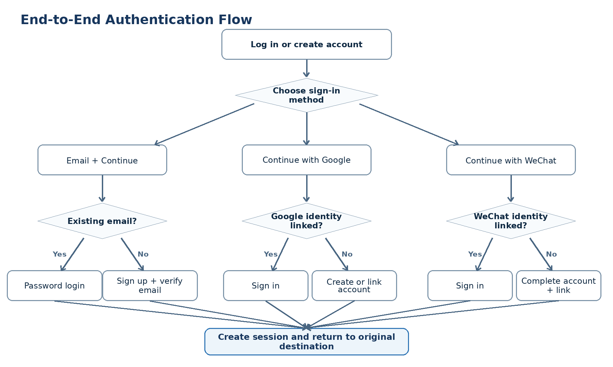
Figure 5-1 End-to-End Authentication Flow

5.1 List of systems and pages
Page / System ID | Name | Purpose / Owner
AUTH-P01 | Login or Create Account | Common entrance; Email Continue, Google, WeChat. Owner: LG Web/Auth
AUTH-P02 | Sign Up | New Email user fills Full Name + Password. Owner: LG Web/Auth
AUTH-P03 | Password Login | Registered email input Password. Owner: LG Web/Auth
AUTH-P04 | Verify Email | Enter 6-digit code to complete the email authentication. Owner: LG Web/Auth
AUTH-P05 | Reset Password | Sends the authentication code and sets the new Password. Owner: LG Web/Auth
AUTH-P06 | Google Authorization | Google external account selection/authorization page. Owner: Google
AUTH-P07 | WeChat Login | WeChat external unified scan login page. WeChat
AUTH-P08 | Complete Your Account | First time WeChat login to Email + FullName. Owner: LG Web/Auth
AUTH-P09 | Link Existing Account | Can not delete folder: %s: No such folder Owner: LG Web/Auth
SYS-AUTH | Authentication Service | User recognition, Token authentication, Identity, Ssession, Twist, etc., and auditing.
SYS-NOTIFY | Notification Service | Email verification / password reset code。

5.2 Trigger point
- Sign in / Sign up in a user click site Header / Purchase / Course Gate.
- Users enter Email and click Continue.
- User click with Google.
- User clicks Continue with WeChat.
- Google / WeChat returns the Learning Guide after authentication.
- Could not close temporary folder: %s
- Could not close temporary folder: %s
- The user Logout or Session expired/ revoked.

5.3 Use Case Mapping
Use Case ID | Name
UC-AUTH-001 | New email user sign-up
UC-AUTH-002 | Existing email password login
UC-AUTH-003 | First-time Google sign-in
UC-AUTH-004 | Returning Google sign-in
UC-AUTH-005 | First-time WeChat sign-in and account completion
UC-AUTH-006 | Returning WeChat sign-in
UC-AUTH-007 | Link social identity to an existing user
UC-AUTH-008 | Verify email
UC-AUTH-009 | Forgot and reset password
UC-AUTH-010 | Logout / session expiry
UC-AUTH-011 | Return to original destination after authentication

6. Functional Requirements

6.1 Login/registration entry and Email recognition
Req. ID | Priority | Requirements | Receiving and Inspection Point
AUTH-ENT-001 | P0 | AUTH-P01 also provides Email input, Continue with Google, Continue with WeChat. | Three entry points are available on the Web desktop and mobile width.
AUTH-ENT-002 | P0 | Email Continue calls the existential check and enters Sign Up or Password Login based on the results. | New Email enters the correct page with registered Email.
AUTH-ENT-003 | P0 | Toggle to the next page to keep the entered Email and provide an entry to return/modify Email. | Re-examining existential judgement after changing Email.
AUTH-ENT-004 | P0 | Prevents the rapid repetition of Continue and batch detection; displays general error when the flow is limited. | Repeated hits do not create a duplicate request link or account object.

6.2 Email New User Registration
Req. ID | Priority | Requirements | Receiving and Inspection Point
AUTH-SIGN-001 | P0 | New Email entered AUTH-P02, Email prefill; full Name, Password required. | Required fields are not available for submission.
AUTH-SIGN-002 | P0 | Password length is 8-72 characters; specific complexity strategies are not overly complicated by UI enforcement. | Shows a readable error when the length does not meet.
AUTH-SIGN-003 | P0 | Creates PENDING VERIFICATION User and EMAIL PASSWORD Identity after submitting, the password is only safe for Hashi. | There is no explicit password in the database.
AUTH-SIGN-004 | P0 | Sends 6-digit email service code; after successful validation, User enters ACTIVE and creates a session. | Only one Active User can be generated after validation.

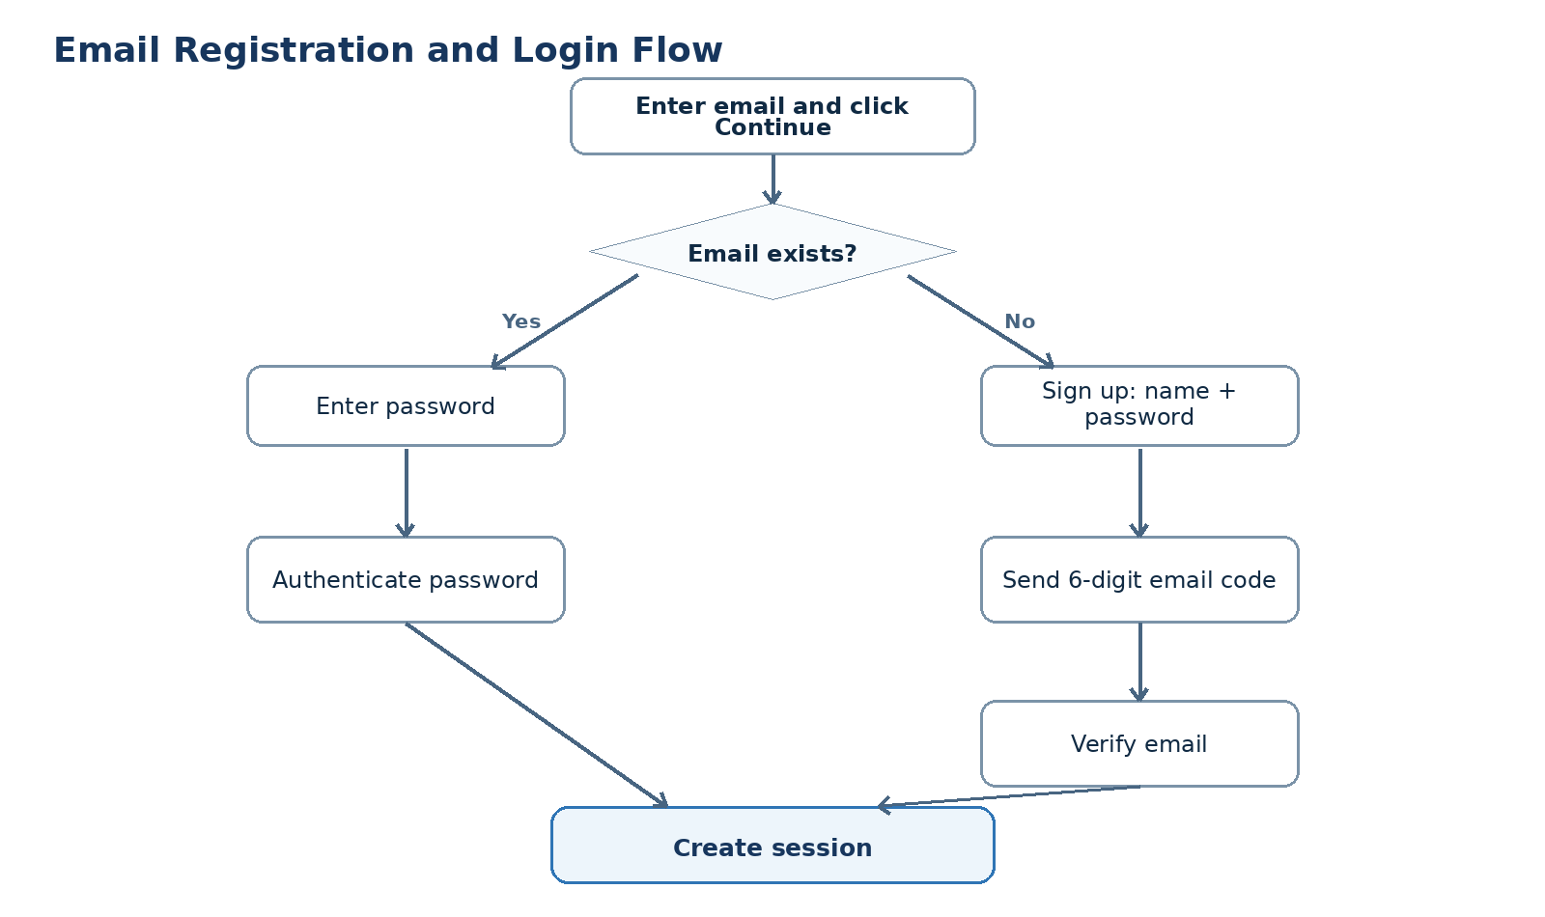
Figure 6-1 Email Registration and Login Flow

6.3 Registered Email Password Login
Req. ID | Priority | Requirements | Receiving and Inspection Point
AUTH-PWD-001 | P0 | Registered Email to AUTH-P03 only requests Password; Email continues to show and returns changes. | Full is not requested again.
AUTH-PWD-002 | P0 | Could not close temporary folder: %s | Login successfully updated last login at.
AUTH-PWD-003 | P0 | Error password displays a generic error and includes a restricted flow; no password rules or account internal status is disclosed. | When the threshold is reached, the speed limit/short stop will be used.
AUTH-PWD-004 | P0 | PENDING VERIFICATION user login to Verify Email instead of the new account number. | Continue the login target after validation.

6.4 Email Authentication
Req. ID | Priority | Requirements | Receiving and Inspection Point
AUTH-VER-001 | P0 | The authentication code is a one-time 6-bit code and sets the validity period, the number of attempts and the state of consumption. | Expiry/used code cannot succeed again.
AUTH-VER-002 | P0 | User can reend code; re-run is controlled by cooling time and frequency limits. | Continuous clicks do not send unlimited mail.
AUTH-VER-003 | P0 | Validates the successful writing of email verified at and completes the corresponding registration or Account Linking action. | The same authentication does not create Identity again.

6.5 Google Login
Req. ID | Priority | Requirements | Receiving and Inspection Point
AUTH-GOO-001 | P0 | Click to enter the account selection/authorization process provided by Google. | LG doesn't collect Google Password.
AUTH-GOO-002 | P0 | Google returns with a backend verification of ID Token's signature, assuer, udience, expiry and necessary numbers. | Token cannot create a session unless it is validated by the service.
AUTH-GOO-003 | P0 | Identity is bound to sign in directly; the user is not required to enter Email again at the first login. | LG Email input for the first time and again.
AUTH-GOO-004 | P0 | Create User + GOOGLE Identity; Full Name to start with Google profile name when the first Google Identity corresponds to Email does not exist. | New after only one User with a Google Identity.
AUTH-GOO-005 | P0 | The first Google Identity corresponds to Email entering Account Linking, without creating a new User. | Following successful binding, the original course/purchase/pace remains unchanged.

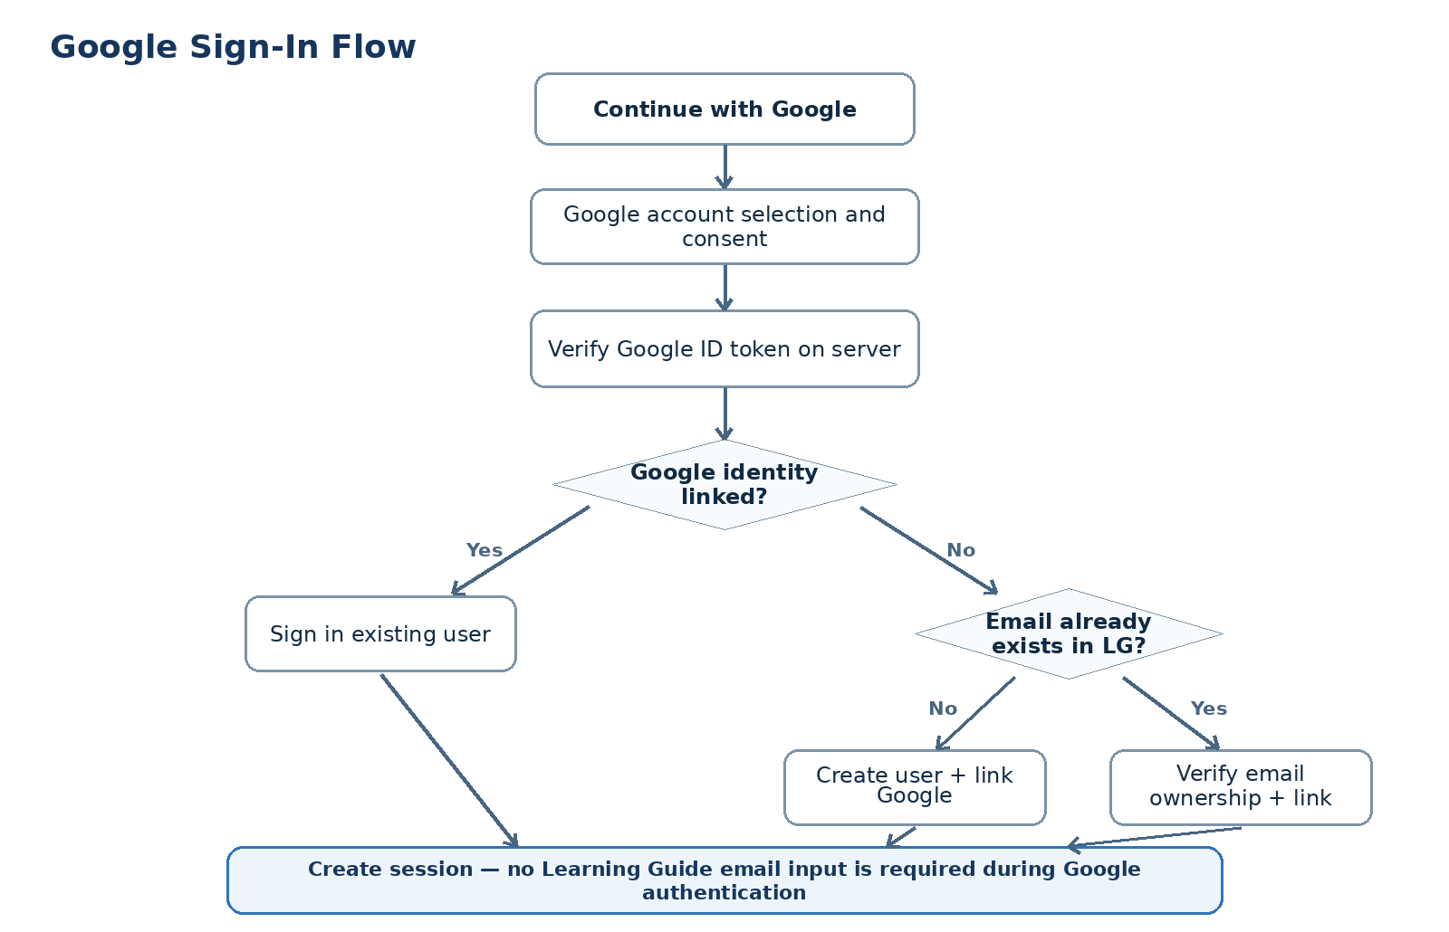
Figure 6-2 Google Sign-In Flow

6.6 WeChat Login
Req. ID | Priority | Requirements | Receiving and Inspection Point
AUTH-WX-001 | P0 | Click on Continue with WeChat and jump to the WeChat Unified Login/ 2D page; P0 does not copy the micro-mail authorization page. | User completes sweep and confirms and returns LG.
AUTH-WX-002 | P0 | Backend validates status, code exchange results and available identifiers for WeChat callback. | Could not close temporary folder: %s
AUTH-WX-003 | P0 | WeChat Identity is bound to sign in directly and no longer requires Email. | Returning WeChat user step back to LG.
AUTH-WX-004 | P0 | First time WeChat Identity into Complete Your Account, fill in Email + Full Name and do not require the creation of Password. | Page does not have a Password field.
AUTH-WX-005 | P0 | The first WeChat login must verify the additional Email; if Email already exists, bind to the existing User or create a new User. | Do not create duplicate User for the same email.
AUTH-WX-006 | P0 | Saves actually available WEChat OpenID and, when available, also the UnionID; field availability is based on the actual open platform configuration. | Identity Tables can support more WeChat applications in the future.

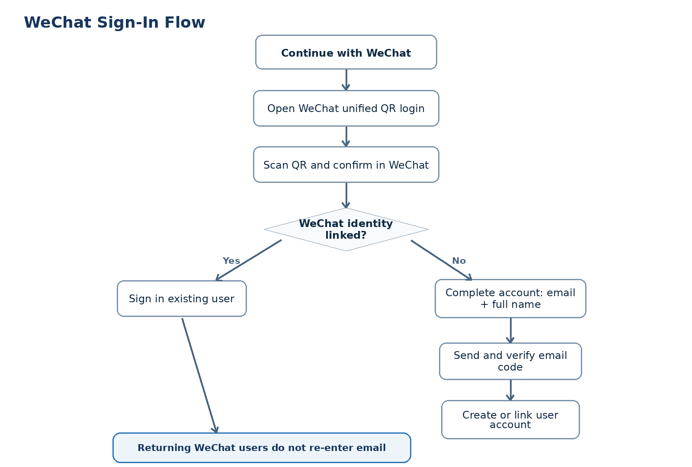
Figure 6-3 WeChat Sign-In Flow

6.7 Account binding and duplicate account number prevention
Req. ID | Priority | Requirements | Receiving and Inspection Point
AUTH-LNK-001 | P0 | Before creating Social User, you must check both provider subject id and regularize Email. | Both layers of uniqueness check is passed before new User is created.
AUTH-LNK-002 | P0 | Could not close temporary folder: %s | No change.
AUTH-LNK-003 | P0 | The same Identity is bound to another User without automatic migration to abnormal treatment/ manual support. | The system does not quietly merge the two existing User.
AUTH-LNK-004 | P0 | Bound action logs provider, source user / target user, time, results and control id. | Auditing.

6.8 Forget/replace passwords
Req. ID | Priority | Requirements | Receiving and Inspection Point
AUTH-RST-001 | P0 | Forgot Password receives Email; regardless of whether the account number exists, the frontend returns the unified hint to reduce the number count risk. | Cannot initialise Evolution's mail component.
AUTH-RST-002 | P0 | Only EMAIL PASSWORD Identity can be set/replaced; social-only users should indicate using the original login. | No password will be created for social-only users silently.
AUTH-RST-003 | P0 | Resets the authentication code/Token for one-time and short-term validity; updates password hash after success and can undo the old session. | The old Reset Token cannot be reused.

6.9 Session, Logout and Return URL
Req. ID | Priority | Requirements | Receiving and Inspection Point
AUTH-SES-001 | P0 | Any authentication method ultimately creates login sessions through a unified session service. | Business level does not rely on provider token as LG session.
AUTH-SES-002 | P0 | Session cookies uses Secure, HttpOnly and a reasonable SameSite policy; the service supports expiry and revocation. | Client script cannot read sensitive session secret.
AUTH-SES-003 | P0 | Logout undoes the current session and returns the pre-entry page or the public front page. | Keep logout after refreshing the page.
AUTH-SES-004 | P0 | Only the station is allowed to open retourn URLs. | External malicious URL cannot be redirected by login process.

6.10 User and Student Profile Create
Req. ID | Priority | Requirements | Receiving and Inspection Point
AUTH-USR-001 | P0 | All registrations only create a core User; User tables do not save the programr-special password/openid/sub field. | The third-party field is located in Authentification Identity.
AUTH-USR-002 | P0 | The new student account ACTIVE was initiated to minimize the number of Studen Profiles and to one-to-one connections through user id. | The accreditation process does not impose learning preferences.
AUTH-USR-003 | P0 | Payment, Order, Subscription, Entitlement, Learning Progress use user id as a connecting key. | Change Email does not affect historical purchase and learning data.
AUTH-USR-004 | P0 | The User status at least supports PENDINGING VERIFICATION, ACTIVE, SUSPENDED, DELETED. | The login is in accordance with section 7 in different states.

7. Account number and authentication status model
The status model deliberately splits User, Regularization Identity and Session to avoid mixing " Whether account numbers are available " with " Whether a login method has been tied " with " Whether the current browser has login ".
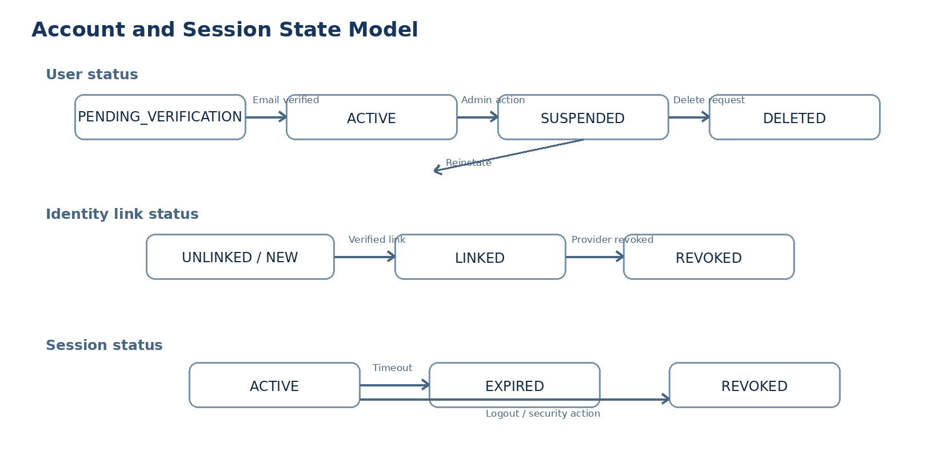
Figure 7-1 Account and Session State Model

7.1 User, Identity and Session Status
Status Group | Recommended status | Meaning of Truth
User | PENDING_VERIFICATION; ACTIVE; SUSPENDED; DELETED | LG User Service; account level status.
Identity | UNLINKED/NEW; LINKED; REVOKED | LG Authentication Service + Provider result。
Email Verification | UNVERIFIED; VERIFIED | LG Verification Service。
Session | ACTIVE; EXPIRED; REVOKED | LG Session Service。

7.2 User-oriented grouping status
Group Status | User Presentation | Allow Actions
New email | Sign up | Fill in Full Name + Password.
Existing email | Welcome back | Enter Password / Forgot Password.
Email unverified | Verify your email | Enter or reissue the authentication code.
Google/WeChat returning | Signing you in… | Returns the target page directly after completion.
New WeChat identity | Complete your account | Fill in Email + FullName.
Email already used | Link your existing account | Could not close temporary folder: %s
Suspended user | Account unavailable | Can not create folder lock on %s: %s
Expired session | Session expired | Re-entry and maintain secure URLs.

8. Page fields, interactive and English prototypes

8.1 Login or Create Account / Sign Up
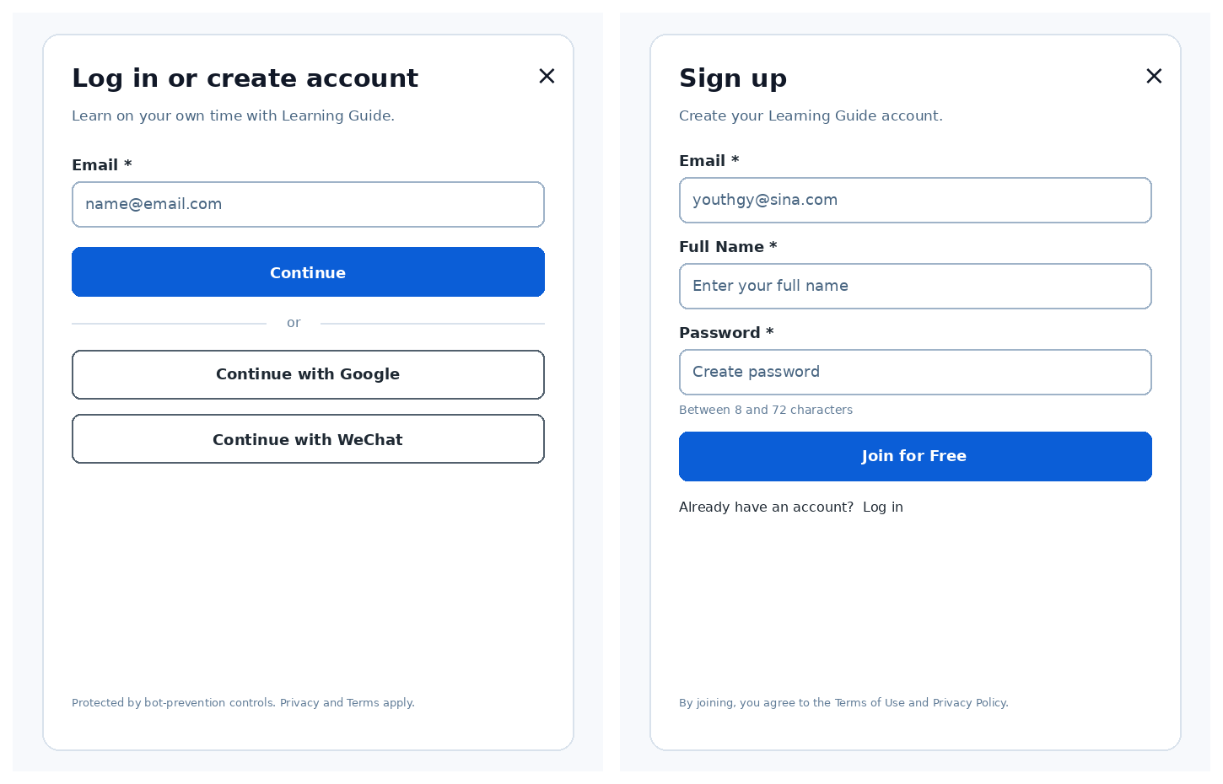
Figure 8-1 Login or Create Account and Sign Up
Page | Key Field / Control | Interactive rules
AUTH-P01 | Email; Continue; Continue with Google; Continue with WeChat | Continue is based on the existence of a diversion from Email; social buttons go directly into processer flow.
AUTH-P02 | Email; Full Name; Password; Join for Free | Email prefill; Password 8-72; enter Verify Email after submission.

8.2 Password Login / Verify Email
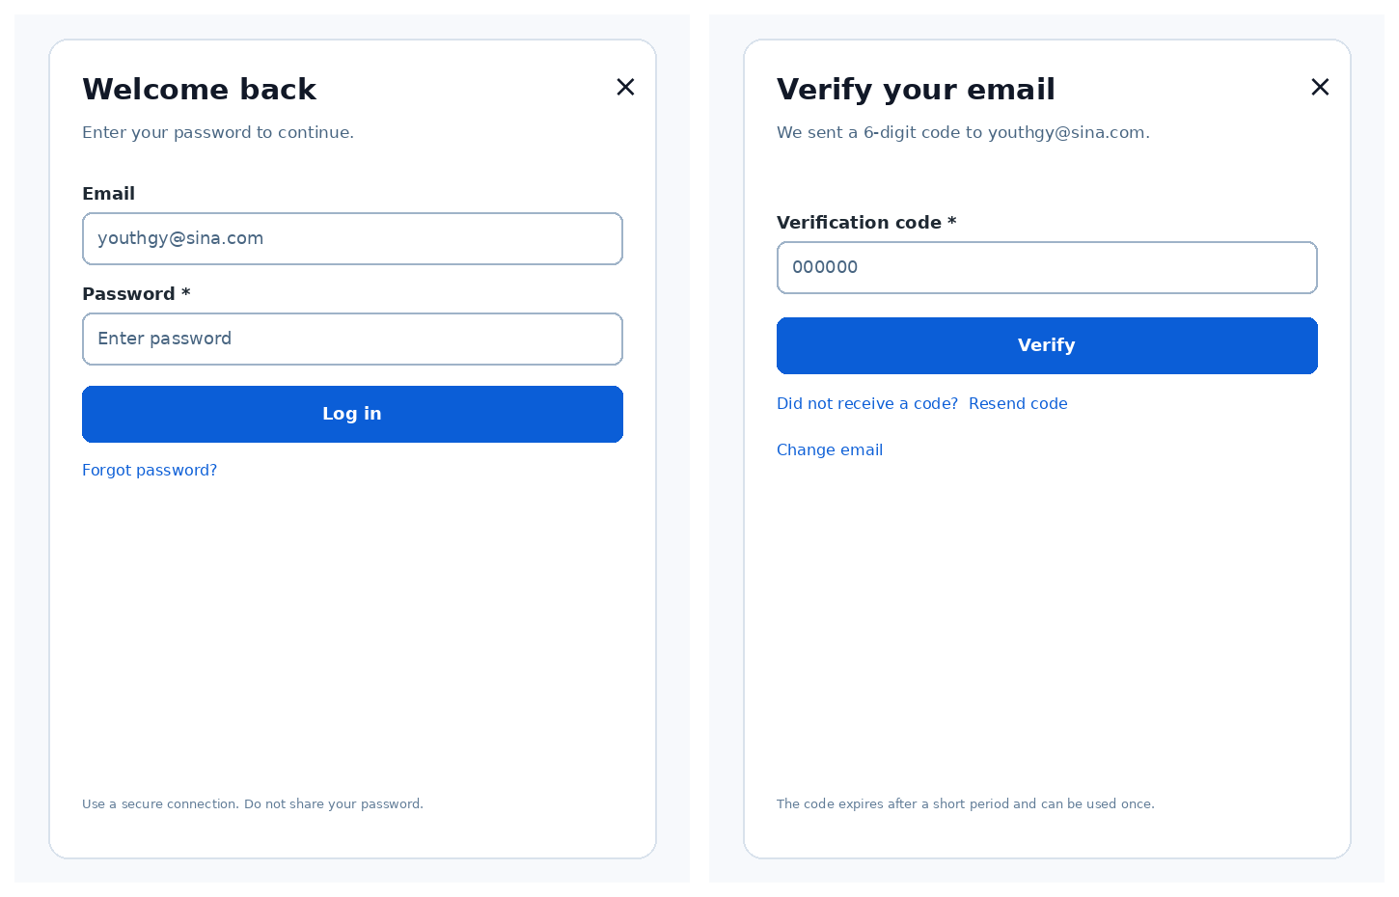
Figure 8-2 Password Login and Verify Email
Page | Key Field / Control | Interactive rules
AUTH-P03 | Email; Password; Log in; Forgot password | Email is visible but is not edited by default; returns a previous step to change.
AUTH-P04 | Verification code; Verify; Resend code; Change email | Inline feedback is used for errors, expirys, and redeals.

8.3 Reset Password / WeChat Login
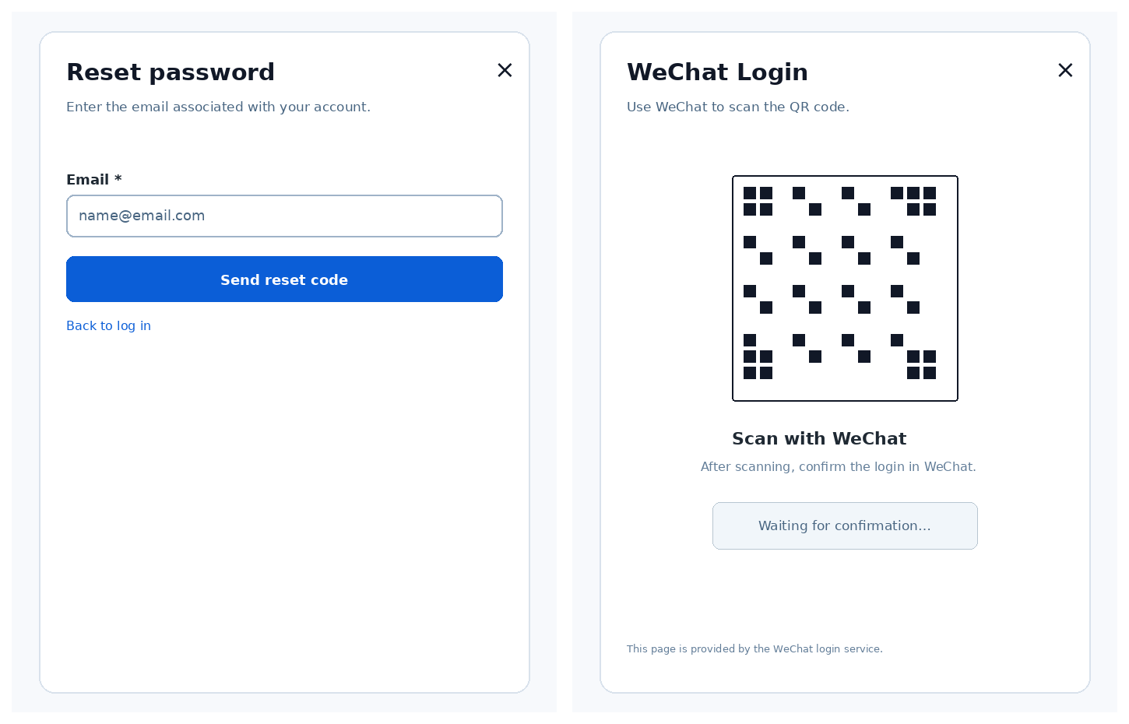
Figure 8-3 Reset Password and WeChat Login
Page | Key Field / Control | Interactive rules
AUTH-P05 | Email; Send reset code; Back to log in | Submits the result using a uniform hint and does not disclose the existence of Email.
AUTH-P07 | QR code; Waiting / Scanned / Confirmed / Expired states | Controls authorized pages by WEChat; LG callsback for follow-up.

8.4 Complete Account / Link Existing Account
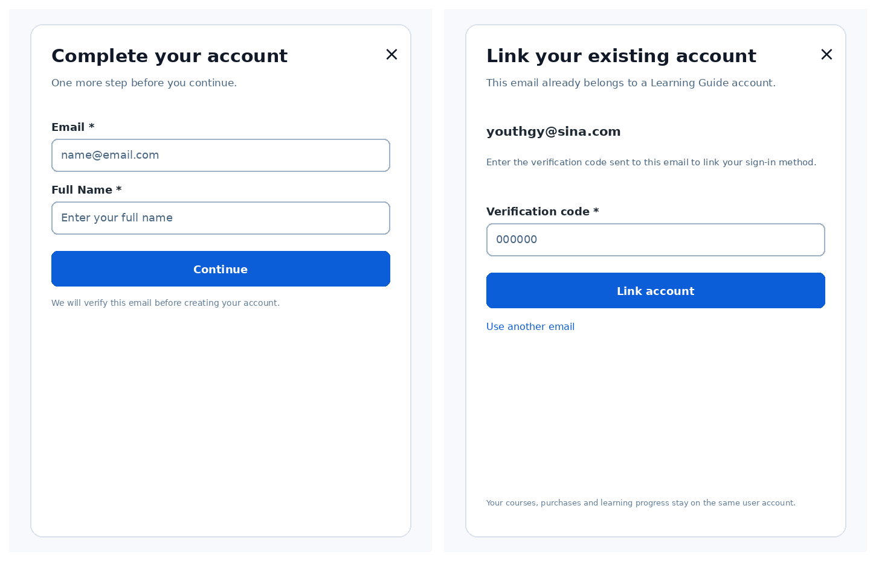
Figure 8-4 Complete Account and Link Existing Account
Page | Key Field / Control | Interactive rules
AUTH-P08 | Email; Full Name; Continue | Only first WeChat login appears; no Password is shown.
AUTH-P09 | Existing Email; Verification code; Link account | Use user id after binding successfully and create a session directly.

8.5 Interaction Notes
- The main entry is defaulted on modal/cented Panel; return to the page before the user triggers login after closing.
- Disables the duplicate submission button during the Loating/Processing status, avoiding the creation of an account or session.
- The Google and WeChat third-party pages can vary depending on the provider / locale. This PRD prototype only confirms the jump-and-turn boundary.
- All errors priority inline display; system failure provides Retry and retains unsensitive input.
- Closes the middle page and restores the URL after third-party login calls are completed; enters /my-Learning if the URL is not valid.

9. Notifications and communication with users
ID | scene | Trigger | Channels | Objective
NTF-AUTH-001 | Email verification code | New Mailbox Register / First WeChat Backbox / Account Linking | Email | AUTH-P04 / AUTH-P09
NTF-AUTH-002 | Password reset code | Forgot Password Request | Email | AUTH-P05
NTF-AUTH-003 | Account linked | Google / WeChat successfully bound to existing User | Email | Account / Security Page
NTF-AUTH-004 | Password changed | Password reset succeeded | Email | No forced jump

9.1 P0 Unspecified Not Send
- Each regular login is notified successfully.
- The third party has sent itself a duplicate notification of authorization.
- Could not close temporary folder: %s

9.2 General rules
- Each business event is sent only once; repeated callback/ retry should not be repeated.
- Authenticated mail should not contain passwords, protocol token or sensitive internal IDs.
- The link or code in all mail must be tied to the target environment, user and purpose.
- UTC; conversion by product time zone/user time zone at user display.

10. Abnormalities and recovery
ID | scene | Product handling | Owner
EX-AUTH-001 | Invalid email format | Stops Continue and makes a hint under Email field. | LG Web
EX-AUTH-002 | Email already registered during sign-up race | Switch to Password Login, without creating a second User. | Auth
EX-AUTH-003 | Wrong password | Common error +rate loss; retaining Email. | Auth
EX-AUTH-004 | Verification code expired | Tip expired, allowed Resend. | Auth / Notification
EX-AUTH-005 | Too many verification attempts | Temporary blockage and allow for re-trying at a later stage. | Auth
EX-AUTH-006 | Google user cancels consent | returns AUTH-P01, displays non-blocing message. | Google / LG Web
EX-AUTH-007 | Invalid Google token | Rejection of Ssession, recording of audit and permission to re-launch. | Auth
EX-AUTH-008 | WeChat QR expired | Refresh/recreate 2D code on the provider page. | WeChat
EX-AUTH-009 | WeChat user cancels confirmation | returns AUTH-P01, does not create an account. | WeChat / LG Web
EX-AUTH-010 | Social email matches existing User | Enter Account Linking; do not create a second User. | Auth
EX-AUTH-011 | Identity already linked to another User | Stops the automatic processing, displays the Support path. | Auth / Support
EX-AUTH-012 | OAuth callback duplicated | Press state/correlation/idepotty key to weigh. | Auth
EX-AUTH-013 | Email service unavailable | Keeps PENDING status, allows later Resend. | Notification
EX-AUTH-014 | Session expired during checkout/course gate | Recertified returns the valid URL. | Auth / LG Web
EX-AUTH-015 | User suspended | Do not create a session; display Accountable. | User Service

11. Sites, indicators and statements

11.1 Types of accreditation
Type | Definition
Email Sign-up | New Email + Full Name + Password + Verification.
Email Password Login | EMAIL PASSWORD Information Login already exists.
Google First-time | First Google Identity, create or bind User.
Google Returning | Other Organiser
WeChat First-time | WeChat Identity, plus Email + Full Name + Verification.
WeChat Returning | Other Organiser
Account Linking | Merge Sociality into existing user id.
Password Reset | Could not close temporary folder: %s

11.2 P0 Core Indicators
Indicators | Formula / Definition
Email Sign-up Completion Rate | Finish Email registration/ new Email user for Sign Up.
Email Verification Completion Rate | Validation successful/ sent authentication code.
Login Success Rate | Successful Session/ Launch authentication attempt, grouping by provider.
Google First-time Conversion | Google first login completes creation or binding/ first Google callback.
WeChat First-time Conversion | WeChat completes Email supplement and authentication for the first time / WeChat returns.
Account Linking Rate | / Social email hit already User.
Duplicate User Prevention Count | Number of new User creations prevented by the Email/provider conflict.
Password Reset Completion Rate | Successfully reset / reset request.

11.3 Incidents of Conduct
Event ID | Event Name | Trigger | Key Properties
EVT-AUTH-001 | auth_entry_viewed | AUTH-P01 opened | source, return_url_type
EVT-AUTH-002 | email_continue_submitted | Continue accepted | email_domain_hash, result=new/existing
EVT-AUTH-003 | signup_submitted | Sign Up accepted | user_id, source
EVT-AUTH-004 | email_verified | Verification success | user_id, purpose
EVT-AUTH-005 | login_succeeded | Session created | user_id, provider
EVT-AUTH-006 | login_failed | Final authentication failure | provider, failure_category
EVT-AUTH-007 | account_linked | Identity linked | user_id, provider
EVT-AUTH-008 | password_reset_succeeded | Password changed | user_id
EVT-AUTH-009 | logout_succeeded | Session revoked | user_id, session_id_hash

11.4 Data fields and attribution
Field Groups | Example Fields | Source / Owner
User | user_id, primary_email, email_verified_at, status, full_name | User Service
Authentication Identity | provider, provider_subject_id, provider_email, openid, unionid | Auth Service / Provider
Session | session_id, user_id, created_at, expires_at, revoked_at | Session Service
Verification | purpose, email, code_hash, expires_at, consumed_at | Verification Service
Student Profile | student_profile_id, user_id | Student Profile
Cross-module References | order.user_id, entitlement.user_id, progress.user_id | Owning business module

12. Security, compliance and non-functional requirements

12.1 Security & Compliance
ID | Requirements | Receiving and Inspection Point
SEC-AUTH-001 | Password cannot be stored explicitly; use mature self-adaptation password hashing. | Databases, logs and events are not specified.
SEC-AUTH-002 | Google ID Token must be verified at the service end; Email/user id cannot be trusted to return only at the frontend. | Token was rejected for forgery or lack of conformity.
SEC-AUTH-003 | Outlook uses state and applies nonce; Callback must match pre-assembly redirect URI. | CSRF/replay test passed.
SEC-AUTH-004 | WeChat authorization results have to be done by the service; code exchange and identification; no confidence in client self-reporting openid. | Illegal callback does not create Identity.
SEC-AUTH-005 | The session cookie uses Secure + HttpOnly and uses a rational SameSite and expired strategy. | Browser check and security test passed.
SEC-AUTH-006 | Email code/reset token is a single-use, short-term valid, only Hash or irreversible security expression. | Database leak does not directly expose valid code.
SEC-AUTH-007 | Email Continue, Password, Verification, Reset have a lot of content / bot protection. | Automatic misuse testing is controlled.
SEC-AUTH-008 | Business access/refresh token does not need to be saved for long periods; if necessary, encrypt with minimal permission. | The data field audit was adopted.
SEC-AUTH-009 | Account Linking, Suspend, Reinstate, Password Change are all included in the audit records. | Retroactivity/time/action/result.
SEC-AUTH-010 | Return URL must stand within, prevent open direct. | External URL is refused or retreated to default development.

12.2 Non-Functional Requirements
ID | Category | Requirement / Target | Measurement
NFR-AUTH-001 | Availability | Authentication core API target availability 99.9% (excluding third-party problemr self failure). | Monitoring
NFR-AUTH-002 | Performance | Email existence/ password auth service response P95 < 800 ms (excluding external provider page). | APM P95
NFR-AUTH-003 | Reliability | #Outhcallback, ID consumption, Identity Linking, etc. | Failure injection / retry test
NFR-AUTH-004 | Observability | All requests for accreditation carry the description id and record the provider, results, fraud case. | Log / trace review
NFR-AUTH-005 | Compatibility | P0 supports the Mainstream Desktop/Moving Web Browser defined for Learning GUI. | Browser test matrix
NFR-AUTH-006 | Accessibility | The form has label, Focus order, keyboard operation and clear error tips. | Accessibility review
NFR-AUTH-007 | Data Retention | Authentication audit, session, preservation review set different retention cycles according to security and privacy policy. | Policy review

13. Acceptance and inspection standards
AC ID | Acceptance and inspection standards | Evidence
AC-AUTH-001 | New Email from Constante → Sign Up → Verify Email → ACTIVE → Summit | E2E test + DB evidence
AC-AUTH-002 | Only Password Login is displayed after email is registered from Continue and can be successfully login. | E2E test
AC-AUTH-003 | Google does not require the first and second login to enter Email in LG; it can be created or bound for the first time, and the user can sign in directly. | Provider sandbox test
AC-AUTH-004 | WeChat first login to fill Email + Full Name + Verification; no more Email requests. | Provider sandbox test
AC-AUTH-005 | Social email does not create a second User, Account Linking, after hitting an existing User. | DB uniqueness + E2E test
AC-AUTH-006 | Modifying User Email does not affect historical Order, Subscription, Entitlement and Learning Programs user id. | Cross-module integration test
AC-AUTH-007 | Error/expired authentication code, repeat callback, duplicate submission does not create UNSer/Intity/session. | Idempotency test
AC-AUTH-008 | Forgot Password does not divulge Email exists; Reset Token is valid once. | Security test
AC-AUTH-009 | Suspended User cannot create a new session. | State test
AC-AUTH-010 | Return URL only supports legitimate targets inside the station and external open redirect failed. | Security test
AC-AUTH-011 | All Password, Token, Verification Code meets section 12 security requirements. | Security review
AC-AUTH-012 | All UIs and flow patterns in the prototype are in English; PRD notes are in Chinese. | Document review

14. Dependency, risk and to be confirmed

14.1 Dependency
ID | Dependency | Owner | Required By
DEP-AUTH-001 | Google Outlook / Google Identity Services Web profile and redirect URI. | Engineering / Ops | Integration test
DEP-AUTH-002 | WeChat Open Platform Website Application, AppID/Secret, authorized callback domain. | Business / Engineering | Integration test
DEP-AUTH-003 | Notification Service. | Platform | P0 E2E
DEP-AUTH-004 | User Service / Auth DB's sole binding and servicing capacity. | Backend | P0 E2E
DEP-AUTH-005 | An intermediate between Return URL and Unity | Web / Platform | P0 E2E
DEP-AUTH-006 | Terms of Use, Privacy Policy, Cookie/Consent. | Legal / Product | Go-live

14.2 Risk
Risk ID | Risk | Impact | Mitigation | Owner
RSK-AUTH-001 | Email Continue diversion may be used for account count. | Medium | RATE limit, bot protection, monitoring; Reset Password uses a unified hint. | Security
RSK-AUTH-002 | Google/WeChat and Email register at the same time, resulting in duplicates of User. | High | Email only bound + policy subject only bound + Account Linking. | Backend
RSK-AUTH-003 | WeChat Website Login audit or regional availability is inconsistent with the plan. | High | Early completion of open platform application; P0 retains Email/Google fallback. | Product/Ops
RSK-AUTH-004 | Third party program callback / changes. | Medium | Provider isolation; integrated testing and observable. | Engineering
RSK-AUTH-005 | The Email delay caused a decrease in the conversion of registration. | Medium | Resend, cooling, service control, alternative mail provider forecast. | Platform
RSK-AUTH-006 | Error Account Linking merges two different users. | High | Target Email control must be verified; automatic displacement is prohibited in case of conflict. | Security

14.3 Open Items
Item ID | Issues / Decision-making | Current Recommendations | Owner
OI-AUTH-001 | Sign Up for Terms/Privacy with a visible checkbox, or a bottom-button statement? | P0 First uses the button to declare that the law requires an upgrade to checkbox at the time of the change. | Product/Legal
OI-AUTH-002 | Does Google Email automatically bind when it hits an existing User? | P0 does not automatically bind; following Email Verification, Link. | Security/Product
OI-AUTH-003 | WeChat Login uses provider-hosted page or station embedded QR? | P0 Use WEChat unified/host login page. | Product/Engineering
OI-AUTH-004 | Does UnionID always be available in the final Website App configuration? | field; confirm actual return when connected. | Engineering
OI-AUTH-005 | Session Lifetime with refresh policy. | A unified platform security strategy. | Security/Platform
OI-AUTH-006 | Cannot initialise Evolution's mail component. | Recommendation P1 Account & Security Settings. | Product

15. Appendix

15.1 User Object
Field | Type / Example | Required | Notes
user_id | UUID / usr_xxx | Yes | Internal non-change main key; all business module references.
primary_email | string | Yes | Only after standardization; can be modified but not used as business primary.
email_verified_at | datetime | Conditional | Email verified time.
full_name | string | Yes | Email/WeChat; Google can be initialized from file.
avatar_url | string | No | Initialize from social profile, followed by Profile.
status | enum | Yes | PENDING_VERIFICATION / ACTIVE / SUSPENDED / DELETED。
created_at | datetime | Yes | Created.
updated_at | datetime | Yes | Update time.
last_login_at | datetime | No | Recently successfully created session time.

DATA MODEL RULE User has no password hash, google sub, wechat openid, wechat unionid. The login is all over the Internet, avoiding the growth of User schema with the growth of the program.

15.2 Authentication Identity Object
Field | Type / Example | Required | Notes
identity_id | UUID / idn_xxx | Yes | Identity primary key.
user_id | UUID | Yes | Associated with User.
provider | enum | Yes | EMAIL_PASSWORD / GOOGLE / WECHAT。
provider_subject_id | string | Conditional | Third-party stability key; Google uses sub, WeChat uses the selected projector subject.
provider_email | string | No | Provider returns an Email snapshot; inaction user id.
password_hash | string | EMAIL only | Only EMAIL PASSWORD Identity is used.
wechat_openid | string | WECHAT | WeChat website application saves when available.
wechat_unionid | string | No | saving when available; nullable.
status | enum | Yes | LINKED / REVOKED。
created_at | datetime | Yes | Tie time.
last_authenticated_at | datetime | No | The Identity recently successfully certified time.

15.3 Supporting Objects
Object | Core field | Use
Session | session_id, user_id, created_at, expires_at, revoked_at, last_seen_at | Unified Web login session; business does not directly use provider token.
Verification Token | verification_id, purpose, email, code_hash, expires_at, attempts, consumed_at | Email Verification / Account Linking / Password Reset。
Auth Audit Log | audit_id, user_id, identity_id, action, provider, result, reason, correlation_id, created_at | Audit login, binding, password change, Suspend/Reinstate etc.
Student Profile | student_profile_id, user_id, display_name / future learning fields | Learning resource objects; minimum initialization records after account activation.

15.4 Cross-module Reference Rule
Business objects | It has to be connected. | Not as a single connection.
Order | user_id | email
Payment / Subscription | user_id | email / provider subject
Course Entitlement | user_id | email
Learning Progress | user_id | email / full_name
AI Tutor Usage | user_id | provider identity

Rule: Email may be used as a notification target or transaction/order snapshot, but once the user changes Email, historical business objects need not be relocated; all ongoing relationships are maintained through user id.

15.5 External Integration Notes
- Google: Web login uses Google Identity / OpenID Contact; the backend should create user identity based on an empirical ID Token and use stable subject identifier instead of Email as a third-party identity key.
- WeChat: The P0 product path is designed in accordance with a unified sweep authorization for Website Application. The end result of the return conditions for identity fields, UnionID, and the return domain name and interface is based on the actual approval of the Learning Guide WeChat Open Platform configuration and alignment.

