Subscription Management
Product Requirement Document

Item | Notes
Author | Firstlight
Document Status | Requirement Review
Document Version | v1.0
Scope | Subscription portals, presentation and selection of plans, and access verification.
Channels | Current Web PRD; scenario displays Mobile entitlement, original App details defined further
Clear currency | USD
Report time zone | Asia/Hong_Kong

Version History
Version | Date | Notes
v1.0 | 14-08-2026 | Client-deliverable version based on confirmed account, trial, subscription, device, AI, order, and payment rules; completes the flows, pages, wireframes, non-functional requirements, tracking, and cross-module interfaces.

Contents
1. Project overview 4
1.1 Background 4
1.2 Product objectives 4
1.3 P0 Criteria for success 4
1.4 Terminology and definitions 4
2. Scope and boundaries 5
2.1 Definition of modules 5
2.2 Scope 5
2.3 Scope External 5
2.4 Cross-modular responsibilities 5
3. Users and cross-module roles 6
4. Global operating rules and subscription rules 6
4.1 Program model and entitlement snapshot 8
4.2 Qualifications for purchase and coverage 8
4.3 Upgrade computing and subscription processing 9
5. Pages and user processes 9
5.1 Page List 9
5.2 Entry 10
5.3 Using Example Maps 10
6. Functional requirements 10
6.1 Access and plan selection 10
6.2 Subscription confirmation and Stripe Checkout jump 11
6.3 Programme upgrades 12
6.4 Successful initial subscription 12
6.5 My subscriptions 13
6.6 Elimination and restoration of automatic continuation costs 13
6.7 Continuation, failure and expiry 14
7. Subscription status model 14
7.1 User Visible Group Status 15
8. Page fields, interactions and prototypes 15
8.1 Subscription plans 15
8.2 Subscription confirmation and Stripe House Checkout 16
8.3 My Subscription 16
8.4 Elimination of automatic renewal windows 18
8.5 Interactive notes 18
8.6 Interactive description of promotions 18
9. Notifications and communication with users 19
9.1 Notification of express non-issuance 19
9.2 General rules 19
10. Abnormalities and recovery 19
11. Sites, indicators and statements 21
11.1 Type of purchase 21
11.2 P0 Core Indicators 21
11.3 Incidents of Conduct 22
11.4 Dimensions and attribution 22
12. Security, compliance and non-functional requirements 22
13. Acceptance and inspection standards 22
14. Dependency, risk and openness 23
15. Appendix 24
15.1 Order Management Backstage Collaboration Matrix 24
15.2 Reasons for cancellation 24
15.3 Payment and Order Alignment Input 24

1. Project overview

1.1 Background
Learning Guide is in the needs analysis and PRD phase. This P0 Subscription Management PRD defines user-side subscriptions as business boundaries, user journeys, page rules, status models, anomalies, data definitions and acceptance standards, as the only business basis for customer review, interactive design, development and testing.

1.2 Product objectives
- Allows users to easily complete their plan selection and settlement from the business portal.
- Using Stripe House Checkout to collect payment information while ensuring that confirmation experiences within LG are clear and consistent.
- Allows users to clearly view subscription records, validity periods, equipment entitlement, AI points and auto-renewal status.
- To provide an understandable and recoverable failure to renew and to try to convert to failure.
- Product decision-making is supported by elimination causes, conversion funnels, renewal fees and upgrading targets.

1.3 P0 Criteria for success
- Once the first payment has been made, the subscription becomes effective and the corresponding course, equipment and AI points are awarded.
- Duplication of the same purchase request shall not result in duplicate deductions, duplicate orders or duplicate subscriptions.
- The elimination of automatic renewals does not affect current paid entitlements; restoration of automatic renewals is not immediately withheld.
- The ordinary auto-renewal is activated three days before the end of the original validity period; no automatic re-test after confirmation of failure and is treated in accordance with this RPD recovery rule. The failure of the trial initial deduction is handled by the Trial Payment Grace rule.
- The boundaries of subscriptions, orders, payments and entitlements are clear; background queries and anomalies are handled by the Organisation.

1.4 Terminology and definitions
Terminology | Definition
Scope of purchase | The range of courses that can be purchased: Course refers to a course that has been configured; Category refers to a class of courses that have been configured; Everything means all the courses that have been published by Learning Guide.
Subscription plan | A purchaseable configuration consisting of the range of purchases, type of equipment access, duration, price, entitlement and Stripe Price mapping.
First purchaser | The first successful payment was never completed before.
Continuing price | The price of the subsequent auto-renewal is clearly recognized at the time of purchase; the annual adjustment only affects the new purchase and does not change the established price still in the auto-renewal.
Cancel automatic renewal | Discontinuation of the next automatic deduction and maintenance of the current paid validity and entitlement to Valid to.
Reinstatement of automatic continuation costs | Reopen the next deduction when the subscription is still valid and the auto-renewal is closed; no immediate deduction.
Trial Payment Grace | Three calendar day restoration periods after the trial of the initial deduction has failed; no automatic re-test may update payment modalities or Pay now.
Equipment entitlements | The PC plan contains 1 PC + 1 mobile; Mobile Everything Only 1 mobile.
Category & Everything Upgrade | Based on the date of the upgrade, the user pays the difference by deducting the amount of the Category that was consumed on a daily basis; everything is valid from the date of the upgrade.
AI Points | Issued once under subscription. PC Course is X; PC State is classified as X; PC Everything is 10,000; Mobile Everything is 0.

2. Scope and boundaries

2.1 Definition of modules
Subscription Management covers user side option selection, subscription confirmation, Stripe House Checkout jump, subscription status, Category & Everything Upgrade, automatic renewal/restoration and renewal failure. Order Management creates and manages business orders; Payment Management creates Stripe Checkout Session and processes Stripe's final results; all backstage capabilities belong to the Order Management.

2.2 Scope
- Subscription portals, presentation and selection of plans, and access verification.
- LG Subscription confirmation, Stripe House Checkout jump, consent evidence and user-visible payment status.
- Pays the Subscription results, the user’s visible status and the entitlement trigger after completion.
- Recordings, validity periods, receipt entrances, cancellations or reinstatements of auto-renewal in my subscriptions.
- Reasons for cancellation, renewal of fees, restoration of travel, notification, burial sites and indicators after failure.
- Notifications, user visible anomalies, burial sites and indicators.

2.3 Scope External
- Backstage plans and price maintenance; price allocation is done by Price Engineering.
- Subscription queries, manual cancellations, notification re-issuance and abnormal synchronization; all under the responsibility of the Order Management backstage.
- Order creation, order number, order status machine and complete order backstage; all under the responsibility of Order Management.
- The definition of the mode of payment, the Stripe transaction, the 3DS, the return of payments and the reasons for failure; all are the responsibility of Payment Management. The exceptional refund was initiated by Order Management and executed by Payment Management/Stripe.
- The same plan was repurchased early in its life to extend entitlements; P0 was not supported.
- Declines, user-selected currencies, independent purchase of AI points, and original App page/interaction details. Category → Everything upgrades in range.
- Storage or processing of complete card numbers, security codes or other sensitive payment information.

2.4 Cross-modular responsibilities
Module | Duties
Subscription Management | User-side programs and eligibility rules, LG Subscription Recognition, Category Everything Upgrade, Subscription Status, auto-renewal cancellation/restoration and failure recovery.
Pricing Engine | Configure Course/Category/everything, duration, standard price, continuing fee price, discount, entitlement and Stripe Price map.
Order Management | Orders and payment records, amounts/status, receipts and details of orders; subscription queries, manual cancellations, notification reissuance, unusual synchronization and ad hoc refunds by administrators.
Payment Management / Stripe | Stripe Hosted Checkout, payment methods, payment attempts, regular D-3 automatic deductions, causes of failure, updated payment methods, Pay now and webhook validation.
Course / Entitlement | Grant/update course, AI points and equipment entitlement after successful payment or confirmation of trial; end counterparty after maturity or approval of refund.
Data Reporting | Subscription to aggregate indicators, trends and management statements.

3. Users and cross-module roles
Role | Competence/function
Synchronising folder | View/select, confirm subscription with Stripe Checkout, view records, purchase different Category, upgrade to Everything, cancel/restore auto-renewal, update payment patterns and manual payments.
Customer service. | Queries about subscriptions, cancellation of auto-renewal as requested, and re-issuance of announcements in the rear of Order Management.
Operation | Queries about subscriptions, reasons/indicators, recirculating notifications are available at the Order Management backstage.
System Administrator | Query, cancel, reissue, initiate subscriptions/entitlement synchronization and approved exceptional refunds at the Order Management backstage.

Scope description: The client, operations and administrator capabilities are used only to illustrate cross-module collaboration; their pages and functions are performed by Order Management and are not part of the Subscription Management function or acceptance. An exceptional refund by a system administrator is not visible to the user and the counterparty is terminated as soon as the refund is completed.

4. Global operating rules and subscription rules
Rule ID | Operational rules
BR-001 | All subscriptions are settled by USD.
BR-003 | The auto-renewal is defaulted after the first paid subscription has been successful; the auto-renewal is granted on a trial basis by setting up the payment mode.
BR-004 | Successful subscriptions are non-refundable, except for duplicate deductions/system errors that are required or recognized by law; there is no user-friendly refund entry.
BR-005 | The initial purchase is determined on the basis of ourer id; only one first successful subscription can be made by a user id.
BR-006 | Users can subscribe to different Course or Category ranges at the same time. Everything covers the entire course; Course/Category will not be available if everything is valid.
BR-007 | The cancellation of the auto-renewal does not change the current validity and entitlement; the subscription expires at the end of the validity period. The right to a probationary cancellation is immediately withdrawn.
BR-008 | The same plan may not be repurchased in advance to extend entitlements during the period of validity; automatic restoration fees or materializations are used when eligible.
BR-009 | Restoring automatic renewal costs does not result in an immediate deduction, order or receipt; Payment Tool continues as originally scheduled and the price of the ongoing renewal is unchanged.
BR-010 | When the same user buys 6 PC Course at the same time, the lowest price 1 is free; no other promotions may be added. The benefit is not automatically renewed.
BR-011 | The subscriptions and entitlements are activated as soon as payment is successful and confirmed by the service; the browser jump is not a factual source of entitlements.
BR-014 | Regularly paid subscriptions are initiated by Payment Management/Payment Tool three days before the end of the original validity period (D-3); no automatic re-try may be repeated after confirmation of failure.
BR-015 | General D-3 automatic deductions fail, and manual payments are provided under the established D+3 recovery mechanism; the user can update the payment mode or Pay now, and the page does not display the internal window name or countdown.
BR-016 | Recovery of payments begun before the cut-off date but returned after the cut-off date, pending the final outcome; success is renewed and failure immediately expires.
BR-017 | This PRD defines the current Web page. The purchase PC plan automatically contains a Mobile entitlement; Mobile Everything only contains a Mobile. Original App page is defined separately.
BR-018 | P0 plans include PC Course, PC State, PC Everything, Mobile Everything; options are 6 or 12 natural months.
BR-019 | Users with valid Category can buy another Category; displays everything that is not blocked.
BR-020 | Category Everything: A daily credit for Category ' s consumption based on the date of promotion and the price difference paid by the user; a snapshot must be retained in the order.
BR-021 | Everything Equities become effective as soon as the upgrade is successful; the new Everything validity period is calculated from the date of the upgrade and uses the continuing fee price of the targeted plan.
BR-022 | AI points are issued once in the subscription period; independent purchase of AI points is a follow-up requirement, not in P0.
BR-023 | Declines, scale upgrades and user-selected currencies are not available in P0.
BR-024 | There is no user-end entrance. System Administrator may only initiate exceptional refunds for approved laws, duplicate deductions or system errors; the refund is completed and ends immediately.

Stripe Border: Stripe is a Hosted Checkout and payment processing tool for P0. Subscription Management defines regular D-3 automatic deductions, trial initial deductions and restoration rules; Stripe/Payment Management provides actual time, date and final payment results. Stripe must display the non-refundable and automatic renewal clauses and save the required confirmations after technical validation; LG does not collect card fields.

4.1 Program model and entitlement snapshot
The subscription plan is a controlled configuration of scope, type of device access, duration of subscription, price and entitlement. Prices, Stripe Maps and Detailed Interests are configured by Pricing Engineering; Subscription Management only shows the approved configuration and applies eligibility rules.
Programme dimensions | P0 rules/ values | Attribution
Scope of purchase | Course (one assigned course), Category (one configured class) or Everything (all delivered). | Pricing / Subscription
Device Access Type | PC: PC + Mobile; Mobile: Mobile only. | Pricing / Entitlement
Duration | Initial support 6 or 12 natural months. | Pricing / Stripe
Price | The current new purchase price, the actual amount paid and the continuing fee price; all USD. | Pricing / Order
Course entitlements | PC Course is the chosen course; PC Category is the full course within the classification; Everything is the full course. | Entitlement
AI Points | PC Course: X; PC State: Number of Classes x X; PC Everything: 10,000; Mobile Everything: 0. | AI / Entitlement
Equipment policy | PC Program 1 PC + 1 Mobile; Mobile Everything 1 Mobile. Specific equipment identification/limitation technical options to be validated. | Product / Engineering

4.2 Qualifications for purchase and coverage
Current user status | Purchase request | Decision-making/ user processing
No valid subscription | Any configured plan | Normal purchases are permitted.
Course/Category A | Course/Category B | Allows the purchase; if Category already exists, the non-stop everything recommendation can be displayed.
Valid Category | PC Everything | Category – Everything is allowed to upgrade; the difference is calculated on the day of the upgrade and on the daily consumption credit.
Everything | Course/Category | Stops purchasing; hints that everything has been covered by corresponding courses.
It's the same range, automatic renewal. | Same scope/same plan | Prevents repurchase; jump to “My Subscription”.
Effective same range, automatic renewal closed | Same scope/same plan | Prevent early repurchases; provide automatic renewal costs.
Mobile Everything | PC Everything | Processing is done only when Price configuration allows; this version does not define a stand-alone formula.
Higher coverage | Low coverage | Decline is not in P0.

4.3 Upgrade computing and subscription processing
Rule | Request
Category → Everything | Raises the date of upgrade from Category to PC Everything; Everything valid from the date of upgrade.
Offset from consumption | Category is calculated on a daily basis for the amount consumed and deducted from the difference to be paid by the user; a snapshot of the source plan, the timing of the upgrade and the formula is to be recorded.
Payable differential | Calculated from a configured Category/ Everything price snapshot and confirmed formula; does not preset specific amounts, X values or zero amounts in the PRD.
Equity and continuation | Everything entitlement and 10,000 AI points (one-time per subscription period) should be applied immediately after success; the target plan continues to pay prices instead of the original price.
Evidence of purchase orders | The upgrade order saves the source/target option, the date of the upgrade, the amount of the credit, the amount payable, the currency, the validity period and evidence of consent; the successful payment generates receipts and the unsuccessful payment does not generate a new entitlement period.
Scope limitations | Upgrading, downgrading and early repurchase at the same level are not at P0.

5. Pages and user processes
1. Options | LG Subscription Confirmation | 3. Creation of an order + service session | 4. Stripe Hosted Checkout | 5. Service-end confirmation results
Select the configured range, equipment option and duration. | Scope of recognition, equipment, duration, amount, continuation price and terms. | Other Organiser | Stripe collects payment information and completes payment/payment mode settings. | Payment validates Stripe events; Order, Subscription and Entitlement apply the final results only once.
Figure 5-1: Stripe House Checkout subscription process

5.1 Page List
Page ID | Page | Use
P01 | Subscription plan | View and select the plan and duration.
P02 | Subscription confirmation | Scope of review, equipment, duration, amount, continuing fee price and terms; continuing trip to Stripe Hosted Checkout.
P03 | Payout Status | Shows success, failure, cancellation, processing or results unknown.
P04 | Synchronising folder | View current entitlement, payment records, validity periods, receipts and automatic renewal actions.
P05 | Cancel automatic renewal window. | Collect and confirm the possible reasons for cancellation.
P06 | Restore automatic renewal window | The information on the next deduction, the price and the renewal clause are confirmed.
P07 | Upgrade Recognition | Review of Category Everything ' s source plan, promotion date, credit amount, margin payable, new validity period and new renewal fee provisions.

5.2 Entry
- Portal home page or CTA subscription in navigation.
- Limited courses, classifications or content portals.
- (c) Entry after trial, failure of payment or maturity.
- Subscription guidance after registration/entry.
- Personal Center/My Subscription.
- Mail, deep chain in station notification; marketing mail is not at P0.
- The top navigator of the portal and the Pricing page entry belong to the Portal information architecture; this module defines its acceptance rules.

5.3 Using Example Maps
Example ID | Name
UC-SUB-001 | First Subscription
UC-SUB-002 | Can not open message
UC-SUB-003 | Cancel automatic renewal
UC-SUB-004 | Reinstatement of automatic continuation costs
UC-SUB-005 | Automatic renewal successful
UC-SUB-006 | Autorenewal failure and restoration
UC-SUB-007 | Resubmit after due
UC-SUB-008 | Purchase/Category
UC-SUB-009 | Category Upgrade to Everything
UC-SUB-010 | Experimental startup, correction, cancellation and restoration (corresponding with Visitor Trial PRD)

Delivery relationship: Use Case delivers separately. Manual cancellation, notification re-issuance and abnormal synchronization are performed by Order Management and defined in its PRD and related Use Case.

6. Functional requirements

6.1 Access and plan selection
Demand ID | Priority | Requirements | Receiving and Inspection Point
SUB-FR-001 | P0 | Support approved business entry points and record entry sources. | Demonstrating source-related or default plans.
SUB-FR-002 | P0 | Users who do not log in must log in/register before returning to the original process. | Retain plan and non-sensitive context.
SUB-FR-003 | P0 | Demonstrate the scope of purchase, equipment entitlements, duration of allocation, summary of entitlements, current new purchase prices and continuing fee prices. | All amounts are USD; currency exchange is not allowed; the validity period is based on the end of the service/payment result.
SUB-FR-004 | P0 | Auto-renewal, non-refundable and trial (if applicable) instructions are displayed on the plan page. | Users can view the rules before subscription confirmation and Stripe Checkout.
SUB-FR-005 | P0 | The same valid range of purchases cannot be repeated. | Reminds me to have a valid subscription and to provide the "My Subscription" portal.
SUB-FR-006 | P0 | Allows independent subscription to a different Course/Category range. | The validity and automatic renewal status of each range is not covered.
SUB-FR-038 | P0 | By scope, PC/Mobile equipment plan and duration demonstration plan, with a summary of standard prices, continuing costs and entitlements. | Show Course/Category/Everything, Equipment, Duration and USD; Unconfigured Programs shall not be displayed.
SUB-FR-039 | P0 | Effective Category users can purchase another Category and display non-stop everything recommended. | Additional purchases are not blocked by hints.
SUB-FR-040 | P0 | Stops the purchase of the Course/Category over which the user already has a valid Everything. | Everything covered and linked to My Subscription.

6.2 Subscription confirmation and Stripe Checkout jump
Demand ID | Priority | Requirements | Receiving and Inspection Point
SUB-FR-007 | P0 | LG Subscriptions confirm the display range, equipment program, duration, current amount, continuing fee price and next deduction date for Stripe, when available. | All amounts are USD; no card fields are displayed.
SUB-FR-008 | P0 | LG does not embed payment methods or card fields; creates Stripe Checkout Session and skips Stripe House Checkout. | LG does not keep the full card number or security code; Stripe collects payment information.
SUB-FR-009 | P0 | Users confirm automatic continuation and non-refundable clauses before continuing to Stripe Checkout. | Confirms that the precontinue is disabled; the evidence is saved by the LG before the jump at Stripe or when the technical need arises.
SUB-FR-010 | P0 | Each new purchase, trial opening and upgrade order records user id, confirmation time, article version, order id, continuing fee price and plan snapshot. | Each order retains one piece of evidence of consent; the final method of collection is through Payment technology.
SUB-FR-011 | P0 | Click on Continue to give the approved program and order context to Order/Payment Management and to disable the action immediately. | No duplicate orders, sessions or payments may be generated.
SUB-FR-012 | P0 | Stripe failed or cancelled and returned to a secure LG payment result page, leaving only the non-sensitive scenario context. | Users can initiate new and effective attempts.
SUB-FR-013 | P0 | Prevent duplicate payments when processed or results are unknown. | Shows results confirming.

6.3 Programme upgrades
Demand ID | Priority | Requirements | Receiving and Inspection Point
SUB-FR-043 | P0 | Provides "upgrade to everything" to valid Category users who qualify. | Shows source Category, date of upgrade, deduction of spent amount, target price, margin payable and new validity period.
SUB-FR-044 | P0 | Following the success of Category Everything, everything will be applied and everything will become effective with the upgrade. | Do not retain the validity of the original Category as Everything.
SUB-FR-045 | P0 | Upgrading is calculated using the confirmed daily credit formula and price snapshot. | Saves source plan id, target plan id, upgrad at, credit amount, charge amount and formula versions in the order.
SUB-FR-046 | P0 | Each upgrade order displays current automatic, non-refundable terms and the target continuing price. | Both the payment-type upgrade and the non-payment-requirement configurations retain evidence of agreement; no unconfigured scenarios are foreseen.
SUB-FR-047 | P0 | Successfully upgraded distribution of AI points for the current period of the targeted plan and updating of equipment entitlements. | PC Everything issues 10,000 AI points, all available for PC + mobile.

6.4 Successful initial subscription
Demand ID | Priority | Requirements | Receiving and Inspection Point
SUB-FR-014 | P0 | Subscriptions are activated as soon as payment is successful. | Syncs the Payment Tool date, activates auto-renewal and grants entitlements.
SUB-FR-015 | P0 | First subscription based on successful subscription to history recognition for user id. | Each user id only marks first-time success.
SUB-FR-016 | P0 | Show programs, equipment entitlements, AI points and validity periods after success. | Sends a notice in the applicable successful station; mail is executed according to the notification matrix.
SUB-FR-041 | P0 | Once the upgrade payment is successful, the target entitlement is applied and the new validity period is generated on the date of the upgrade. | Successful upgrades generate purchase orders, payment records and receipts; the same Everything validity period shall not occur in parallel.

6.5 My subscriptions
Demand ID | Priority | Requirements | Receiving and Inspection Point
SUB-FR-017 | P0 | A record is created for each successful initial purchase, additional Course/Category purchase, automatic renewal, reinstatement or upgrade payment. | The amount, scope, plan, validity period, date of payment and receipt are from a zero-value order that is allowed for the same completed payment or configuration.
SUB-FR-018 | P0 | Unsolved automatic deduction failed to show as Payment Failed. | No receipts, no new validity period.
SUB-FR-019 | P0 | Sort in reverse by Payment Date / Attempt Date. | Notification carries a subscription id and locates the corresponding records.
SUB-FR-020 | P0 | The cancellation or restoration of auto-renewal is shown on a state-of-the-art basis in the latest valid record. | There is no cancellation/restoration of historical payment lines.
SUB-FR-021 | P0 | Opens the security hosting entrance to the corresponding Receipt. | Subscription Management does not present full background order details.
SUB-FR-022 | P0 | Payment Failed presents Update Payment Method and Pay Now. | Do not display an internal grace period name or countdown.
SUB-FR-042 | P0 | Each user records the extent, type of plan, equipment, duration and type of purchase. | The user field is consistent with the Order Management business field; the internal Stripe ID is not displayed to the user.

6.6 Elimination and restoration of automatic continuation costs
Demand ID | Priority | Requirements | Receiving and Inspection Point
SUB-FR-023 | P0 | The justification window is always opened from the “elimination auto-renewal”. | Users may not cancel directly by bypassing a bullet window.
SUB-FR-024 | P0 | Use the optional single cancellation cause and other text input. | Submit save; skip or continue; cancel or abort.
SUB-FR-025 | P0 | Displays the end-of-entitlement date, statement of non-refundable expenses and statement of non-renewal. | The current entitlement remains unchanged after cancellation.
SUB-FR-026 | P0 | After success, it shows that “auto-renewal have been cancelled”. | Sends spotless, instant station notifications.
SUB-FR-027 | P0 | Displays " Restoring the automatic renewal " when subscription is valid and automatic renewal is closed. | Other Organiser
SUB-FR-028 | P0 | Restoring the window display of Payment Tool ' s next deduction date, continuing fee price and terms. | Confirmation does not give rise to an immediate deduction.
SUB-FR-029 | P0 | Payment Tool continues and maintains the continuing fee price as originally scheduled. | No orders, payment records or receipts are created.

6.7 Continuation, failure and expiry
Demand ID | Priority | Requirements | Receiving and Inspection Point
SUB-FR-030 | P0 | Allows Payment Management/Payment Tool to initiate automatic deductions three days before the expiry of the original validity period (D-3). | Automatic renewal fees are closed without deduction; Subscription Management does not define precise timestamps.
SUB-FR-031 | P0 | Updates the next subscription period after success on the Payment Tool result. | Sends successful messages from a station without a navigational drop.
SUB-FR-032 | P0 | D-3; do not attempt again automatically. | Similar visits are maintained during periods of restoration.
SUB-FR-033 | P0 | Sends messages from the failed station immediately after confirmation of failure and locates the corresponding “My Subscription” record. | Presentation of updated payment patterns and Pay Now.
SUB-FR-034 | P0 | Following the successful manual payment of D+3, the date was updated and the original renewal was maintained. | Normalization of active status and start of automatic renewal; new cycle begins with planned renewal.
SUB-FR-035 | P0 | Recover payments that begin before the deadline and return after the deadline, and retain visits until the final outcome. | Successful renewal; final failure immediately expires.
SUB-FR-036 | P0 | When D+3 is not paid successfully, the subscription expires and the visit is closed. | Can not append message to mh folder: %s: %s
SUB-FR-037 | P0 | Other Organiser | Automatic renewal fees cannot be reinstated.

7. Subscription status model
The status model consists of the main subscription, automatic renewal and temporary processing status. Payment Management and Order Management have payment and order status respectively; Subscription Management only consumes confirmed results.
Effective + Autorenewal start | D-3 Deduction result | D+3 Restore | Due/ renewed
Payment Management/Payment Tool initiated automatic deductions three days before the end of the original validity period. | Successfully renewed as originally scheduled; confirmation failed shows Payment Failed and allows manual recovery. | Access continues to D+3; no automatic retry; users can update payment methods or Pay Now. | Manual success is extended from the planned renewal date; access is closed before D+3 is successful, and end-of-life users follow the normal subscription process.
Figure 7-1: General subscription D-3 automatic deduction and failure recovery path

Main State | Meaning | Visits
Valid. | The current subscription period is valid. | Valid.
Continuation fee failed - Internal D+3 restored | D-3 Automatic deduction confirmation failed. The user can still pay manually in 3 calendar days after the end of the original validity period; the user does not show the internal name. | Valid.
Due | The subscription period that has been cancelled is closed, or payment is unsuccessful before D+3. | Invalid

7.1 User Visible Group Status
Group Status | User Display | Allow Actions
Effective + Autorenewal start | Effective / Cancel automatic renewal | Elimination of automatic renewal; update of payment modalities
Effective + Autorenewal close | Automatic renewals cancelled / restored | Reinstatement of automatic continuation costs
Automatic withholding treatment | Processing of payments | viewing status; no duplicate payments
Automatic withholding failed | Payments failed | Updating payment modalities; Pay Now
Due | Due | Resubscribe

8. Page fields, interactions and prototypes

8.1 Subscription plans
The following prototypes are used only to describe the information structure. The final program card must show the configuration scope, PC/Mobile entitlement, duration, AI points description, standard price and continuing fee price; the specific name, price, X value, course and line configuration above Stripe Price ID.

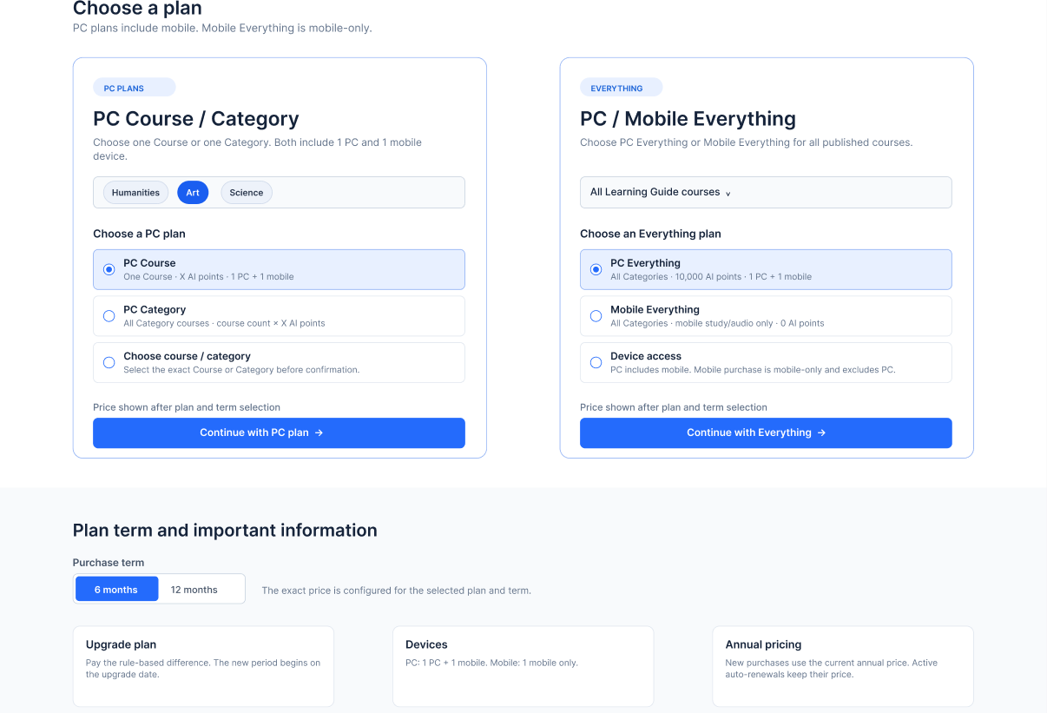
Figure 8-1: Subscription plan page

8.2 Subscription confirmation and Stripe House Checkout
LG does not collect card numbers, validity periods, CVCs or wallets. The following figure illustrates the liability boundary of the LG confirmation page and Stripe Hosted Checkout.
1. Subscription confirmation | 2. Payment Management | 3. Stripe Hosted Checkout | 4. LG Payment Results
Presentation of the plan, scope, equipment, duration, price, price and terms of continuation; collection of necessary confirmations. | Creates LG Order/Payment Attempt and Stripe Checkout Session; transmits approved programs and orders context. | Demonstrate payment patterns, collect sensitive data and confirm payment or subscription. | Shows success, failure, cancellation or processing; the final success is based on the verified Stripe event.
Figure 8-2: LG confirmation page border with Stripe House Checkout

8.3 My Subscription
The following prototypes are for illustration only. Each user record must use business fields aligned to the Order Management, including the scope of purchase, the type of plan, the duration, the date of payment/attempt date, the period of validity, the amount, the type of purchase and the receipt entry when applicable.

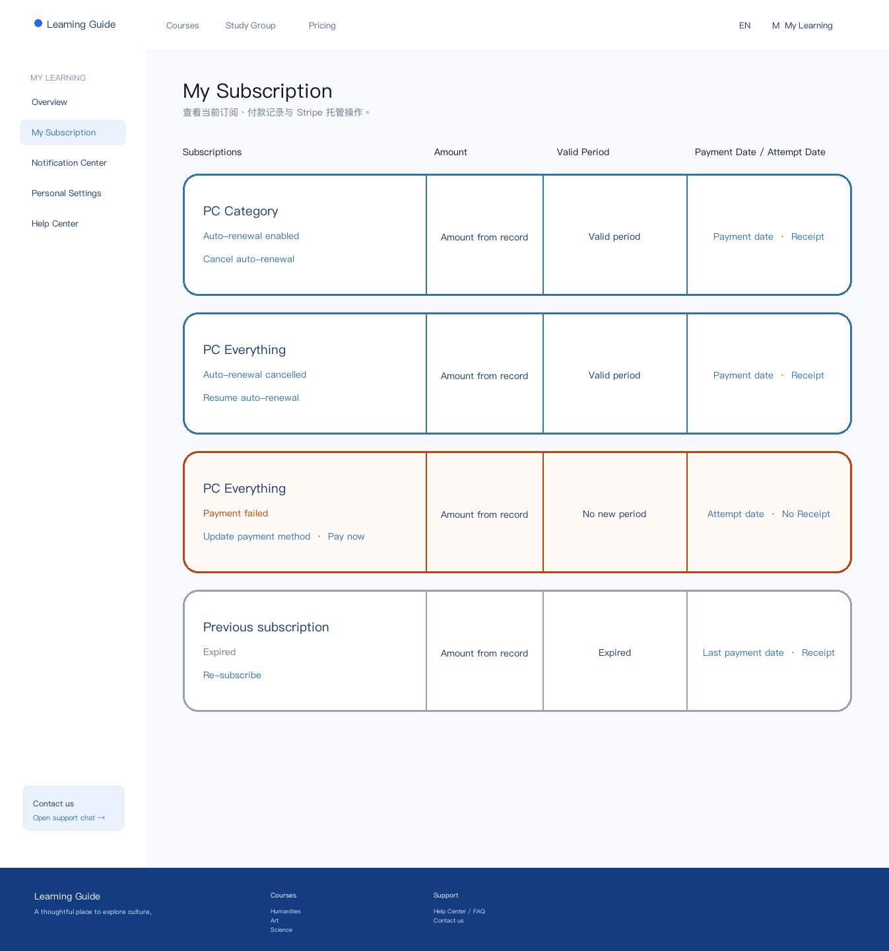
Figure 8-3: My subscription page

8.4 Elimination of automatic renewal windows
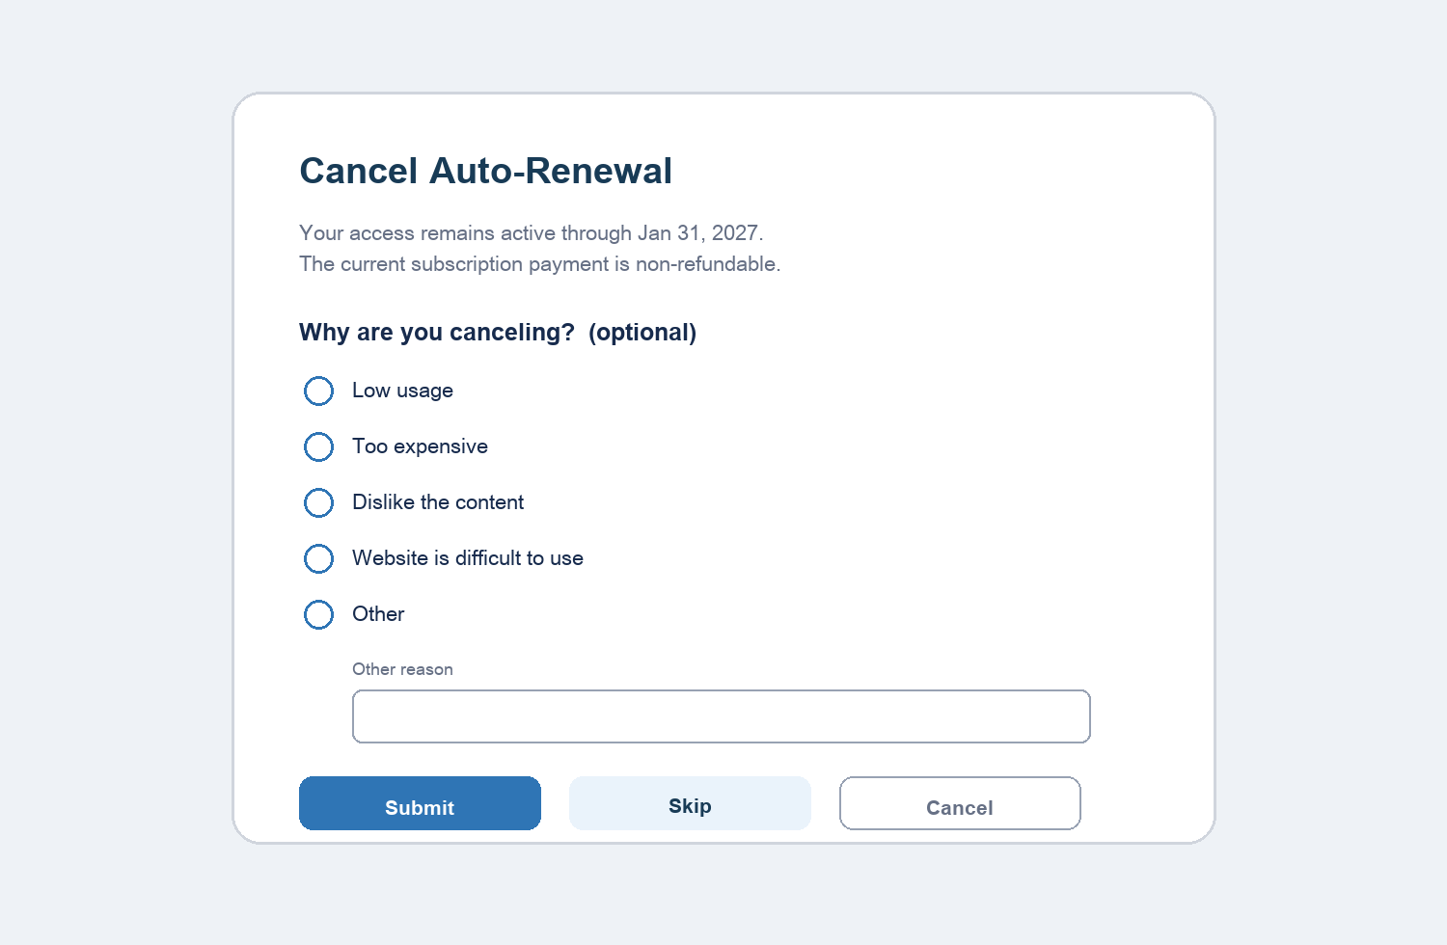
Figure 8-4: Reasons for cancellation

8.5 Interactive notes
- Unallow auto-renewal opens the bullet window and does not jump to the stand-alone page.
- “Recover auto-renewal” opens the confirmation window; confirms that only the renewal fee is changed and no immediate deductions are made.
- Update payment patterns, Pay now, Receipt and Re-subscribe using secure hosting portals provided by Payment/Order; the cancellation/restoration of auto-renewal is always done within LG.
- Payment failure notification opens my subscription and locates the corresponding record.
- The user page does not display an internal grace period name or countdown.
- The status of payment results includes success, failure, cancellation, processing and unknown results.

8.6 Interactive description of promotions
Additional purchases are different from Category, which is still an ordinary purchase process; everything recommends only a hint and does not block the settlement.
Category Everything uses the "upgrade recognition" view, which must show the original Category, the target scenario, the date of the upgrade, the daily consumption deduction, the difference payable, the new validity period and the new continuing fee price.
Upon completion of the upgrade, the user sees everything that is updated in My Subscription and is informed of the success of the upgrade.

9. Notifications and communication with users
This version only defines the notice scene, trigger, channel and location and does not define the text. Transaction type notifications are not recalcitrant; station-based notifications can be read in accordance with Platform rules. Marketing mail is not at P0.
ID | Announcements | Trigger | Channels | Drop Point | Scope
NTF-001 | First subscription successfully | After Activation | station notifications; try-to-dividation switch to Trial Conversion | None | P0
NTF-002 | Automatic renewal successful | After the automatic deduction is successful | Station announcement | None | P0
NTF-003 | Automatic renewal fee failed | After Failed to Confirm | Station announcement | Corresponds to my subscription record | P0
NTF-004 | Automatic renewal fee cancelled. | After Cancel Success | Station announcement | None | P0
NTF-005 | Subscription due | When D+3 has not recovered successfully | Mail + Site Notification | Subscription plan | P0
NTF-006 | Promotion payments were successful | After upgrading payments and updating entitlements | Station announcement | Corresponds to my subscription record | P0

9.1 Notification of express non-issuance
- 72 hour reminder before routine renewal.
- Synchronising "%s"
- Restores the manual renewal fee from the window.
- Resume successful mail for automatic renewal.
- Pays the successful but subscribes to an unusual notification sent separately on active processing; restores to send a normal successful notification.

9.2 General rules
- Each subscription shall be sent not more than once; duplicate results shall not be repeated.
- Mail to subscribe to account email; event date returns with Payment Tool or associated module.
- Opens a drop-off notification when the user does not log in, and then returns to the drop-off.
- Payment Production does not trigger failed messages; only sent after failure to confirm.
- Specific title, body and button text: To be confirmed by the content team.

10. Abnormalities and recovery
ID | scene | Product handling | Attribution
EX-001 | User Not Login | Login is required, and then the selected option or upgrade confirmation is returned. | Subscription Management
EX-002 | Select the same valid range again | Prevents the repurchase and skipping of “My Subscription”; provides recovery only when the automatic renewal is closed. | Subscription Management
EX-003 | Repeat Click | Disable action immediately; reuse valid order/session status when applicable. | Subscription / Payment
EX-004 | Could not create an order or Stripe Checkout Session | Stay on the LG Subscription confirmation page to show that you can restore an error; do not create duplicate orders. | Order / Payment
EX-005 | Stripe payment failed or cancelled | Returns a secure LG payment result page and allows new effective payment attempts. | Payment / Subscription
EX-006 | Payment processing or outcome unknown | Showing ongoing and preventing duplicate payments pending final results. | Payment Management
EX-007 | Payment successful but subscription not active | Displays the subscription processing, prevents duplicate payments; automatically restores or enters manual processing. | Subscription Management
EX-008 | Subscription is valid but entitlement is missing | Displays processing; Autorestore, or the rights sync is initiated by the Order Management administrator. | Subscription / Order / Entitlement
EX-009 | Manual recovery payments failed | D+3 maintains a failed recovery without prolonging the restoration; it can be attempted manually again before the deadline. | Payment / Subscription
EX-010 | Start before the deadline and return after the deadline | The visit was held on a temporary basis pending the final outcome; the visit was successfully renewed and the failure immediately expired. | Payment / Subscription
EX-011 | Cancel with automatic withholding | The cancellation is not withheld until the commencement of the deduction; the deduction may continue if completed at the commencement or after. | Subscription / Payment
EX-012 | Multiple browsers or tabs | is the end state of the service and the other pages are updated. | Subscription Management
EX-013 | Duplicate success event | No activation, renewal or notification shall be repeated. | Subscription Management
EX-014 | Inconsistent across modules | Displays the sync; autofixes, or is initiated by the Order Management administrator. | Cross module
EX-015 | Effective Category User Buys another Category | Allows the purchase and display of everything recommended. | Subscription Management
EX-016 | Effective Everything User Buys Course/Category | Stop purchasing; states everything is covered. | Subscription Management
EX-017 | Upgrade price or configuration anomaly | Based on price and promotion formula snapshots; prevent settlement and record anomalies when no reliable calculation is possible without creating an entitlement. | Order / Subscription
EX-018 | Approved exceptional refunds completed | Refund orders are terminated immediately and user status updated. | Order / Subscription / Entitlement

Removed: Geographical/user type limitations, unusable and temporary unusable plans are not P0 user anomalies. Different configured Course/Category can subscribe independently; Everything covers all courses; no program is configured or available.

11. Sites, indicators and statements

11.1 Type of purchase
Type | Definition
First Subscription | The user id has never successfully paid for any of the configured purchase ranges.
Additional Course/Category Purchase | Could not close temporary folder: %s
Automatic renewal | Payment Management/Payment Tool initiates an automatic deduction at D-3 for automatic renewal subscriptions.
D+3 Manual renewal for recovery period | When the automatic deductions fail, the user is successful in paying manually before D+3.
Resubmit after due | Other Organiser
Scope Upgrade | Eligible Category subscriptions are upgraded to Everything on the upgrade date and are offset against the amount consumed on a daily basis.
I'm on probation. | The initial deduction at the end of the trial was successful and entered into formal subscription under the Trial Conversion rule.

11.2 P0 Core Indicators
Indicators | Formula / Definition
Program to settlement conversion rate | Number of visitors to the Independent Checkout / Independent Program page.
Settlement to payment conversion rate | Number of independent paid hits/ Independent Checkout arrivals.
First subscription success rate | Number of first successful users / Number of first subscription subscribers initiated.
Success rate for automatic renewal | Success auto-renewal fees / Should automatically renew subscriptions.
Auto-renewal failure rate | Confirms the number of failures / the number of subscriptions that should be automatically renewed.
Auto-renewal elimination rate | Cancels the number of valid subscriptions that are open for automatic continuation/ automatic renewal.
Recovery rate after cancellation | Restores the number of valid subscriptions to the auto-renewal / the closing of the auto-renewal.
Recovery rate | Successes in manual payments prior to D+3 / D-3 auto-renewal recognition failure.
Resubscribe rate after due | Other Organiser
Reason distribution for cancellation | Number and percentage by cause of cancellation.
Additional Course/Category Purchase Rate | Number of users buying extra range / Effective Course/Category subscriptions.
Category & Everything Upgrade Rate | Number of successful range upgrades / Number of valid Category users eligible.
Trial positive rate | Trial Conversion / Trial Acticed.

11.3 Incidents of Conduct
- Enter the program page, select the option, enter the Subscription confirmation page, and continue to move to Stripe Checkout.
- Read the terms, tick/extend the consent, and proceed to Stripe Checkout.
- Click/ confirm/renounce to cancel automatic renewal; submit or skip the cause of cancellation.
- Click/ confirm/renounce to restore auto-renewal.
- Click to update payment patterns, Pay now, Receipt, Re-subscribe.
- First success, additional Category purchase, Category Everything Upgrade, Autorenewal success/failure, manual recovery success, normal expiry, failure expiration, resubscription after expiry.

11.4 Dimensions and attribution
- Dimensions: Date, source of entry, type of purchase range, scope ID, type of plan, type of equipment, plan id, duration, type of purchase, subscription status, automatic renewal status, reason, initial purchase/old user.
- The behaviour and subscription status is the responsibility of Subscription Management; the amount and order status is the responsibility of Order Management; the payment results are the responsibility of Payment Management; the aggregation report is the responsibility of Data Reporting.
- The operational area of the report is Asia/Hong Kong; this aggregation rule does not define the deduction time area for Payment Tool.
- All amounts are reported as USD and heavy on repeat incidents.

12. Security, compliance and non-functional requirements
Category | Request
Agree with the evidence. | Each first purchase, additional Course/Category, upgrade and trial opening order recording user, time, clause version, order ID, continuing fee price and program snapshot. Stripe recognizes that capacity is on Payment; technology needs are supplemented by LG.
Exceptions to refunds | There is no user-end entrance. System Administrators initiate approved laws, duplicate deductions or system error refunds in Order Management; Payment Management executes Stripe refunds and terminates counterparty immediately upon completion.
Privacy and desensitization | Only subscription business fields are visible to users. Order Management saves internal order/payment references; user pages and logs should not contain sensitive payment information.
Cross-module audits | Manual cancellation, notification of re-issuance and unusual sync recording operator, time, reason and state of front and forth.
Coherence | An order is activated or renewed at most once; repeat results must e. g.
Availability | Submits action displays loading, success, failure and retry feedback; handles to prevent duplication.
Localize | Operating dates are asia/Hong Kong; currency is USD; the script follows site language norms.
Compatibility | This PRD covers Web page; Mobile entitlements are displayed. Original App page, interactive and device recognition designed separately.
Device access | The plan commits PC 1 + mobile 1 or only mobile 1; equipment technology will require engineering confirmation, but will not change the Sold entitlement snapshot for users.

13. Acceptance and inspection standards
The complete Use Case document is the basis for the business acceptance and inspection. Below is the RPD level threshold; for each function, see chapter 6.
- All P0 requirements and corresponding Use Case are passed.
- Payment may not commence until the automatic renewal/non-refundable clause has been recognized.
- The subscription and course entitlements become effective immediately after payment has been successful; failure to pay cannot create a valid subscription.
- The same order shall not be subject to double deductions, activation, renewal or successful notification.
- The elimination of automatic renewals retains the current entitlement and prevents subsequent automatic deductions.
- There is no immediate deduction for the restoration of automatic renewal; Payment Tool continues to be scheduled and the price of the continuation is maintained.
- The ordinary renewal fee may not be automatically retried after it has failed; manual payments are provided under the D-3 initiated, D+3 restoration rules. The failure of the first trial is handled by the Trial Payment Grace rule.
- A request to begin paying before the deadline is reinstated awaits the final outcome; the final failure is immediately due.
- The internal fields of each successful subscription record are consistent; no receipts are available for failure records and no new validity period is available.
- Manual cancellation, notification reissuance, abnormal synchronization and audit interfaces match the Order Management border.
- Data teams can verify core events, purchase types and indicator definitions.
Upgrade acceptance supplement:
- Active Category users can buy different Category and get a non-stop recommendation for everything.
- Active Category users can upgrade the Category & Everything on an upgrade date; the amount consumed in Category is deducted on a daily basis and the difference is created, and the new E Everything is calculated from the upgrade day.
- If the result of the calculation is zero or negative, it must be handled by a configured business formula; this version does not foresee refunds or unjustified zero-value upgrades.
- Upgrading at the same level is not within the scope of this version.
- Automatic deductions are initiated once at D-3; after failure, manual payments are supported in accordance with recovery rules and are not automatically retried.
- System Administrator terminates the counterparty immediately upon completion of the exceptional refund and the user does not provide a return entry.

14. Dependency, risk and openness
ID | Open | Attribution | Impact
TBD-001 | Payment Tool Finalized | Product / Payment | Do not block the PRD structure; influence the final Checkout design and PCI range.
TBD-002 | Notification of specific cases | Product / Content | This version retains triggers, channels and points of entry.
TBD-003 | Automatic continuation and non-refundable legal texts | Legal / Product | It must be read before going online.
TBD-004 | Maximum duration of payment processing | Payment / Engineering | Impact processing UI with abnormal alarm.
TBD-005 | Abnormal Sync SLA | Engineering / Operations | Impact automatic recovery and manual intervention.
TBD-006 | Final Price Catalogue and Stripe Product/Price Map | Pricing / Product | The Course/Category list, the price, the continuous fee price and the Stripe map must be provided.
TBD-007 | X-specific values and AI points purchase plan | Product / AI | X is not determined in the current PRD with the purchase of AI points separately.
TBD-008 | Stripe needs to agree to the evidence. | Payment / Legal | Confirm whether Stripe Hosted Checkout can enforce the identification and presentation of evidence; otherwise, the LG confirmation page must be supplemented.
TBD-009 | Equipment access mandatory technology plan | Engineering / Product | Decision to log-in equipment identification, relocation and restriction; no change in plan statement.

15. Appendix

15.1 Order Management Backstage Collaboration Matrix
Scope: This matrix describes cross-modular responsibilities and collaboration in the review of Subscription Management. All of the following capabilities are achieved by Order Management.

Capacity | Customer service. | Operation | Administrator
Query Subscription | Allow | Allow | Allow
Manual cancellation of automatic renewal | Allow | Not permitted | Allow
Reissuance announcement | Allow | Allow | Allow
Launch abnormal sync | Not permitted | Not permitted | Allow
Directly modify price/life/state | Not permitted | Not permitted | Not permitted

15.2 Reasons for cancellation
Low frequency of use, high price, lack of entitlement in content, difficult use of websites, other (free input).

15.3 Payment and Order Alignment Input
The following is a cross-module input and is not the functional requirement of Subscription Management. Before the technical evaluation, the corresponding Payment and Order PRD must be synchronized.
Module | It has to be the same.
Payment Management | Only Stripe Hosted Checkout; agreed evidentiary feasibility; plan/scope/equipment/duration input; D-3 automatic deduction; D+3 restoration; updated payment modalities; Pay Now; Stripe Information and PaymentIntent treatment of renewals, upgrades and trial correction.
Order Management | Each first purchase, additional Course/Category, renewal, recovery and successful upgrade corresponds to an order/payment record; a trial start-up of 0 USD Order; an exceptional refund for administrators only; an immediate termination of entitlement upon refund; subscription queries, manual cancellations, notification reissuance and unusual synchronization.
Pricing / Entitlement | Finally, the Course/Category list, the plan price, the continuing fee price, the Stripe Project/Price map, the scope of the course, the AI point policy and the feasibility of implementing the equipment.

