LEARNING GUIDE / PRODUCT REQUIREMENTS DOCUMENT
Learning Guide Study Group PRD
Learning Guide
Study Group
DEFINITION Study Group is a Course-linked learning group that can have many joined members. P0 group activity is organised through one-off Live Sessions. Each Live Session supports 2–6 participants including the Host. Persistent public Discussion is not included in P0.

Item | Details
Document version | v0.10
Status | For Review / Approval
Scope | Learning Guide P0 — Study Group
Date | 30 September 2026
Channel | Web
RTC Platform | LiveKit Cloud
Initial Markets | Mainland China / Hong Kong / Taiwan

Document Revision History
Version | Date | Summary of Changes | Source
v0.5 | 1 September 2026 | Initial P0 discussion draft covering Study Group creation, reservation, Meeting Room, Host moderation and LiveKit integration. | Initial PRD discussion
v0.6 | 7 September 2026 | Course changed from optional to required; valid Course access required for reservation and Session entry; recurring Course-level Study Groups recorded as a future direction. | Product review meeting
v0.7 | 16 September 2026 | Study Group redefined as a persistent Course-based learning group. Reservation replaced by membership and Plan to Attend. Persistent Discussion and Live Sessions introduced as separate Group capabilities. | Stakeholder discussion and revised prototype
v0.8 | 25 September 2026 | Persistent Study Group Discussion removed from P0. Group activity simplified around Live Sessions. AI Tutor added to Live Session Chat and grounded in Course AI Tutor / Knowledge System configuration. | Stakeholder feedback and Figma prototype
v0.9 | 25 September 2026 | Complete rewrite following page-by-page prototype confirmation. Public discoverability, Course-gated joining, Host Group management, one-off Live Session lifecycle, equal in-room permissions, Leave Session completion logic, and all-participant AI Tutor access are clarified. Host-disconnect grace and moderation controls are removed. Latest approved screenshots are embedded in the related functional modules. | Page-by-page product review and final prototype screenshots
v0.10 | 30 September 2026 | Live Session entry and lifecycle clarified. From T-10, joined members may enter the Session and wait for the Host to start; waiting users count towards Currently in session and Session capacity. Host Start remains the only transition to Live. Reminder rules are aligned to the P0 timing/channels for Host and members who selected Plan to Attend. A new Waiting for Host Start prototype is embedded. | Lifecycle clarification and waiting-room prototype

Contents
1. Overview
2. Scope and Boundaries
3. Roles and Permissions
4. Global Business Rules
5. Information Architecture and End-to-End Flows
6. Functional Requirements and Prototype Screens
7. State Models
8. Data and Integration Rules
9. Notifications
10. Exceptions and Recovery
11. Security, Privacy and Non-Functional Requirements
12. Test Cases
13. Post-P0 Direction

1. Overview
1.1 Background
Study Group provides a Course-linked place for learners to find a group, join it, and take part in small real-time learning sessions. The P0 design deliberately separates the persistent Study Group from each one-off Live Session.
A Study Group can have many joined members. A Host schedules Live Sessions beneath the Group, and each Live Session supports a maximum of six participants including the Host. The MVP does not include a persistent public Discussion or comment feed.
Live Sessions run in the browser using LiveKit Cloud. AI Tutor can be enabled for an individual Live Session and appears in the shared Chat. When enabled, every live participant may invoke AI Tutor. AI Tutor answers and generates understanding-check questions under the related Course AI Tutor configuration and Course Knowledge / Knowledge System grounding.
1.2 Product Model
P0 MODEL Course → Study Group → Members + Live Sessions. Study Group membership can be larger than six. Each Live Session is an independent real-time event with a 2–6 participant limit including the Host.

The Study Group itself is publicly discoverable in P0. Any user may view the Group Overview and Members. Joining the Group, planning to attend a Session, and entering a Live Session are gated by valid access to the related Course.
1.3 Product Objectives
• Provide a simple Study Group entry point with My Study Groups and Discover Study Groups.
• Allow any user to discover a Group while requiring valid Course access to join.
• Allow a learner with valid Course access to create a Group linked to one Course and become its Host.
• Allow the Host to schedule and manage one-off Live Sessions beneath the Group.
• Allow joined members to express attendance intent without reserving a seat.
• Provide browser-based audio, video, screen sharing, participant presence, Raise Hand and shared Chat for up to six live participants.
• Keep in-room permissions equal for Host and Participants in P0; Host remains an identity and Group-management role outside the room.
• Allow all live participants to use a shared AI Tutor when enabled for the Session.
• Keep AI Tutor answers and generated questions grounded in Course Knowledge; do not analyse the shared screen in P0.
1.4 P0 Success Criteria
ID | Success Criterion
SC-001 | A signed-in learner with valid access to a Course can create a Study Group linked to that Course and becomes Host.
SC-002 | A Study Group is discoverable to users who have not joined it, including users without Course access.
SC-003 | A user with valid Course access can join a discoverable Study Group immediately without Host approval.
SC-004 | A user without valid Course access is directed to get Course access and cannot join.
SC-005 | A Study Group can contain many members; the six-person limit applies only to each Live Session.
SC-006 | Host can schedule, edit, cancel and start an eligible Live Session.
SC-007 | Joined members can Plan to Attend / Cancel Attendance without reserving a place.
SC-008 | A Live Session supports 2–6 concurrent participants including Host.
SC-009 | All live participants have the same in-room controls for their own media, screen share, Chat, Raise Hand and Leave Session.
SC-010 | When AI Tutor is enabled, any live participant can invoke it in shared Chat and everyone sees the interaction.
SC-011 | AI Tutor follows Course AI Tutor configuration and Course Knowledge / Knowledge System grounding; screen-share content is not parsed in P0.
SC-012 | A Live Session becomes Completed after the final participant leaves.
SC-013 | From 10 minutes before the scheduled start time, eligible joined members can enter the Session waiting state; entered users count towards Currently in session and Session capacity before the Host starts the Session.

1.5 Terms and Definitions
Term | Definition
Study Group | A publicly discoverable learning group linked to exactly one Course. It owns membership and one-off Live Sessions.
Host | The learner who created the Study Group. Host manages Group settings and Live Sessions outside the room. In-room media/control permissions are the same as other participants in P0.
Joined Member | A learner who has joined the Study Group and currently has the Group in My Study Groups.
Live Session | A one-off real-time activity beneath a Study Group. Maximum 2–6 concurrent participants including Host.
Plan to Attend | Attendance intent for an upcoming Live Session. It enables a reminder but does not reserve a seat.
Starting Soon | The Live Session state beginning 10 minutes before its scheduled start time and continuing until Host Start. Eligible joined members may enter and wait from this state; entered users count towards current occupancy and capacity.
Session Chat | Shared real-time text Chat visible to all current Live Session participants.
AI Tutor | The related Course AI Tutor surfaced in shared Session Chat when enabled for the Session.

2. Scope and Boundaries
2.1 In Scope
• Study Groups home page, My Study Groups and Discover Study Groups.
• Create Study Group, creation success, Host Group Detail, edit Group and cancel Group.
• Public discoverability of Study Groups; Course-access gate for joining.
• Scrollable Group Member list.
• Schedule one-off Live Session, optional Related Lesson, date/time/duration, 2–6 participant maximum and Session Focus.
• Enable / disable AI Tutor per Live Session; default enabled.
• Host Live Session list with Starting Soon and Completed history.
• Participant Live Session list with Upcoming, Starting Soon / Waiting for Host Start, Live Now, Plan to Attend, Cancel Attendance and Completed history.
• Browser-based Live Session with mic, camera, screen sharing, Participants panel, shared Chat, Raise Hand and Leave Session.
• Shared AI Tutor in Live Session Chat for all current participants when enabled.
• Course Knowledge / Knowledge System grounding for AI Tutor answers and generated understanding-check questions.
2.2 Out of Scope
• Persistent Study Group Discussion, comments, threaded replies and comment moderation.
• Private / invitation-only Study Groups or Host approval to join.
• Recurring Live Sessions.
• Seat reservation, guaranteed place or waitlist.
• Recording, playback or post-session recording archive.
• Host-only moderation inside the Live Session such as mute others, disable camera, remove participant or Invite to Speak.
• Host disconnect grace period or automatic Session end when Host leaves.
• Co-host, Host transfer and large webinar mode.
• Private Chat.
• AI Tutor parsing or analysing the shared screen, video or Interactive Exhibit in P0.
• Group-mode Explore workflow, shared scored group assessment, badges or learning streaks.
2.3 Cross-Module Responsibilities
Module / System | Responsibility
Study Group | Group creation/discovery, membership, Host ownership, Group cancellation, Live Session metadata, attendance intent and user-facing state.
Authentication / User | Sign-in state, user identity and display name.
Course | Course metadata, current entitlement/access status and optional Lesson list.
AI Tutor | Course-scoped AI Tutor behaviour and runtime settings used in shared Live Session Chat.
Knowledge System | Current student-facing Course knowledge grounding used by AI Tutor.
Notification | Host and Plan-to-Attend Live Session reminders, plus Study Group cancellation notification.
LiveKit Cloud | Realtime room, participant transport, audio/video, screen share and data transport.

3. Roles and Permissions
Role | Group-level permissions | Live Session room permissions
Visitor / Signed-in non-member | Can discover and open Group Detail. Cannot join without valid Course access. | No Session access until the user has joined the Study Group and the Session is available for entry.
Joined Member | Can view Group members and Live Sessions, Plan to Attend, Cancel Attendance, Leave Study Group, and enter a Session from Starting Soon (T-10) if capacity allows. | Controls own mic/camera; can share screen, view Participants, use shared Chat, Raise Hand, invoke AI Tutor when enabled, and Leave Session.
Host | All Member capabilities plus Edit Group, Cancel Group, Schedule/Edit/Cancel eligible Live Sessions and Start Live Session. | Same in-room permissions as other participants. Host label is identity only in P0.
AI Tutor | No Group membership role. | When enabled, participates in shared Chat. Any live participant may invoke it.
Learning Guide Backend | Validates Course access, Group role, capacity, state and reminder eligibility. | Issues short-lived LiveKit access credentials and applies business rules.

4. Global Business Rules
Rule ID | Business Rule
BR-001 | A Study Group is linked to exactly one Related Course.
BR-002 | The Related Course is immutable after Study Group creation.
BR-003 | Create Study Group only lists Courses for which the current user has valid Course access.
BR-004 | Every newly created Study Group is publicly discoverable in P0.
BR-005 | Discover Study Groups excludes Groups the current user has already Joined or Hosts.
BR-006 | A Group-level Live badge means at least one child Live Session is currently Live. It is not a Study Group lifecycle state.
BR-007 | Only users with valid access to the Related Course may Join the Study Group. No Host approval is required.
BR-008 | Study Group membership is not limited by the Live Session six-person capacity.
BR-009 | Group Member list is scrollable and can contain many members.
BR-010 | Host may edit Study Group Title and About text. Related Course cannot be edited.
BR-011 | Cancel Group makes the Group unavailable, removes it from Discover/My Study Groups, cancels all Upcoming Live Sessions and notifies Members. Completed Live Session history remains retained in system history.
BR-012 | Each Live Session supports 2–6 participants including Host.
BR-013 | Related Lesson is optional Live Session metadata. It does not affect joining, AI Tutor behaviour or Session operation and does not need to be displayed on P0 Session cards.
BR-014 | Enable AI Tutor defaults to on for a new Live Session. Host can turn it off before scheduling or while editing an unstarted Session.
BR-015 | Starting Soon begins 10 minutes before the scheduled start time. From this point, eligible joined members may enter the Session and wait for the Host. The Session does not become Live until the Host selects Start Live Session; reaching the scheduled start time does not auto-start it.
BR-016 | Edit Session and Cancel Session are available only before the Session starts.
BR-017 | Cancel Session removes the Session record from the list; a Cancelled history card is not retained in P0.
BR-018 | Plan to Attend is attendance intent only and never reserves one of the live places.
BR-019 | The Host and members who selected Plan to Attend receive a Live Session reminder 10 minutes before the scheduled start time through in-site notification and email. Cancelling attendance removes the member reminder.
BR-020 | A joined member may enter from Starting Soon (T-10) even if they did not Plan to Attend, provided capacity is available and Course access remains valid. Before Host Start, the member sees the Waiting for Host Start page.
BR-021 | When live capacity is reached, further entry is blocked and the UI shows Session Full.
BR-022 | Participant and Host can both view Completed Live Session history.
BR-023 | Leaving a Study Group cancels the user’s future Plan to Attend records and reminders. If the Group remains available, it becomes discoverable to that user again.
BR-024 | Inside a Live Session, Host and Participants have equal P0 room controls. Host label remains visible but does not grant moderation controls.
BR-025 | Raise Hand is a lightweight signal meaning “I have a question / I want to speak”; it does not require approval and does not change speaking permission.
BR-026 | Leave Session exits only the current user. The Live Session remains Live while at least one participant remains.
BR-027 | When the final participant leaves, the Live Session becomes Completed.
BR-028 | Host disconnect grace, Host-return countdown and Host-leave auto-end are not part of the current P0 scope.
BR-029 | When AI Tutor is enabled, any current participant may invoke @AI Tutor in shared Chat. The prompt and AI response are visible to all current participants.
BR-030 | AI Tutor answers and generated understanding-check questions must follow the Related Course AI Tutor configuration and Course Knowledge / Knowledge System grounding.
BR-031 | AI Tutor does not parse or analyse the current screen share in P0. Users must provide required context in text if they want a question about a specific topic.
BR-032 | Valid Course access is revalidated before restricted actions such as Join Study Group and Join Live Session.
BR-033 | A user who has entered the Waiting for Host Start page is already inside the Session space and therefore counts towards Currently in session and towards the configured Maximum Participants. Plan to Attend alone does not count towards current occupancy.
BR-034 | When the Host selects Start Live Session, all users already waiting transition into the Live Session without needing to join again. The current occupancy count continues across the Waiting-to-Live transition.

5. Information Architecture and End-to-End Flows
5.1 Information Architecture
INFORMATION ARCHITECTURE Course → Study Group → Members (many Joined Members) + Live Sessions. Each Live Session is a separate one-off event with a maximum of six participants including the Host.

There is no persistent Discussion activity in P0. Live Session Chat exists only while participants are in the real-time Session.
5.2 Create and Host Flow
• Study Groups → Create Study Group.
• Choose a Related Course from Courses the current user can access → enter Title and About → Create.
• Creator becomes Host → creation success → Go to Study Group.
• Host can Edit Group, Cancel Group or Schedule Live Session.
• Host schedules Session → Session appears in Live Sessions list → at T-10 it becomes Starting Soon and members may enter the waiting state → Host selects Start Live Session → waiting members transition into Live.
5.3 Discover and Join Flow
• Any user can discover a Study Group not already Joined/Hosted.
• User opens Group Detail and can see Overview and Members.
• If user has valid Course access → Join Study Group is available → immediate membership; no Host approval.
• If user lacks Course access → Get Course access opens the Course subscription/purchase journey → Join remains unavailable until access is valid.
5.4 Attendance and Live Entry Flow
• Joined Member views Upcoming Sessions → Plan to Attend or Cancel Attendance.
• Plan to Attend subscribes the member to the T-10 reminder but does not reserve capacity. The Host receives the T-10 reminder regardless of Plan to Attend.
• From T-10 (Starting Soon), any Joined Member with valid Course access can Join Now while capacity is available. Before Host Start the member waits on the Waiting for Host Start page; after Host Start the member enters the Live Session.
• Inside Session, participants use their own media, screen share, Chat, Raise Hand and shared AI Tutor when enabled.
• Each user Leaves Session individually → when the last participant leaves, the Session becomes Completed.

6. Functional Requirements and Prototype Screens
The screenshots in this section are the latest product-owner supplied prototypes from 25 September 2026. Where residual visual copy conflicts with the written rules in this PRD, the written rules are authoritative.
6.1 Study Groups — Initial / No Selection State
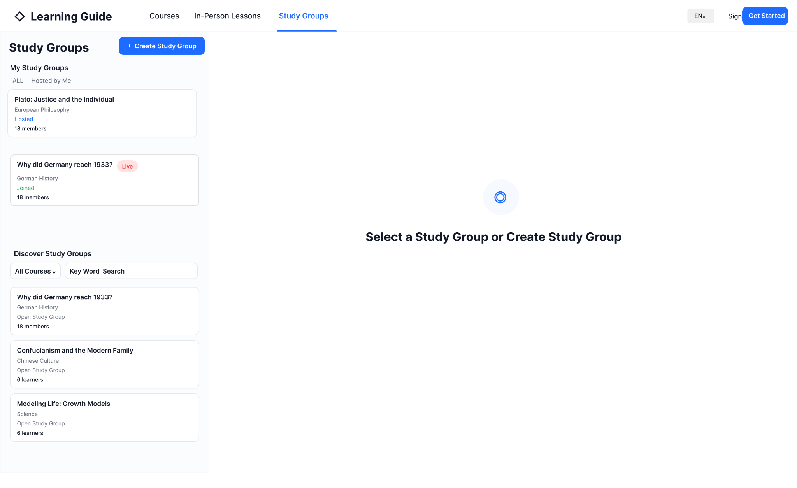
Figure 6.1 — Study Groups initial page: My Study Groups, Discover Study Groups, no Group selected
Req. ID | Requirement | Acceptance Point
GS-HOME-001 | Opening Study Groups with no selection shows My Study Groups and Discover Study Groups on the left and a no-selection state on the right. | Right side prompts the user to select a Study Group or create one.
GS-HOME-002 | My Study Groups contains Groups the user has Joined or Hosts. | Hosted and Joined status are visually distinguishable.
GS-HOME-003 | Discover Study Groups contains discoverable Groups the user has neither Joined nor Hosts. | No duplicate Group appears in My and Discover for the same user.
GS-HOME-004 | Discover supports Course filtering and keyword search. | Results update to matching Groups.
GS-HOME-005 | A Live badge on a Group card is shown when at least one child Live Session is currently Live. | Badge is driven by child Session state.

6.2 Create Study Group
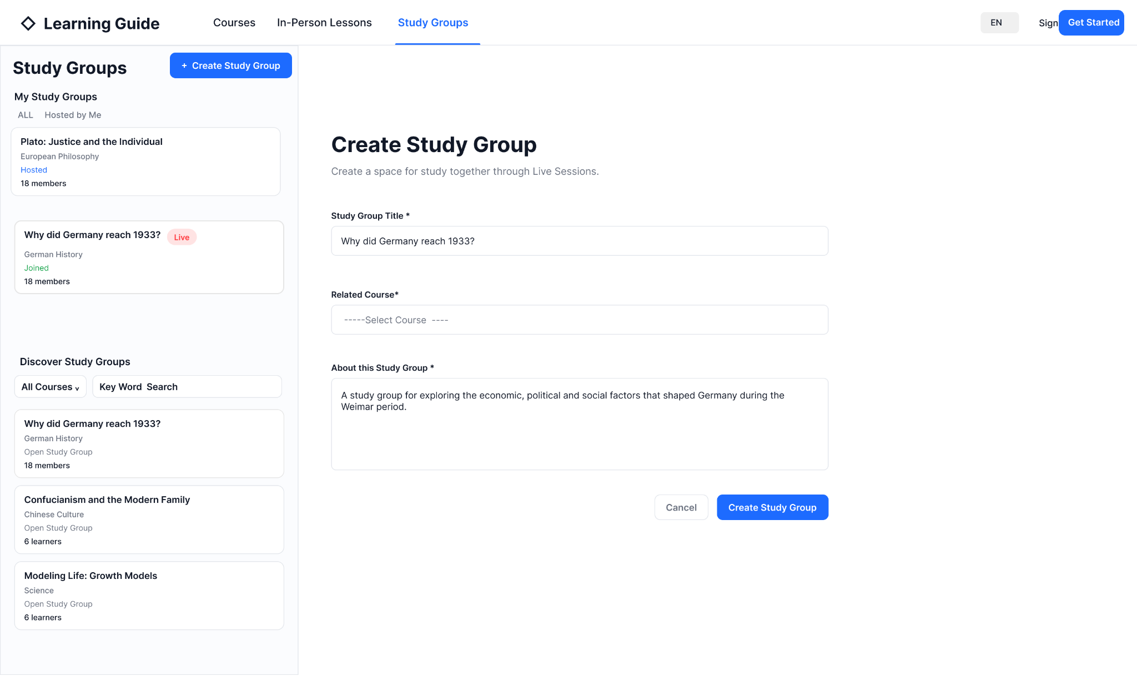
Figure 6.2 — Create Study Group
Field / Action | Rule
Study Group Title * | Required. Editable after creation.
Related Course * | Required. Dropdown only lists Courses with current valid access. Immutable after creation.
About this Study Group * | Required. Editable after creation.
Create Study Group | Validates required fields, creates the Group, makes it publicly discoverable and assigns current user as Host.
Cancel | Returns without creating a Group.

P0 does not collect Group-level Lesson, date, time, duration, language, format or maximum participants. These are not Study Group properties; applicable scheduling fields belong to Live Session.

6.3 Study Group Created
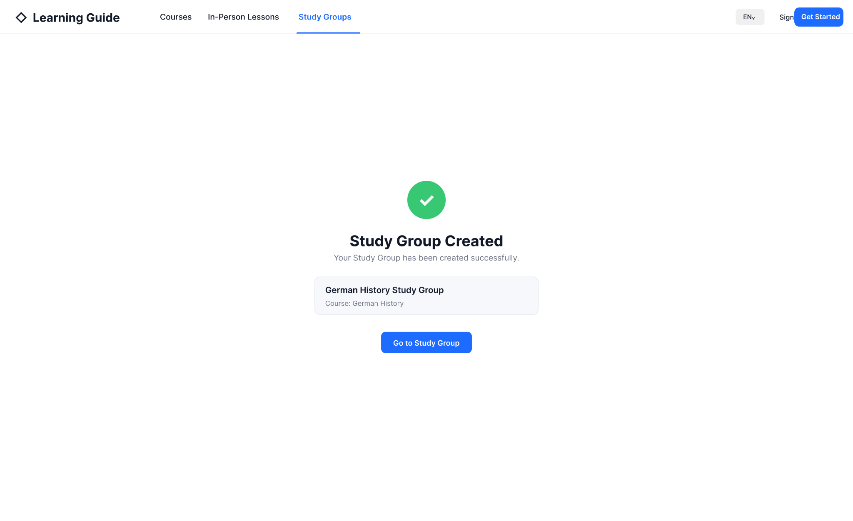
Figure 6.3 — Study Group creation success
Req. ID | Requirement
GS-CREATE-006 | Successful creation shows a confirmation state with the new Study Group title and Related Course.
GS-CREATE-007 | The creator is already the Host at this point; no additional save or confirmation is required.
GS-CREATE-008 | Go to Study Group opens the newly created Group in Host view.

6.4 Study Group Detail — Host / No Live Sessions
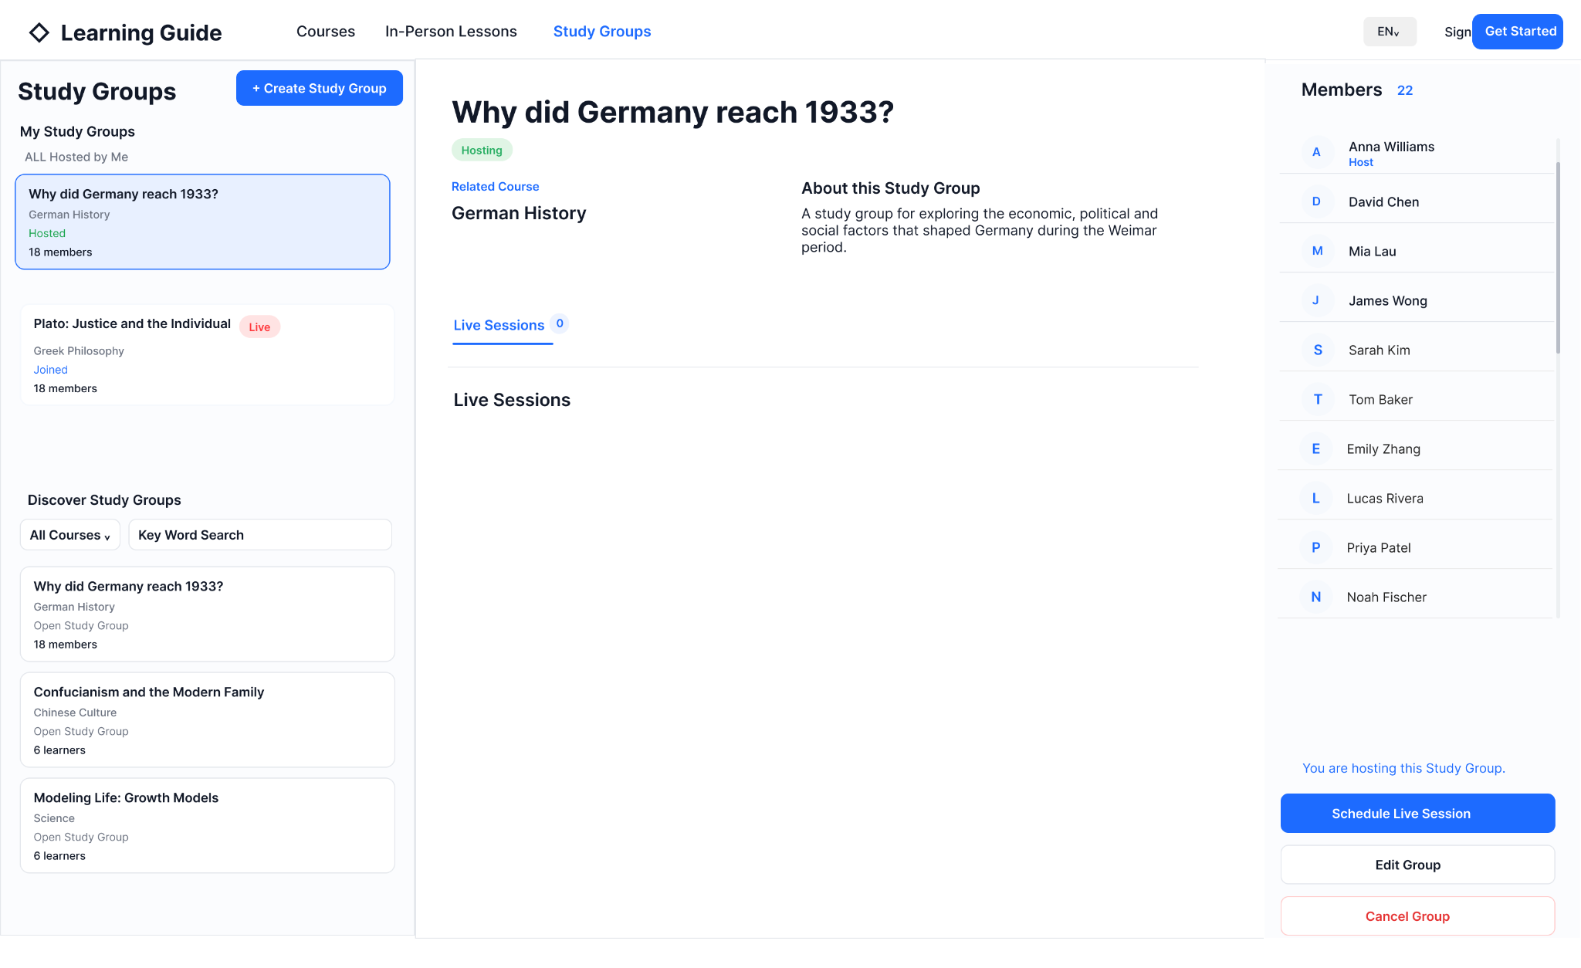
Figure 6.4 — Host Study Group Detail with no Live Sessions
Area / Action | Rule
Hosting state | Shows that current user is Group Host.
Related Course | Read-only after Group creation.
About this Study Group | Displays current About text.
Live Sessions 0 | No Live Session records exist yet.
Members | Shows total Group members and a scrollable list; member count is not capped at six.
Schedule Live Session | Host-only Group-level action.
Edit Group | Host can change Title and About only.
Cancel Group | Requires confirmation. Group becomes inaccessible, Upcoming Sessions are cancelled, Group disappears from lists and Members are notified. Completed Session history remains retained in system history.

6.5 Schedule Live Session — Host
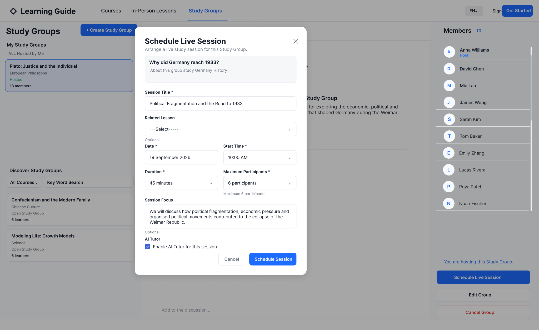
Figure 6.5 — Schedule Live Session modal
Field / Action | Rule
Study Group context | Read-only context for the current Group.
Session Title * | Required.
Related Lesson | Optional. No effect on AI Tutor or Session behaviour; P0 does not require displaying it on Session cards.
Date * | Required.
Start Time * | Required.
Duration * | Required planned duration.
Maximum Participants * | Required. 2–6 including Host.
Session Focus | Optional descriptive text.
Enable AI Tutor for this session | Default enabled. Host can uncheck it. AI Tutor remains Course-scoped.
Schedule Session | Creates a one-off Live Session beneath the current Study Group.
Cancel / Close | Closes modal without creating the Session.

Scheduling a Session does not send a reminder to every Group member. The Host and members who selected Plan to Attend receive the P0 reminder 10 minutes before the scheduled start time through in-site notification and email.

6.6 Study Group Detail — Host / Live Sessions List
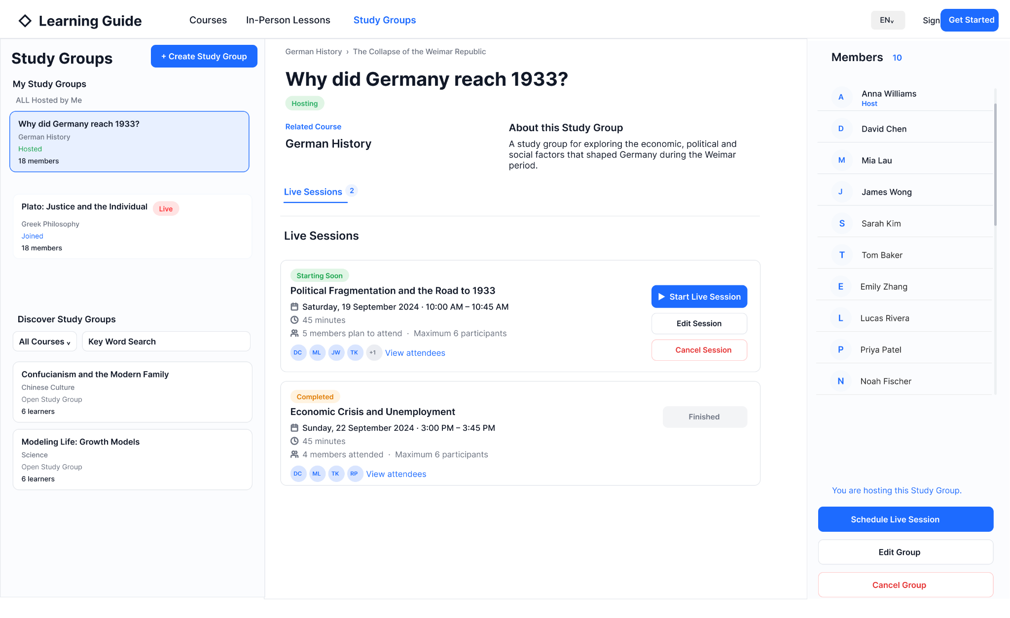
Figure 6.6 — Host Live Sessions list: Starting Soon and Completed
State / Action | Rule
Live Sessions count | Counts retained Session records shown for the Group.
Starting Soon | Begins 10 minutes before the scheduled start time and continues until Host Start. Joined members may enter the waiting state from this point. Waiting entrants count towards current occupancy and Session capacity. Host can Start Live Session.
Waiting entry / occupancy | A member who enters during Starting Soon is counted in Currently in session even though the Session is not yet Live. Plan to Attend without entering is not counted.
Edit Session | Available only before Session starts.
Cancel Session | Available only before Session starts. Cancelling removes the Session record; no Cancelled history card is retained.
Plan-to-attend count | Shows attendance intent, not reserved seats.
View attendees | Shows the planned attendees for an unstarted Session; for Completed Session shows actual attendees.
Completed / Finished | Read-only history after the final participant has left. No Start/Edit/Cancel actions.
Schedule Live Session | Host can schedule additional one-off Sessions.

6.7 Study Group Detail — Not Joined / Has Course Access
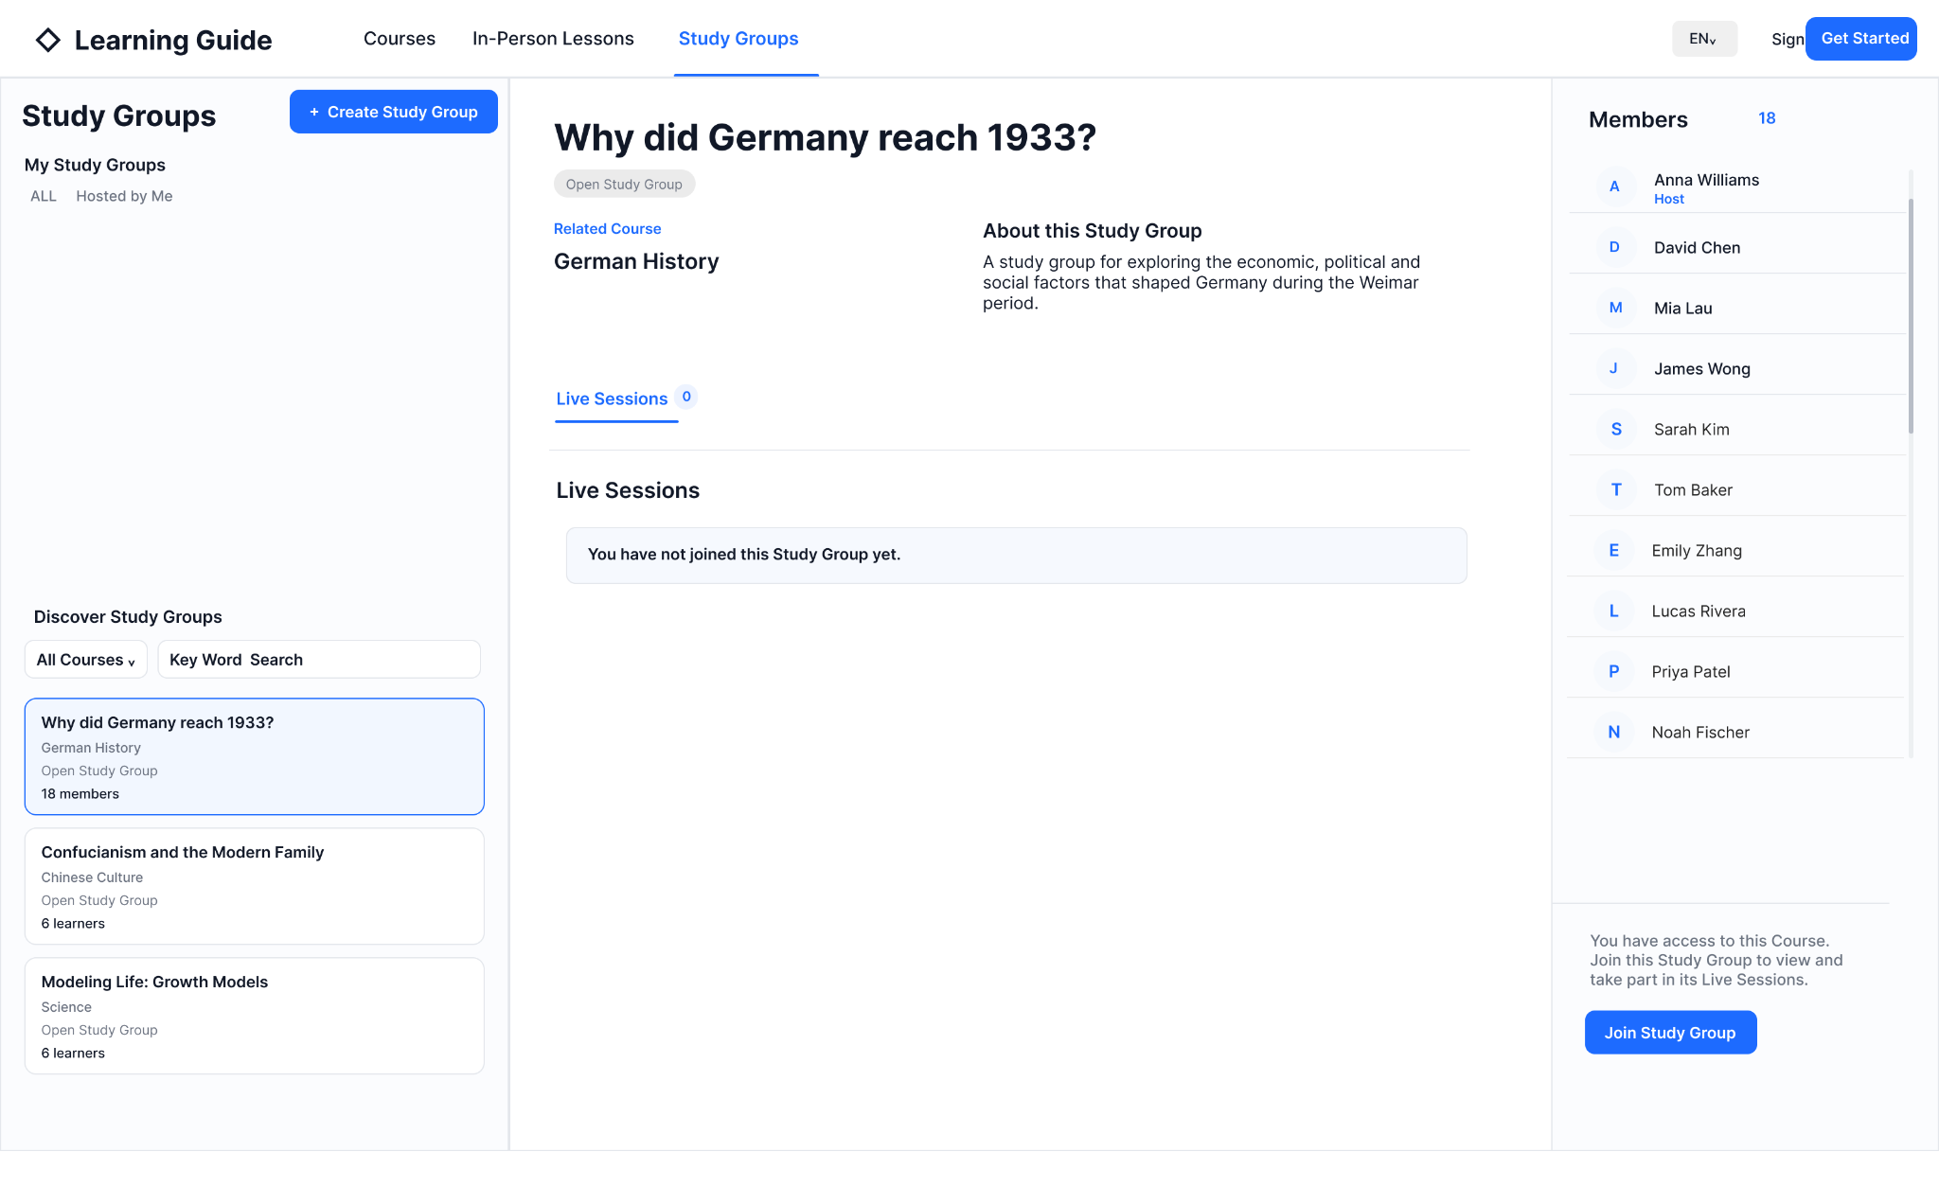
Figure 6.7 — Discoverable Study Group for a user who has Course access but has not joined
Req. ID | Requirement
GS-JOIN-001 | User can view Group title, Related Course, About and Members before joining.
GS-JOIN-002 | Live Session details remain hidden until the user joins; the page asks the user to Join the Study Group to view Live Sessions.
GS-JOIN-003 | Because the user has valid Course access, Join Study Group is enabled.
GS-JOIN-004 | Join is immediate and does not require Host approval.
GS-JOIN-005 | After Join, Group moves from Discover Study Groups to My Study Groups.

6.8 Study Group Detail — No Course Access
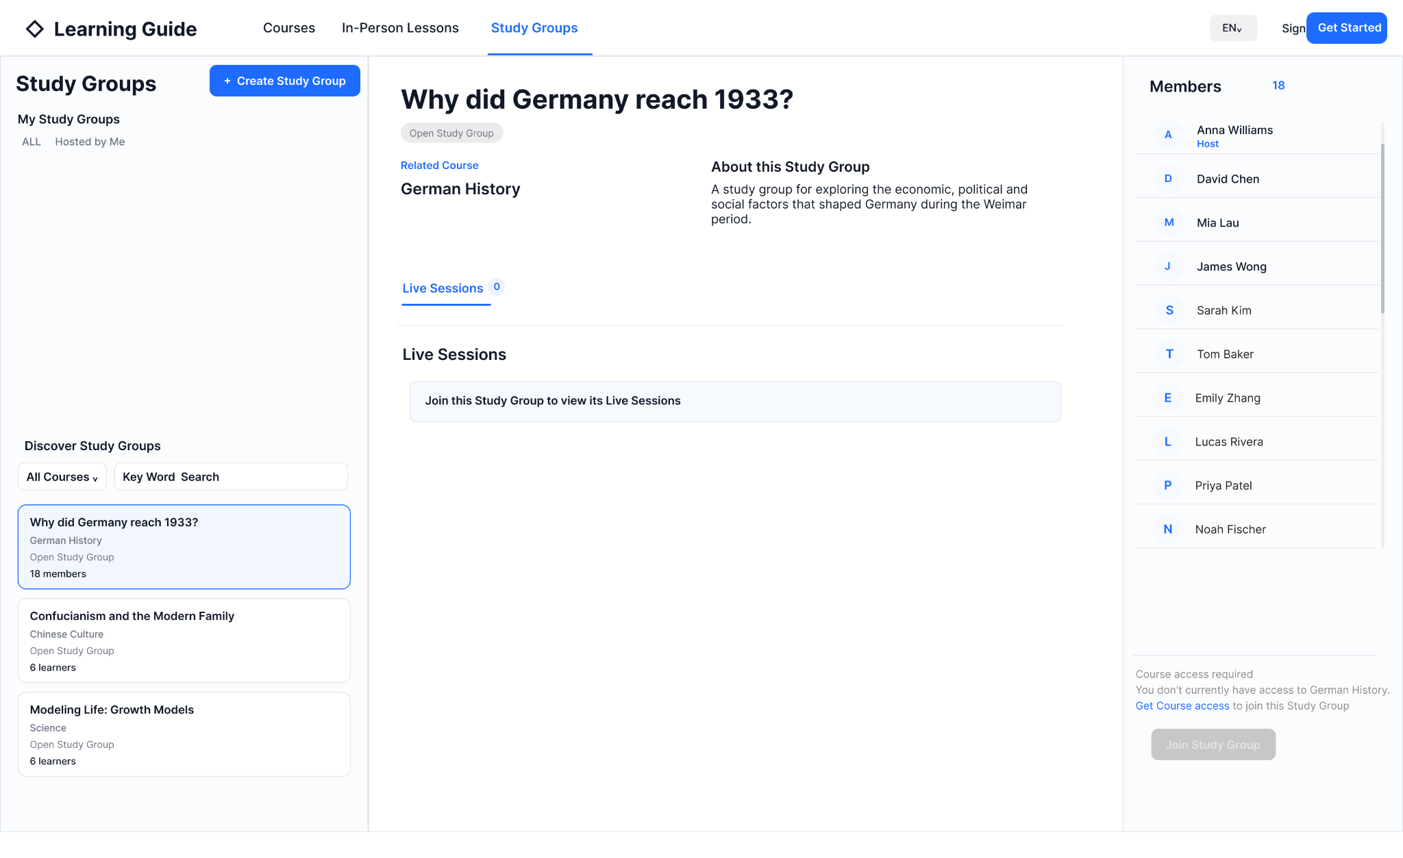
Figure 6.8 — Discoverable Study Group for a user without Course access
Req. ID | Requirement
GS-ACCESS-001 | A user without Course access may still discover and open the Study Group Detail.
GS-ACCESS-002 | Group Overview and Members remain visible, but Live Session details remain hidden.
GS-ACCESS-003 | Join Study Group is unavailable while Course access is invalid.
GS-ACCESS-004 | Get Course access links to the related Course subscription / purchase journey.
GS-ACCESS-005 | After valid Course access is obtained, the page can transition to the normal Not Joined / Has Course Access state.

6.9 Study Group Detail — Joined Participant
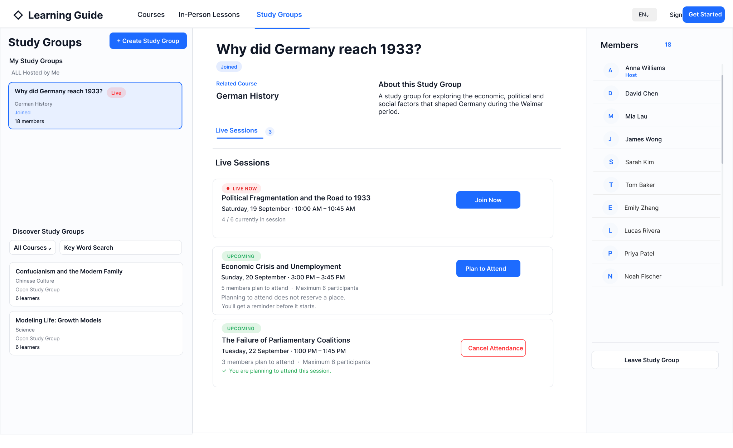
Figure 6.9 — Joined participant: Live Now, Upcoming, Plan to Attend and Cancel Attendance
State / Action | Rule
Joined | Current user is a Group Member.
Starting Soon | From T-10, Join Now is available. If the Host has not started the Session, the member enters the Waiting for Host Start page and counts towards current occupancy/capacity.
Live Now | Shown only after Host Start. Shows current occupancy such as 4 / 6. Join Now is available while capacity and Course access allow.
Session Full | When occupancy reaches the Session maximum, Join Now is disabled/replaced by Session Full.
Upcoming — not planned | Shows planned-attendance count and Plan to Attend.
Plan to Attend | Records intent and subscribes user to reminder; does not reserve a place.
Upcoming — planned | Shows confirmation and Cancel Attendance.
Cancel Attendance | Removes attendance intent and reminder.
Completed history | Participant can view Completed Session history as read-only.
Leave Study Group | Leaves membership, cancels all future Plan to Attend records and reminders, and removes Group from My Study Groups. If the Group remains available it becomes discoverable again to that user.
6.9.1 Live Session Entry — Waiting for Host Start
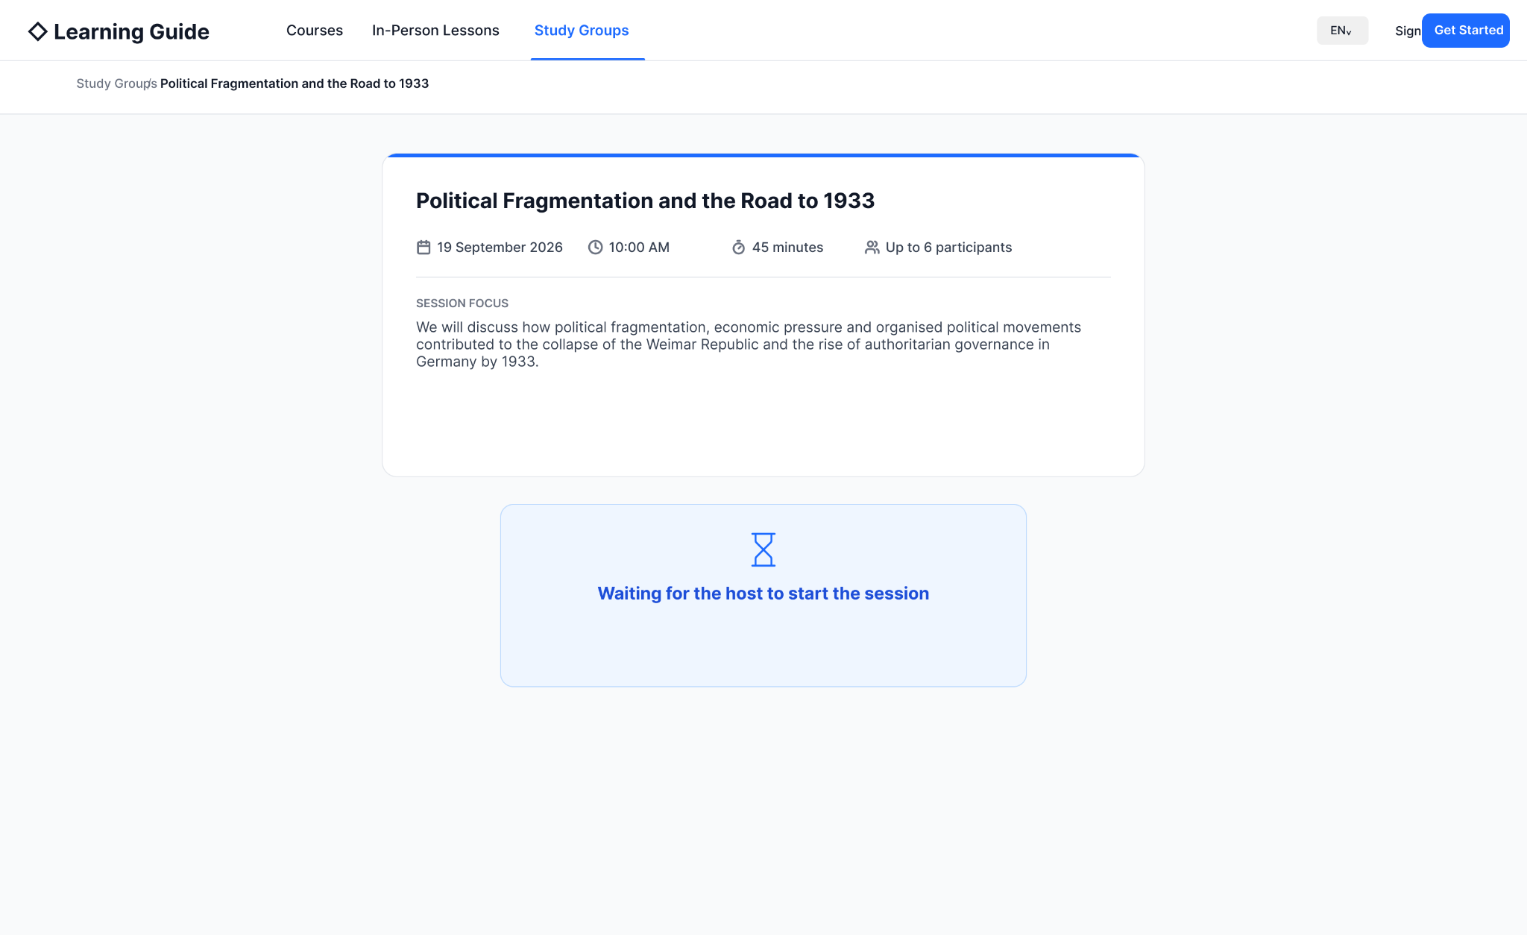
Figure 6.9.1 — Waiting for Host Start after a member enters during Starting Soon
From 10 minutes before the scheduled start time, the Live Session enters Starting Soon and becomes available for eligible joined members to enter. Joining during Starting Soon does not start the Session. If the Host has not yet selected Start Live Session, the member is taken to the Waiting for the host to start the session page shown above.
A user on this waiting page has already entered the Live Session space and therefore counts towards Currently in session and towards the Session’s configured Maximum Participants. Plan to Attend alone does not count towards Currently in session. The Session remains unstarted until the Host explicitly selects Start Live Session; reaching the scheduled start time does not auto-start the Session.
When the Host selects Start Live Session, the Session becomes Live. Members already waiting transition into the Live Session without needing to join again, and the current occupancy count is preserved. Additional eligible joined members may enter while capacity remains.

6.10 Live Session Room — Unified Participant Permissions
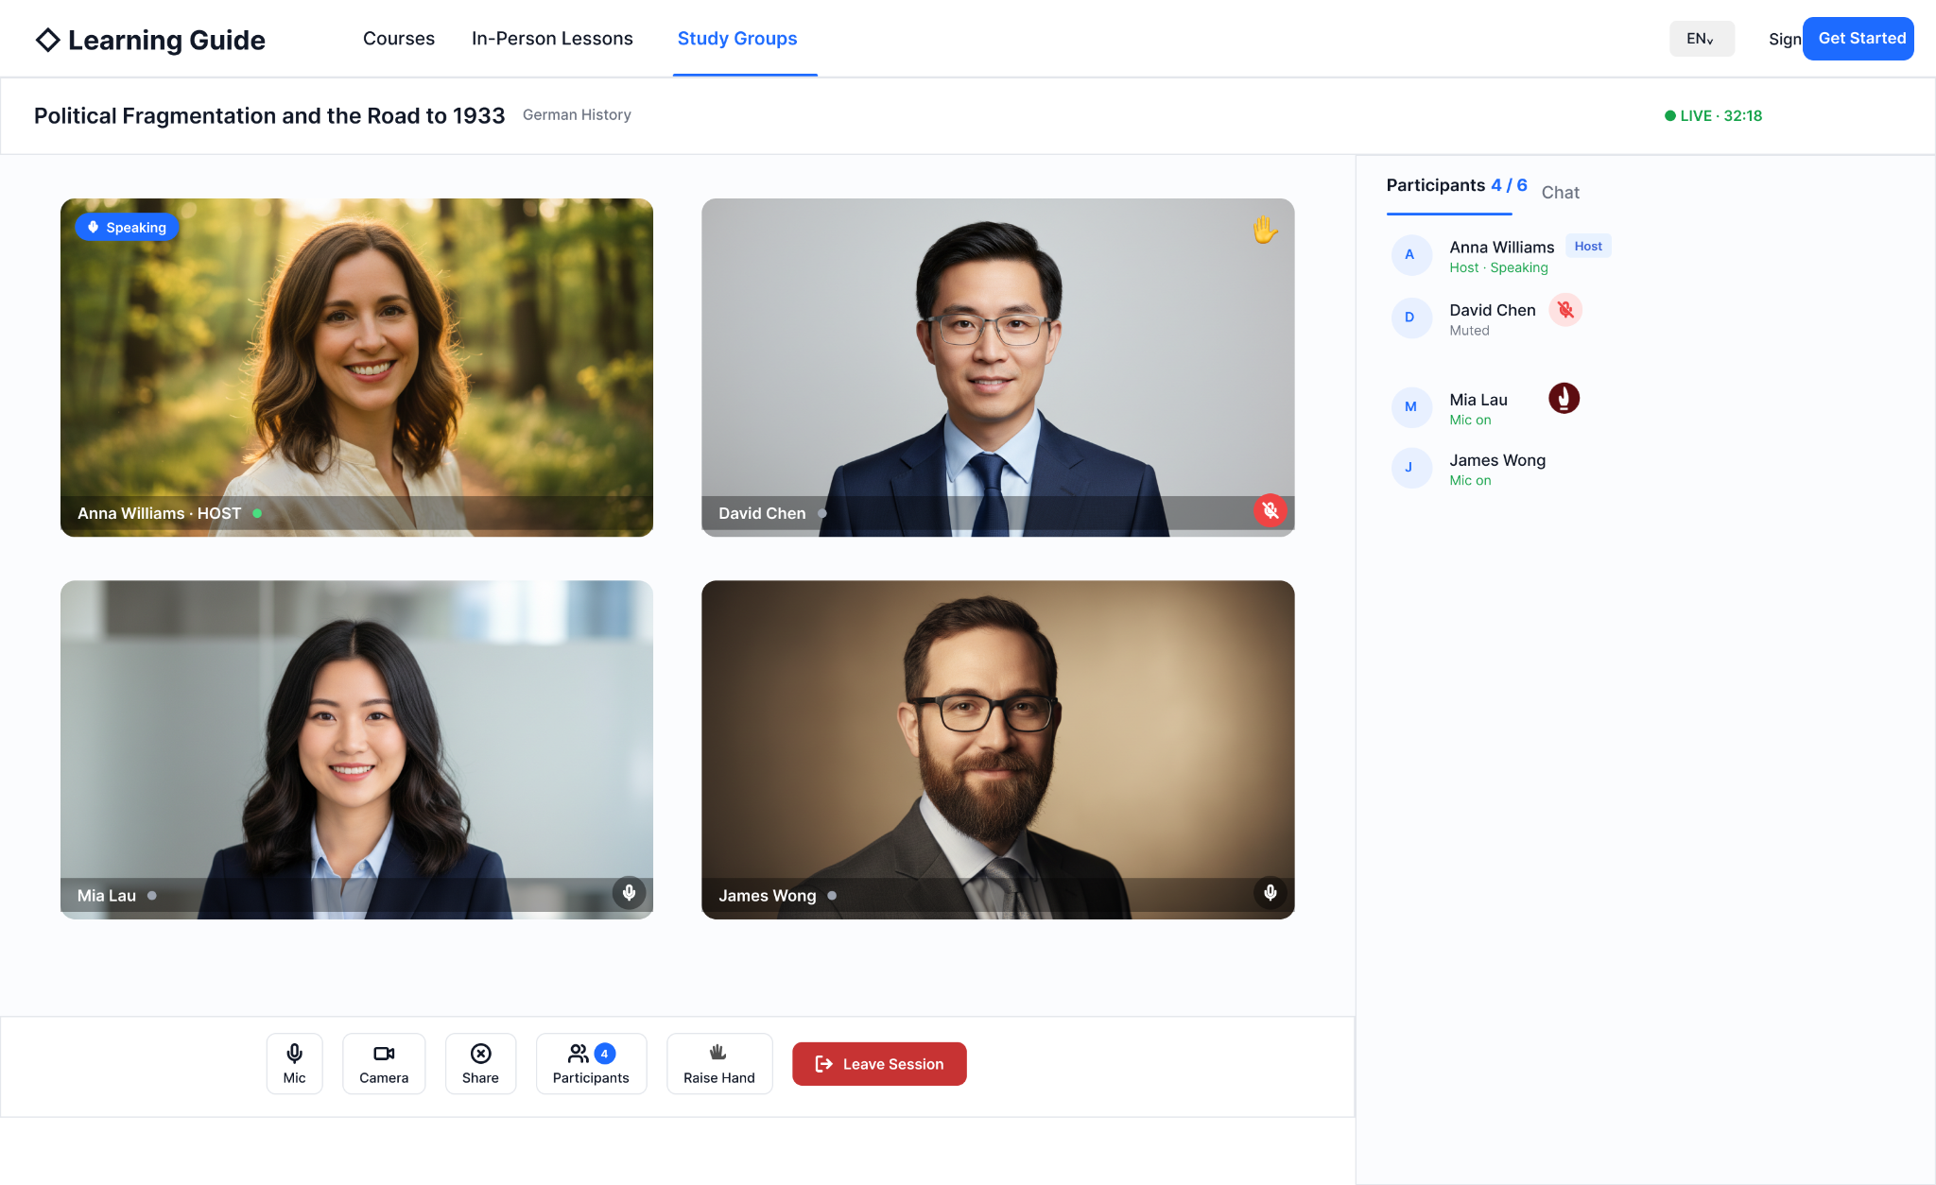
Figure 6.10 — Live Session room with equal in-room permissions
Control / Area | P0 behaviour
Host badge | Identity label only inside the room; does not grant moderation controls.
Mic | Each participant controls only their own microphone.
Camera | Each participant controls only their own camera.
Share | Any participant may share their screen.
Participants | Shows the current participant presence/status. Currently in session includes users who entered during Starting Soon and were waiting before Host Start, as well as users in the Live room.
Chat | Shared real-time Chat visible to current Session participants.
Raise Hand | Signal that the user has a question or wants to speak. No approval is required.
Leave Session | Exits only the current user. Session remains Live while anyone remains. When the final participant leaves, Session becomes Completed.

P0 explicitly removes Host mute/disable/remove controls, Invite to Speak, End Session, Host-disconnect grace and Host-leave auto-end.

6.11 Screen Sharing and AI Tutor as Live Learning Assistant
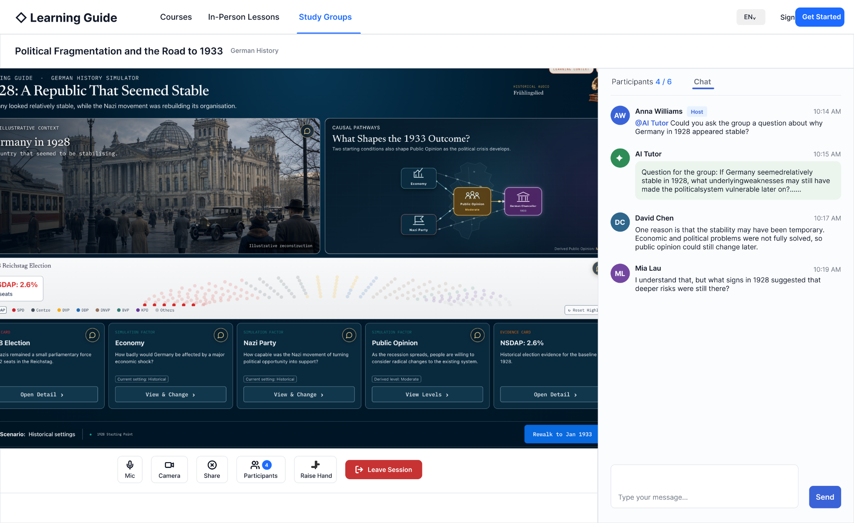
Figure 6.11 — Live Session layout used for screen sharing and shared AI Tutor assistance
Screen sharing is a normal Live Session capability available to any current participant. When content is shared, the shared content should be presented as the main learning area while Participants and Chat remain available.
If AI Tutor was enabled when the Session was scheduled, every current participant may invoke @AI Tutor from the shared Chat. AI Tutor interaction is public to the Session: the participant prompt and AI Tutor response are visible to everyone currently in the room.
AI Tutor capability | P0 rule
Who can invoke | Any current Live Session participant when AI Tutor is enabled.
Learning assistance | AI Tutor may answer learning questions under the related Course AI Tutor configuration and Course Knowledge grounding.
Understanding check | AI Tutor may generate a relevant question for the group to answer, constrained by Course Knowledge.
Knowledge source | Related Course AI Tutor Configuration + current student-facing Course Knowledge / Knowledge System grounding.
Related Lesson | Optional Session metadata only; does not change AI Tutor grounding in P0.
Shared screen context | Not parsed or analysed in P0. AI Tutor does not automatically know what is on the shared screen.
User-provided context | If a participant wants AI Tutor to focus on a specific topic, the participant must provide the topic/context in text.
Visibility | AI Tutor prompts and responses are shared with all current Session participants.

7. State Models
7.1 Study Group Membership State
State | Entry | Available actions | Exit
Discoverable / Not Joined | User does not Host or belong to Group. | View Overview/Members; Get Course access or Join if eligible. | Join Group → Joined.
Joined | User joins with valid Course access. | View Sessions, Plan to Attend, Join Live, Leave Group. | Leave Group → Discoverable if the Group remains available.
Hosting | User creates Group. | Edit/Cancel Group; Schedule/manage Sessions; all Member actions. | Cancel Group → unavailable.
Cancelled | Host cancels Group. | No member access in P0. | Terminal for front-end Group access.

7.2 Live Session State
State | Rule | Actions
Scheduled | Session created and more than 10 minutes before the scheduled start. | Host: Edit / Cancel. Member: Plan to Attend / Cancel Attendance. Session entry is not yet available.
Starting Soon | Begins at T-10 and continues until the Host selects Start Live Session. Eligible joined members may enter and wait. Entered users count towards Currently in session and the Session capacity. | Host: Start / Edit / Cancel until Session starts. Member: Enter Session → Waiting for Host Start. No automatic start at the scheduled time.
Live | Host has selected Start Live Session. Users already waiting transition into the Live Session automatically. | Eligible joined members may enter while capacity remains; all participants use equal in-room controls.
Completed | After the Session has been started, the final participant has left. | Read-only history; actual attendees may be viewed.

Cancel before start removes the Session record; no Cancelled state card is retained in P0. Starting Soon is the Session state from T-10 until Host Start. “Waiting for Host Start” is the participant page state shown after entry during Starting Soon. Entered waiting users count towards current occupancy and capacity. Host-disconnect recovery is not part of this model.
7.3 Attendance Intent State
State | Action | Effect
Not Planned | Plan to Attend | Creates attendance intent and reminder eligibility. Does not reserve capacity.
Planning to Attend | Cancel Attendance | Removes attendance intent and reminder.
Session entry | Join Now | Available from Starting Soon (T-10), independent of Plan to Attend; requires membership, valid Course access and available capacity. Before Host Start, entry leads to the waiting page and counts towards current occupancy.

8. Data and Integration Rules
8.1 Core Entities
Entity | Key P0 fields
Study Group | Group ID, Title, Related Course ID, About, Host User ID, status, created/updated timestamps.
Group Membership | Group ID, User ID, role (Host/Member), joined/left timestamps.
Live Session | Session ID, Group ID, Session Title, optional Related Lesson ID, date/start time, duration, max participants, Session Focus, AI Tutor enabled flag, state.
Attendance Intent | Session ID, User ID, plan-to-attend flag/timestamp, reminder eligibility.
Actual Attendance | Session ID, User ID, joined/left timestamps used for occupancy and Completed history.

8.2 Course Access and Identity
• Course access is checked when creating a Group, joining a Group and entering a Live Session. The backend remains authoritative.
• The Study Group module does not create or own Course entitlements.
• If Course access becomes invalid, restricted actions are blocked and the user is directed to restore Course access.
8.3 LiveKit Integration Boundary
Learning Guide owns | LiveKit Cloud owns
Study Group and membership records | Realtime room/media transport
Course access and business permission checks | Audio/video tracks
Live Session metadata and state | Screen-share transport
Attendance intent and reminders | Participant realtime presence / data transport
AI Tutor enablement and Course knowledge selection | Low-level RTC room connectivity

LiveKit API credentials and server-side privileges must never be exposed to the browser. Learning Guide backend issues only the short-lived client credentials needed for the current user and Session.
8.4 AI Tutor and Knowledge System Boundary
• Study Group does not choose an independent Knowledge Release.
• AI Tutor follows the Related Course AI Tutor Configuration and the current student-facing Course Knowledge / Knowledge System grounding.
• AI Tutor may answer questions and generate understanding-check questions, but generated content must remain within Course grounding.
• Shared screen pixels/content are not sent to AI Tutor for interpretation in P0.

9. Notifications
Trigger | Audience | P0 behaviour
Plan to Attend | The member who selected it | Member is included in the Live Session reminder audience. Reminder is sent 10 minutes before the scheduled start time through in-site notification and email.
Cancel Attendance | The same member | Future reminder for that Session is cancelled for the member.
Leave Study Group | The leaving member | All future Plan to Attend reminder subscriptions for that Group are cancelled.
Cancel Study Group | All current Group Members | Members receive Study Group cancelled notification.
Live Session reminder — Host | Session Host | Host receives a reminder 10 minutes before the scheduled start time through in-site notification and email, regardless of Plan to Attend.

P0 does not send the Live Session reminder to all Group Members. The reminder is sent 10 minutes before the scheduled start time through in-site notification and email to the Host and to members who selected Plan to Attend. Session-cancellation notification behaviour is not otherwise expanded beyond the currently approved scope.

10. Exceptions and Recovery
Scenario | Expected behaviour
Create Group without required fields | Block submission and show field-level validation.
Course access invalid at Join | Block Join and show Get Course access path.
Course access invalid at Live entry | Block Join Now and direct user to restore Course access.
Live Session reaches capacity | Block additional entry and show Session Full.
User planned to attend but Session is full | Plan does not guarantee entry; user remains blocked by live capacity.
Participant network disconnects | LiveKit reconnect behaviour may restore the participant; Session remains Live while at least one participant remains.
Host disconnects/leaves | No special grace or auto-end behaviour. Host is treated like any other live participant for room lifecycle.
Final participant leaves | If the Session has been started, set Session to Completed.
Host cancels unstarted Session | Remove Session record from user-facing list.
Host cancels Group | Group becomes inaccessible; upcoming Sessions cancelled; Group removed from discovery/my lists; Members notified.
Member enters during Starting Soon | Show Waiting for Host Start. Count the member in Currently in session and against Session capacity.
Scheduled start time arrives before Host Start | Do not auto-start. Users who already entered remain on the waiting page until Host Start or Session cancellation.
Waiting room reaches Session capacity | Block additional entry using the same Maximum Participants rule; Plan to Attend does not affect occupancy.

11. Security, Privacy and Non-Functional Requirements
Area | Requirement
Authentication | Only authenticated Learning Guide users may create/join Groups or enter Live Sessions. Public discovery may still require normal site access/session policy.
Authorisation | Backend validates Host/Member role, Course access, Session state and capacity before restricted actions.
Secrets | LiveKit API secret remains server-side only.
Client tokens | LiveKit participant token is short-lived and scoped to the intended Session/user permissions.
Recording | No recording or playback in P0.
AI privacy | AI Tutor messages are shared Session content, visible to current participants. No private AI channel in P0.
Screen share / AI boundary | Shared screen content is not analysed by AI Tutor in P0.
Performance | Study Group page should remain responsive with a scrollable Member list and many Group members.
RTC capacity | Each Live Session enforces configured 2–6 participant maximum including Host.
Browser support | Target modern desktop browsers supported by Learning Guide and LiveKit WebRTC stack.

12. Test Cases
ID | Scenario | Expected Result
TC-001 | Open Study Groups with no Group selected | No-selection message shown; My and Discover lists visible.
TC-002 | User Hosts a Group | Group appears in My Study Groups with Hosted state and not in Discover.
TC-003 | User Joined a Group | Group appears in My Study Groups with Joined state and not in Discover.
TC-004 | Child Session is Live | Group card shows Live badge.
TC-005 | Create Group Related Course dropdown | Only Courses with current valid access are listed.
TC-006 | Create Group missing required field | Submission blocked with validation.
TC-007 | Create Group succeeds | Creator becomes Host; success page shown; Group is publicly discoverable to other users.
TC-008 | Edit Group | Title/About editable; Related Course read-only.
TC-009 | Cancel Group | Group inaccessible; upcoming Sessions cancelled; Group removed from lists; Members notified; completed history retained in system.
TC-010 | Member list with many users | List scrolls and total count is shown.
TC-011 | Schedule Session max participants | Allowed range is 2–6 including Host.
TC-012 | Schedule Session Related Lesson blank | Session schedules successfully; no functional impact.
TC-013 | Schedule Session AI Tutor default | Enable AI Tutor is checked by default and can be unchecked.
TC-014 | Starting Soon threshold | Session enters Starting Soon at T-10 minutes.
TC-015 | Edit Session before start | Host can edit.
TC-016 | Cancel Session before start | Host can cancel; record disappears.
TC-017 | Edit/Cancel after Live start | Controls are unavailable.
TC-018 | Completed state | After final participant leaves, Session becomes Completed.
TC-019 | Completed Session host view | Finished/read-only history is visible with actual attendees.
TC-020 | Discover Group with Course access | Overview/Members visible; Join enabled; Live Sessions hidden until Join.
TC-021 | Join Group with Course access | User joins immediately; no Host approval; Group moves to My Study Groups.
TC-022 | Discover Group without Course access | Overview/Members visible; Join disabled; Get Course access available.
TC-023 | Get Course access | Link opens related Course subscription/purchase path.
TC-024 | Plan to Attend | Intent recorded; reminder eligibility created; no seat reserved.
TC-025 | Cancel Attendance | Intent and reminder removed.
TC-026 | Join Live without Plan | Joined member can enter if Course access valid and capacity available.
TC-027 | Session capacity reached | Additional Join blocked; Session Full displayed.
TC-028 | Participant views Completed history | Completed Session is visible and read-only.
TC-029 | Leave Study Group | Membership removed; future Plan to Attend/reminders cancelled; Group becomes discoverable again if the Group remains available.
TC-030 | Host enters Live room | Host badge visible but no extra moderation controls.
TC-031 | Participant media controls | User can toggle own mic/camera.
TC-032 | Screen share | Any participant can start/stop screen sharing.
TC-033 | Raise Hand | Signal visible without approval workflow or speaking permission change.
TC-034 | Leave Session | Only current user exits; others remain.
TC-035 | Host leaves before others | Session stays Live; no grace countdown or auto-end.
TC-036 | AI Tutor disabled | @AI Tutor is unavailable for the Session.
TC-037 | AI Tutor enabled | Any current participant can invoke @AI Tutor in shared Chat.
TC-038 | AI Tutor visibility | Prompt and AI response visible to all current participants.
TC-039 | AI Tutor learning question | Response follows Course AI Tutor / Knowledge grounding.
TC-040 | AI Tutor understanding check | Generated question is constrained by Course Knowledge.
TC-041 | Shared screen not parsed | AI Tutor does not automatically infer screen-share content.
TC-042 | User supplies topic in text | AI Tutor can respond to provided topic while respecting Course grounding.
TC-043 | Course access expires before Live entry | Join Now blocked and user directed to restore access.
TC-044 | Enter during Starting Soon | At T-10 or later, an eligible joined member selects Join Now before Host Start → Waiting for Host Start page is shown.
TC-045 | Waiting user counts towards occupancy | A member who has entered the waiting page is included in Currently in session and counts against Maximum Participants.
TC-046 | Plan to Attend does not count occupancy | Selecting Plan to Attend without entering changes attendance intent/reminder eligibility only; Currently in session does not change.
TC-047 | Host starts with members waiting | Host selects Start Live Session while members are waiting → Session becomes Live, waiting members transition without joining again, and occupancy is preserved.
TC-048 | No automatic start at scheduled time | If Host has not selected Start when the scheduled time arrives, the Session does not become Live; entered members remain on the waiting page.
TC-049 | Live Session reminder audience and channels | At T-10, Host and members who selected Plan to Attend receive the reminder through in-site notification and email; other Group members do not.

13. Post-P0 Direction
The following areas are deliberately not part of the current build. They may be revisited after real usage data is available:
• Public persistent Discussion/comments with moderation, reporting and safety workflows.
• Recurring Live Sessions and recurring attendance patterns.
• Host moderation controls or formal speaking permissions for larger/public groups.
• AI Tutor interpretation of shared Learning Guide content or screen context.
• Group Understanding workflow where members discuss and the Host submits one agreed answer.
• Learning-discipline features such as check-ins, streaks, badges or mutual accountability mechanics.
• AI-generated post-session summaries or reusable group learning records.
PRODUCT DIRECTION P0 validates whether Course-linked membership, small Live Sessions and a shared Course-grounded AI Tutor create useful group-learning behaviour. More social/community functionality should be introduced only after actual usage and moderation needs are understood.

